Metabolomic Insights into Triticum aestivum L.: Comparative Profiling of Growth Stages and Parts Using Hydrophilic Extracts
Supplementary material 1
- In vitro assays
  - Determination of total phenolic and total flavonoid contents
Figure S1 shows the standard calibration curves used for TPC and TFC assays.
A
B
Fig. S1 Calibration curves for the determination of total phenolic and total flavonoid contents; (A) Gallic acid standard calibration curve for total phenolic content assay and (B) Quercetin standard calibration curve for total flavonoid content assay
  - Evaluation of antioxidant activity of extracts
Figure S2 shows the standard calibration curves used for the 4 antioxidant determining assays.
B
A
D
C
Fig. S2 Calibration curves used for the antioxidant assays; (A) BHA standard calibration curve for CUPRAC assay, (B) Trolox standard calibration curve for DPPH assay, (C) Quercetin standard calibration curve for ABTS assay, and (D) Ferrous sulphate standard calibration curve for FRAP assay
- GC-MS and LC-MS/MS analysis
Table S1 Order of sample injection in GC-MS and LC-MS/MS of derivatized hydroalcoholic extract of whole seeds, bran, germ, groats, stage 1 aerial part, stage 1 roots, stage 2 aerial part, stage 2 roots, stage 3 aerial part and stage 3 roots.
- Seeds 3 | 6. Aerial 1.3 | 11. Roots 1.3 | 16. Aerial 3.3 | 21. Germ 2 | 26. Aerial 3.2
- Aerial 2.2 | 7. Groats 1 | 12. Seeds 1 | 17. Groats 3 | 22. Roots 2.1 | 27. Roots 1.2
- Roots 3.1 | 8. Aerial 3.1 | 13. Aerial 2.3 | 18. Roots 1.1 | 23. Groats 2 | 28. Bran 3
- Germ 1 | 9. Germ 3 | 14. Roots 3.2 | 19. Aerial 1.2 | 24. Aerial 2.1 | 29. Aerial 1.1
- Bran 2 | 10. Roots 2.2 | 15. Bran 1 | 20. Seeds 2 | 25. Roots 3.3 | 30. Roots 2.3

- Tukey Multiple comparisons between the extracts for in-vitro assays
Table S2 shows the Tukey Multiple comparisons between the extracts for in-vitro assays.
Table S2 Tukey Multiple comparisons between the extracts for in-vitro assays
Total Phenolic Content |  |  | Total Flavonoid Content
Tukey's multiple comparisons test | Below threshold? | Adjusted p value | Tukey's multiple comparisons test | Below threshold? | Adjusted p value
Seeds vs. Groats | No | 0.983 | Seeds vs. Groats | No | 0.54
Seeds vs. Germ | No | >.999 | Seeds vs. Germ | Yes | 0.025
Seeds vs. Bran | No | 0.99 | Seeds vs. Bran | No | 0.163
Seeds vs. Aerial 1 | No | 0.273 | Seeds vs. Aerial 1 | Yes | <.001
Seeds vs. Roots 1 | No | >.999 | Seeds vs. Roots 1 | Yes | <.001
Seeds vs. Aerial 2 | No | 0.298 | Seeds vs. Aerial 2 | Yes | <.001
Seeds vs. Roots 2 | No | >.999 | Seeds vs. Roots 2 | No | >.999
Seeds vs. Aerial 3 | Yes | <.001 | Seeds vs. Aerial 3 | Yes | <.001
Seeds vs. Roots 3 | Yes | <.001 | Seeds vs. Roots 3 | No | 0.942
Groats vs. Germ | No | 0.998 | Groats vs. Germ | No | 0.75
Groats vs. Bran | No | >.999 | Groats vs. Bran | No | 0.998
Groats vs. Aerial 1 | No | 0.858 | Groats vs. Aerial 1 | Yes | <.001
Groats vs. Roots 1 | No | >.999 | Groats vs. Roots 1 | Yes | 0.039
Groats vs. Aerial 2 | No | 0.882 | Groats vs. Aerial 2 | Yes | <.001
Groats vs. Roots 2 | No | >.999 | Groats vs. Roots 2 | No | 0.751
Groats vs. Aerial 3 | Yes | <.001 | Groats vs. Aerial 3 | Yes | <.001
Groats vs. Roots 3 | Yes | 0.01 | Groats vs. Roots 3 | No | 0.065
Germ vs. Bran | No | 0.999 | Germ vs. Bran | No | 0.992
Germ vs. Aerial 1 | No | 0.402 | Germ vs. Aerial 1 | Yes | <.001
Germ vs. Roots 1 | No | >.999 | Germ vs. Roots 1 | No | 0.668
Germ vs. Aerial 2 | No | 0.434 | Germ vs. Aerial 2 | Yes | <.001
Germ vs. Roots 2 | No | >.999 | Germ vs. Roots 2 | No | 0.052
Germ vs. Aerial 3 | Yes | <.001 | Germ vs. Aerial 3 | Yes | <.001
Germ vs. Roots 3 | Yes | 0.002 | Germ vs. Roots 3 | Yes | 0.001
Bran vs. Aerial 1 | No | 0.821 | Bran vs. Aerial 1 | Yes | <.001
Bran vs. Roots 1 | No | >.999 | Bran vs. Roots 1 | No | 0.184
Bran vs. Aerial 2 | No | 0.847 | Bran vs. Aerial 2 | Yes | <.001
Bran vs. Roots 2 | No | >.999 | Bran vs. Roots 2 | No | 0.292
Bran vs. Aerial 3 | Yes | <.001 | Bran vs. Aerial 3 | Yes | <.001
Bran vs. Roots 3 | Yes | 0.008 | Bran vs. Roots 3 | Yes | 0.012
Aerial 1 vs. Roots 1 | No | 0.451 | Aerial 1 vs. Roots 1 | Yes | 0.004
Aerial 1 vs. Aerial 2 | No | >.999 | Aerial 1 vs. Aerial 2 | Yes | <.001
Aerial 1 vs. Roots 2 | No | 0.641 | Aerial 1 vs. Roots 2 | Yes | <.001
Aerial 1 vs. Aerial 3 | Yes | <.001 | Aerial 1 vs. Aerial 3 | Yes | <.001
Aerial 1 vs. Roots 3 | No | 0.217 | Aerial 1 vs. Roots 3 | Yes | <.001
Roots 1 vs. Aerial 2 | No | 0.484 | Roots 1 vs. Aerial 2 | Yes | <.001
Roots 1 vs. Roots 2 | No | >.999 | Roots 1 vs. Roots 2 | Yes | <.001
Roots 1 vs. Aerial 3 | Yes | <.001 | Roots 1 vs. Aerial 3 | Yes | <.001
Roots 1 vs. Roots 3 | Yes | 0.002 | Roots 1 vs. Roots 3 | Yes | <.001
Aerial 2 vs. Roots 2 | No | 0.675 | Aerial 2 vs. Roots 2 | Yes | <.001
Aerial 2 vs. Aerial 3 | Yes | <.001 | Aerial 2 vs. Aerial 3 | No | 0.076
Aerial 2 vs. Roots 3 | No | 0.197 | Aerial 2 vs. Roots 3 | Yes | <.001
Roots 2 vs. Aerial 3 | Yes | <.001 | Roots 2 vs. Aerial 3 | Yes | <.001
Roots 2 vs. Roots 3 | Yes | 0.004 | Roots 2 vs. Roots 3 | No | 0.808
Aerial 3 vs. Roots 3 | Yes | 0.029 | Aerial 3 vs. Roots 3 | Yes | <.001

CUPRAC |  |  | FRAP
Tukey's multiple comparisons test | Below threshold? | Adjusted p value | Tukey's multiple comparisons test | Below threshold? | Adjusted p value
Seeds vs. Groats | No | 0.995 | Seeds vs. Groats | No | 0.988
Seeds vs. Germ | Yes | 0.022 | Seeds vs. Germ | No | 0.829
Seeds vs. Bran | Yes | <.001 | Seeds vs. Bran | Yes | 0.004
Seeds vs. Aerial 1 | Yes | 0.003 | Seeds vs. Aerial 1 | Yes | <.001
Seeds vs. Roots 1 | No | 0.99 | Seeds vs. Roots 1 | No | 0.842
Seeds vs. Aerial 2 | No | 0.186 | Seeds vs. Aerial 2 | Yes | <.001
Seeds vs. Roots 2 | No | 0.997 | Seeds vs. Roots 2 | Yes | <.001
Seeds vs. Aerial 3 | Yes | <.001 | Seeds vs. Aerial 3 | Yes | <.001
Seeds vs. Roots 3 | Yes | <.001 | Seeds vs. Roots 3 | Yes | <.001
Groats vs. Germ | No | 0.095 | Groats vs. Germ | No | >.999
Groats vs. Bran | Yes | <.001 | Groats vs. Bran | Yes | 0.031
Groats vs. Aerial 1 | Yes | 0.012 | Groats vs. Aerial 1 | Yes | <.001
Groats vs. Roots 1 | No | >.999 | Groats vs. Roots 1 | No | >.999
Groats vs. Aerial 2 | No | 0.57 | Groats vs. Aerial 2 | Yes | <.001
Groats vs. Roots 2 | No | >.999 | Groats vs. Roots 2 | Yes | <.001
Groats vs. Aerial 3 | Yes | <.001 | Groats vs. Aerial 3 | Yes | <.001
Groats vs. Roots 3 | Yes | 0.004 | Groats vs. Roots 3 | Yes | 0.003
Germ vs. Bran | No | 0.056 | Germ vs. Bran | No | 0.105
Germ vs. Aerial 1 | No | 0.994 | Germ vs. Aerial 1 | Yes | 0.003
Germ vs. Roots 1 | No | 0.11 | Germ vs. Roots 1 | No | >.999
Germ vs. Aerial 2 | No | 0.937 | Germ vs. Aerial 2 | Yes | 0.003
Germ vs. Roots 2 | No | 0.086 | Germ vs. Roots 2 | Yes | <.001
Germ vs. Aerial 3 | Yes | <.001 | Germ vs. Aerial 3 | Yes | <.001
Germ vs. Roots 3 | No | 0.862 | Germ vs. Roots 3 | Yes | 0.009
Bran vs. Aerial 1 | No | 0.139 | Bran vs. Aerial 1 | No | 0.785
Bran vs. Roots 1 | Yes | <.001 | Bran vs. Roots 1 | No | 0.099
Bran vs. Aerial 2 | Yes | 0.005 | Bran vs. Aerial 2 | No | 0.802
Bran vs. Roots 2 | Yes | <.001 | Bran vs. Roots 2 | Yes | 0.003
Bran vs. Aerial 3 | Yes | <.001 | Bran vs. Aerial 3 | Yes | <.001
Bran vs. Roots 3 | No | 0.379 | Bran vs. Roots 3 | No | 0.969
Aerial 1 vs. Roots 1 | Yes | 0.015 | Aerial 1 vs. Roots 1 | Yes | 0.003
Aerial 1 vs. Aerial 2 | No | 0.437 | Aerial 1 vs. Aerial 2 | No | >.999
Aerial 1 vs. Roots 2 | Yes | 0.011 | Aerial 1 vs. Roots 2 | No | 0.117
Aerial 1 vs. Aerial 3 | Yes | <.001 | Aerial 1 vs. Aerial 3 | Yes | <.001
Aerial 1 vs. Roots 3 | No | 0.999 | Aerial 1 vs. Roots 3 | No | >.999
Roots 1 vs. Aerial 2 | No | 0.624 | Roots 1 vs. Aerial 2 | Yes | 0.003
Roots 1 vs. Roots 2 | No | >.999 | Roots 1 vs. Roots 2 | Yes | <.001
Roots 1 vs. Aerial 3 | Yes | <.001 | Roots 1 vs. Aerial 3 | Yes | <.001
Roots 1 vs. Roots 3 | Yes | 0.005 | Roots 1 vs. Roots 3 | Yes | 0.009
Aerial 2 vs. Roots 2 | No | 0.537 | Aerial 2 vs. Roots 2 | No | 0.11
Aerial 2 vs. Aerial 3 | Yes | <.001 | Aerial 2 vs. Aerial 3 | Yes | <.001
Aerial 2 vs. Roots 3 | No | 0.186 | Aerial 2 vs. Roots 3 | No | >.999
Roots 2 vs. Aerial 3 | Yes | <.001 | Roots 2 vs. Aerial 3 | Yes | <.001
Roots 2 vs. Roots 3 | Yes | 0.004 | Roots 2 vs. Roots 3 | Yes | 0.041
Aerial 3 vs. Roots 3 | Yes | <.001 | Aerial 3 vs. Roots 3 | Yes | <.001

ABTS
Tukey's multiple comparisons test | Below threshold? | Adjusted p value
Seeds vs. Groats | No | >.999
Seeds vs. Germ | No | >.999
Seeds vs. Bran | No | 0.909
Seeds vs. Aerial 1 | No | 0.867
Seeds vs. Roots 1 | No | 0.401
Seeds vs. Aerial 2 | No | 0.962
Seeds vs. Roots 2 | No | 0.347
Seeds vs. Aerial 3 | No | 0.832
Seeds vs. Roots 3 | No | 0.983
Groats vs. Germ | No | >.999
Groats vs. Bran | No | 0.61
Groats vs. Aerial 1 | No | 0.993
Groats vs. Roots 1 | No | 0.746
Groats vs. Aerial 2 | No | >.999
Groats vs. Roots 2 | No | 0.685
Groats vs. Aerial 3 | No | 0.495
Groats vs. Roots 3 | No | >.999
Germ vs. Bran | No | 0.634
Germ vs. Aerial 1 | No | 0.99
Germ vs. Roots 1 | No | 0.723
Germ vs. Aerial 2 | No | >.999
Germ vs. Roots 2 | No | 0.662
Germ vs. Aerial 3 | No | 0.519
Germ vs. Roots 3 | No | >.999
Bran vs. Aerial 1 | No | 0.158
Bran vs. Roots 1 | Yes | 0.031
Bran vs. Aerial 2 | No | 0.269
Bran vs. Roots 2 | Yes | 0.025
Bran vs. Aerial 3 | No | >.999
Bran vs. Roots 3 | No | 0.334
Aerial 1 vs. Roots 1 | No | 0.997
Aerial 1 vs. Aerial 2 | No | >.999
Aerial 1 vs. Roots 2 | No | 0.993
Aerial 1 vs. Aerial 3 | No | 0.112
Aerial 1 vs. Roots 3 | No | >.999
Roots 1 vs. Aerial 2 | No | 0.973
Roots 1 vs. Roots 2 | No | >.999
Roots 1 vs. Aerial 3 | Yes | 0.021
Roots 1 vs. Roots 3 | No | 0.946
Aerial 2 vs. Roots 2 | No | 0.954
Aerial 2 vs. Aerial 3 | No | 0.198
Aerial 2 vs. Roots 3 | No | >.999
Roots 2 vs. Aerial 3 | Yes | 0.017
Roots 2 vs. Roots 3 | No | 0.917
Aerial 3 vs. Roots 3 | No | 0.25

- Loadings plot
Table S3. GC-MS based loadings plot coding identifiers
Code | Rt | Sample | Name | Match
M416 | 24.978 | GR2 | D-(-)-Fructofuranose, pentakis(trimethylsilyl) ether (isomer 1) | 690
M590 | 39.454 | B1 | D-(+)-Turanose, octakis(trimethylsilyl) ether | 739
M591 | 39.463 | GE 2 | D-(+)-Turanose, octakis(trimethylsilyl) ether | 723
M600 | 39.491 | B3 | D-(+)-Turanose, octakis(trimethylsilyl) ether | 728
M601 | 39.502 | B2 | D-(+)-Turanose, octakis(trimethylsilyl) ether | 727
M628 | 40.767 | B3 | Resveratrol, O,O',O''-tri(trimethylsilyl)- | 748
M631 | 40.776 | B3 | Resveratrol, O,O',O''-tri(trimethylsilyl)- | 723
M636 | 40.799 | B2 | Resveratrol, O,O',O''-tri(trimethylsilyl)- | 729
M639 | 40.806 | GE 2 | Resveratrol, O,O',O''-tri(trimethylsilyl)- | 734

- LC-MS results
  - Data processing:
5.1.1 MzMine
All extracted .RAW files were extracted from UPLC and converted to .mzXML extension using ProteoWizard 3.0. These files were then uploaded to Mzmine 4.80 software for further processing. The MS1 spectra were first filtered (crop filter: MS1, retention time (R_{T}) 0-40 min, all ion modes, any type of spectrum, with m/z 30-1000 mass range). Then, mass detection was applied (R_{T} (retention time) 0-40 min, all ion modes, any time of spectrum) with centroided mass detector and noise level of 8.3E3. Chromatogram builder was used after that (R_{T} 0-40 min, all ion modes, any type of spectrum) with minimum time span over which the same ion must be observed in order to be recognized as chromatogram was 0 min, minimum intensity of the highest data point in the chromatogram was 8.3E3 and the m/z tolerance (maximum allowed difference between the 2 m/z values to be considered the same) was 0.1 m/z or 0. For the chromatogram deconvolution process, noise-amplitude algorithm was used with minimum acceptable height for a chromatographic peak of 8.3E3, minimum peak duration range of 0-3 minutes, amplitude noise of 8.3E3 and median approach for m/z center calculation. Isotopic peaks were detected and grouped together into isotope patterns using the following conditions: m/z tolerance was 2 m/z or 0 ppm, R_{T} tolerance (maximum allowed difference between two retention time values) was 1 min, maximum charge to consider for detecting the isotope pattern was 3 and the representative isotope was the most intense isotope as the compounds were of small molecular weights. The chromatograms peaks were aligned using Join Aligner as follows: m/z tolerance was 1 m/z or 0 ppm with a score for perfectly matching m/z values of 75%, while R_{T} tolerance was 1 min with a score for perfectly matching R_{T} values of 25% and only rows with having same charge state being aligned. The isotope patterns were compared, with m/z tolerance of 1 m/z or 0 ppm for the 2 isotopes to be considered the same, minimum absolute intensity of the isotopes to be compared 8.3E3 and a minimum score of 5%.
The MS2 spectra were then filtered (crop filter: MS2, retention time (R_{T}) 0-40 min, all ion modes, any type of spectrum, with m/z 30-1000 mass range). Then, mass detection was applied (RT 0-40 min, all ion modes, any time of spectrum) with centroided mass detector and noise level of 2.0E5. Chromatogram builder was used after that (R_{T} 0-40 min, all ion modes, any type of spectrum) with minimum time span over which the same ion must be observed in order to be recognized as chromatogram was 0 min, minimum intensity of the highest data point in the chromatogram was 2.0E5 and the m/z tolerance (maximum allowed difference between the 2 m/z values to be considered the same) was 0.1 m/z or 0 ppm. For the chromatogram deconvolution process, noise-amplitude algorithm was used with minimum acceptable height for a chromatographic peak of 2.0E5, minimum peak duration range of 0-3 minutes, amplitude noise of 2.0E5 and median approach for m/z center calculation. Isotopic peaks were detected and grouped together into isotope patterns using the following conditions: m/z tolerance was 1 m/z or 0 ppm, RT tolerance (maximum allowed difference between two retention time values) was 1 min, maximum charge to consider for detecting the isotope pattern was 3 and the representative isotope was the most intense isotope as the compounds were of small molecular weights. The chromatograms peaks were aligned using Join Aligner as follows: m/z tolerance was 0.1 m/z or 0 ppm with a score for perfectly matching m/z values of 75%, while RT tolerance was 1 min with a score for perfectly matching R_{T} values of 25% and only rows with having same charge state being aligned. The isotope patterns were compared, with m/z tolerance of 1 m/z or 0 ppm for the 2 isotopes to be considered the same, minimum absolute intensity of the isotopes to be compared 2.0E5 and a minimum score of 5%.
5.1.2 Metaboanalyst
The resulting aligned features were then uploaded to Metaboanalyst software (https://www.metaboanalyst.ca/faces/ModuleView) for further processing. Statistical analysis (one factor) was chosen for the analysis. The type of data was peak intensities with unpaired sample in columns. For MS1 spectra, interquartile (IQR) filtration was applied and normalization was done using pooled sample group (QC samples), with mean scaling. As for the MS2 spectra, interquartile (IQR) filtration was applied and normalization was done using pooled sample group (QC samples), with logarithmic transformation of the intensities and pareto centering.

5.2 Multivariate analysis methods

5.2.1 Unsupervised method

5.2.1.1 Principal Component Analysis (PCA)
Figure S3 is pairwise score plots providing an overview of the various separation patterns among the most significant PCs. The results showed that PC1 and PC2 showed the most variations among the different extracts (PC1=3.7, PC2=3.1). The 2 selected PCs were used for further data analysis using PCA.
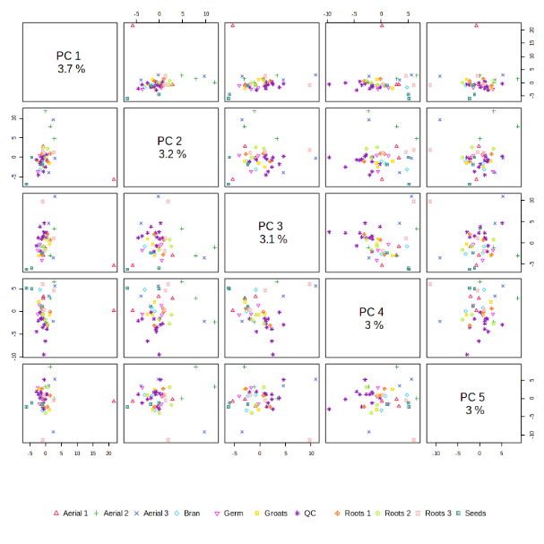
Fig. S3 Pairwise PCA score plots between the selected PCs for the LC-MSMS data. The explained variance of each PC is shown in the corresponding diagonal cell

5.2.2 Supervised methods

5.2.2.1 Partial Least Squares - Discriminant Analysis (PLS-DA)
Figure S4 is pairwise PLS-DA score plots providing an overview of the various separation patterns among the most significant PCs. The results showed that PC1 and PC2 showed the most variations among the different extracts (PC1=3.2.9, PC2=2.9). The 2 selected PCs were used for further data analysis using PLS-DA.

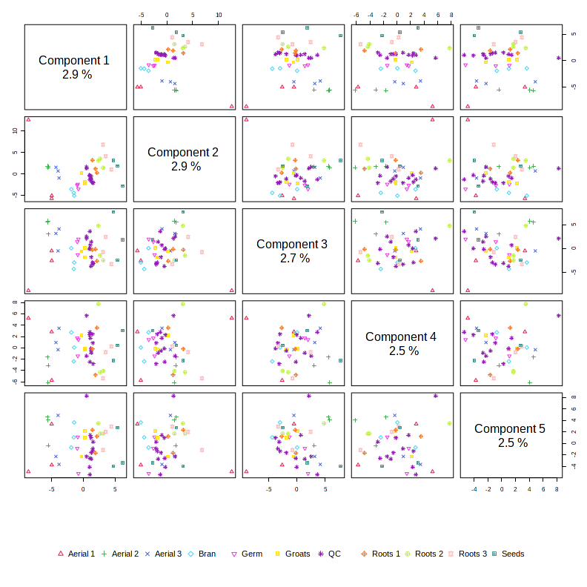
Fig. S4 Pairwise PLS-DA scores plots between the selected components for the LC-MSMS data. The explained variance of each component is shown in the corresponding diagonal cell

5.3 Hierarchical Clustering
In hierarchical cluster analysis, each sample begins as a separate cluster and the algorithm proceeds to combine them until all samples belong to one cluster. Two parameters need to be considered when performing hierarchical clustering. The first one is similarity measure - Euclidean distance, Pearson’s correlation, Spearman’s rank correlation. The other parameter is clustering algorithms, including average linkage (clustering uses the centroids of the observations), complete linkage (clustering uses the farthest pair of observations between the two groups), single linkage (clustering uses the closest pair of observations) and Ward’s linkage (clustering to minimize the sum of squares of any two clusters). Figure S5 shows the clustering result in the form of a dendrogram.
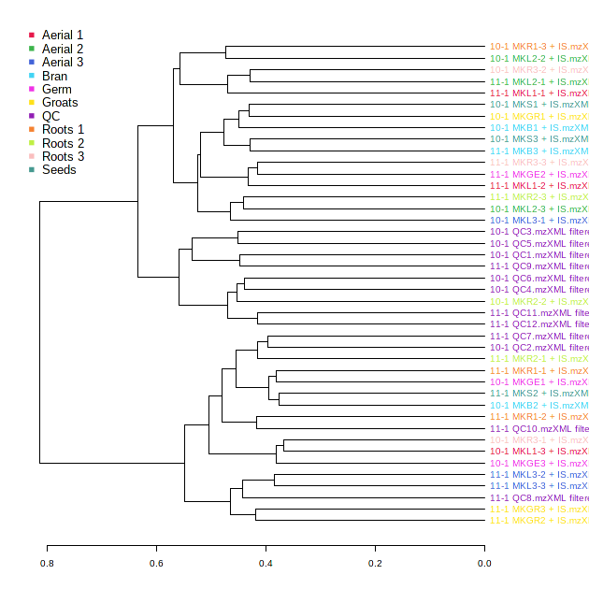
Fig. S5 Clustering result shown as dendrogram (distance measure using spearman, and clustering algorithm using Ward.D)

