Supplementary material

Table S 1: Effect of pasteurization on selected CIELAB colour parameters of haskap juice. The values are expressed as mean ± SE (n = 9). Mean values followed by different letters within the same row are significantly different according to Tukey’s test (p ≤ 0.05).
Parameter | Unpasteurized | Pasteurized | p-value
b* | 3.23 ± 0.05ª | 3.35 ± 0.07^{b} | 0.018
C* | 3.34 ± 0.01ª | 3.45 ± 0.02^{b} | <0.001
h* | 66.06 ± 0.57ª | 67.99 ± 0.21^{b} | 0.002

Table S 2: Effect of pasteurization on sucrose, fructose, and total sugar content in aronia juice (g/L). The values are expressed as mean ± SE (n = 9). Mean values followed by different letters within the same row are significantly different at p ≤ 0.05.
Parameter | Unpasteurized | Pasteurized | p-value
Sucrose | 5.86 ± 0.35ª | 6.42 ± 0.25^{b} | 0.036
Fructose | 36.68 ± 0.34ª | 38.23 ± 0.60^{b} | 0.002
Total sugars | 138.75 ± 2.38ª | 145.06 ± 3.52^{b} | 0.009

Table S 3: Sorbitol content in aronia juice under different enzyme treatments and pasteurization conditions (g/L). Mean values followed by a different letter are significantly different according to Tukey’s test (p ≤ 0.05).
Treatment | Sorbitol content | ± SE | p
Unpasteurized No | 42.937 | 0.817 | a
Unpasteurized Low | 49.114 | 0.832 | bc
Unpasteurized High | 48.039 | 0.868 | b
Pasteurized No | 42.039 | 0.802 | a
Pasteurized Low | 52.081 | 0.676 | cd
Pasteurized High | 53.116 | 0.917 | d
p-value Pasteurization | 0.004
p-value Enzyme | <0.001
p-value Interaction | 0.011

Table S 4: Effect of pasteurization on selected organic acids in aronia and haskap juices. Values are expressed as mean ± SE (n = 9). Mean values followed by different superscript letters within the same row are significantly different between unpasteurized and pasteurized samples (p ≤ 0.05).
Fruit | Organic acid | Unpasteurized | Pasteurized | p-value
Aronia | Malic acid | 32.77 ± 0.43ª | 33.74 ± 0.42^{b} | 0.004
Haskap | Quinic acid | 11.15 ± 0.20^{b} | 10.35 ± 0.30ª | 0.009
Haskap | Shikimic acid | 0.073 ± 0.001^{b} | 0.050 ± 0.002ª | <0.001
Haskap | Fumaric acid | 0.027 ± 0.001^{b} | 0.023 ± 0.001ª | 0.029

Table S 5: Concentrations of major phenolic compound groups and total analyzed phenolic compounds in aronia juice as affected by pasteurization (mg/L). Values are expressed as mean ± SE (n = 9). Mean values within each compound group followed by different superscript letters are significantly different according to the two-way ANOVA followed by Tukey’s test (p ≤ 0.05).
Pasteurization | Anthocyanins (mg/L) |  | Flavones (mg/L) |  | Flavonols (mg/L) | Flavanols (mg/L) | Flavanones (mg/L) | HCA (mg/L) | Total phenolics (mg/L)
Unpasteurized | 6805.32 ± 160.11^{ᵃ} |  | 11.54 ± 0.25^{ᵃ} |  | 537.39 ± 5.35^{ᵇ} | 1615.39 ± 27.10^{ᵇ} | 54.11 ± 0.49^{ᵇ} | 2580.60 ± 21.86^{ᵇ} | 11604.66± 595.46^{ᵃ}
Pasteurized | 6487.28 ± 96.85^{ᵃ} |  | 11.30 ± 0.32^{ᵃ} |  | 520.62 ± 4.77^{ᵃ} | 1474.73 ± 17.38^{ᵃ} | 51.71 ± 0.75^{ᵃ} | 2344.82 ± 27.53^{ᵃ} | 10890.69± 324.58^{ᵇ}
p-value | 0.0877 | 0.4150 |  | <0.001 |  | <0.001 | <0.001 | <0.001 | 0.0025

Table S 6: Concentrations of major phenolic compound groups and total analyzed phenolic compounds in haskap juice as affected by pasteurization (mg/L). Values are expressed as mean ± SE (n = 9). Mean values within each compound group followed by different superscript letters are significantly different according to the two-way ANOVA followed by Tukey’s test (p ≤ 0.05).
Pasteurization | Anthocyanins (mg/L) |  | Iridoids (mg/L) |  | Flavanols (mg/L) | HCA (mg/L) | Total phenolics (mg/L)
Unpasteurized | 6032.47 ± 44.57^{ᵃ} |  | 73.16 ± 1.54^{ᵃ} |  | 2326.23 ± 28.81^{ᵃ} | 2438.84 ± 17.85^{ᵃ} | 11629.40 ± 99.71^{ᵃ}
Pasteurized | 6479.90 ± 59.92^{ᵇ} |  | 88.99 ± 2.05^{ᵇ} |  | 2616.24 ± 34.42^{ᵇ} | 2611.20 ± 13.39^{ᵇ} | 12617.42 ± 112.57^{ᵇ}
p-value | <0.001 | <0.001 |  | <0.001 |  | <0.001 | <0.001

Table S 7: Stilbenes content in aronia juice under different enzyme treatments and pasteurization conditions (mg/L). Mean values followed by a different letter are significantly different according to Tukey’s test (p ≤ 0.05).
Treatment | Stilbenes concentration | ± SE | p
Unpasteurized No | 0.298 | 0.005 | bcd
Unpasteurized Low | 0.313 | 0.001 | cd
Unpasteurized High | 0.347 | 0.030 | d
Pasteurized No | 0.158 | 0.005 | a
Pasteurized Low | 0.249 | 0.001 | b
Pasteurized High | 0.272 | 0.005 | bc
p-value Pasteurization | <0.001
p-value Enzyme | <0.001
p-value Interaction | 0.024

Table S 8: List of individual phenolic compounds identified in aronia juice by HPLC-PDA-MS^{n}.
No. | Phenolic group | Identified compound | [M-H]⁻/ [M+H]⁺ | MS^{n} fragments | Reference standard used for quantification | Quantification basis
1 | Anthocyanins | Cyanidin-3-galactoside | 449 | 287 | Cyanidin-3-galactoside | Authentic standard
2 | Anthocyanins | Cyanidin-3-glucoside | 449 | 287 | Cyanidin-3-glucoside | Authentic standard
3 | Anthocyanins | Cyanidin-3-arabinoside | 419 | 287 | Cyanidin-3-arabinoside | Authentic standard
4 | Anthocyanins | Pelargonidin-3-galactoside | 433 | 271 | Pelargonidin-3-glucoside | Pelargonidin-3-glucoside equivalents
5 | Anthocyanins | Cyanidin-3-xyloside | 419 | 287 | Cyanidin-3-glucoside | Cyanidin-3-glucoside equivalents
6 | Anthocyanins | Cyanidin-3-O-hexosylpyruvate | 517 | 355 | Cyanidin-3-glucoside | Cyanidin-3-glucoside equivalents
7 | Flavones | Apigenin dirhamnoside | 561 | 269 | Apigenin-7-glucoside | Apigenin-7-glucoside equivalents
8 | Flavonols | Quercetin dirhamnosylhexoside | 755 | 609,301 | Quercetin-3-glucoside | Quercetin-3-glucoside equivalents
9 | Flavonols | Quercetin dihexoside 1 | 625 | 301 | Quercetin-3-glucoside | Quercetin-3-glucoside equivalents
10 | Flavonols | Quercetin dihexoside 2 | 625 | 301 | Quercetin-3-glucoside | Quercetin-3-glucoside equivalents
11 | Flavonols | Quercetin-3-vicianoside | 595 | 301 | Quercetin-3-glucoside | Quercetin-3-glucoside equivalents
12 | Flavonols | Quercetin-3-robinobioside | 609 | 301 | Quercetin-3-glucoside | Quercetin-3-glucoside equivalents
13 | Flavonols | Quercetin-3-rutinoside | 609 | 301 | Quercetin-3-rutinoside | Authentic standard
14 | Flavonols | Kaempferol pentosylhexoside | 579 | 285 | Kaempferol-3-glucoside | Kaempferol-3-glucoside equivalents
15 | Flavonols | Quercetin-3-galactoside | 463 | 301 | Quercetin-3-galactoside | Authentic standard
16 | Flavonols | Isorhamnetin pentosylhexoside | 609 | 315 | Isorhamnetin-3-glucoside | Isorhamnetin-3-glucoside equivalents
17 | Flavonols | Quercetin-3-glucoside | 463 | 301 | Quercetin-3-glucoside | Authentic standard
18 | Flavonols | Kaempferol rhamnosylhexoside | 593 | 285 | Kaempferol-3-glucoside | Kaempferol-3-glucoside equivalents
19 | Flavonols | Isorhamnetin rhamnosylhexoside 1 | 623 | 315 | Isorhamnetin-3-glucoside | Isorhamnetin-3-glucoside equivalents
20 | Flavonols | Isorhamnetin rhamnosylhexoside 2 | 623 | 315 | Isorhamnetin-3-glucoside | Isorhamnetin-3-glucoside equivalents
21 | Flavonols | Kaempferol hexoside | 447 | 285 | Kaempferol-3-glucoside | Kaempferol-3-glucoside equivalents
22 | Flavonols | Quercetin pentoside | 433 | 301 | Quercetin-3-xyloside | Quercetin-3-xyloside equivalents
23 | Flavanols | Procyanidin pentamer 1 | 1441 | 1135, 983, 865, 863, 577, 289 | Procyanidin B1 | Procyanidin B1 equivalents
24 | Flavanols | Procyanidin dimer 1 | 577 | 425,451,407,289 | Procyanidin B1 | Procyanidin B1 equivalents
25 | Flavanols | Procyanidin dimer 2 | 577 | 425,451,407,289 | Procyanidin B1 | Procyanidin B1 equivalents
26 | Flavanols | Procyanidin dimer 3a | 577 | 425,407,289 | Procyanidin B1 | Procyanidin B1 equivalents
27 | Flavanols | Procyanidin trimer 1 | 865 | 577,425,407,289 | Procyanidin B1 | Procyanidin B1 equivalents
28 | Flavanols | Procyanidin trimer 2 | 865 | 577,425,407,289 | Procyanidin B1 | Procyanidin B1 equivalents
29 | Flavanols | Procyanidin tetramer 1 | 1153 | 1027, 983, 865, 863, 577 | Procyanidin B1 | Procyanidin B1 equivalents
30 | Flavanols | Procyanidin tetramer 2 | 1153 | 1135, 1027, 983, 865, 863, 577 | Procyanidin B1 | Procyanidin B1 equivalents
31 | Flavanols | Procyanidin tetramer 3 | 1153 | 1135, 1027, 983, 865, 863, 695,577 | Procyanidin B1 | Procyanidin B1 equivalents
32 | Flavanols | Procyanidin tetramer 4 | 1153 | 1135, 1027, 865, 863, 695,577 | Procyanidin B1 | Procyanidin B1 equivalents
33 | Flavanols | Procyanidin pentamer 3 | 1441 | 1135, 983, 865, 863, 577, 289 | Procyanidin B1 | Procyanidin B1 equivalents
34 | Flavanols | Procyanidin hexamer 1 | 1729 | 1441,1559,1153,863,729 | Procyanidin B1 | Procyanidin B1 equivalents
35 | Flavanols | Procyanidin hexamer 2 | 1729 | 1577,1441.1153,864,575,693 | Procyanidin B1 | Procyanidin B1 equivalents
36 | Flavanols | Catechin | 289 | 245 | Catechin | Authentic standard
37 | Flavanols | Epicatechin | 289 | 245 | Epicatechin | Authentic standard
38 | Flavanols | Procyanidin dimer 3b | 577 | 425,407,289 | Procyanidin B1 | Procyanidin B1 equivalents
39 | Flavanones | Naringenin hexoside 1 | 433 | 271 | Naringenin | Naringenin equivalents
40 | Flavanones | Naringenin hexoside 2 | 433 | 271 | Naringenin | Naringenin equivalents
41 | Flavanones | Naringenin hexoside 3 | 433 | 271 | Naringenin | Naringenin equivalents
42 | Flavanones | Eriodictyol-7-glucuronide | 463 | 287 | Naringenin | Naringenin equivalents
43 | Stilbenes | Resveratrol hexoside | 389 | 227 | Resveratrol | Resveratrol equivalents
44 | Hydroxycinnamic acids | Dicaffeoylquinic acid | 515 | 191, 179, 173 | Caffeic acid | Caffeic acid equivalents
45 | Hydroxycinnamic acids | Caffeic acid | 179 | 135 | Caffeic acid | Authentic standard
46 | Hydroxycinnamic acids | 3-Caffeoylquinic acid | 353 | 191, 179, 135 | 3-Caffeoylquinic acid | Authentic standard
47 | Hydroxycinnamic acids | Caffeic acid hexoside 1 | 341 | 179 | Caffeic acid | Caffeic acid equivalents
48 | Hydroxycinnamic acids | p-Coumaric acid hexoside | 325 | 163 | p-Coumaric acid | p-Coumaric acid equivalents
49 | Hydroxycinnamic acids | 3-p-Coumaroylquinic acid | 337 | 163, 191, 173 | p-Coumaric acid | p-Coumaric acid equivalents
50 | Hydroxycinnamic acids | 5-Caffeoylquinic acid 1 | 353 | 191,179,135 | 5-Caffeoylquinic acid | Authentic standard
51 | Hydroxycinnamic acids | 3-Feruloylquinic acid | 367 | 193, 134 | Ferulic acid | Ferulic acid equivalents
52 | Hydroxycinnamic acids | 4-Caffeoylquinic acid | 353 | 173, 179, 191 | 4-Caffeoylquinic acid | Authentic standard
53 | Hydroxycinnamic acids | Caffeic acid hexoside 2 | 341 | 179 | Caffeic acid | Caffeic acid equivalents
54 | Hydroxycinnamic acids | 5-Caffeoylquinic acid 2 | 353 | 191,179,135 | 5-Caffeoylquinic acid | 5-Caffeoylquinic acid equivalents
55 | Hydroxycinnamic acids | 4-Feruloylquinic acid | 367 | 173 | Ferulic acid | Ferulic acid equivalents
56 | Hydroxycinnamic acids | 5-p-Coumaroylquinic acid 1 | 337 | 191, 173, 163 | p-Coumaric acid | p-Coumaric acid equivalents
57 | Hydroxycinnamic acids | 5-Feruloylquinic acid | 367 | 191, 173 | Ferulic acid | Ferulic acid equivalents
58 | Hydroxycinnamic acids | 5-p-Coumaroylquinic acid 2 | 337 | 191, 173, 163 | p-Coumaric acid | p-Coumaric acid equivalents
Note: “Authentic standard” indicates that the identified compound was quantified using a calibration curve prepared from the same compound. For compounds quantified using another reference standard, concentrations are reported as equivalents of the indicated reference standard.

Table S 9: List of individual phenolic compounds identified in haskap juice by HPLC-PDA-MS^{n}.
No. | Phenolic group | Compound | [M-H]⁻/ [M+H]⁺ | MS^{n} fragments | Reference standard used for quantification | Quantification basis
1 | Anthocyanins | Cyanidin-3,5-diglucoside | 611 | 449, 287 | Cyanidin-3-glucoside | Cyanidin-3-glucoside equivalents
2 | Anthocyanins | Peonidin-3,5-dihexoside | 625 | 463, 301 | Peonidin-3-glucoside | Peonidin-3-glucoside equivalents
3 | Anthocyanins | Pelargonidin dihexoside | 595 | 433/271 | Pelargonidin-3-glucoside | Pelargonidin-3-glucoside equivalents
4 | Anthocyanins | Cyanidin-3-glucoside | 449 | 287 | Cyanidin-3-glucoside | Authentic standard
5 | Anthocyanins | Cyanidin-3-rutinoside | 595 | 449/287 | Cyanidin-3-rutinoside | Authentic standard
6 | Anthocyanins | Pelargonidin-3-glucoside | 433 | 271 | Pelargonidin-3-glucoside | Authentic standard
7 | Anthocyanins | Peonidin-3-glucoside | 463 | 301 | Peonidin-3-glucoside | Authentic standard
8 | Anthocyanins | Peonidin-3-rutinoside | 609 | 463/301 | Peonidin-3-glucoside | Peonidin-3-glucoside equivalents
9 | Anthocyanins | Delphinidin-3-rutinoside | 611 | 465/303 | Delphinidin-3-glucoside | Delphinidin-3-glucoside equivalents
10 | Anthocyanins | Cyanidin-rhamnosyl hexoside | 595 | 449/287 | Cyanidin-3-glucoside | Cyanidin-3-glucoside equivalents
11 | Iridoids | Loganin-7-O-pentoside | 521 | 389, 227 | Quercetin-3-glucoside | Quercetin-3-glucoside equivalents
12 | Flavones | Genistein hydroxyhexoside | 449 | 269 | Luteolin glucoside | Luteolin glucoside equivalents
13 | Flavones | Luteolin-3-rutinoside | 593 | 447, 285 | Luteolin glucoside | Luteolin glucoside equivalents
14 | Flavones | Luteolin hexoside 1 | 447 | 285 | Luteolin glucoside | Luteolin glucoside equivalents
15 | Flavones | Diosmetin rhamnoside hexoside | 607 | 299 | Luteolin glucoside | Luteolin glucoside equivalents
16 | Flavones | Luteolin hexoside 2 | 447 | 285 | Luteolin glucoside | Luteolin glucoside equivalents
17 | Flavanones | Naringenin hexoside 1 | 433 | 271 | Naringenin | Naringenin equivalents
18 | Flavanones | Naringenin hexoside 2 | 433 | 271 | Naringenin | Naringenin equivalents
19 | Flavanones | Naringenin hexoside 3 | 433 | 271 | Naringenin | Naringenin equivalents
20 | Flavanones | Naringenin hexoside 4 | 433 | 271 | Naringenin | Naringenin equivalents
21 | Flavonols | Quercetin glycoside | 755 | 479, 301 | Quercetin-3-glucoside | Quercetin-3-glucoside equivalents
22 | Flavonols | Isorhamnetin dirhamnoside hexoside | 769 | 605, 315 | Isorhamnetin-3-glucoside | Isorhamnetin-3-glucoside equivalents
23 | Flavonols | Isorhamnetin dihexoside pentoside | 771 | 315 | Isorhamnetin-3-glucoside | Isorhamnetin-3-glucoside equivalents
24 | Flavonols | Quercetin-vicianoside | 595 | 301 | Kaempferol-3-glucoside | Kaempferol-3-glucoside equivalents
25 | Flavonols | Quercetin hexoside pentoside | 595 | 301 | Quercetin-3-glucoside | Quercetin-3-glucoside equivalents
26 | Flavonols | Quercetin-3-rutinoside | 609 | 301 | Quercetin-3-rutinoside | Authentic standard
27 | Flavonols | Quercetin hexoside | 463 | 301 | Quercetin-3-glucoside | Quercetin-3-glucoside equivalents
28 | Flavonols | Isorhamnetin hexoside pentoside | 609 | 315 | Isorhamnetin-3-glucoside | Isorhamnetin-3-glucoside equivalents
29 | Flavonols | Quercetin-3-galactoside | 463 | 301 | Quercetin-3-galactoside | Authentic standard
30 | Flavonols | Quercetin-3-glucoside | 463 | 301 | Quercetin-3-glucoside | Authentic standard
31 | Flavonols | Isorhamnetin-3-rutinoside | 623 | 315 | Isorhamnetin-3-glucoside | Isorhamnetin-3-glucoside equivalents
32 | Flavonols | Quercetin-3-xyloside | 433 | 301 | Quercetin-3-xyloside | Authentic standard
33 | Flavonols | Quercetin-3-arabinopyranoside | 433 | 301 | Quercetin-3-arabinopyranoside | Authentic standard
34 | Flavonols | Isorhamnetin hexoside | 477 | 315 | Isorhamnetin-3-glucoside | Isorhamnetin-3-glucoside equivalents
35 | Flavonols | Quercetin-3-arabinofuranoside | 433 | 301 | Quercetin-3-arabinofuranoside | Authentic standard
36 | Flavonols | Quercetin-3-rhamnoside | 447 | 301 | Quercetin-3-rhamnoside | Authentic standard
37 | Flavonols | Quercetin acetylhexoside | 505 | 301 | Quercetin-3-glucoside | Quercetin-3-glucoside equivalents
38 | Flavonols | Isorhamnetin acetyl rhamnoside hexoside | 665 | 315 | Isorhamnetin-3-glucoside | Isorhamnetin-3-glucoside equivalents
39 | Flavonols | Kaempferol hexoside pentoside | 579 | 285 | Kaempferol-3-glucoside | Kaempferol-3-glucoside equivalents
40 | Flavonols | Kaempferol-3-rutinoside | 593 | 285 | Kaempferol-3-glucoside | Kaempferol-3-glucoside equivalents
41 | Flavonols | Kaempferol-3-galactoside | 447 | 285 | Kaempferol-3-glucoside | Kaempferol-3-glucoside equivalents
42 | Flavonols | Kaempferol-3-glucoside | 447 | 285 | Kaempferol-3-glucoside | Authentic standard
43 | Flavonols | Kaempferol acetylhexoside | 489 | 285 | Kaempferol-3-glucoside | Kaempferol-3-glucoside equivalents
44 | Flavanols | Procyanidin dimer 1 | 577 | 425, 407, 289 | Procyanidin B1 | Procyanidin B1 equivalents
45 | Flavanols | Procyanidin dimer 2 | 577 | 425, 407, 289 | Procyanidin B1 | Procyanidin B1 equivalents
46 | Flavanols | Procyanidin trimer 1 | 865 | 577, 451, 425, 407, 289 | Procyanidin B1 | Procyanidin B1 equivalents
47 | Flavanols | Procyanidin trimer 2 | 865 | 451, 425, 407, 289 | Procyanidin B1 | Procyanidin B1 equivalents
48 | Flavanols | Catechin | 289 | 245 | Catechin | Authentic standard
49 | Flavanols | Procyanidin trimer 3 | 865 | 575,425,407,289 | Procyanidin B1 | Procyanidin B1 equivalents
50 | Flavanols | Procyanidin tetramer 1 | 1153 | 865,577,575,561,289 | Procyanidin B1 | Procyanidin B1 equivalents
51 | Flavanols | Procyanidin dimer 3 | 577 | 451,425,407,289 | Procyanidin B1 | Procyanidin B1 equivalents
52 | Flavanols | Procyanidin trimer 4 | 865 | 451,425,407,289 | Procyanidin B1 | Procyanidin B1 equivalents
53 | Flavanols | Procyanidin dimer 4 | 577 | 407,289,287 | Procyanidin B1 | Procyanidin B1 equivalents
54 | Flavanols | Procyanidin trimer 5 | 865 | 575,451, 407,287 | Procyanidin B1 | Procyanidin B1 equivalents
55 | Flavanols | Procyanidin tetramer 2 | 1153 | 865,713,577,561,289 | Procyanidin B1 | Procyanidin B1 equivalents
56 | Flavanols | Epicatechin | 289 | 245 | Epicatechin | Authentic standard
57 | Flavanols | Procyanidin trimer 6 | 865 | 425,407,289,287 | Procyanidin B1 | Procyanidin B1 equivalents
58 | Flavanols | Procyanidin tetramer 3 | 1153 | 865,577,575,561,289 | Procyanidin B1 | Procyanidin B1 equivalents
59 | Flavanols | Procyanidin dimer 6 | 577 | 451,425,407,289,287 | Procyanidin B1 | Procyanidin B1 equivalents
60 | Hydroxycinnamic acids | 3-Caffeoylquinic acid | 353 | 191, 179, 135 | 3-Caffeoylquinic acid | Authentic standard
61 | Hydroxycinnamic acids | p-Coumaric acid hexoside | 325 | 169, 119 | p-Coumaric acid | p-Coumaric acid equivalents
62 | Hydroxycinnamic acids | Caffeic acid hexoside | 341 | 179 | Caffeic acid | Caffeic acid equivalents
63 | Hydroxycinnamic acids | 3-p-Coumaroylquinic acid | 337 | 163, 191, 173 | p-Coumaric acid | p-Coumaric acid equivalents
64 | Hydroxycinnamic acids | 5-Caffeoylquinic acid 1 | 353 | 191,179,135 | 5-Caffeoylquinic acid | Authentic standard
65 | Hydroxycinnamic acids | 3-Feruloylquinic acid | 367 | 193, 134 | Ferulic acid | Ferulic acid equivalents
66 | Hydroxycinnamic acids | 4-Caffeoylquinic acid | 353 | 173, 179, 191 | 4-Caffeoylquinic acid | Authentic standard
67 | Hydroxycinnamic acids | 5-Caffeoylquinic acid 2 | 353 | 191,179,135 | 5-Caffeoylquinic acid | Authentic standard
68 | Hydroxycinnamic acids | Caffeic acid | 179 | 135 | Caffeic acid | Authentic standard
69 | Hydroxycinnamic acids | 4-p-Coumaroylquinic acid | 337 | 173, 191 | p-Coumaric acid | p-Coumaric acid equivalents
70 | Hydroxycinnamic acids | 5-p-Coumaroylquinic acid 1 | 337 | 191, 173, 163 | p-Coumaric acid | p-Coumaric acid equivalents
71 | Hydroxycinnamic acids | 5-Feruloylquinic acid | 367 | 191, 173 | Ferulic acid | Ferulic acid equivalents
72 | Hydroxycinnamic acids | 5-p-Coumaroylquinic acid 2 | 337 | 191, 173, 163 | p-Coumaric acid | p-Coumaric acid equivalents
73 | Hydroxycinnamic acids | 4-Feruloylquinic acid | 367 | 173 | Ferulic acid | Ferulic acid equivalents
74 | Hydroxycinnamic acids | Dicaffeoylquinic acid 1 | 515 | 191, 179, 173 | Caffeic acid | Caffeic acid equivalents
75 | Hydroxycinnamic acids | Dicaffeoylquinic acid 2 | 515 | 173, 179, 191 | Caffeic acid | Caffeic acid equivalents
76 | Hydroxybenzoic acids | Ellagic acid hexoside | 463 | 301 | Ellagic acid | Ellagic acid equivalents
Note: “Authentic standard” indicates that the identified compound was quantified using a calibration curve prepared from the same compound. For compounds quantified using another reference standard, concentrations are reported as equivalents of the indicated reference standard.
Table S 10: Calibration and analytical sensitivity parameters for reference standards used for quantification of individual phenolic compounds in aronia and haskap juices
Reference standard | Concentration range (mg/mL) | k | R² | LOD (µg/mL) | LOQ (µg/mL)
Delphinidin-3-glucoside | 0.005-0.025 | 190.905 | 0.9969 | 1.775 | 5.379
Peonidin-3-glucoside | 0.005-0.025 | 349.848 | 0.9995 | 0.740 | 2.241
Cyanidin-3-glucoside | 0.001-0.010 | 566.344 | 0.9998 | 0.196 | 0.594
Pelargonidin-3-glucoside | 0.001-0.010 | 223.124 | 0.9997 | 0.261 | 0.791
Cyanidin-3-galactoside | 0.001-0.010 | 268.786 | 0.9990 | 0.469 | 1.421
Cyanidin-3-arabinoside | 0.001-0.010 | 274.144 | 0.9999 | 0.174 | 0.528
Cyanidin-3-rutinoside | 0.001-0.010 | 71.836 | 0.9975 | 0.735 | 2.228
Kaempferol-3-glucoside | 0.005-0.050 | 919.832 | 0.9997 | 1.291 | 3.913
Quercetin-3-arabinopyranoside | 0.001-0.010 | 656.007 | 0.9948 | 0.993 | 3.009
Quercetin-3-arabinofuranoside | 0.001-0.010 | 568.004 | 0.9946 | 1.012 | 3.068
Quercetin-3-xyloside | 0.001-0.010 | 944.869 | 0.9993 | 0.362 | 1.097
Quercetin-3-galactoside | 0.001-0.010 | 1765.461 | 0.9995 | 0.322 | 0.974
Quercetin-3-rutinoside | 0.005-0.050 | 448.261 | 1.0000 | 0.323 | 0.980
Quercetin-3-glucoside | 0.001-0.010 | 614.595 | 0.9996 | 0.258 | 0.783
Quercetin-3-rhamnoside | 0.002-0.010 | 863.690 | 0.9745 | 1.997 | 6.051
Isorhamnetin-3-glucoside | 0.001-0.010 | 489.697 | 0.9998 | 0.227 | 0.689
Luteolin glucoside | 0.020-0.100 | 57.374 | 0.9879 | 13.664 | 41.405
Procyanidin B1 | 0.005-0.050 | 107.042 | 0.9966 | 4.037 | 12.234
Caffeic acid | 0.001-0.010 | 948.347 | 0.9890 | 1.455 | 4.408
Neochlorogenic acid | 0.001-0.010 | 507.381 | 0.9897 | 1.409 | 4.268
p-Coumaric acid | 0.001-0.010 | 1568.277 | 0.9994 | 0.346 | 1.047
Chlorogenic acid | 0.005-0.050 | 494.326 | 0.9991 | 2.320 | 7.031
Ferulic acid | 0.010-0.100 | 1309.157 | 1.0000 | 0.874 | 2.649
Cryptochlorogenic acid | 0.001-0.010 | 504.561 | 0.9987 | 0.491 | 1.487
Ellagic acid | 0.005-0.050 | 126.317 | 0.9891 | 7.236 | 21.928
Epicatechin | 0.005-0.050 | 188.543 | 0.9993 | 1.930 | 5.849
Catechin | 0.001-0.010 | 122.616 | 0.9977 | 0.668 | 2.025
Apigenin-7-glucoside | 0.001-0.010 | 529.086 | 0.9975 | 0.738 | 2.235
Naringenin | 0.001-0.005 | 489.800 | 0.9737 | 1.212 | 3.673
Resveratrol | 0.0095-0.095 | 385.737 | 0.9998 | 1.973 | 5.978
Note: Calibration curves were generated from triplicate measurements at each concentration level. LOD and LOQ were calculated as LOD = 3.3σ/S and LOQ = 10σ/S, respectively, where σ is the residual standard deviation of the calibration regression and S is the slope of the calibration curve. For compounds quantified using a reference standard, the corresponding sensitivity parameters of that reference standard are reported.

Table S 11: Content of flavones, flavanones, flavonols and hydroxybenzoic acids (HBA) in haskap juice under different enzyme treatments and pasteurization conditions (mg/L). Mean values followed by a different letter are significantly different according to Tukey’s test (p ≤ 0.05).
Treatment | Flavones |  | Flavanones |  | Flavonols | HBA
Unpasteurized No | 129.51±0.562ª |  | 16.55±0.398ª |  | 557.83±2.16ª | 27.27±0.733ª
Unpasteurized Low | 133.11±0.502^{b} |  | 18.79±0.906^{b} |  | 569.74±2.59ª | 33.26±0.695^{b}
Unpasteurized High | 135.77±0.516^{b} |  | 20.89±0.091^{c} |  | 598.86±2.53^{b} | 34.51±0.398^{b}
Pasteurized No | 138.59±0.451^{c} |  | 21.90±0.189^{cd} |  | 610.89±3.18^{bc} | 34.23±1.08^{b}
Pasteurized Low | 140.41±0.518^{c} |  | 23.05±0.153^{d} |  | 619.49±1.23^{cd} | 35.08±0.676^{b}
Pasteurized High | 148.45±0.728^{d} |  | 23.68±0.195^{d} |  | 630.62±2.37^{d} | 36.84±0.938^{b}
p-value Pasteurization | <0.001 | <0.001 |  | <0.001 |  | <0.001
p-value Enzyme | <0.001 | <0.001 |  | <0.001 |  | <0.001
p-value Interaction | 0.001 | 0.024 |  | 0.003 |  | 0.012

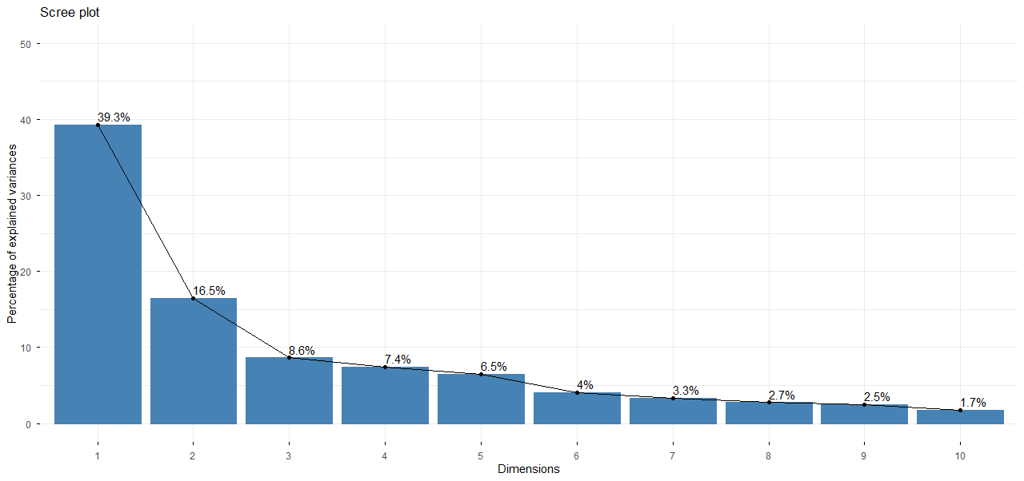
Figure S 1: Percentage of variance explained by each principal component in aronia juice.

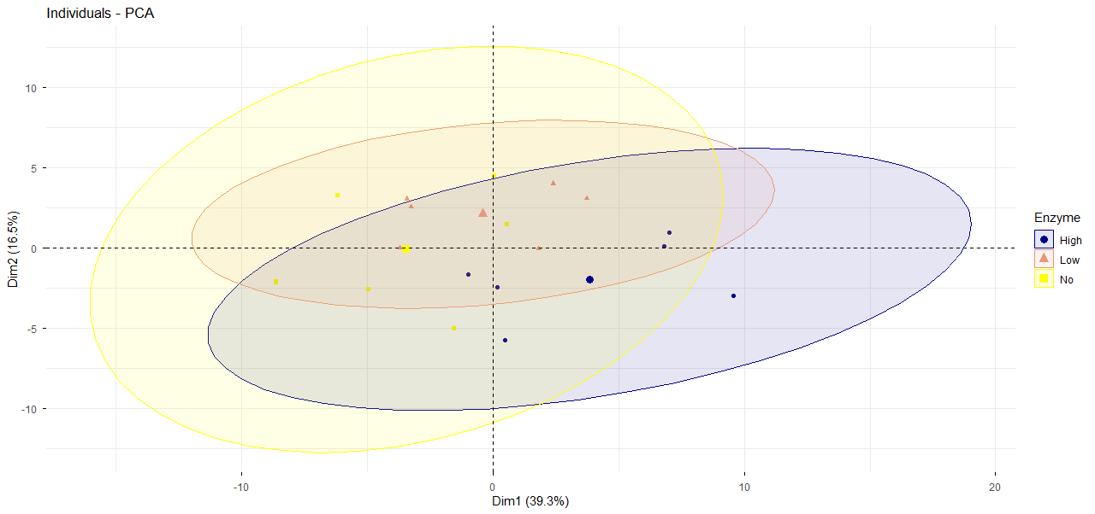
Figure S 2: PCA ellipse plot based on enzyme treatment in aronia juice

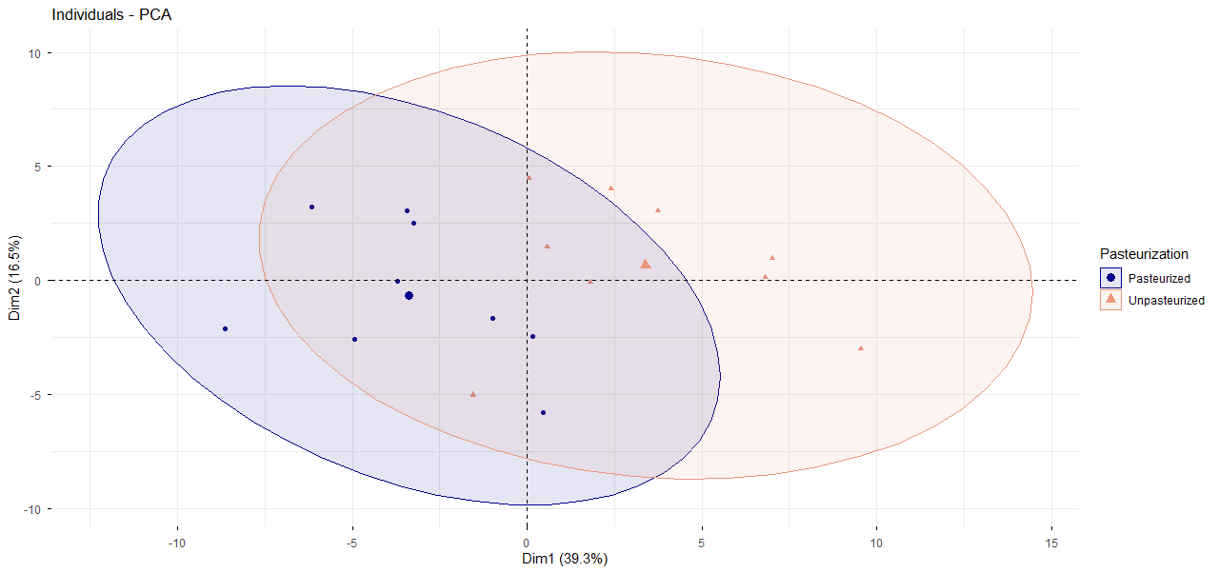
Figure S 3: PCA ellipse plot based on pasteurization treatment in aronia juice

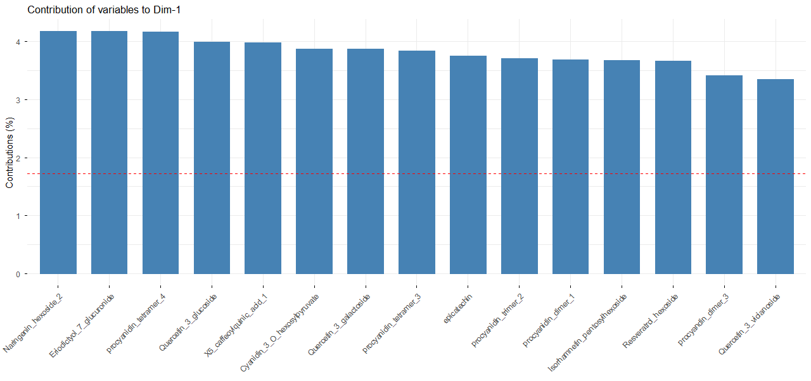
Figure S 4: Contribution of variables to dimension 1 (Dim-1) of PCA in aronia juice. The red dotted line represents the threshold of average contribution. Variables above this line contribute more than average to Dim-1.

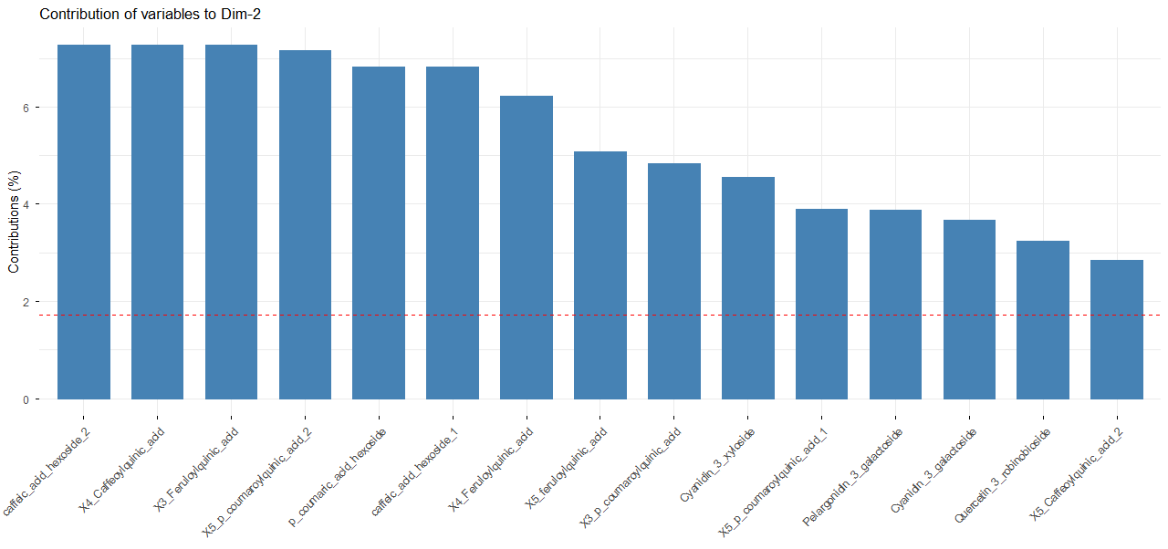
Figure S 5: Contribution of variables to dimension 2 (Dim-2) of PCA in aronia juice. The red dotted line represents the threshold of average contribution. Variables above this line contribute more than average to Dim-2.

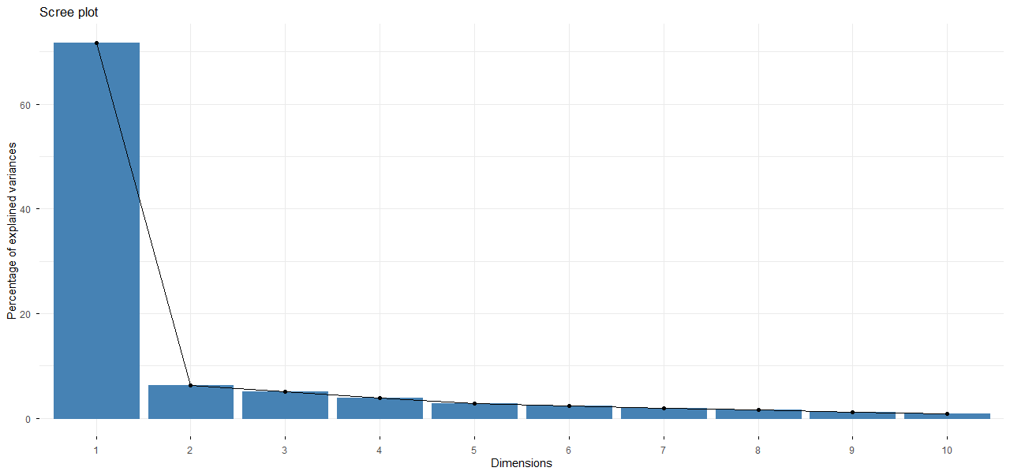
Figure S 6: Percentage of variance explained by each principal component in haskap juice.
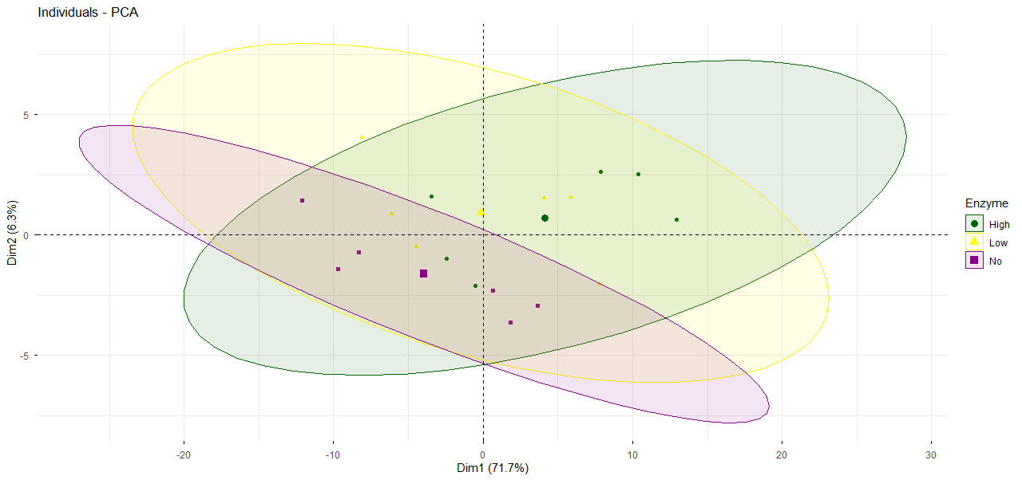
Figure S 7: PCA ellipse plot based on enzyme treatment in haskap juice

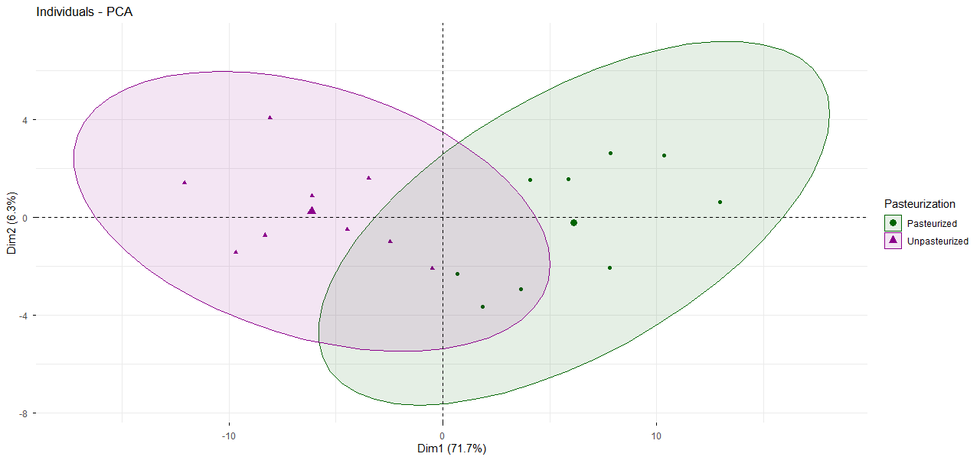
Figure S 8: PCA ellipse plot based on pasteurization treatment in haskap juice

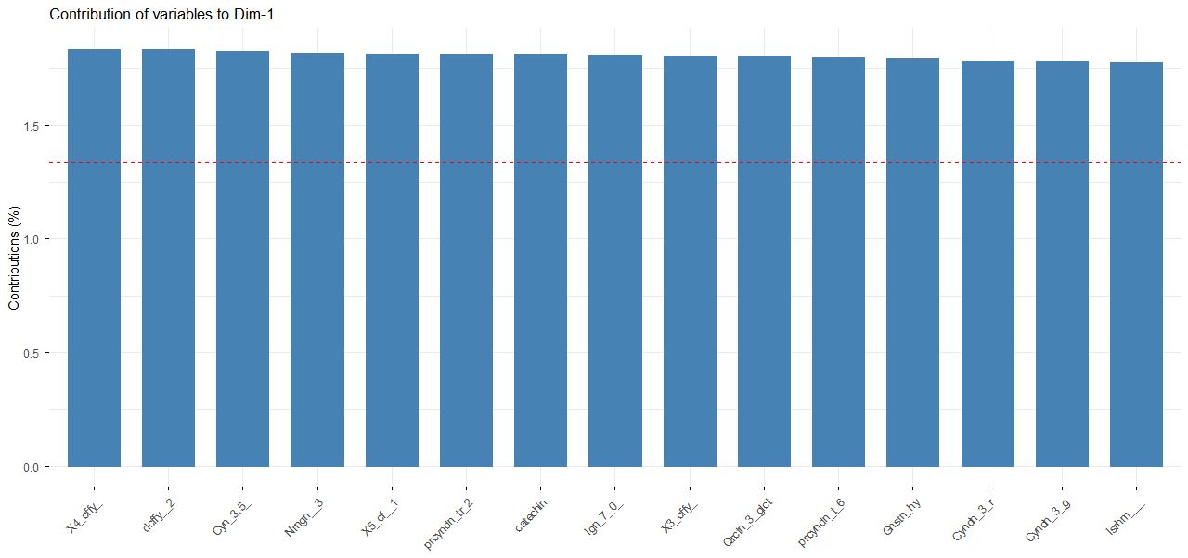
Figure S 9: Contribution of variables to dimension 1 (Dim-1) of PCA in haskap juice. The red dotted line represents the threshold of average contribution. Variables above this line contribute more than average to Dim-1.

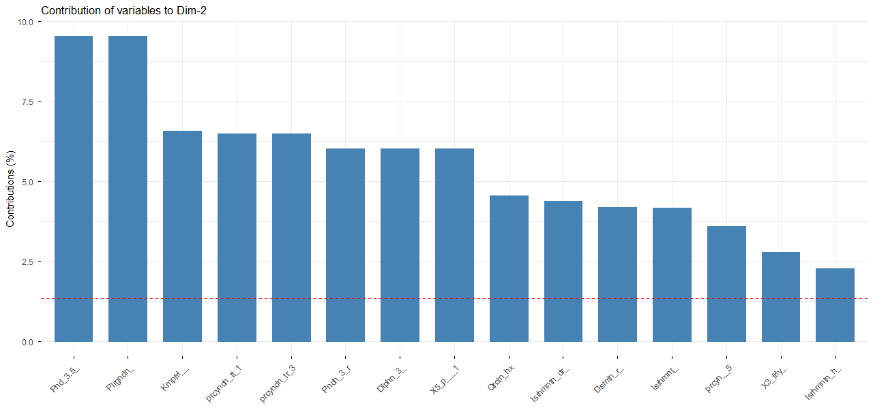
Figure S 10: Contribution of variables to dimension 2 (Dim-2) of PCA in haskap juice. The red dotted line represents the threshold of average contribution. Variables above this line contribute more than average to Dim-2.

