Supplementary File 1
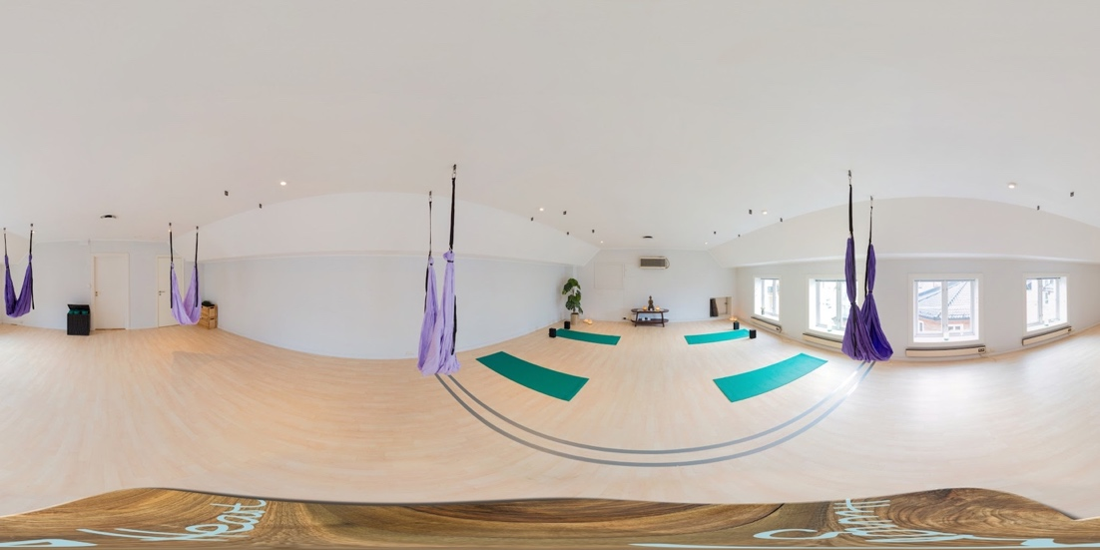
Figure 1. The scene considered to have lower belongingness with painful stimuli delivered to bare feet.
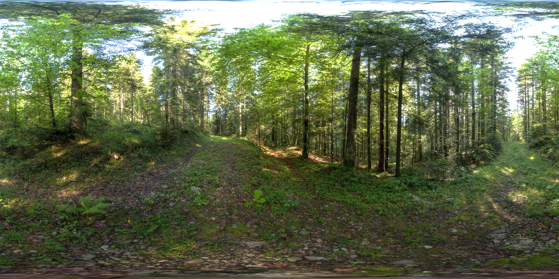
Figure 2. The scene considered to have higher belongingness with painful stimuli delivered to bare feet.

Figure 3. The neutral/transition scene, not used in the analysis.

