Supplemental Figures
Figure 1. Correlations between the changes in skill and training performance for skilled and non-skilled task training. Each datum point for each colour represents one participant. N = 18.
Figure 2. Correlations between the changes in short-interval intracortical facilitation (SICF) and skill for skilled and non-skilled task training. Left panels, facilitatory peak 1; central panels, facilitatory peak 2; right panels, facilitatory peak 3; top panels, change in SICF from before training to mid training; bottom panels, change in SICF from before training to after training. Each datum point for each colour represents one participant. N = 15.
Figure 3. A. Short-interval intracortical inhibition (SICI), and B. THT; before, mid, and after skilled and non-skilled task training (N = 8). Boxes, 25th and 75th percentiles; whiskers, 10th and 90th percentiles.
Figure 4. Correlations between the changes in short-interval intracortical inhibition (SICI) and skill for skilled and non-skilled task training. Left panel, change in SICI from before training to mid training; right panel, change in SICI from before training to after training. Each datum point for each colour represents one participant. N = 8.

Supplemental Figures
Figure 1
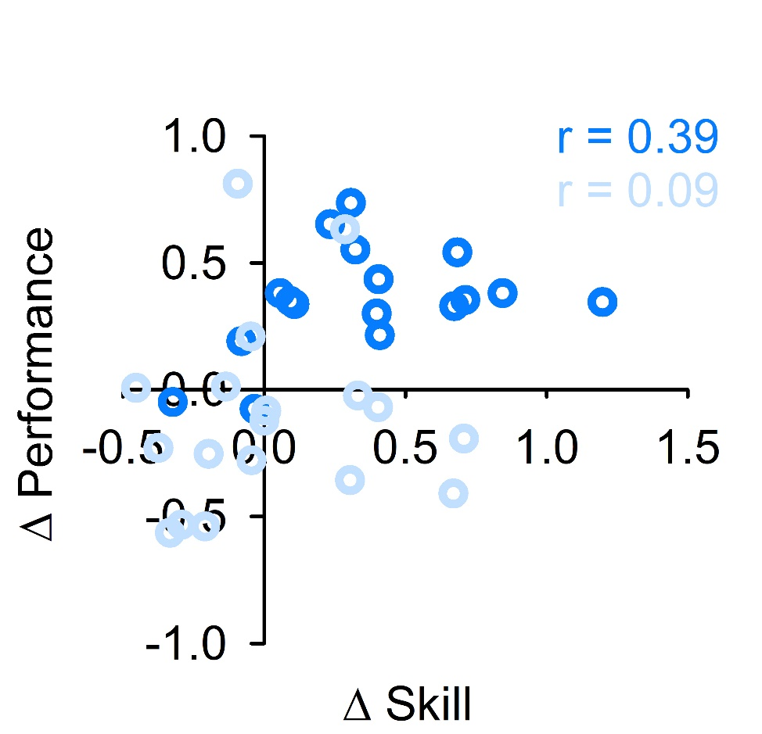

Figure 2
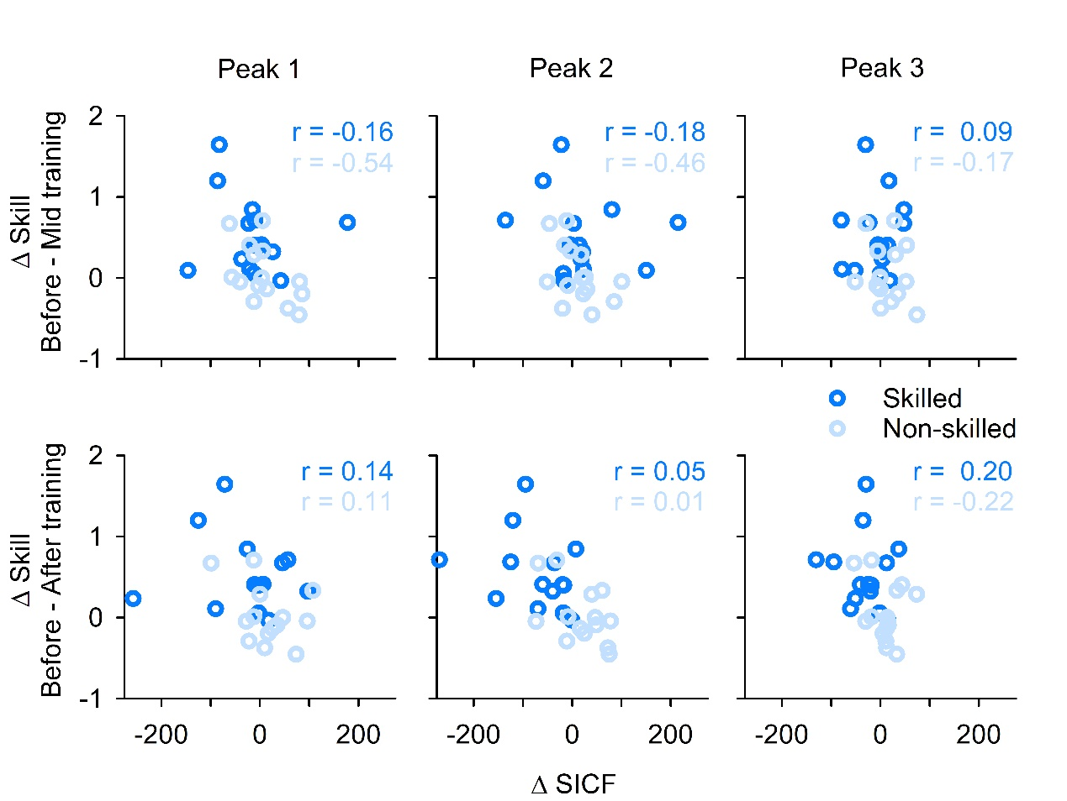
Figure 3
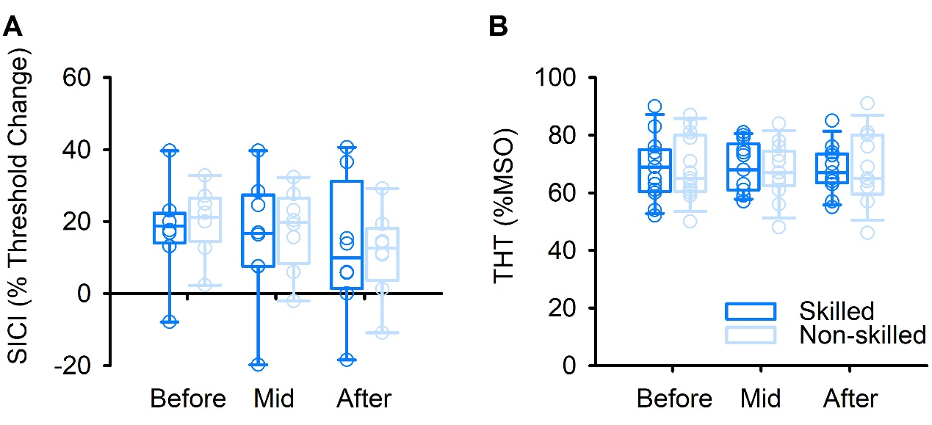
Figure 4
