Supplementary material

AV  onestim | AV  twostim | VA  onestim | VA  twostim | wholeTBW  onestim | wholeTBW  twostim
183 | 186 | 79 | 71 | 262 | 257
277 | 284 | 86 | 78 | 363 | 362
181 | 188 | 133 | 143 | 314 | 331
503 | 551 | 144 | 149 | 647 | 700
229 | 226 | 195 | 194 | 424 | 420
361 | 360 | 302 | 313 | 663 | 672
209 | 208 | 192 | 168 | 401 | 376
242 | 236 | 190 | 226 | 433 | 462

Supplementary table 1: Individual differences for the AV, VA and whole TBW between the passive condition with one auditory simuls and the passive condition with two auditory stimuli. Each line represents the data from each participant.
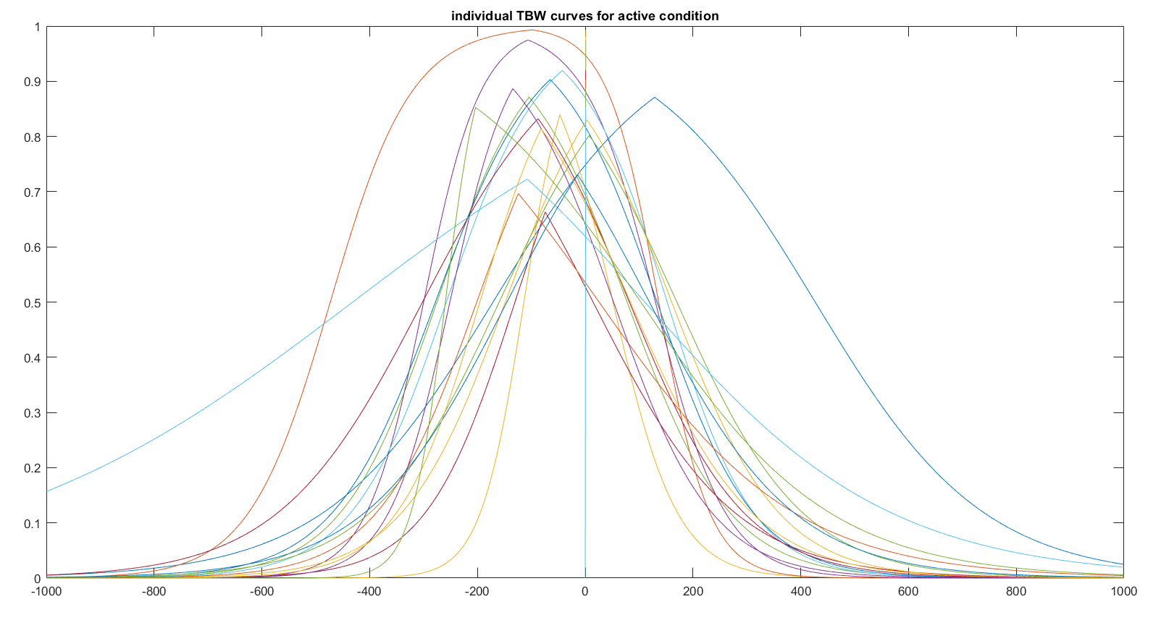
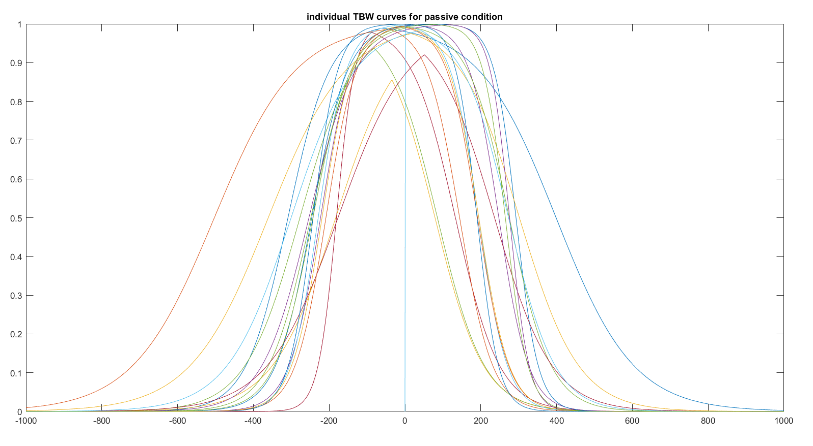

Supplementary Figure 1: Individual TBW curves for each of the 15 subjects for the active and passive condition. Each line represents the TBW of each individual. The x-axis represents the stimulus onset asynchronies (SOAs) where the negative ones indicate those where the auditory stimulus leads (AV) and the positive ones indicate those where the visual stimulus leads (VA). The y-axis represents the percentage of the synchrony reported by the participants in each SOA.

