Supplementary Material and Methods
Recombinant human TRAP 5a and 5b production
Recombinant human TRAP 5a was derived from conditioned media from Baculovirus-infected Spodoptera frugiperda (Sf9) insect cells (GenScript, Piscataway, NJ) as previously described [28]. Recombinant human TRAP 5b was generated from recombinant human TRAP 5a by proteolytic cleavage with cathepsin L as previously described [28]. Both isoforms were stored in homogenisation buffer (0.15M KCl, 0.1% Triton X-100) containing 10µg/ml of inhibitor E64 (Roche Diagnostics, Indianapolis, IN) to prevent further proteolysis. When used as standards in ELISA, TRAP 5a and 5b was further diluted in the same buffer as the samples were kept.
Generation of monoclonal antibodies against human TRAP 5a and total TRAP (5a+5b)
Mouse monoclonal antibodies (mAbs) against TRAP 5a was raised using the human loop peptide region 165 to 177 aa from the 325 aa TRAP sequence as an immunogen (P13686) (GeneScript). This antibody recognizing the peptide loop of TRAP 5a was named mAb 46 and used as a capture antibody for TRAP 5a. Second mAb against TRAP 5a+5b (monomeric and proteolytically processed) was raised using recombinant human TRAP 5a as immunogen and named mAb 25.44 and used as a capture antibody for TRAP 5b [28]. Third mAb against TRAP 5a+5b was raised using recombinant human TRAP 5a as immunogen, named mAb 12.56, biotiylated and used for detection of both isoforms.
For the hybridoma generation, Balb/c mice were kept according to the guidelines of the Swedish Ethical Committee for Animal Protection. The animals were immunized 3 times with adjuvant human loop peptide or human recombinant TRAP 5a conjugated with bovine serum albumin (BSA). Three days after a fourth booster dose of antigen without adjuvant, mice were sacrificed and the splenocytes were prepared and fused with mouse myeloma cells, Sp2/0.
Purification and biotinylation of mAbs
Purification and biotinylation of mAbs was performed as previously described [28]. Briefly, human loop peptide region (TRAP 5a) or TRAP 5a+5b-reactive hybridomas were identified by testing in ELISA against coated human peptide loop region or TRAP 5a, conjugated to keyhole limpet hemocyanin (KLH). Selected hybridomas were subcloned and re-tested against the immunogen and mAbs were produced and purified on Protein G affinity columns (GE Healthcare, Uppsala, Sweden) following manufacturer´s instructions. Isotyping was performed by a dipstick method (IsoStrip; Roche Diagnostics, Mannheim, Germany). Purified and selected clones were biotinylated using long chain biotinyl-N-hydroxysuccinimide ester sulfonic acid (Pierce, Rockford, IL) according to the manufacturer´s instructions.
Bone chips
Rods (6 mm in diameter) of bovine femoral cortical bone were cut with a diamond saw (Buehler, USA) into 100-150 µm thick slices. The slices were washed by ultrasonication in 70% ethanol and rinsed extensively in distilled water.

Bone-coated coverslips
Glass coverslips were coated with 400ug of bone particles and used as a translucent bone substrate. Briefly, the glass coverslips were sterilized on ethanol and covered with poly-L-lysine (Sigma-Aldrich) overnight. The next day 400ug of bone particles were added to the hydrophilic surface and allowed to sediment overnight. On the third day the bone particles were crosslinked on coverslips with 4% paraformaldehyde (PFA) during 30 min and stored at 4°C until further use.

TRAP activity staining of osteoclast (OC) cultures
Samples were fixed with mixture of acetone and 3% formaldehyde in citrate buffer, at room temperature for 30s and then stained for phosphatase activity using the Leukocyte acid phosphatase (TRAP) kit (Sigma-Aldrich) according to manufacturer’s protocol. Cells were imaged using 10X objective with Nikon Eclipse TE300 microscope (Nikon) and RGB colour CCD camera (Supplementary figure 2).
mAbs affinity of mAb46 and mAb25.44 in sandwich ELISA
TRAP 5a and TRAP 5b concentration gradients (standard curves) were added to mAb46 or mAb25.44 coated plates followed by incubation overnight. Next day, ELISA assay was performed as explained above.
Culture of human OC
Peripheral blood monocytes (PBMC) were isolated from coded samples of donated healthy male blood at (Karolinska University Hospital Laboratory, Huddinge). The study was performed in accordance of guidelines from Swedish Research Council and Karolinska institutet. All donors involved in the study gave written informed consent in accordance with the Helsinki Declaration. The white blood cells were purified from buffy coats using density gradient centrifugation on Ficoll plaque Plus at room temperature. CD14 positive fraction was selected with CD14+ magnetic microbeads (Miltenyi biotech) to provide more uniform differentiation of OCs. Selected cells were seeded 150.000 cells/wells on plastic 96-well plates (NUNC, delta surface) and 250.000 cells/wells on bone chips (bovine cortical bone) and differentiated started with 30 ng mL-1 macrophage colony stimulating factor (M-CSF) (human rM-CSF, R&D Systems) and 2 ng mL-1 receptor activator of nuclear factor kappa-Β ligand (RANKL) (recombinant human sRANKL, Peprotech) or 30 ng mL-1 M-CSF alone. Half of the medium was replaced on day 3 of the cultures. Samples were collected from PBMCs of three donors in three replicate cultures on days 1-6 (Supplementary figure 2). Medium was collected from the wells, cells were washed twice with PBS and lysed with 150 mM KCl and 0.1 % Triton X-100 for 20 min at 37 °C. Cysteine protease inhibitor, 10 ng mL-1 E64 (Sigma-Aldrich), was added to both medium and lysate to maintain stability of the samples. Samples without RANKL were measured for TRAP 5a and 5b protein in 1:5 dilution and samples with RANKL in 1:20 dilution.
Measurement of type I collagen degradation marker (CTX-I)
CTX-I was measured using Serum CrossLaps® and CrossLaps for Culture (CTX-I) ELISA (IDS, Tyne and Wear, UK) according to manufacturer’s protocols. CTX-I was measured in 50µl serum and culture samples as stated for TRAP 5a/5b under “Human serum samples” in the main text. Media from cells cultured on bone slices was collected and E-64 (Boehringer Mannheim) was added to a final concentration of 200µM before aliquoted and stored at -20C. CTX-I was measured in 50µl of media. Assay runs with standard curves with a r > 0.98 (example is shown in Supplementary figure 3) and controls within the acceptable range (Supplementary table I) was accepted.
Immunocytochemical TRAP staining of OC cultures
The cells were grown in glass chambers (LabTek-II, ThermoFisher). Cells were washed with PBS and fixed with 4% PFA. Cells were permeabilized by 15 min treatment with 0.1% Triton X-100 in PBS and blocked with 0.1% BSA in PBS for 60 min, both at RT. Cells were stained overnight at +4°C against TRAP isoforms using 7.6 μg/ml of mouse mAb46 for TRAP 5a (specific for the loop region) and 1:300 dilution of polyclonal rabbit anti rat total TRAP [37]. Slides were washed and secondary stained with donkey anti-rabbit Alexa647 and goat anti-mouse Alexa488 (both 1:300) along with Hoechst 33342 (1:70000) overnight at +4°C. After staining, the cells were washed and mounted with ProLong Diamond mounting medium (ThermoFisher). Z-stacks were captured with a NikonA1R+ confocal laser microscope system (Nikon) using 20X objective and a frame size fulfilling Nyquist sampling theorem. Laser power and detector gain were adjusted to cover widest possible range of intensity values and the pictures shown were z-stacks processed to maximum intensity projections. To facilitate separation of TRAP-isoforms in immunocytochemical (IC exposure of TRAP 5a staining (green) was set higher than that of total TRAP antibody (magenta) that recognized both isoforms. Therefore, areas in the merged image appearing as green or white (colocalized signals) have TRAP 5a. However, the features appearing only in magenta would represent exclusively TRAP 5b, because both antibodies can bind TRAP 5a but only the total TRAP can bind TRAP 5b.

Supplementary table I
 | Study runs |  | Control information from IDS
Control | Run 1 (ng mL⁻¹) | Run 2 (ng mL⁻¹) | LOT | Result (ng mL⁻¹) | Mean and acceptable range (ng mL⁻¹)
AC-0205A | 0.251 | 0.248 | J40282 | 0.246 | 0.269 (0.215-0.323)
AC-0205B | 1.055 | 0.974 | J40283 | 0.907 | 0.962 (0.770-1.154)

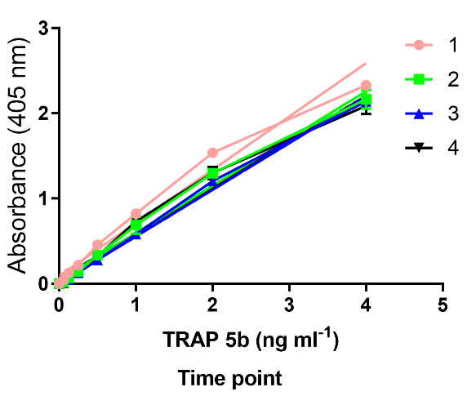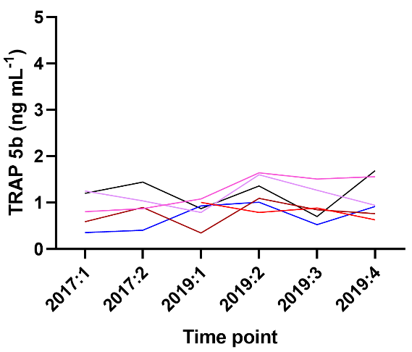
A
B
Supplementary figure 1. Recombinant TRAP 5b protein and serum TRAP 5b protein measured after different storage times. (A) Recombinant TRAP 5b standard curves (n=4). (B) Serum TRAP 5b (n= 5) measured at different time points (n=4).

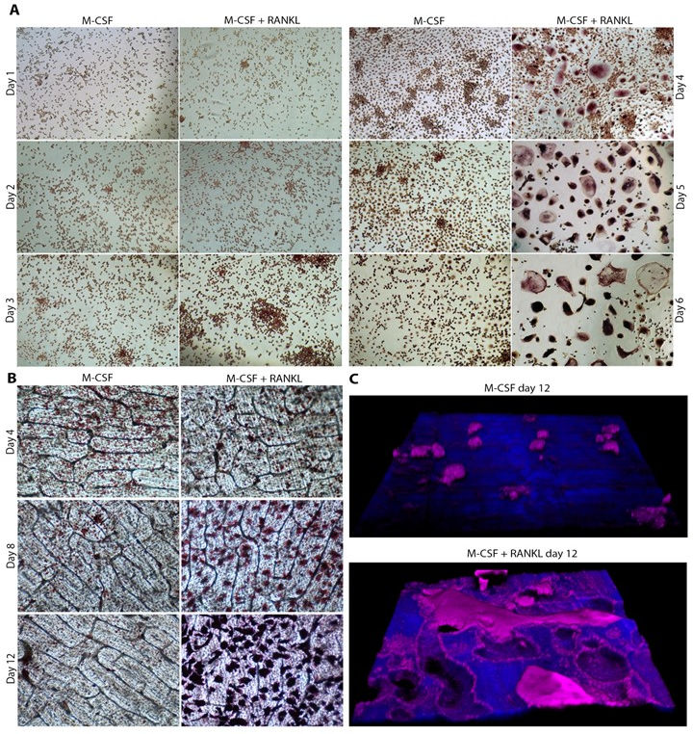
Supplementary figure 2. TRAP activity staining in M-CSF and RANKL stimulated cultures of CD14+ PBMCs on plastic and bone. A. TRAP activity staining during OC differentiation of CD14+ PBMCs stimulated with 30 ng mL-1 M-CSF alone or with 30 ng mL-1 M-CSF and 2 ng mL-1 RANKL for 1-6 days on plastic for 1-6 days on plastic. B. TRAP activity staining of OC differentiated from CD14+ PBMCs stimulated with 30 ng mL-1 M-CSF alone or with 30 ng mL-1 M-CSF and 2ng mL-1 RANKL for 4, 8 and 12 days on cortical bovine bone discs. C. Resorption pits in TRAP activity stained cultures of OC differentiated from CD14+ PBMCs stimulated with 30 ng mL-1 M-CSF alone or with 30 ng mL-1 M-CSF and 2 ng mL-1 RANKL for 12 days on bovine bone discs. Volume 3D-projections of z-stacks captured with a confocal microscope where bone (blue) and TRAP stain (magenta) are superimposed.

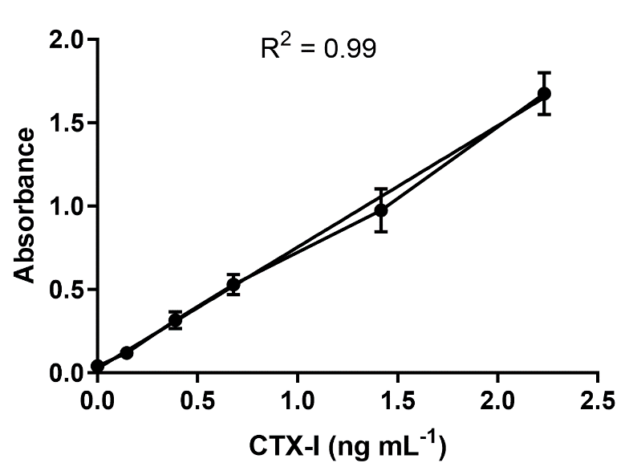
Supplementary figure 3. Example of standard curve from CTX-I measurement.

