Tumor-induced osteomalacia: a systematic clinical review of 895 cases

Authors: Ariadne Bosman¹*, Andrea Palermo²*, Julien Vanderhulst³, Suzanne Jan De Beur⁴ , Seiji Fukumoto⁵, Salvatore Minisola⁶, Weibo Xia⁷, Jean-Jacques Body³, M. Carola Zillikens¹.

*These authors contributed equally to this work

Author Affiliations:
¹ Erasmus MC, University Medical Center Rotterdam, The Netherlands, Department of Internal Medicine.
² Unit of Metabolic bone and thyroid disorders, Fondazione Policlinico Universitario Campus Bio-Medico, Rome, Italy
³ Department of Medicine, CHU Brugmann, Université Libre de Bruxelles (ULB), Brussels, Belgium.
⁴ Johns Hopkins University School of Medicine, Baltimore, MD, USA

⁵ Fujii Memorial Institute of Medical Sciences, Institute of Advanced Medical Sciences, Tokushima University, Tokushima, Japan

⁶ Department of Clinical, Internal, Anesthesiological and Cardiological Sciences, "Sapienza" Rome University, 00161 Rome, Italy

⁷ Department of Endocrinology, Key Laboratory of Endocrinology, The National Commission of Health, Peking Union Medical College Hospital, Chinese Academy of Medical Sciences, Beijing, China

Corresponding author:
M. Carola Zillikens
Erasmus MC, University Medical Center Rotterdam, The Netherlands, Department of Internal Medicine
Email: m.c.zillikens@erasmusmc.nl

APPENDIX MATERIAL

Appendix Table 1. Search Strategies

Source | Search
Pubmed | (“Oncogenic osteomalacia”[tiab] OR “oncogenous osteomalacia”[tiab] OR “Rickets, Hypophosphatemic” [MESH] OR “hypophosphatemic rickets”[tiab] OR “tumor-induced osteomalacia”[tiab] OR “tumor-induced rickets”[tiab] OR “oncogenic rickets”[tiab])
Embase | ('oncogenic osteomalacia'/exp OR 'oncogenic osteomalacia':ab,ti OR 'oncogenous osteomalacia':ab,ti OR 'hypophosphatemic rickets':ab,ti OR 'tumor-induced osteomalacia':ab,ti OR 'tumor-induced rickets':ab,ti OR 'oncogenic rickets':ab,ti)
Web of Science | (TOPIC: ("oncogenic osteomalacia" OR "oncogenous osteomalacia" OR "hypophosphatemic rickets" OR "tumor-induced osteomalacia" OR "tumor-induced rickets" OR "oncogenic rickets")

Appendix Figure 1. Year of publication

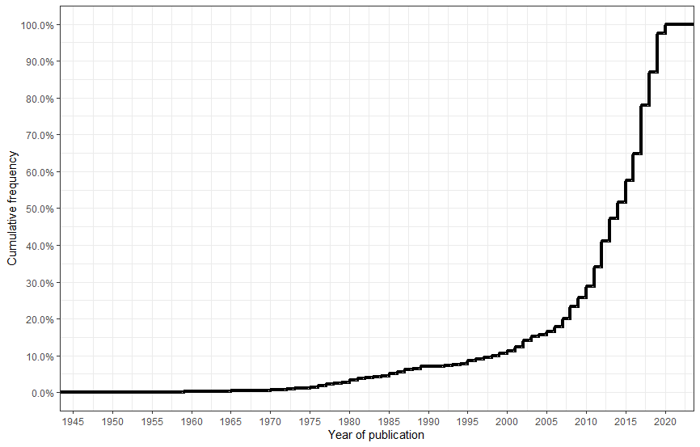

Appendix Figure 2. Distribution of age at diagnosis
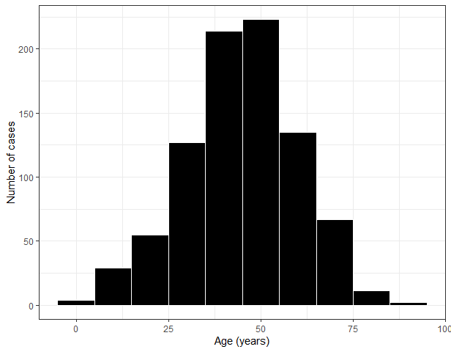

Appendix Figure 3. Scatterplot of tumor size plotted against xULN FGF-23
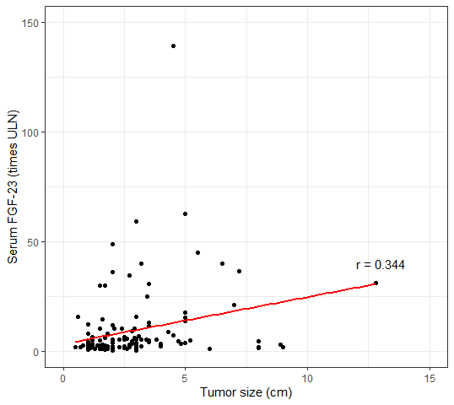

Appendix Table 2. Differences between adult patients with and without FGF-23 measurements

 | FGF23 measured |  | FGF23 not measured
 | N | Median (range) | N | Median (range) | P value
Age, years | 355 | 48.0 (18, 90) | 477 | 45.0 (18, 88) | 0.011
Diagnostic delay, years | 254 | 3.0 (0.08, 42.0) | 363 | 4.0 (0.17, 38.0) | 0.218
Tumor size, cm | 128 | 2.5 (0.6, 12.8) | 265 | 2.9 (0.5, 15.0) | 0.013
Phosphate, mmol/L | 355 | 0.48 (0.10, 1.07) | 474 | 0.45 (0.11, 1.20) | 0.259
TmP/GFR, mmol/L | 185 | 0.39 (0.02, 1.50) | 172 | 0.32 (0.03, 1.80) | 0.010

Data presented as median (range). Abbreviations: FGF23, Fibroblast Growth Factor 23; TmP/GFR, maximum tubular reabsorption rate of phosphate.

Appendix Figure 4. Identification of external vs internal tumors by year of publication
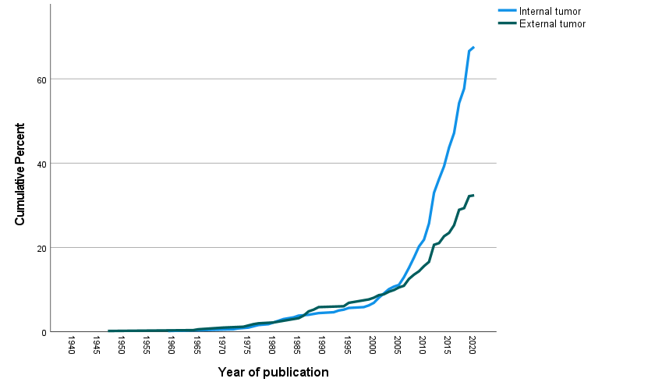

Appendix Table 3. Differences between malignant and benign isolated tumors in adult patients
 | Malignant |  | Benign
 | N | Median (Range) | N | Median (Range) | P value
Age, years | 56 | 55.0 (18.0, 88.0) | 523 | 46.0 (18.0, 90.0) | 0.003
Diagnostic delay, years | 39 | 3.0 (0.12, 19.0) | 393 | 4.0 (0.1, 38.0) | 0.086
Tumor size, cm | 18 | 5.3 (1.2, 15.0) | 257 | 2.5 (0.5, 15.0) | <0.001
Phosphate, mmol/L | 56 | 0.39 (0.13, 1.20) | 523 | 0.45 (0.10, 1.07) | 0.002
Calcium, mmol/L | 40 | 2.24 (1.27, 2.90) | 363 | 2.25 (1.10, 10.50) | 0.527
TmP/GFR, mmol/L | 20 | 0.26 (0.04, 1.80) | 242 | 0.36 (0.02, 1.60) | 0.223
FGF23 times ULN | 21 | 4.8 (1.2, 32.0) | 223 | 3.7 (0.02, 139.2) | 0.299
BMD T-score L1-L4 | 5 | -2.4 (-3.5, -1.2) | 70 | -3.1 (-6.9, 0.1) | 0.174
BMD T-score total hip | 2 | -1.3 (-1.4, -1.2) | 24 | -2.95 (-4.0, -0.9) | 0.074
BMD T-score femoral neck | 1 | - | 31 | -3.2 (-7.4, -1.5) | 0.278
Data presented as median (range). Abbreviations: BMD, bone mineral density; FGF23: Fibroblast growth factor 23; TmP/GFR, maximum tubular reabsorption rate of phosphate; ULN, upper limit of normal.

Appendix Figure 5. Cumulative frequency of the diagnostic delay overall and during the last 10 years, calculated as the time gap between clinical presentation and diagnosis, in years



