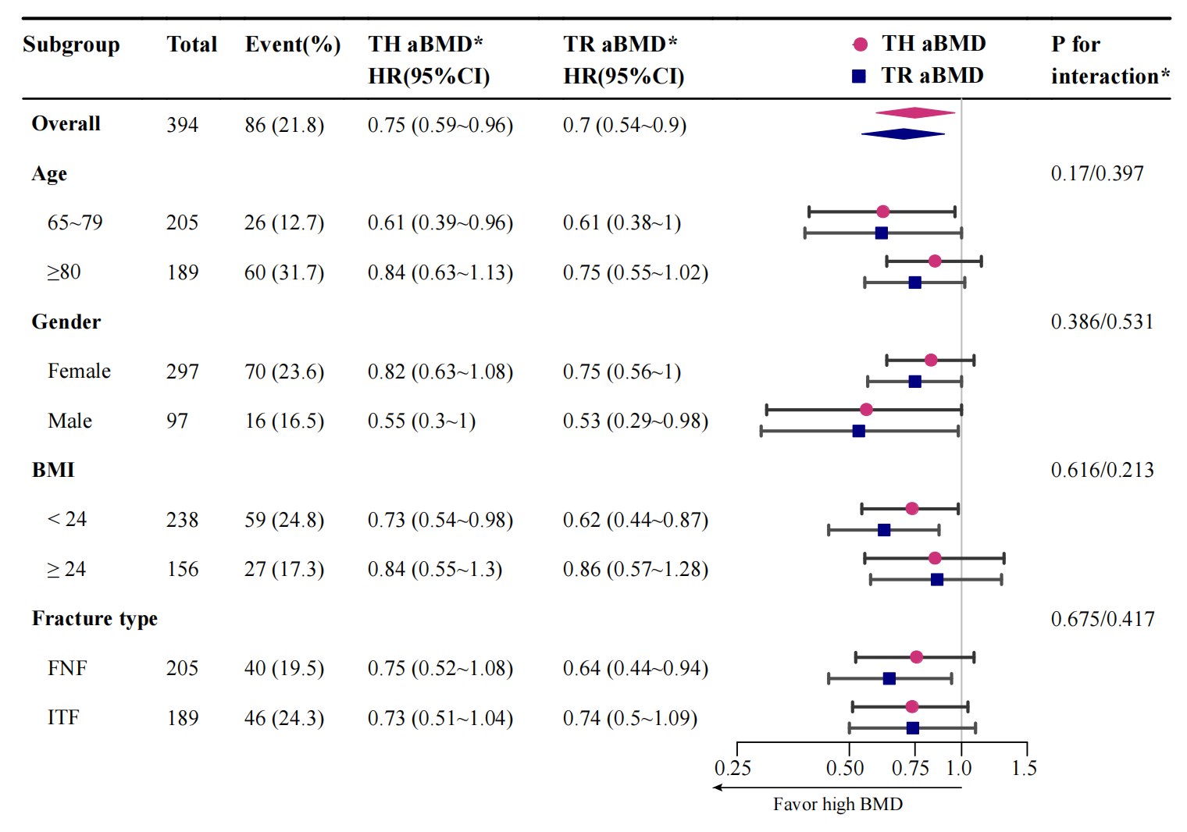
Supplementary Fig.3 HRs of mortality risk per sex-specific SD increase of TH aBMD and TR aBMD in different subgroups.
*the former for TH aBMD and the latter for TR aBMD
TH aBMD total hip areal bone mineral density, TR aBMD trochanter areal bone mineral density, BMI bone mass index, FNF femoral neck fracture, ITF intertrochanteric fracture;

