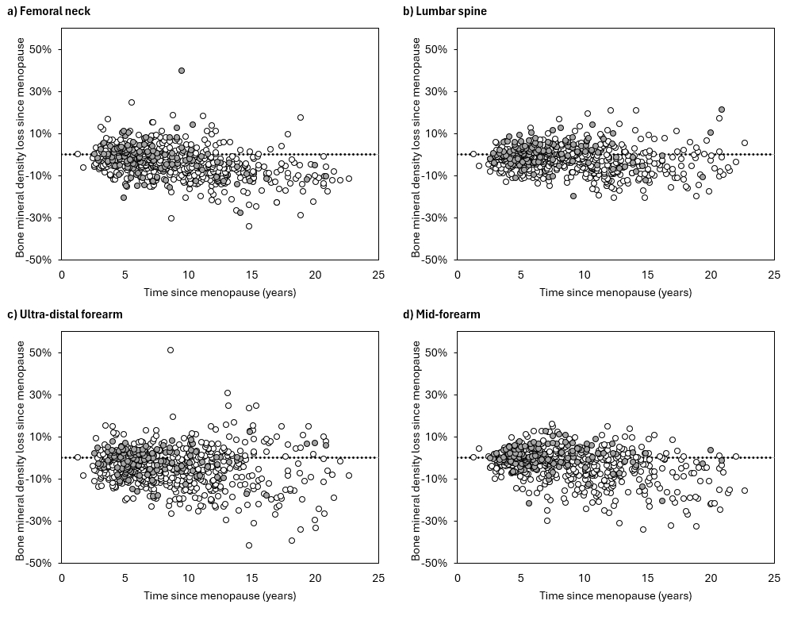
Supplementary Figure 1: Scatterplots showing time since menopause versus bone mineral density loss for the a) femoral neck, b) lumbar spine, c) ultra-distal forearm and d) mid-forearm sites. Light shading corresponds to hormone replacement therapy non-users and dark shading to hormone replacement therapy users.

a) Femoral neck | b) Lumbar spine
   | <5yr (N) | 5 to <10yr (N) | ≥10yr (N)
  Normal | 171 | 95 | 56
  Osteopenia | 103 | 71 | 101
  Osteoporosis | 4 | 3 | 7
   | <5yr (N) | 5 to <10yr (N) | ≥10yr (N)
  Normal | 210 | 115 | 109
  Osteopenia | 62 | 51 | 51
  Osteoporosis | 8 | 5 | 5
c) Ultra-distal forearm | d) Mid-forearm
   | <5yr (N) | 5 to <10yr (N) | ≥10yr (N)
  Normal | 226 | 128 | 117
  Osteopenia | 50 | 41 | 49
  Osteoporosis | 1 | 0 | 3
   | <5yr (N) | 5 to <10yr (N) | ≥10yr (N)
  Normal | 242 | 139 | 101
  Osteopenia | 33 | 27 | 49
  Osteoporosis | 1 | 4 | 19

Supplementary Figure 2: Proportions of users and non-users of hormone replacement therapy combined with normal bone mineral density (BMD), osteopenia and osteoporosis at the a) femoral neck, b) lumbar spine, c) ultra-distal forearm and d) mid-forearm sites at different times since menopause (<5yr, 5 to <10yr and ≥10yr).

