Supporitng Information

Enzymatic hydrolysis lignin and kraft lignin from birch wood: a source of functional bio-based materials
Edgar Ramirez Huerta ¹, Muhammad Muddasar ¹, Maurice N. Collins ^{1,2,3,} *
¹ Stokes Laboratories, School of Engineering, Bernal Institute, University of Limerick, Limerick, V94 T9PX, Ireland.
² AMBER, University of Limerick, Ireland.
³ BiOrbic, University of Limerick, Ireland.
*Corresponding author.
E-mail: Maurice.Collins@ul.ie

Chemical Characterization
Lignin and Residual Carbohydrates Composition
The birch wood and the lignin-rich substrates were analyzed to determine the samples' lignin and residual carbohydrates composition according to NREL “Structural Carbohydrates and Lignin in Biomass” methodology [13]. Tested samples were labelled as follows:
- Enzymatic hydrolysis lignin (EHL)
- Hydrothermally pretreated birch wood (HTBW)
- Milled birch wood (MBW)
- Lignin-rich precipitate at pH 4 (LG4)
- Lignin-rich precipitate at pH 1.5(LG1.5)
Elemental Analysis
Elemental analysis (C, H, N, S) was performed using an Elementar Macro Cube elemental analyzer (Quantum Analytics, USA). The analysis was carried according to the European Standard EN 15104:2011 “Solid biofuels – Determination of Total carbon, hydrogen, and nitrogen – Instrumental methods” [13]. For background, 3-4 scans were recorded and subtracted from the evaluated samples. The results were reported on a dry-mass basis. The moisture and ash content of the samples were determined.
The Elementar was equipped with a combustion tube that contained an ash crucible, with a bottom base of aluminium oxide wool where the sample drops in. The combustion component was granulated tungsten oxide (WO3) separated from the ash crucible by conundrum balls. The WO3 catalyzes the combustion of the samples, providing additional oxygen to the reaction to prevent the formation of non-volatile sulphates and binds alkali elements.
The combustion tube was maintained at 750 °C while oxygen was dosed to identify the target elements (C, H, N, S) by producing CO2, H2O, NOx, SO2, SO3. After the combustion, 600 ml/min of helium set up at 1.6 bar acted as a carrier gas towards the reduction tube. The reduction tubes were kept at 1100 °C, packed with 3 layers of copper equally distributed along the tube, separated by a 10 mm layer of conundrum balls and a thin layer of silver wool at the top of the tube. NOx is reduced to N2 reacting with copper in the reduction tubes, and the SOx gets attached to the silver layer. The produced gases flow through a thermal conductivity detector, and a series of separation columns quantify the elements corresponding to their retention times.
Structural Characterization
Fourier Transform Infrared Spectroscopy (FTIR)
FTIR characterization was carried out using a Nicolet Nexus FTIR spectrometer equipped with an attenuated reflectance accessory (ATR). Appropriate contact between the samples and the ATR-crystal was ensured with the pressure mechanism before all measurements to obtain good quality bands with transmittance levels as near as possible to 50%. A total of 10 scans were run-up in transmission mode with a resolution of (2 cm⁻¹). For background, 10 scans were recorded. The collected spectra were considered in the wavenumber range of 4000 to 650 cm-^{1.}
Nuclear Magnetic Resonance Spectroscopy (NMR)
1H NMR was performed on a benchtop Spinsolve Proton 60 MHz (Magritek, Germany/New Zealand). 50 mg of the samples were dissolved in 0.5 mL DMSO d6 or Deuterated Chloroform. The mixture was sonicated for 30 min before being left to settle for 2h. The supernatant solution was extracted and inserted in a 5mm NMR tube. The volume was brought up to 1 mL for the analysis. 40 scans were recorded.
Thermal Characterization
Differential Scanning Calorimetry (DSC)
DSC analysis of the LRSs was performed using a DSC 214 Netzsch Polyma (Germany). The samples were measured (5-10 mg) and placed in an aluminium Netzsch pan (5 mm diameter, 30/40 µl). The analysis was carried out over two cycles under a 60 ml/min nitrogen atmosphere. A first scan was done to remove the thermal history of the LRSs from 20 to 150 °C using a heating rate of 20 °C/min, held isothermally for 2 min, and quenched to -10 °C. The second scan, which was used for characterization, was carried out from -10 to 200 °C employing a heating rate of 10 °C/min under the same atmosphere.
Thermogravimetric Analysis (TGA)
The thermal stability of the samples was characterized using a SETARAM TG-DTA 1600 (Setaram Instrumentation, France). 6 ± 1 mg of sample was introduced in an Alumina crucible. The samples were heated in nitrogen to 1000 °C at a heating rate of 10 °C/min. The MBW and HTBW were heated only until 900°C. The Carbon Yield was determined using the formula: CY=m_T/m_0 *100
Surface Area and Pore Size Distribution
The samples' surface area and Pore Size Distribution (PoSD) were determined using a NOVA 2200e surface area analyzer. The water and volatile compounds trapped in the sample's pores were outgassed to ensure quality results. The outgassing releases loosely bound water and other low-temperature volatile compounds trapped in the sample's pores. Approximately 70% volume of a 9 mm glass bulb cell was filled with the samples of interest and plugged into the vacuum degassing station of the NOVA, and the bulb cell was covered with a heating mantel at 50 °C. This temperature was selected to ensure the structural integrity of the pores. The degassing was carried out overnight for more than 16 hours. The bulb cell was cooled down for around 10 minutes before measuring the weight change of the samples after degassing. Subsequently, a glass rod was inserted into the bulb cell to reduce the cell volume to improve the analysis results. Finally, the bulb cell and the glass rod were plugged into the analysis station, the dewar was filled with liquid nitrogen and placed into the analysis station. The analysis settings were 360 seconds of thermal delay, 30 mmHg of evacuation cross-over pressure, nitrogen as absorbate gas, 0.2 mmHg of pressure tolerance, equilibrium time in/out 200/600 seconds. The pore size distribution measured points were equally distributed from P/Po 0.05 to 0.99 (ads: 12, des: 10). The data reduction parameters for the calculation model were (N2 at 77 K on carbon (slit/cylinder/sphere, QSDFT adsorption branch). The BET results were ensured by the Micropore BET Assistant tool, and the PoSD was obtained using the QSDFT method.
Scanning Electron Microscopy (SEM)
Scanning electron microscopy (SEM) was performed using a Table Microscope TM-1000 (Hitachi, Japan) to determine the morphology of the Kraft Lignins and Enzymatic Hydrolysis Lignins. The samples were placed in a sample holder and coated with gold sputtering for two minutes. The equipment was run in charge-up reduction mode, and the autofocus tool was used at x1000 before magnification.

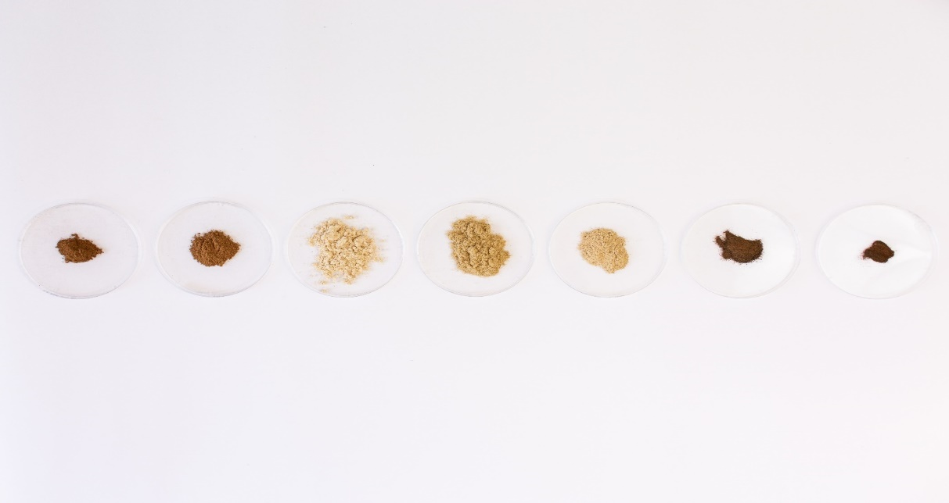
Figure S1. Lignin-rich substrates produced in this research (left to right shows): EHL, HTBW, MBW, LG4, LG1.5.

Figure S2. Pretreated birch wood and enzymatic hydrolysis lignin Isotherms graphs by using nitrogen as sorption gas

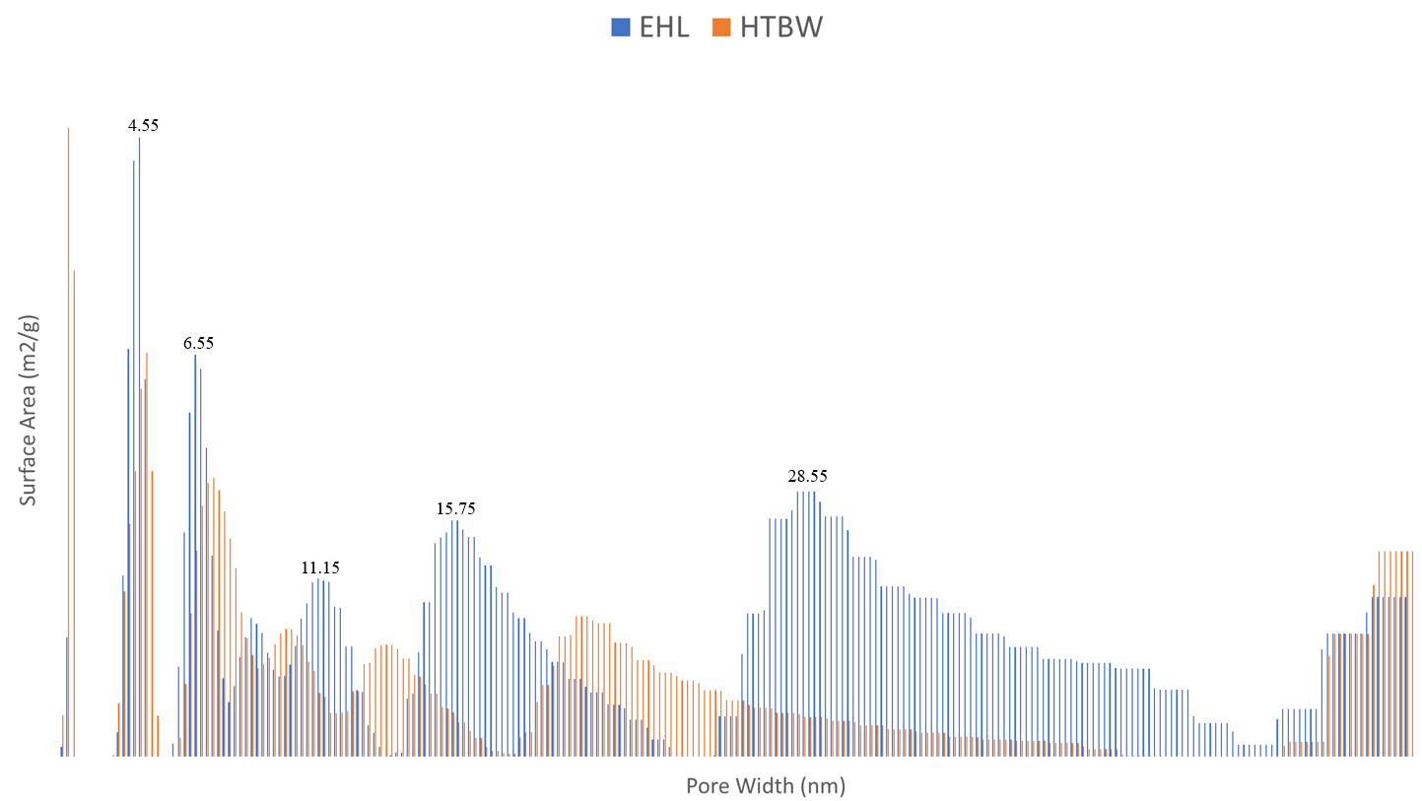
Figure S3. Pretreated birch wood and enzymatic hydrolysis lignin Pore Size Distribution Area Histogram

Figure S4. Pretreated birch wood and enzymatic hydrolysis lignin pore size distribution graphs

Table S1. Composition of hydrothermally treated birch wood produced utilizing accelerated solvent extraction.
% | Glucose | Xylose | Mannose | Arabinose | Galactose | Rhamnose | Lignin | Ash
MBW | 35.7 | 20.5 | 1.7 | 0.5 | 0.7 | 0.4 | 22.7 | 0.4
HTBW (170 °C) | 48.0 | 5.2 | 0.7 | 0.1 | 0.1 | 0.0 | 34.4 | 0.1
HTBW (190 °C) | 48.9 | 2.0 | 0.3 | 0.0 | 0.1 | 0.0 | 39.2 | 0.1
HTBW (200 °C) | 10.5 | 0.1 | 0.0 | 0.0 | 0.0 | 0.0 | 49.3 | 0.1

Table S2. Composition of enzymatic hydrolysis lignin produced using hydrothermal pretreatment with subsequent enzymatic hydrolysis.
% | Glucose | Xylose | Mannose | Arabinose | Galactose | Rhamnose | Lignin | Ash
MBW | 35. | 20.5 | 1. | 0.5 | 0.7 | 0.4 | 22.7 | 0.4
EHL (170 °C) | 30.1 | 3.3 | 0.7 | 0.0 | 0.2 | 0.1 | 54.0 | 2.4
EHL (190 °C) | 24.1 | 0.8 | 0.4 | 0.0 | 0.1 | 0.0 | 67.0 | 1.9
EHL (200 °C) | 38.9 | 0.4 | 0.2 | 0.0 | 0.0 | 0.0 | 54.4 | 1.3

Table S3. The composition of kraft lignins produced at 140, 170 and 190 °C and precipitated at pH 4 and 1.5
% | Glucose | Xylose | Mannose | Arabinose | Galactose | Rhamnose | Lignin | Ash
MBW | 35.7 | 20.5 | 1.6 | 0.5 | 0.7 | 0.4 | 22.7 | 0.4
LG4 (140 °C) | 0.3 | 24.3 | 0.0 | 0.1 | 0.3 | 0.0 | 31.1 | 25.9
LG4 (170 °C) | 0.2 | 5.5 | 0.0 | 0.2 | 0.4 | 0.0 | 51.5 | 21.6
LG4 (190 °C) | 0.2 | 0.1 | 0.0 | 0.0 | 0.1 | 0.0 | 59.2 | 14.7
LG1.5 (140 °C) | 0.4 | 11.0 | 0.0 | 0.1 | 0.3 | 0.0 | 64.8 | 33.8
LG1.5 (170 °C) | 0.3 | 1.5 | 0.0 | 0.0 | 0.2 | 0.0 | 47.9 | Not Determined
LG1.5 (190 °C) | 0.3 | 0.1 | 0.0 | 0.0 | 0.2 | 0.0 | 49.3 | Not Determined

Table S4. Assignation of lignin-related bands corresponding to FTIR spectra
Band Position | Band Assignation
1750-1730 | Acetyl groups, hemicellulose
1607-1597 | Aromatic skeletal vibrations (S > G)
1514-1511 | Aromatic skeletal vibrations (G > S)
1460-1450 | C-H deformations; asym. in -CH3 and -CH2-
1426-1420 | Aromatic skeletal vibrations with C-H in-plane deform.
1374-1353 | Aliphatic C—H stretching in CH3, not in OCH3
1330-1325 | S ring breathing
1273-1257 | G ring breathing
1228-1214 | C-C and C-O stretch, G condensed > G
1167-1165 | Typical for HGS lignins: C=O stretch in ester groups
1140 | Typical for G unit
1128-1086 | Typical for S unit
1037-1028 | Aromatic C-H in plane deformation (G > S)
1035-1030 | Glycosidic C-O-C, hemicelluloses
898 | Presense of cellulose

Table S5. Solubility of 50mg of samples in 0.5 mL of solvent, a solution used for NMR analysis
Sample/Solubility | Name | In DMSO | In Chloroform
Sample 1 | EHL | Good | Good
Sample 2 | LG4 | Fully | Poor
Sample 3 | LG1.5 | Fully | Poor
Sample 4 | HTBW | None | Good
Sample 5 | MBW | Very Poor | Very poor

Table S6. TGA. Maximum weight loss temperature and carbon yield of lignin-rich substrates
 | Tmax (°C) | Carbon Yield (%)
MBW | 377 | 12.0
HTBW | 379 | 17.6
EHL | 329 | 13.0
LG4 | 773 | 24.8
LG1.5 | 775 | 21.0

