SUPPORTING INFORMATION
Exploring Wood as a Sustainable Solution for Water Filtration: Nanoparticle Removal, Size Exclusion and Molecular Adsorption
Antoni Sánchez-Ferrer*, Jenifer Guerrero Parra
Technical University of Munich, School of Life Sciences, Chair of Wood Science, D-80797 Munich, Germany
Antoni Sánchez-Ferrer*: orcid.org/0000-0002-1041-0324; email: sanchez@hfm.tum.de
Jenifer Guerrero-Parra: email: jenifer.guerrero@tum.de

Figure SI-1 Wood filtration disk and filtration setup 2
Figure SI-2 DLS data and fitting autocorrelation function 2
Figure SI-3 Hydrodynamic diameter as a function of particle concentration 3
Figure SI-4 Count rate as a function of particle concentration 3
Figure SI-5 Gymnosperms and angiosperms anatomical structure 4
Figure SI-6 and SI-7 SEM image of the four wood species 5-6
Figure SI-8 Autocorrelation function and PSD for the reference dispersions 8-9
Figure SI-9 to SI-13 DLS data for the tracers before and after filtration 10-14
Figure SI-14 to SI-18 PSD for the tracers before and after filtration 15-19
Figure SI-19 Size reduction percentage of the tracers before and after filtration 20
Figure SI-20 PdI of the tracers before and after filtration 21
Figure SI-21 Manual water filtration system with a beech wood cylindrical filter 23
Figure SI-22 Structure and characteristics of the dye Molecules 24
Figure SI-23 UV-vis spectra of the dye molecules 25

Table SI-1 Density and dimensions of the anatomical features for the wood species 7
Table SI-2 Flow rate values through the three wood directions 7
Table SI-3 Nanopaerticle’s removal per mass of wood 22
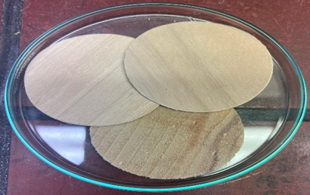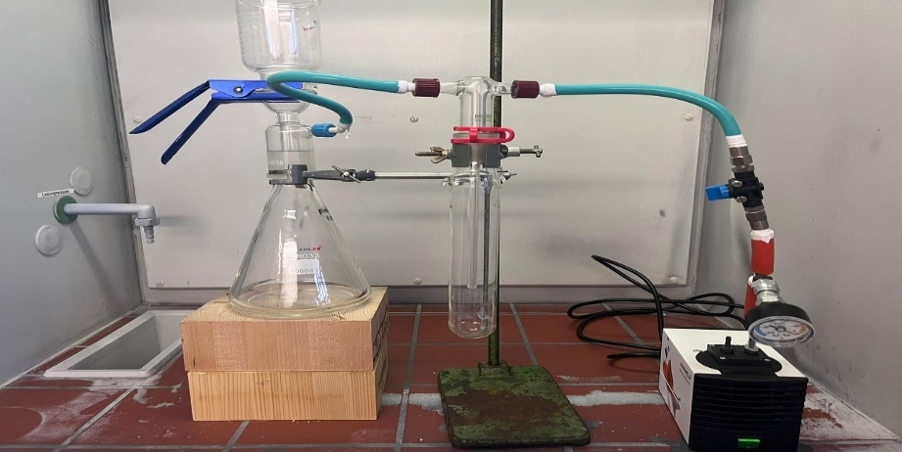
(6)
(5)
(4)
(2)
(1)
(3)
Figure SI-1. Left: Wood filtration disks (50 mm diameter and 1 mm thickness at 20 °C and 65% RH). Right: Setup for the filtration experiments: graduated funnel (1), filter flask (2), aluminum clamp (3), water trap (4), pressure gauge (5), and vacuum membrane pump (6).

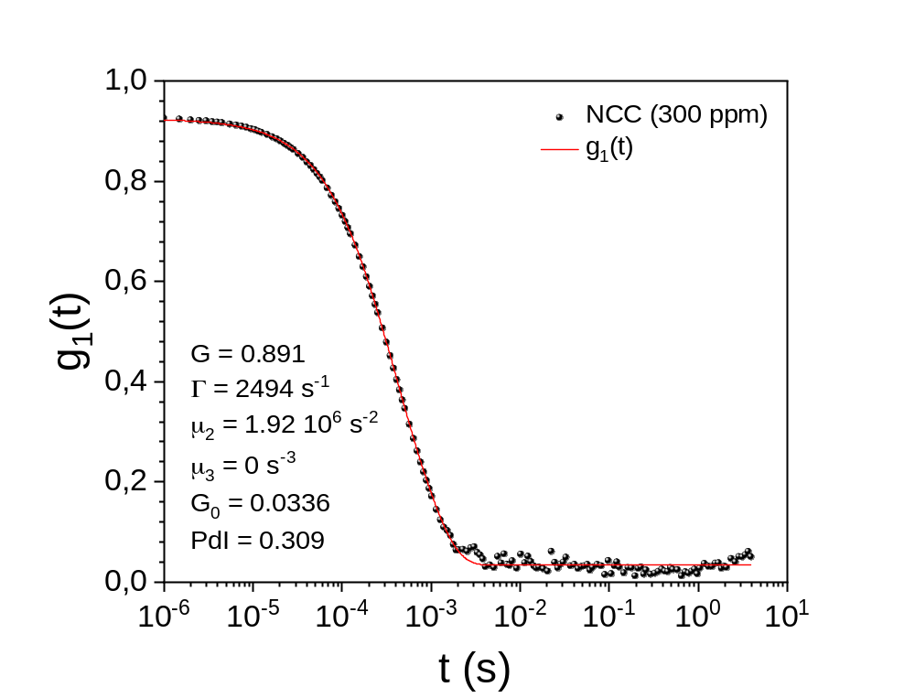
Figure SI-2. DLS data from a 300 ppm NCC dispersion in water (filled symbols), DLS autocorrelation function g₁(t) (red curve), and the parameters obtained after the analysis following the cumulant method for polydisperse samples.
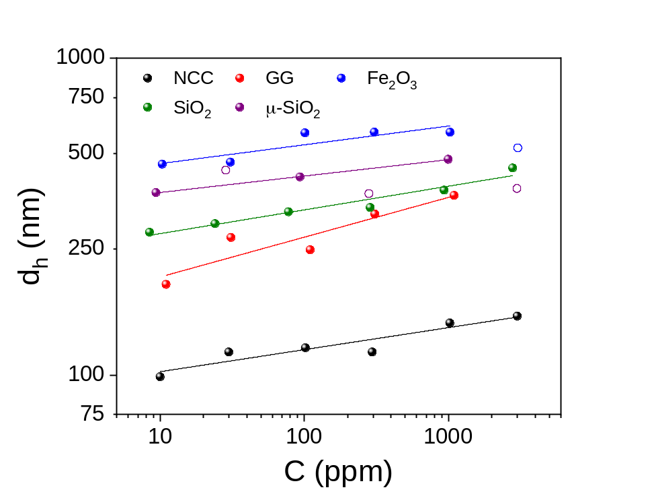
Figure SI-3. Hydrodynamic diameter d_{h} as a function of particle concentration C for the different tracers: NCC (black), GG (red), Fe₂O₃ (blue), SiO₂ (green) and μ-SiO₂ (violet).

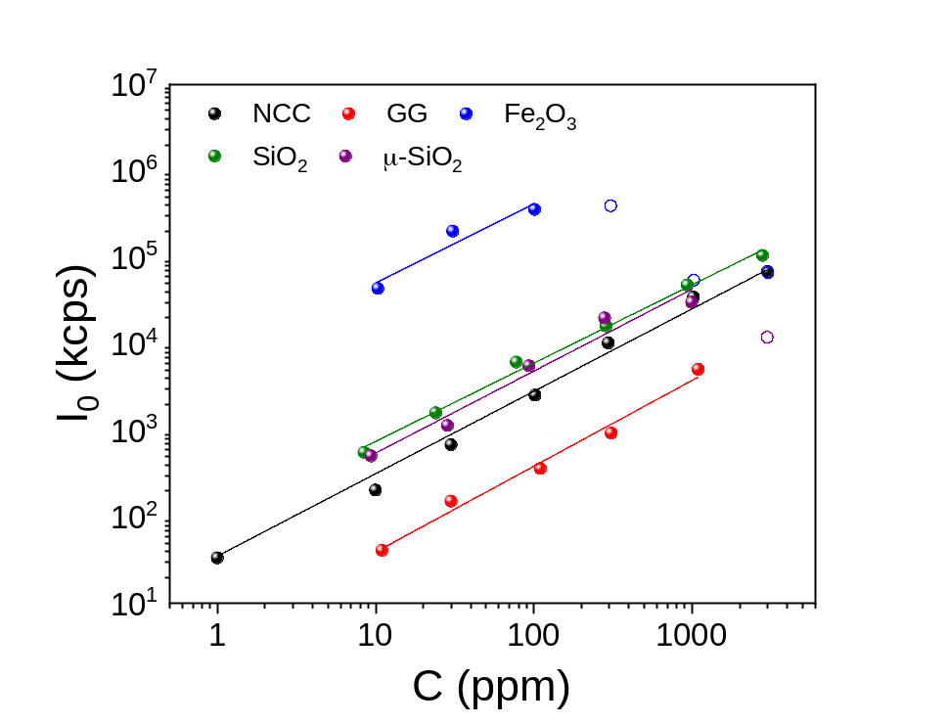
Figure SI-4. Mean count rate I₀ as a function of particle concentration C for the different tracers: NCC (black), GG (red), Fe₂O₃ (blue), SiO₂ (green) and μ-SiO₂ (violet).
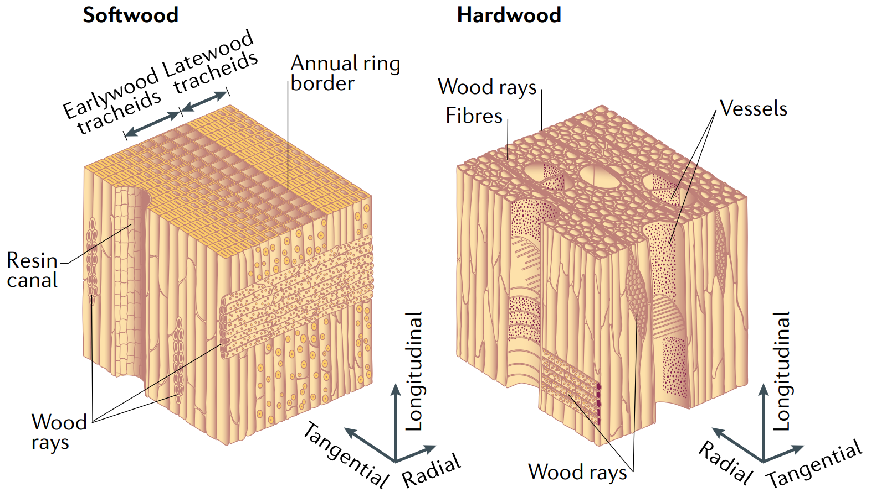
Angiosperms
Gymnosperms
Figure SI-5. Gymnosperms and angiosperms anatomical structure (Chen et al., 2020).

A)  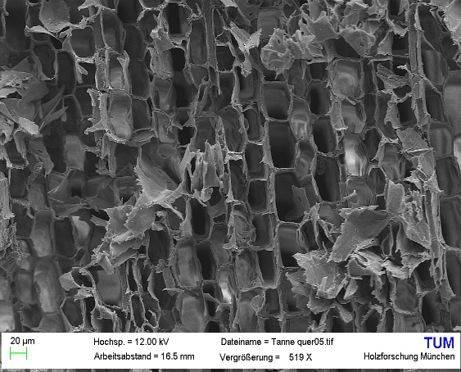 | B)
Figure SI-6. Scanning electron microscope image of the two gymnosperm species – A) silver fir and B) Douglas fir in the longitudinal (upper), radial (middle), and tangential (bottom) directions.

A) | B)
Figure SI-7. Scanning electron microscope image of the two angiosperm species – A) poplar and B) beech in the longitudinal (upper), radial (middle), and tangential (bottom) directions.

Table SI-1. Density ρ for the four wood species, mean diameter values d of tracheids (silver fir and Douglas fir) and vessels (poplar and beech) in the L-directions, and minor/major diameter values for rays and pits in the R- and T-direction.
wood | ρ (kg/m³) | d_{L} (μm) | d_{R} (μm) | d_{T} (μm)
silver fir | 415 | 30-60 | 10-16 | 4-5
Douglas fir | 530 | 30-60 | 8-18 | 7-8
poplar | 400 | 80-150 | 9-19 | 7-8
beech | 750 | 70-90 | 9-12 | 2-5

Table SI-2. Average flow rates during the filtration process for the four wood species in the three directions – water and 100 ppm nanoparticles.
Q (mL/(hcm²)) | silver fir | Douglas fir | poplar | beech
L | 547 | 619 | 594 | 590
R | 0.02 | 0.07 | 0.39 | 0.17
T | 0.01 | 0.01 | 0.06 | 0.05

A)  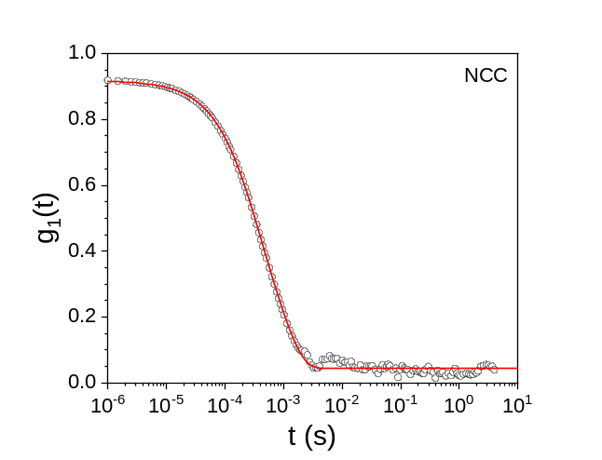 | 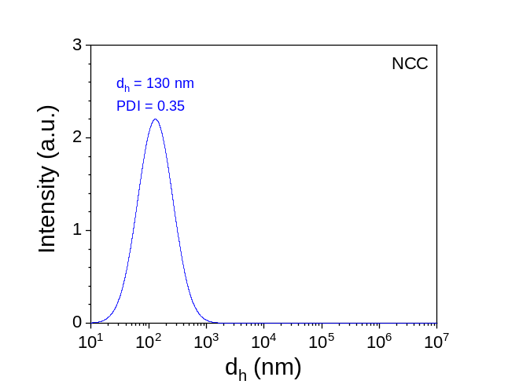
B)  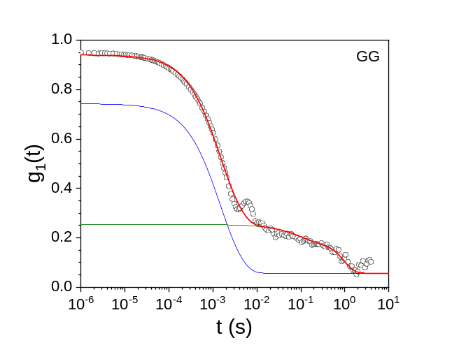 | 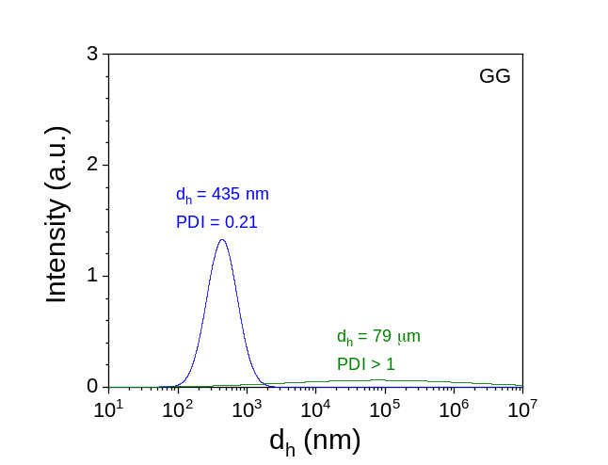
C)  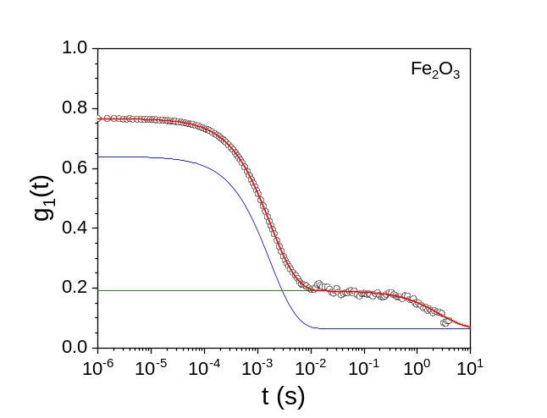 | 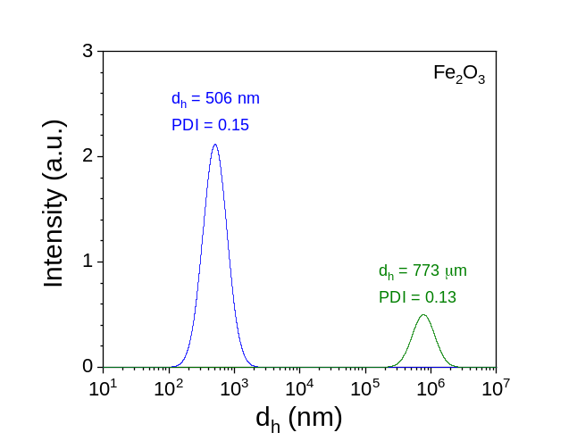
D)  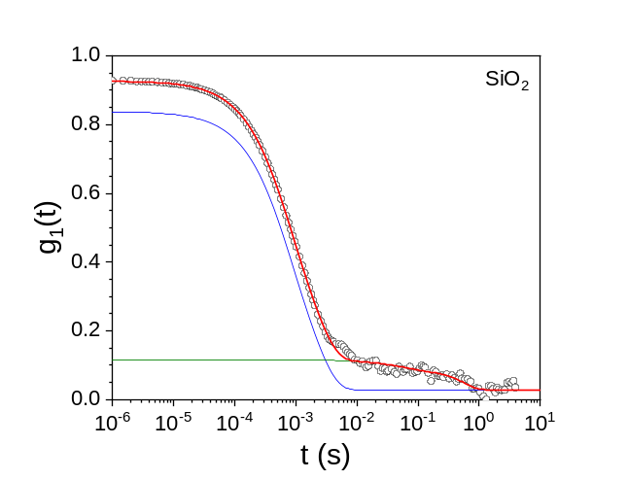 | 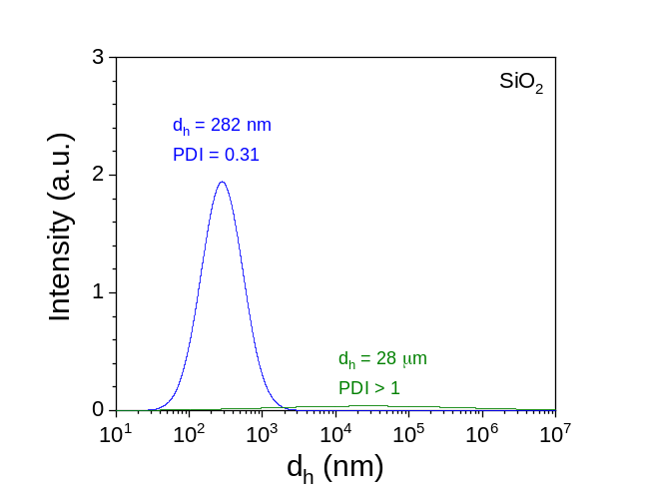
E)  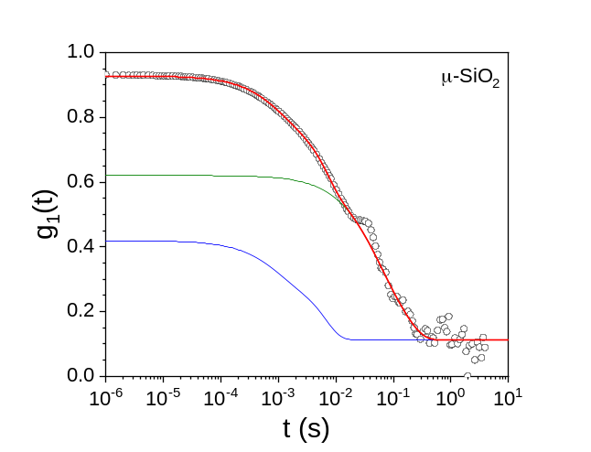 | 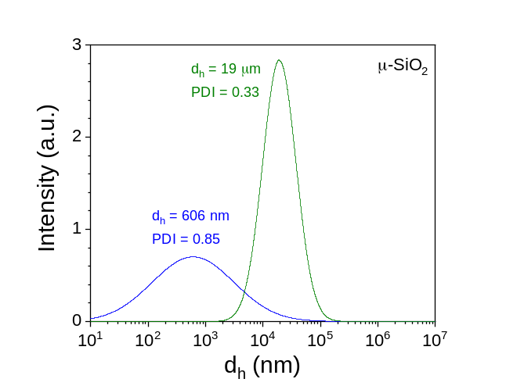
Figure SI-8. Left: DLS data (open symbols) and autocorrelation function g₁(t) (red curve) of a ca. 100 ppm dispersion of A) NCC, B) GG, C) Fe₂O₃, D) SiO₂, and E) μ-SiO₂ tracers. Right: Intensity particle size distribution (PSD) obtained from the deconvolution of the DLS fitting function. Note: the blue and green curves are the deconvolution curves when more than one particle distribution was present in the sample.

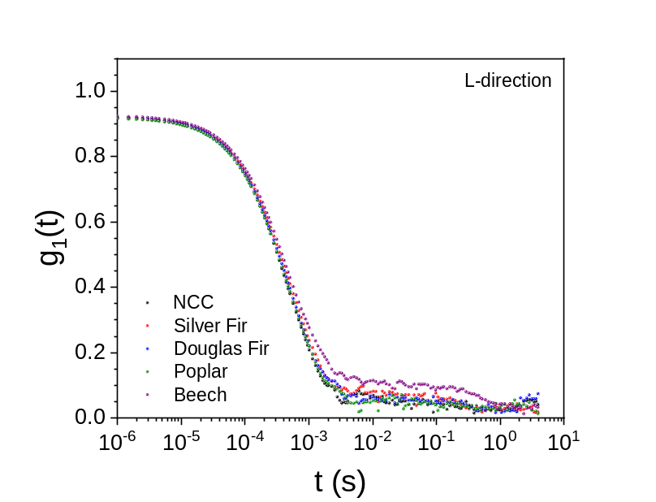
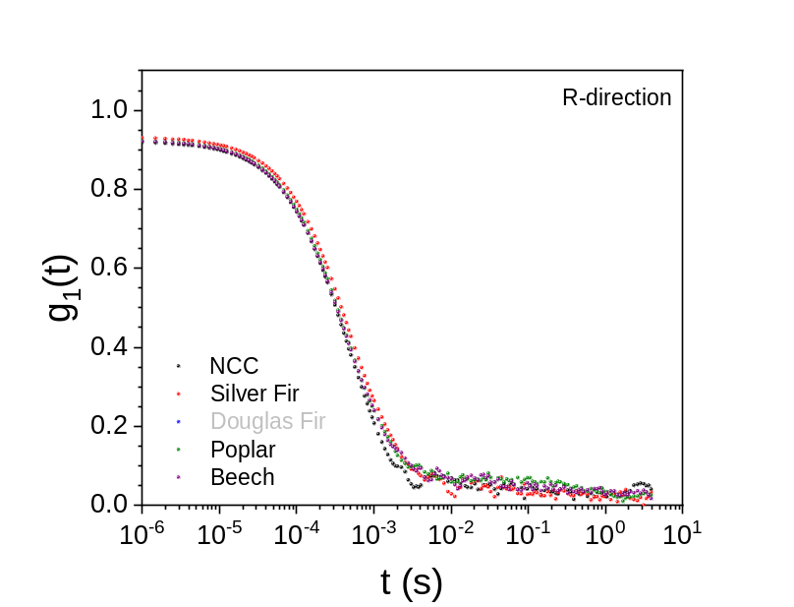
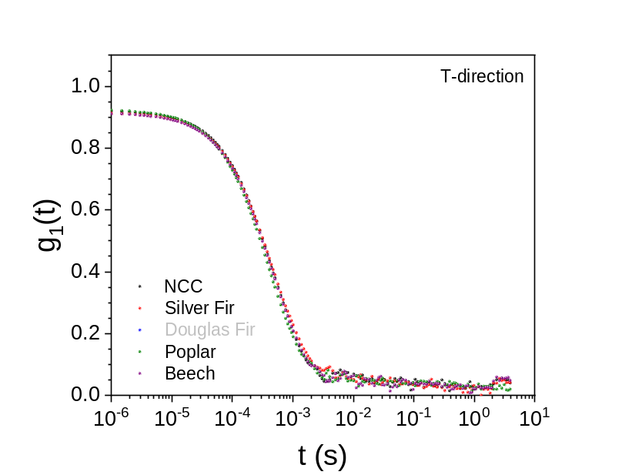
Figure SI-9. DLS data for the 130 ppm NCC dispersion (black), and after filtration for the four different wood species in the three orthotropic directions.
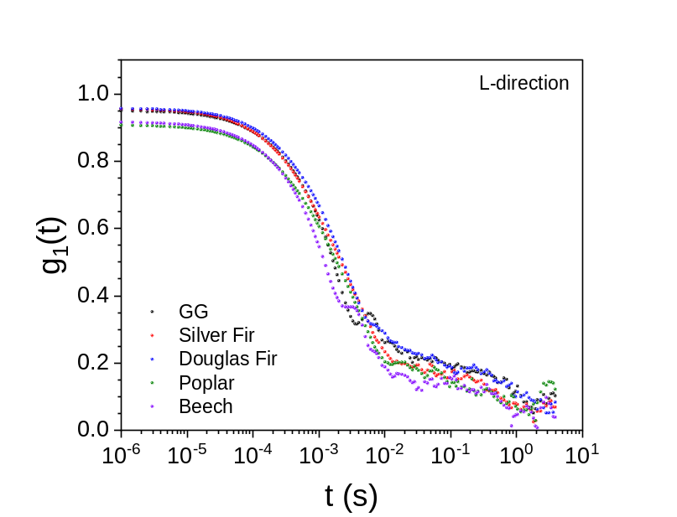
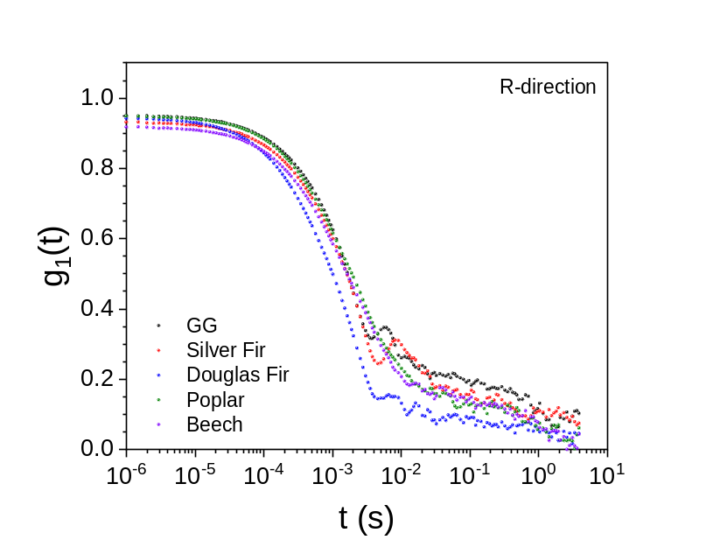
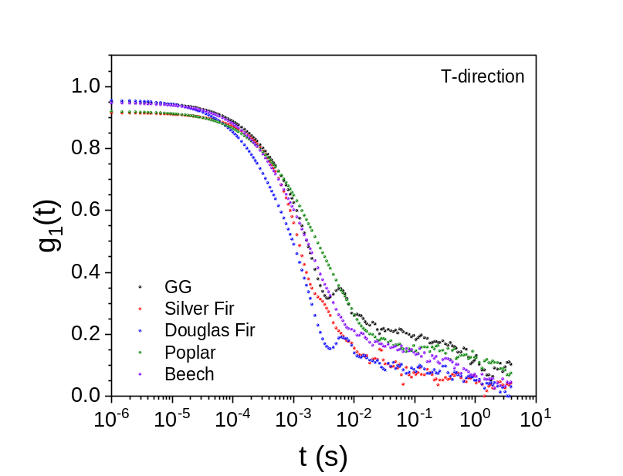
Figure SI-10. DLS data for the 104 ppm GG dispersion (black), and after filtration for the four different wood species in the three orthotropic directions.
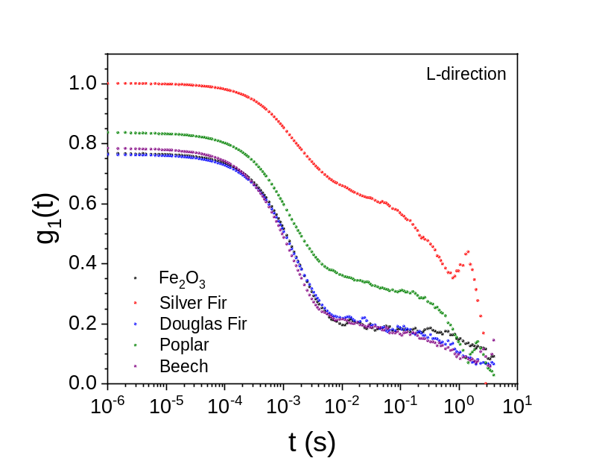
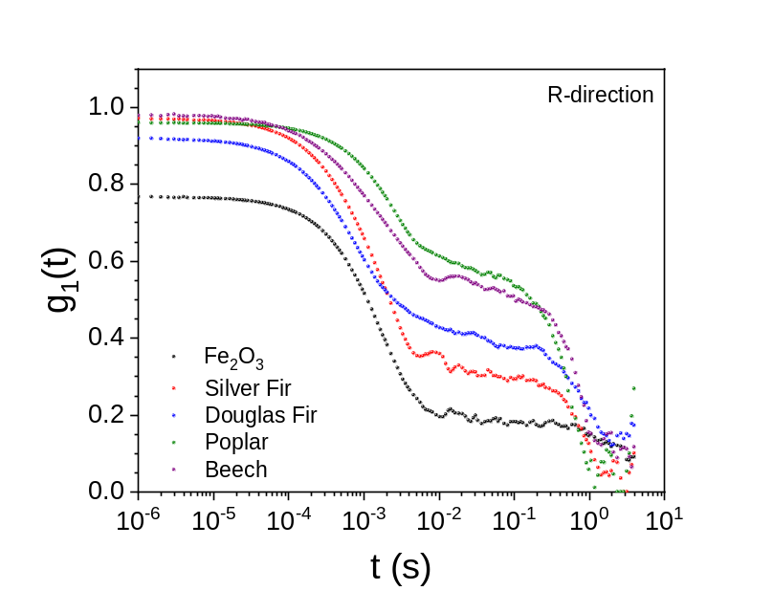
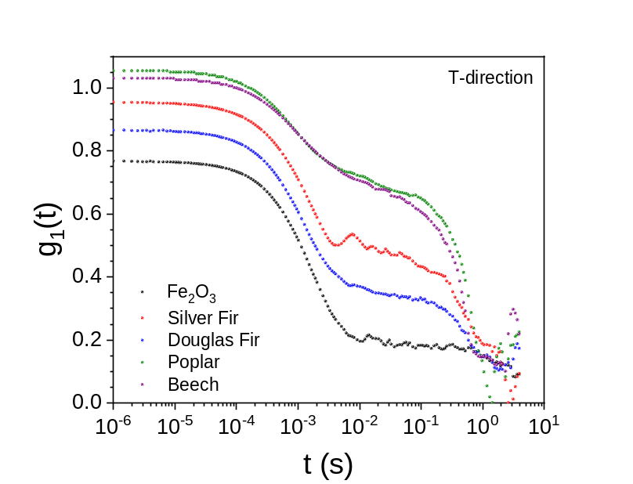
Figure SI-11. DLS data for the 105 ppm Fe₂O₃ dispersion (black), and after filtration for the four different wood species in the three orthotropic directions.
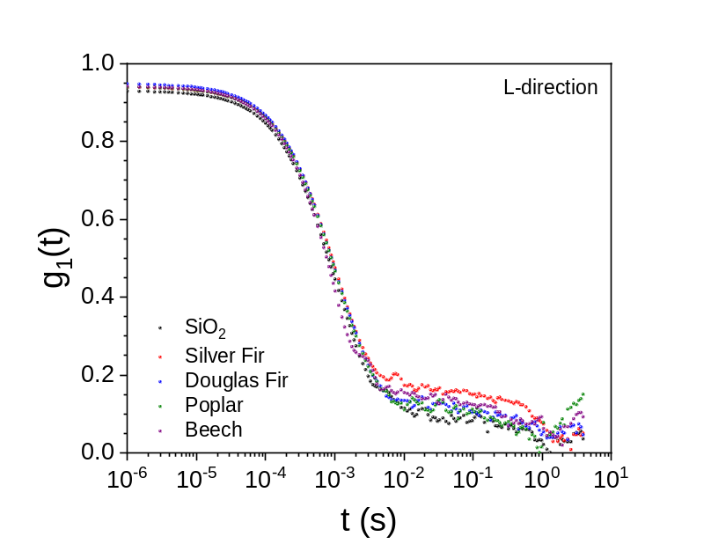
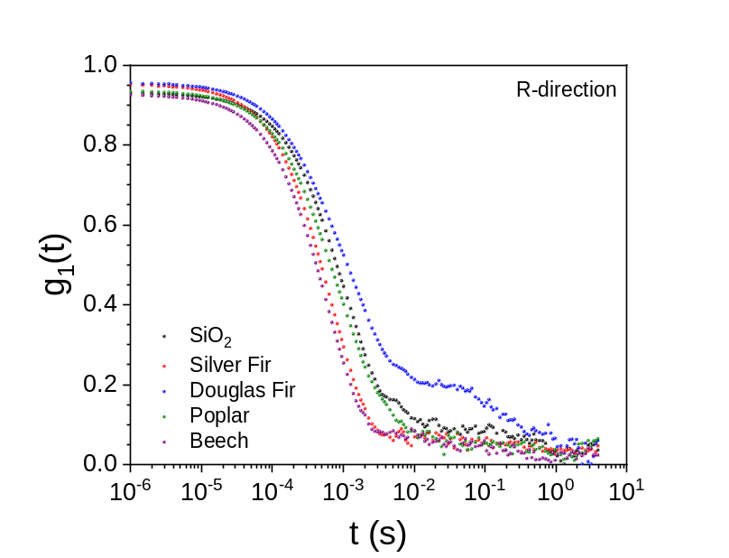
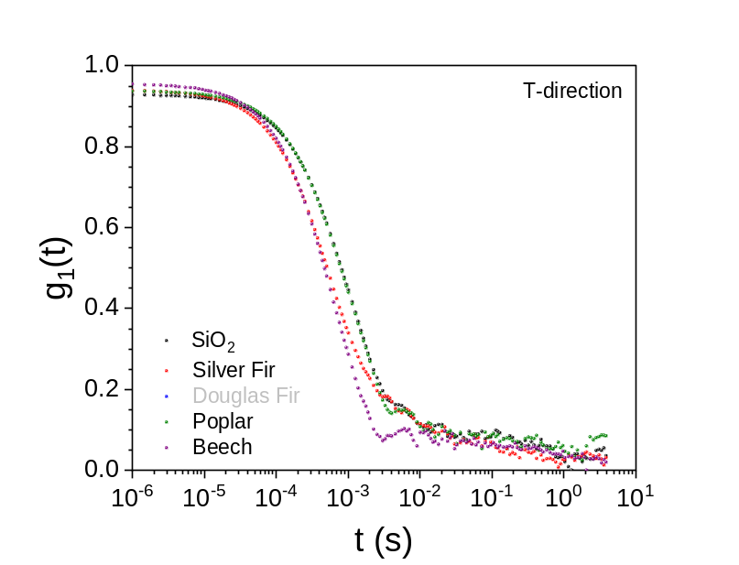
Figure SI-12. DLS data for the 100 ppm SiO₂ dispersion (black), and after filtration for the four different wood species in the three orthotropic directions.
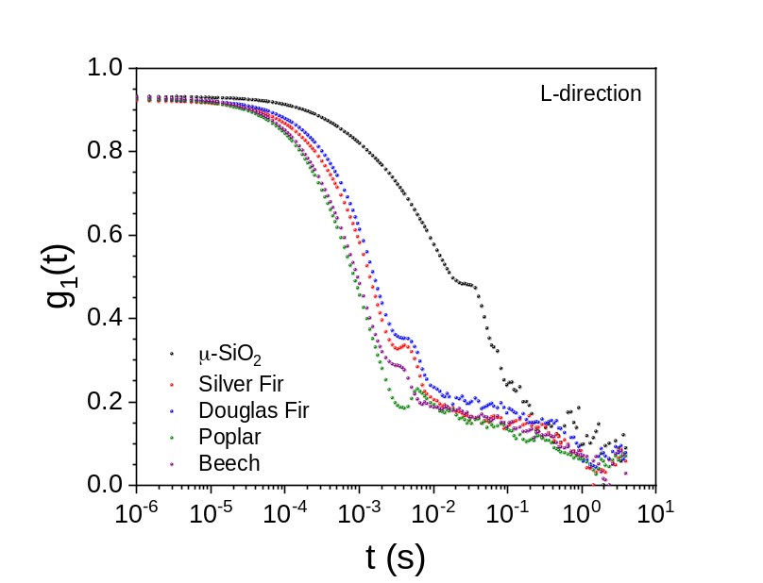
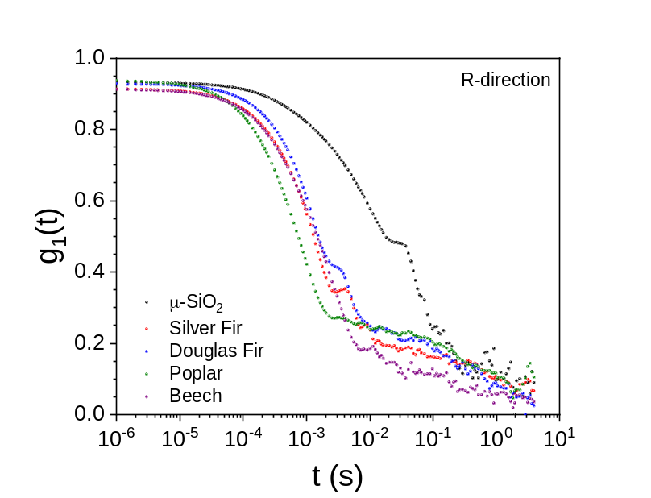
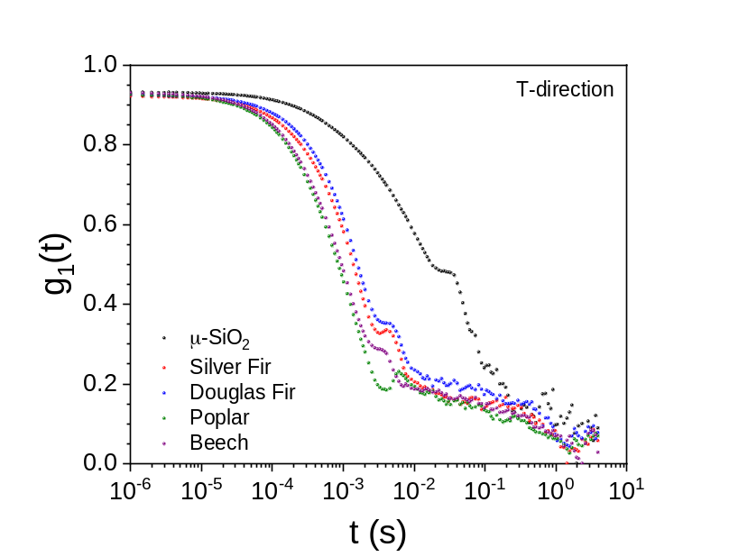
Figure SI-13. DLS data for the 115 ppm μ-SiO₂ dispersion (black), and after filtration for the four different wood species in the three orthotropic directions.

A)  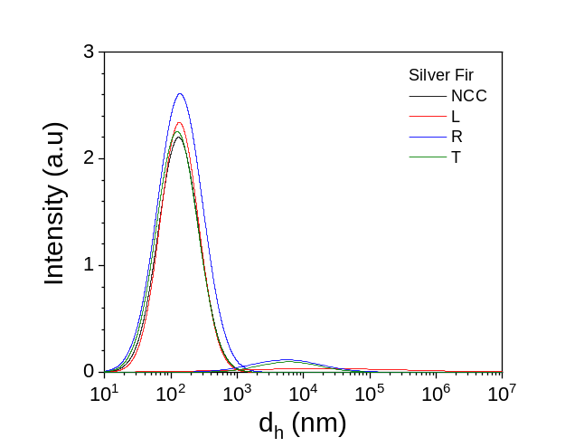 | B)  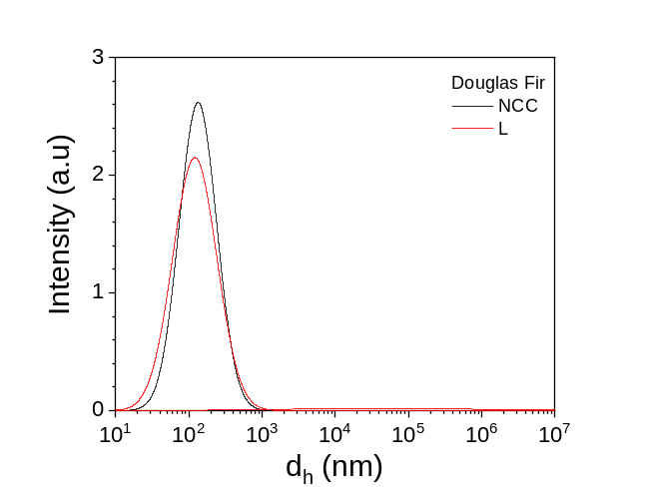
C)  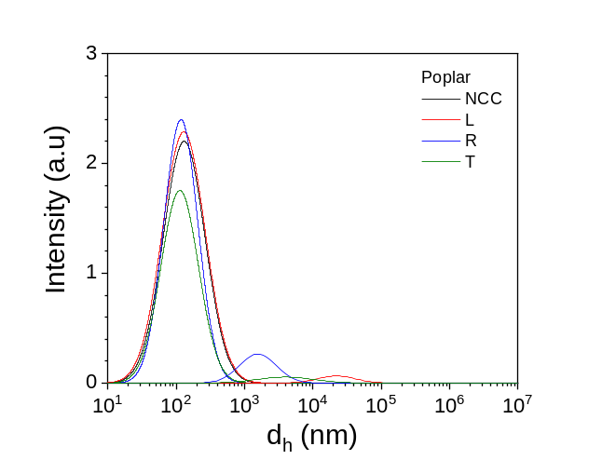 | D)  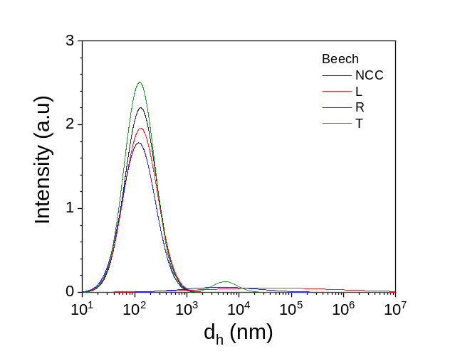
Figure SI-14. Intensity particle size distribution (PSD) of the NCC filtrates in the three directions (L, red; R, blue; T, green) for the four different wood species: A) silver fir, B) Douglas fir, C) poplar, and D) beech. The black curves correspond to the ca. 100 ppm dispersion before filtering.

A)  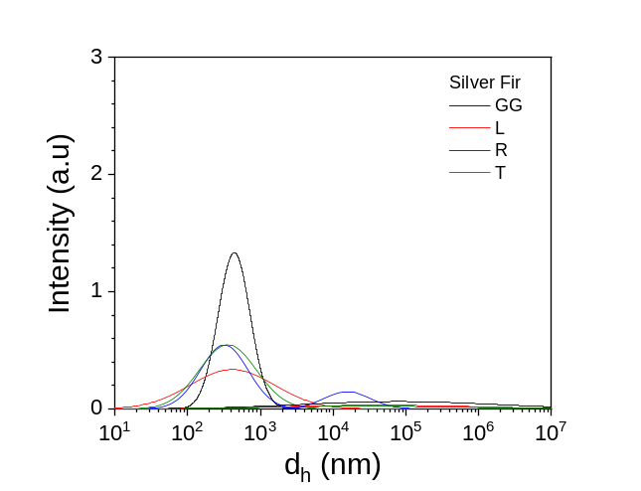 | B)  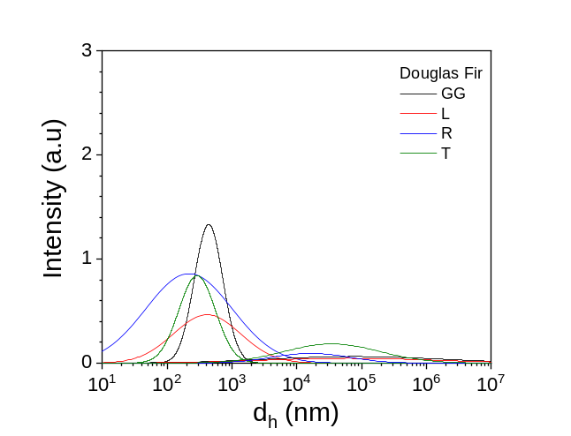
C)  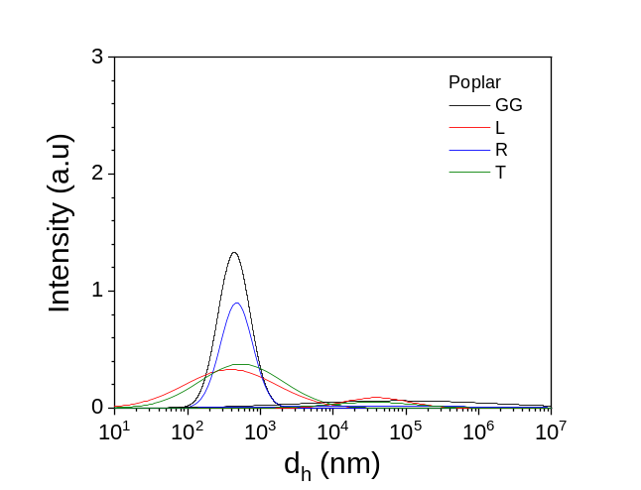 | D)  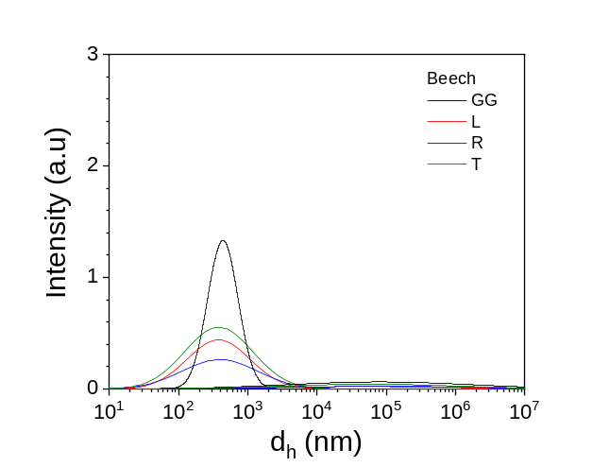
Figure SI-15. Intensity particle size distribution (PSD) of the GG filtrates in the three directions (L, red; R, blue; T, green) for the four different wood species: A) silver fir, B) Douglas fir, C) poplar, and D) beech. The black curves correspond to the ca. 100 ppm dispersion before filtering.

A)  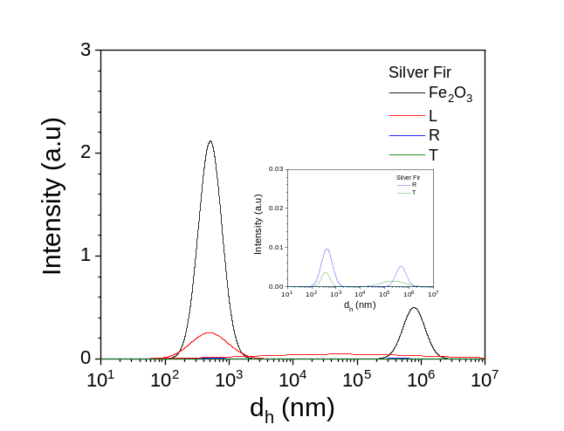 | B)  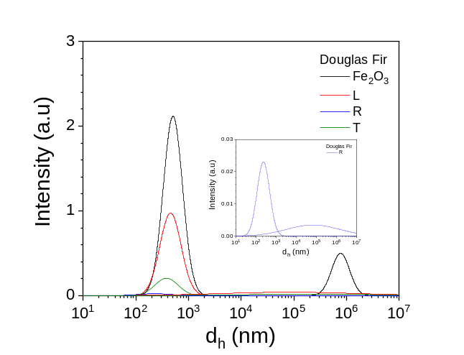
C)  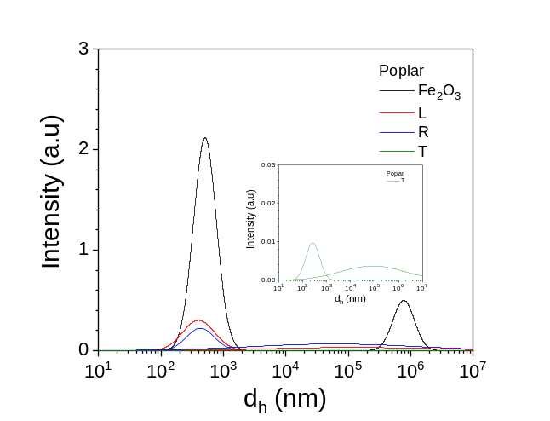 | D)  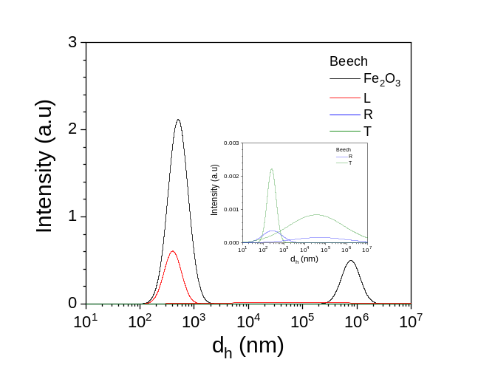
Figure SI-16. Intensity particle size distribution (PSD) of the Fe₂O₃ filtrates in the three directions (L, red; R, blue; T, green) for the four different wood species: A) silver fir, B) Douglas fir, C) poplar, and D) beech. The black curves correspond to the ca. 100 ppm dispersion before filtering.

A)  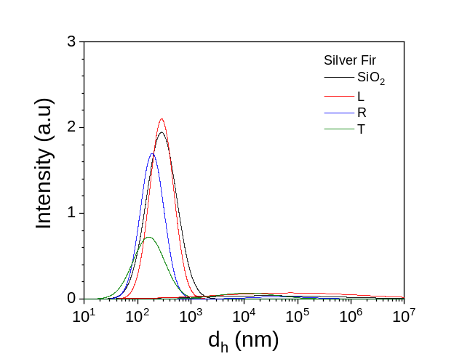 | B)  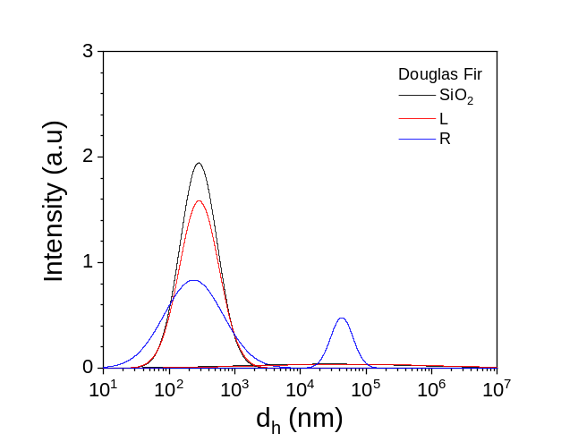
C)  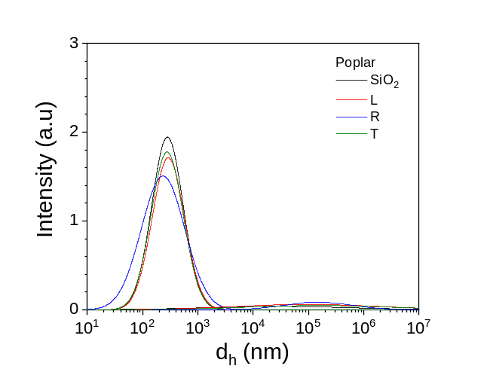 | D)  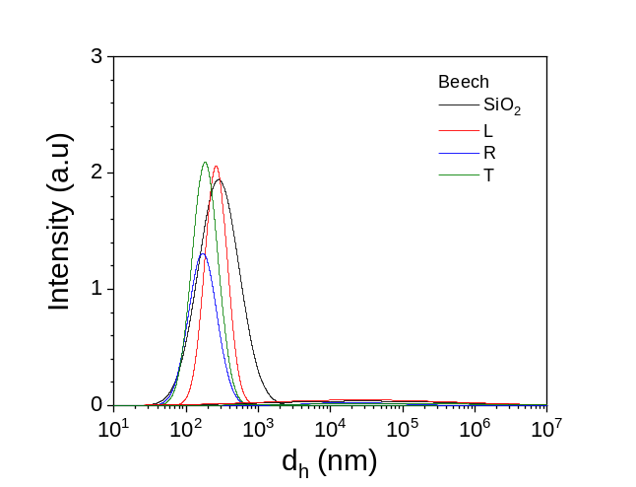
Figure SI-17. Intensity particle size distribution (PSD) of the SiO₂ filtrates in the three directions ((L, red; R, blue; T, green) for the four different wood species: A) silver fir, B) Douglas fir, C) poplar, and D) beech. The black curves correspond to the ca. 100 ppm dispersion before filtering.

A)  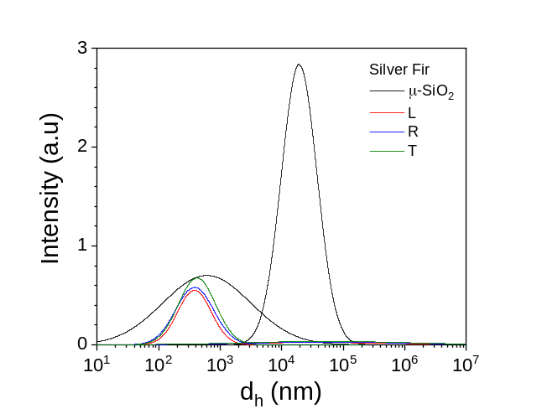 | B)  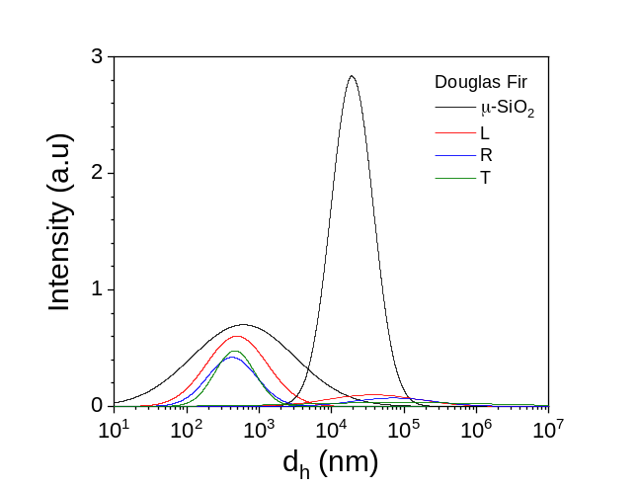
C)  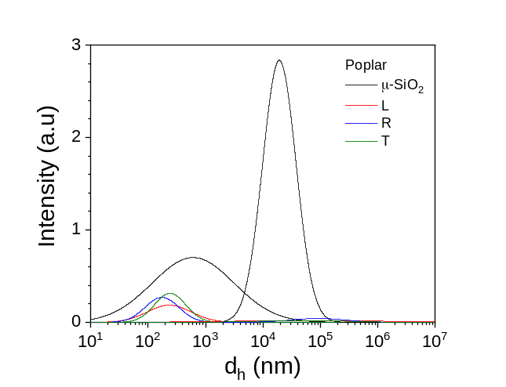 | D)  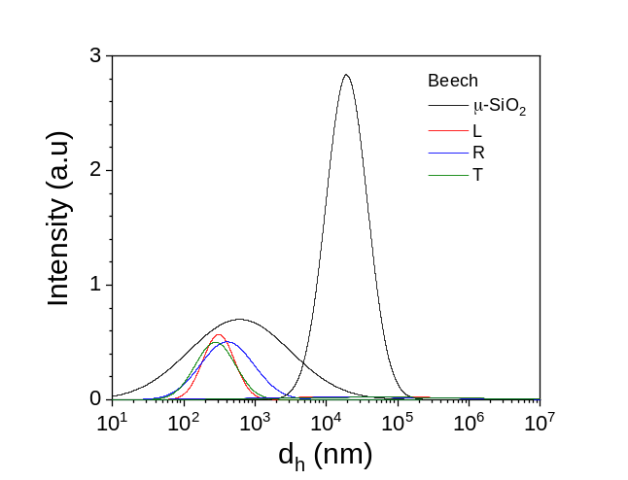
Figure SI-18. Intensity particle size distribution (PSD) of the μ-SiO₂ filtrates in the three directions (L, red; R, blue; T, green) for the four different wood species: A) silver fir, B) Douglas fir, C) poplar, and D) beech. The black curves correspond to the ca. 100 ppm dispersion before filtering.

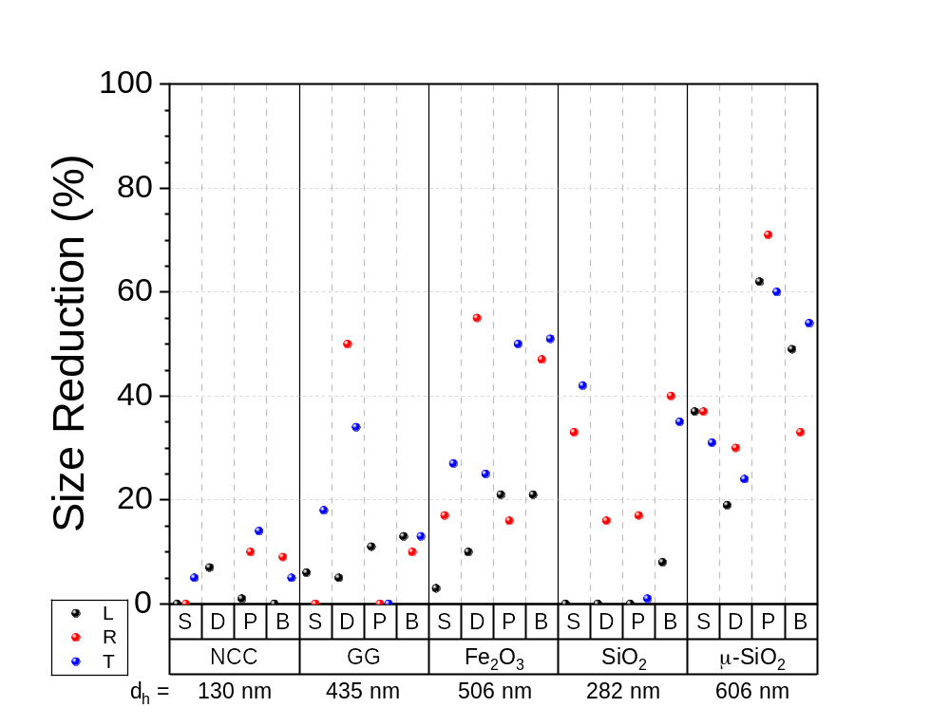
Figure SI-19. Size reduction percentage for the four wood species (S = silver fir, D = Douglas fir, P = poplar, B = beech) in the three directions (L, R and T) for the five tracers (NCC, GG, Fe₂O₃, SiO₂ and μ-SiO₂) after filtration. The orange dotted line corresponds to 100% efficiency.

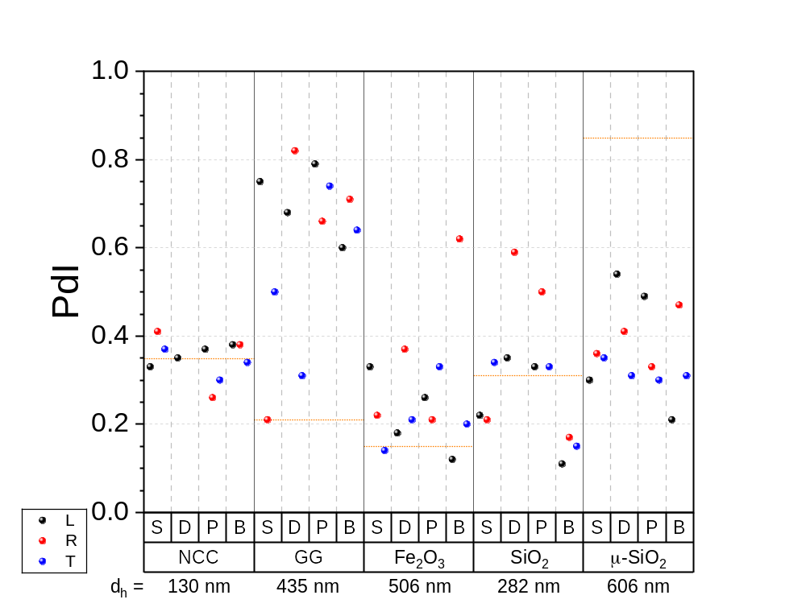
Figure SI-20. Polydispersity index of the filtrates for the four wood species (S = silver fir, D = Douglas fir, P = poplar, B = beech) in the three directions (L, R and T) with the five tracers (NCC, GG, Fe₂O₃, SiO₂ and μ-SiO₂) after filtration. The orange dotted line corresponds to 100% efficiency.

Table SI-3. Nanoparticles removal per mass of wood for each tracer and for the four wood species and the three directions (L, R and T). The concentration before filtration for NNC, GG, Fe₂O₃, SiO₂ and
μ-SiO₂ was 130, 104, 105, 100 and 115 ppm, respectively.
wood  m (g) | direction | NPs removal (mg/g)
wood  m (g) | direction | NCC | GG | Fe₂O₃ | SiO₂ | μ-SiO₂
silver fir  0.471 g | L | 0 | 0.8 | 1.6 | 0.1 | 2.1
silver fir  0.471 g | R | 0 | 0.9 | 2.2 | 0.7 | 2.0
silver fir  0.471 g | T | 0 | 0.8 | 2.2 | 1.2 | 2.0
Douglas fir  0.601 g | L | 0 | 0.3 | 0.8 | 0.2 | 1.5
Douglas fir  0.601 g | R | nd | 0 | 1.7 | 0.4 | 1.6
Douglas fir  0.601 g | T | nd | 0 | 1.5 | nd | 1.7
poplar  0.454 g | L | 0 | 0.8 | 1.7 | 0.1 | 2.3
poplar  0.454 g | R | 0 | 0.2 | 1.7 | 0 | 2.3
poplar  0.454 g | T | 0.7 | 0.8 | 2.3 | 0.1 | 2.3
beech  0.851 g | L | 0 | 0.5 | 0.9 | 0.1 | 1.2
beech  0.851 g | R | 0.1 | 0.7 | 1.2 | 0.6 | 1.1
beech  0.851 g | T | 0 | 0.2 | 1.2 | 0.4 | 1.2

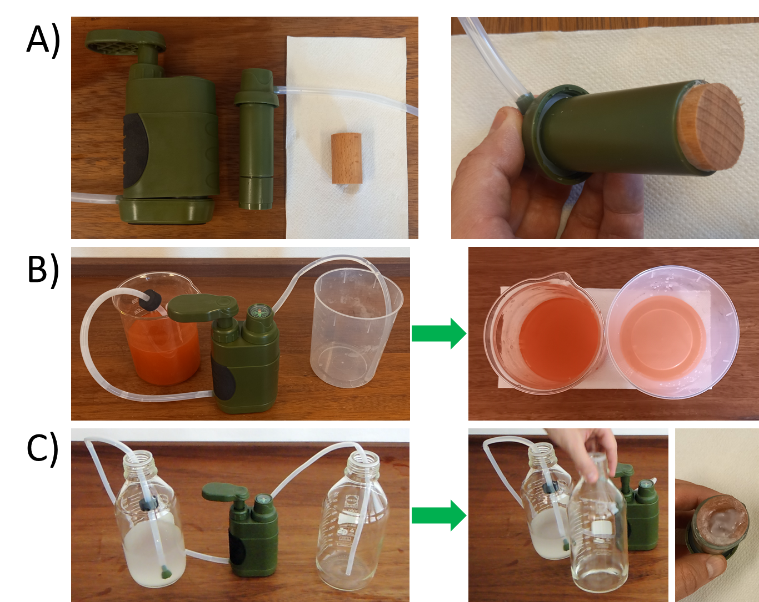
Figure SI-21. Details of a manual water filtration system using a cylinder of 4.5 mm in length and 2.5 mm in diameter beech wood sample in the L-direction. A) Filtration system and beech wood filter. B) Filtration of 100 ppm Fe₂O₃ NPs. C) Filtration of 1000 ppm μ-SiO₂ particles.

A)
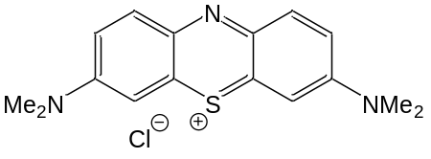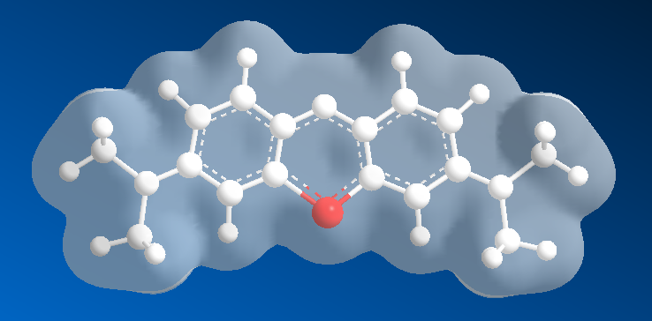
mw = 319 Da, V = 0.269 nm³, V_{exc} = 0.856 nm³, μ = 4.3 D, R_{g} = 0.40 nm, d_{max} = 1.4 nm
B)
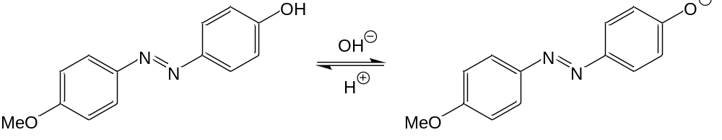
AZ4 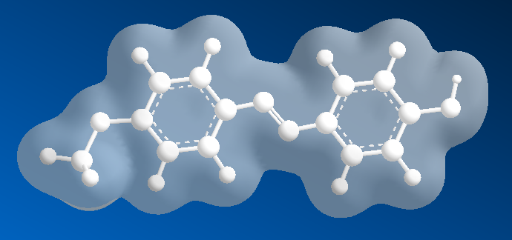 AZ12 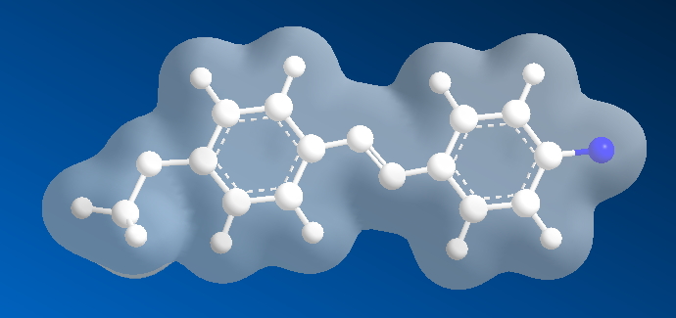
(AZ4) mw = 228 Da, V = 0.213 nm³, V_{exc} = 0.725 nm³, μ = 1.6 D, R_{g} = 0.39 nm, d_{max} = 1.4 nm
(AZ12) mw = 227 Da, V = 0.210 nm³, V_{exc} = 0.715 nm³, μ = 14.1 D, R_{g} = 0.39 nm, d_{max} = 1.4 nm
C)
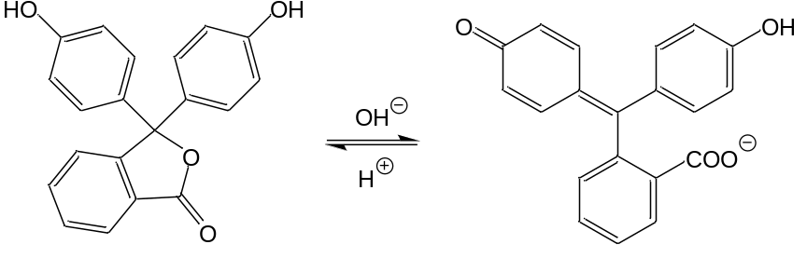
PH4 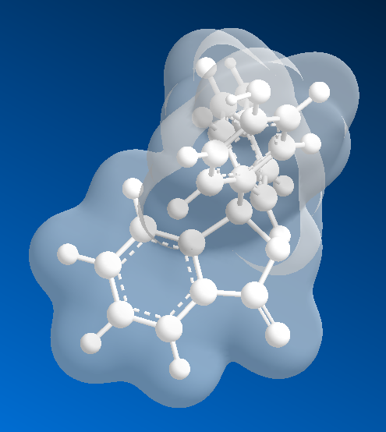 PH12 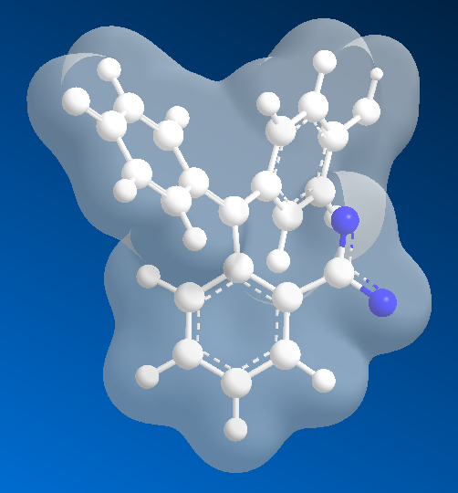
(PH4) mw = 318 Da, V = 0.282 nm³, V_{exc} = 0.880 nm³, μ = 2.6 D, R_{g} = 0.35 nm, d_{max} = 1.0 nm
(PH12) mw = 317 Da, V = 0.283 nm³, V_{exc} = 0.886 nm³, μ = 25.5 D, R_{g} = 0.35 nm, d_{max} = 1.0 nm
Figure SI-22. Molecular structure, charge density (blue: negative; red: positive), molar mass, molecular volume, excluded volume, dipole moment, radius of gyration and the largest molecular distance for the three dye molecules: A) methylene blue (MB), B) azobenzene (AZ), and C) phenolphthalein (PH).
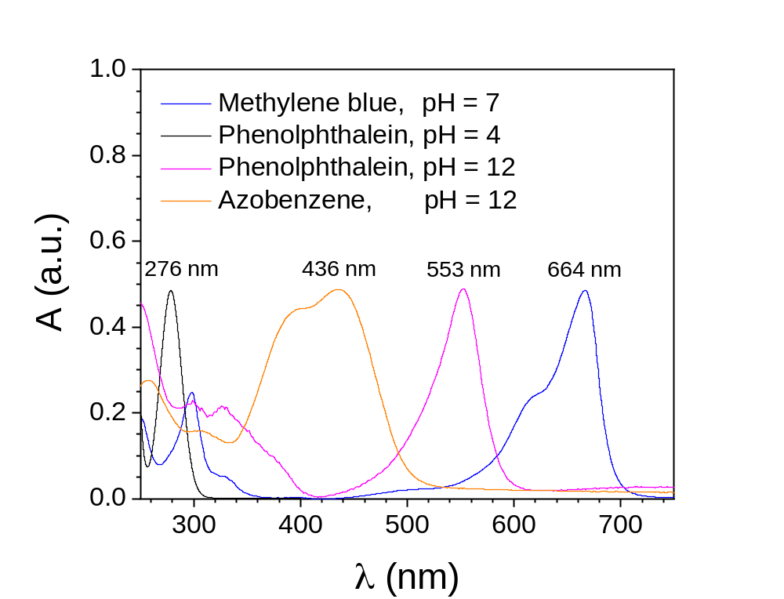
Figure 23. UV-vis spectra of methylene blue (pH 7) – blue -, phenolphthalein (pH 4) – black -, phenolphthalein (pH 12) – violet -, and azobenzene (pH 12) – orange – with the corresponding peak maxima.

