Electronic Supplementary Material
Seasonal variation and species-specific concentrations of the essential vitamin B₁ (thiamin) in zooplankton and seston
Emil Fridolfsson¹*, Carina Bunse^{1,2}, Catherine Legrand¹, Elin Lindehoff¹, Sanna Majaneva^{1, 3}, Samuel Hylander¹
¹Linnaeus University, Centre for Ecology and Evolution in Microbial model Systems - EEMiS, SE-39182 Kalmar, Sweden.
²Helmholtz Institute for Functional Marine Biodiversity at the University of Oldenburg (HIFMB), Ammerländer Heerstrasse 231, D-26129 Oldenburg, Germany
³UiT, The Arctic University of Norway, Faculty for Biosciences, Fisheries and Economics, Department for Arctic and Marine Biology, NO-9037 Tromsø, Norway.
* Correspondence:
Emil Fridolfsson
emil.fridolfsson@lnu.se
+4673- 41 65 878

Supplementary Tables
Table S1 Average carbon (POC) and nitrogen (PON) content and C:N ratios in the large (> 3 µm) and small (0.7–3 µm) size fractions of plankton at LMO (Baltic Sea) and the Gullmar fjord (Skagerrak area). Values in parentheses are standard deviation and n shows number of samples that average values are based on
Location | Size fraction | n  POC/PON | POC  (ug L⁻¹) | PON  (ug L⁻¹) | C:N
LMO | Large | 44 | 167 (±92) | 23 (±13) | 7.4 (±1.0)
LMO | Small | 44 | 79 (±37) | 12 (± 7) | 7.6 (±3.9)
Gullmar fjord | Large | 14 | 202 (±95) | 28 (±14) | 7.2 (±0.8)
Gullmar fjord | Small | 14 | 61 (±21) | 11 (± 6) | 6.4 (±2.0)

Supplementary Figures
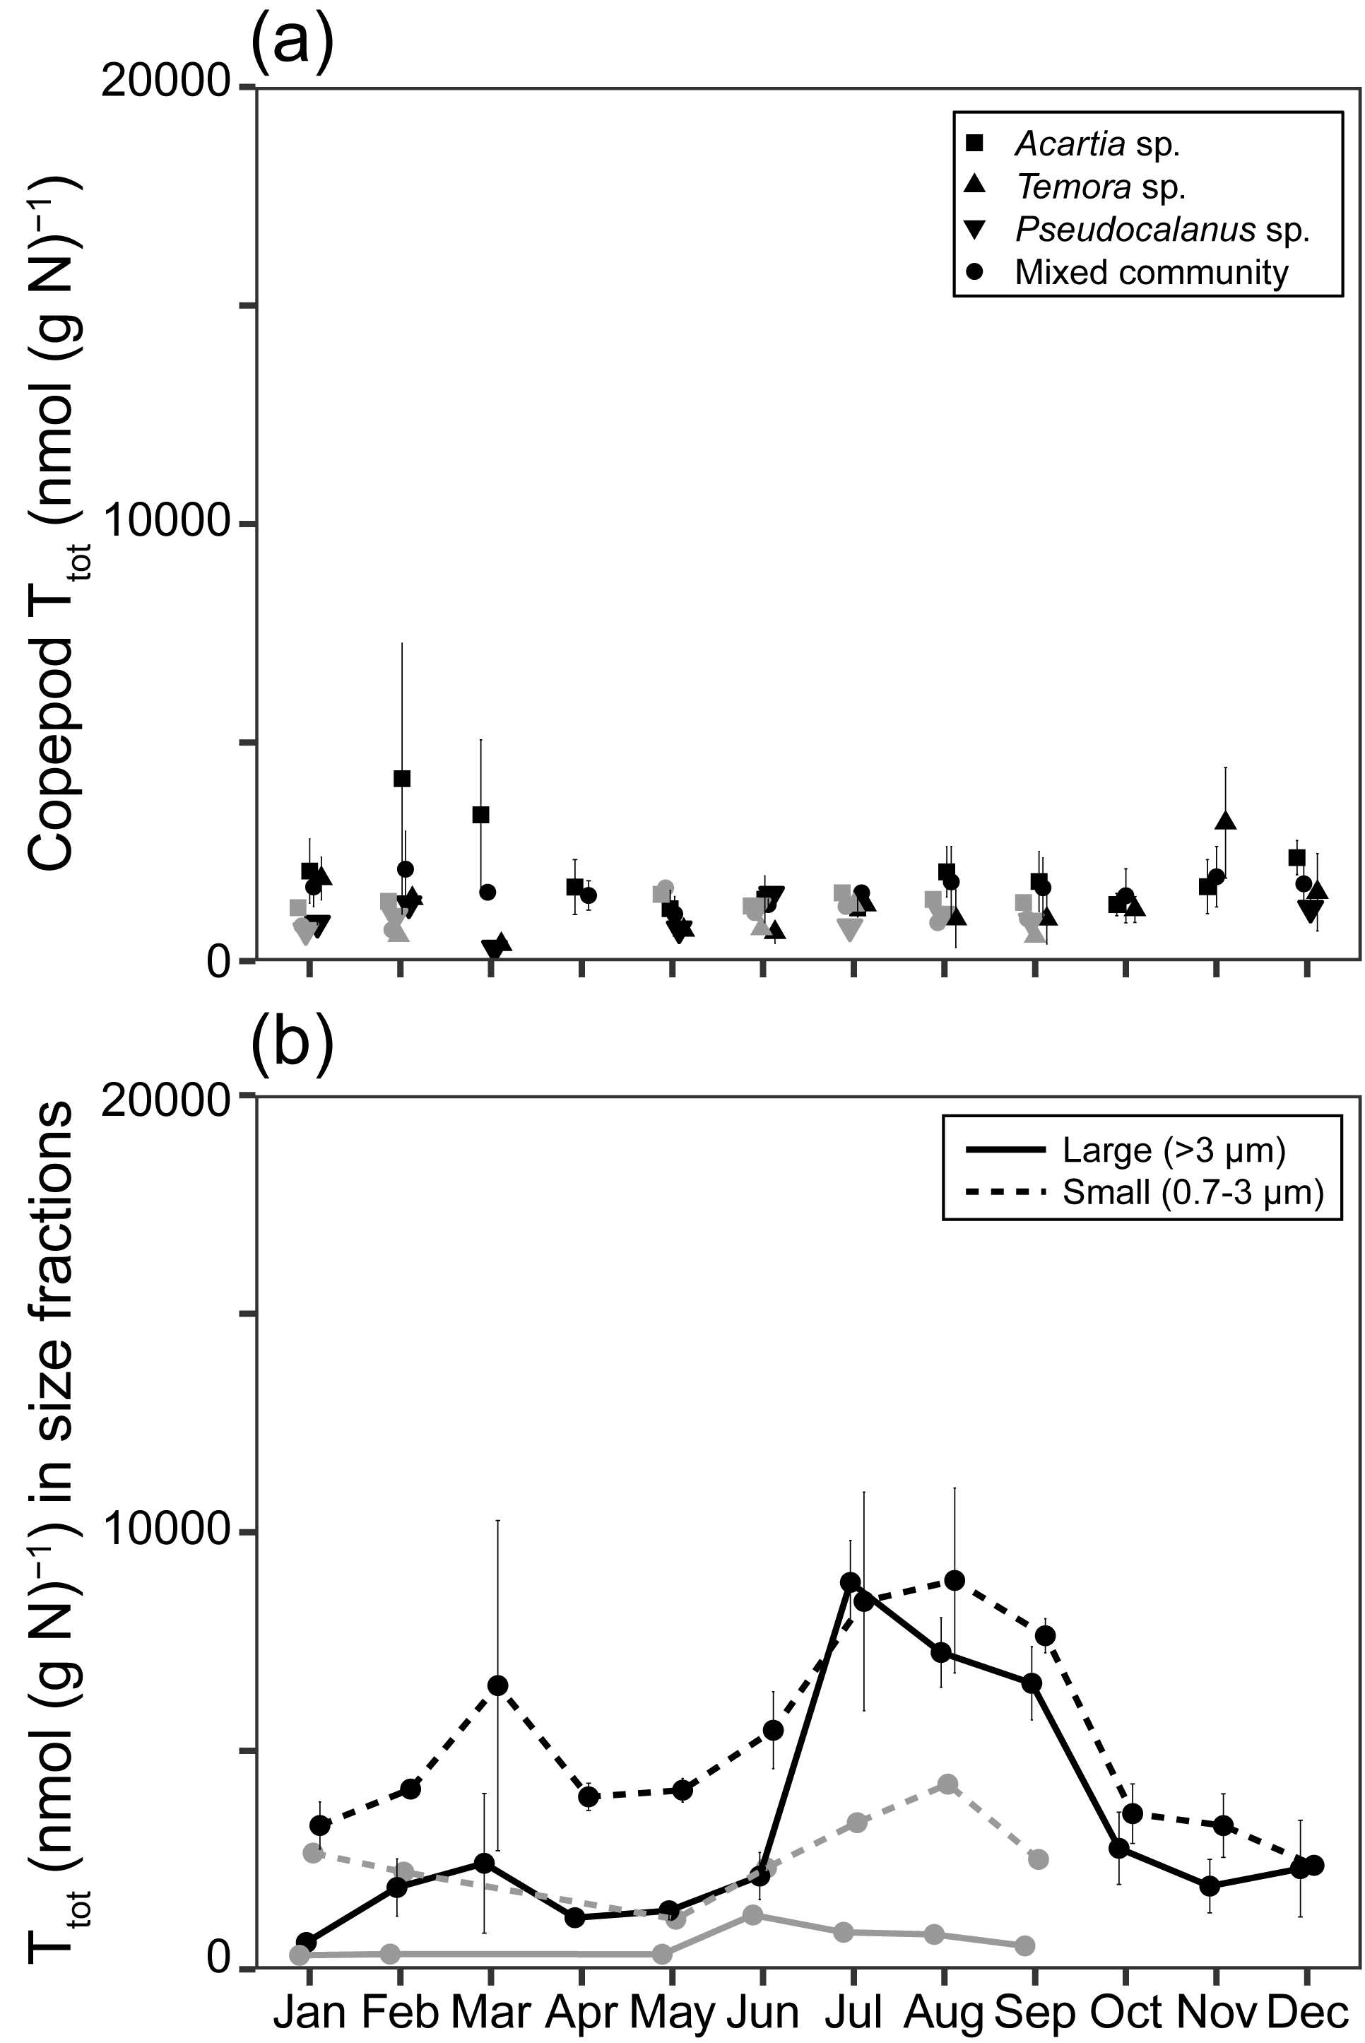
Fig. S1 Nitrogen-specific thiamin content in copepods and the two size-fractions of plankton at LMO (Baltic Sea, black) and the Gullmar fjord (Skagerrak area, grey). a Average seasonal nitrogen-specific thiamin content in different copepod genera. b Average seasonal nitrogen-specific thiamin content in the two size fractions of plankton. Error bars illustrate standard deviation for inter-annual variation
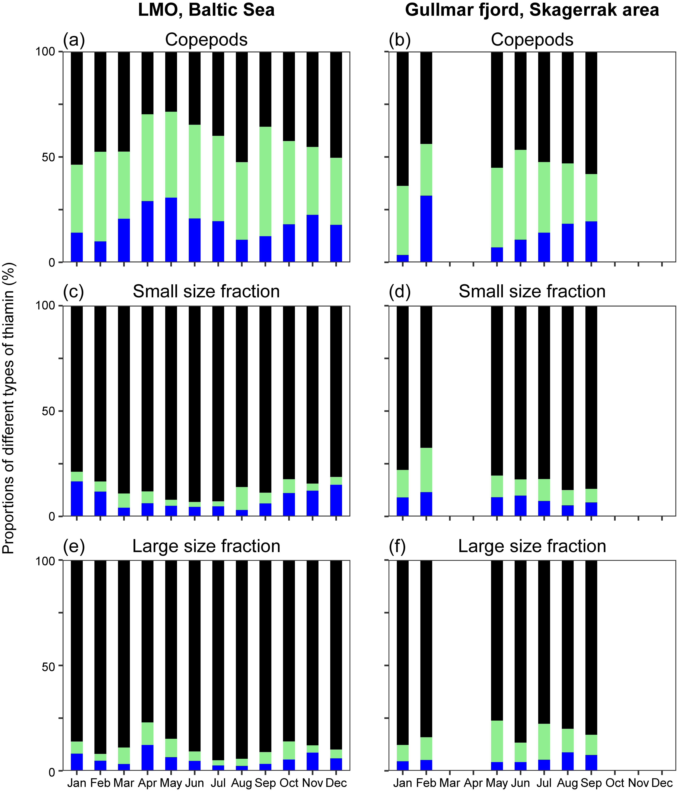
Fig. S2 Monthly average proportions of different types of thiamin, free thiamin (TF; black), thiamin monophosphate (TMP; green) and thiamin diphosphate (TDP; blue)
Fig. S3 Copepod abundances at LMO (Baltic Sea; a) and in the Gullmar fjord (Skagerrak area; b). Background color illustrate season, winter (Dec, Jan, Feb; blue), spring (Mar, Apr, May; yellow), summer (Jun, Jul, Aug; green) and autumn (Sep, Oct, Nov; red)
Fig. S4 Total (solid, left y-axis) and auto fluorescent (dashed, right y-axis) bacterial abundances at LMO (Baltic Sea, a) and in the Gullmar fjord (Skagerrak area, b). Abundances are for the non-filtered sample. Background color illustrate season, winter (Dec, Jan, Feb; blue), spring (Mar, Apr, May; yellow), summer (Jun, Jul, Aug; green) and autumn (Sep, Oct, Nov; red). Error bars illustrate standard deviation of technical duplicates

