Supplemenary data

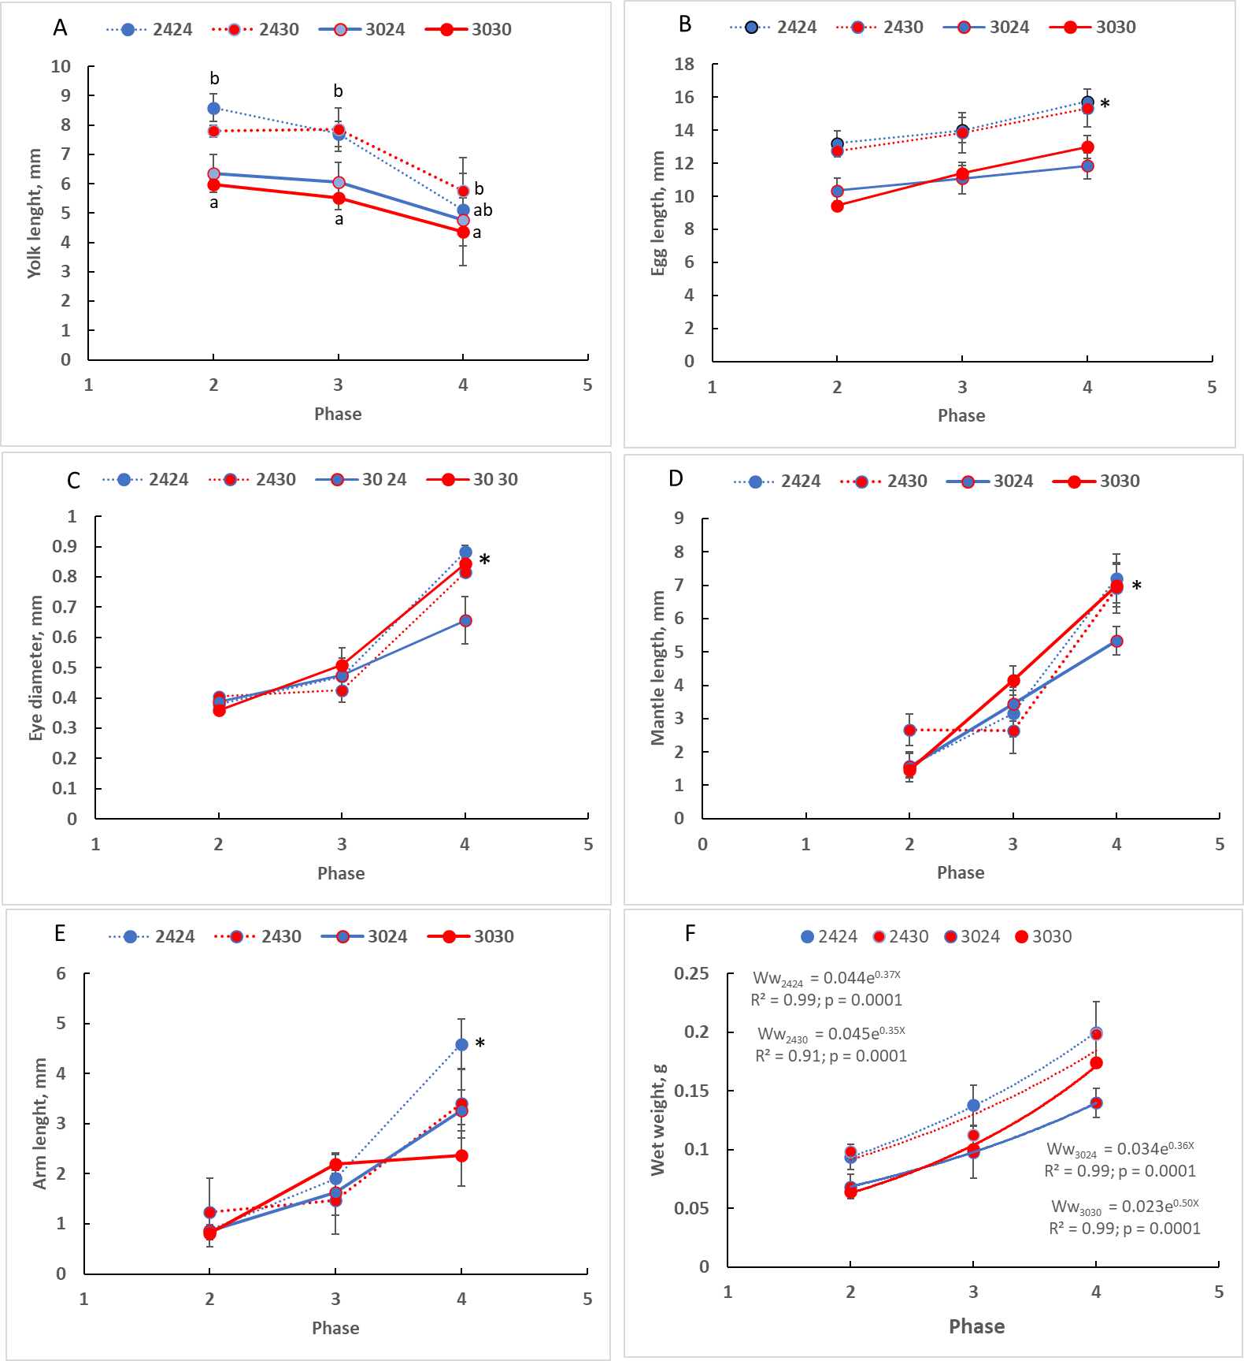

Figure S-1. Morphological changes of Octopus maya embryos during development. Phase 2 = organogenesis; phase 3 = activation; phase 4 = growth. Values as mean + SD. Different letters or asterisk indicate statistical differences at p ˂ 0.05. The first number in the marker indicate temperature where female was maintained. The second number in the marker indicate the temperature where embryos were incubated.

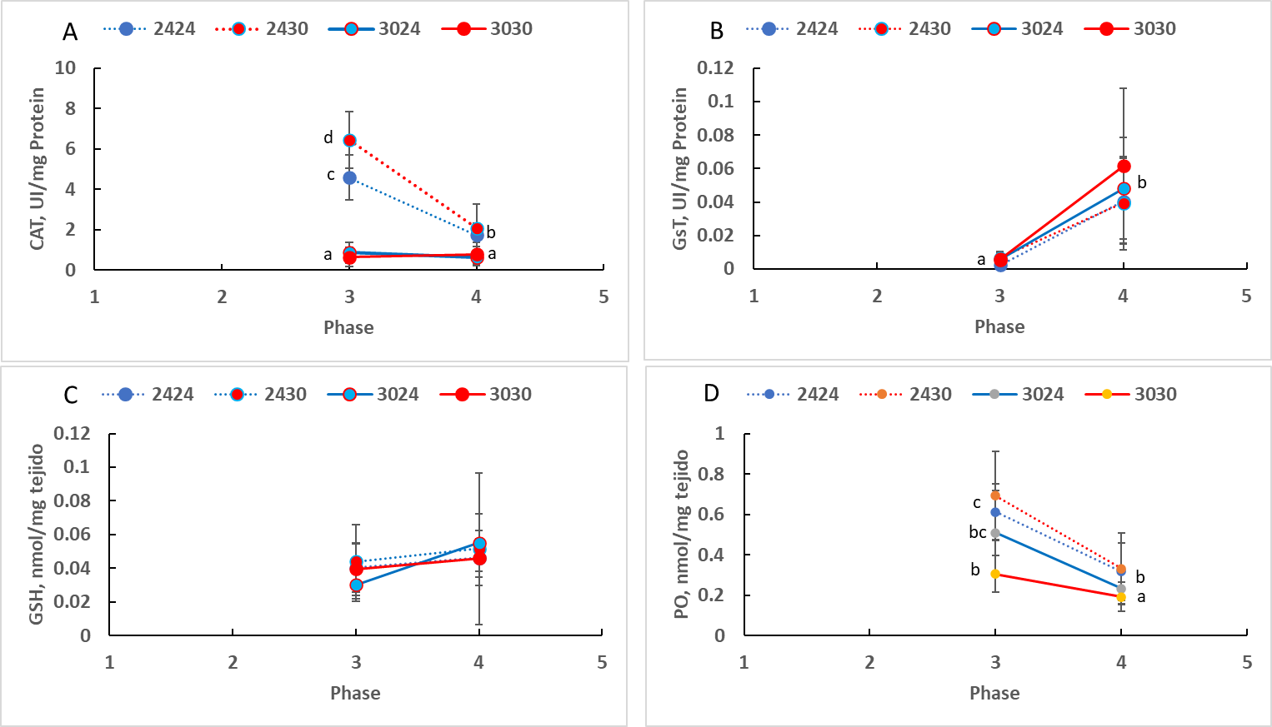
Figure S-2. Antioxidant defense mechanisms (CAT, GsT and GSH) and oxidant damage (PO), of Octopus maya embryos during development. Phase 3 = activation; phase 4 = growth. Values as mean + SD. Different letters indicate statistical differences at p ˂ 0.05. The first number in the marker indicate temperature where female was maintained. The second number in the marker indicate the temperature where embryos were incubated.

Table S-1. PERMANOVA table of result of the Antioxidant defence mechanisms (CAT, GSH and GsT) and oxidant damage (PO) during activation phase of O. maya embryos.
Factors
Name Abbrev. Type Levels
T Mother T M Fixed 2
T Embryo T E Fixed 2

Unique
Source df SS MS seudo-F P(perm) perms
T°C Mother 1 99.335 99.335 41.874 0.0001 9956
T°C Embryo 1 -2.508 -2.508 Negative
T MxT E 1 19.061 19.061 8.0352 0.0004 9965

Res 54 128.1 2.3722
Total 57 239.9

Term 'T MxT E' for pairs of levels of factor 'T Embryo'

Within level '24' of factor 'T Mother'
Unique
Groups t P(perm) perms
24, 30 2.0557 0.0244 9962

Denominators
Groups Denominator Den.df
24, 30 1*Res 28

Average Distance between/within groups
24 30
24 1.299
30 2.0032 2.1449

Within level '30' of factor 'T Mother'
Unique
Groups t P(perm) perms
24, 30 1.713 0.0462 9937

Denominators
Groups Denominator Den.df
24, 30 1*Res 26

Average Distance between/within groups
24 30
24 2.1292
30 2.1204 1.5856

Table S-2. PERMANOVA table of result of the Antioxidant defence mechanisms (CAT, GSH and GsT) and oxidant damage (PO) during phase of growth of O. maya embryo.
Factors
Name Abbrev. Type Levels
T Mother T M Fixed 2
T Embryo T E Fixed 2

PERMANOVA table of results
Unique
Source df SS MS Pseudo-F P(perm) perms
Temperature Mother 1 55.227 55.227 15.779 0.0001 9955
Temperature Embryo 1 11.007 11.007 3.1448 0.0335 9959
T Mother x Embryo 1 3.4179 3.4179 0.97652 0.4041 9965
Res 143 500.51 3.5
Total 146 578.88

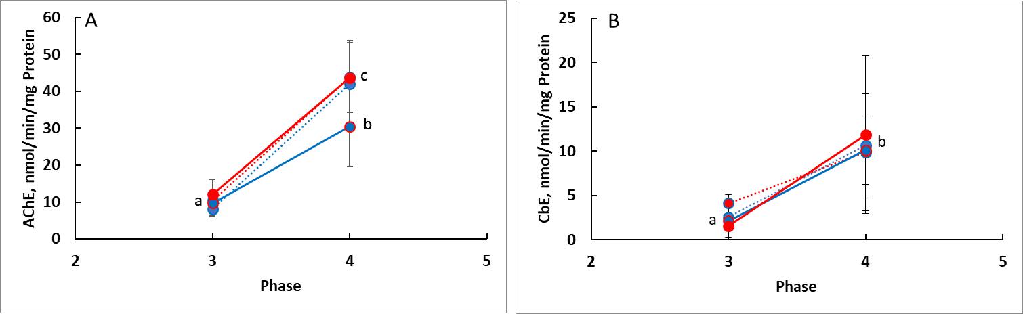
Fig. S-3. Acetylcholinesterase and carboxyl-esterase of Octopus maya embryos during development. Phase 3 = activation; phase 4 = growth. Values as mean + SD. Different letters indicate statistical differences at p ˂ 0.05. The first number in the marker indicates the temperature where the female was maintained. The second number in the marker indicates the temperature where embryos were incubated.

