Supplementary Material 1
Table S1.1 Volumes (in ml) of rockpools sampled at each site. O = Rockpools with overhangs used in analyses. P = Rockpools with pits used in analyses. N = Rockpools without microhabitats used in analyses with overhangs/pits. N* = Rockpools without microhabitats used in analyses with overhangs. E = Rock pools that could not be sampled due to environmental conditions or high canopy cover, or had more than one microhabitat.
 | Coastal |  |  | Outer Harbour |  | Inner Harbour
 | Bondi | Freshwater | Curl Curl | Bradleys Head | Delwood | Balmain | Berry Island Reserve
1 | 422 (N*) | 600 (N) | 260 (N*) | 1450 | 2350 | 580 | 3200
2 | 1580 (O) | 1400 (O) | 1290 (O) | 11380 | 3620 | 940 | 55
3 | 900 (N) | 2000 (O) | 190 | 610 | 900 | 2040 | 2620
4 | 11180 (E) | 3690 (E) | 400 (N*) | 2780 | 320 | 380 | 2970
5 | 810 (N) | 420 (P) | 500 (O) | 32 | 3900 | 890 | 490
6 | 1150 (E) | 2080 (P) | 1220 (P) | 260 | 44 | 2580 | 680
7 | 34 | 1140 (O) | 700 (P) | 9 | 1750 | 7100 | 550
8 | 1220 (O) | 1200 (P) | 2310 (N) | 7 | 1710 | 1400 | 140
9 | 4510 (O) | 2500 (P) | 1200 (E) | 89 | 4000 | 290 | 1720
10 | 130 | 12560 (P) | 5530 (O) | 1780 | 20 | 840 | 4890
11 | 65 | 1050 (O) | 510 (N) | 9 | 42 | 1310 | 20
12 | 57 | 17040 (E) | 690 (E) | 10 | 2300 | 4420 | 500
13 | 102 | 1230 (E) | 230 | 210 | 2350 | 2950 | 9600
14 | 480 (N) | 2290 (N) | 10000 (O) | 1460 | 1310 | 1830 | 5100
15 | 3360 (P) | 1390 (E) | 2230 (E) | 7500 | 1440 | 1850 | 2680
16 | 1920 (E) | 1000 (N) | 183 (E) | 410 | 2230 | 90 | 2880

Differences between methodologies
Since we used different sampling methods to record the mobile taxa (video and photos), we tested for potential confounding effects. To do this, we compared a subsample of two randomly selected rock pools (with or without microhabitats) at each site that were sampled using both videos and photos for direct comparison between methods. The total number of taxa found in the pools did not differ between methodologies.
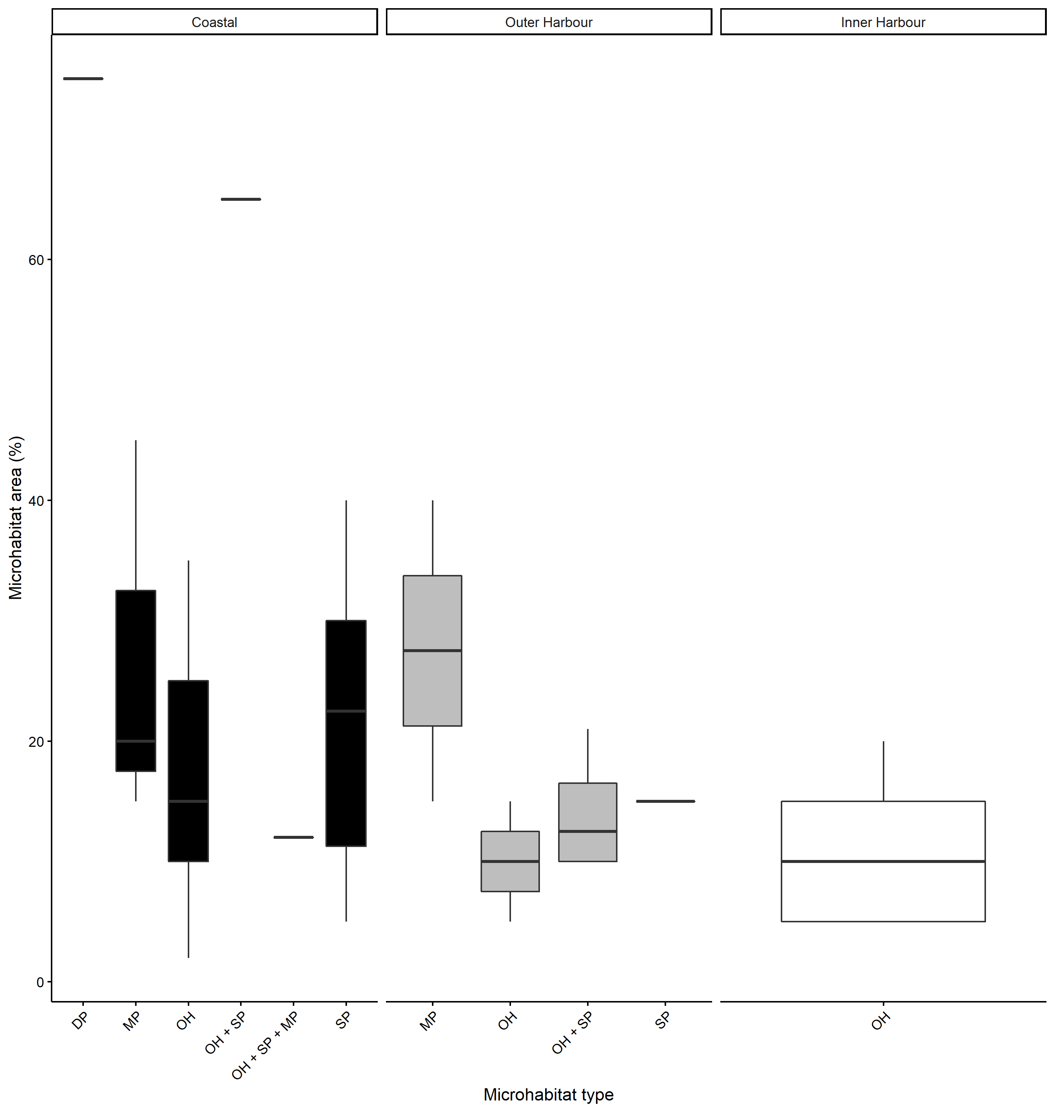
Figure S1.1 Boxplot of the total estimated area (%) of microhabitats at each location (standardised by overall rock pool area), showing the first quartile (Q1) and third quartile (Q3) of the data, the median and data outliers). Abbreviations: VW=Vertical walls, OH=Overhang, DP=Deep pit, MP=Medium pit, SP=Shallow pit.

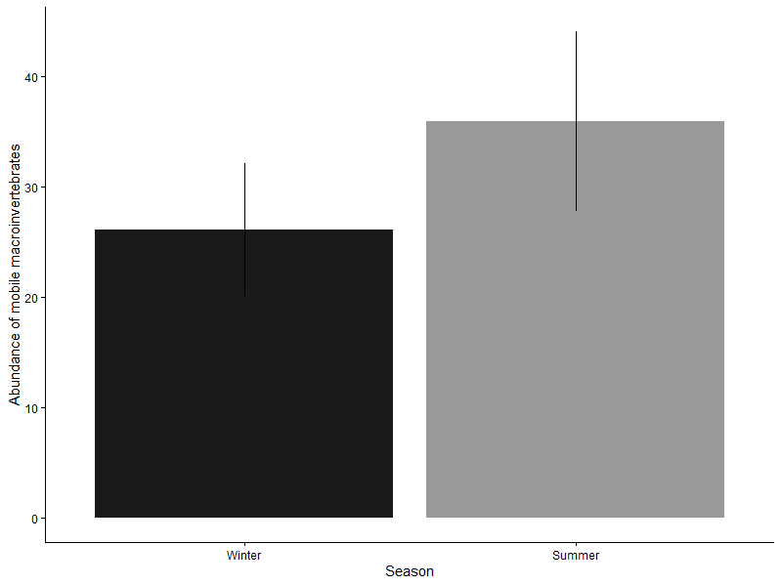
Figure S1.2 Species richness at each sampling time of rock pools without microhabitats that could be sampled across all sampling times.
Table S1.2 Proportion of occurrence of species/taxa found in the rock pools with and without microhabitats used in the analyses. N is the total number of occurrences across sampling times (number of rock pools without or with microhabitats x total number of samplings (4). This equals a total of 88 possible occurrences for rock pools with (1) and without (0) overhangs (11 rock pools in each group) and a total of 64 possible occasions for rock pools with and without pits (8 rock pools in each group).

 | Overhangs |  |  | Pits
Species/Taxon | Absent | Present | N | Absent | Present | N
Bembicium nanum | 0.49 | 0.51 | 80 | 0.53 | 0.47 | 51
Austrocochlea spp. | 0.35 | 0.65 | 48 | 0.36 | 0.64 | 28
Nerita melanotragus | 0.42 | 0.58 | 71 | 0.53 | 0.47 | 36
Tenguella marginalba | 0.23 | 0.77 | 30 | 0.40 | 0.60 | 10
Austrolittorina unifasciata | 0.46 | 0.54 | 35 | 0.48 | 0.52 | 31
Nodlittorina pyramidalis | 0.00 | 1.00 | 2 | NA | NA | 0
Dicathais orbita | 0.29 | 0.71 | 7 | 0.50 | 0.50 | 4
Cellana tramoserica | 0.50 | 0.50 | 64 | 0.51 | 0.49 | 41
Montfortula rugosa | 0.36 | 0.64 | 22 | 0.44 | 0.56 | 18
Patelloida spp. | 0.43 | 0.57 | 7 | 0.60 | 0.40 | 5
Siphonaria spp. | 0.67 | 0.33 | 15 | 0.53 | 0.47 | 19
Unidentified limpet | 0.32 | 0.68 | 38 | 0.40 | 0.60 | 30
Parvulastra exigua | 0.29 | 0.71 | 31 | 0.44 | 0.56 | 16
Meridiastra calcar | NA | NA | 0 | 0.00 | 1.00 | 1
Sipharochiton pelliserpentes | 0.22 | 0.78 | 18 | 0.00 | 1.00 | 5
Ischnochiton | 0.00 | 1.00 | 1 | NA | NA | 0
Unidentified chiton | 0.20 | 0.80 | 5 | 1.00 | 0.00 | 1

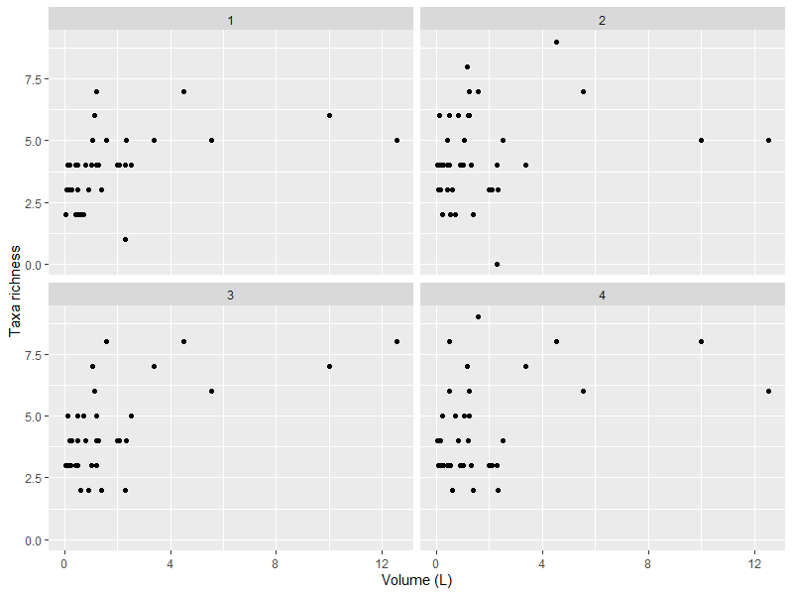 Figure S1.3: Species richness at each sampling time of rock pools without microhabitats that could be samples across all sampling times.

