Supplementary Material 2:
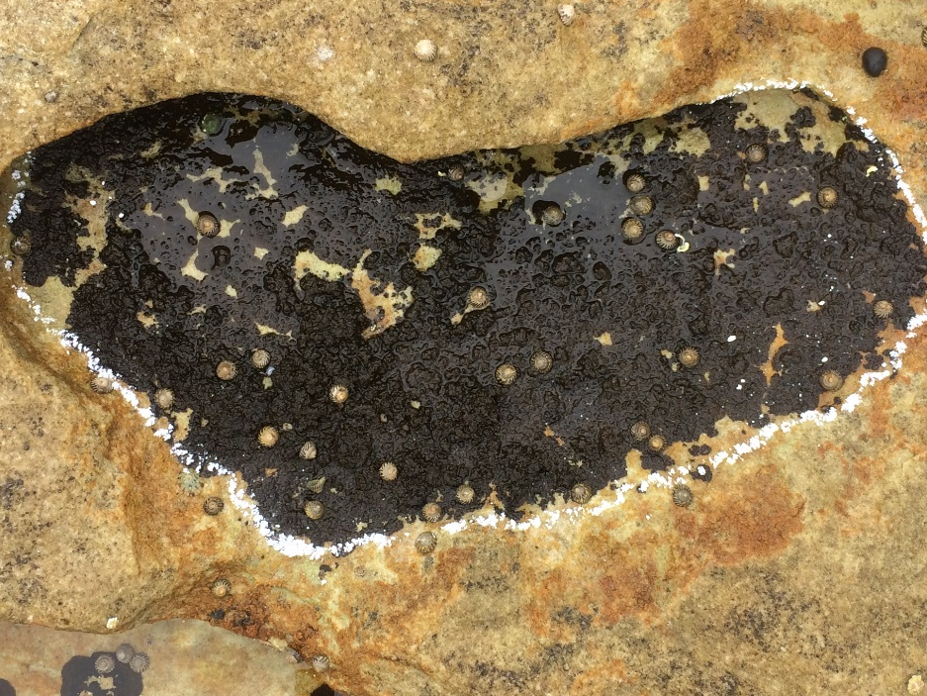
Figure S2.1: Overhang from above.

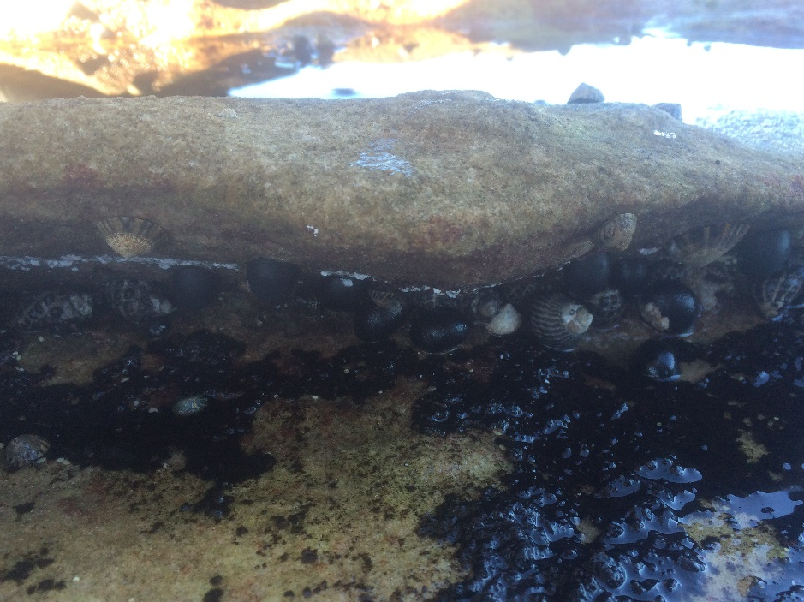
Figure S2.2: Overhang from the side.

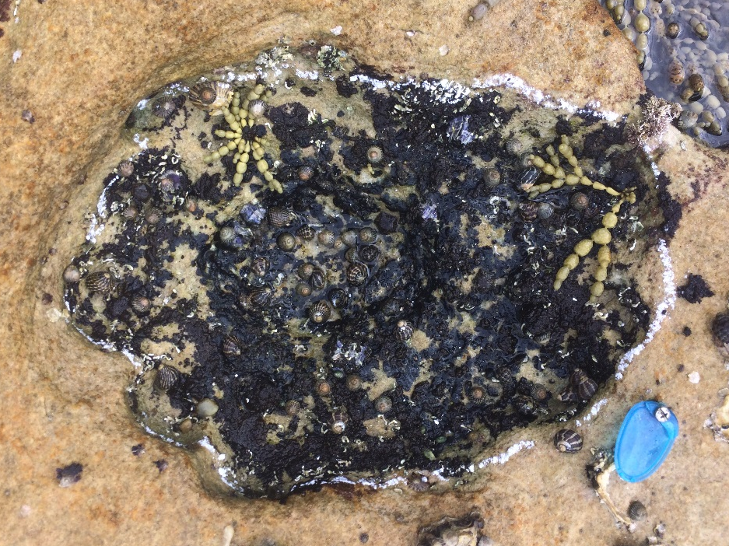
Figure S2.3: Small pit form above.

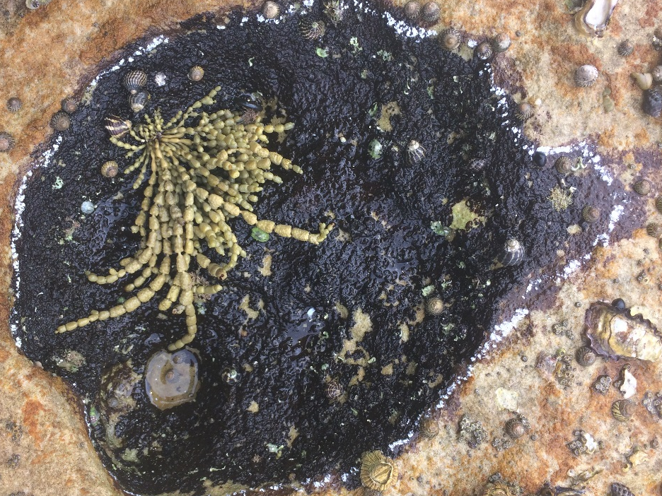
Figure S2.4: Medium pit from above.

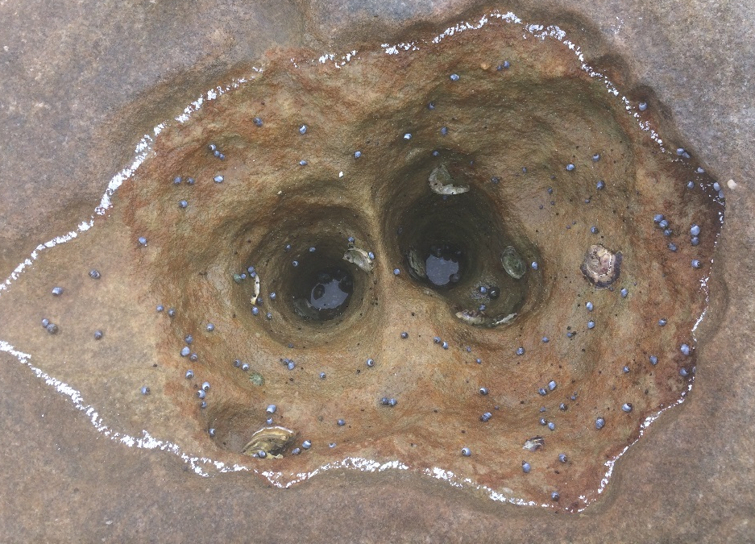
Figure S2.5: Deep pit from above.

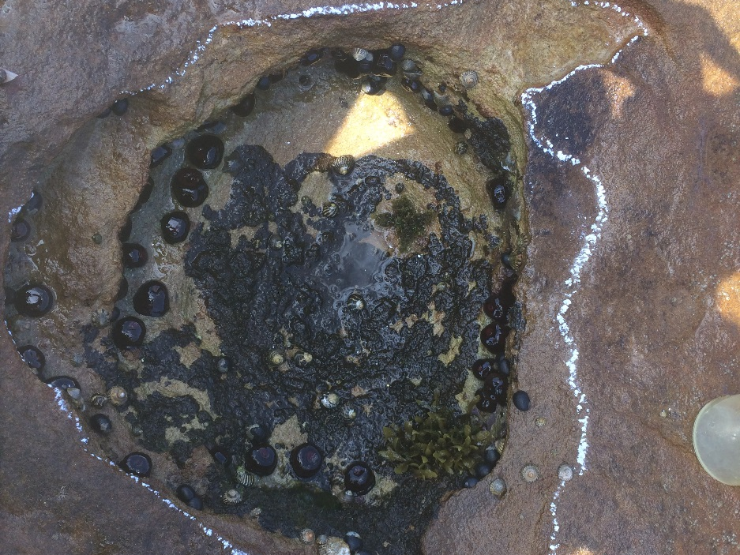
Figure S2.6: Vertical submerged form above.

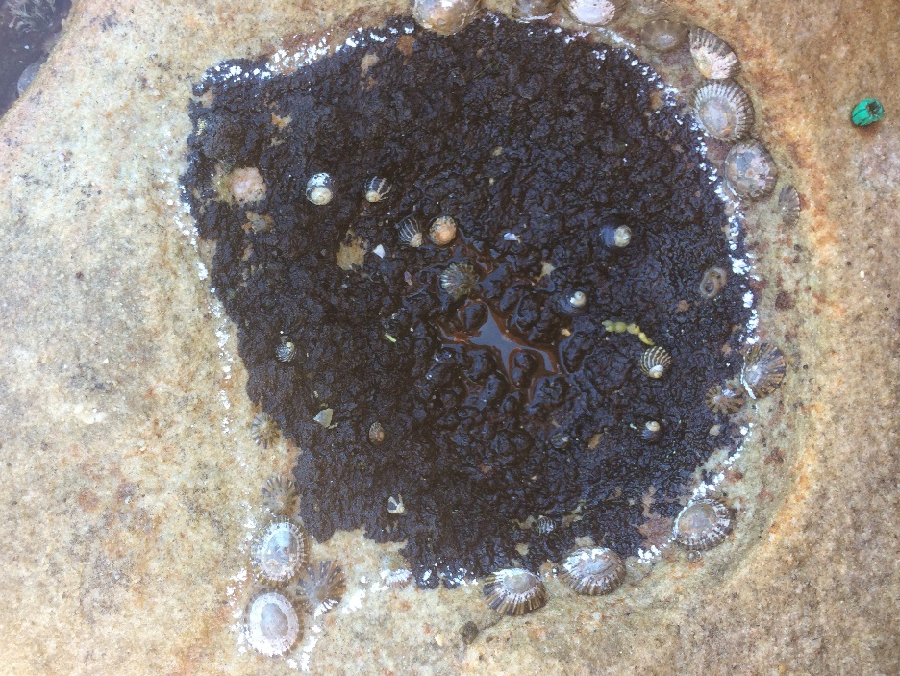
Figure S2.7: Vertical emerged from above.

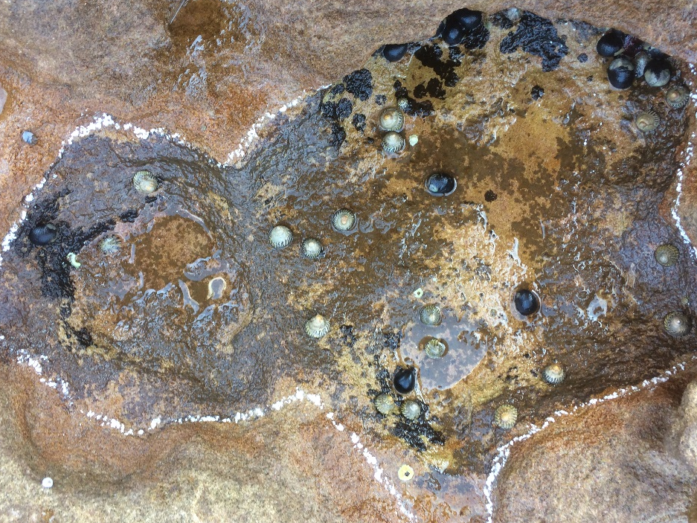
b
a
Figure S2.8: Horizontal submerged (a) and emerged (b) from above.

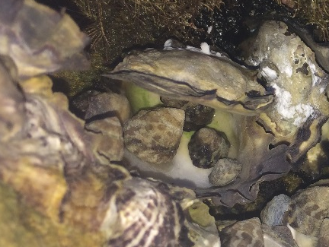
Figure S2.9: Oyster shell.
Figure S2.10: Rock pool interface

