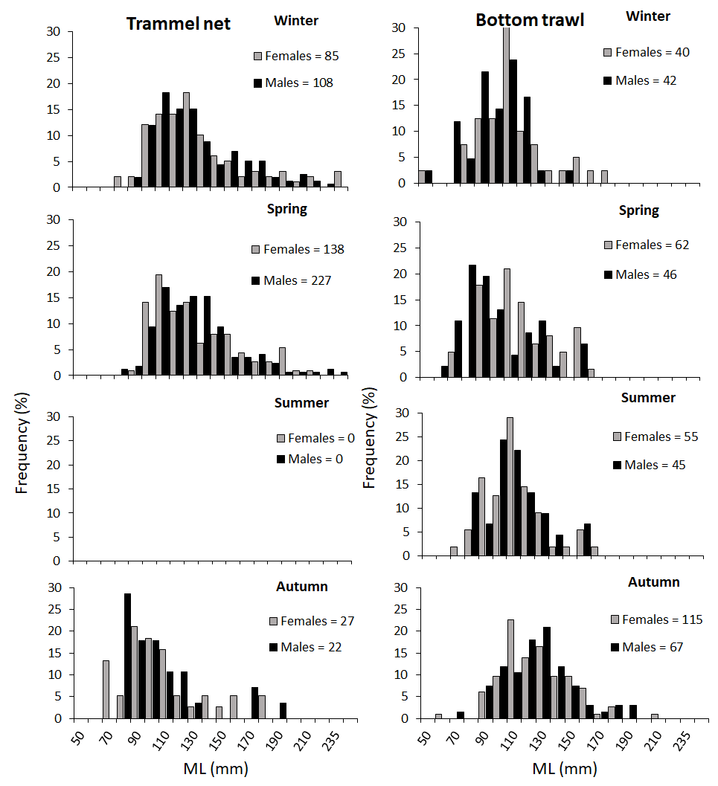
Fig. 1 Temporal size frequency distributions by sex for the Sepia officinalis L. fished by trammel net and bottom trawl between 2017 and 2019 off the Balearic Islands.
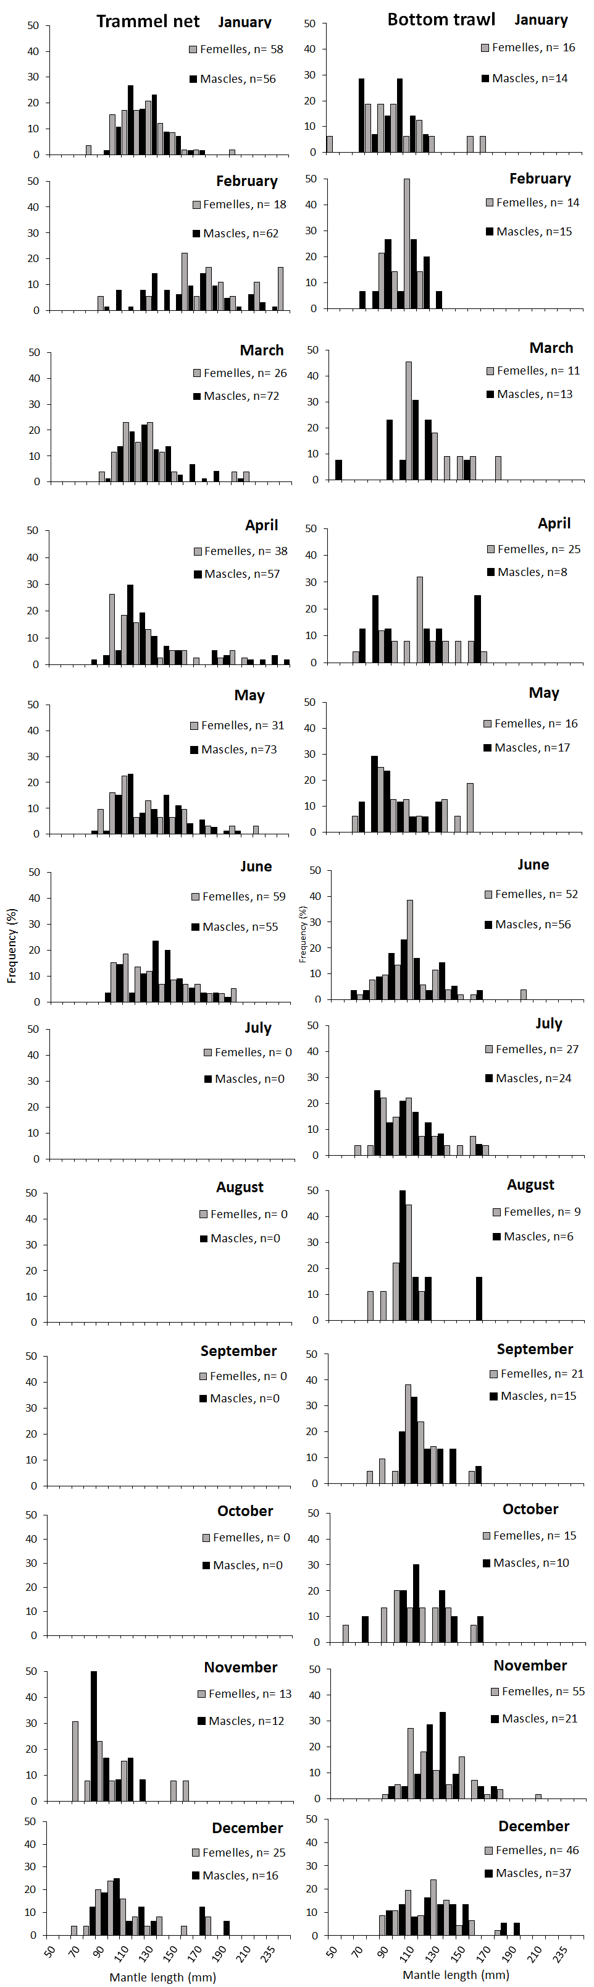
Fig. 2 Monthly size frequency distributions by sex for the Sepia officinalis L. fished by trammel net and bottom trawl between 2017 and 2019 off the Balearic Islands.

Figure 3. Maturity ogives for females and males of Sepia officinalis according to mantle length (mm).
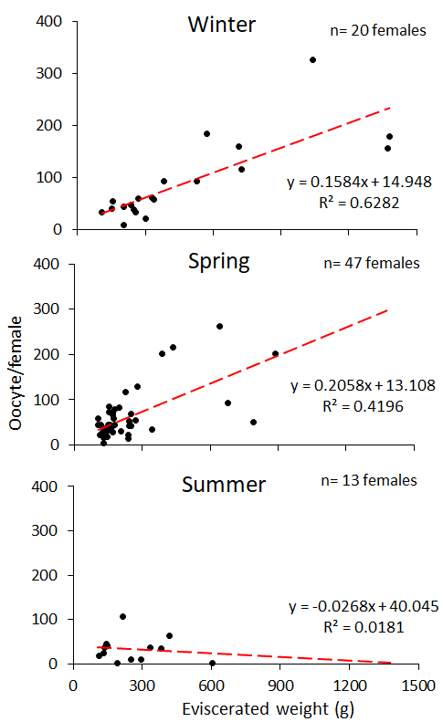
Fig. 4 Seasonal relationships between Advanced mode fecundity (F_{AM}) and eviscerated weight of Sepia officinalis L. from the Balearic Islands.
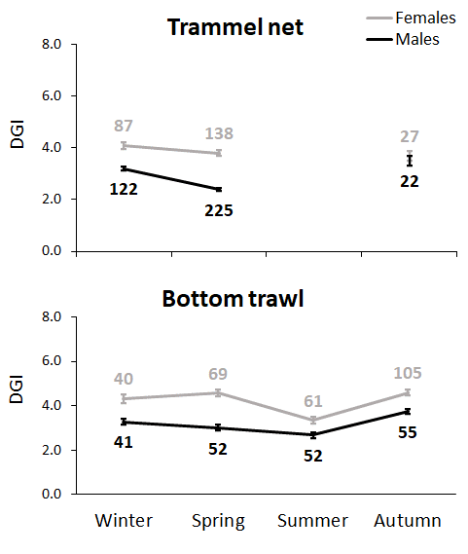
Fig. 5 Mean values (± SE) of Digestive Gland Index (DGI) by season, sex and fishing gear of Sepia officinalis L. from the Balearic Islands.

Bottom trawl
Year/month | ML | W | GW | n | DGW | n | SCW |  | n |  | EW |  | n
2017
June | 114.22 ± 3.01 | 222.22± 21.41 | 0.67 ± 0.66 | 54
2018
January | 102.67 ± 4.66 | 165.47 ±23.35 | 1.97 ± 0.39 | 30 | 6.44 ± 1.12 | 30 | 1.98± 0.43 |  | 30 |  | 435.10 ± 284.06 |  | 30
February | 108.07 ± 2.39 | 174.85 ± 9.24 | 3.52 ± 0.46 | 29 | 5.63 ± 0.42 | 29 | 1.74±0.20 |  | 29 |  | 150.95 ± 7.70 |  | 29
March | 121.63 ± 5.50 | 264.06 ± 35.33 | 11.05 ± 2.44 | 24 | 10.78 ± 1.72 | 24 | 4.09±2.28 |  | 24 |  | 215.32 ± 26.38 |  | 24
June | 110.96 ± 3.35 | 192.01 ± 17.77 | 4.09 ± 1.05 | 43 | 5.67 ± 0.65 | 43 | 0.95±0.22 |  | 43 |  | 151.55 ± 13.32 |  | 43
October | 119.56 ± 4.84 | 250.19 ± 25.99 | 0.93 ± 0.22 | 25 | 10.80 ± 1.44 | 24 | 2.24±0.45 |  | 25 |  | 218.26 ± 23.37 |  | 24
November | 133.54 ± 2.63 | 331.98 ± 19.94 | 1.40 ± 0.18 | 76 | 14.13 ± 1.22 | 75 | 2.59±0.32 |  | 76 |  | 290.57 ± 17.22 |  | 76
December | 130.39 ± 2.65 | 299.71 ± 16.34 | 2.58 ± 0.32 | 83 | 12.51 ± 0.79 | 83 | 1.59±0.21 |  | 83 |  | 253.96 ± 14.66 |  | 82
2019
April | 123.79 ± 4.79 | 277.35 ± 27.49 | 15.17 ± 2.56 | 33 | 13.32 ± 1.61 | 33 | 2.78±0.81 |  | 33 |  | 221.19 ± 20.72 |  | 33
May | 108.76 ± 4.68 | 202.66 ± 27.11 | 8.78 ± 2.30 | 32 | 8.49 ± 1.73 | 34 | 2.07±0.61 |  | 34 |  | 164.20 ± 19.91 |  | 34
July | 111.65 ± 3.15 | 203.65 ± 17.30 | 0.44 ± 0.09 | 49 | 5.75 ± 0.82 | 50 | 1.88±0.23 |  | 51 |  | 177.70 ± 14.58 |  | 51
August | 113.13 ± 4.51 | 218.43 ± 27.92 | 1.33 ± 0.82 | 15 | 6.84 ±0.93 | 15 | 1.13±0.35 |  | 15 |  | 193.65 ± 24.97 |  | 15
September | 119.97 ± 2.92 | 243.71 ± 16.78 | 1.11 ± 0.49 | 36 | 8.30 ± 0.67 | 36 | 1.52±0.37 |  | 36 |  | 217.48 ± 14.84 |  | 36
Global | 118.99 ± 1.08 | 245.36 ± 6.53 | 3.49 ± 0.33 | 529 | 9.73 ± 0.37 | 476 |  | 1.84 ±0.15 |  | 524 |  | 230.48 ± 18.88 |  | 477
Table 1. Biological parameters of specimens caught by bottom trawl by month and year.
Table 2. Biological parameters of specimens caught by trammel net by month and year.
Trammel net
Year/month | ML | W | n | GW | n | DGW | n | SCW | n | EW | n
2017
January | 128.83 ± 2.63 | 284.07 ± 18.65 | 64 | 7.47 ± 1.05 | 62 | 10.54 ± 1.00 | 64 | 2.35 ± 1.36 | 64 | 240.19 ± 14.07 | 64
February | 157.97± 6.94 | 511.73 ± 61.20 | 30 | 14.61 ± 2.95 | 29 | 20.49 ± 3.23 | 29 | 1.68 ± 0.71 | 30 | 426.72 ± 46.80 | 30
March | 135.82± 4.07 | 325.69 ± 31.48 | 49 | 8.03 ± 1.13 | 49 | 9.53 ± 1.55 | 49 | 1.72 ± 0.48 | 49 | 275.67 ± 25.50 | 49
April | 132.84 ± 3.79 | 297.88 ± 30.71 | 50 | 7.10 ± 0.91 | 50 | 7.53 ± 1.04 | 50 | 0.65 ± 0.14 | 49 | 256.64 ± 25.71 | 50
May | 138.42 ± 3.72 | 308.02 ± 26.00 | 52 | 7.81 ± 132 | 52 | 8.35 ± 1.03 | 51 | 1.22 ± 0.34 | 51 | 266.14 ± 21.50 | 52
June | 148.54 ± 3.67 | 392.61 ± 28.41 | 50 | 13.46 ±1 .68 | 50 | 14.29 ± 1.91 | 50 | 1.95 ± 0.62 | 49 | 324.94 ± 22.11 | 50
2018
January | 124.96 ± 2.17 | 236.46 ± 11.34 | 50 | 5.59 ± 0.83 | 50 | 7.72 ± 0.60 | 50 | 0.39 ± 0.11 | 50 | 200.3 8± 9.54 | 50
February | 169.92 ± 4.98 | 614.94 ± 54.80 | 50 | 17.88 ± 3.07 | 36 | 20.88 ± 2.38 | 50 | 2.22 ± 0.60 | 49 | 529.38 ± 44.79 | 50
March | 125.37 ± 2.21 | 237.28 ± 12.28 | 49 | 6.18 ± 0.65 | 49 | 6.71 ± 0.66 | 33 | 0.84 ± 0.20 | 49 | 198.50 ± 14.81 | 33
April | 138.60 ± 6.08 | 387.04 ± 54.35 | 45 | 16.33 ± 3.11 | 30 | 17.48 ± 2.83 | 30 | 2.64 ± 0.98 | 45 | 419.78 ± 63.30 | 30
May | 126.38± 3.67 | 258.88 ± 23.75 | 52 | 8.40 ± 1.42 | 37 | 8.39 ± 1.11 | 37 | 0.92 ± 0.22 | 52 | 257.02 ± 24.79 | 37
June | 129.48 ± 2.92 | 261.69 ± 18.62 | 64 | 8.34 ± 0.95 | 64 | 7.98 ± 0.90 | 63 | 0.59 ± 0.13 | 64 | 223.24 ± 16.02 | 64
October
November | 97.88 ± 4.52 | 136.93 ± 21.92 | 25 | 1.25 ± 0.44 | 25 | 5.10 ± 0.93 | 25 | 1.00 ± 0.28 | 25 | 119.21 ± 18.14 | 25
December | 117.73 ± 4.65 | 233.33 ± 28.82 | 41 | 4.57 ± 1.09 | 41 | 8.46 ± 1.26 | 41 | 0.77 ± 0.24 | 41 | 199.77 ± 23.76 | 41
2019
Global | 134.37 ± 1.20 | 320.19 ± 9.48 | 671 | 8.80 ± 0.43 | 624 | 10.80 ± 0.45 | 622 | 1.36 ± 0.17 | 667 | 280.32 ± 8.29 | 625

Table 3. Percentages of maturity stages breakdown by month and sex of bottom trawl specimens.
 |  |  |  |  | Bottom Trawl
 |  |  | Females |  |  |  |  |  | Males
 | 1 | 2a | 2b | 3a | n | 1 |  | 2a | 2b | 3a | n
Jan | 19% | 63% | 19% | 0% | 16 | 7% |  | 57% | 14% | 21% | 14
Feb | 7% | 36% | 29% | 29% | 14 | 15% |  | 0% | 0% | 85% | 13
Mar | % | 0% | 18% | 82% | 11 | 0% |  | 8% | 38% | 54% | 13
Apr | 20% | 4% | 0% | 76% | 25 | 50% |  | 0% | 13% | 38% | 8
May | 25% | 0% | 13% | 63% | 16 | 76% |  | 0% | 12% | 12% | 17
Jun | 33% | 8% | 0% | 60% | 52 | 29% |  | 9% | 0% | 63% | 56
Jul | 67% | 33% | 0% | 0% | 27 | 54% |  | 38% | 0% | 8% | 24
Aug | 89% | 0% | 0% | 11% | 9 | 83% |  | 17% | 0% | 0% | 6
Sept | 52% | 33% | 10% | 5% | 21 | 7% |  | 47% | 40% | 7% | 15
Oct | 60% | 40% | 0% | 0% | 15 | 0% |  | 80% | 10% | 10% | 10
Nov | 2% | 98% | 0% | 0% | 55 | 0% |  | 33% | 29% | 38% | 21
Dec | 0% | 93% | 0% | 7% | 46 | 0% |  | 14% | 49% | 38% | 37

Table 4. Percentages of maturity stages breakdown by month and sex of trammel net specimens.
 |  |  |  |  | Trammel net
 |  |  | Females |  |  |  |  |  |  | Males
 | 1 | 2a | 2b | 3a | n | 1 |  | 2a |  | 2b |  | 3a |  | n
Jan | 2% | 22% | 7% | 69% | 58 | 0% |  | 0% |  | 13% |  | 88% |  | 56
Feb | 0% | 0% | 6% | 94% | 18 | 2% |  | 0% |  | 3% |  | 95% |  | 62
Mar | 0% | 0% | 0% | 100% | 26 | 0% |  | 15% |  | 18% |  | 67% |  | 72
Apr | 0% | 0% | 0% | 100% | 38 | 0% |  | 0% |  | 11% |  | 89% |  | 57
May | 0% | 0% | 3% | 97% | 31 | 0% |  | 4% |  | 1% |  | 95% |  | 73
Jun | 0% | 0% | 0% | 100% | 59 | 0% |  | 0% |  | 0% |  | 100% |  | 55
Jul
Aug
Sept
Oct
Nov | 62% | 23% | 8% | 8v% | 13 | 0% |  | 67% |  | 33% |  | 0% |  | 12
Dec | 4% | 64% | 0% | 32% | 25 | 0% |  | 25% |  | 38% |  | 38% |  | 16

