Supplement 4. Distance from colony in response to time of day and night-time foraging
In order to validate our results about apparent night-time foraging at Sklinna and Muddvær, we ran two additional analyses. Firstly, using the same dataset as for the GAMMs to analyse time of day and water level changes on foraging activity (see Methods in main manuscript), we analysed the relationship of distance from colony in response to time of day. We thus ran a GAMM with distance from colony as response variable, and included time of day and site as well as their two-way interaction as explanatory variables. Time of day was included using cyclic cubic regression splines (since hour of the day is circular). For the number of knots, we proceeded as described in the Methods section for GAMMs. Bird ID was included as random effect.
The results matched those of Figure 3 (main manuscript). Distance from the colony varied over the course of the day (Figure S4.1), and birds from Muddvær and Sklinna were further away from the colony during night-time hours than those from Røst.
Secondly, we investigated for Muddvær if foraging over deeper waters coincided with night-time foraging. We used the same dataset as for the GAMMs to analyse foraging habitats. We plotted two histograms, one showing the foraging activity in response to hour of the day for the full dataset (comparable to Figure 3 in the main manuscript), and one showing the same histogram but only for those foraging locations associated with depths > 75m. Both plots are shown in Figures S4.2.

Figure S4.1. Response curves from the GAMM testing the effect of hour of the day on distance from colony at the three colonies. For Røst and Sklinna, data from all years were pooled. F and p-values refer to the summary-statistics of the GAMM. Grey areas indicate the maximum twilight hours at the sites when birds were tracked. In this figure, data from all birds, also those with unknown breeding status, were used. Hour of the day refers to local time (i.e. GMT + 2 hours).

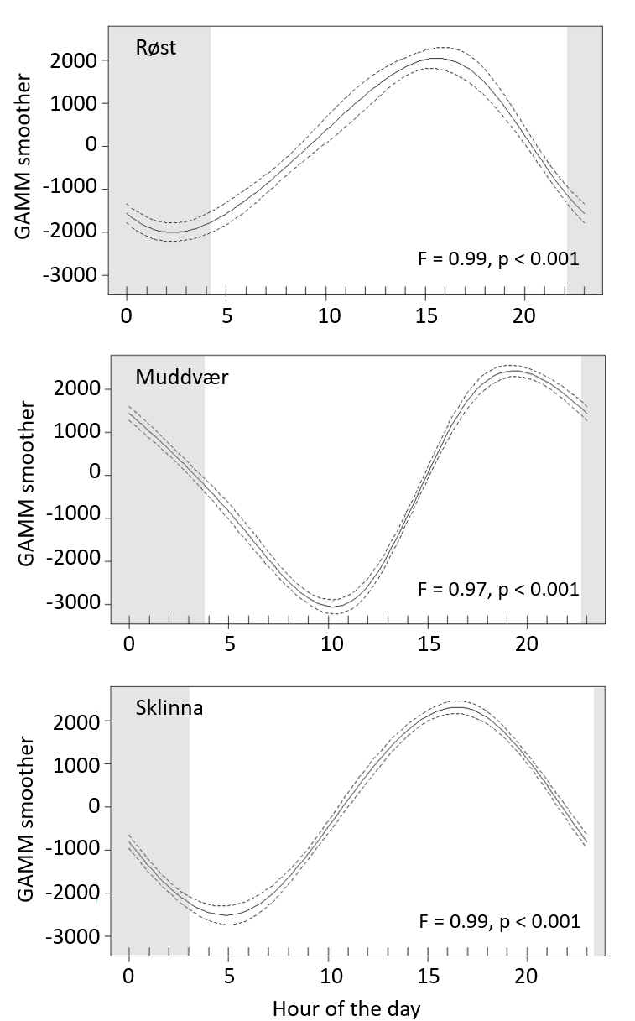
Figure S4.2. Histogram (top) showing the distribution of foraging activity over the course of the day, and (bottom) showing the same plot for foraging locations over waters deeper than 75m. In these figures, data from all birds, also those with unknown breeding status, were used. Hour of the day refers to local time (i.e. GMT + 2 hours).

