SUPPLEMENTARY MATERIAL

to

Sex-specific foraging behaviour in a long-lived seabird

by

Teresa Militão^{1,2*}, Nathalie Kürten¹, Sandra Bouwhuis¹

¹ Institute of Avian Research, An der Vogelwarte 21, D-26386 Wilhelmshaven, Germany
² Departament de Biologia Evolutiva, Ecologia i Ciències Ambientals, Facultat de Biologia, Universitat de Barcelona (UB), Av. Diagonal 643, 08028 Barcelona, Spain.

*Corresponding author: tetecaloirinha@gmail.com

Figure S1 – Distribution of the main subtidal sediments within the study area. The common tern colony is represented by an orange diamond, the Banter See area marked in light blue.

Figure S2 – Foraging (dark circles) and travelling (light circles) GPS positions of male and female common terns during the incubation period. The common tern colony is represented by an orange diamond, the Banter See area marked in light blue. The grey background gradient represents the bathymetry (in m).

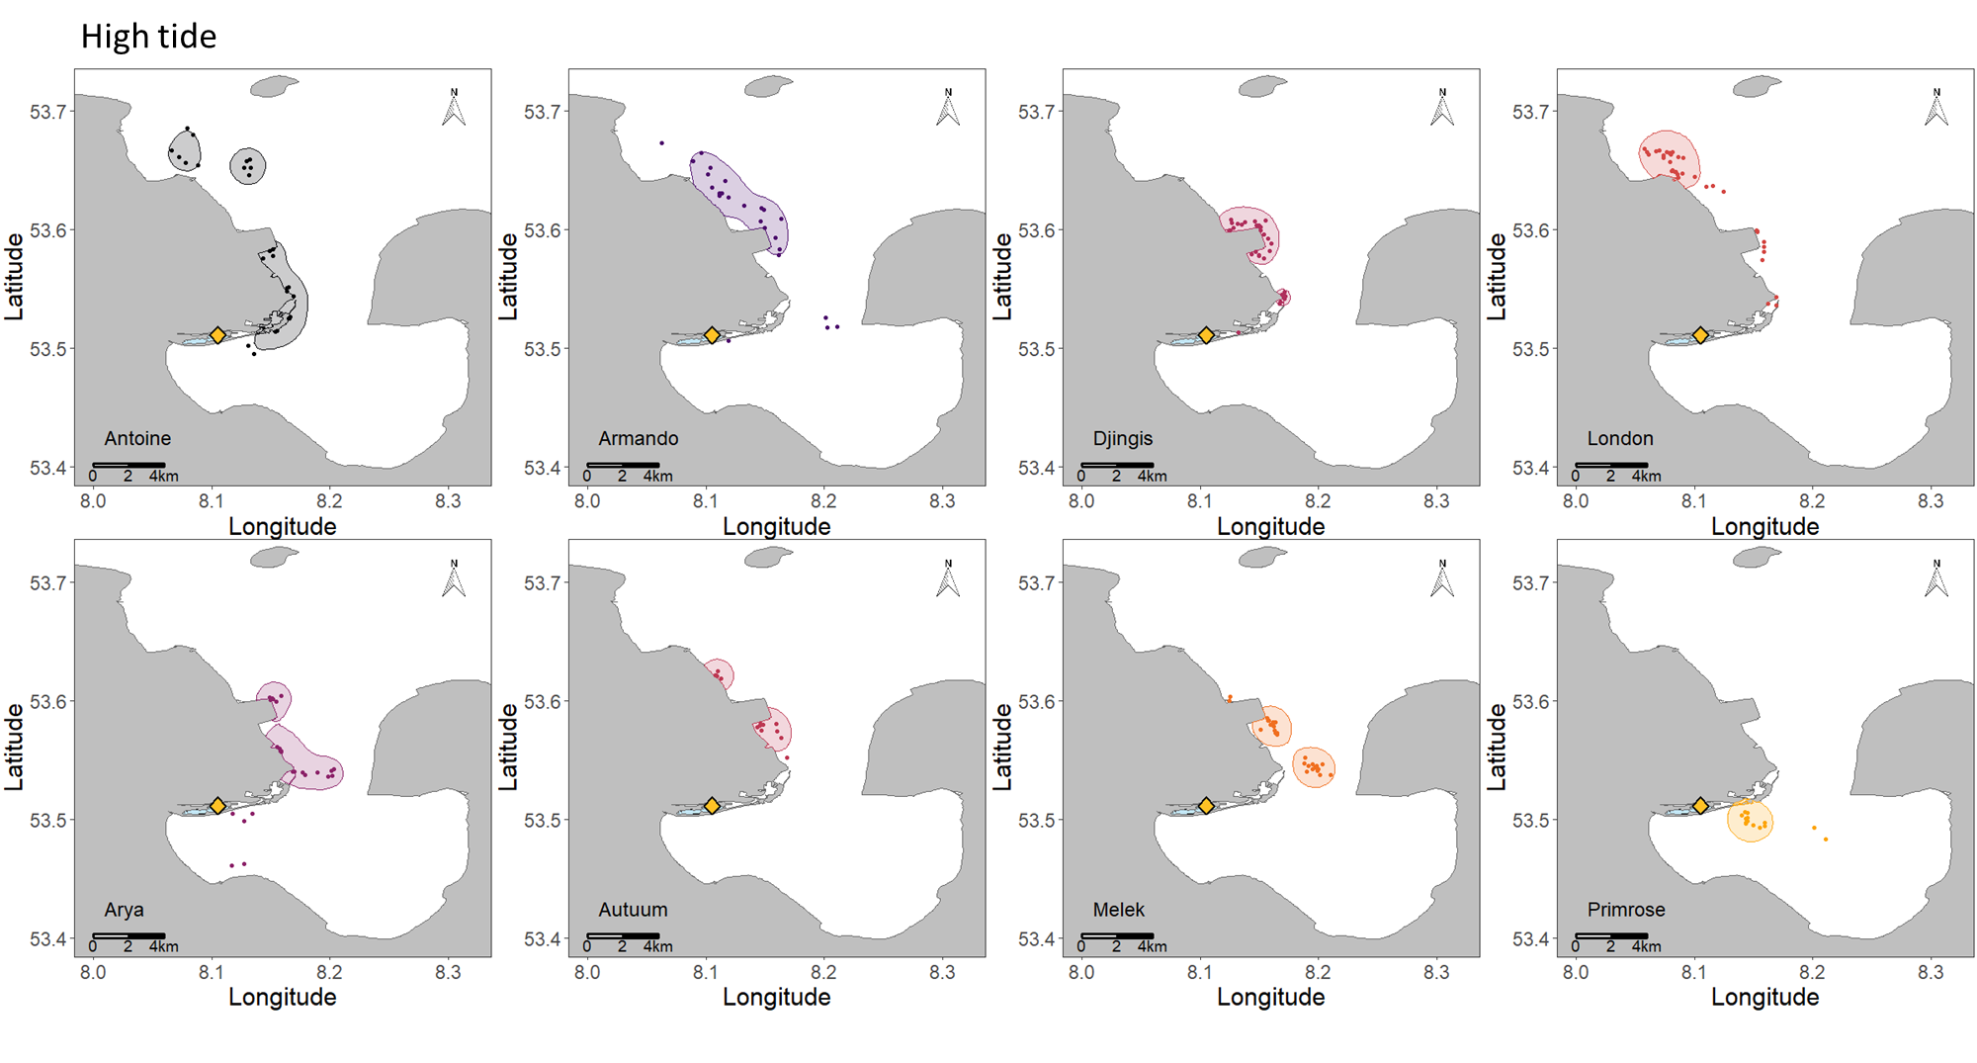
Figure S3 - Kernel contours (50%UD) of the foraging positions of male (upper panel) and female (bottom panel) common terns tracked with GPS during high tide (i.e., one hour before and after high tide). Circles represent foraging GPS positions.
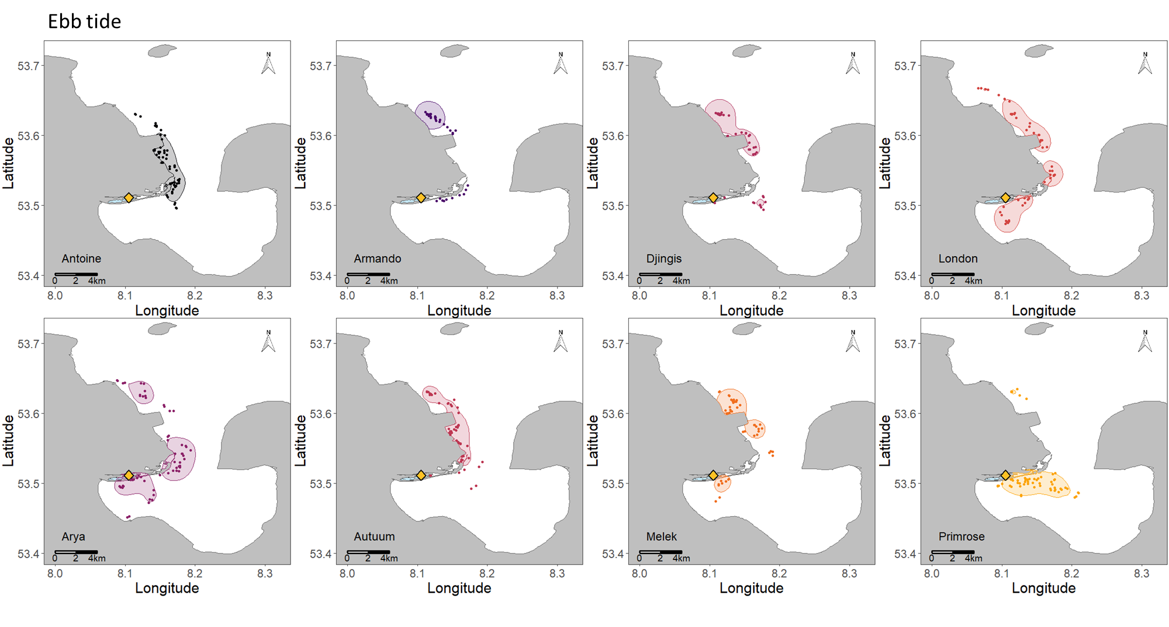Figure S4 - Kernel contours (50%UD) of the foraging positions of male (upper panel) and female (bottom panel) common terns tracked with GPS during ebb tide (i.e., one hour after high tide until one hour before low tide). Circles represent foraging GPS positions.

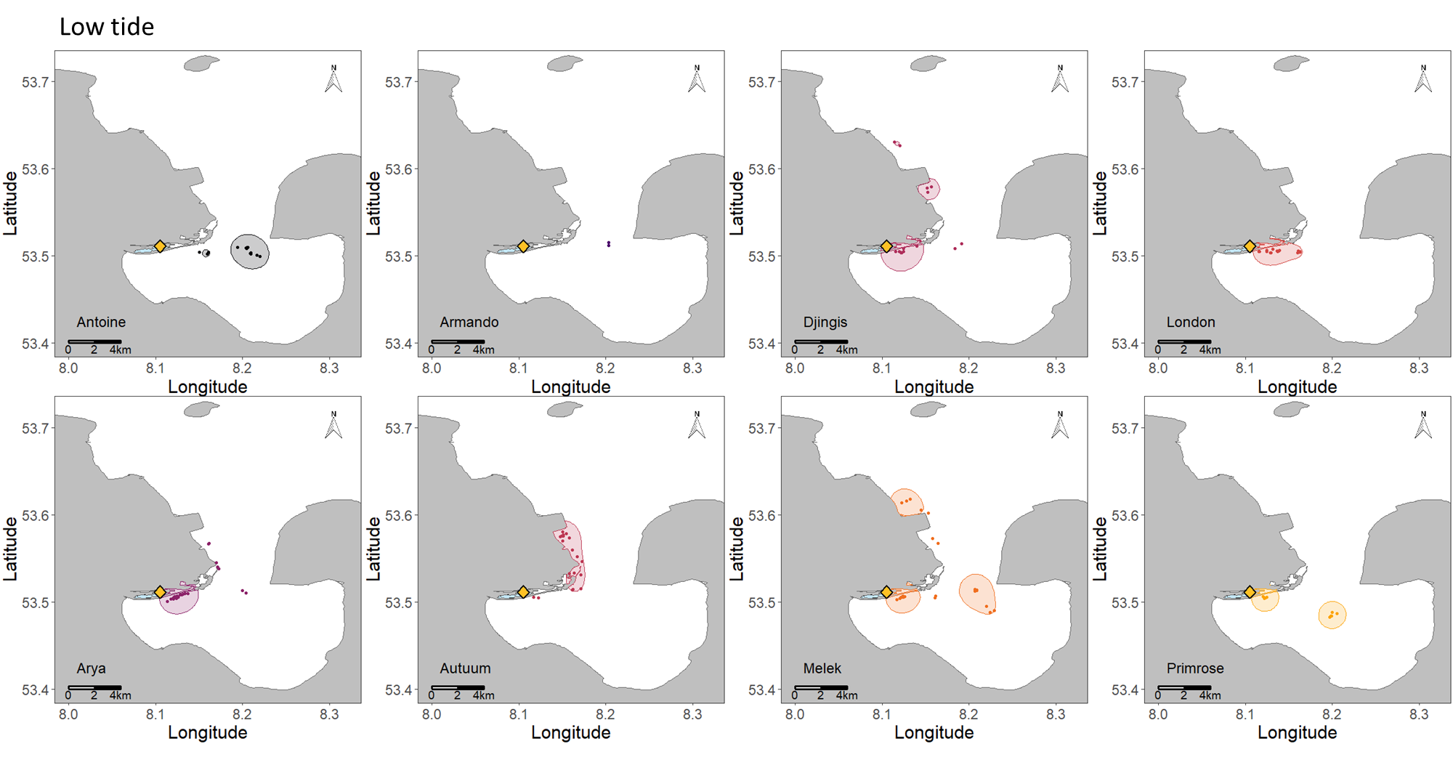
Figure S5 - Kernel contours (50%UD) of the foraging positions of male (upper panel) and female (bottom panel) common terns tracked with GPS during low tide (i.e., one hour before and after low tide). Circles represent foraging GPS positions. Please note that Armando did not have sufficient foraging positions at low tide to draw his kernel contour.
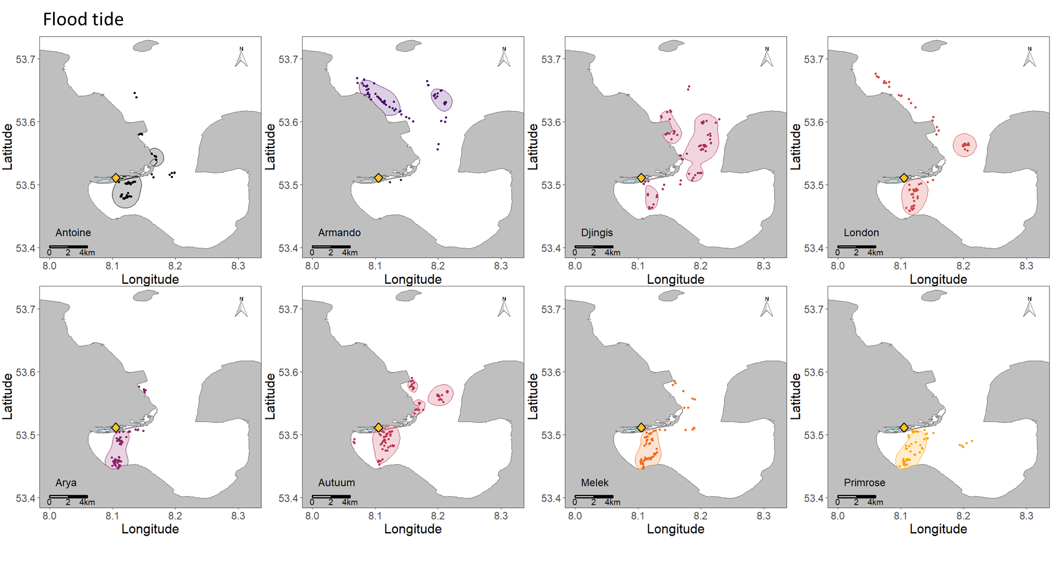Figure S6 - Kernel contours (50%UD) of the foraging positions of male (upper panel) and female (bottom panel) common terns tracked with GPS during flood tide (i.e., one hour after low tide until one hour before high tide). Circles represent foraging GPS positions.

Table S1 - Description of trip characteristics of common terns tracked with GPS devices during the incubation period. The number of trips per day (n), total distance travelled per day (km) and the time spent at each type of behaviour (%) were calculated based on the days in which the individuals were tracked for the entire day (9th–12th June 2019) and excluding the days of deployment (8th June 2019) and recovery (13th June 2013). Due to some GPS failure during tracking, the total number of tracked hours per day was lower than 24h. Data are presented as mean ± standard deviation (minimum–maximum).
Bird ID | Sex | Nest ID | Capture date-time  (GPS deployment handling time in min) | Recovery date-time  (GPS recovery handling time in min) | N trips (8th - 13th June) | Maximum distance from colony (km) | Trip duration (h) | Total distance travelled per trip (km) | Maximum speed (km.h⁻¹) | N trips (9th -12th June) | N trips per day | Total distance travelled per day (km) | Tracked hours per day | Time foraging (%) | Time resting (%) | Time travelling (%)
Arya | F | 472 | 08/06/2019 10:01  (7) | 13/06/2019 16:00  (4) | 39 | 5.7 ± 3.4 (1.4–16.1) | 0.8 ± 0.5 (0.2–2.1) | 13.6 ± 10.9 (1.8–49.4) | 34.1 ± 12.4 (13.3–51.1) | 31 | 7.8 ± 1.0 (7.0–9.0) | 110.2 ± 15.8 (87.3–121.7) | 23.1 ± 0.7 (22.1–23.7) | 12.4 ± 0.5 (9.3–15.2) | 75.1 ± 1.5 (68.9–79.4) | 12.4 ± 0.7 (8.2–15.9)
Autuum | F | 471 | 08/06/2019 14:51  (5) | 13/06/2019 17:01  (5) | 28 | 6.7 ± 4.0 (0.3–15.9) | 1.1 ± 0.7 (0.2–3.4) | 17.6 ± 12.6 (0.5–41.1) | 32.4 ± 10.7 (3.0–50.5) | 20 | 5.0 ± 1.4 (3.0–6.0) | 97.3 ± 25.5 (69.6–125.1) | 23.8 ± 0.2 (23.4–23.9) | 12.9 ± 0.7 (10.2–15.3) | 75.3 ± 1.2 (69.0–81.8) | 11.8 ± 0.9 (8.1–15.7)
Melek | F | 389 | 08/06/2019 09:16  (7) | 13/06/2019 10:43  (5) | 17 | 7.6 ± 4.0 (1.6–13.3) | 1.7 ± 0.9 (0.5–3.5) | 21.7 ± 15.0 (2.6–57.6) | 34.0 ± 12.3 (9.2–52.2) | 15 | 3.8 ± 1.0 (3.0–5.0) | 79.9 ± 30.8 (34.4–102.4) | 23.1 ± 0.2 (22.9–23.4) | 14.9 ± 0.7 (10.5–18.0) | 75.6 ± 1.3 (69.4–81.5) | 9.5 ± 1.1 (2.5–12.6)
Primrose | F | 470 | 08/06/2019 14:03  (6) | 13/06/2019 15:12  (5) | 33 | 5.3 ± 3.0 (1.4–13.9) | 1.0 ± 0.6 (0.2–2.5) | 12.6 ± 9.9 (1.7–42.3) | 28.4 ± 10.9 (9.4–53.3) | 28 | 7.0 ± 1.2 (6.0–8.0) | 95.6 ± 13.0 (81.1–112.7) | 20.9 ± 0.5 (20.4–21.7) | 14.1 ± 0.8 (10.8–17.7) | 71.9 ± 0.4 (70.0–75.1) | 14.0 ± 0.8 (10.4–19.2)
TOTAL | F |  |  |  | 116 | 6.1 ± 3.6 | 1.1 ± 0.7 | 15.5 ± 12.0 | 32.1 ± 11.7 | 94 | 5.9 ± 1.9 | 95.7 ± 23.0 | 22.7 ± 0.4 | 13.6 ± 0.5 | 74.5 ± 0.7 | 11.9 ± 0.5
Antoine | M | 472 | 08/06/2019 13:03  (5) | 13/06/2019 10:33  (6) | 28 | 6.9 ± 4.4 (1.5–19.5) | 1.0 ± 0.6 (0.2–3.3) | 16.4 ± 13.3 (1.7–60.4) | 34.2 ± 8.8 (17.4–49.2) | 25 | 6.2 ± 1.5 (5.0–8.0) | 105.3 ± 7.6 (94.7–112.4) | 23.9 ± 0.1 (23.8–24.0) | 11.8 ± 0.7 (9.3–15.7) | 75.8 ± 0.3 (74.1–76.8) | 12.4 ± 0.4 (10.1–14.6)
Armando | M | 574 | 08/06/2019 15:42  (7) | 13/06/2019 14:00  (5) | 20 | 12.4 ± 4.7 (2.4–18.3) | 1.7 ± 0.9 (0.3–4.0) | 33.8 ± 17.0 (5.5–77.6) | 46.0 ± 8.8 (27.8–61.9) | 16 | 4.0 ± 0.8 (3.0–5.0) | 141.6 ± 36.9 (110.0–194.3) | 22.6 ± 1.0 (21.1–23.2) | 12.8 ± 1.3 (5.2–16.6) | 71.0 ± 1.1 (61.7–77.8) | 16.2 ± 1.0 (10.9–21.7)
Djingis | M | 573 | 08/06/2019 14:16  (6) | 13/06/2019 15:31  (5) | 24 | 9.6 ± 4.1 (1.4-17.1) | 1.3 ± 0.7 (0.5-2.9) | 25.7 ± 14.1 (2.1–60.8) | 44.7 ± 9.1 (15.8–56.7) | 20 | 5.0 ± 0.8 (4.0–6.0) | 122.9 ± 16.7 (98.5–136.4) | 23.8 ± 0.3 (23.3–24.0) | 12.6 ± 0.5 (10.5–14.7) | 74.4 ± 0.5 (71.7–79.3) | 13.0 ± 0.5 (10.2–14.4)
London | M | 256 | 08/06/2019 10:01  (7) | 13/06/2019 10:07  (5) | 20 | 9.1 ± 6.0 (2.0–18.6) | 1.5 ± 0.7 (0.4–3.2) | 21.7 ± 16.5 (3.2–46.9) | 36.6 ± 14.5 (13.6–59.8) | 16 | 4.0 ± 1.2 (3.0–5.0) | 93.9 ± 10.3 (78.7–101.3) | 23.8 ± 0.1 (23.7–23.9) | 12.7 ± 1.1 (8.4–19.0) | 77.1 ± 1.0 (72.2–81.8) | 10.2 ± 0.3 (8.8–11.6)
TOTAL | M |  |  |  | 92 | 9.3 ± 5.1 | 1.3 ± 0.8 | 23.7 ± 16.1 | 40.0 ± 11.4 | 77 | 4.8 ± 1.4 | 115.9 ± 26.6 | 23.5 ± 0.3 | 12.5 ± 0.7 | 74.6 ± 0.5 | 12.9 ± 0.4
ALL | All |  |  |  | 208 | 7.5 ± 4.6 | 1.2 ± 0.7 | 19.1 ± 14.5 | 35.6 ± 12.2 | 171 | 5.3 ± 1.7 | 105.8 ± 26.5 | 23.1 ± 0.2 | 13.0 ± 0.7 | 74.6 ± 1.4 | 12.4 ± 0.8

Table S2 - Results from the likelihood ratio tests used to evaluate the inclusion (if p < 0.050, marked in bold) of the variables in the different candidate sets of Generalized Additive Mixed Models (GAMMs) constructed. The t2() denotes an interaction between two continues smoothing factors, s() indicates a smoothing factor, bs=”cc” indicates that we used a cyclic cubic regression spline for that smoothing factor (as it is a circular variable) and ”tp” that we used a thin plate regression spline for bathymetry factor.
Model parameter | χ² value | d.f. | p-value
(A) GAMM of resting versus active behaviours
s(time since nearest low tide, bs = "cc", by = sex) | 33.50 | 1 | <0.001
s(time since sunrise, bs = "cc", by = sex) | 55.31 | 1 | <0.001
(B) GAMM of travelling versus foraging behaviours
t2(time since the nearest low tide, bathymetry, bs = c("cc", "tp")) | 56.73 | 3 | <0.001
s(minimum distance from coast, by = sex) | 7.63 | 2 | 0.022
s(distance to colony, by = sex) | 2.68 | 2 | 0.261
s(distance to colony) | 380.73 | 2 | <0.001
main sediment | 13.99 | 2 | 0.001
(C) GAMM of the maximum distance from the colony
s(time since nearest low tide, bs = "cc", by = sex) | 0.00 | 1 | 1.000
s(time since sunrise, bs = "cc", by = sex) | 0.68 | 1 | 0.409
s(time since nearest low tide, bs = "cc") | 17.27 | 1 | <0.001
s(time since sunrise, bs = "cc") | 0.00 | 1 | 1.000
sex | 6.41 | 1 | 0.011
(D) GAMM of the total distance travelled per trip
s(time since nearest low tide, bs = "cc", by = sex) | 0.00 | 1 | 1.000
s(time since sunrise, bs = "cc", by = sex) | 0.00 | 1 | 0.961
s(time since nearest low tide, bs = "cc") | 22.41 | 1 | <0.001
s(time since sunrise, bs = "cc") | 0.00 | 1 | 1.000
sex | 3.98 | 1 | 0.046
(E) GAMM of the total trip duration
s(time since nearest low tide, bs = "cc", by = sex) | 0.00 | 1 | 1.000
s(time since sunrise, bs = "cc", by = sex) | 0.92 | 1 | 0.337
s(time since nearest low tide, bs = "cc") | 8.92 | 1 | 0.003
s(time since sunrise, bs = "cc") | 0.00 | 1 | 1.000
sex | 1.11 | 1 | 0.291

Table S3 - Comparison of Generalised Additive Mixed Models (GAMMs) performed to assess the (sex-specific) influence of the tide and the daylight cycles on resting and active (i.e., foraging or travelling) behaviour of common terns during the incubation period based on GPS data, where s() denotes smoothing factors, ‘by’ refers to the interaction between variables and bs = ”cc” indicates that the smoothing factor is circular. All models included individual as a random factor. Note that df refers to the degrees of freedom of the model, AIC to the Akaike Information Criterion and ∆AIC to the difference in AIC between the focal and the most parsimonious model shown in bold. The models are ordered by their AIC value.
Formula | df | AIC | ∆AIC | R²adjusted
sex + s(time since the nearest low tide, bs = "cc", by = sex) + s(time since sunrise, bs = "cc", by = sex) | 7 | 9944.38 | 0.00 | 0.15
sex + s(time since the nearest low tide, bs = "cc") + s(time since sunrise, bs = "cc", by = sex) | 6 | 9975.88 | 31.50 | 0.14
sex + s(time since the nearest low tide, bs = "cc", by = sex) + s(time since sunrise, bs = "cc") | 6 | 9997.69 | 53.31 | 0.14
s(time since the nearest low tide, bs = "cc") + s(time since sunrise, bs = "cc") | 4 | 10027.29 | 82.91 | 0.13
sex + s(time since the nearest low tide, bs = "cc") + s(time since sunrise, bs = "cc") | 5 | 10028.41 | 84.03 | 0.13
s(time since sunrise, bs = "cc") | 3 | 10084.85 | 140.48 | 0.12
sex + s(time since sunrise, bs = "cc") | 4 | 10085.98 | 141.61 | 0.12
s(time since the nearest low tide, bs = "cc") | 3 | 11420.42 | 1476.04 | 0.03
sex + s(time since the nearest low tide, bs = "cc") | 4 | 11421.46 | 1477.08 | 0.03
null | 2 | 11707.93 | 1763.56 | 0.00
sex | 3 | 11708.90 | 1764.52 | 0.00

Table S4 - Comparison of the Generalised Additive Mixed Models (GAMMs) performed to assess how bathymetry (in meters), time since the nearest low tide (in hours), minimum distance from the coast (in km), distance from the colony (in km) and the main subtidal sediments influenced the travelling and foraging behaviour of male and female common terns tracked with GPS during the incubation period. The t2() denotes an interaction between two continues smoothing factors, s() denotes a smoothing factor and bs=c(”cc”,”tp”) indicates that we used a cyclic cubic regression spline for the time since nearest low tide (as it is a circular variable) and a thin plate regression spline for bathymetry. All models included trip ID nested in individual as a random effect. Note that df refers to the degrees of freedom of the model, AIC to the Akaike Information Criterion and ∆AIC to the difference in AIC value of each model compared to the AIC value of the model with the lowest AIC. The models are ranked from low to high AIC. The best model, i.e. the most parsimonious, is shown in bold.
Formula | df | AIC | ∆AIC | R²adjusted
t2(time since low tide, bathymetry, bs = c("cc", "tp")) + s(minimum distance to coast, by = sex) + sex + s(distance to colony) + main sediment | 16 | 2620.49 | 0.00 | 0.24
t2(time since low tide, bathymetry, bs = c("cc", "tp")) + s(minimum distance to coast) + sex + s(distance to colony) + main sediment | 14 | 2624.12 | 3.63 | 0.24
t2(time since low tide, bathymetry, bs = c("cc", "tp")) + s(minimum distance to coast) + s(distance to colony) + main sediment | 13 | 2625.88 | 5.39 | 0.22
t2(time since low tide, bathymetry, bs = c("cc", "tp")) + s(minimum distance to coast, by = sex) + sex + s(distance to colony) | 14 | 2630.47 | 9.99 | 0.24
t2(time since low tide, bathymetry, bs = c("cc", "tp")) + s(minimum distance to coast) + sex + s(distance to colony) | 12 | 2632.67 | 12.18 | 0.24
t2(time since low tide, bathymetry, bs = c("cc", "tp")) + s(minimum distance to coast) + s(distance to colony) | 11 | 2634.48 | 13.99 | 0.22
t2(time since low tide, bathymetry, bs = c("cc", "tp")) + sex + s(distance to colony) + main sediment | 12 | 2694.00 | 73.51 | 0.23
t2(time since low tide, bathymetry, bs = c("cc", "tp")) + s(distance to colony) + main sediment | 11 | 2694.56 | 74.07 | 0.22
t2(time since low tide, bathymetry, bs = c("cc", "tp")) + s(distance to colony) | 9 | 2702.71 | 82.22 | 0.22
t2(time since low tide, bathymetry, bs = c("cc", "tp")) + sex + s(distance to colony) | 10 | 2713.03 | 92.54 | 0.23
s(minimum distance to coast) + sex + s(distance to colony) + main sediment | 10 | 2887.61 | 267.12 | -0.12
s(minimum distance to coast) + s(distance to colony) + main sediment | 9 | 2889.42 | 268.93 | -0.15
s(minimum distance to coast, by = sex) + sex + s(distance to colony) + main sediment | 12 | 2891.39 | 270.90 | -0.13
sex + s(distance to colony) + main sediment | 8 | 2911.98 | 291.49 | -0.05
s(distance to colony) + main sediment | 7 | 2913.05 | 292.56 | -0.07
s(minimum distance to coast) + sex + s(distance to colony) | 8 | 2966.33 | 345.84 | -0.15
s(minimum distance to coast) + s(distance to colony) | 7 | 2968.51 | 348.02 | -0.19
s(minimum distance to coast, by = sex) + sex + s(distance to colony) | 10 | 2970.09 | 349.60 | -0.15
t2(time since low tide, bathymetry, bs = c("cc", "tp")) + s(minimum distance to coast) + sex + main sediment | 12 | 2977.96 | 357.47 | 0.18
sex + s(distance to colony) | 6 | 2983.15 | 362.66 | -0.11
s(distance to colony) | 5 | 2984.94 | 364.45 | -0.13
t2(time since low tide, bathymetry, bs = c("cc", "tp")) + main sediment | 9 | 2996.07 | 375.58 | 0.15
t2(time since low tide, bathymetry, bs = c("cc", "tp")) + s(minimum distance to coast, by = sex) + sex + main sediment | 14 | 2997.22 | 376.73 | 0.15
t2(time since low tide, bathymetry, bs = c("cc", "tp")) + sex + main sediment | 10 | 2998.06 | 377.57 | 0.15
t2(time since low tide, bathymetry, bs = c("cc", "tp")) + s(minimum distance to coast) | 9 | 2999.23 | 378.74 | 0.16
t2(time since low tide, bathymetry, bs = c("cc", "tp")) + s(minimum distance to coast, by = sex) + sex | 12 | 3000.42 | 379.93 | 0.15
t2(time since low tide, bathymetry, bs = c("cc", "tp")) + s(minimum distance to coast) + sex | 10 | 3001.23 | 380.74 | 0.16
t2(time since low tide, bathymetry, bs = c("cc", "tp")) | 7 | 3001.24 | 380.75 | 0.14
t2(time since low tide, bathymetry, bs = c("cc", "tp")) + sex | 8 | 3003.24 | 382.75 | 0.14
s(minimum distance to coast, by = sex) + sex + main sediment | 10 | 3186.86 | 566.37 | 0.03
s(minimum distance to coast) + main sediment | 7 | 3199.69 | 579.20 | 0.02
s(minimum distance to coast) + sex + main sediment | 8 | 3201.46 | 580.97 | 0.02
s(minimum distance to coast, by = sex) + sex | 8 | 3203.70 | 583.21 | 0.01
main sediment | 5 | 3212.47 | 591.98 | 0.02
sex + main sediment | 6 | 3214.17 | 593.69 | 0.02
s(minimum distance to coast) | 5 | 3214.56 | 594.08 | 0.00
s(minimum distance to coast) + sex | 6 | 3215.87 | 595.38 | 0.00
null | 3 | 3225.52 | 605.03 | 0.00

Table S5 - Observed versus expected number of foraging positions of female and male common terns within the different protection areas used for the χ² test. The expected number of foraging positions was calculated automatically by the chisq.test function by multiplying the number of observed foraging positions of males and females within a certain area (for example non-protected area) by the number of foraging positions of a certain sex within all areas and then dividing by the total number observed of foraging positions.
Area | Female |  | Male
Area | Observed | Expected | Observed | Expected
Non-protected | 286 | 342 | 392 | 336
Intermediate protection | 208 | 179 | 146 | 175
Higher protection | 220 | 193 | 163 | 190

Table S6 - Overlap (in %) and standard deviation of the 50% UD kernel contours of among female, among male and between female and male foraging positions across the tide cycle periods.
Sex comparison | Tide comparison | overlap (%) | Standard deviation
Female |  | 52.6 | 12.8
Female | ebb | 22.9 | 14.3
Female | flood | 64.7 | 16.5
Female | high | 19.7 | 22.8
Female | low | 25.1 | 28.0
Female | ebb vs. flood | 15.2 | 12.4
Female | ebb vs. high | 26.7 | 23.9
Female | ebb vs. low | 30.8 | 21.4
Female | flood vs. ebb | 17.3 | 12.0
Female | flood vs. high | 5.0 | 6.7
Female | flood vs. low | 17.1 | 8.7
Female | high vs. ebb | 18.2 | 24.1
Female | high vs. flood | 2.8 | 6.8
Female | high vs. low | 13.8 | 23.5
Female | low vs. ebb | 21.9 | 22.6
Female | low vs. flood | 17.8 | 16.7
Female | low vs. high | 14.6 | 18.1
Male |  | 25.5 | 16.6
Male | ebb | 37.3 | 27.1
Male | flood | 21.7 | 27.9
Male | high | 17.4 | 13.9
Male | low | 23.7 | 38.4
Male | ebb vs. flood | 16.2 | 22.2
Male | ebb vs. high | 22.8 | 26.4
Male | ebb vs. low | 6.8 | 10.1
Male | flood vs. ebb | 28.7 | 26.0
Male | flood vs. high | 15.3 | 21.2
Male | flood vs. low | 18.8 | 22.7
Male | high vs. ebb | 35.0 | 27.7
Male | high vs. flood | 5.7 | 6.6
Male | high vs. low | 6.1 | 7.3
Male | low vs. ebb | 8.9 | 17.7
Male | low vs. flood | 10.3 | 16.7
Male | low vs. high | 0.0 | 0.0
Female vs. Male |  | 33.8 | 23.6
Female vs. Male | ebb | 32.2 | 19.6
Female vs. Male | flood | 35.5 | 28.6
Female vs. Male | high | 15.8 | 14.6
Female vs. Male | low | 37.8 | 30.2

