Supplemental Figures for:

Population genomics of an Octopus species identify oceanographic barriers and inbreeding patterns
Bernhard Bein^{1,2,3,4}†, Françoise D. Lima⁵†*, Henrique Lazzarotto⁶, Luiz A. Rocha⁶, Tatiana S. Leite⁷, Sergio M. Q. Lima⁵, Ricardo J. Pereira^{1,8*}

1 – Division of Evolutionary Biology, Faculty of Biology II, Ludwig-Maximilians-Universität München, Grosshaderner Strasse 2, 82152 Planegg-Martinsried, Germany.
2 – LOEWE Centre for Translational Biodiversity Genomics, Senckenberganlage 25, 60325 Frankfurt, Germany.
3 – Senckenberg Research Institute, Senckenberganlage 25, 60325 Frankfurt, Germany.
4 – Goethe-University, Faculty of Biosciences, Max-von-Laue-Str. 9, 60438 Frankfurt, Germany.
5 - Laboratório de Ictiologia Sistemática e Evolutiva, Departamento de Botânica E Zoologia, Universidade Federal do Rio Grande Do Norte, 59978–970 Lagoa Nova, Natal, RN, Brazil.
6 - Department of Ichthyology, California Academy of Sciences, 55 Music Concourse Drive, San Francisco, CA, 90118, USA.
7 - Laboratório de Métodos de Estudos Subaquáticos e Cefalópodes, Departamento de Ecologia e Zoologia, Universidade Federal de Santa Catarina, Florianópolis, SC, 88062–200, Brazil.
8 - Department of Zoology, State Museum of Natural History Stuttgart, Stuttgart, 70191, Germany
†- these authors contributed equally to this work

* Corresponding authors:
Ricardo J. Pereira; email: ricardojn.pereira@gmail.com
Françoise D. Lima; email: francoisedl@yahoo.com.br

Table of Contents:

Figure S1 | Page 3
Figure S2 | Page 4
Figure S3 | Page 5
Figure S4 | Page 6
Figure S5 | Page 7
Figure S6 | Page 8
Figure S7 | Page 9
Figure S8 | Page 10
Figure S9 | Page 11
Figure S10 | Page 12
Figure S11 | Page 13
Figure S12 | Page 14
Figure S13 | Page 15
Figure S14 | Page 16
Figure S15 | Page 17
Figure S16 | Page 18
Figure S17 | Page 19
Figure S18 | Page 20
Figure S19 | Page 21

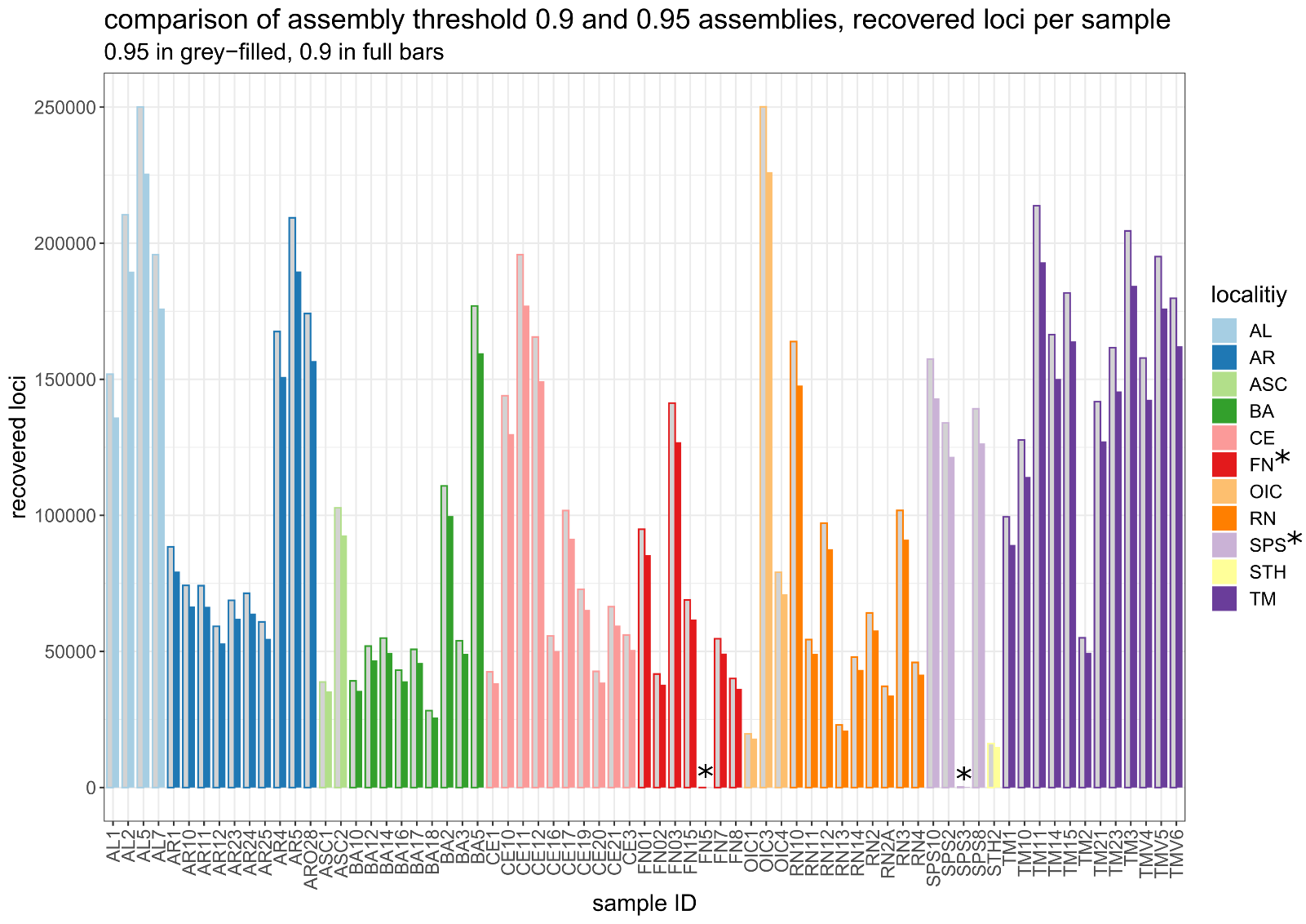
Figure S1: Comparison of recovered loci per individual between the two assemblies. Full bars represent the 0.9 similarity threshold, and grey-filled bars the 0.95 similarity threshold. The two individuals with lowest number of loci recovered are marked with * and were removed from the dataset.
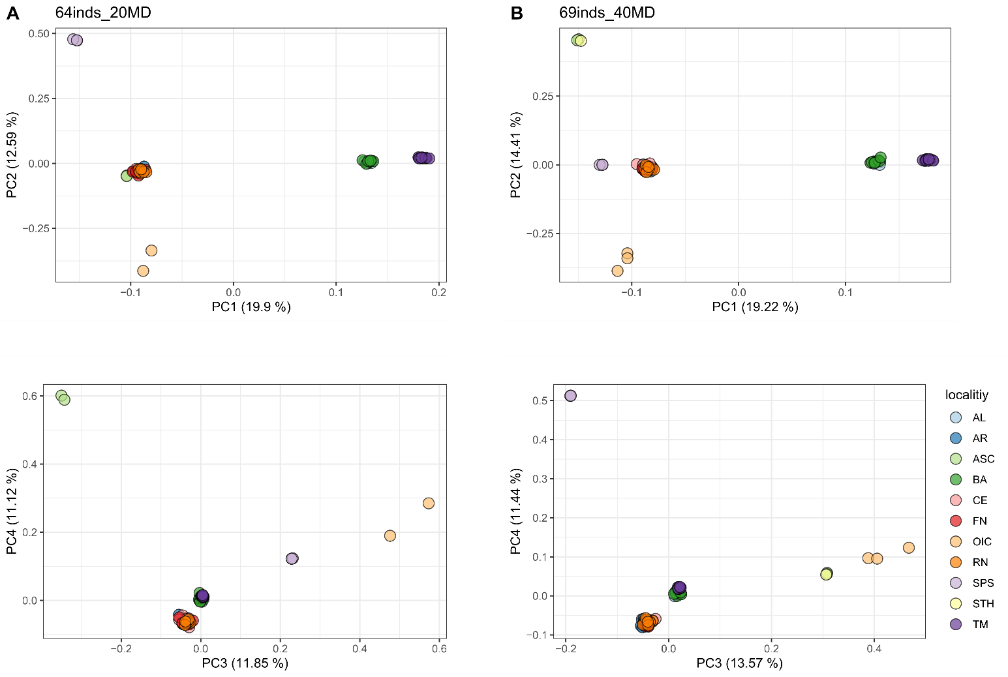

Figure S2: Genetic variation within Octopus insularis. EMU PCA of the “64inds_20MD” (A) and “69inds_40MD” (B) datasets for K = 11. Genetic clusters containing the same individuals are recovered, although certain differences in PC scores between clusters are apparent, especially as the positioning of SPS and ASC/STH is swapped.

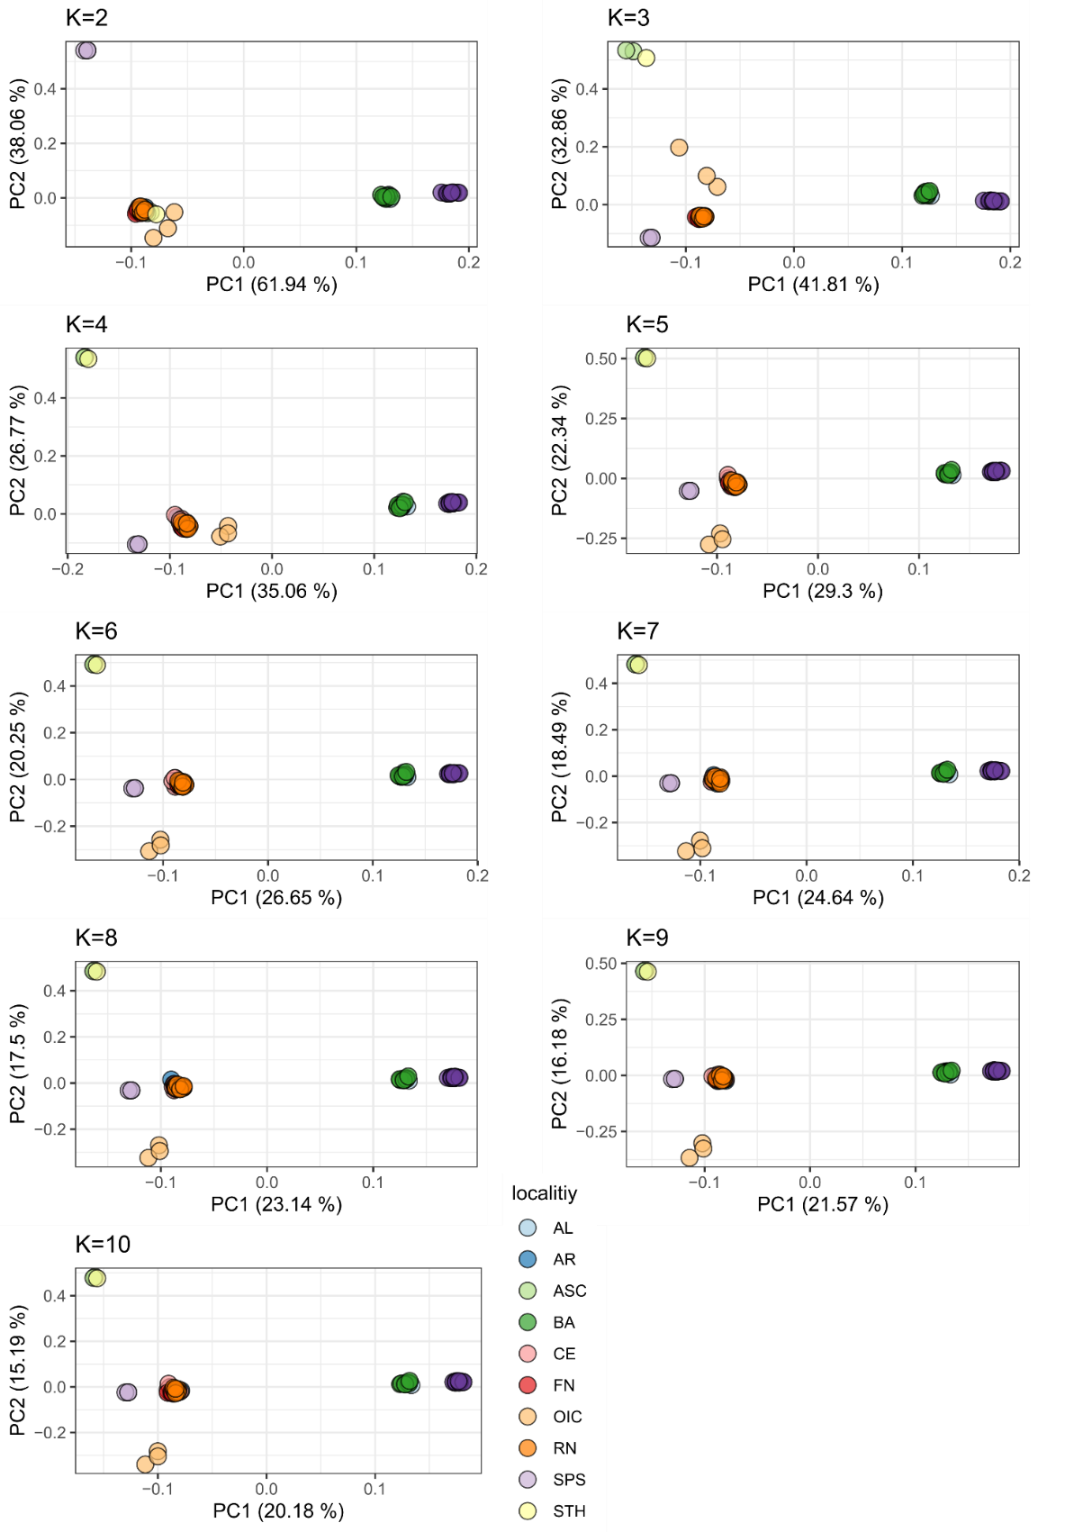

Figure S3: EMU PCA of the “69inds_40MD” for 2 – 10 eigenvalues. PCs 1 and 2 recovered from EMU PCA. Irrespective of the number of retained eigenvalues, the same six genetic clusters are evident.

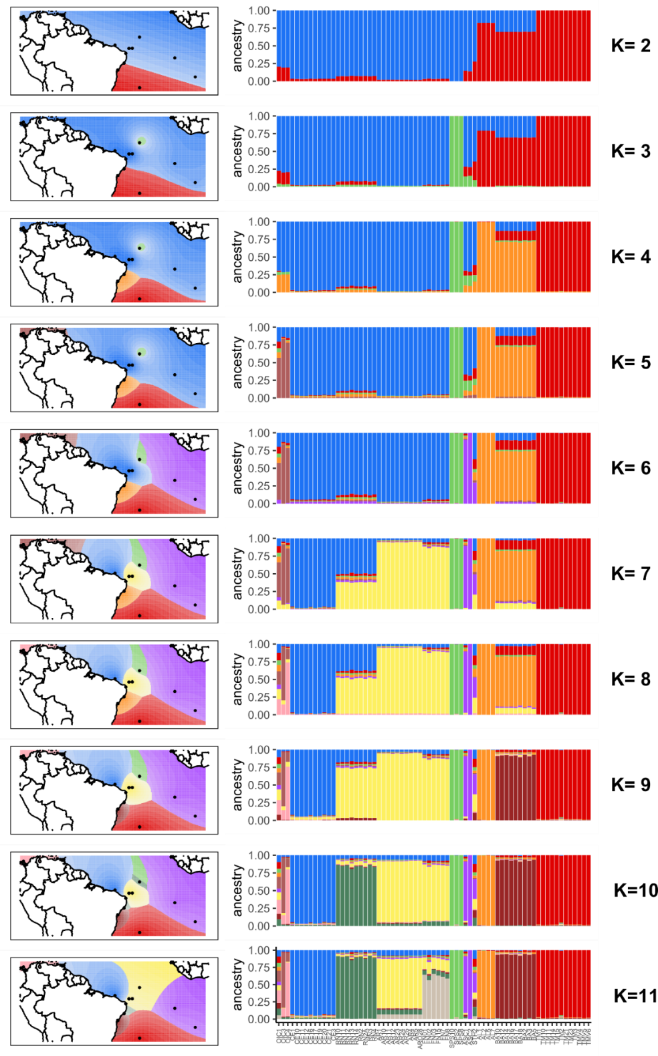
Figure S4: Clustering analysis of the sampled individuals considering an incremental number of ancestral K clusters and the “69inds_40MD_filt” dataset. Left: spatial interpolation of the distribution of the genetic clusters in the Atlantic Ocean. Right: ancestry coefficients for all individuals. Note that interpolation of Q-matrices did not work properly for K = 10 and K = 11, as too many locations with small geographic extension are interpolated.
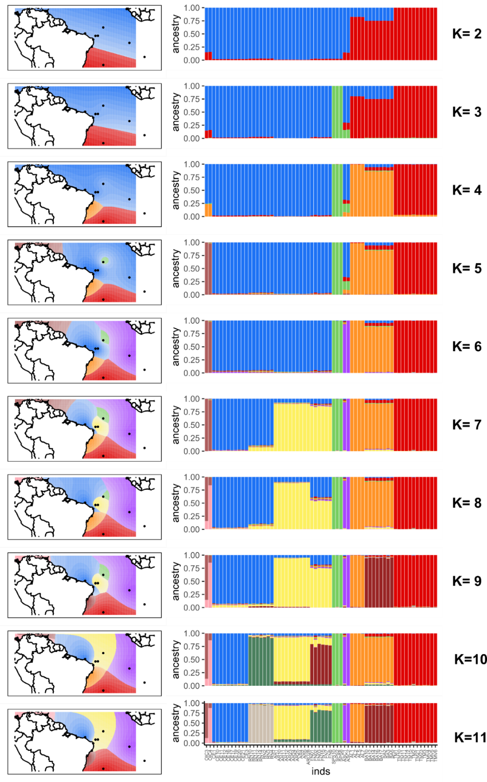
Figure S5: Clustering analysis of the sampled individuals considering an incremental number of ancestral K clusters and the “64inds_20MD_filt” dataset. Left: spatial interpolation of the distribution of the genetic clusters in the Atlantic Ocean. Right: ancestry coefficients for all individuals. Note that interpolation of Q-matrices did not work properly for K = 3, K= 4 and K = 9 - 11, as too many locations with small geographic extension are interpolated

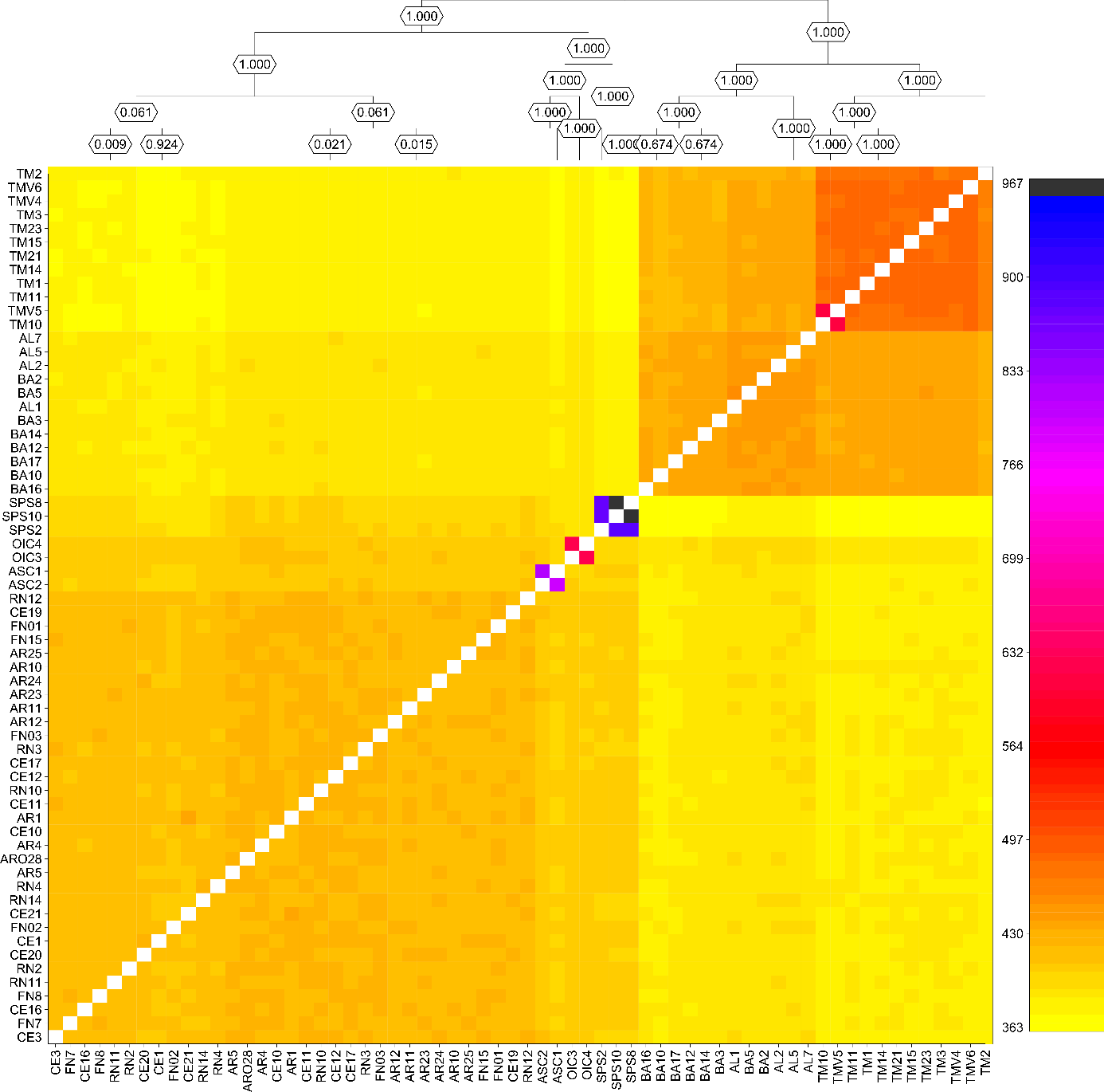
Figure S6: Co-ancestry matrix for the 64inds_20MD dataset reflecting six hierarchical clusters recovered for all datasets. Numbers at nodes in the dendrogram signify posterior probability of a split. The relation of clusters to each other is slightly different from the results of the “full” dataset, as individuals from the Caribbean, Atlantic and SPS cluster together without individuals from the northern coast in between.

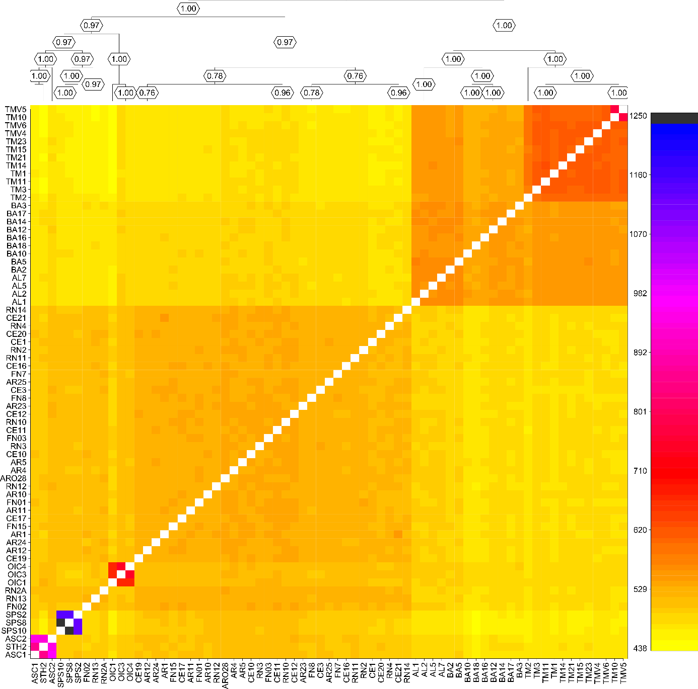
Figure S7: Co-ancestry matrix for the 69inds_40MD dataset, reflecting six hierarchical clusters recovered for all datasets. Numbers at nodes in the dendrogram signify posterior probability of a split. The results are very similar to those of the “full” dataset, except the split order of the minor clusters in the north. Here, individuals from SPS and the Atlantic form a sister clade.

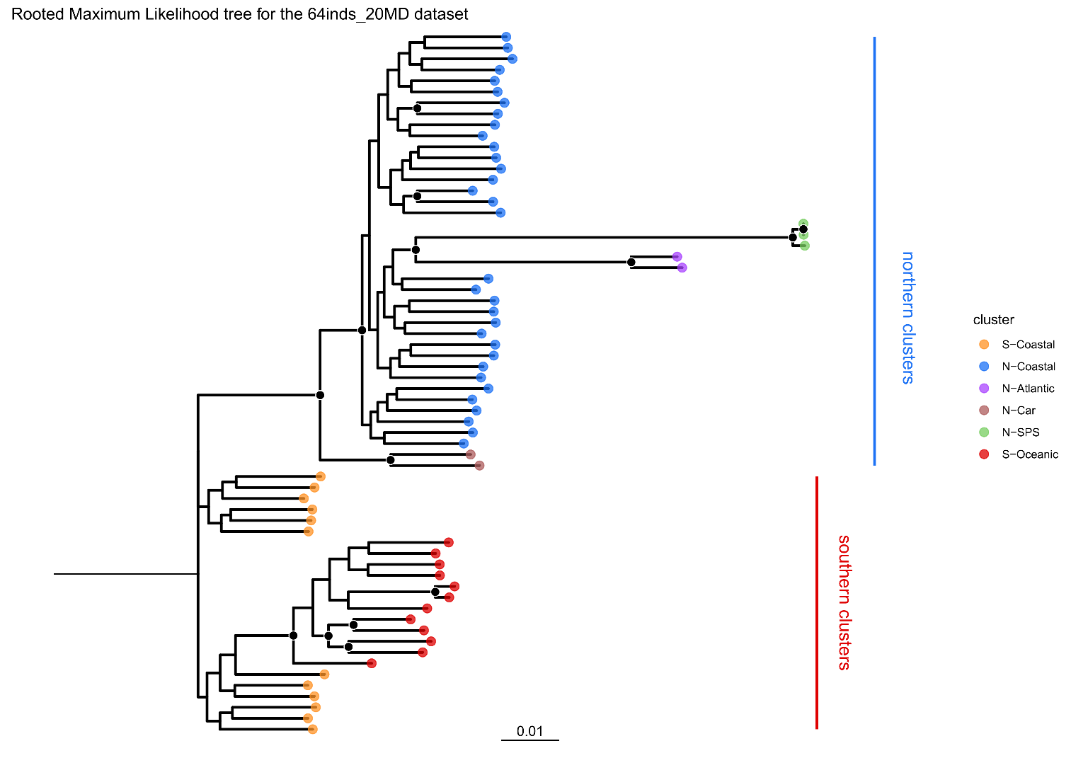
Figure S8: Phylogenetic relationship between individuals analyzed in this study: Maximum Likelihood tree of 64 individuals inferred by IQtree. Individuals colored according to their cluster identity as defined by our population structure analysis. Black circles at nodes demarcate ultrafast bootstrap support of >90. The scale corresponds to 0.01 nucleotide substitutions per site. Here, N-SPS and N-Atlantic form a monophyletic group with high ultrafast bootstrap support.
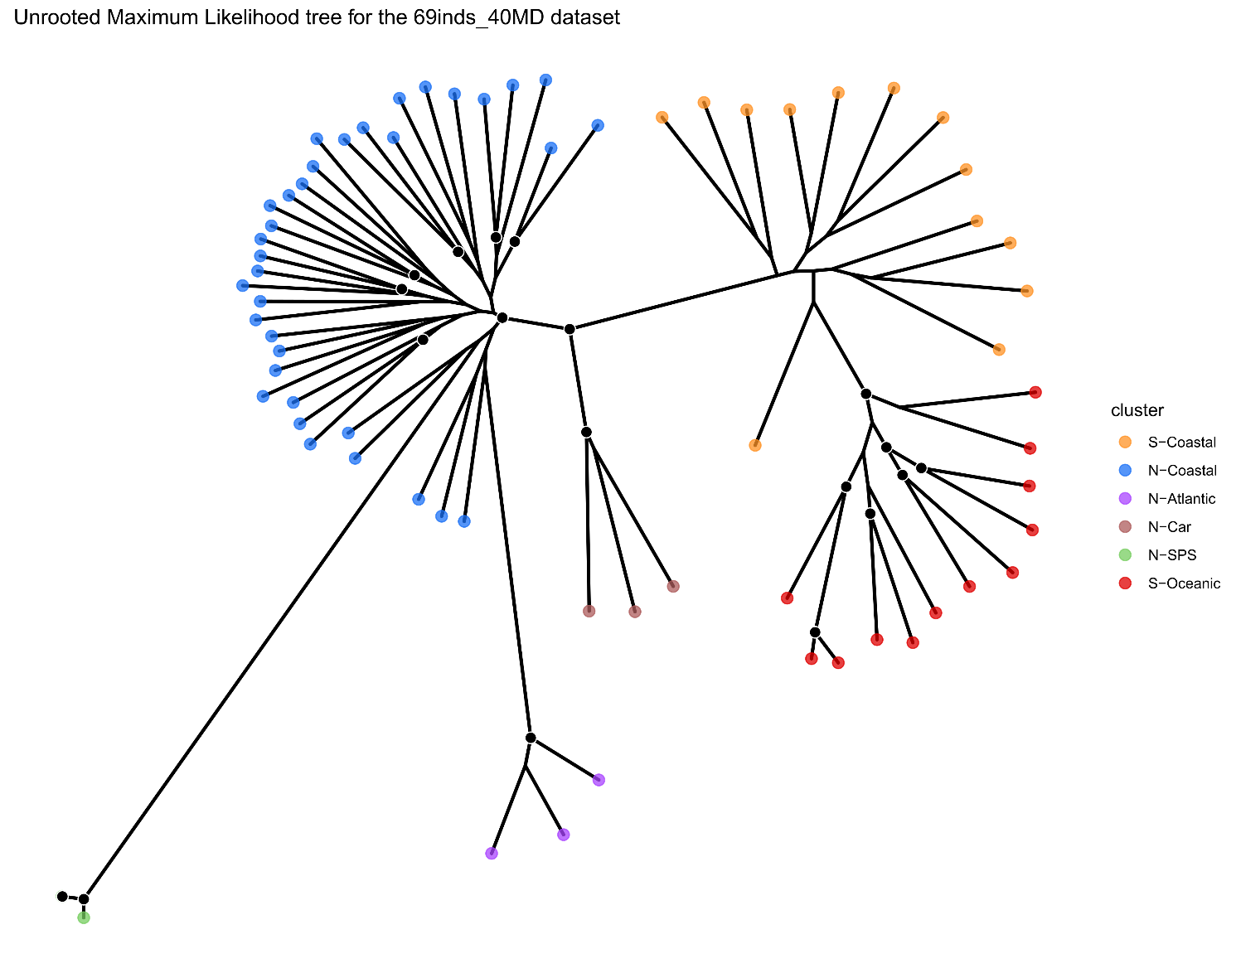
Figure S9: Phylogenetic relationship between individuals analyzed in this study: unrooted maximum Likelihood tree of 69 individuals inferred by IQtree. Individuals are colored according to their cluster identity as defined by our population structure analysis. Black circles at nodes demarcate ultrafast bootstrap support of >90. Individuals within northern and southern clusters are closely related to each other, clusters from oceanic locations show long branch lengths

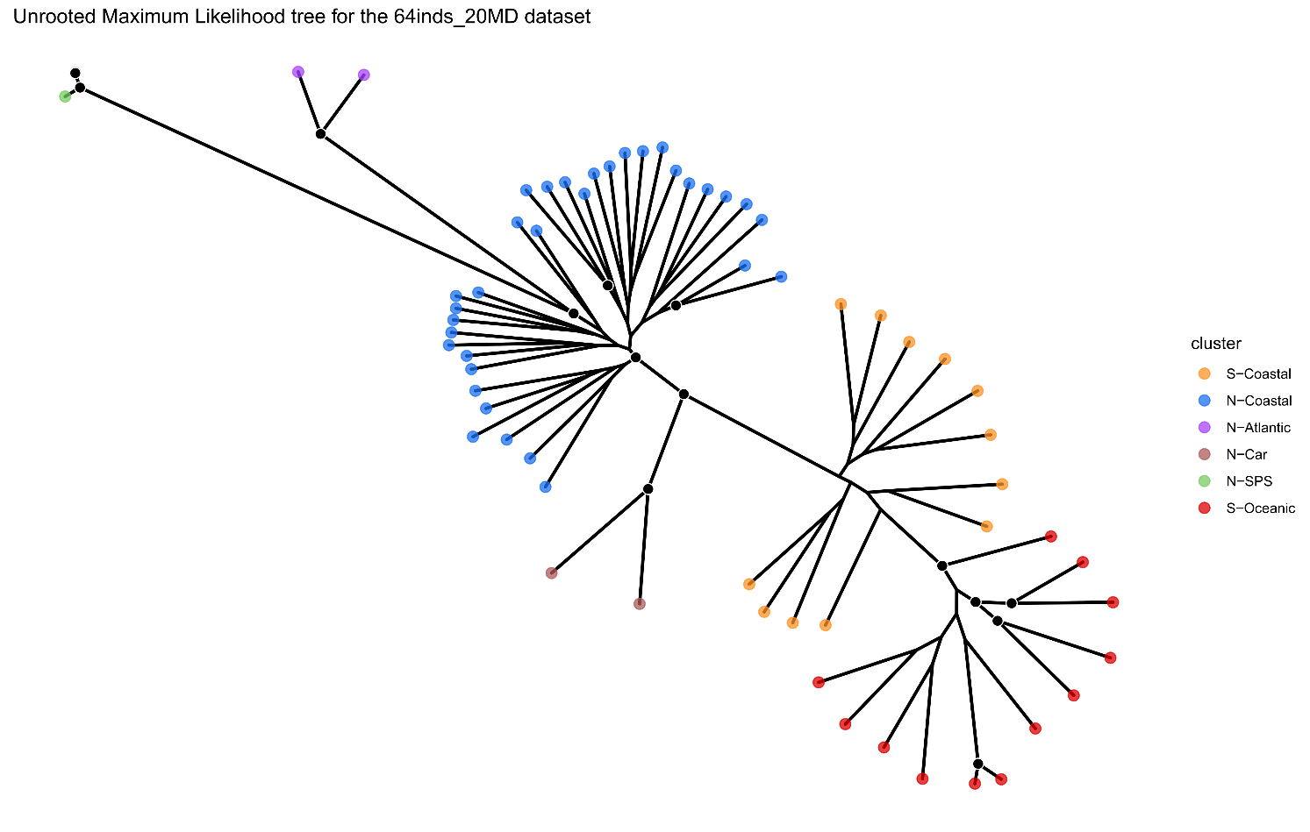
Figure S10: Phylogenetic relationship between individuals analyzed in this study: unrooted maximum Likelihood tree of 64individuals inferred by IQtree. Individuals are colored according to their cluster identity as defined by our population structure analysis. Black circles at nodes demarcate ultrafast bootstrap support of >90. Overall topology and branch lengths of individuals relative to each other very similar to the tree inferred for 69 individuals.

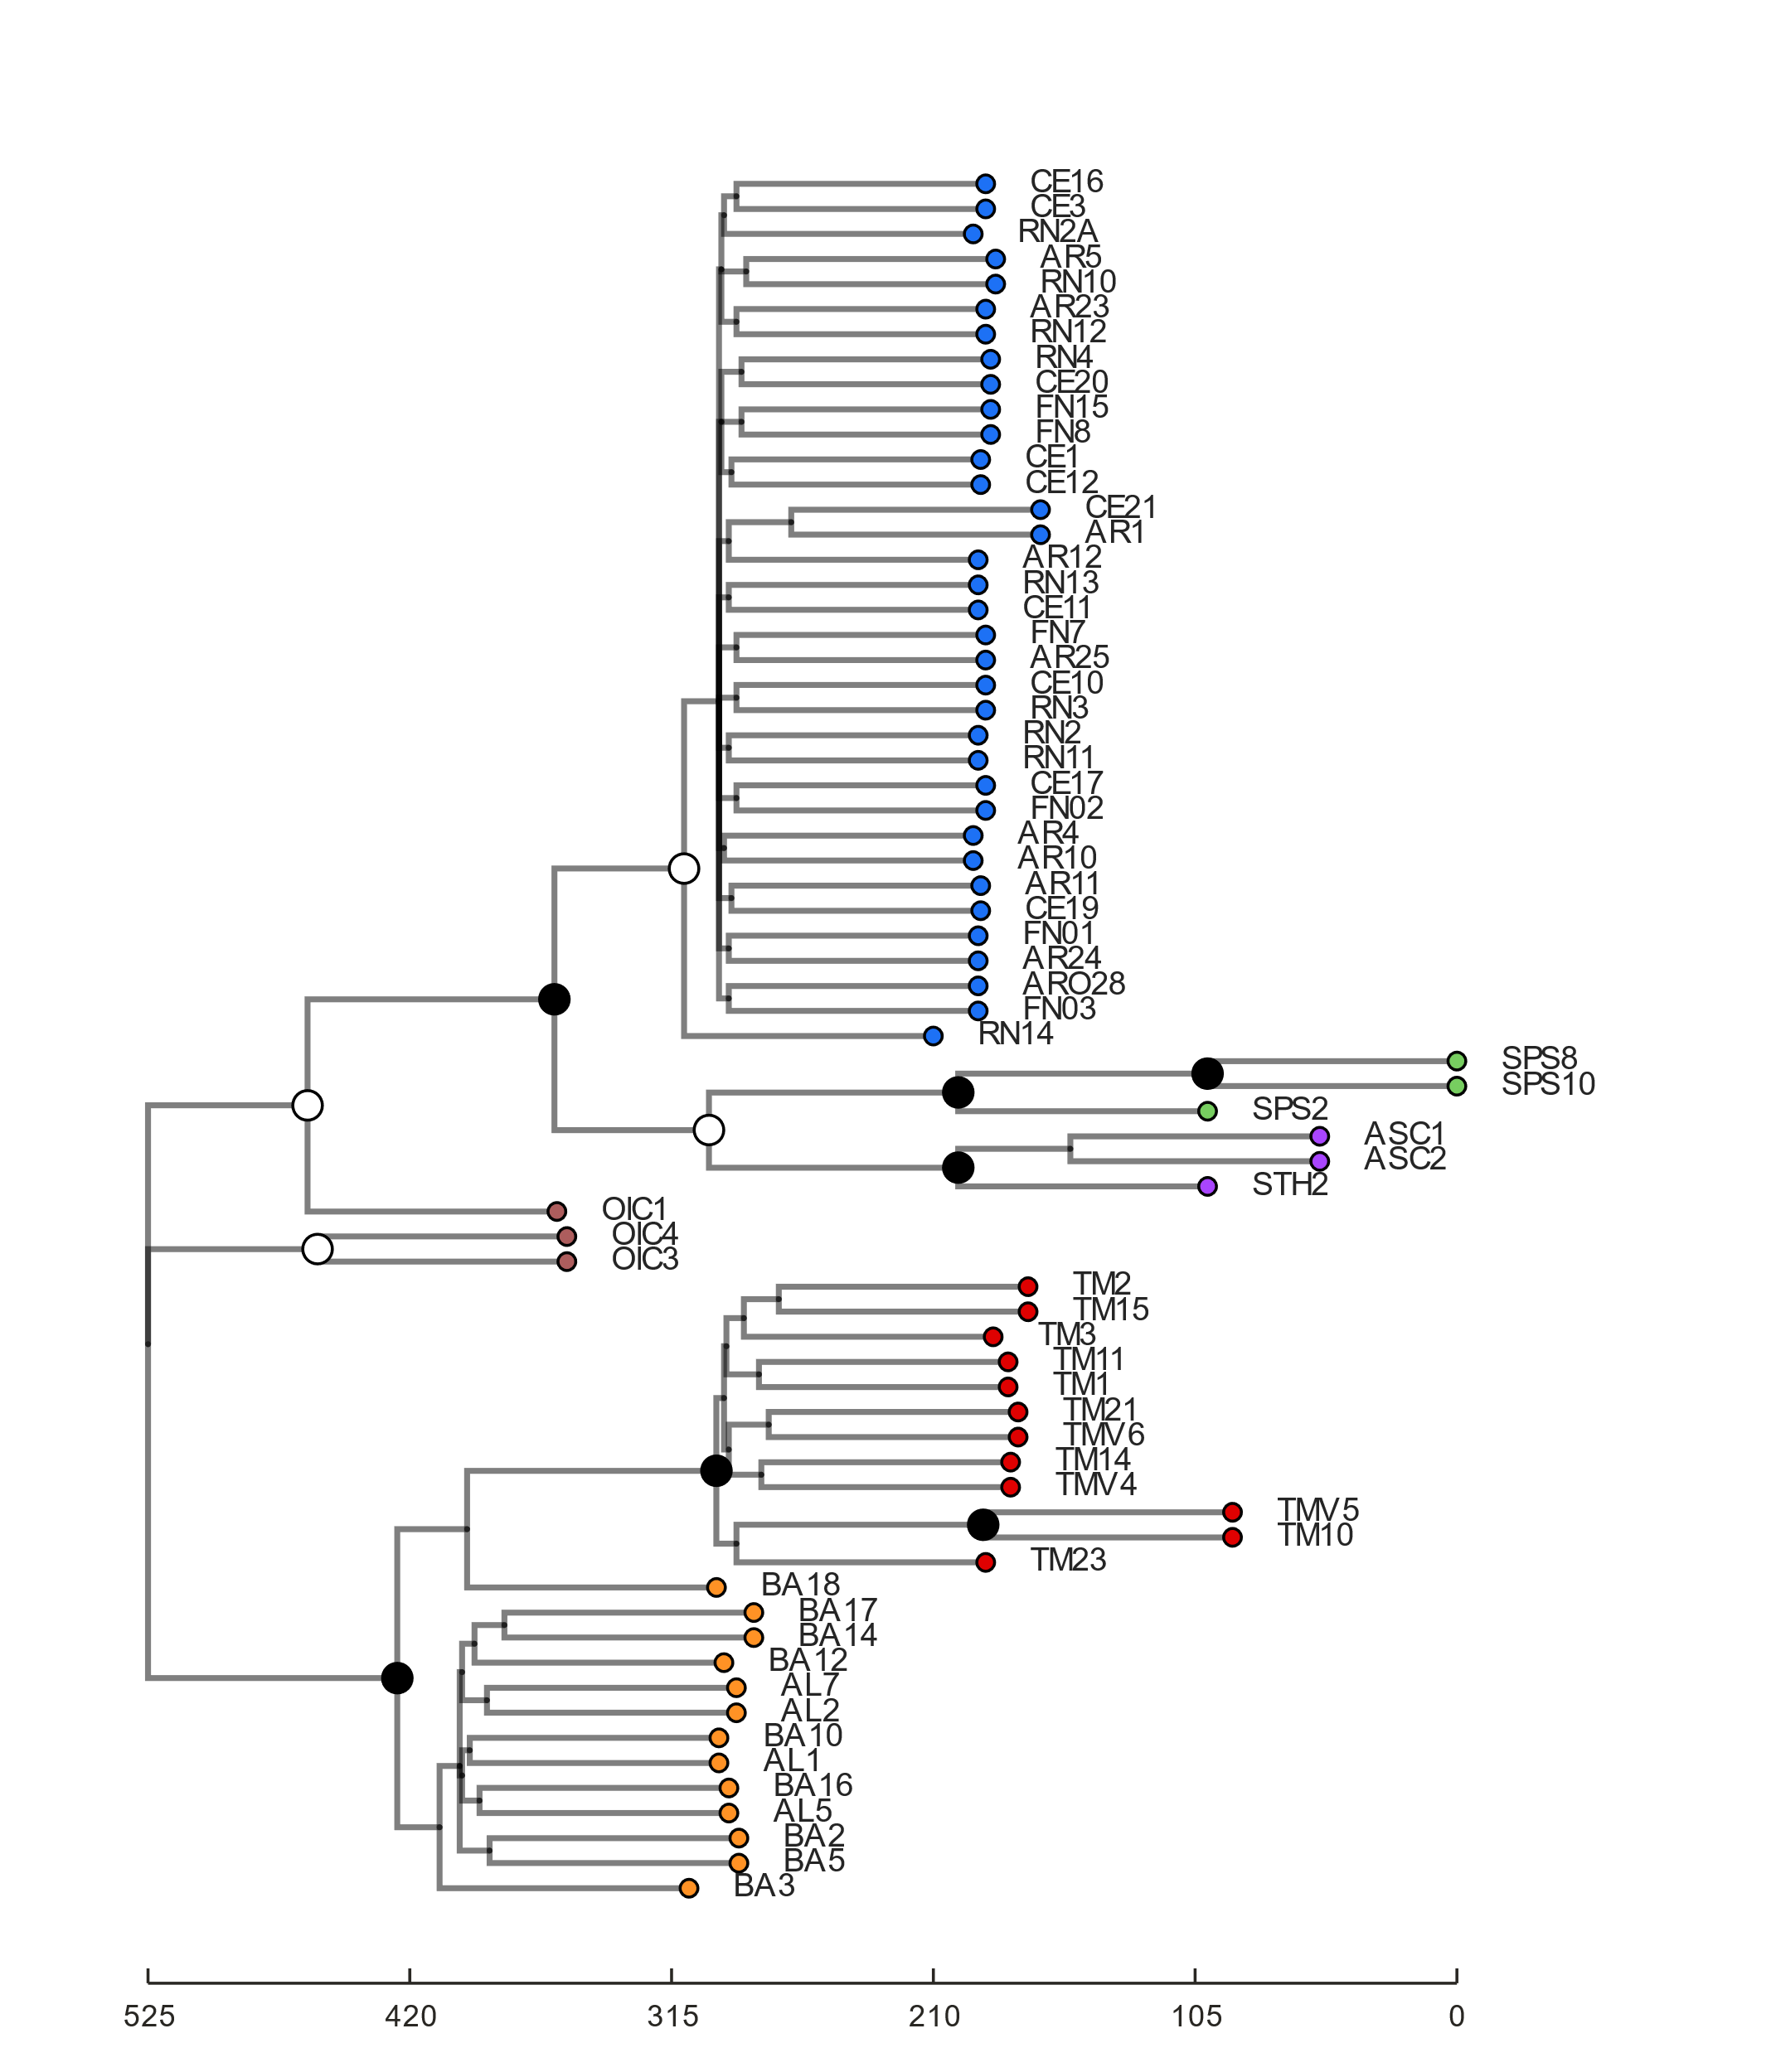
Figure S11: Phylogenetic relationship between individuals analyzed in this study: multi-population coalescent tree phylogeny of 69 individuals inferred by tetrad. Individuals are colored according to their cluster identity as defined by our population structure analysis. Black circles at nodes demarcate bootstrap support of >90, white notes demarcate bootstrap support >50. Note longer branch lengths of insular clusters.
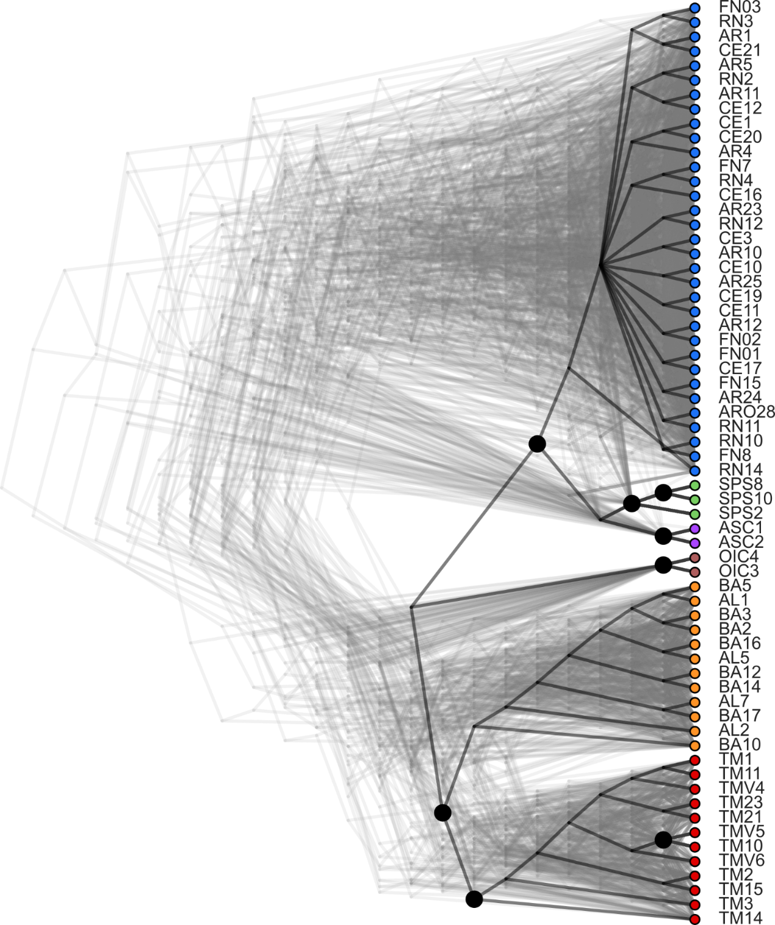

Figure S12: Phylogenetic relationship between individuals analyzed in this study: multi-population coalescent tree topology of 64 individuals inferred by tetrad. Individuals are colored according to their cluster identity as defined by our population structure analysis. Black circles at nodes demarcate bootstrap support of >90, white notes demarcate bootstrap support >50. Branch lengths do not reflect evolutionary distance.
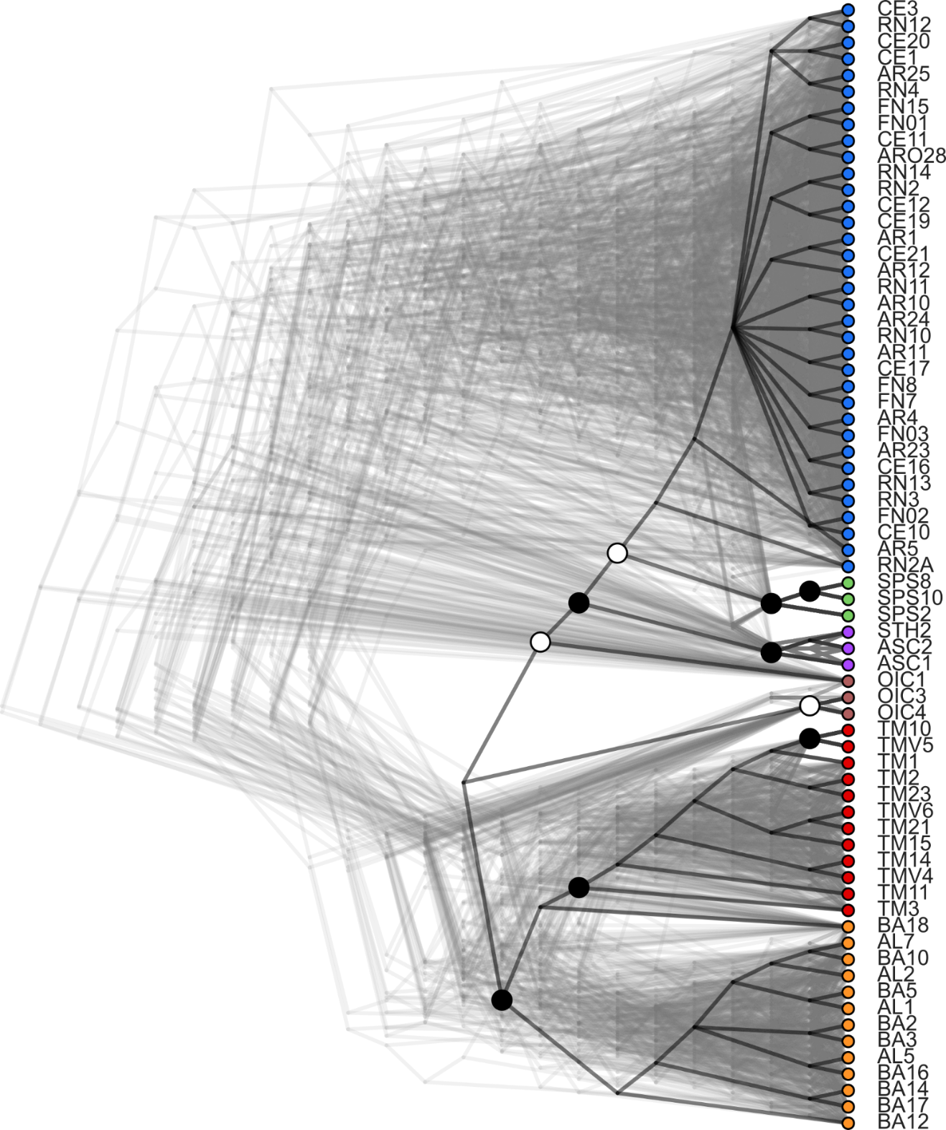
Figure S13: Phylogenetic relationship between individuals analyzed in this study: multi-population coalescent tree topology of 69 individuals, not filtered for missing sites (full dataset), inferred by tetrad. Individuals are colored according to their cluster identity as defined by our population structure analysis. Black circles at nodes demarcate bootstrap support of >90, white circles signify bootstrap support >50. Branch lengths do not reflect evolutionary distance.
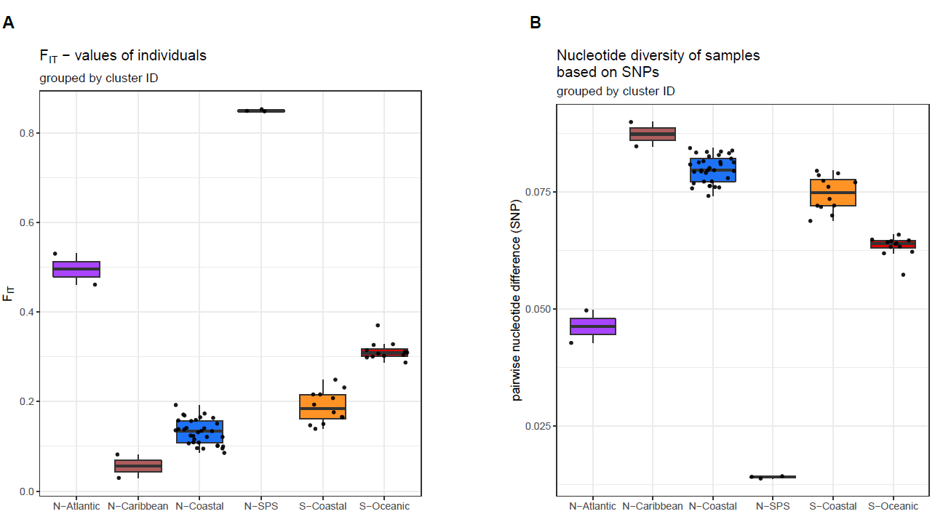
Figure S14: Genetic diversity within inferred clusters for the 64inds_20MD dataset. Top: Individual F_{IT}, bottom: π* values. Individuals are grouped by clusters inferred from tess3R at K = 6 and fineRADstrucuture. Boxplots are drawn for each cluster, with the solid black line marking the median, the top and bottom end of the box the 25% and 75% quartile boundaries and the whiskers the 1.5 interquartile range.

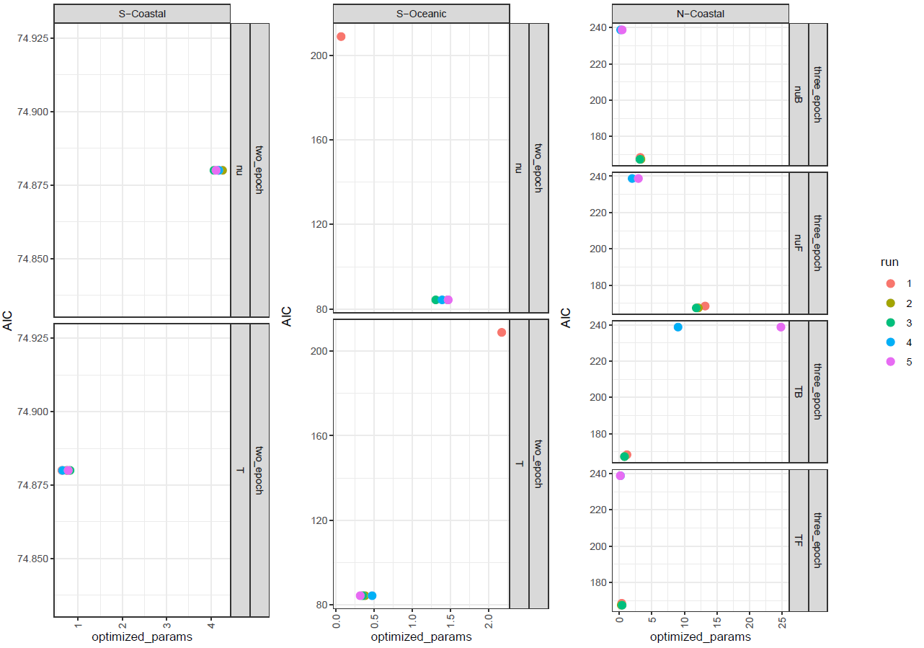
Figure S15: Estimated model parameters of the one population demographic modelling. AIC scores associated with these parameters for best model according to AIC scores as inferred by dadi for the clusters N-Coastal, S-Coastal and S-Oceanic. Parameter estimates are depicted in boxes for each unique parameter.

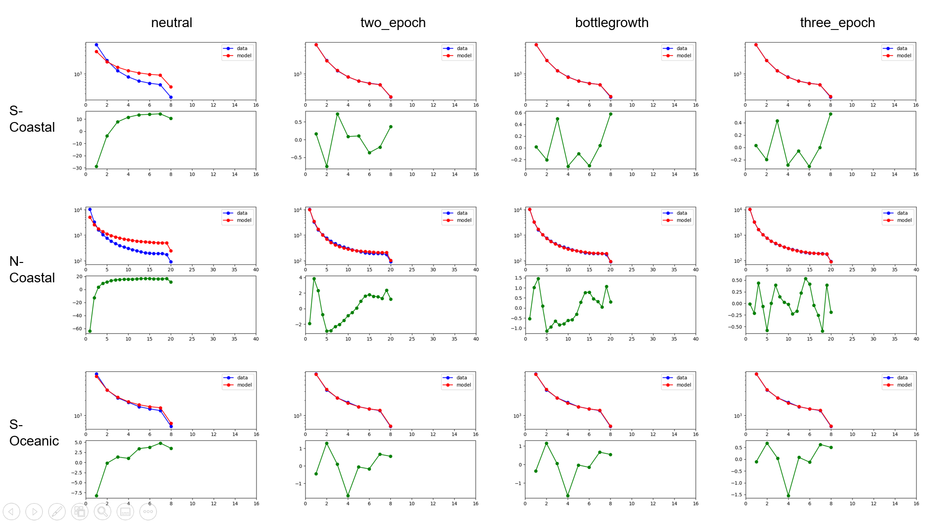
Figure S16: Observed and Modelled Site-Frequency Spectra (SFS) of the one population demographic modelling. Blue lines depict observed SFS, red lines modelled SFS and green lines residuals. Models used to infer SFS as columns and clusters for which models were fitted as rows.
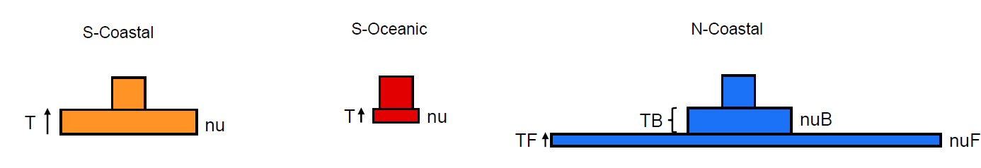
Figure S17: Schematic of best model fits of the single population demographic analysis. Left: two_epoch model for the S-Coastal cluster, middle: “two-epoch” model for the S-Oceanic cluster, right: “three_epoch” model for the N-Coastal cluster. Boxes are drawn to scale, with all ancient effective population sizes set to the same size for easier visualization. Parameters: nu: Ratio of contemporary to ancient population size, T: time since size change, nuB: Ratio of bottleneck to ancient population size, nuF: Ratio of contemporary to ancient population size, TB: Length of bottleneck change, TF: Time since end of bottleneck

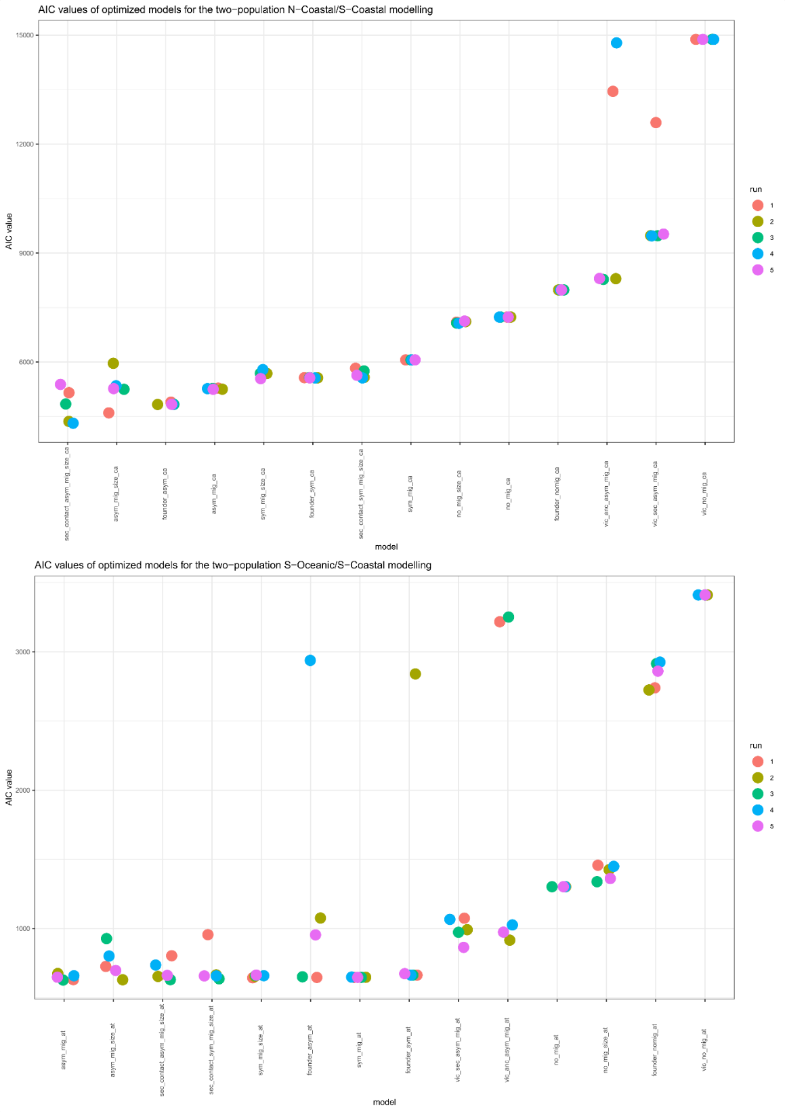
Figure S18: AIC values of investigated two population demographic models. A: AIC values of five independent runs of each of 15 models run for the N-Coastal/S-Coastal comparison. B: AIC values of five independent runs of each of 15 models run for the N-Coastal/S-Coastal comparison. AIC values are drawn on the y-axis and model names on the x-axis.
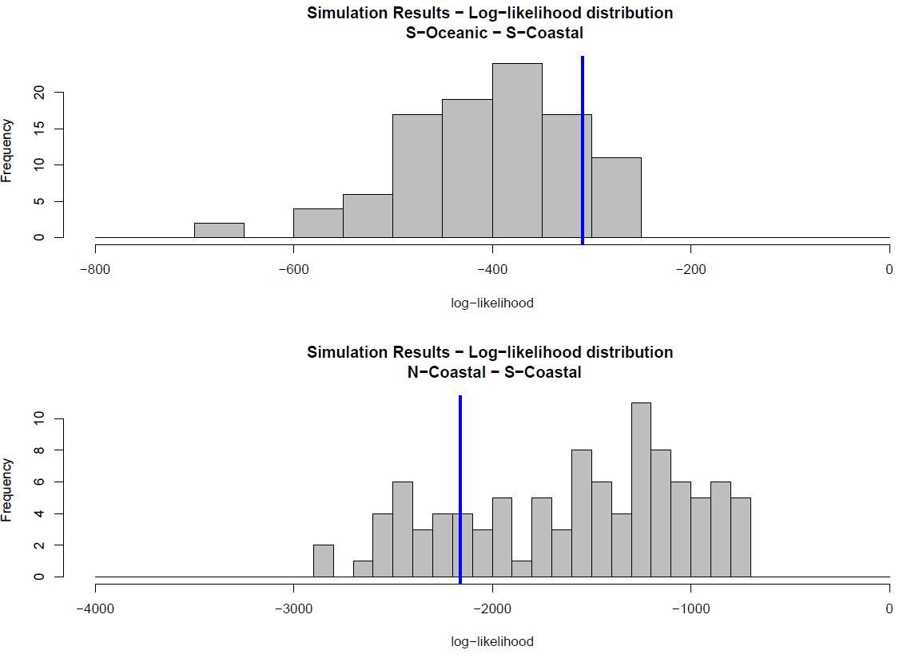
Figure S19: Results of the goodness-of-fit test for the best models of the two population modelling. Histogram of 100 log. likelihood values obtained after parameter optimization with regards to a simulated SFS. Blue lines depict empirical log. likelihood values. For both the asym_mig model (top) and the sec_contact_asym_mig_size model (bottom), empirical log. likelihood values fall within the distribution of simulated log. likelihood values.

