Supplementary figures and statistical data for the article titled “Implications of changing Caribbean coral reefs on Diadema antillarum larvae settlement”

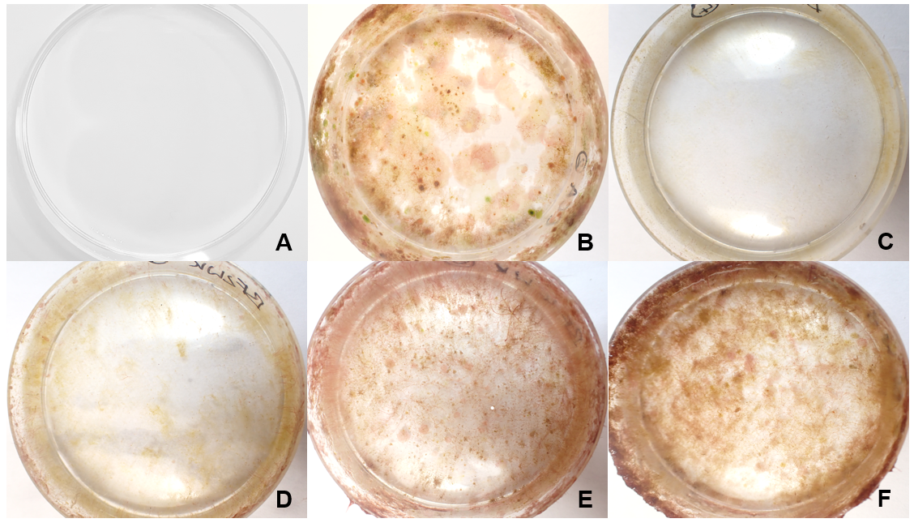
Fig. S1. Petri dishes used to test biofilm showing, (A) control, (B) CCA, and biofilm of (C) 1W, (D) 2W, (E) 4W, and (F) 6W.
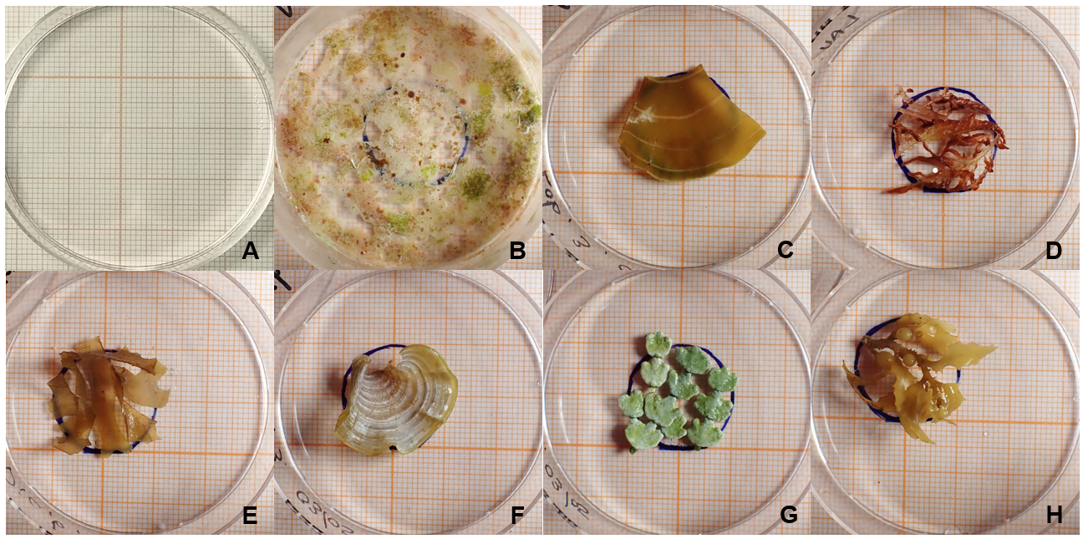
Fig. S2. Petri dishes used to test the different macroalgal species showing, (A) control, (B) CCA, (C) Lobophora variegata, (D) Laurencia sp., (E) Dictyota pinnatifida, (F) Padina pavonica, (G) Halimeda incrassata, and (H) Sargassum fluitans.
Table 1 and Table 2 show the results for the Generalized Linear Model (GLM) with binomial distribution for the Biofilm and Macroalgae experiment respectively. Treatment is the response variable with settlement as possible explanatory variable for both tests.

Table S1 Statistical results for the Biofilm experiment of the Generalized Linear Model (GLM) with a binomial distribution to test if Treatment had a significant effect on settlement. P values in bold are significant (p < 0.05).
Treatment | Estimate | Std. Error | T value | p value
Control | -2.738 | 1.052 | -2.603 | 0.012
CCA | 2.347 | 0.360 | 6.526 | 0.000
1WK | -1.858 | 0.294 | -6.316 | 0.000
2WK | 1.858 | 0.356 | 5.215 | 0.000
4WK | 1.777 | 0.356 | 4.989 | 0.000
6WK | 1.410 | 0.359 | 3.927 | 0.000

Table S2 Statistical results for the Macroalgae experiment of the Generalized Linear Model (GLM) with a binomial distribution to test if Treatment had a significant effect on settlement. P values in bold are significant (p < 0.05).
Treatment | Estimate | Std. Error | t value | p value
CCA | -0.895 | 0.260 | -3.449 | 0.001
Control | -1.691 | 0.530 | -3.193 | 0.002
Dictyota | -0.555 | 0.397 | -1.397 | 0.167
Halimeda | -0.151 | 0.374 | -0.403 | 0.688
Laurencia | -0.920 | 0.427 | -2.153 | 0.035
Lobophora | -1.856 | 0.560 | -3.316 | 0.001
Padina | -0.203 | 0.376 | -0.540 | 0.591
Sargassum | 0.187 | 0.361 | 0.519 | 0.605

Table 3 and Table 4 show the pairwise comparison using a Tukey’s post hoc test, adjusted for multiple comparisons for the Biofilm and Macroalgae experiment respectively.
Table S3 Biofilm experiment results for the Tukey’s post hoc test, adjusted for multiple comparisons. P values in bold are significant (p < 0.05).
Treatments | Estimate | SE | df | Z ratio | p value
1WK - 2WK | -1.857 | 0.36 | Inf | -5.215 | 0.000
1WK - 4WK | -1.777 | 0.36 | Inf | -4.989 | 0.000
1WK - 6WK | -1.41 | 0.36 | Inf | -3.927 | 0.001
1WK - CCA | -2.347 | 0.36 | Inf | -6.526 | 0.000
1WK - Control | 2.738 | 1.05 | Inf | 2.603 | 0.097
2WK - 4WK | 0.08 | 0.28 | Inf | 0.281 | 1.000
2WK - 6WK | 0.447 | 0.29 | Inf | 1.554 | 0.629
2WK - CCA | -0.49 | 0.29 | Inf | -1.697 | 0.534
2WK - Control | 4.595 | 1.03 | Inf | 4.462 | 0.000
4WK - 6WK | 0.367 | 0.29 | Inf | 1.276 | 0.799
4WK - CCA | -0.57 | 0.29 | Inf | -1.973 | 0.358
4WK - Control | 4.515 | 1.03 | Inf | 4.384 | 0.000
6WK - CCA | -0.937 | 0.29 | Inf | -3.208 | 0.017
6WK - Control | 4.148 | 1.03 | Inf | 4.024 | 0.001
CCA - Control | 5.085 | 1.03 | Inf | 4.932 | 0.000

Table S4 Macroalgae experiment results for the Tukey’s post hoc test, adjusted for multiple comparisons. P values in bold are significant (p < 0.05).
Treatments | Estimate | SE | df | Z ratio | p value
CCA - Control | 1.691 | 0.53 | Inf | 3.193 | 0.031
CCA - Dictyota | 0.555 | 0.397 | Inf | 1.397 | 0.859
CCA - Halimeda | 0.151 | 0.373 | Inf | 0.403 | 1.000
CCA - Laurencia | 0.92 | 0.427 | Inf | 2.153 | 0.381
CCA - Lobophora | 1.856 | 0.56 | Inf | 3.316 | 0.021
CCA - Padina | 0.203 | 0.376 | Inf | 0.54 | 0.999
CCA - Sargassum | -0.187 | 0.361 | Inf | -0.519 | 1.000
Control - Dictyota | -1.137 | 0.551 | Inf | -2.064 | 0.438
Control - Halimeda | -1.541 | 0.534 | Inf | -2.885 | 0.076
Control - Laurencia | -0.771 | 0.573 | Inf | -1.346 | 0.881
Control - Lobophora | 0.165 | 0.678 | Inf | 0.243 | 1.000
Control - Padina | -1.488 | 0.536 | Inf | -2.777 | 0.101
Control - Sargassum | -1.879 | 0.525 | Inf | -3.577 | 0.008
Dictyota - Halimeda | -0.404 | 0.403 | Inf | -1.003 | 0.974
Dictyota - Laurencia | 0.365 | 0.453 | Inf | 0.806 | 0.993
Dictyota - Lobophora | 1.302 | 0.58 | Inf | 2.245 | 0.325
Dictyota - Padina | -0.351 | 0.405 | Inf | -0.867 | 0.989
Dictyota - Sargassum | -0.742 | 0.391 | Inf | -1.897 | 0.553
Halimeda - Laurencia | 0.769 | 0.433 | Inf | 1.777 | 0.636
Halimeda - Lobophora | 1.706 | 0.564 | Inf | 3.024 | 0.051
Halimeda - Padina | 0.053 | 0.382 | Inf | 0.138 | 1.000
Halimeda - Sargassum | -0.338 | 0.367 | Inf | -0.92 | 0.984
Laurencia - Lobophora | 0.936 | 0.601 | Inf | 1.558 | 0.776
Laurencia - Padina | -0.717 | 0.435 | Inf | -1.648 | 0.721
Laurencia - Sargassum | -1.107 | 0.422 | Inf | -2.624 | 0.147
Lobophora - Padina | -1.653 | 0.566 | Inf | -2.922 | 0.068
Lobophora - Sargassum | -2.043 | 0.556 | Inf | -3.678 | 0.006
Padina - Sargassum | -0.39 | 0.37 | Inf | -1.056 | 0.966

