Successful large-scale and long-term kelp forest restoration by culling sea urchins with quicklime and supported by crab predation
Hartvig Christie^{1*}, Frithjof E Moy², Camilla W Fagerli¹, Eli Rinde¹, Mette Strand², Lise A Tveiten¹, Hans K Strand².
¹ Norwegian Institute for Water Research (NIVA), Økernveien 94, 0579 Oslo, Norway.
² Institute for Marine Research (IMR), P.O box 1870 Nordnes, NO-5817 Bergen
*Corresponding author: hartvig.christie@niva.no

Supplementary Information (SI)

SI Table 1. Total number of sea urchins sampled (n) and percentage damaged urchins, among urchins sampled from sites treated with quicklime (coastline 1, 3, 5) and the control sites (coastline 2, 4, 6), 8th October 2013, i.e. a few days after the quicklime treatment. The site code is based on the coastline code (1-6) and the site's placement along the respective coastline (N-north, M-middle, S-south).
Treatment | Q | Control | C
Site | n / % damage | Site | n / % damage
1 N | 128 / 16 | 2 N | 99 / 0
1 S | 122 / 42 | 2 M | 131 / 0.8
3 N | 123 / 39 | 2 S | 102 / 0
3 S | 80 / 9 | 4 N | 120 / 0
5 M | 152 / 47 | 4 M | 114 / 0
5 S | 99 / 27 | 4 S | 113 / 0
 |  | 6 N | 122 / 0
 |  | 6 S | 128 / 0

SI Table 2. Macroalgae species and average biomass (AVerage with Standard Deviation) of the wet weight given as gm⁻² based on samples from quadrats (40x40 cm) on treated, control, and new sites 7,8,9 (pooled for each treatment) in 2016. Species are listed as brown (b) green (g) and red (r) macroalgae.

 |  | Q-lime |  | Control |  | Sites 7,8,9
Type | Name | AV | (SD) | AV | (SD) | AV | (SD)
b | Alaria esculenta | 1825 | (1811) | 1198 | (1096)
b | Chaetopteris plumosa | 9.0 | (26.9) | 1.4 | (4.2) | 0.02 | (0.03)
b | Chorda filum | 0.01 | (0.02) | 3.5 | (10.6) | 119 | (129)
b | Chordaria flagelliformis | 0.01 | (0.02) | 31.6 | (89.1) | 127 | (235)
b | Desmarestia aculeata | 2122 | (2223) | 763 | (1362)
b | Desmarestia viridis | 228 | (271) | 51.3 | (101) | 204 | (318)
b | Dictyosiphon foniculaceus | 5.1 | (10.2) | 70.7 | (114) | 20.7 | (22.8)
b | Ectocarpus fasciculatus |  |  | 0.01 | (0.02)
b | Ectocarpus siliculosus | 14.1 | (27.9) | 24.4 | (35.2) | 64.3 | (57.2)
b | Eudesme virescens |  |  | 5.8 | (15.3) | 165 | (291)
b | Haplospora globosa |  |  |  |  | 0.02 | (0.03)
b | Hinksia ovata | 0.01 | (0.02) | 0.01 | (0.02)
b | Isthmoplea sphaerophora |  |  |  |  | 0.02 | (0.03)
b | Litosiphon laminariae |  |  |  |  | 0.04 | (0.03)
b | Pilayiella littoralis |  |  |  |  | 0.01 | (0.03)
b | Pylaiella littoralis |  |  | 0.01 | (0.03)
b | Saccharina latissima | 1059 | (2050) | 4180 | (5820) | 1.1 | (2.8)
b | Saccorhiza dermatodea | 143 | (240) | 5.0 | (15.0) | 347 | (536)
g | Acrosiphonia arcta | 0.03 | (0.03) | 0.03 | (0.03) | 0.04 | (0.03)
g | Bolbocoleon piliferum |  |  |  |  | 0.01 | (0.03)
g | Derbesia marina |  |  | 0.01 | (0.03)
g | Rhizoclonium riparium | 0.01 | (0.02)
g | Spongomorpha aeruginosa |  |  |  |  | 0.01 | (0.03)
r | Antithamnionella fluccosa | 0.02 | (0.03) | 0.01 | (0.02)
r | Bonnemaisonia hemifera | 0.03 | (0.03) | 0.03 | (0.03)
r | Ceramium virgatum | 0.02 | (0.03)
r | Ceramiun "strictum type" | 0.01 | (0.02) | 0.01 | (0.02)
r | Chlorochytrium sp. |  |  |  |  | 0.01 | (0.03)
r | Corallina officinalis |  |  |  |  | 0.01 | (0.03)
r | Euthora cristata | 4.5 | (13.5) | 0.02 | (0.03)
r | Odonthalia dentata |  |  | 0.01 | (0.02)
r | Phycodrus rubens | 6.8 | (20.4) | 3.9 | (8.86)
r | cf. Plocamium cartilagineum | 0.01 | (0.02)
r | Polysiphonia arctica |  |  | 0.01 | (0.03)
r | Polysiphonia stricta | 38.6 | (78.9) | 14.3 | (28.6) | 0.01 | (0.03)
r | Porphyra sp. |  |  | 0.01 | (0.02)
r | Pterothamnion plumula |  |  | 0.01 | (0.02)
r | Ptilota gunneri | 3.1 | (9.2)
r | Ptilota serrata |  |  | 0.01 | (0.02)
r | Rhodocorton purpureum |  |  | 0.01 | (0.02) | 0.01 | (0.03)
r | Rhodomela confervoides | 0.01 | (0.02) | 0.01 | (0.03) | 0.02 | (0.03)
r | Rubrointrusa membranacea | 0.01 | (0.02) | 0.01 | (0.02)
r | Scagelia pylaisaei |  |  |  |  | 0.01 | (0.03)
r | Scageliothamnion pussilum |  |  | 0.01 | (0.02)
 | Sum total | 5459 | (2766) | 6353 | (5627) | 1049 | (814)

SI Table 3. Summary statistics of the PERMANOVA analysis of the fauna trap community at quicklime treated (Q), controls (C), and additional sites, in the Porsangerfjord, northern Norway, in the period 2013-2016. Coastline as well as an interaction between treatment and year was included in the analysis. The distance matrix used was Bray-Curtis.
 | Df | SumOfSqs | R2 | F | Pr(>F)
Coastline | 7 | 3.4675 | 0.24 | 4.9142 | 0.001 | ***
Treatment | 1 | 0.3512 | 0.02 | 3.4844 | 0.001 | ***
Year | 3 | 4.8132 | 0.33 | 15.9164 | 0.001 | ***
Treatment:Year | 4 | 1.6673 | 0.11 | 4.135 | 0.001 | ***
Residual | 41 | 4.1329 | 0.29
Total | 56 | 14.4321 | 1

SI Table 4. Overview of sampled sugar kelp plants and their associated fauna abundance and species richness based on sampling from the lime treated coastlines 1, 3 and 5 in Porsangerfjord, northern Norway in 2015 (6 plants) and 2016 (9 plants). Average Saccharina lamina length, average number of individuals and number of species of macrofauna on the sampled sugar kelp plants are given (with standard error in brackets).
 | 2015 | 2016
Lamina length (cm) | 107 (14.3) | 102.6 (8.3)
No of individuals | 238.7 (88.4) | 104.2 (11)
No of species | 15.2 (2.7) | 10.6 (0.7)

SI Fig. 1. Pooled data per year and across depth levels for; A) sea urchin density (nm⁻²), and B) macroalgae cover (%, mainly kelp) on the three treatment (green) and control (red) sites studied in the Porsangerfjord (northern Norway) in the period 2012-2016. Urchin density (light colored, nm⁻²) and algae cover (dark brown, %) of the new sites (7,8,9) surveyed in the period 2014-2016, are shown in panel C. In 2014 samples were taken in both spring (S) and autumn (A). The 2012 data is sampled one year before the quicklime treatment, the 2013 data is sampled just after treatment. Numbers are average with St Error. The figures are based on all the 2010 frame recordings.

SI Fig. 2. Summary of observations from drop camera surveys, summer 2021. The chart shows mean ±SE abundance of kelp and sea urchins estimated on a semiquantitative scale (0: absent, 1: single specimen, 2: scattered, 3: common, and 4: dominating) pooled for CaO treated coastlines (1,3,5) and control coastlines (2,4,6). N of video transects; treated 6, control 5.

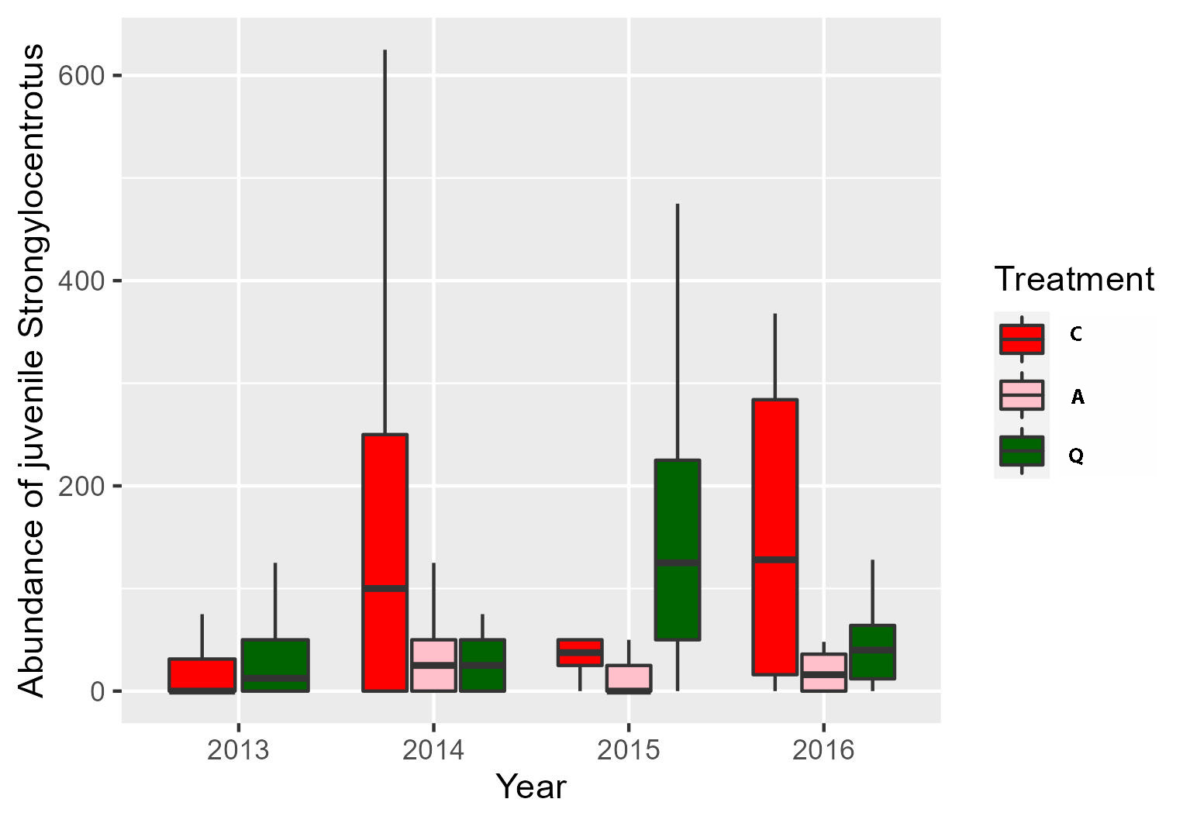SI Fig. 3. Abundance of juvenile sea urchins (mean ±SE) in the gravel samples in quicklime treated (Q), controls (C), and additional sites 7,8,9 (A), based on samples within 20x20 cm frames.

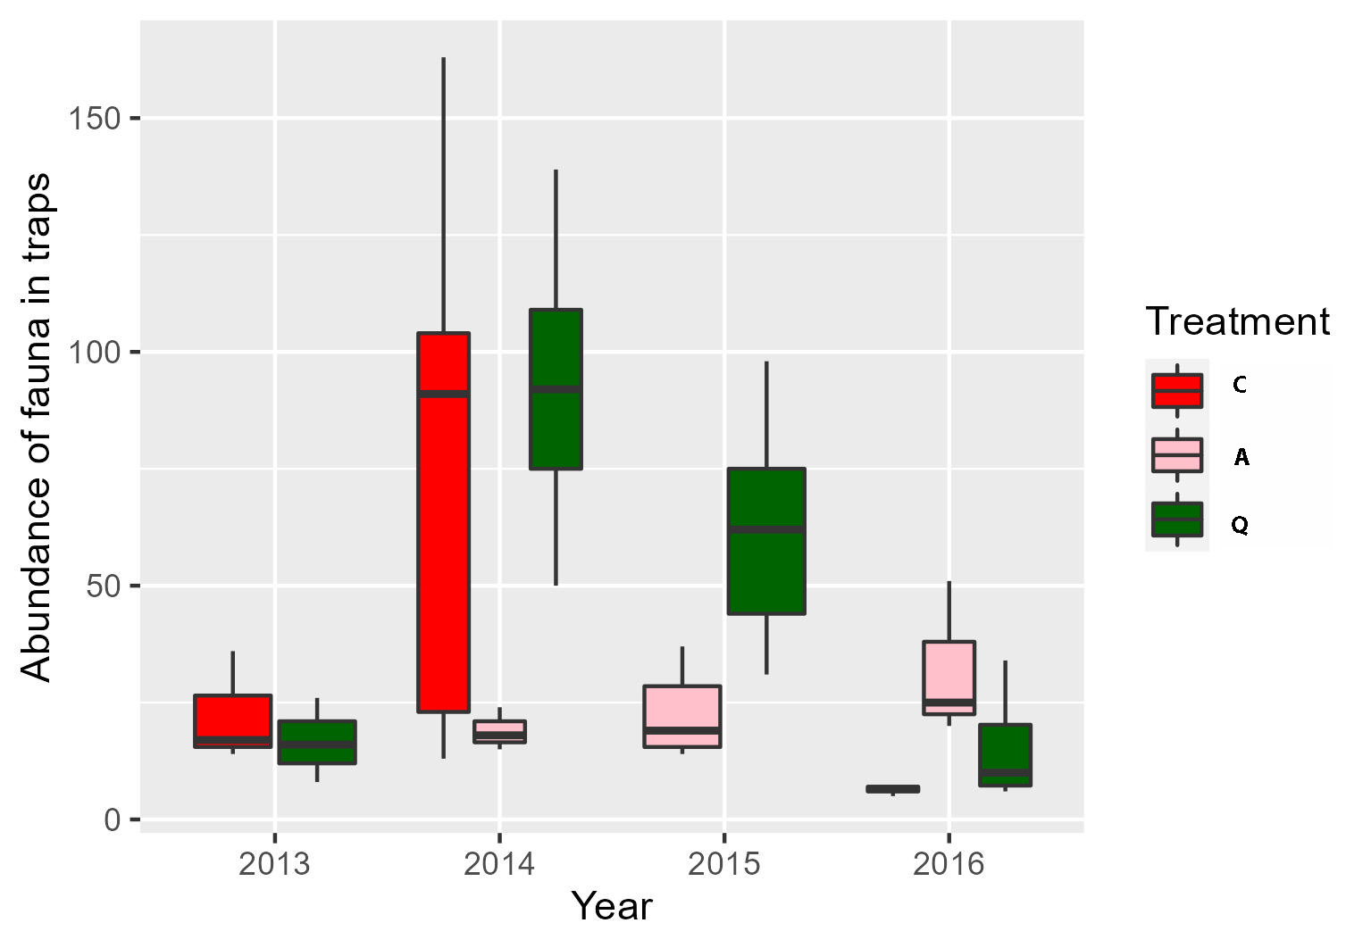
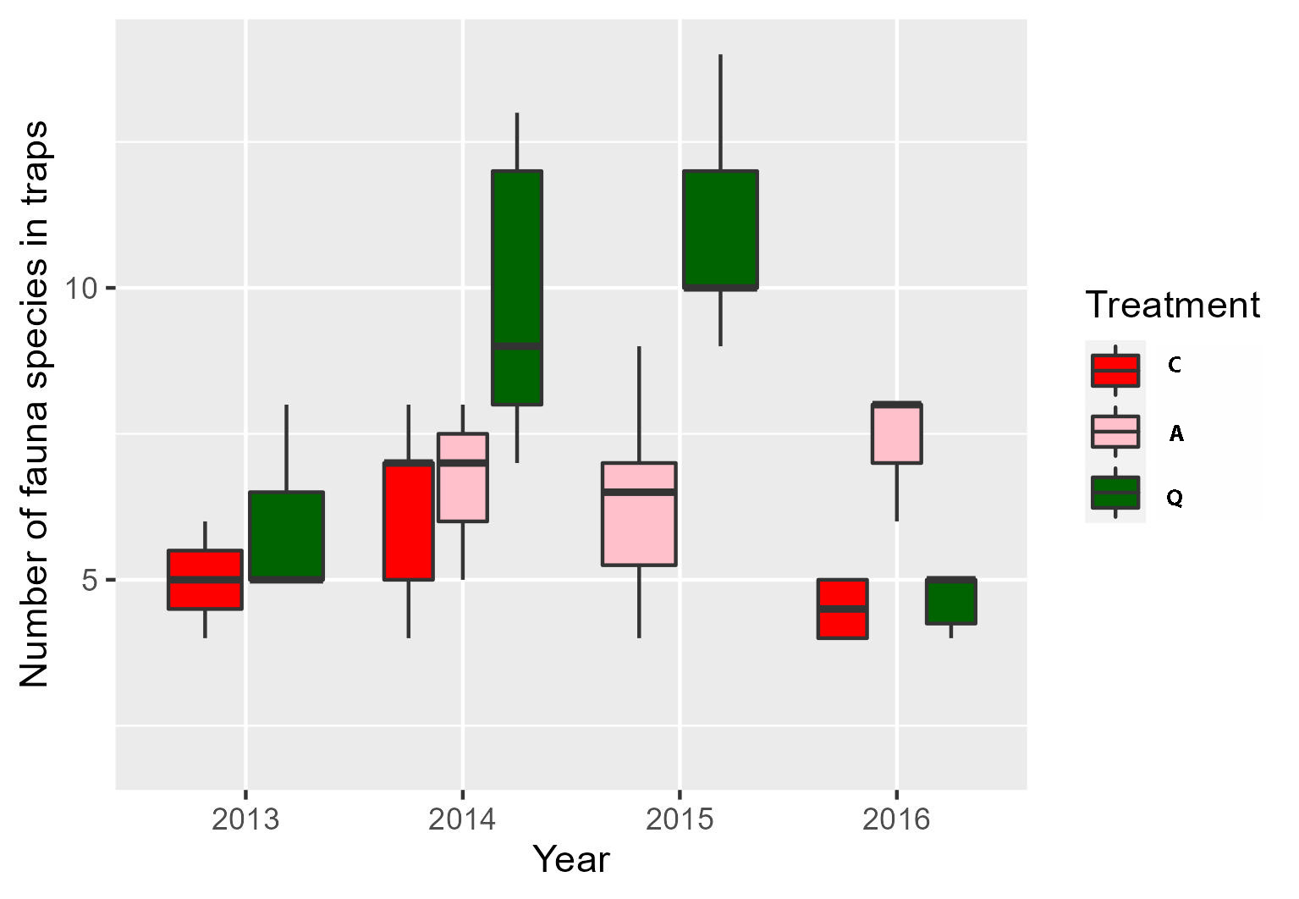
SI Fig. 4. Boxplots of average number of individuals (upper panel) and number of fauna species (lower panel) found in fauna traps deployed in quicklime treated (Q), controls (C) and the sites 7,8,9 (A) in the Porsangerfjord, northern Norway, in the period 2013-2016. No traps were recovered in the original C sites in 2015. PERMANOVA of the content in the fauna traps showed a significant impact of coastline, treatment, and year on the fauna community as well as a significant interaction between year and treatment (SI Table 3). When fitting the environmental variables onto the NMDS ordination, year explained 43 % of the variance in the community structure (i.e., based on r² values in the goodness of fit analysis). Coastline explained about 25 % of the variation and treatment 13 %.

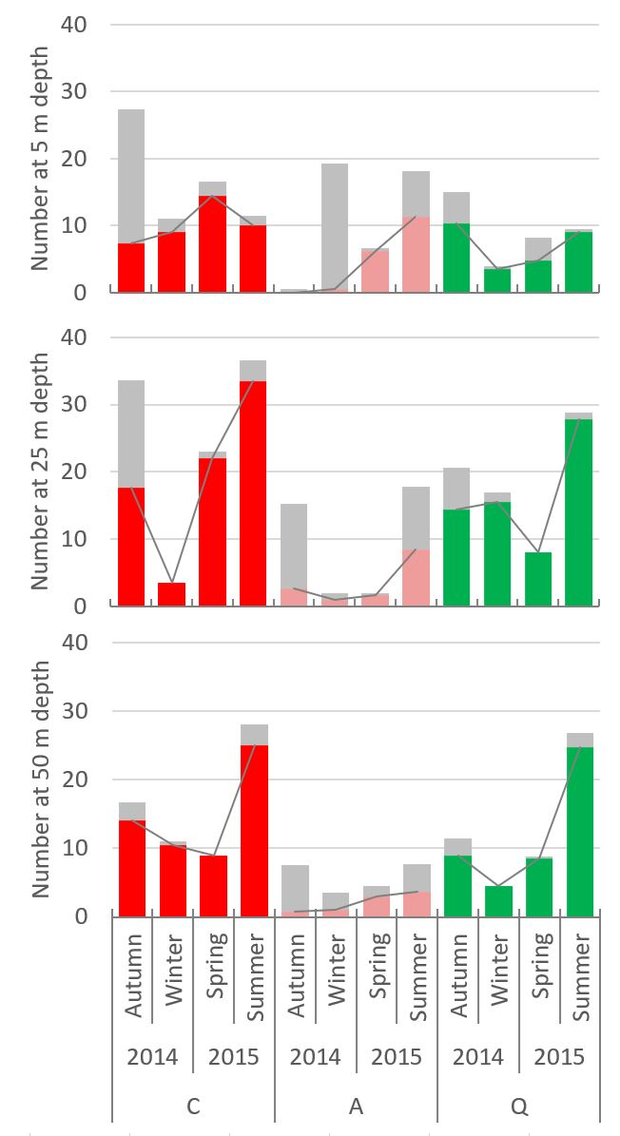

SI Fig. 5. Average number of king crabs in catches at 5, 25 and 50 m depth. Large crabs (dark color and line) and small (<100 mm, gray shaded) crab catches are shown for seasons and the sites controls: C = red; additional sites: A = pink; quicklime treated: Q = green).

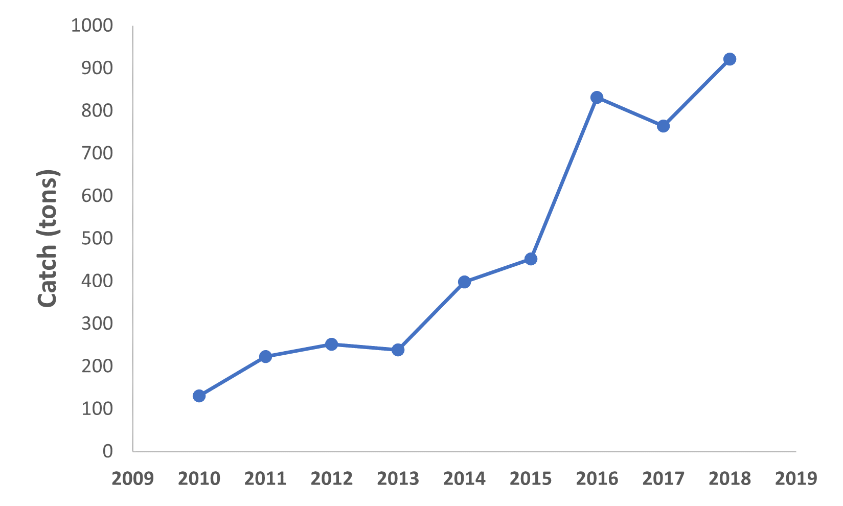
SI Fig. 6. Catch statistics of the red king crab from the Porsangerfjord between 2010 and 2018, based on information from The Norwegian Fishermen’s Sales Organization (https://www.rafisklaget.no/).

