Supplementary material for Marine Biology

Applying acoustic telemetry, vessel tracking and fisher knowledge to investigate and manage fisher-shark conflict at Lord Howe Island, Australia

Jonathan D. Mitchell^{1,2*}, Victoria Camilieri-Asch^{1,2,3}, Sallyann Gudge⁴, Fabrice R.A. Jaine^{5,6}, Victor M. Peddemors⁷, Tim J. Langlois^{1,2}

¹ The University of Western Australia Oceans Institute, Indian Ocean Marine Research Centre, Crawley, Western Australia, Australia
² School of Biological Sciences, The University of Western Australia, Crawley, Western Australia, Australia
³ Queensland University of Technology, Max Planck Queensland Centre, Kelvin Grove, Queensland, Australia
⁴ Western Australia Department of Biodiversity, Conservation and Attractions, Parks and Wildlife, Exmouth WA, Australia
⁵ Integrated Marine Observing System (IMOS), Battery Point, Tasmania, Australia
⁶ Department of Biological Sciences, Macquarie University, North Ryde, New South Wales, Australia
⁷ New South Wales Department of Primary Industries, Fisheries, Mosman, New South Wales, Australia
* jonathan.mitchell@uwa.edu.au ORCID: 0000-0002-1990-1381

Questions used in the survey of LHI charter and recreational fishers
1. What type of operator / fisher are you? i.e. charter operator, recreational fisher, supply for restaurants only – one or all the above?
2. How many people are usually on your vessel fishing? Minimum and Maximum?
3. How regularly do you go out fishing?
4. How frequently do you lose hooked fish to sharks? Roughly how many times per trip?
5. Do you get part of the fish back or do the sharks usually take the whole fish and snap the line?
6. How frequently do you lose bait to sharks? How many times per trip?
7. How much gear do you lose on average per trip due to sharks taking bait/hooked fish?
8. Roughly, what would be the cost of lost gear to that?
9. At what locations do you have most issues with sharks being present/taking fish or bait? In the location groups you usually report catch i.e. lagoon, near shore, shelf LHI, shelf edge LHI, shelf pyramid, shelf edge pyramid, >250m deep?
10. Are there any locations that you go to deliberately where you know there are less sharks? If so, which are these locations?
11. How does depth influence how often depredation happens? Is there a threshold depth after which less shark interactions occur, e.g. 100m, 500m etc.?
12. Do you clean your fish on the move or at a given location? How do you think this affects the shark behaviour?
13. Do you see any seasonality in the patterns of shark depredation?
14. Do you have more issues when targeting demersal species or pelagic species?
15. Do the sharks depredate certain species of fish more than others?
16. How many sharks do you catch as bycatch per trip and per year?
17. Do you release all the sharks you catch? If no, what do you do with ones you keep?
18. Do you report all shark interactions in your catch returns/e-logbook, or only dead bycatch?
19. Is your choice of fishing gear based on reducing depredation events?
20. Do you have more success getting fish past the sharks with alvey reels, handlines, hydraulic winches vs. rod and line?
21. Do customers prefer using rod and line even if they have higher risk of losing fish? Or would they be open to changing gear types if it meant less depredation?
22. How else do you currently try to reduce shark interactions?
23. Do you think shark deterrents could be used in a practical and cost-effective way during fishing, and would you be interested in trialling one of two of them?
24. Do you ever catch other species of sharks?
25. Do you have any other comments, questions or information you would like to share about your experience fishing and with sharks within the marine parks surrounding LHI?

Figures

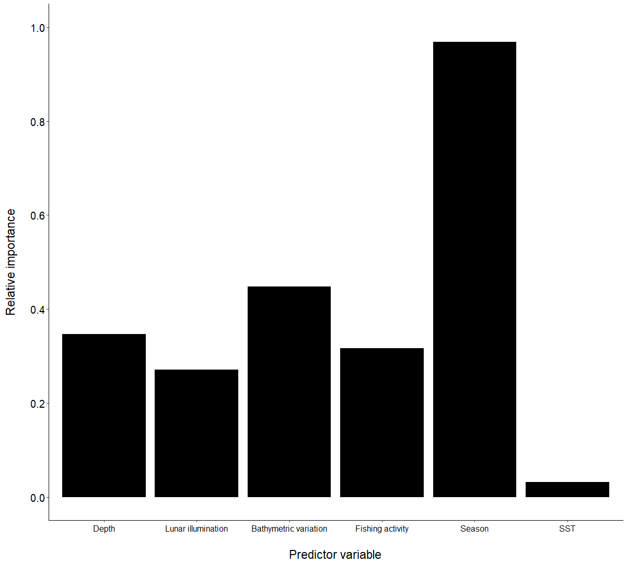

Fig. S1 Relative importance values of all predictor variables tested in the full-subsets Generalised Additive Mixed Model (GAMM) quantifying number of Galapagos shark detections per day. SST = Sea Surface Temperature

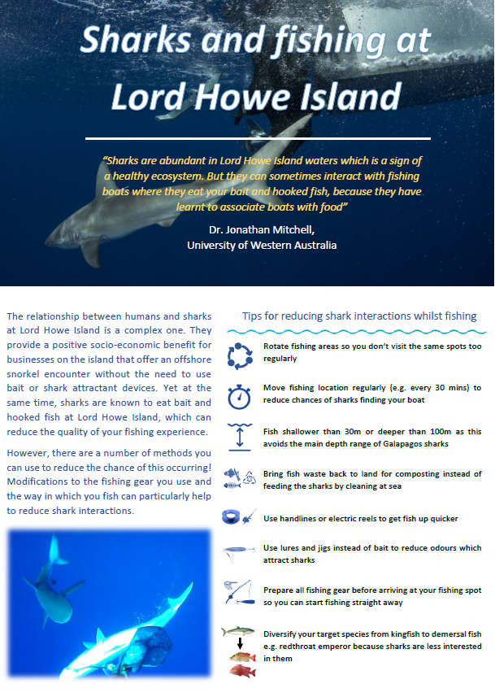

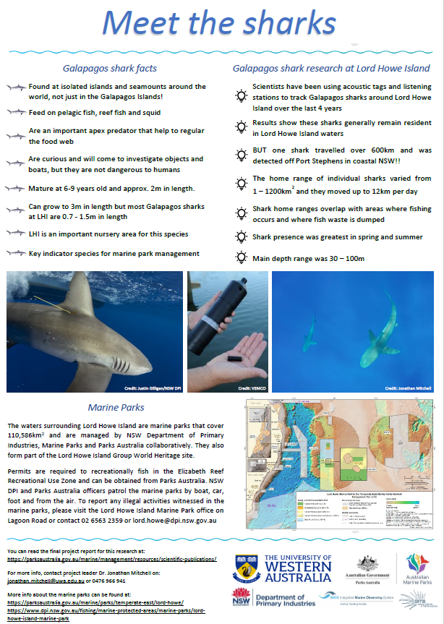

Fig. S2 Two page flyer providing information on Galapagos sharks and a set of best-practice guidelines for minimising shark interactions whilst fishing

