Supplementary Materials

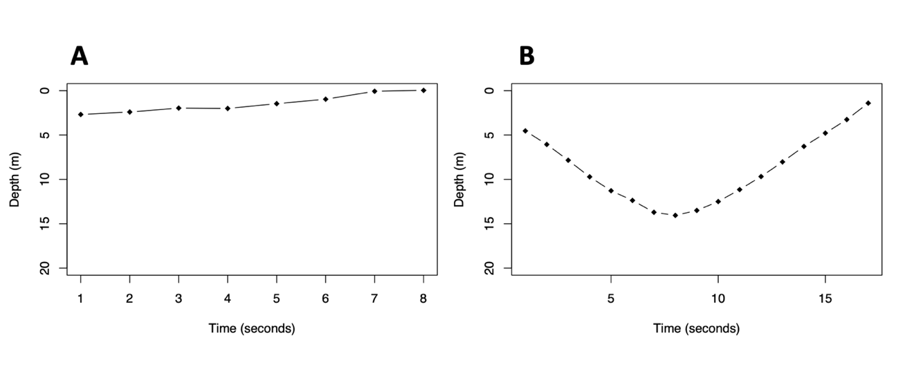
Supplementary 1. Examples of false and real dives recorded by the Time Depth Recorder (TDR) logger where the device was activated based on a pressure threshold (>1.5 metres). A) Depth plotted against time for a dive which was identified as false where the bird is most likely sat on the water. In B) depth is plotted against time for a dive that was identified as real.

Response | Model number | Coefficient | Effect Size | Confidence Intervals | χ² | p value
Number of Evening Dives (females only) | 4 | Intercept  Breeding Stage (pre-laying)  Colony Visit (Present)  Interactive term | 33.862  -1.693  -23.674  8.038 | 23.849, 43.344  -10.330, 6.583  -45.165, -4.103  -18.432, 33.543 | -  0.465  8.323  0.379 | -  >0.05  <0.0001***  >0.05

Supplementary 2. A table representing the results of supplementary mixed effects model 4 where we tested the effect of colony visitation on evening dive number when males were excluded. For each coefficient, confidence intervals and effect sizes were obtained through bootstrapping, whilst χ² and p values were obtained through likelihood ratio tests. Significant predictors are highlighted in bold and significance levels indicated by the number of asterisks (< 0 ‘***’, <0.001 ‘**’, <0.01 ‘*’

