SUPPLEMENTAY MATERIAL
Table S1. Number of visual censuses (25×4 m linear transects) analyzed by island, site, and season. Seasons are denoted as summer (S) and winter (W), followed by the corresponding year.
Island | Site | Season: | S16 | W17 | S17 | W18 | S18 | W19 | S19 | W20 | S20 | W21 | Total
El Hierro | 1 | Faro Orchilla | - | - | - | - | - | - | 6 | 6 | 6 | 6 | 24
 | 2 | Punta Los Mozos | 6 | 6 | 6 | 6 | 6 | 6 | 6 | 6 | 6 | 6 | 60
 | 3 | Tacorón | 6 | 6 | 6 | 6 | 6 | 6 | 6 | 6 | 6 | 6 | 60
 | 4 | El Río | 4 | 6 | 6 | - | 6 | - | - | - | - | - | 22
 | 5 | Roque de Bonanza | 4 | 6 | 6 | 6 | 6 | 6 | 6 | 6 | 6 | 6 | 58
 | 6 | La Caleta | 6 | 6 | 6 | 6 | 6 | 6 | 6 | 6 | 6 | 6 | 60
 | 7 | Tamaduste | 6 | 6 | 6 | 6 | 6 | 6 | 6 | 6 | 6 | 6 | 60
Tenerife | 8 | Punta de Teno | 6 | 6 | 6 | 6 | 6 | 6 | 6 | 6 | 6 | 6 | 60
 | 9 | Puertito de Adeje | 6 | 6 | 6 | 6 | 6 | 6 | 6 | 6 | 6 | 6 | 60
 | 10 | Tajao | 6 | 6 | 6 | 6 | 6 | 6 | 6 | 6 | 6 | 6 | 60
 | 11 | Abades | 6 | 6 | 6 | 6 | 6 | 6 | 6 | 6 | 6 | 6 | 60
 | 12 | Punta del Hidalgo | 6 | 6 | 6 | 6 | 6 | - | 6 | 6 | 6 | 6 | 54
 | 13 | El Prís | - | - | - | - | - | - | 6 | 6 | 6 | 6 | 24
Lanzarote | 14 | Playa Quemada | 5 | 6 | 6 | 6 | 6 | 6 | 6 | 6 | 6 | 6 | 59
 | 15 | Playa Chica | - | - | - | - | - | - | 6 | 5 | 6 | 6 | 23
 | 16 | Los Cocoteros | 6 | 6 | 6 | 6 | 6 | 6 | 6 | 6 | 6 | 6 | 60
 | 17 | Charco del Palo | 5 | 6 | 6 | 6 | 6 | 6 | 6 | 6 | 6 | 6 | 59
 | 18 | Mojón Blanco | 4 | 6 | - | - | 6 | 6 | - | - | - | - | 22
 | 19 | Órzola | - | - | 6 | 6 | 6 | 6 | 6 | 6 | 6 | 6 | 48
 | 20 | Montaña Amarilla | - | - | - | - | - | - | 6 | 6 | 6 | 6 | 24
 |  | Total | 82 | 90 | 90 | 84 | 96 | 84 | 108 | 107 | 108 | 108 | 957

Figure S1. Pairwise correlation matrix of explanatory variables used in the GAMs.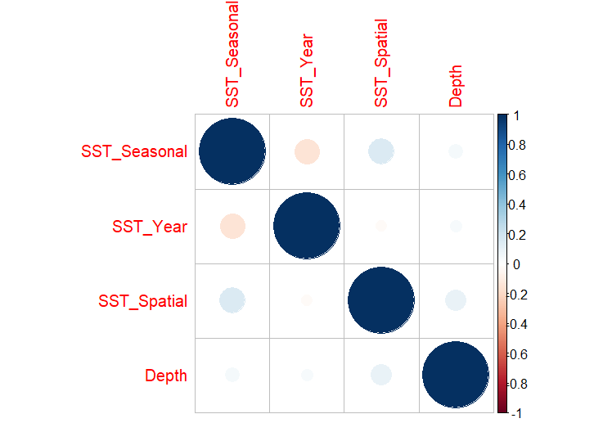
Table S2. Observed concurvity values for each predictor in the fitted GAMs.
A) FISH ASSEMBLAGE | Predictor | Obs. concurvity
Aulostomus strigosus | Depth | 0.5139452
 | SST_Seasonal | 0.1215917
 | SST_Spatial | 0.6062798
 | SST_Year | 0.5265312
Canthigaster capistrata | Depth | 0.4967303
 | SST_Seasonal | 0.1906109
 | SST_Spatial | 0.5051109
 | SST_Year | 0.5425153
Similiparma lurida | Depth | 0.4440214
 | SST_Seasonal | 0.2425903
 | SST_Spatial | 0.3499736
 | SST_Year | 0.5410280
Sparisoma cretense | Depth | 0.5425810
 | SST_Seasonal | 0.3550005
 | SST_Spatial | 0.6912071
 | SST_Year | 0.4883522
Thalassoma pavo | Depth | 0.4429039
 | SST_Seasonal | 0.08503193
 | SST_Spatial | 0.3417705
 | SST_Year | 0.6643893
B) BIOGEOGRAPHIC AFF. | Predictor | Obs. concurvity
TROPICAL | Depth | 0.3682213
 | SST_Spatial | 0.2647369
 | SST_Year | 0.04819501
WARM-TEMPERATE | SST_Seasonal | 0.1474854
 | SST_Spatial | 0.1144661
 | SST_Year | 0.5693493
TEMPERATE | Depth | 0.4601916
 | SST_Spatial | 0.1090508

