Title: Examining coastal habitat co-utilization of chimaeras using social network analysis
Authors: Laura Avila Turriago^{1*}, David Moreno¹, Jayson Semmens¹

¹Institute for Marine and Antarctic Studies, University of Tasmania, Hobart, Australia
*Corresponding author: laura.avilaturriago@utas.edu.au

Laura Avila Turriago 0009-0000-7242-4329, David Moreno 0000-0002-9474-1082,
Jayson Semmens 0000-0003-1742-6692

Table S1 Tagging details of adult elephant fish selected for the social network analysis

ID | Sex | TL (cm) | Manufacturer | Tag
EF42 | F | 78 | Innovasea | V16-6L
EF25 | F | 95 | Innovasea | V16-4L
EF24 | F | 90 | Innovasea | V16-4L
EF23 | F | 89 | Innovasea | V16-4L
EF21 | F | 91 | Innovasea | V16-4L
EF18 | F | 86 | Innovasea | V9A-2L
EF16 | F | 81 | Innovasea | V9A-2L
EF6 | F | 85 | Innovasea | V16-4L
EF8 | F | 89 | Innovasea | V16-4L
EF38 | F | 96 | Innovasea | V16-4L
EF36 | F | 88 | Innovasea | V16-4L
EF34 | F | 76 | Innovasea | V13A-1L
EF32 | F | 90 | Innovasea | V16-4L
EF31 | F | 80 | Innovasea | V13-1L
EF29 | F | 91 | Innovasea | V16-4L
EF26 | F | 83 | Innovasea | V16-4L
EF17 | F | 85 | Innovasea | V9A-2L
EF13 | F | 85 | Innovasea | V16-4L
EF12 | F | 88 | Innovasea | V16-4L
EF7 | F | 91 | Innovasea | V16-4L
EF5 | F | 88 | Innovasea | V16-4L
EF4 | F | 91 | Innovasea | V16-4L
EF46 | M | 67 | Innovasea | V16-4L
EF45 | M | 75 | Innovasea | V16-4L
EF44 | M | 70 | Innovasea | V13A-1L
EF43 | M | 73 | Innovasea | V13A-1L
EF41 | M | 71 | Innovasea | V16-4L
EF39 | M | 71 | Innovasea | V16-4L
EF35 | M | 68 | Innovasea | V13A-1L
EF30 | M | 74 | Innovasea | V13-1L
EF28 | M | 73 | Titley | T17
EF27 | M | 72 | Innovasea | V9A-2L
EF14 | M | 70 | Innovasea | V16-4L
EF10 | M | 71 | Titley | T17
EF3 | M | 75 | Innovasea | V16-4L
EF2 | M | 71 | Innovasea | V16-4L
EF1 | M | 74 | Innovasea | V16-4L

Association matrix

Table S2 Association matrix of adult elephant fish in a) 2012, and b) 2013. The first half of the matrix correspond to the binary matrix where 0 represents no association and 1 represents association. The other half correspond to the simple ratio index where the continuous values (0-1) represent the strength of the association. Females in blue. Numbers in bold are the highest associations (>1)
2012
2013
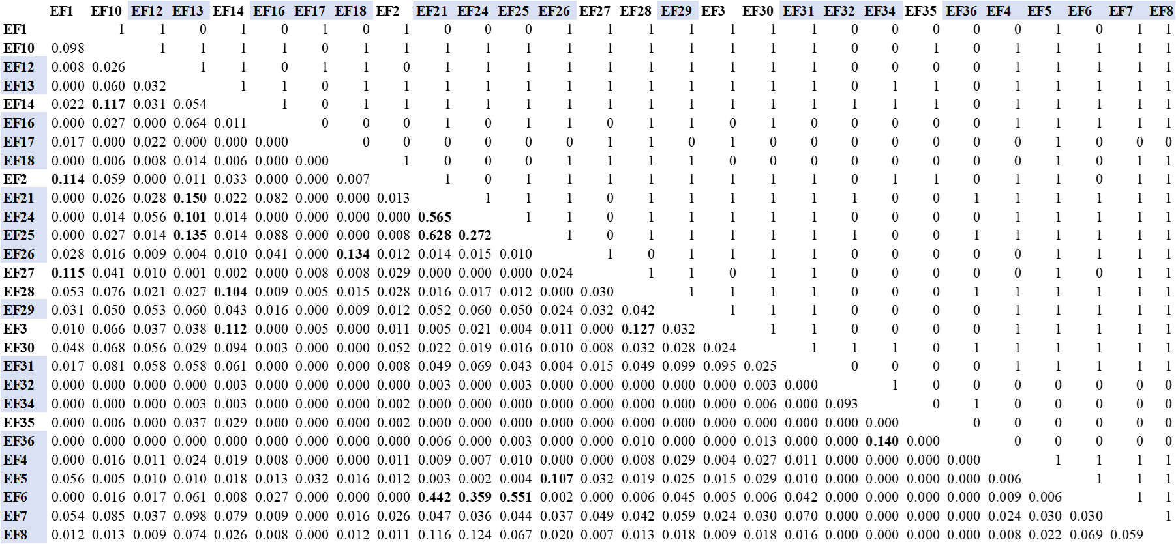
a
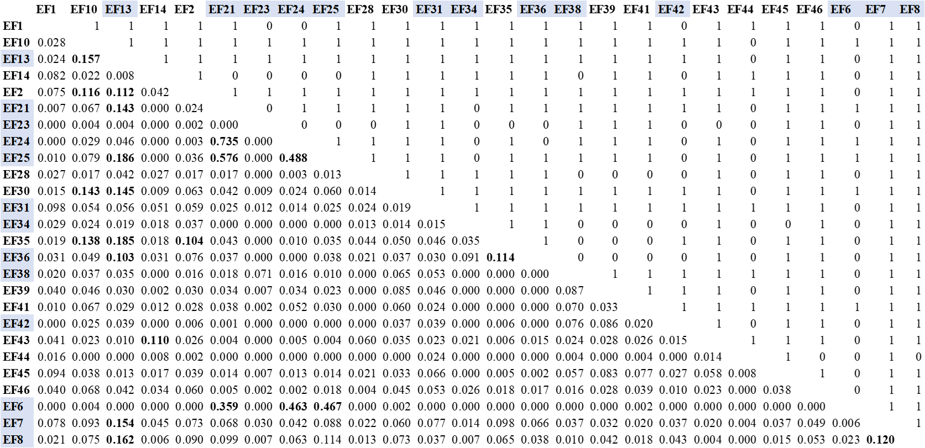
b

Influence of detections in SNA

Relationship between detected Days, detections and strength
We calculate a Generalized Linear Model (GLM) and Pearson correlation coefficient (r) using IGRAPH to establish the relationship between different acoustic biotelemetry aspects that could impact the SNA. We found a positive relationship between detected days and the strength calculated for each individual (r = 0.92, $P<$ 0.001) (Fig. S1). The more detected days an individual has, the strength increases with a coefficient of 0.0035. The GLM model had an AIC value of –3.67, indicating low information loss and providing support for the model’s adequacy in describing the relationship. These results confirmed the susceptibility of SNA to the acoustic biotelemetry information such as detected days; therefore, it is recommended to be cautious in interpreting the results.
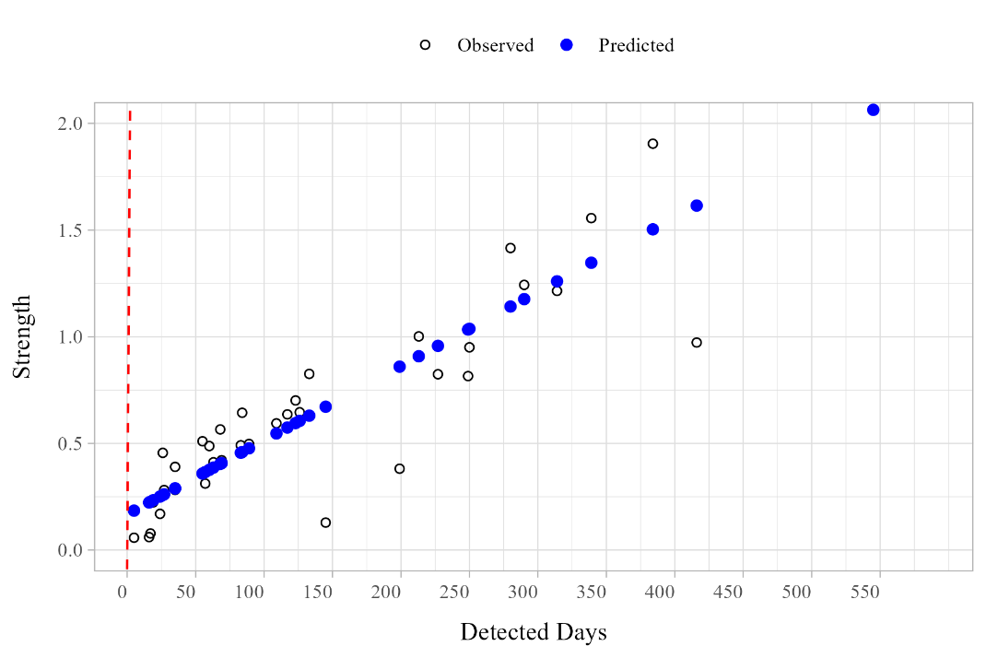
Fig. S1 Performance of the Generalized Linear Model (GLM) of the relationship between detected days and strength of each elephant fish. The outliers were removed from this graph to better capture the relationship. Black circles without filling are the observed values. Blue filled circles are the predicted values. Red dashed line is the p-value

Comparing shallow and deep networks to assess depth influence on elephant fish connectivity

To assess how depth and array receiver influences the network structure of elephant fish, additional analyses were conducted using the 2012 dataset. Two networks were constructed: a shallow network (~7.5–11 m depth) encompassing the UP and LP areas (13 stations) and a deeper network (~25 m depth) comprising FHB, E, and H (35 stations). For the shallow network, the same seven sentinel receivers retained in the main analysis were used. Association definitions remained consistent with the main analysis, a 12-hour temporal window and a 550 m spatial threshold.

The shallow network included 27 individuals (18 females and 9 males), while the deeper network included 18 individuals (9 females and 9 males). The shallow network showed a significant non-random structure (observed coefficient of variation = 67.68; random = 66.94; P < 0.05), whereas the deeper network did not (observed coefficient of variation = 36.27; random = 37.38; P = 0.63). The shallow network contained 231 dyads, compared to 78 dyads in the deeper network. As the shallow network exhibited non-random co-occurrences and was dominated by females, these results reinforce that the shallow coastal areas of southeastern Tasmania represent the main shared-use habitat for elephant fish, particularly females.

Both networks displayed moderate modularity (shallow: Q = 0.33; deep: Q = 0.31). The shallow network was divided into four clusters, while the deeper network contained three (Fig. S2). The resident female community remained consistent with previous analyses (Fig. S2a, blue cluster), although mixed-sex groups appeared subdivided into smaller clusters.

Closer inspection indicated that these subdivisions reflected differences in detection timing rather than true biological separation. For example, within the shallow network, mixed-sex individuals moving seasonally through UP and LP were separated into three clusters: one detected throughout most of the year except winter (Fig. S2a, green cluster), one detected only early in the year (females 5, 26, and 18; Fig. S2a, orange cluster), and another detected only late in the year after tagging in December (females 32, 34, and 36; Fig. S2a, yellow cluster). A similar pattern was observed in the deeper network which was subdivided into three groups according to detection periods: one detected most of the year except winter (Fig. S2b, green cluster), one comprising females 31, 29, and 4, last detected in curtain H (Fig. S2b, orange cluster), and another detected primarily between March and April in curtain E (Fig. S2b, pink cluster).

Although these additional analyses helped evaluate elephant fish co-utilization across depth gradients, separating the networks resulted in the loss of important information on overall spatial connectivity, as individuals move throughout the entire estuary.

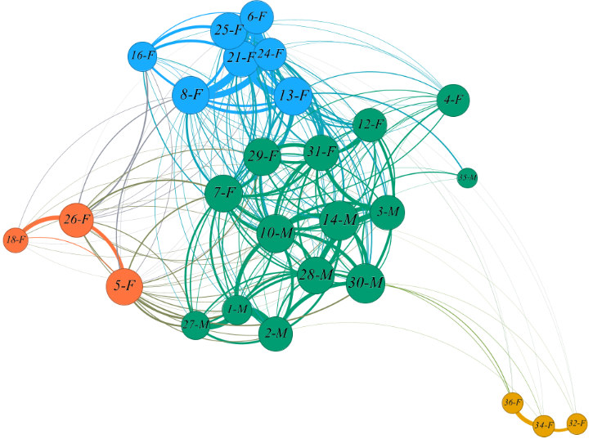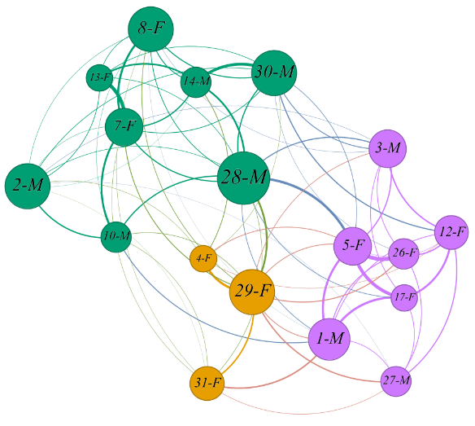
a
b

Fig. S2 Co-occurrence networks of elephant fish in 2012. a) Shallow and b) deeper network. The individuals (nodes) are connected to others through the associations (edges) defined on the spatial and temporal threshold. Each cluster is represented by a different colour (Blue nodes represent the resident female community). Node size represents the degree of each individual. The thickness of the edges denotes the strength of the association (simple ratio index). The labels indicate the name of the elephant fish and sex. Network visualization was generated using Gephi software (Bastian et al. 2009)

