SUPPORTING INFORMATION

Disentangling the main causes and potential origin of an unusual razorbill (Alca torda) die-off in the Mediterranean Sea

Ángela Loring¹, Joan Giménez², Sara Dallarés³, Salvador García-Barcelona² and Joan Navarro^{1,*}

¹ Institut de Ciències del Mar (ICM), CSIC, Barcelona, Spain
² Centro Oceanográfico de Málaga (COMA), Instituto Español de Oceanografía (IEO-CSIC), Málaga, Spain
³ Departament de Biologia Animal, Biologia Vegetal i d’Ecologia, Universitat Autònoma de Barcelona, Cerdanyola del Vallès, 08193, Barcelona, Spain

*Corresponding author:
joan@icm.csic.es

Table S1. Reference stable isotope values of razorbills from different sampling areas (see Figure 1 for geographic locations). For each study, the sampling year, tissue type, sample size (n), age category, period, and bibliographic reference are provided.
Sampling area | Country | Year | Tissue | n | Age | Period | Metric | δ¹³C (‰) | δ¹⁵N (‰) | Reference
Isle of May (1) | Scotland | 2007-2008 | Body feathers | 16 | Adults | Non-breeding | Median± SD | -16.47±0.71 | 16.44±1.4 | St. John Glew et al. 2019
Isle of May (1) | Scotland | 2014-2015 | Body feathers | 9 | Adults | Non-breeding | Median± SD | -16.48±0.68 | 17.79±0.46 | St. John Glew et al. 2019
Isle of May (1) | Scotland | 2014-2015 | Cheek feathers | 7 | Adults | Non-breeding | Median± SD | -16.77±0.31 | 15.76±0.65 | St. John Glew et al. 2019
Labrador Sea (2) | Greenland | 2011 | Back feathers | 15 | Adults | Non-breeding | Mean± SE | -17.95±0.22 | 12.11±0.26 | Linnebjerg et al. 2013
Labrador Sea (2) | Greenland | 2011 | Blood | 14 | Adults | Non-breeding | Mean± SE | -20.2±1.45 | 12.46±0.02 | Linnebjerg et al. 2013
Labrador Sea (2) | Greenland | 2011 | Throat feathers | 15 | Adults | Non-breeding | Mean± SE | -17.32±0.11 | 13.54±0.37 | Linnebjerg et al. 2013
Labrador Sea (3) | Canada | 2015 | Blood | 13 | Adults | Non-breeding | Mean± SD | -19.4±0.11 | 14.53±0.17 | Pratte et al. 2017
Newfoundland (4,5) | Canada | 2017-2020 | Head feathers | 34 | Adults | Pre-breeding | Mean± SD | -18.95±0.06 | 13.9±0.1 | Runnells et al. 2024
Newfoundland (4,5) | Canada | 2017 | Blood | 20 | Adults | Non-breeding | Mean± SD | -19.73±0.31 | 13.79±0.26 | Jenkins & Davoren 2021
Newfoundland (4,5) | Canada | 2017 | Blood | 17 | Adults | Non-breeding | Mean± SD | -19.92±0.23 | 14.08±0.25 | Jenkins & Davoren 2021
Gulf St. Lawrence (6) | Canada | 2006-2007 | Blood | 20 | Adults | Non-breeding | Mean± SD | -19.3±0.1 | 15.2±0.3 | Lavoie et al. 2012
Gulf of Maine (7) | Canada | 2005 | Blood | 10 | Adults | Non-breeding | Mean± SD | -19.94±0.32 | 11.64±0.41 | Bond & Diamond 2007
Gulf of Maine (7) | Canada | 2005 | Blood | 10 | Chicks | Pre-breeding | Mean± SD | -20.09±0.13 | 11.4±0.42 | Bond & Diamond 2007

Figure S1. Principal Component Analysis (PCA) performed on razorbills biometric measurements

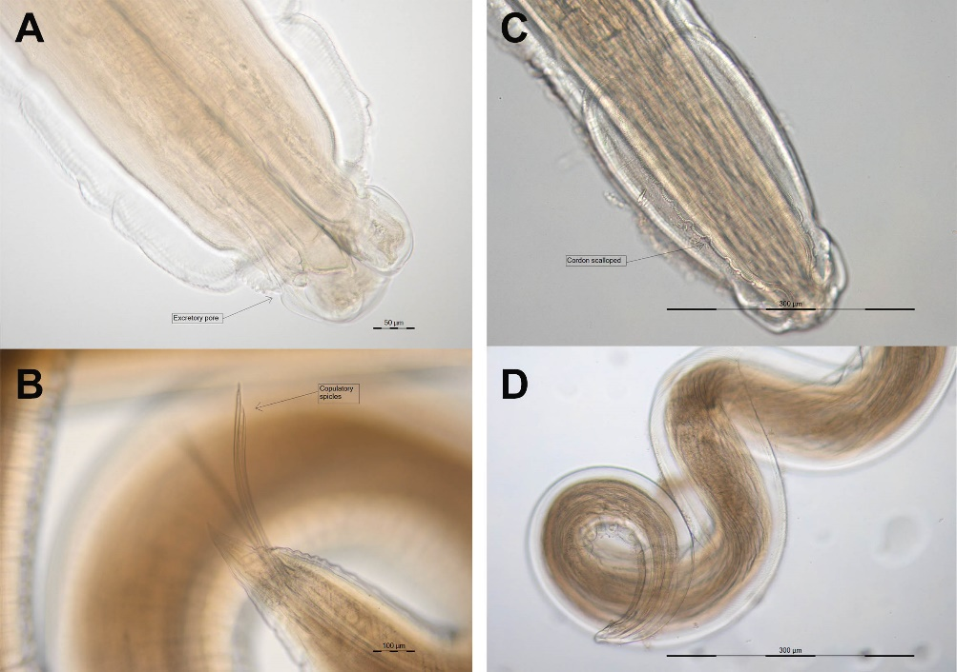
Figure S2. Nematodes found in digestive tracts of razorbills collected in Malaga coasts (Spain) between November and December 2020. Contracaecum variegatum head (A) and male spicles (B). Cosmocephalus obvelatus head (C) and male tale (D).

References
Bond, A. L., & Diamond, A. W. (2007). Comparing adult and chick diet in two alcid species using stable isotope analysis. Challenges in Environmental Management in the Bay of Fundy-Gulf of Maine, 176.
Jenkins, E. J., & Davoren, G. K. (2021). Seabird species‐and assemblage‐level isotopic niche shifts associated with changing prey availability during breeding in coastal Newfoundland. Ibis, 163, 183-196.
Lavoie, R. A., Rail, J. F., & Lean, D. R. (2012). Diet composition of seabirds from Corossol Island, Canada, using direct dietary and stable isotope analyses. Waterbirds, 35, 402-419.
Linnebjerg, J. F., Fort, J., Guilford, T., Reuleaux, A., Mosbech, A., & Frederiksen, M. (2013). Sympatric breeding auks shift between dietary and spatial resource partitioning across the annual cycle. PLoS One, 8, e72987.
Pratte, I., Robertson, G. J., & Mallory, M. L. (2017). Four sympatrically nesting auks show clear resource segregation in their foraging environment. Marine Ecology Progress Series, 572, 243-254.
Runnells, E. S., Montevecchi, W. A., & Davoren, G. K. (2024). Spatiotemporal and isotopic niche overlap among Atlantic puffins, razorbills, and common murres during the non-breeding season in the Northwest Atlantic. Marine Ecology Progress Series, 739, 241-256.
St John Glew, K., Wanless, S., Harris, M. P., Daunt, F., Erikstad, K. E., Strøm, H., ... & Trueman, C. N. (2019). Sympatric Atlantic puffins and razorbills show contrasting responses to adverse marine conditions during winter foraging within the North Sea. Movement Ecology, 7, 1-14.

