Supplementary material for “The cymothoid isopod Anilocra chromis is negatively associated with multiple metrics of host condition in the Caribbean damselfish Chromis multilineata”
Jan-Alexis Barry¹ (ORCID: 0009-0005-4335-4428), Kyle G. Jerris¹ (ORCID: 0000-0002-1389-1872), Teresa R. Turner² (000-0002-8397-6900), Jenilee B. Robinson² (ORCID: 0000-0002-7740-4009) , Matthew D. Nicholson³ (ORCID: 0000-0003-1367-8534) , Paul C. Sikkel ^{1,3,4} (ORCID: 0000-0002-2652-7498)
- Center of Marine and Environmental Studies, University of the Virgin Islands, St. Thomas, United States Virgin Islands
- College of Science and Mathematics, University of the Virgin Islands, St. Thomas, United States Virgin Islands
3. Department of Marine Biology and Ecology, Rosenstiel School of Marine, Atmospheric and Earth Science, University of Miami, 4600 Rickenbacker Causeway, Miami FL 33146 USA
4. Water Research Group, Unit for Environmental Sciences and Management, North-West University, Potchefstroom 2520, South Africa.
Corresponding author: Department of Marine Biology and Ecology, Rosenstiel School of Marine, Atmospheric and Earth Science, University of Miami, 4600 Rickenbacker Causeway, Miami FL 33146 USA
Paul Sikkel– paul.sikkel@gmail.com
Matthew Nicholson – sharkynichol@gmail.com
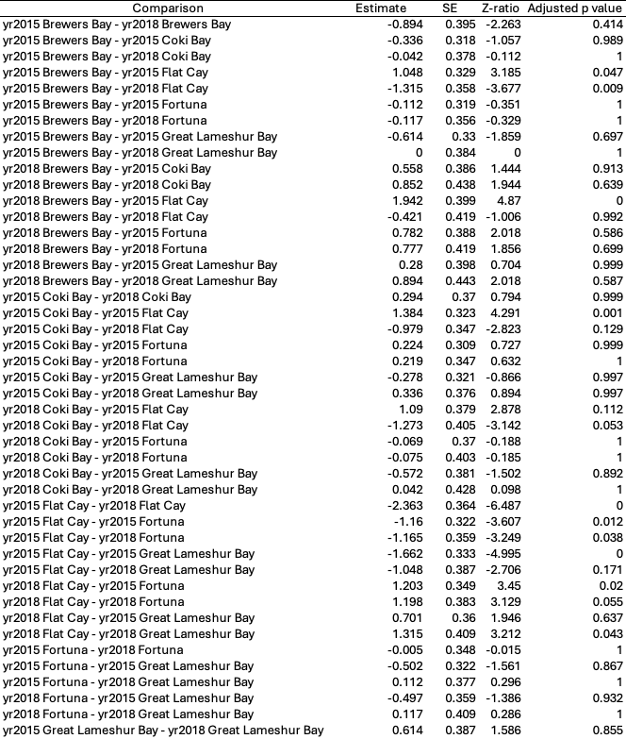
Table S1: Model outputs for the analysis of the influence of year and site on parasite prevalence.
Table S2: Model output for the analysis of the incidence of infection with additional parasites for host Chromis multilineata with and without Anilocra chromis infestation.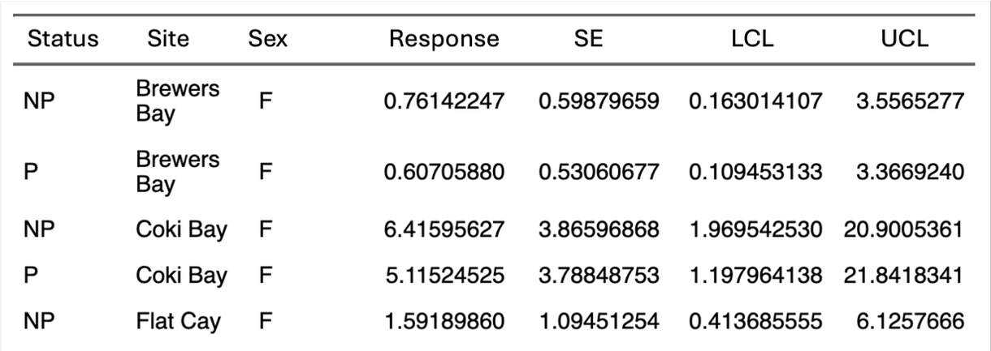

Table S3: Model output from the analysis of the influence of Anilocra chromis on the gonad size of Chromis multilineata.
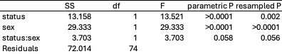

Table S4: Model output for the analysis of the influence of Anilocra chromis presence on the biting behavior of Chromis multilineata.
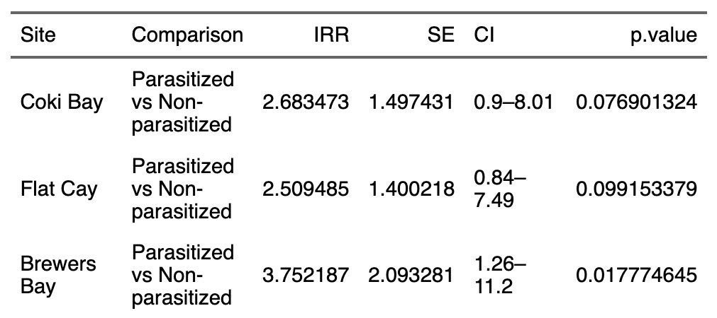

Table S5: Model output for the analysis of the influence of Anilocra chromis presence on the fin beats by Chromis multilineata.
