Pharmacist participation in hospital ward teams and hospital readmission rates among people with dementia: a randomized controlled trial

Appendix 1

European Journal of Clinical Pharmacology

Maria Gustafsson, PhD^{1,2}, Maria Sjölander, PhD¹, Bettina Pfister, MPharm¹, Jeanette Jonsson, MSc Pharm¹ , Jörn Schneede, PhD¹ , Hugo Lövheim, PhD²

¹ Department of Pharmacology and Clinical Neuroscience, Division of Clinical Pharmacology, Umeå University, Umeå, Sweden
² Department of Community Medicine and Rehabilitation, Geriatric Medicine, Umeå University, Umeå, Sweden

Corresponding Author:
Maria Gustafsson, Department of Pharmacology and Clinical Neuroscience, Umeå University, Umeå, Sweden, SE-901 87 Umeå, Sweden. Phone: +46 90 785 35 62;
Fax: +46 90 12 04 30
E-mail: maria.gustafsson@umu.se
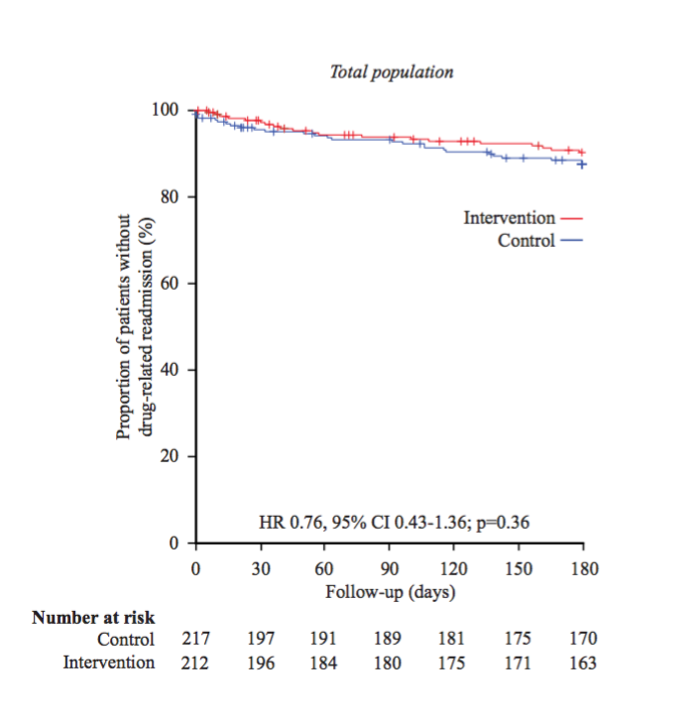
Figure 1 Kaplan-Meier plots for drug-related readmissions (certain and probable) within 180 days in the total sample. HR and CI according to univariable Cox regression analysis and p-value from log rank test.

HR and CI according to univariable Cox regression analysis and p-value from log rank test.

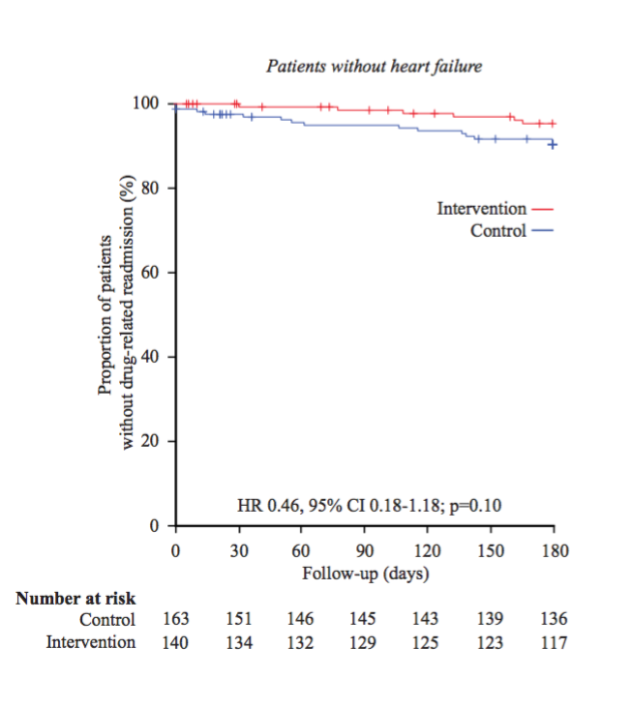

Figure 2 Kaplan-Meier plots for drug-related readmissions (certain and probable) within 180 days in the subgroup of people without heart failure. HR and CI according to univariable Cox regression analysis and p-value from log rank test.

HR and CI according to univariable Cox regression analysis and p-value from log rank test.

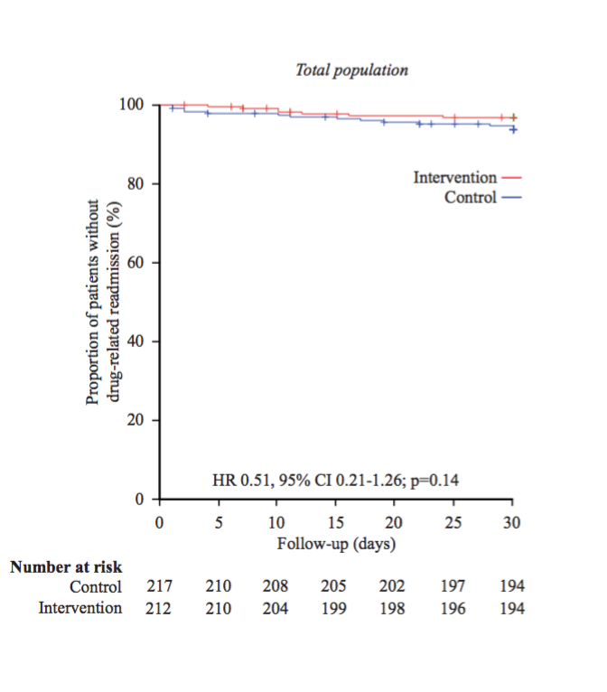

Figure 3 Kaplan-Meier plots for drug-related readmissions (certain and probable) within 30 days in the total sample. HR and CI according to univariable Cox regression analysis and p-value from log rank test.

HR and CI according to univariable Cox regression analysis and p-value from log rank test.

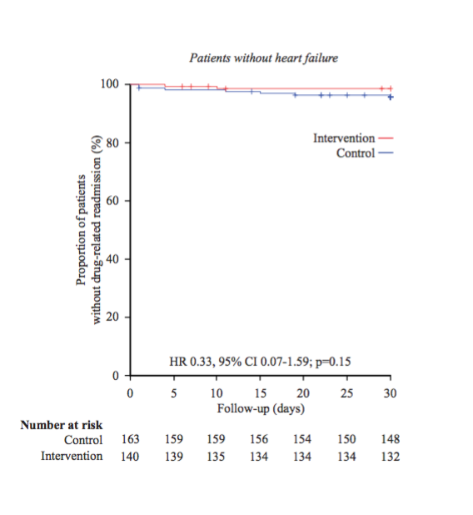
Figure 4 Kaplan-Meier plots for drug-related readmissions (certain and probable) within 30 days in the subgroup of people without heart failure. HR and CI according to univariable Cox regression analysis and p-value from log rank test.

HR and CI according to univariable Cox regression analysis and p-value from log rank test.

