European Journal of Clinical Pharmacology
Electronic Supplementary Material
INFLUENCE OF GENETIC CO-FACTORS ON THE POPULATION PHARMACOKINETIC MODEL FOR CLOPIDOGREL AND ITS ACTIVE THIOL METABOLITE
Dorota Danielak¹, Marta Karaźniewicz-Łada, Anna Komosa, Paweł Burchardt, Maciej Lesiak, Łukasz Kruszyna, Agnieszka Graczyk-Szuster, Franciszek Główka
¹ Department of Physical Pharmacy and Pharmacokinetics, Poznan University of Medical Sciences, Poznań, Poland, e-mail: danielak@ump.edu.pl

Supplementary Figure 1. Clopidogrel metabolic pathway. The CYP-450 enzymes involved in the metabolism are presented according to Kazui et al. (Drug Metab. Dispos. 2010;38:92–9.). CES-1 - carboxylesterase 1.

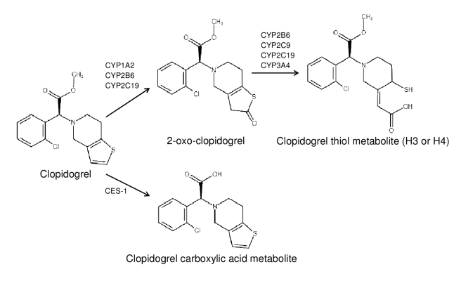

Supplementary Figure 2: A, Conditional weighted residuals (CWRES) versus time. B, CWRES versus predicted concentrations. The solid lines represent the line of identity in A and B, and the line y=0 in C and D.

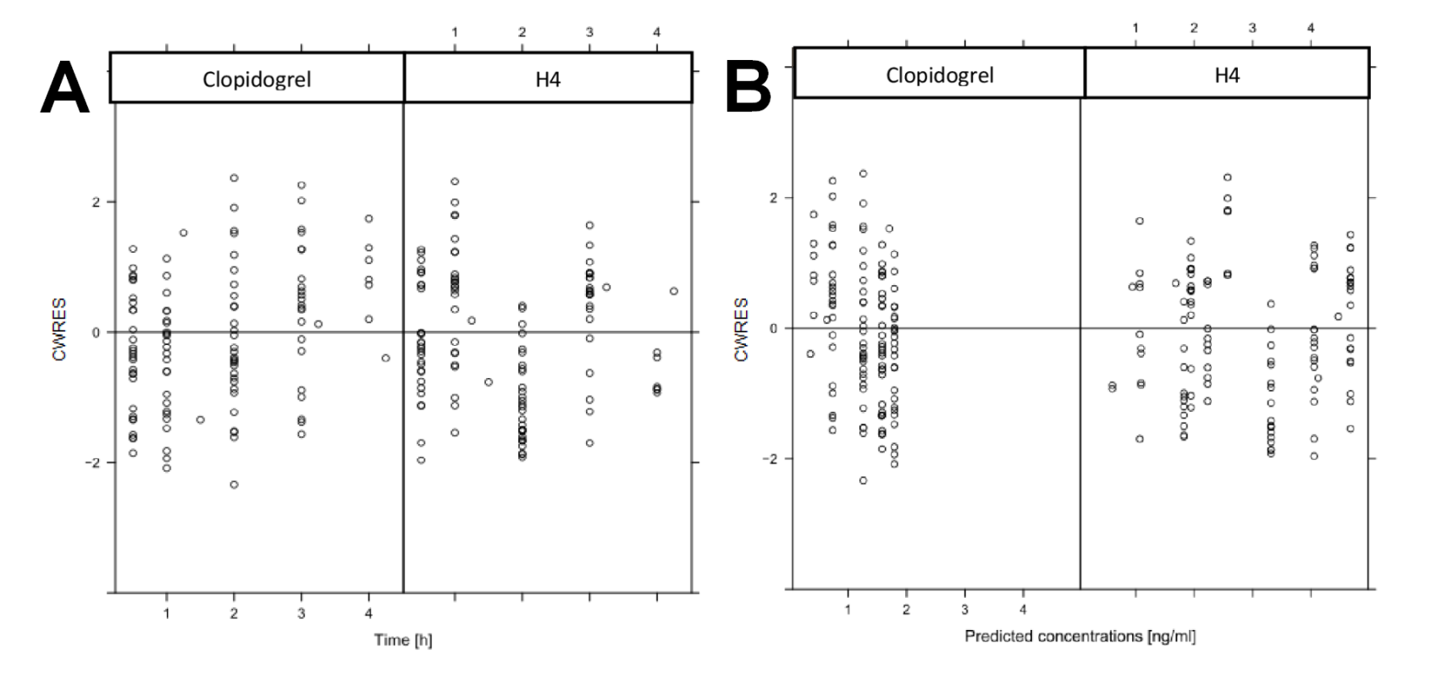
Supplementary Table 1: Optimization of model structure prior to covariate analysis.
Model |  | OFV | dOFV | Included?
Base model | K_{a} = θ₁ × e^{η}₁  CL = θ₂ × e^{η}₂  V2/F = θ₃ × e^{η}₃  FM = θ₄ × e^{η}₄  V3/F = θ₅ × e^{η}₅  Q/F = θ₆ | 506.99 | - | -
Addition of lag time | ALAG1 = θ₇ | 510.930 | 3.94 | No
Introduction of first pass-metabolism | K13 = θ₇ | 516.045 | 9.055 | No
Fixed compartment volumes | V2 = V3 | 824.499 | 318.813 | No
Non-linear metabolism of clopidogrel to H4 | KM = θ₇  VMAX = θ₈ | 658.065 | 151.672 | No
OFV – objective function value, dOFV – difference in the objective function value

Supplementary Table 2. Step 1 of a forward-inclusion backward-elimination covariate selection.

Pharmacokinetic parameter | Covariate | Drop in OFV | p | Significant?
CL/F | AGE | 0.18742 | 0.6651
 | WEIGHT | 0.95058 | 0.3296
 | BMI | 0.44010 | 0.5071
 | OBESITY | 0.36178 | 0.5475
 | SEX | 0.80401 | 0.3699
 | DIABETES MELLITUS | 0.25300 | 0.6150
 | PPI | 0.15739 | 0.6916
 | STATINS | 0.21398 | 0.6437
 | CYP2C19*2 | 0.58309 | 0.4451
 | CYP2C19*17 | 0.52110 | 0.4704
 | ABCB1 3435 TT | 4.53027 | 0.0333 | YES
 | CYP3A4*1G | 2.79143 | 0.0948
FM | AGE | 0.74827 | 0.3870
 | WEIGHT | 0.02316 | 0.8790
 | BMI | 0.51448 | 0.4732
 | OBESITY | 0.85586 | 0.3549
 | SEX | 1.03016 | 0.3101
 | DIABETES MELLITUS | 0.00597 | 0.9384
 | PPI | 0.20144 | 0.6536
 | STATINS | 0.03331 | 0.8552
 | CYP2C19*2 | 14.49229 | 0.0001 | YES
 | CYP2C19*17 | 5.64373 | 0.0175 | YES
 | ABCB1 3435 TT | 1.64051 | 0.2002
 | CYP3A4*1G | 2.1522 | 0.1424
K₁₂ | AGE | 0.74827 | 0.3870
 | WEIGHT | 1.2655 | 0.2606
 | BMI | 0.06895 | 0.7929
 | OBESITY | 0.23077 | 0.6310
 | SEX | 5.11594 | 0.0237 | YES
 | DIABETES MELLITUS | 3.46269 | 0.0628
 | PPI | 0.28910 | 0.5908
V2/F | AGE | 1.72706 | 0.1888
 | WEIGHT | 2.60213 | 0.1067
 | BMI | 0.23794 | 0.6257
 | OBESITY | 0.34052 | 0.5595
 | SEX | 5.45637 | 0.0194 | YES
 | DIABETES MELLITUS | 0.98102 | 0.3219
V3/F | AGE | 0.25529 | 0.6134
 | WEIGHT | 0.00116 | 0.9729
 | BMI | 2.01532 | 0.1557
 | OBESITY | 0.07283 | 0.7873
 | SEX | 0.11846 | 0.7307
 | DIABETES MELLITUS | 0.18695 | 0.6655

Supplementary Table 3. Step 2 of a forward-inclusion backward-elimination covariate selection, after including CYP2C19*2 as a covariate on FM

Pharmacokinetic parameter | Covariate | Drop in OFV | p | Significant?
CL/F | AGE | -1.98190 | -
 | WEIGHT | -1.07394 | -
 | BMI
 | OBESITY
 | SEX | -0.33616 | -
 | DIABETES MELLITUS | -0.06814 | -
 | PPI
 | STATINS
 | CYP2C19*2 | -0.27884 | -
 | CYP2C19*17 | -1.04557 | -
 | ABCB1 3435 TT | -2.07771 | -
 | CYP3A4*1G | 1.77473 | 0.1828
FM | AGE | -1.68202 | -
 | WEIGHT | -1.75417 | -
 | BMI
 | OBESITY
 | SEX | -2.17480
 | DIABETES MELLITUS | 0.35216 | 0.5529
 | PPI
 | STATINS
 | CYP2C19*17 | 0.41426 | 0.5198
 | ABCB1 3435 TT | 2.47309 | 0.1158
 | CYP3A4*1G | -0.4354 | -
K₁₂ | AGE | -2.03425 | -
 | WEIGHT | -0.21861 | -
 | BMI
 | OBESITY
 | SEX | -1.42025 | -
 | DIABETES MELLITUS | 1.32519 | 0.2497
 | PPI
V2/F | AGE | -2.19929 | -
 | WEIGHT | -1.59112 | -
 | BMI
 | OBESITY
 | SEX | -1.36292 | -
 | DIABETES MELLITUS | 0.65973 | 0.4166
V3/F | AGE | 0.64199 | 0.4230
 | WEIGHT | 0.67633 | 0.4108
 | BMI
 | OBESITY
 | SEX | -0.25325 | -
 | DIABETES MELLITUS | 0.17395 | 0.6766

Supplementary Table 4. Step 3 of a forward-inclusion backward-elimination covariate selection. Backward elimination of CYP2C19*2 on FM.

Pharmacokinetic parameter | Covariate | Drop in OFV | p | Significant?
FM | CYP2C19*2 | -13.82742 | 0.0002 | YES

