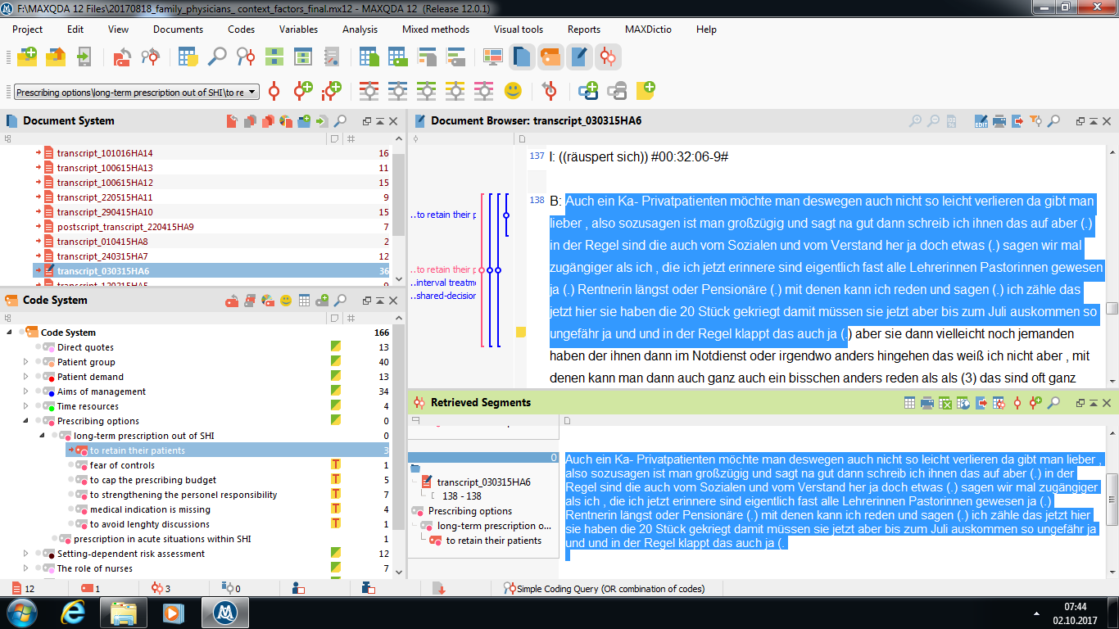
Appendix 5: Excerpt from the data analysis (step 7), using MAXQDA
Picture 1: Excerpt from the analysis with general practitioners
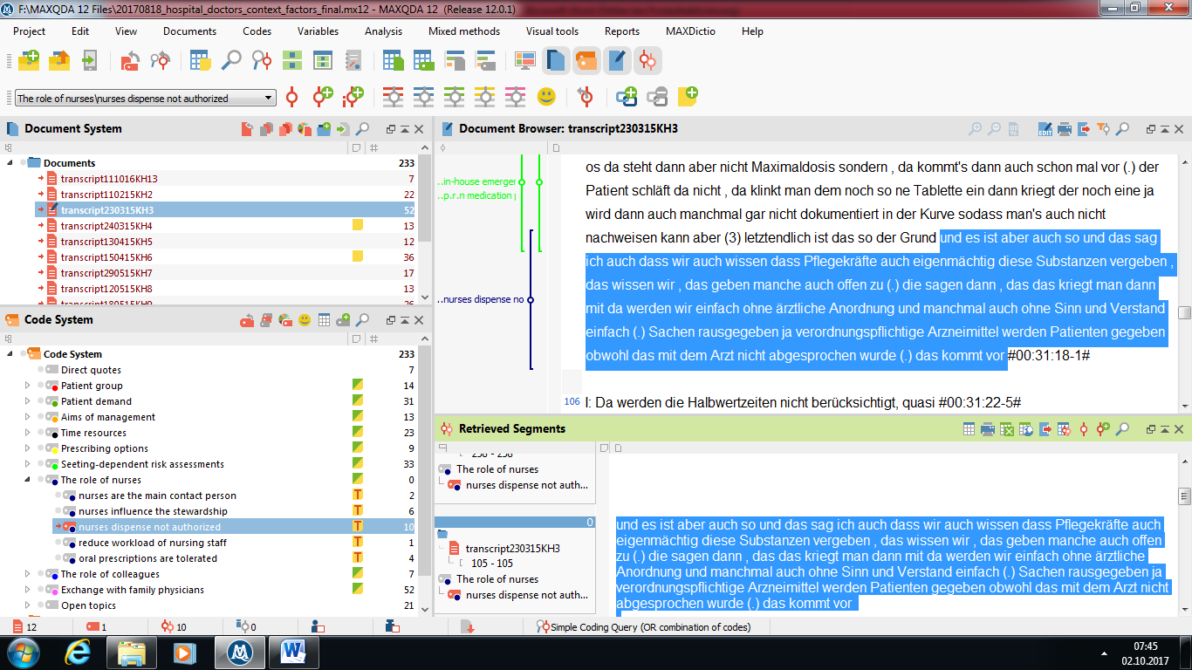
Picture 2: Excerpt from the analysis with hospital doctors

