Use of tramadol and other analgesics
following media attention and risk minimization actions from regulators:
A Danish nationwide drug utilization study
European Journal of Clinical Pharmacology
Online resource 2

Authors: Anne Mette Skov Sørensen, Lotte Rasmussen, Martin Thomsen Ernst, Stine Hasling Mogensen, Mona Vestergaard, Espen Jimenez Solem and Anton Pottegård
Corresponding author: Anton Pottegård, Clinical Pharmacology, University of Southern Denmark, E-mail: apottegaard@health.sdu.dk

Contents
Figure 1. Total use of opioids per 1000 individuals measured in Defined Daily Doses (DDD) and specified by different opioids per month from 2014 to 2019
Figure 2. Prevalence proportion per 1000 individuals per year from 2014 to 2019, opioids
Figure 3. Prevalence proportion per 1000 individuals per quarter from 2014 to 2019, nonsteroidal anti-inflammatory drugs (NSAIDs) and gabapentinoids
Figure 4. Lorenz curves for tramadol 2016
Figure 5. Lorenz curves for tramadol 2017
Table 1. Gender-, age- and morbidity-characteristics for opioid users in 2016
Table 2. Gender-, age- and morbidity-characteristics for opioid users in 2017
Table 3. Medical profile of prescribers issuing prescriptions of tramadol among prevalent tramadol users
Table 4. Medical profile of prescribers issuing prescriptions of tramadol among new tramadol users
Table 5. Number of unique prescribers among opioid users during the given year

Figure 1. Total monthly use of opioids per 1000 individuals measured in defined daily doses (DDD) and specified by different opioids from 2014 to 2019. The three dashed vertical lines denote the time of the media attention (June 2017) and regulatory actions (September 2017 and January 2018) – see the main text for additional details.
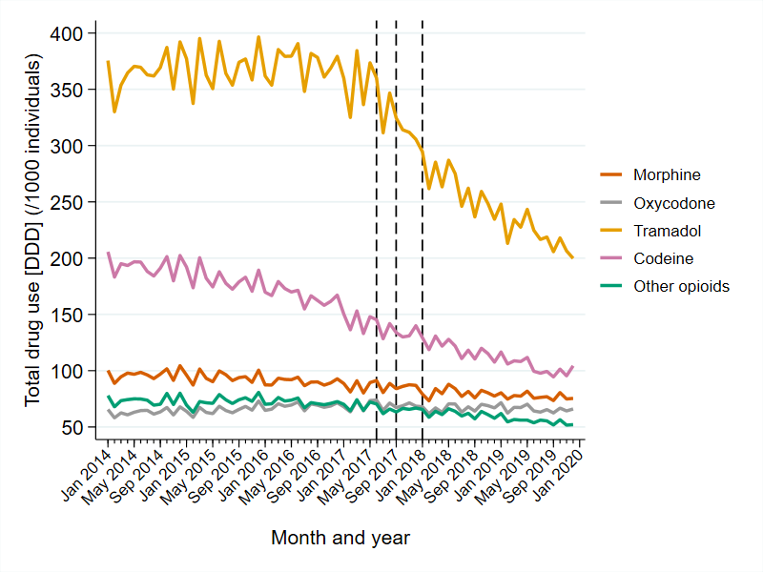

Figure 2. Annual prevalence proportion per 1000 individuals of opioid users from 2014 to 2019.

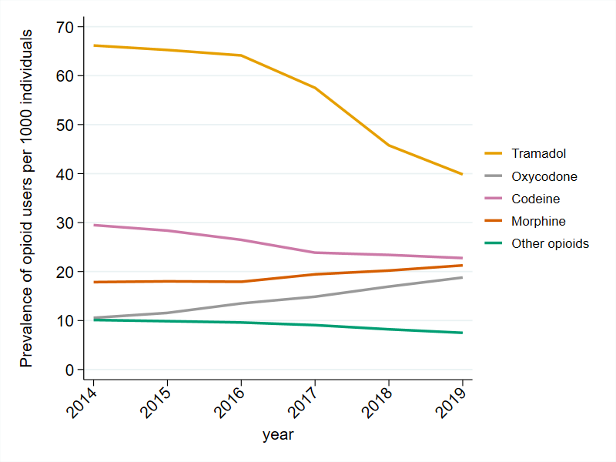

Figure 3. Quarterly prevalence proportion per 1000 individuals of nonsteroidal anti-inflammatory drug (NSAID) and gabapentinoid use from 2014 to 2019. The three dashed vertical lines denote the time of the media attention (June 2017) and regulatory actions (September 2017 and January 2018) – see the main text for additional details.

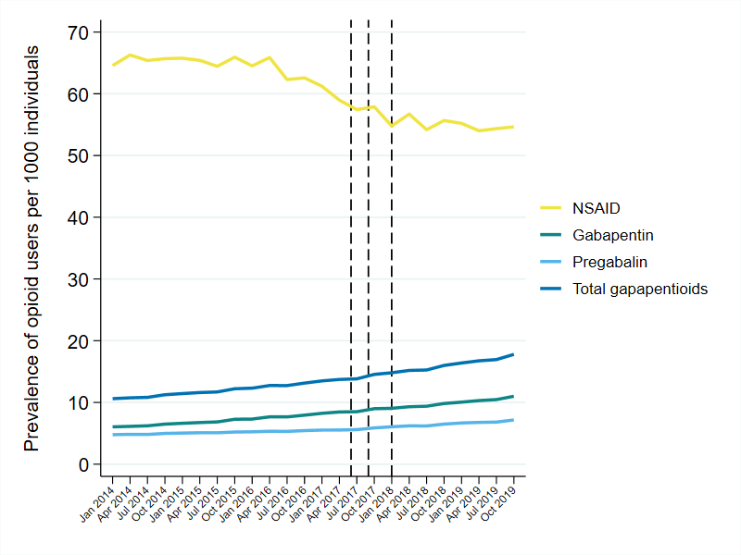
Figure 4. Lorenz curves of tramadol use in 2016. The curve denotes the proportion X of the total filled amount of tramadol (measured in defined daily doses (DDDs)) in 2016 that is accounted for by the proportion X of users.
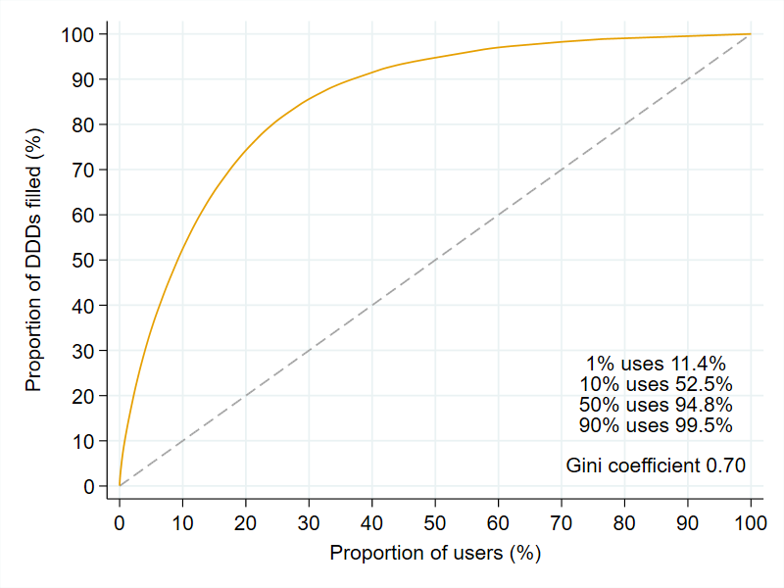

Figure 5. Lorenz curves of tramadol use in 2017. The curve denotes the proportion X of the total filled amount of tramadol (measured in defined daily doses (DDDs)) in 2017 that is accounted for by the proportion X of users.
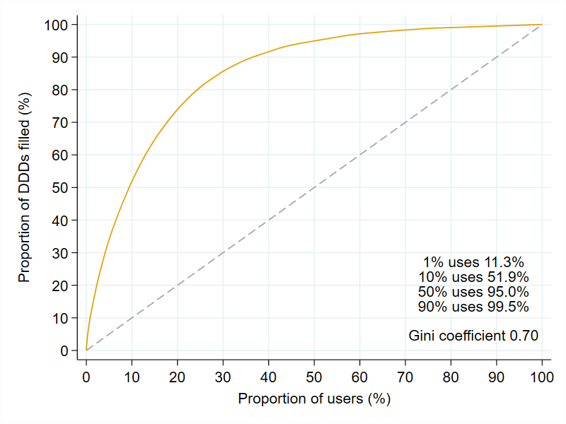

Table 1 Gender-, age- and morbidity-characteristics for opioid users in 2016

 | Any opioid | Morphine | Oxycodone | Tramadol | Codeine | Other opioids
 | (n=487,239) | (n=81,375) | (n=61,309) | (n=291,149) | (n=120,243) | (n=43,627)
Female sex (%) | 286,178 (58.7%) | 44,753 (55.0%) | 34,888 (56.9%) | 166,868 (57.3%) | 79,640 (66.2%) | 28,353 (65.0%)
Age (years)¹ | 61 (47-73) | 65 (52-76) | 64 (50-75) | 60 (46-72) | 60 (47-72) | 74 (60-84)
Essential hypertension | 117,268 (24.1%) | 23,349 (28.7%) | 17,284 (28.2%) | 69,603 (23.9%) | 25,390 (21.1%) | 16,257 (37.3%)
Ischemic heart disease | 63,963 (13.1%) | 12,935 (15.9%) | 9,313 (15.2%) | 38,305 (13.2%) | 13,682 (11.4%) | 8,592 (19.7%)
Chronic kidney disease | 10,042 (2.1%) | 1,803 (2.2%) | 1,981 (3.2%) | 6,184 (2.1%) | 1,694 (1.4%) | 1,782 (4.1%)
Osteoarthritis | 109,234 (22.4%) | 21,715 (26.7%) | 20,081 (32.8%) | 64,872 (22.3%) | 22,861 (19.0%) | 12,611 (28.9%)
Diabetes | 65,769 (13.5%) | 12,700 (15.6%) | 9,222 (15.0%) | 39,878 (13.7%) | 14,667 (12.2%) | 7,480 (17.1%)
Affective disorders | 42,612 (8.7%) | 8,636 (10.6%) | 5,942 (9.7%) | 25,496 (8.8%) | 9,353 (7.8%) | 5,704 (13.1%)
Depression | 39,192 (8.0%) | 7,984 (9.8%) | 5,517 (9.0%) | 23,412 (8.0%) | 8,493 (7.1%) | 5,319 (12.2%)
Migraine | 10,183 (2.1%) | 1,596 (2.0%) | 1,331 (2.2%) | 5,860 (2.0%) | 3,254 (2.7%) | 859 (2.0%)
Cancer² | 54,340 (11.2%) | 15,886 (19.5%) | 9,285 (15.1%) | 28,452 (9.8%) | 10,939 (9.1%) | 9,687 (22.2%)
Substance abuse³ | 44,908 (9.2%) | 10,019 (12.3%) | 6,259 (10.2%) | 27,496 (9.4%) | 8,940 (7.4%) | 4,858 (11.1%)
COPD | 37,304 (7.7%) | 9,309 (11.4%) | 5,488 (9.0%) | 21,822 (7.5%) | 7,748 (6.4%) | 5,672 (13.0%)
Pain | 53,561 (11.0%) | 13,910 (17.1%) | 10,725 (17.5%) | 27,893 (9.6%) | 8,956 (7.4%) | 10,341 (23.7%)
Acute | 5,029 (1.0%) | 1,251 (1.5%) | 947 (1.5%) | 2,849 (1.0%) | 957 (0.8%) | 759 (1.7%)
Chronic | 32,195 (6.6%) | 8,886 (10.9%) | 6,867 (11.2%) | 16,012 (5.5%) | 4,808 (4.0%) | 6,854 (15.7%)
Fibromyalgia | 2,723 (0.6%) | 486 (0.6%) | 365 (0.6%) | 1,669 (0.6%) | 645 (0.5%) | 378 (0.9%)
Rheumatoid arthritis | 7,391 (1.5%) | 1,528 (1.9%) | 1,102 (1.8%) | 4,571 (1.6%) | 1,502 (1.2%) | 1,034 (2.4%)
¹Results are presented as median (IQR) ²Cancers excluding nonmelanoma skin cancer ³Mental and behavioural disorders due to psychoactive substance use
COPD: Chronic Obstructive Pulmonary Disease

Table 2. Gender-, age- and morbidity-characteristics for opioid users in 2017

 | Any opioid | Morphine | Oxycodone | Tramadol | Codeine | Other opioids
 | (n=466,425) | (n=89,055) | (n=68,143) | (n=263,474) | (n=109,305) | (n=41,532)
Female sex (%) | 273,578 (58.7%) | 49,534 (55.6%) | 38,897 (57.1%) | 150,551 (57.1%) | 72,636 (66.5%) | 27,224 (65.5%)
Age (years)¹ | 62 (48-74) | 66 (52-76) | 64 (50-75) | 60 (47-73) | 61 (48-72) | 74 (61-84)
Essential hypertension | 118,404 (25.4%) | 26,367 (29.6%) | 19,611 (28.8%) | 65,969 (25.0%) | 24,575 (22.5%) | 16,269 (39.2%)
Ischemic heart disease | 62,840 (13.5%) | 14,426 (16.2%) | 10,343 (15.2%) | 35,369 (13.4%) | 12,841 (11.7%) | 8,208 (19.8%)
Chronic kidney disease | 10,561 (2.3%) | 2,085 (2.3%) | 2,297 (3.4%) | 6,003 (2.3%) | 1,742 (1.6%) | 1,833 (4.4%)
Osteoarthritis | 111,078 (23.8%) | 23,843 (26.8%) | 22,824 (33.5%) | 61,675 (23.4%) | 22,280 (20.4%) | 12,565 (30.3%)
Diabetes | 65,357 (14.0%) | 14,225 (16.0%) | 10,147 (14.9%) | 37,498 (14.2%) | 13,894 (12.7%) | 7,449 (17.9%)
Affective disorders | 42,303 (9.1%) | 9,615 (10.8%) | 6,593 (9.7%) | 23,966 (9.1%) | 8,720 (8.0%) | 5,566 (13.4%)
Depression | 39,021 (8.4%) | 8,946 (10.0%) | 6,131 (9.0%) | 22,068 (8.4%) | 7,980 (7.3%) | 5,228 (12.6%)
Migraine | 10,391 (2.2%) | 1,778 (2.0%) | 1,510 (2.2%) | 5,650 (2.1%) | 3,263 (3.0%) | 850 (2.0%)
Cancer² | 54,935 (11.8%) | 17,396 (19.5%) | 10,328 (15.2%) | 26,831 (10.2%) | 10,400 (9.5%) | 9,351 (22.5%)
Substance abuse³ | 44,723 (9.6%) | 10,802 (12.1%) | 7,098 (10.4%) | 26,036 (9.9%) | 8,606 (7.9%) | 4,707 (11.3%)
COPD | 37,444 (8.0%) | 10,589 (11.9%) | 6,163 (9.0%) | 20,313 (7.7%) | 7,417 (6.8%) | 5,561 (13.4%)
Pain | 57,421 (12.3%) | 15,686 (17.6%) | 12,027 (17.6%) | 28,652 (10.9%) | 9,098 (8.3%) | 10,691 (25.7%)
Acute | 5,207 (1.1%) | 1,355 (1.5%) | 1,016 (1.5%) | 2,796 (1.1%) | 963 (0.9%) | 809 (1.9%)
Chronic | 34,604 (7.4%) | 9,963 (11.2%) | 7,666 (11.2%) | 16,522 (6.3%) | 4,844 (4.4%) | 7,117 (17.1%)
Fibromyalgia | 2,975 (0.6%) | 552 (0.6%) | 450 (0.7%) | 1,773 (0.7%) | 645 (0.6%) | 390 (0.9%)
Rheumatoid arthritis | 7,392 (1.6%) | 1,654 (1.9%) | 1,265 (1.9%) | 4,315 (1.6%) | 1,444 (1.3%) | 979 (2.4%)
¹Results are presented as median (IQR) ²Cancers excluding nonmelanoma skin cancer ³Mental and behavioural disorders due to psychoactive substance use
COPD: Chronic Obstructive Pulmonary Disease

Table 3. Medical profile of prescribers issuing prescriptions of tramadol among prevalent tramadol users in 2016, 2017, 2018, and 2019

Type of prescriber | 2016 | 2017 | 2018 | 2019
General practitioner | 900,567 (94%) | 809,235 (94%) | 611,908 (93%) | 505,608 (92%)
Practicing specialist | 2,755 (0%) | 2,869 (0%) | 2,413 (0%) | 2,088 (0%)
Hospital doctor | 43,544 (5%) | 39,513 (5%) | 31,704 (5%) | 27,754 (5%)
Dentist | 884 (0%) | 777 (0%) | 616 (0%) | 670 (0%)
Other | 677 (0%) | 164 (0%) | 154 (0%) | 83 (0%)
Missing | 11,119 (1%) | 9,914 (1%) | 8,669 (1%) | 11,952 (2%)

Table 4. Medical profile of prescribers issuing prescriptions of tramadol among new tramadol users in 2016, 2017, 2018, and 2019

Type of prescriber | 2016 | 2017 | 2018 | 2019
General practitioner | 76,102 (68%) | 63,226 (66%) | 45,554 (64%) | 40,284 (62%)
Practicing specialist | 1,414 (1%) | 1,461 (2%) | 762 (1%) | 697 (1%)
Hospital doctor | 27,542 (25%) | 24,091 (25%) | 19,061 (27%) | 16,941 (26%)
Dentist | 1,319 (1%) | 1,262 (1%) | 1,057 (1%) | 1,317 (2%)
Other | 779 (1%) | 132 (0%) | 94 (0%) | 75 (0%)
Missing | 4,522 (4%) | 5,158 (5%) | 5,177 (7%) | 5,503 (8%)

Table 5. Number of unique prescribers among opioid users during 2016, 2017, 2018, and 2019
Number of prescribers | 2016 | 2017 | 2018 | 2019
Any opioid
1 | 56.03% | 56.18% | 55.97% | 55.43%
2 | 27.57% | 27.45% | 28.44% | 28.65%
3 | 11.03% | 10.98% | 10.88% | 11.20%
4 | 3.71% | 3.80% | 3.40% | 3.43%
5 | 1.65% | 1.60% | 1.31% | 1.29%
Codeine
1 | 73.63% | 73.60% | 74.37% | 75.49%
2 | 19.58% | 19.55% | 19.99% | 18.63%
3 | 4.94% | 5.02% | 4.41% | 4.65%
4 | 1.38% | 1.31% | 0.91% | 0.94%
5 | 0.47% | 0.52% | 0.32% | 0.29%
Tramadol
1 | 67.17% | 69.03% | 70.78% | 71.76%
2 | 23.57% | 22.49% | 21.94% | 21.64%
3 | 6.77% | 6.22% | 5.64% | 5.20%
4 | 1.75% | 1.66% | 1.28% | 1.11%
5 | 0.74% | 0.60% | 0.36% | 0.29%
Oxycodone
1 | 47.44% | 47.16% | 45.78% | 45.56%
2 | 33.42% | 33.28% | 35.63% | 34.94%
3 | 13.21% | 13.34% | 13.08% | 14.09%
4 | 3.97% | 4.31% | 4.16% | 4.01%
5 | 1.96% | 1.90% | 1.36% | 1.39%
Morphine
1 | 52.89% | 52.58% | 53.80% | 53.24%
2 | 29.56% | 30.27% | 30.23% | 30.08%
3 | 12.29% | 12.22% | 11.68% | 12.07%
4 | 3.85% | 3.54% | 3.18% | 3.50%
5 | 1.41% | 1.39% | 1.12% | 1.11%

