Subgroup analysis 1: Prescribing error for all indication by setting
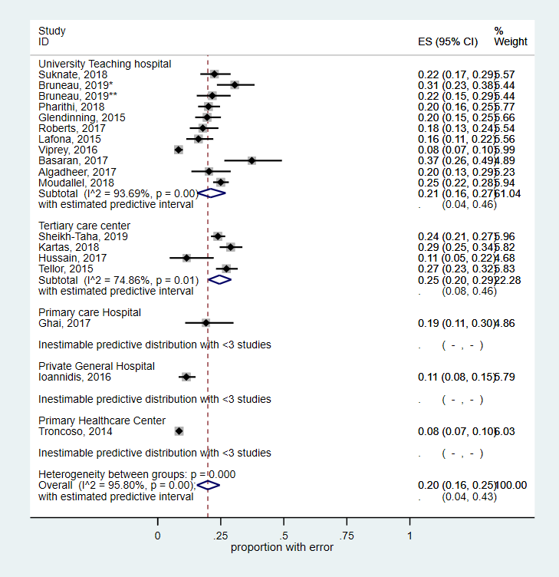

Subgroup analysis 2: Prescribing errors as per indication
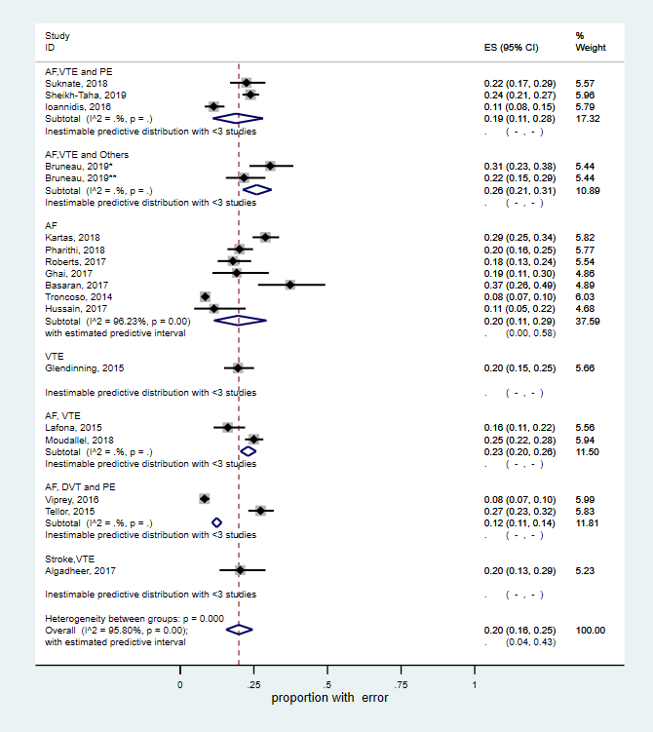

Subgroup analysis 3: Administration error by setting
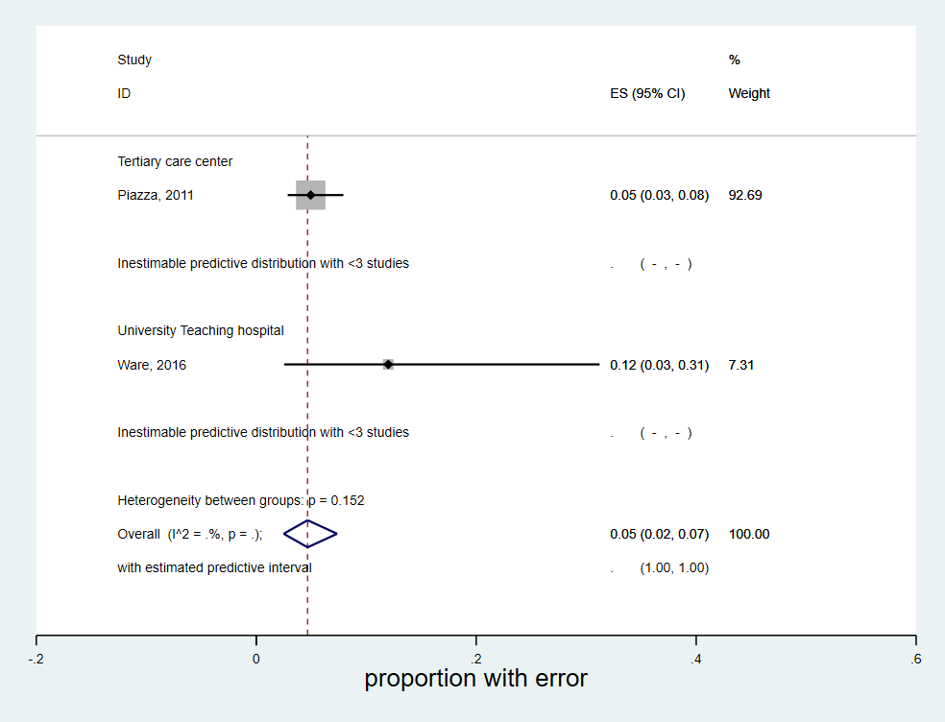

Subgroup analysis 4: Administration error by indication
