Title manuscript
A drug-based model to predict chronic hyponatremia in geriatric outpatients

Authors
Anne Claire B. van Orten-Luiten, Elske M. Brouwer-Brolsma, André Janse, Renger F. Witkamp

Supplementary Information

Table 4 Frequency of use of 27 specific drug groups and dietary supplements in 2181 geriatric outpatients

ATC-coded substance |  |  |  |  | ATC code ^{b} | Use in  total population  (N=2181) |  |  |  | Use if  hyponatremia  (N=230) |  |  | Use if  normonatremia  (N=1951)
 |  |  |  |  | ATC code ^{b} | n | % | rank |  | n | % |  | n | %
Proton pump inhibitors |  |  |  |  | A02BC | 1092 | 50.1 % | 1 |  | 165 | 71.7 % |  | 927 | 47.5 %
Osmotically acting laxatives |  |  |  |  | A06AD | 330 | 15.1 % | 12 |  | 51 | 22.2 % |  | 279 | 14.3 %
Multivitamins and minerals |  |  |  |  | A11A | 184 | 8.4 % | 19 |  | 23 | 10.0 % |  | 161 | 8.3 %
Vitamin D |  |  |  |  | A11CC | 629 | 28.8 % | 3 |  | 84 | 36.5 % |  | 545 | 27.9 %
Calcium |  |  |  |  | A12AA | 331 | 15.2 % | 11 |  | 51 | 22.2 % |  | 280 | 14.4 %
Potassium |  |  |  |  | A12BA | 164 | 7.5 % | 20 |  | 29 | 12.6 % |  | 135 | 6.9 %
Vitamin K antagonists |  |  |  |  | B01AA | 320 | 14.7 % | 13 |  | 32 | 13.9 % |  | 288 | 14.8 %
Platelet aggregation inhibitors |  |  |  |  | B01AC | 700 | 32.1 % | 2 |  | 96 | 41.7 % |  | 604 | 31.0 %
Cardiac therapy |  |  |  |  | C01 | 195 | 8.9 % | 18 |  | 26 | 11.3 % |  | 169 | 8.7 %
Thiazide diuretics |  |  |  |  | C03AA | 368 | 16.9 % | 9 |  | 73 | 31.7 % |  | 295 | 15.1 %
Loop diuretics |  |  |  |  | C03CA | 230 | 10.5 % | 16 |  | 27 | 11.7 % |  | 203 | 10.4 %
Potassium-sparing diuretics |  |  |  |  | C03D | 132 | 6.1 % | 25 |  | 26 | 11.3 % |  | 106 | 5.4 %
Selective beta blockers |  |  |  |  | C07AB | 585 | 26.8 % | 4 |  | 77 | 33.5 % |  | 508 | 26.0 %
Dihydropyridines |  |  |  |  | C08CA | 348 | 16.0 % | 10 |  | 36 | 15.7 % |  | 312 | 16.0 %
ACE inhibitors ^{c} |  |  |  |  | C09AA | 460 | 21.1 % | 6 |  | 71 | 30.9 % |  | 389 | 19.9 %
Angiotensin-2 antagonists |  |  |  |  | C09CA | 290 | 13.3 % | 15 |  | 50 | 21.7 % |  | 240 | 12.3 %
Statins |  |  |  |  | C10AA | 560 | 25.7 % | 5 |  | 52 | 22.6 % |  | 508 | 26.0 %
Thyroid preparations |  |  |  |  | H03A | 138 | 6.3 % | 23 |  | 27 | 11.7 % |  | 111 | 5.7 %
NSAIDs ^{d} |  |  |  |  | M01A | 156 | 7.2 % | 21 |  | 17 | 7.4 % |  | 139 | 7.1 %
Bisphosphonates |  |  |  |  | M05BA | 155 | 7.1 % | 22 |  | 22 | 9.6 % |  | 133 | 6.8 %
Opioid analgetics |  |  |  |  | N02A | 123 | 5.6% | 26 |  | 20 | 8.7% |  | 103 | 5.3%
Anilides (paracetamol) |  |  |  |  | N02BE | 314 | 14.4 % | 14 |  | 54 | 23.5 % |  | 260 | 13.3%
Antiepileptics |  |  |  |  | N03 | 119 | 5.5 % | 27 |  | 29 | 12.6 % |  | 90 | 4.6 %
Antipsychotics |  |  |  |  | N05A | 136 | 6.2 % | 24 |  | 8 | 3.5 % |  | 128 | 6.6 %
Benzodiazepines ^{e} |  |  |  |  | N05 ^{e} | 399 | 18.3 % | 7 |  | 58 | 25.2 % |  | 341 | 17.5 %
Antidepressants |  |  |  |  | N06A | 383 | 17.6 % | 8 |  | 35 | 15.2 % |  | 348 | 17.8 %
Adrenergic inhalants |  |  |  |  | R03A | 202 | 9.3 % | 17 |  | 26 | 11.3 % |  | 176 | 9.0 %
Any ATC-coded supplement ^{f} |  |  |  |  | multiple | 1105 | 50.7 % |  |  | 143 | 62.2% |  | 962 | 49.3%
ª estimated glomerular filtration rate (ml/min/1.73m²); ^{b} Anatomical Therapeutic Chemical classification code; ^{c} angiotensin-converting enzyme inhibitors; ^{d} non-steroid antiinflammatory drugs; ^{e} N05BA, NO5CD, NO5CF; ^{f} use of any ATC-coded dietary supplement: A02AA, A11, A12, B03A-, B03B-, A16AA01, C10AX06, M01AX05, N05C, N06DX02; this variable was not included as a candidate predictor

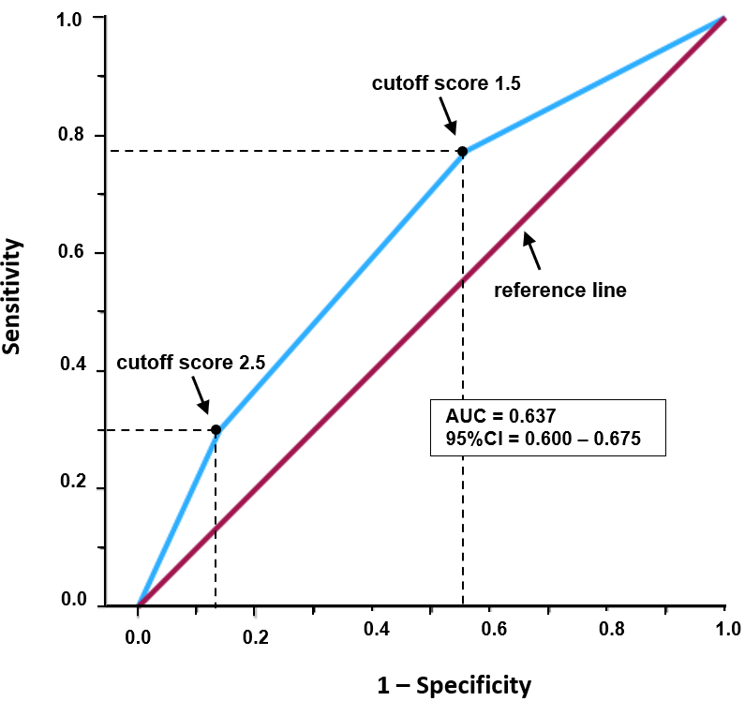
Figure 2 Receiver operating characteristic (ROC) curve illustrating the performance of the simple score-based model, classifying a subject as hypo- or normonatremic. Sensitivity is plotted against 1-Specificity for different cutoff model scores for hyponatremia. A total risk score above the cutoff (positive result) classifies a subject as hyponatremic; a score below the cutoff (negative result) indicates normonatremia. The area under the curve (AUC) quantifies model performance: an AUC of 0.5 (below the reference line) indicates random classification; a larger AUC indicates that the model has predictive qualities. Sensitivity (true positive rate) is the proportion of hyponatremic patients with scores above the cutoff, thus correctly classified as hyponatremic. 1-Specificity (false positive rate) is the proportion of normonatremic patients with scores above the cutoff, thus incorrectly classified as hyponatremic.

