Supplementary Files :

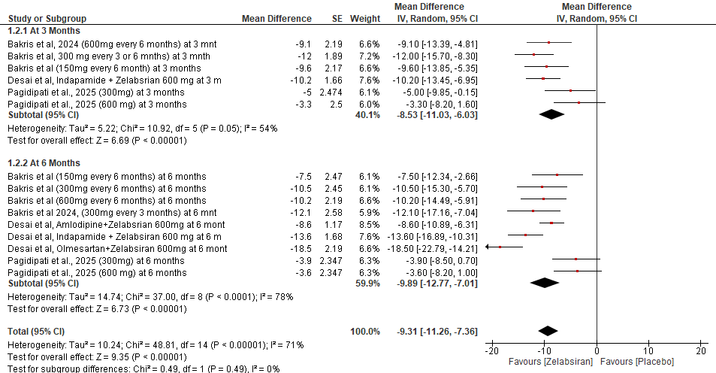

Supplementary Figure 1. Subgroup analysis of office systolic blood pressure (SBP) by time point.

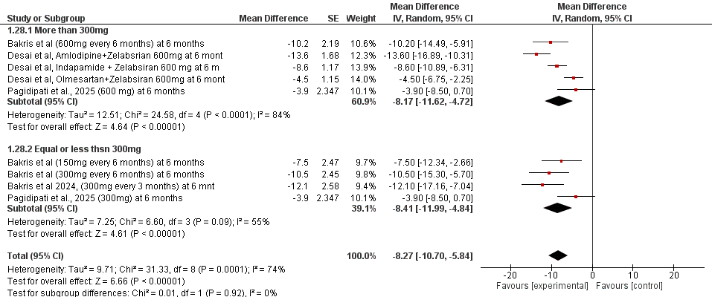
Supplementary Figure 2. Subgroup analysis of office systolic blood pressure (SBP) by Dose.

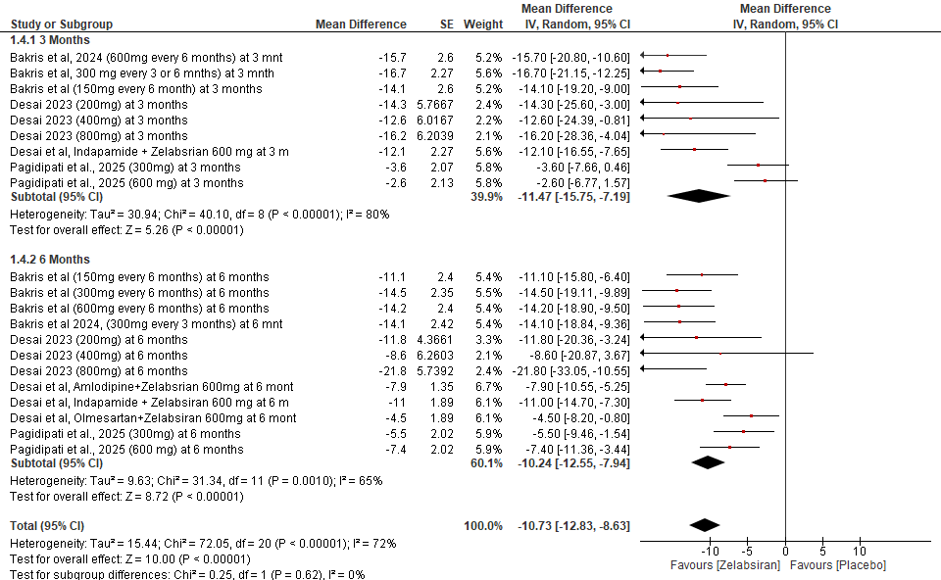
Supplementary Figure 3. Subgroup analysis of 24-hour ambulatory systolic blood pressure (SBP) by time point.

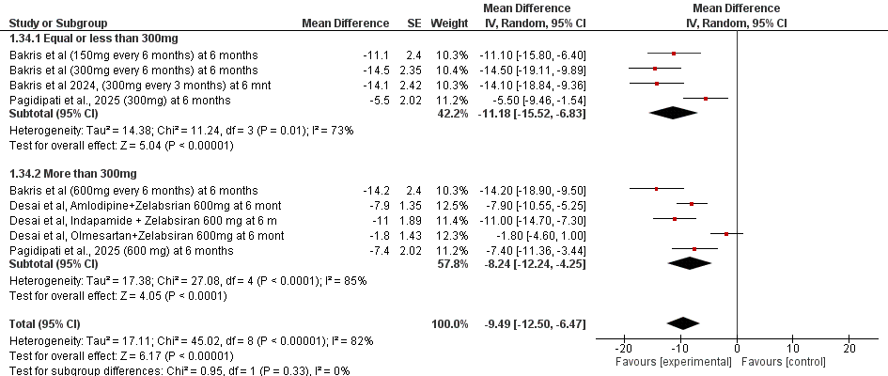
Supplementary Figure 4. Subgroup analysis of 24-hour ambulatory systolic blood pressure (SBP) by dose.

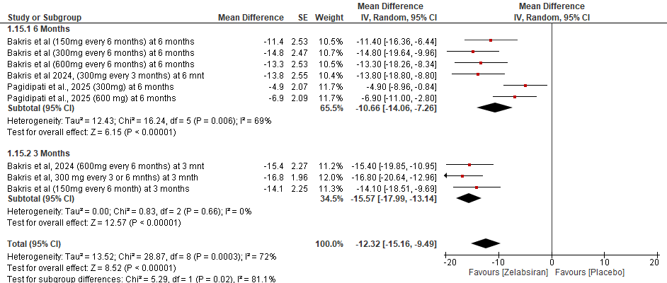
Supplementary Figure 5. Subgroup analysis of 24-hour ambulatory daytime systolic blood pressure (SBP) by time point.

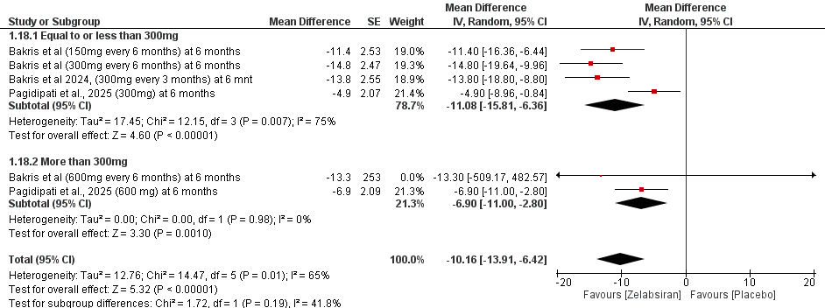
Supplementary Figure 6. Subgroup analysis of 24-hour ambulatory daytime systolic blood pressure (SBP) by dose.

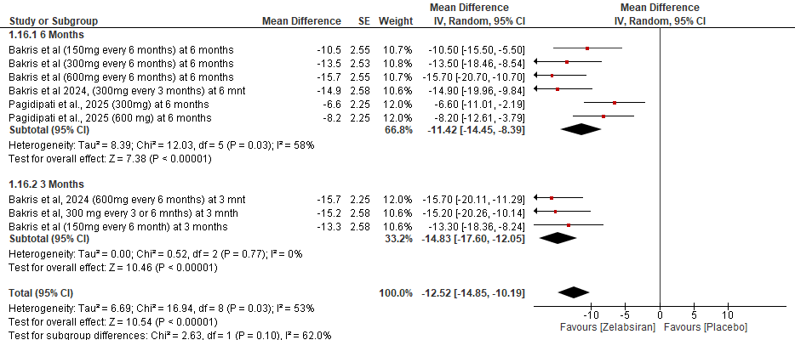

Supplementary Figure 7. Subgroup analysis of 24-hour ambulatory nighttime systolic blood pressure (SBP) by time point.

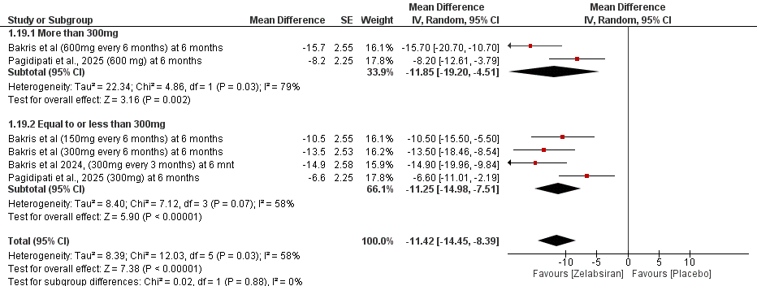
Supplementary Figure 8. Subgroup analysis of 24-hour ambulatory nighttime systolic blood pressure (SBP) by dose.

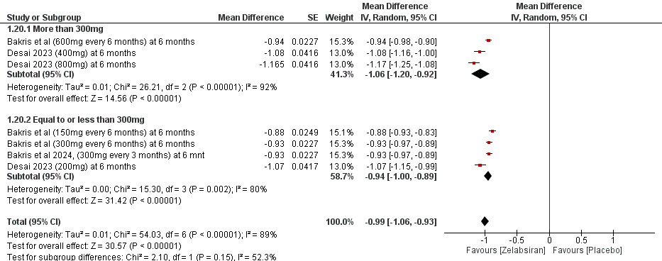
Supplementary Figure 9. Subgroup analysis of angiotensinogen (ATG) levels by dose.

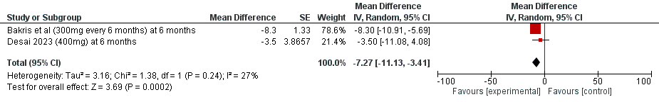
Supplementary Figure 10. Forest plot of 24-hour diastolic blood pressure (DBP).

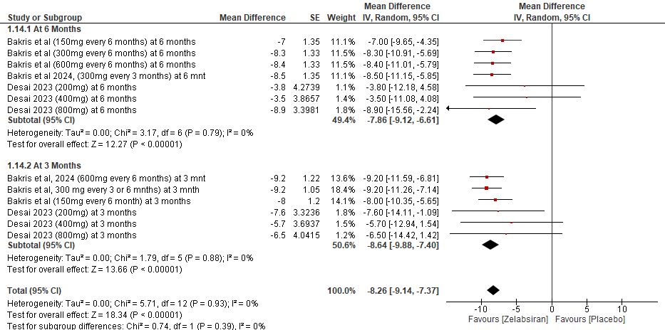
Supplementary Figure 11. Subgroup analysis of 24-hour ambulatory DBP by time point

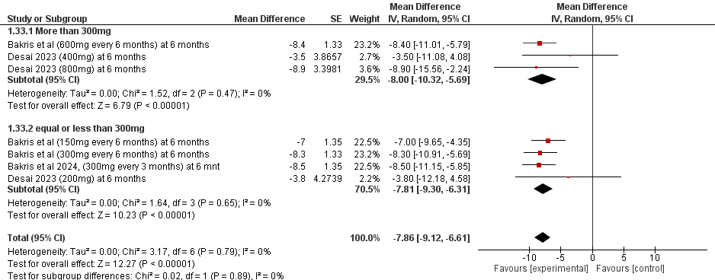
Supplementary Figure 12. Subgroup analysis of 24-hour ambulatory DBP by dose.

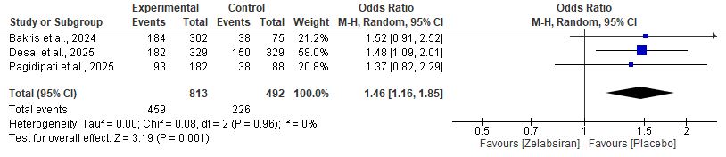
Supplementary Figure 13. Forest plot of odds ratios for all adverse events.

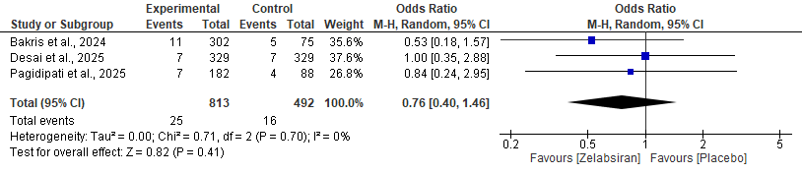
Supplementary Figure 14. Forest plot of odds ratios for serious adverse events.

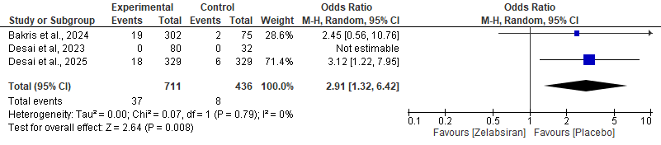Supplementary Figure 15. Forest plot of odds ratios for hyperkalemia.

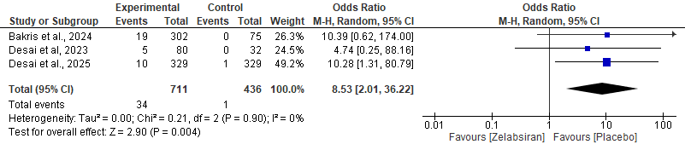Supplementary Figure 16. Forest plot of odds ratios for injection-site reactions.

I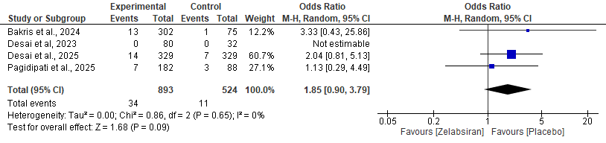Supplementary Figure 17. Forest plot of odds ratios for hypotension or orthostatic hypotension.

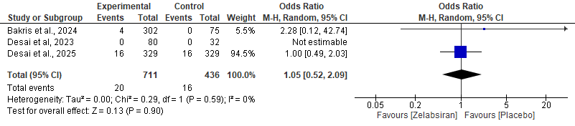

Supplementary Figure 18. Forest plot of odds ratios for renal adverse events.

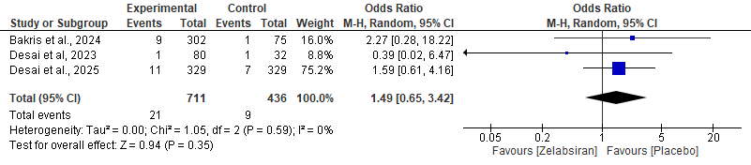
Supplementary Figure 19. Forest plot of odds ratios for hepatic adverse events.

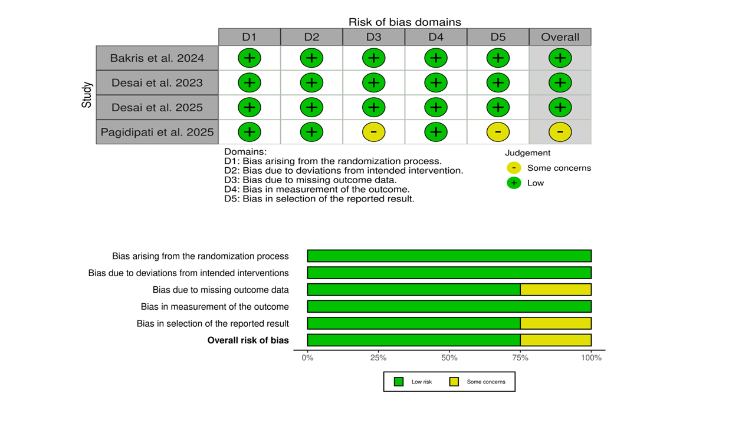
Supplementary Figure 20. Risk-of-bias assessment for included studies reporting safety outcomes evaluated across Cochrane RoB 2.0 domains.

Database | Date searched | Search strategy (exact syntax) | Records retrieved
PubMed | 19 November 2025 | (("Zilebesiran" OR "ALN-AGT01" OR "AD-85481" OR "siRNA therapy" OR "RNA interference") AND ("Hypertension"[Mesh] OR hypertension OR "high blood pressure" OR "elevated blood pressure" OR "arterial hypertension")) | 591
Cochrane Library | 19 November 2025 | ("Zilebesiran" OR "ALN-AGT01" OR "AD-85481" OR siRNA OR "small interfering RNA" OR "RNA interference") AND (hypertension OR "high blood pressure" OR "arterial hypertension" OR "elevated blood pressure") | 518
Google Scholar | 19 November 2025 | ("Zilebesiran" OR "ALN-AGT01" OR "AD-85481") AND (hypertension OR "high blood pressure") | 414
ClinicalTrials.gov | 19 November 2025 | ("Zilebesiran" OR "ALN-AGT01" OR "AD-85481") AND (hypertension OR "high blood pressure") | 1000
Embase | 19 November 2025 | ('hypertension'/exp OR hypertension:ti,ab OR "high blood pressure":ti,ab) AND (zilebesiran:ti,ab,kw OR "ALN-AGT01":ti,ab,kw OR "AD-85481":ti,ab,kw) | 65

Supplementary Table 1. Database-specific search strategies and number of records retrieved for zilebesiran in hypertension (searched on November 19, 2025)

Outcome | No. of participants (studies) | Effect estimate (95% CI) | Risk of Bias | Inconsistency | Indirectness | Imprecision | Publication Bias | Certainty of Evidence
Office SBP (Placebo-adjusted mean change) | 2 studies | MD -7.16 [-13.63, -0.70] | Not serious | Serious (I² = 74%) | Not serious | Not serious | N/A | Moderate
24-hour Ambulatory SBP | 2 studies | MD -9.92 [-18.74, -1.10] | Not serious | Serious (I² = 88%) | Not serious | Not serious | N/A | Moderate
24-hour Ambulatory Daytime SBP | 2 studies | MD -9.76 [-19.46, -0.06] | Not serious | Serious (I² = 89%) | Not serious | Serious (wide CI) | N/A | Low
24-hour Ambulatory Nighttime SBP | 2 studies | MD -9.95 [-16.71, -3.19] | Not serious | Serious (I² = 76%) | Not serious | Serious (wide CI) | N/A | Low
Angiotensinogen (ATG) Levels | 2 studies | MD -1.00 [-1.15, -0.85] | Not serious | Serious (I² = 90%) | Not serious | Not serious | N/A | Moderate
24-hour Ambulatory DBP | 2 studies | MD -7.27 [-11.13, -3.41] | Not serious | Not serious (I² = 27%) | Not serious | Not serious | N/A | High
At least 1 Serious Adverse Event | 3 studies | OR 0.76 [0.40, 1.46] | Not serious | Not serious | Not serious | Serious (wide CI) | N/A | Moderate
At least 1 Adverse Event | 3 studies | OR 1.46 [1.16, 1.85] | Not serious | Not serious (I² = 0%) | Not serious | Not serious | N/A | High
Hypotension / Orthostatic Hypotension | 3 studies | OR 1.85 [0.90, 3.79] | Not serious | Not serious (I² = 0%) | Not serious | Serious (CI includes no effect) | N/A | Low
Hyperkalemia | 3 studies | OR 2.91 [1.32, 6.42] | Not serious | Not serious (I² = 0%) | Not serious | Serious (wide CI, few events) | N/A | Moderate
Injection-Site Reaction | 3 studies | OR 8.53 [2.01, 36.22] | Not serious | Not serious (I² = 0%) | Not serious | Serious (very wide CI) | N/A | Low
Renal Adverse Event (Acute Kidney Failure) | 3 studies | OR 1.05 [0.52, 2.09] | Not serious | Not serious (I² = 0%) | Not serious | Serious (CI crosses no effect) | N/A | Low
Hepatic Adverse Event | 3 studies | OR 1.49 [0.65, 3.42] | Not serious | Not serious (I² = 0%) | Not serious | Serious (CI crosses no effect) | N/A | Low

Supplementary Table 2. GRADE summary of efficacy and safety outcomes for zilebesiran. Effect estimates are shown as mean differences (MD) or odds ratios (OR) with 95% confidence intervals. Evidence quality was assessed across risk of bias, inconsistency, indirectness, imprecision, and publication bias, and rated as high, moderate, or low.

Study | Group / Subgroup | Dosage | Duration | Reduction in Office SBP (mmHg) | Reduction in 24-hr Ambulatory SBP (mmHg)
Pagidipati et al., 2025 | Zilebesiran 300 mg | 300 mg | 3 months | −5.0 ± 2.47 | −3.6 ± 2.07
Pagidipati et al., 2025 | Zilebesiran 600 mg | 600 mg | 3 months | −3.3 ± 2.50 | −2.6 ± 2.13
Pagidipati et al., 2025 | Zilebesiran 300 mg | 300 mg | 6 months | −3.9 ± 2.35 | −5.5 ± 2.02
Pagidipati et al., 2025 | Zilebesiran 600 mg | 600 mg | 6 months | −3.6 ± 2.35 | −7.4 ± 2.02
Bakris et al., 2024 | Zilebesiran 150 mg q6mo | 150 mg every 6 months | 3 months | −9.6 ± 2.17 | −14.1 ± 2.60
Bakris et al., 2024 | Zilebesiran 300 mg q3/6mo | 300 mg every 3 or 6 months | 3 months | −12.0 ± 1.89 | −16.7 ± 2.27
Bakris et al., 2024 | Zilebesiran 600 mg q6mo | 600 mg every 6 months | 3 months | −9.1 ± 2.19 | −15.7 ± 2.60
Bakris et al., 2024 | Zilebesiran 150 mg q6mo | 150 mg every 6 months | 6 months | −7.5 ± 2.47 | −11.1 ± 2.40
Bakris et al., 2024 | Zilebesiran 300 mg q6mo | 300 mg every 6 months | 6 months | −10.5 ± 2.45 | −14.5 ± 2.35
Bakris et al., 2024 | Zilebesiran 300 mg q3mo | 300 mg every 3 months | 6 months | −12.1 ± 2.58 | −14.1 ± 2.42
Bakris et al., 2024 | Zilebesiran 600 mg q6mo | 600 mg every 6 months | 6 months | −10.2 ± 2.19 | −14.2 ± 2.40
Desai et al., 2023 | Zilebesiran 200 mg | 200 mg | 3 months | NR | −14.3 ± 16.3*
Desai et al., 2023 | Zilebesiran 400 mg | 400 mg | 3 months | NR | −12.6 ± 2.8
Desai et al., 2023 | Zilebesiran 800 mg | 800 mg | 3 months | NR | −16.2 ± 3.2
Desai et al., 2025 | Zilebesiran 600 mg + indapamide | 600 mg (+ indapamide) | 3 months | −18.5 ± 2.19 | −12.1 ± 2.27
Desai et al., 2025 | Zilebesiran 600 mg + amlodipine | 600 mg (+ amlodipine) | 3 months | −10.2 ± 1.66 | −9.7 ± 1.61
Desai et al., 2025 | Zilebesiran 600 mg + olmesartan | 600 mg (+ olmesartan) | 3 months | −6.7 ± 1.76 | −4.5 ± 1.89
Desai et al., 2025 | Zilebesiran 600 mg + indapamide | 600 mg (+ indapamide) | 6 months | −13.6 ± 1.68 | −11.0 ± 1.89
Desai et al., 2025 | Zilebesiran 600 mg + amlodipine | 600 mg (+ amlodipine) | 6 months | −8.6 ± 1.17 | −7.9 ± 1.35
Desai et al., 2025 | Zilebesiran 600 mg + olmesartan | 600 mg (+ olmesartan) | 6 months | −4.5 ± 1.15 | −1.8 ± 1.43

Supplementary Table 3. Placebo-adjusted change in office and 24-hour ambulatory systolic blood pressure across included trials, by dose group and follow-up time point. Values represent mean placebo-adjusted change from baseline ± standard error (mmHg). SBP, systolic blood pressure; NR, not reported.

