Supplementary Material

To replicate the search resulting in Figure 2 and Table 1, go to the web site of the STRING database, http://string-db.org/

In the “search” box put gsk3b and homo sapiens, as shown below, and click the search button:
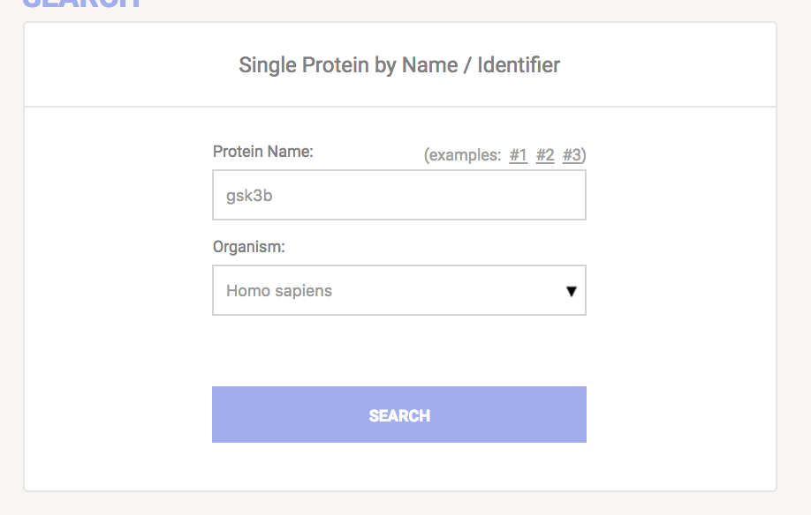

In the next screen, press the “continue” button.

In the next screen, shown below, press the “data settings” button. Within data settings, set the maximum number of elements in the first shell to 300 and the confidence level to 0.7 Then press the “update settings” button.

This will produce the visualization of Figure 2 (with live links to the gene names), the information in Table 1, and links to much more relevant information.

