Supplemental material 2:
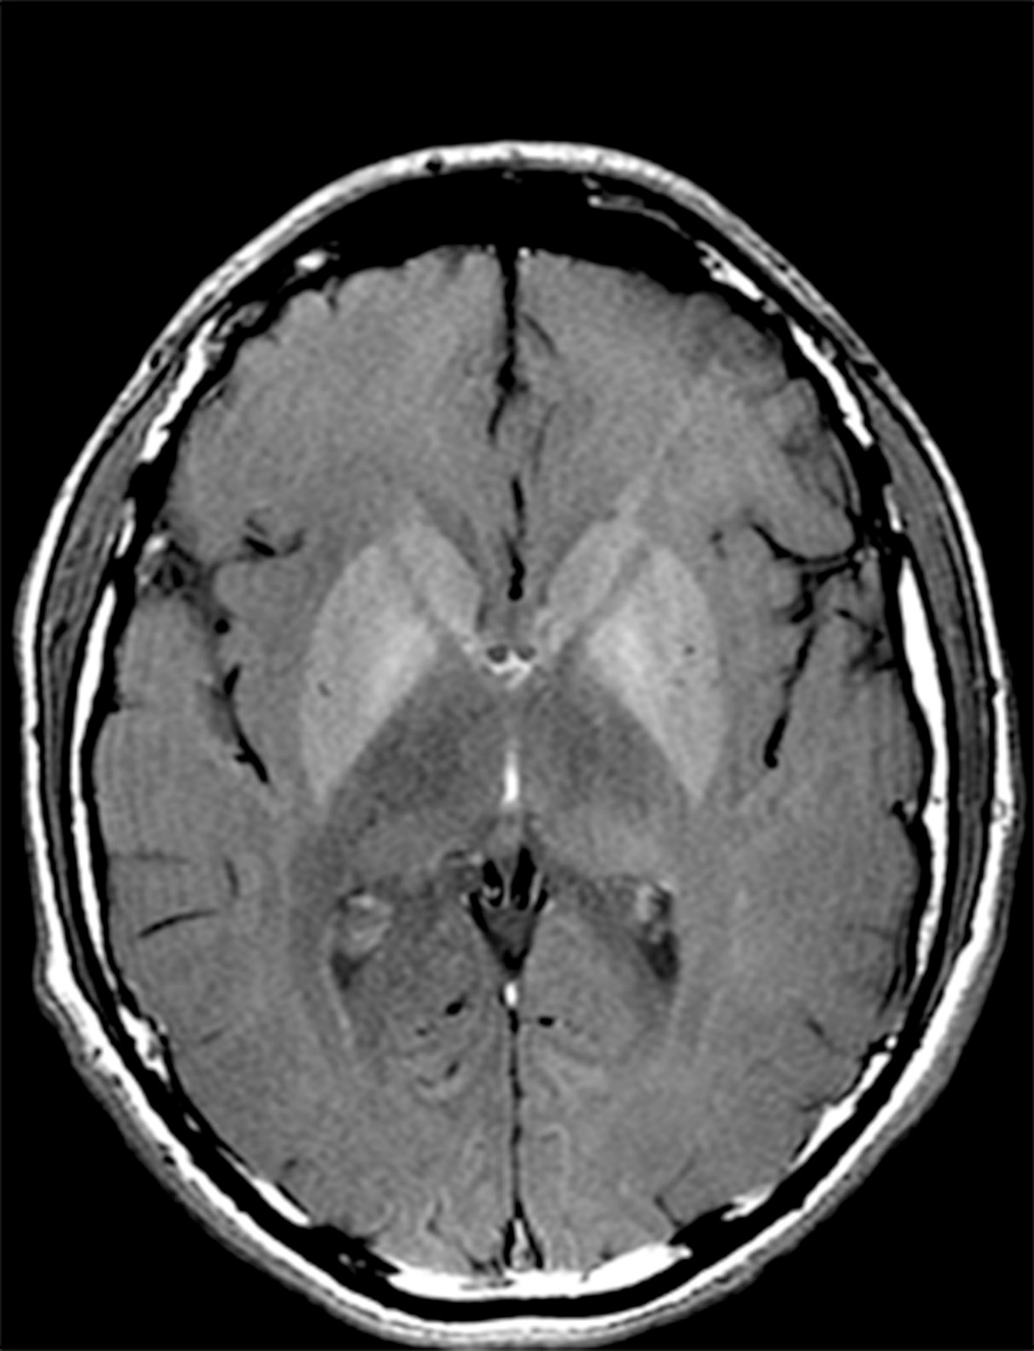
Brain non-contrast axial T1-weighted MR image shows T1 hyperintense signal in the basal ganglia in a sixty-five-year-old man with alcoholic related cirrhosis.

