Supplementary Material
 | Without JLK-ICH assistance  (n = 400) | With JLK-ICH assistance  (n = 400) | Difference | P-value
Sensitivity,
% (95% CI)
Reader 1 | 88.8 (84.4 – 93.1) | 92.2 (88.5 – 95.9) | 3.4 (0.3 – 6.6) | 0.03
Reader 2 | 90.2 (86.2 – 94.3) | 92.7 (89.1 – 96.3) | 2.4 (-0.7 – 5.6) | 0.13
Reader 3 | 88.8 (84.4 – 93.1) | 93.2 (89.7 – 96.6) | 4.3 (1.0 – 7.8) | 0.011
Reader 4 | 89.3 (85.0 – 93.5) | 92.2 (88.5 – 95.9) | 2.9 (-0.6 – 6.5) | 0.11
Reader 5 | 94.1 (90.9 – 97.4) | 91.2 (87.3 – 95.1) | -2.9 (-6.2 – 0.4) | 0.08
Reader 6 | 80.5 (75.0 – 85.9) | 88.3 (83.9 – 92.7) | 7.8 (3.5 – 12.2) | < 0.001
Specificity,
% (95% CI)
Reader 1 | 95.9 (93.1 – 98.7) | 97.4 (95.2 – 99.7) | 1.5 (-0.2 – 3.3) | 0.08
Reader 2 | 99.0 (97.6 – 100) | 99.0 (97.6 – 100) | 0 (-1.4 – 1.4) | 1.00
Reader 3 | 97.9 (96.0 – 99.9) | 96.4 (93.8 – 99.0) | -1.5 (-4.6 – 1.5) | 0.32
Reader 4 | 94.9 (91.8 – 98.0) | 97.4 (95.2 – 99.7) | 2.6 (-0.4 – 5.6) | 0.09
Reader 5 | 93.3 (89.8 – 96.8) | 98.5 (96.7 – 100) | 5.1 (2.0 – 8.2) | 0.001
Reader 6 | 96.9 (94.5 – 99.4) | 94.4 (91.1 – 97.6) | -2.6 (-5.6 – 0.4) | 0.09

Supplementary Table 1. Sensitivity and specificity of each reader without and with JLK-ICH assistance in the reader performance study. CI, Confidence interval
 | Difference, % (95% CI) in sensitivity, with JLK-ICH assistance – without JLK-ICH assistance
 | IPH  (n = 96) | IVH  (n = 50) | SAH  (n = 79) | SDH  (n = 67) | EDH  (n = 7) | Multiple  (n = 73)
Average | -1.0 (-2.2 – 0.1) | 1.7 (-0.5 – 3.8) | 2.1 (-0.3 – 4.5) | 3.1 (0.6 – 5.5) | 7.2 (-5.0 – 19.3) | 0 (-1.1 – 1.1)
Reader 1 | 0 (-2.9 – 2.9) | 6.0 (-0.6 – 12.6) | 3.8 (-1.7 – 9.3) | 3.0 (-1.1 – 7.1) | 28.6 (-4.9 – 62.0) | 1.4 (-1.3 – 4.0)
Reader 2 | 0 | 0 | -1.3 (-5.6 – 3.0) | 1.5 (-1.4 – 4.4) | 0 | 0
Reader 3 | 0 | 2.0 (-4.8 – 8.8) | -1.3 (-6.8 – 4.3) | 1.5 (-5.0 – 8.0) | -14.3 (-40.2 – 11.6) | -1.4 (-4.0 – 1.3)
Reader 4 | -3.1 (-6.6 – 0.4) | -2.0 (-5.9 – 1.9) | 0 (-5.0 – 5.0) | 6.0 (-2.2 – 14.1) | -14.3 (-40.2 – 11.6) | -2.7 (-6.5 – 1.0)
Reader 5 | -4.2 (-8.2 – -0.2) | 2.0 (-1.9 – 5.9) | 0 (-6.1 – 6.1) | -1.5 (-6.6 – 3.6) | 14.3 (-11.6 – 40.2) | 1.4 (-1.3 – 4.0)
Reader 6 | 1.0 (-2.5 – 4.6) | 2.0 (-4.8 – 8.8) | 11.4 (3.6 – 19.2) | 7.5 (1.2 – 13.8) | 28.6(-4.9 – 62.0) | 1.4 (-1.3 – 4.0)

Supplementary Table 2. Difference in sensitivity with and without JLK-ICH assistance for each reader by ICH subtype in a reader performance study. IPH, intraparenchymal hemorrhage; IVH, intraventricular hemorrhage; SAH, subarachnoid hemorrhage; SDH, subdural hematoma; EDH, epidural hematoma.

Ageª, mean ± S.D. | 66.0 ± 15.8
Sex^{b}, male, n (%) | 317 (47.3%)
Company
Gradient Health, Inc., n (%) | 580 (86.6%)
Segmed, Inc., n (%) | 90 (13.4%)
Ethnicity
White, n (%) | 243 (36.2%)
Black, n (%) | 59 (8.8%)
Hispanic, n (%) | 33 (4.9%)
Asian & Pacific Islander, n (%) | 8 (1.2%)
American Indian, n (%) | 1 (0.1%)
Native Hawaiian, n (%) | 1 (0.1%)
Unknown, n (%) | 345 (51.5%)
Manufacturers
Siemens, n (%) | 407 (60.7%)
GE, n (%) | 152 (22.7%)
Philips, n (%) | 82 (12.2%)
Toshiba or Canon, n (%) | 23 (3.4%)
Etc^{c}, n (%) | 6 (0.9%)
Slice thickness
2.0 ~ 3.0 mm, n (%) | 85 (12.7%)
3.1 ~ 4.9 mm, n (%) | 50 (7.5%)
5.0 mm, n (%) | 535 (79.9%)
Supplementary Table 3. Baseline characteristics of multi-ethnic U.S. dataset used as an additional external validation (N = 670). ªData were missing in 45 scans. ^{b}Data were missing in 47 scans. ^{c}AMICAS, FUJI, Hitachi and NeuroLogica were included.
 | All subjects | IPH (n = 102) | IVH (n = 51) | SAH (n = 80) | SDH (n = 44) | EDH (n = 15) | Multiple (n=63)
AUROC (95% CI) | 0.960  (0.942 − 0.974) | 0.955  (0.935 − 0.971) | 0.967  (0.948 − 0.981) | 0.960  (0.940 − 0.975) | 0.969  (0.950 − 0.982) | 0.975  (0.956 − 0.987) | 0.966  (0.947 − 0.980)
Sensitivity, % (95% CI) | 95.4  (91.8 − 97.8) | 94.1  (87.6 − 97.8) | 96.1  (86.5 − 99.5) | 96.3  (89.4 − 99.2) | 93.2  (81.3 − 98.6) | 100.0  (78.2 − 100.0) | 93.7  (84.5 − 98.2)
Specificity, % (95% CI) | 90.0 (86.9 − 92.6)
PPV, %  (95% CI) | 82.3  (77.9 − 86.0) | 68.1  (61.7 − 73.9) | 52.1  (45.1 − 59.1) | 63.1  (56.4 − 69.4) | 47.7  (40.6 − 54.9) | 25.0  (20.2 − 30.6) | 56.7  (50.0 − 63.5)
NPV, %  (95% CI) | 97.6  (95.7 − 98.7) | 98.5  (96.9 − 99.3) | 99.5  (98.1 − 99.9) | 99.3  (97.8 − 99.8) | 99.3  (97.8 − 99.8) | 100.0  (99.1 − 100.0) | 99.0  (97.5 − 99.6)
Accurary, % (95% CI) | 91.8  (89.5 − 93.8) | 90.8  (88.1 − 93.1) | 90.6  (87.7 − 93.0) | 91.0  (88.2 − 93.3) | 90.3  (87.4 − 92.8) | 90.3  (87.3 − 92.9) | 90.5  (87.6 − 92.9)

Supplementary Table 4. Performance of JLK-ICH for detecting intracranial hemorrhage in the multi-ethnic U.S. dataset. IPH, intraparenchymal hemorrhage; IVH, intraventricular hemorrhage; SAH, subarachnoid hemorrhage; SDH, subdural hematoma; EDH, epidural hematoma; AUROC, area under the receiver operating characteristic curve; CI, confidence interval; PPV, positive predictive value; NPV, negative predictive value.

 | High-confidence cases |  |  | Low-confidence cases
 | Accuracy without JLK-ICH, % (95% CI) | with JLK-ICH, % (95% CI) | P-for-diff | without JLK-ICH, % (95% CI) | with JLK-ICH, % (95% CI) | P-for-diff | Difference of differences | P-value
Reader 1 | 0.959  (0.938 – 0.979) | 0.970  (0.952 – 0.987) | 0.424 | 0.556  (0.393 – 0.718) | 0.778  (0.642 – 0.914) | 0.046 | 0.211  (-0.002 – 0.425) | 0.026
Reader 2 | 0.972  (0.955 – 0.989) | 0.975  (0.959 – 0.991) | 0.816 | 0.854  (0.745 – 0.962) | 0.854  (0.745 – 0.962) | >0.999 | -0.003  (-0.158 – 0.152) | 0.514
Reader 3 | 0.965  (0.946 – 0.984) | 0.974  (0.957 – 0.991) | 0.506 | 0.807  (0.705 – 0.909) | 0.842  (0.747 – 0.937) | 0.622 | 0.026  (-0.116 – 0.168) | 0.358
Reader 4 | 0.955  (0.933 – 0.976) | 0.972  (0.954 – 0.989) | 0.231 | 0.696  (0.563 – 0.829) | 0.761  (0.638 – 0.884) | 0.482 | 0.048  (-0.135 – 0.232) | 0.303
Reader 5 | 0.958  (0.939 – 0.978) | 0.961  (0.942 – 0.980) | 0.855 | 0.400  (0.152 – 0.648) | 0.733  (0.51 – 0.957) | 0.066 | 0.331  (-0.004 – 0.666) | 0.027
Reader 6 | 0.908  (0.878 – 0.937) | 0.932  (0.907 – 0.958) | 0.222 | 0.710  (0.550 – 0.869) | 0.774  (0.627 – 0.921) | 0.562 | 0.04  (-0.181 – 0.261) | 0.361
Pooled | 0.953  (0.944 – 0.962) | 0.964  (0.956 – 0.972) | 0.069 | 0.712  (0.653 – 0.771) | 0.801  (0.749 – 0.853) | 0.028 | 0.077  (-0.002 – 0.157) | 0.028

Supplementary Table 5. Accuracy of each reader, with and without JLK-ICH assistance, based on confidence level. High-confidence cases are those rated by the reader as “no hemorrhage” or “hemorrhage,” while low-confidence cases are those rated as “unlikely hemorrhage,” “uncertain,” or “likely hemorrhage.”.
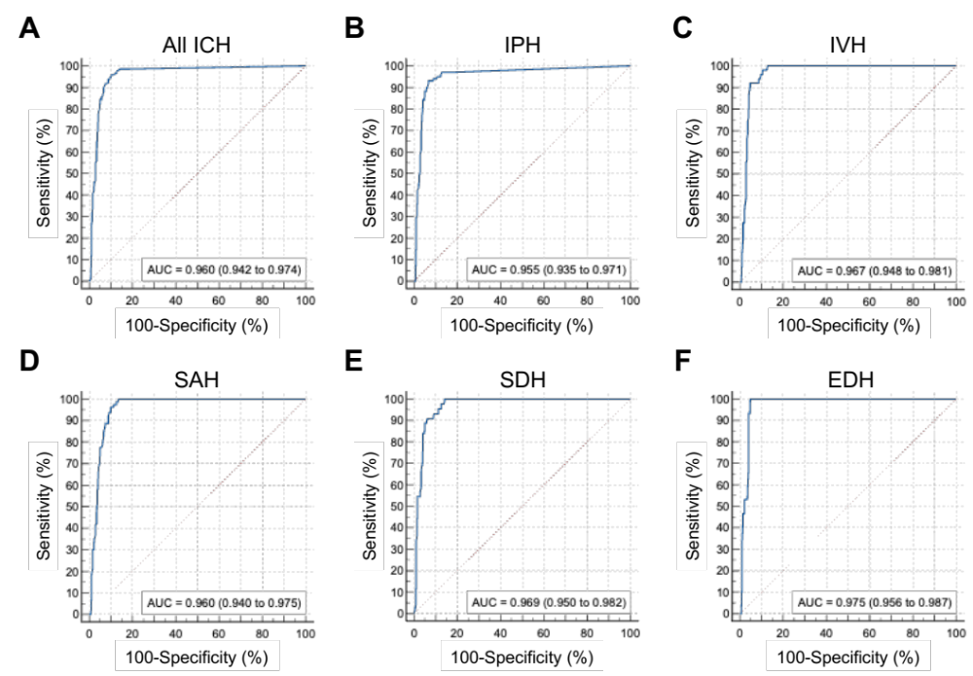
Supplementary Figure 1. Reciever operating characteristics curve for JLK-ICH in the multi-ethnic U.S. dataset as an additional external validation.
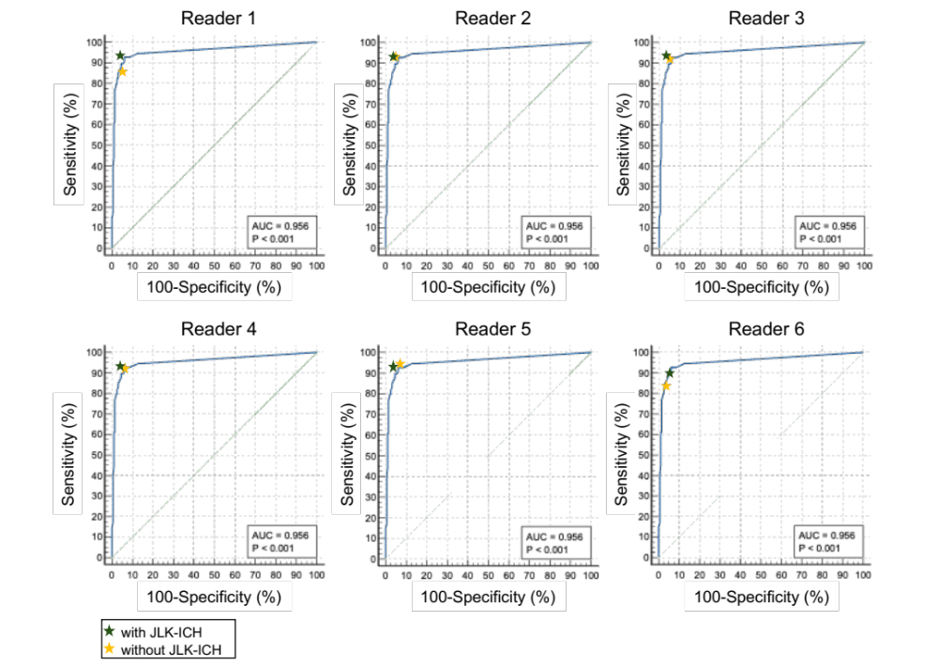
Supplementary Figure 2. The performance of each reader without JLK-ICH assistance (yellow) and with JLK-ICH assistance (green) is shown with the ROC curve of the deep learning algorithm.

