Supplementary material:
Title.
Endovascular Therapy vs. Conventional Medical Treatment for Symptomatic Intracranial Atherosclerotic Stenosis: An Updated Meta-Analysis of Randomized Controlled Trials.

Contents:
Tables and figures.
Table S1: Search strategy.
Figure S1: Short-term mortality sensitivity analysis.
Figure S2: Short-term ipsilateral stroke sensitivity analysis.
Figure S3: Short-term ischemic stroke sensitivity analysis.
Figure S4: Short-term hemorrhagic stroke sensitivity analysis.
Figure S5: Short-term TIA sensitivity analysis.
Figure S6: Long-term death or stroke forest plot.
Figure S7: Long-term death or stroke sensitivity analysis.
Figure S8: Long-term death forest plot.
Figure S9: Long-term death sensitivity analysis.
Figure S10: Long-term ipsilateral stroke forest plot.
Figure S11: Long-term ipsilateral stroke sensitivity analysis.
Figure S12: Long-term ischemic stroke forest plot.
Figure S13: Long-term ischemic stroke sensitivity analysis.
Figure S14: Long-term hemorrhagic stroke forest plot.
Figure S15: Long-term hemorrhagic stroke sensitivity analysis.
Figure S16: Long-term TIA forest plot.
Figure S17: Long-term TIA sensitivity analysis.
Figure S18: Long-term dependency forest plot.
Figure S19: Long-term dependency sensitivity analysis.

Database | Search Terms | Search Field | Search Results
PubMed | ("Angioplasty, Balloon"[MeSH] OR "Percutaneous Transluminal Angioplasty"[MeSH] OR balloon angioplasty OR PTA OR percutaneous transluminal angioplasty OR angioplasty) AND ("Stents"[MeSH] OR stent OR stents OR stenting) AND ("Ischemic Attack, Transient"[MeSH] OR "Brain Ischemia"[MeSH] OR "Intracranial Arteriosclerosis"[MeSH] OR "Intracranial Arterial Diseases"[MeSH] OR cerebral ischemia OR stroke OR intracranial arteriosclerosis OR intracranial artery) AND ("Randomized Controlled Trial"[MeSH] OR Randomized Controlled Trial OR RCT OR randomized OR random OR controlled trial*) | All Field | 1154
Cochrane | (“balloon angioplasty” OR PTA OR “percutaneous transluminal angioplasty” OR angioplasty) AND (stent OR stents OR stenting) AND (“transient ischemic attack” OR “brain ischemia” OR “intracranial arteriosclerosis” OR “intracranial arterial diseases” OR “cerebral ischemia” OR stroke OR “intracranial artery”) AND (“randomized controlled trial” OR RCT OR randomized OR random OR “controlled trial”) | All Field | 677
WOS | TS= (("balloon angioplasty" OR PTA OR "percutaneous transluminal angioplasty" OR angioplasty)) AND TS=((stent OR stents OR stenting)) AND TS=(("transient ischemic attack" OR "brain ischemia" OR "intracranial arteriosclerosis" OR "intracranial arterial diseases" OR "cerebral ischemia" OR stroke OR "intracranial artery")) AND TS=(("randomized controlled trial" OR RCT OR randomized OR random OR "controlled trial")) | All Field | 1190
SCOPUS | (“balloon angioplasty” OR PTA OR “percutaneous transluminal angioplasty” OR angioplasty) AND (stent OR stents OR stenting) AND (“transient ischemic attack” OR “brain ischemia” OR “intracranial arteriosclerosis” OR “intracranial arterial diseases” OR “cerebral ischemia” OR stroke OR “intracranial artery”) AND (“randomized controlled trial” OR RCT OR randomized OR random OR “controlled trial”) | Title, Abstract, Keywords | 1,568
EMBASE | ('balloon angioplasty'/exp OR 'percutaneous transluminal angioplasty'/exp OR 'balloon angioplasty' OR PTA OR 'percutaneous transluminal angioplasty' OR angioplasty)  AND  ('stent'/exp OR stent OR stents OR stenting)  AND  ('transient ischemic attack'/exp OR 'brain ischemia'/exp OR 'intracranial arteriosclerosis'/exp OR 'intracranial artery'/exp OR 'cerebral ischemia' OR stroke OR 'intracranial arteriosclerosis' OR 'intracranial artery')  AND  ('randomized controlled trial'/exp OR RCT OR randomized OR random OR 'controlled trial') | All Field | 1286
Table S1: Search Strategy.

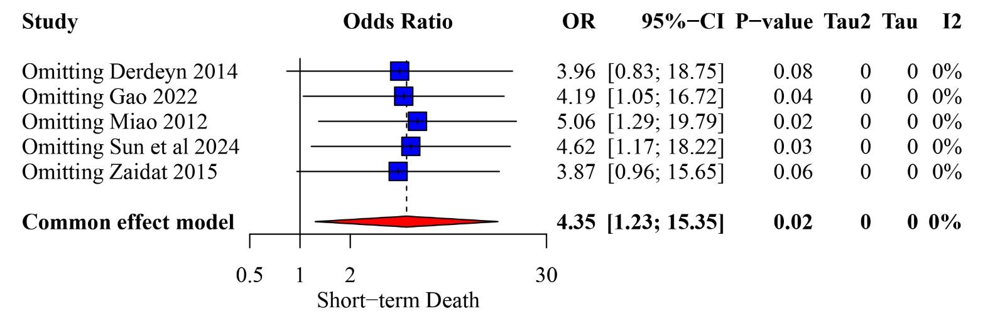Figure S1: Short-term mortality sensitivity analysis.
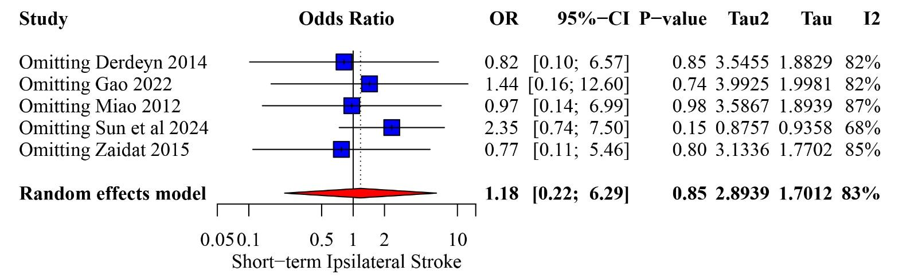Figure S2: Short-term ipsilateral stroke sensitivity analysis.
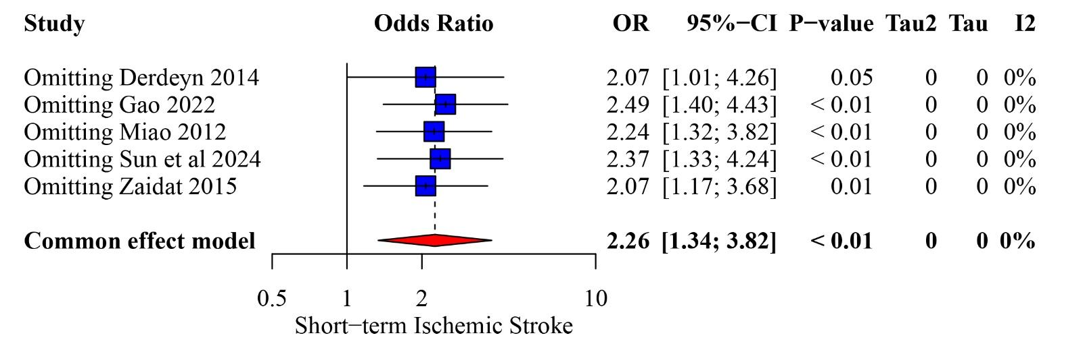Figure S3: Short-term ischemic stroke sensitivity analysis.
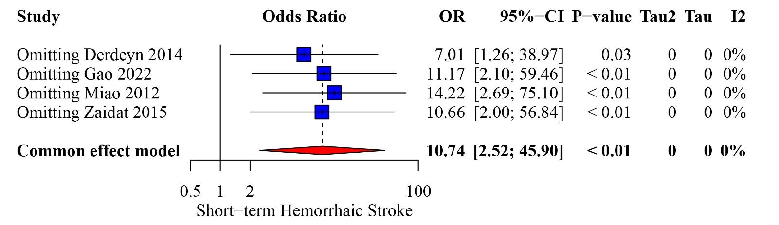Figure S4: Short-term hemorrhagic stroke sensitivity analysis.
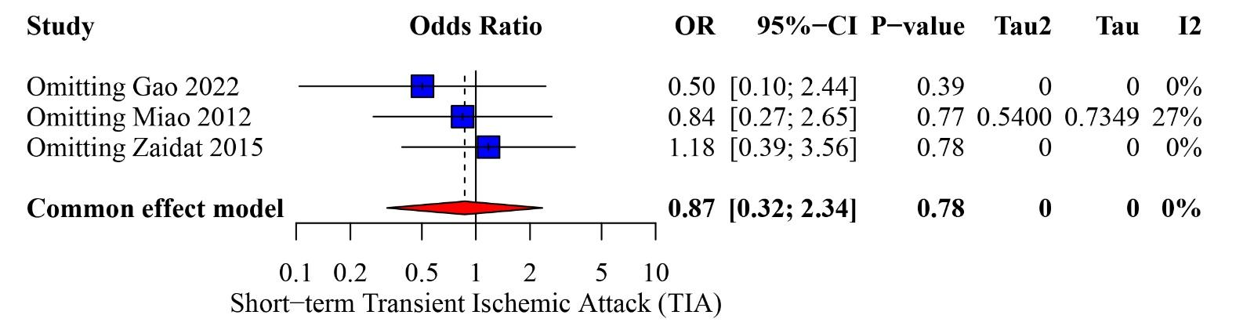Figure S5: Short-term TIA sensitivity analysis.
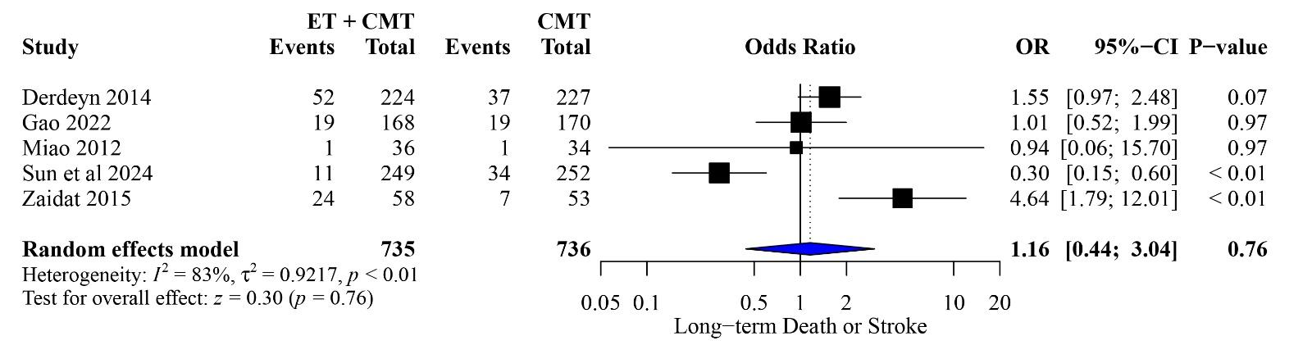Figure S6: Long-term death or stroke forest plot.
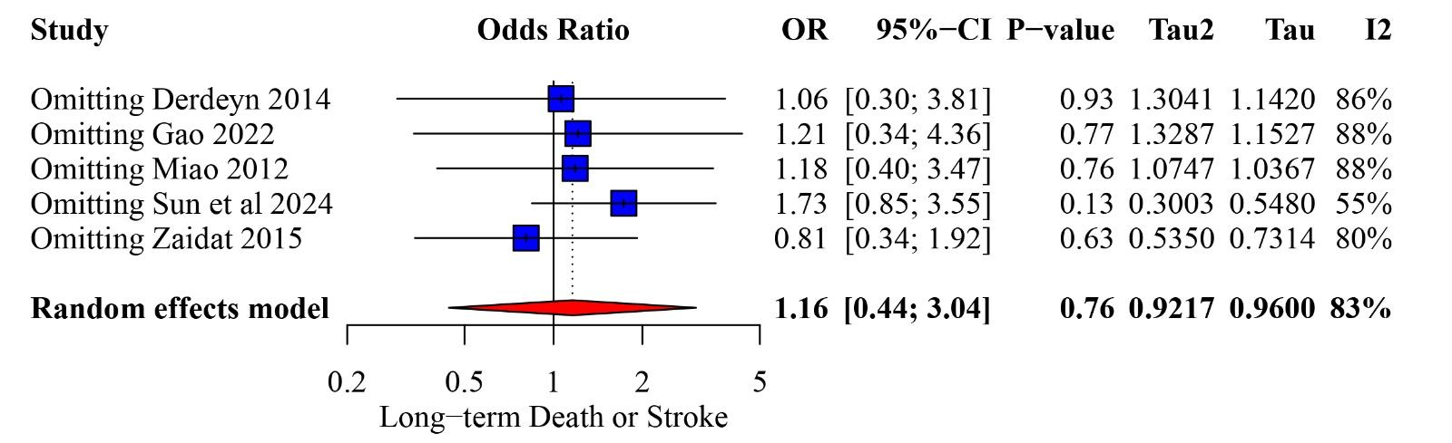Figure S7: Long-term death or stroke sensitivity analysis.
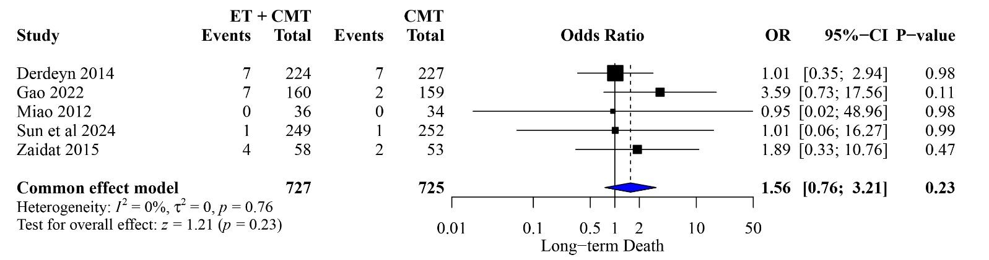Figure S8: Long-term death forest plot.
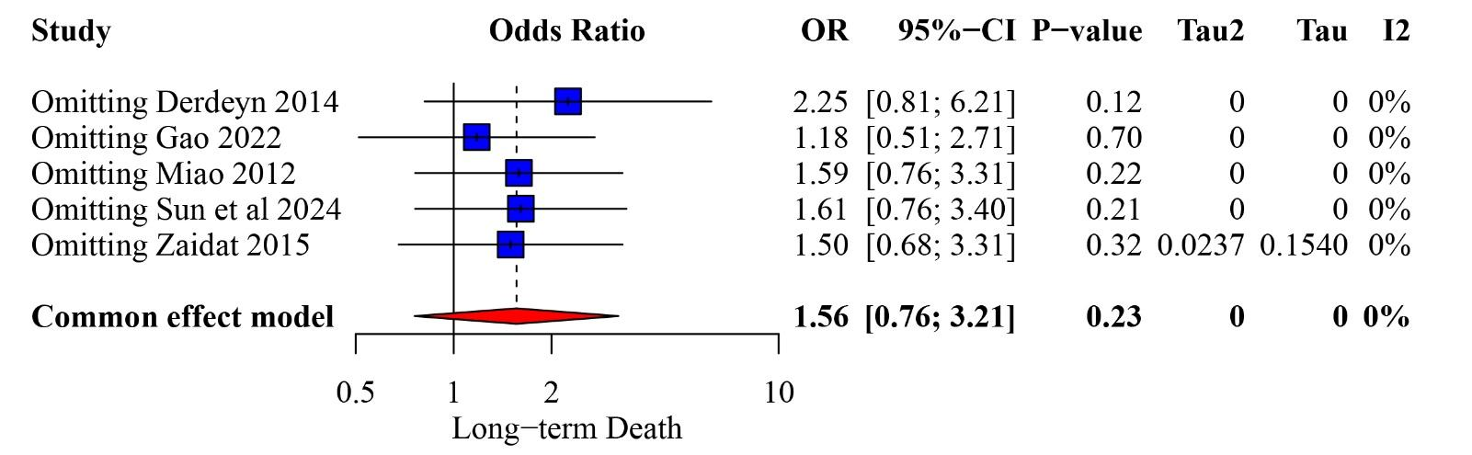Figure S9: Long-term death sensitivity analysis.
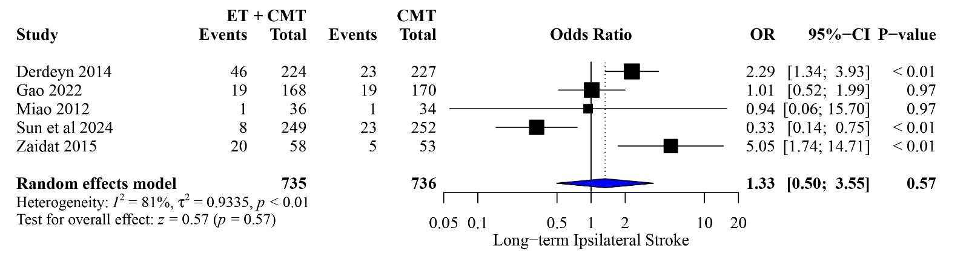Figure S10: Long-term ipsilateral stroke forest plot.
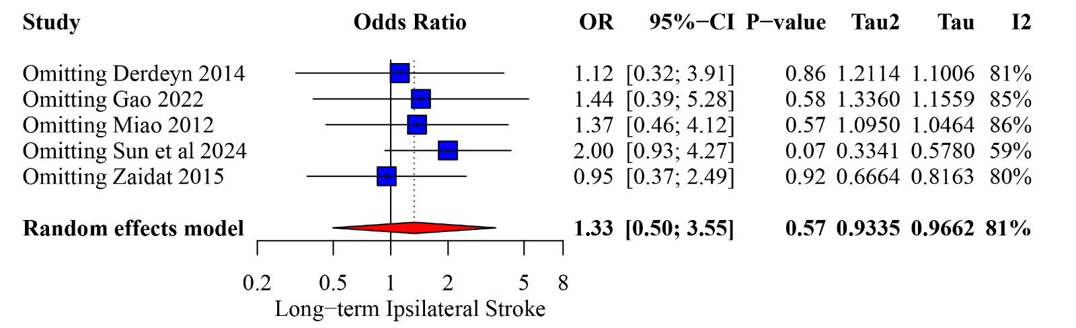Figure S11: Long-term ipsilateral stroke sensitivity analysis.
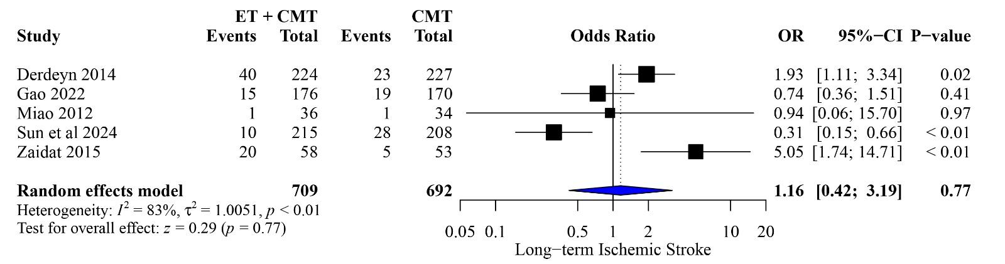Figure S12: Long-term ischemic stroke forest plot.

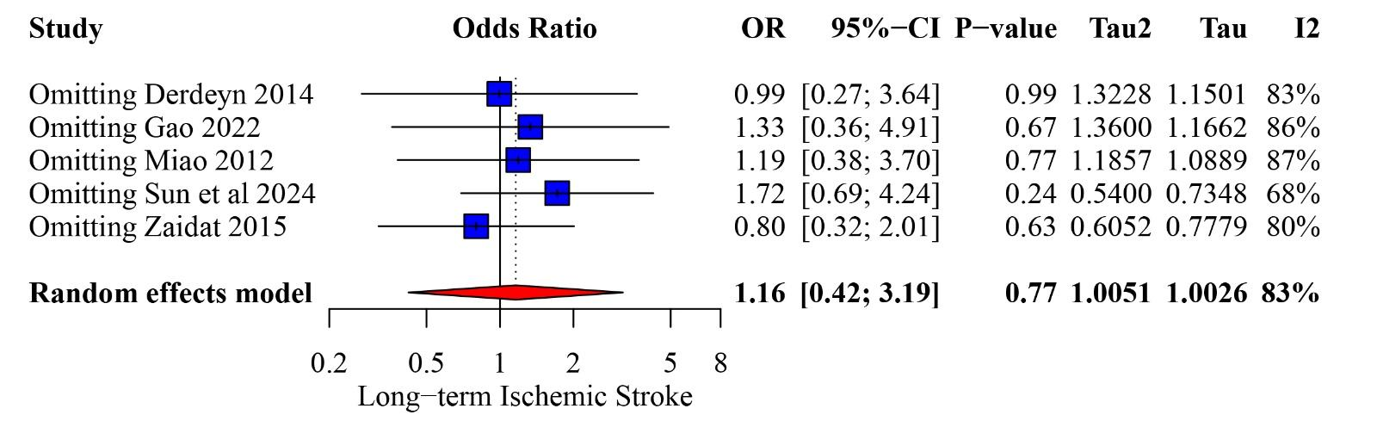Figure S13: Long-term ischemic stroke sensitivity analysis.
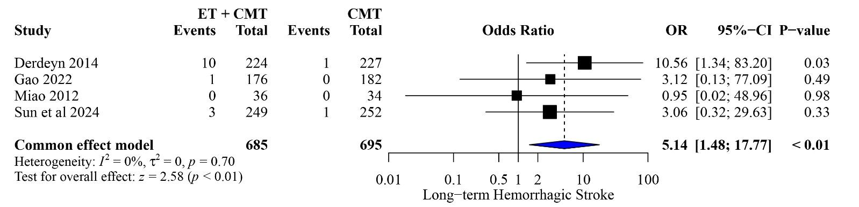Figure S14: Long-term hemorrhagic stroke forest plot.
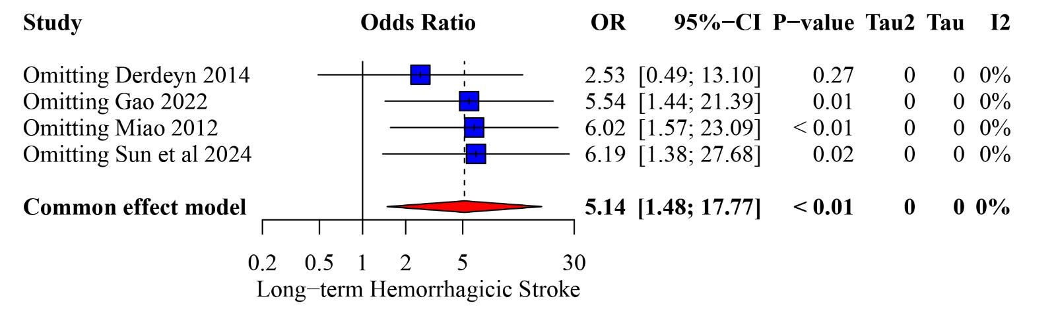Figure S15: Long-term hemorrhagic stroke sensitivity analysis.
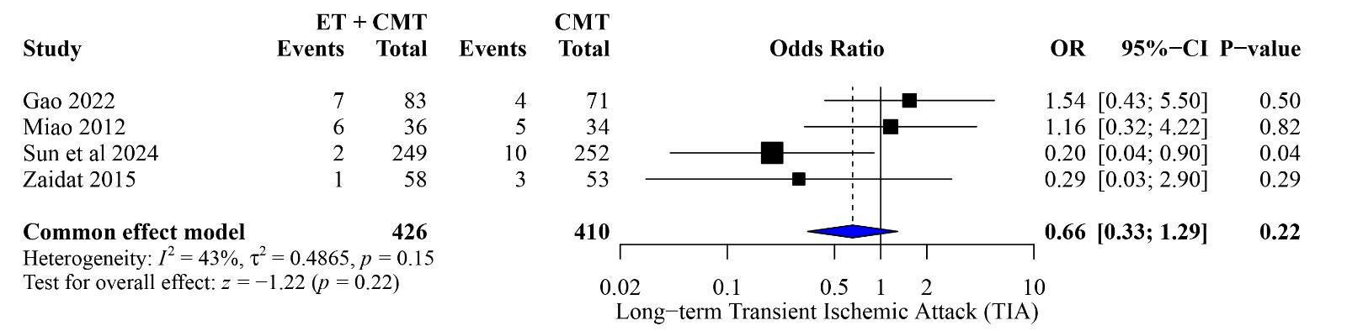Figure S16: Long-term TIA forest plot.
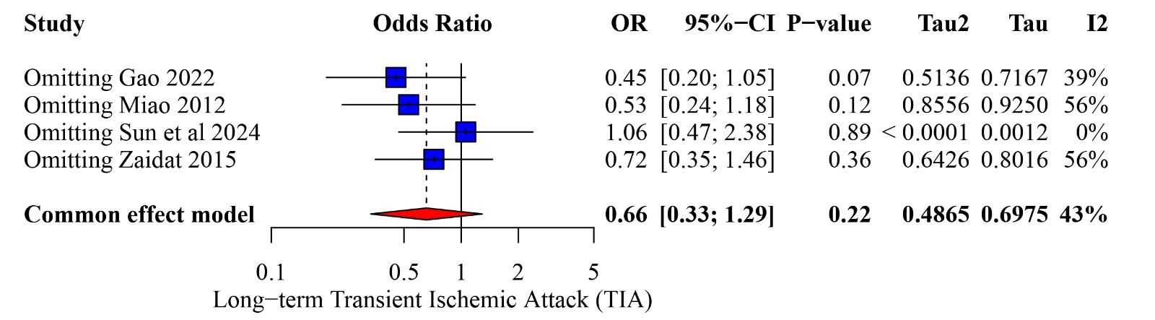Figure S17: Long-term TIA sensitivity analysis.
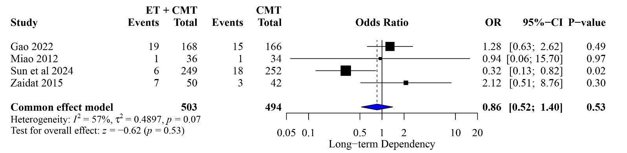Figure S18: Long-term dependency forest plot.
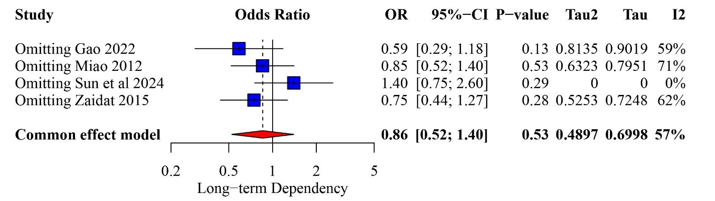
Figure S19: Long-term dependency sensitivity analysis.

