Cerebellar and brainstem MRI alterations in Primary Brain Calcification: results from the Padova PBC cohort
Supplementary Material

Renzo Manara^{1,2†*}, Giovanni Librizzi^{1,2†}, Simone Cauzzo^{3†}, Matilde Corazza⁴, Silvia Valeggia ^{1,2}, Francesca Pistonesi^{3,4}, Cinzia Bertolin⁵, Leonardo Salviati⁵, Angelo Antonini^{1,3,4}, Giulia Bonato^{3,4,6‡}, Miryam Carecchio^{1,3,4‡*}

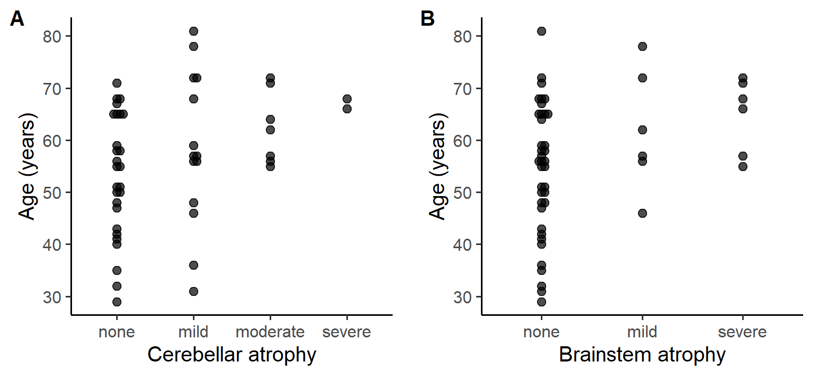
Supplementary Figure S1. Correlation of age and degree of atrophy in cerebellum (A) and brainstem (B)

Supplementary Table S1. Susceptibility-weighted imaging (SWI) findings in Primary Brain Calcification patients and controls. *symmetric punctate hypointensity located posteriorly close to the midline, likely corresponding to the hypoglossal nuclei.
Structure | Severity | PBC patients (n=50) | Controls (n=50) | p
Dentate nuclei | Normal | 12 | 45 | p<0.001
Dentate nuclei | Mild | 10 | 5 | p<0.001
Dentate nuclei | Moderate | 12 | 0 | p<0.001
Dentate nuclei | Severe | 16 | 0 | p<0.001
Red nuclei | Normal | 46 | 48 | p=0.426
Red nuclei | Mild | 1 | 2 | p=0.426
Red nuclei | Moderate | 2 | 0 | p=0.426
Red nuclei | Severe | 1 | 0 | p=0.426
Subthalamic nuclei | Normal | 28 | 37 | p=0.020
Subthalamic nuclei | Mild | 16 | 13 | p=0.020
Subthalamic nuclei | Moderate | 6 | 0 | p=0.020
Subthalamic nuclei | Severe | 0 | 0 | p=0.020
Substantia nigra | Normal | 38 | 46 | p=0.053
Substantia nigra | Mild | 12 | 4 | p=0.053
Substantia nigra | Moderate | 0 | 0 | p=0.053
Substantia nigra | Severe | 0 | 0 | p=0.053
Cerebellar cortex | Normal | 29 | 50 | p<0.001
Cerebellar cortex | Hypointense | 21 | 0 | p<0.001
Medulla oblongata | Normal | 45 | 50 | p=0.056
Medulla oblongata | Hypointense* | 5 | 0 | p=0.056
Medullary corpora  (signal intensity) | Normal | 24 | 50 | p<0.001
Medullary corpora  (signal intensity) | Mild | 9 | 0 | p<0.001
Medullary corpora  (signal intensity) | Severe | 17 | 0 | p<0.001
Medullary corpora  (affected area) | Normal | 24 | 50 | p<0.001
Medullary corpora  (affected area) | Mild | 10 | 0 | p<0.001
Medullary corpora  (affected area) | Severe | 16 | 0 | p<0.001
Middle cerebellar peduncles | Normal | 38 | 50 | p<0.001
Middle cerebellar peduncles | Affected | 12 | 0 | p<0.001

Supplementary Table S2. T1-weighted imaging findings in Primary Brain Calcification patients and controls.
Structure | MRI feature | PBC patients (n=50) | Controls (n=50) | p-value
Dentate nuclei | Isointense | 24 | 50 | <0.001
Dentate nuclei | Predominantly hyperintense | 16 | 0 | <0.001
Dentate nuclei | Predominantly hypointense | 10 | 0 | <0.001
Red nuclei | Isointense | 45 | 50 | 0.056
Red nuclei | Hyperintense | 5 | 0 | 0.056
Subthalamic nuclei | Isointense | 49 | 50 | 1
Subthalamic nuclei | Hyperintense | 1 | 0 | 1
Substantia nigra | Isointense | 50 | 50 | 1
Cerebellar cortex | Isointense | 34 | 50 | <0.001
Cerebellar cortex | Hyperintense | 5 | 0 | <0.001
Cerebellar cortex | Hypointense | 11 | 0 | <0.001
Medulla oblongata | Isointense | 50 | 50 | 1

Supplementary Table S3. Relation between dentate nuclei hila signal intensity, and cerebellar atrophy, brainstem atrophy and red nuclei T1 signal intensity.
 |  | Dentate nuclei hila FLAIR signal
Feature |  | Isointense | Hyperintense
Cerebellar atrophy | None | 25 | 2
 | Mild | 11 | 3
 | Moderate | 2 | 5
 | Severe | 2 | 0
Brainstem atrophy | None | 35 | 3
 | Mild | 2 | 4
 | Severe | 3 | 3
Red nucleus | T1 isointense | 38 | 7
 | T1 hyperintense | 2 | 3

Supplementary Table S4. Relation between PBC genetic subtype and radiological alterations severity.
 | Genetics
Structure | Severity | Unknown (n=16) | SLC20A2 (n=12) | MYORG (n=9) | PDGF(R)B  (n=8) | XPR1  (n=1)
Cerebellar atrophy | None (n=25) | 9 | 10 | 0 | 5 | 1
Cerebellar atrophy | Mild (n=13) | 7 | 1 | 3 | 2 | 0
Cerebellar atrophy | Moderate (n=6) | 0 | 1 | 4 | 1 | 0
Cerebellar atrophy | Severe (n=2) | 0 | 0 | 2 | 0 | 0
Brainstem atrophy | None (n=35) | 14 | 11 | 2 | 7 | 1
Brainstem atrophy | Mild (n=6) | 2 | 1 | 3 | 0 | 0
Brainstem atrophy | Severe (n=5) | 0 | 0 | 4 | 1 | 0
SWI hypointense dentate nuclei | None (n=11) | 8 | 3 | 0 | 0 | 0
SWI hypointense dentate nuclei | Mild (n=9) | 5 | 2 | 0 | 2 | 0
SWI hypointense dentate nuclei | Moderate (n=12) | 3 | 5 | 1 | 3 | 0
SWI hypointense dentate nuclei | Severe (n=14) | 0 | 2 | 8 | 3 | 1
SWI medullary corpora signal intensity | None (n=22) | 14 | 7 | 0 | 1 | 0
SWI medullary corpora signal intensity | Mild (n=9) | 2 | 1 | 2 | 4 | 0
SWI medullary corpora signal intensity | Severe (n=15) | 0 | 4 | 7 | 3 | 1
SWI medullary corpora hypointensity area | None (n=22) | 14 | 7 | 0 | 1 | 0
SWI medullary corpora hypointensity area | Mild (n=10) | 1 | 3 | 0 | 5 | 1
SWI medullary corpora hypointensity area | Severe (n=14) | 1 | 2 | 9 | 2 | 0

Supplementary Table S5. Associations between imaging findings and patients’ clinical picture (univariate analysis). MDS-UPDRS-III=Unified Parkinson’s Disease Rating Scale part III; MoCA=Montreal Cognitive Assessment; SWI=Susceptibility-Weighted Imaging; FLAIR=Fluid Attenuated Inversion Recovery; * the subgroup of 10 patients with predominantly T1 hypointense dentate nuclei had a worse clinical phenotype, with 5/10 having cerebellar disorders, 7/10 dysarthria and 8/10 had cognitive impairment (seven mild cognitive impairment and one dementia); #symmetric punctate hypointensity located posteriorly close to the midline, likely corresponding to the hypoglossal nuclei.
Predictor | Clinical feature | Data | p-value
Brainstem Vascular Involvement | MDS-UPDRS-III | 17.8±13.1 vs. 5.3±10.2 | 0.022
Brainstem Vascular Involvement | freezing | 4/9 vs. 2/41 | 0.007
Brainstem Vascular Involvement | falls | 7/9 vs. 5/41 | <0.001
Brainstem Vascular Involvement | Oculomotor alterations | 4/9 vs. 5/41 | 0.043
Cerebellar Atrophy presence | Cerebellar signs | 10/23 vs. 1/27 | <0.001
Cerebellar Atrophy presence | Dysarthria | 11/23 vs. 1/27 | <0.001
Cerebellar Atrophy presence | Cognitive impairment | 13/22 vs. 7/27 | 0.01
Cerebellar atrophy severity | Cerebellar signs | none 1/26,  mild 3/14,  moderate 5/7,  severe 2/2 | <0.001, tau=0.56
Cerebellar atrophy severity | dysarthria | none 1/26,  mild 3/14,  moderate 6/7,  severe 2/2 | <0.001, tau=0.61
Cerebellar atrophy severity | MoCA | none 24.2±3.2  mild 22.9±3.7  moderate 19.7±5.5  severe 21.0±1.3 | 0.013, tau=-0.28
Brainstem atrophy presence | freezing | 6/12 vs 0/38 | <0.001
Brainstem atrophy presence | falls | 7/12 vs 5/38 | 0.001
Brainstem atrophy presence | Oculomotor dysfunction | 7/12 vs 2/38 | 0.001
Brainstem atrophy severity | Motor symptoms | none 17/38  mild 5/6  severe 6/6 | 0.004, tau=0.40
Brainstem atrophy severity | MDS-UPDRS-III | none 3.9±10.1,  mild 17.0±20.8,  severe 21.2±14.2 | <0.001, tau=0.43
Brainstem atrophy severity | MoCA | none 24.0±3.4,  mild 19.9±6.4,  severe 21.0±1.0 | 0.006, tau=-0.32
SWI dentate nuclei hypointensity presence | Cerebellar signs | 11/38 vs. 0/12 | 0.003
SWI dentate nuclei hypointensity presence | Dysarthria | 12/38 vs. 0/12 | <0.001
SWI dentate nuclei hypointensity presence | Cognitive impairment | 17/38 vs. 3/11 | 0.02, ρ=0.34
SWI dentate nuclei hypointensity severity | MoCA | none 25.4±2.7,  mild 24.2±4.1,  moderate 23.2±3.2,  severe 20.8±4.1 | <0.001, tau=-0.37
T1 dentate nuclei signal changes* | Cerebellar signs | 9/26 vs. 2/24 | 0.009
T1 dentate nuclei signal changes* | Dysarthria | 11/26 vs. 1/24 | 0.002
Dentate nucleus hilum FLAIR hyperintensity | Dysarthria | 6/10 vs. 6/40 | 0.01
Dentate nucleus hilum FLAIR hyperintensity | Cognitive impairment | 7/10 vs. 3/39 | 0.015
Dentate nucleus hilum FLAIR hyperintensity | MoCA | 20.2±5.0 vs. 23.9±3.3 | 0.047
SWI medullary corpora area of involvement | Cerebellar signs | none 1/24  mild 2/10  severe 8/16 | 0.001, tau=0.45
SWI medullary corpora area of involvement | Dysarthria | none 1/24  mild 1/10  severe 10/16 | <0.001, tau=0.54
SWI medullary corpora area of involvement | Cognitive impairment | none 6/23  mild 3/10  severe 11/16 | 0.01, tau=0.35
SWI medullary corpora area of involvement | MoCA | none 24.8±3.1,  mild 23.0±3.9,  severe 20.8±4.0 | 0.001, tau=-0.37
SWI medullary corpora hypointensity severity | Cerebellar signs | none 1/24  mild 3/9  severe 7/17 | 0.004, tau=0.39
SWI medullary corpora hypointensity severity | Dysarthria | none 1/24  mild 2/9  severe 9/17 | <0.001 tau=0.498
SWI medullary corpora hypointensity severity | Cognitive impairment | none 6/23  mild 3/9  severe 11/17 | 0.014, tau=0.33
SWI medullary corpora hypointensity severity | MoCA | none 24.8±3.1,  mild 22.4±3.4,  severe 21.2±4.4 | 0.002, tau=-0.35
SWI middle cerebellar peduncles abnormalities | Cerebellar signs | 8/12 vs. 3/38 | <0.001
SWI middle cerebellar peduncles abnormalities | Dysarthria | 9/12 vs. 3/38 | <0.001
SWI middle cerebellar peduncles abnormalities | Cognitive impairment | 9/12 vs. 11/37 | 0.003
SWI middle cerebellar peduncles abnormalities | MoCA | 20.4±4.8 vs. 24.0±3.2 | 0.029
Red nuclei T1 hyperintensity | Dysarthria | 5/5 vs. 7/45 | <0.001
Red nuclei T1 hyperintensity | Cerebellar signs | 4/5 vs. 7/45 | 0.006
Red nuclei SWI hypointensity | Dysarthria | 3/4 vs. 9/46 | 0.038
Red nuclei SWI hypointensity | Cerebellar signs | 3/4 vs. 8/46 | 0.030
Medulla oblongata nuclei SWI hypointensity# | Dysarthria | 5/5 vs. 7/45 | <0.001
Medulla oblongata nuclei SWI hypointensity# | Cerebellar signs | 4/5 vs. 7/45 | 0.006

