SUPPLEMENTAL INFORMATION

Supplemental File 1: Embedding similarities (with and without SWE) and sequence identities for cross-species complementation experiments for all models and layer choices

Supplemental Figures

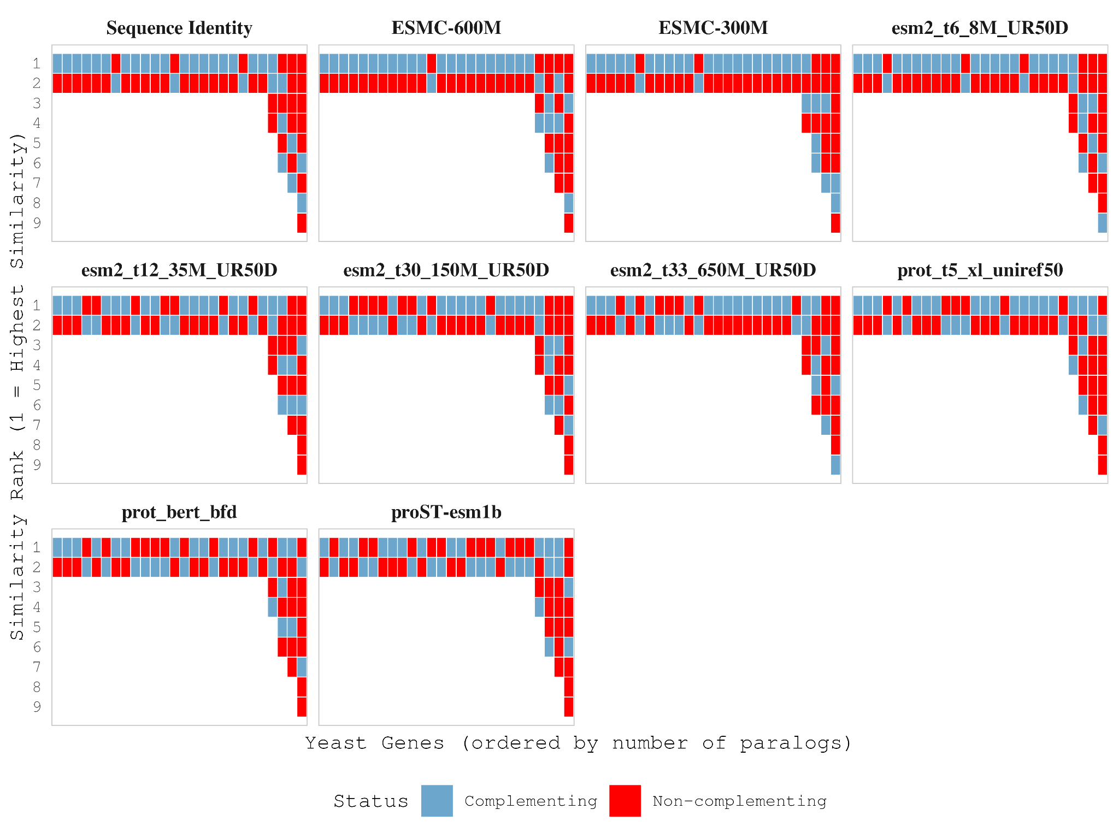Supplemental Figure 1. Poor performance prioritizing complementing proteins from one-to-many groups. Both sequence identity and all models tested were unable to prioritize complementing genes from 1-to-many expanded families with a single yeast gene, but multiple human paralogs (In order:Uroporphyrinogen decarboxylase (4 human inparalogs), Myosin-1 (6 human inparalogs), Actin( 7 human inparalogs) and β-tubulin (9 human inparalogs)).
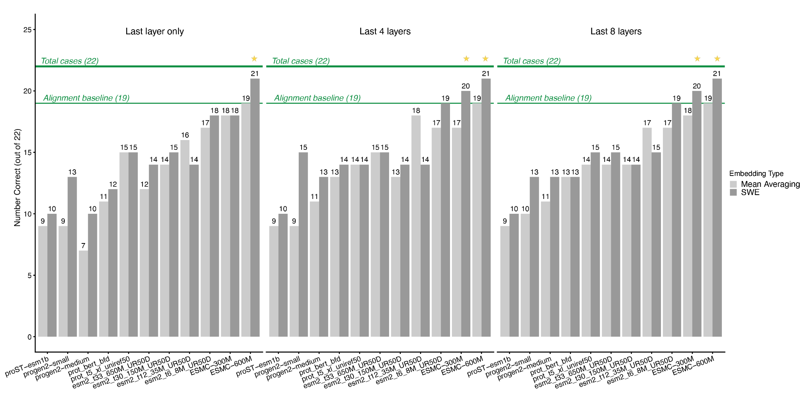

Supplemental Figure 2. Comparison of different protein language models for predicting cross-species complementation between proteins with different layer choices. Bar chart showing the predictive accuracy of various protein language models in identifying which human or Arabidopsis paralog can functionally complement a yeast ortholog. The horizontal line indicates baseline accuracy using sequence identity (19/22 correct). There is a general boost in accuracy from using concatenated embeddings from more than the last layer only. As esm2_t6_8M has only six layers, only six layers are used for the “Last 8 layers” panel.

