Supplemental Information: Genomic and structural analysis of gamete recognition proteins in a broadcast spawning echinoderm Mesocentrotus franciscanus

Pearl R. Rivers Key*, Yueling Hao, Darin R. Rokyta, Don R. Levitan*

Department of Biological Science, Florida State University, King Life Sciences Building, 319 Stadium Dr. Tallahassee, FL 32304

*Corresponding authors: Pearl R. Rivers Key privers@bio.fsu.edu; Don R. Levitan levitan@fsu.edu

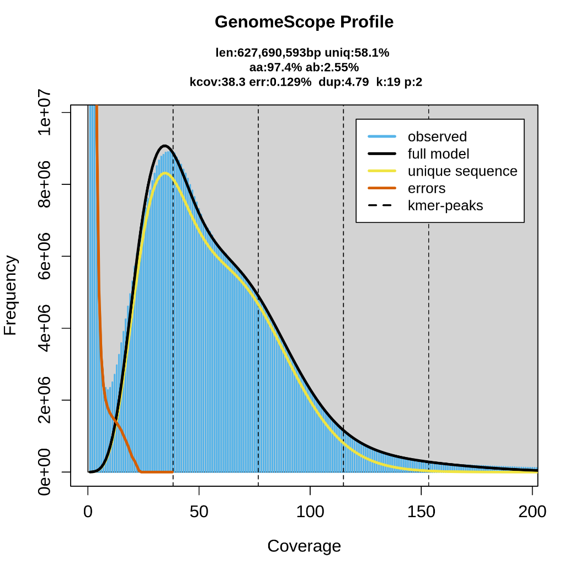
Figure S1: K-mer spectra output generated from PacBio HiFi data using Genomescope 2.0.
Table S1: Comparison of M. franciscanus reference genome (GMGI_Mfr-1.0) and our draft genome assembly.

 | GMGI_Mfr-1.0 | Draft Genome
 | (Polinski et al. 2024) | Draft Genome
Genome Size | 773.2 Mb | 738.6 Mb
Number of scaffolds | 21 | 21 (+6 contigs)
Scaffold N50 | 36.1 Mb | 34.2 Mb
Scaffold L50 | 9 | 10
Number of contigs | 4034 | 194
Contig N50 | 359.45 Kb | 6958.95 Kb
Contig L50 | 656 | 35
Number of Gaps (Percent genome in gaps) | 4013 (0.25%) | 166 (0.0022%)
% GC content | 37.07% | 37.24%
BUSCO (genome)
% complete single copy | 910 (95.4%) | 932 (97.7%)
% complete duplicated | 13 (1.4%) | 18 (1.9%)
% Fragmented | 23 (2.4%) | 2 (0.2%)
% Missing | 8 (0.8%) | 2 (0.2%)
Number Genes | 22,240 | 23,923
Avg. Gene length | 13,408 | 13,652
BUSCO (protein)
% complete single copy | 887 (93.0%) | 889 (96.2%)
% complete duplicated | 27 (2.8%) | 19 (2.0%)
% Fragmented | 31 (3.2%) | 11 (1.2%)
% Missing | 9 (1.0%) | 6 (0.6%)

Table S2: Comparison of repeat elements in our draft M. franciscanus genome assembly, compared to the repeat elements in the Polinski et al. (2024) M. franciscanus reference genome assembly.

Genome Assembly |  |  | Draft Assembly |  |  | GMGI_Mfr-1.0 (Polinski et al. 2024)
 |  |  | number of elements | length occupied | percentage of sequence | percentage of sequence
Retroelements |  |  | 845079 | 180725234 bp | 24.47% | 25.27%
 | SINEs |  | 194402 | 33007892 bp | 4.47% | 4.67%
 |  | Penelope | 8603 | 1606949 bp | 0.22% | 0.42%
 | LINEs |  | 577335 | 125656899 bp | 17.01% | 17.62%
 |  | CRE/SLACS | 0 | 0 bp | 0.00% | 0.00%
 |  | L2/CR1/Rex | 338673 | 74185387 bp | 10.05% | 11.03%
 |  | R1/LOA/Jockey | 10651 | 2722849 bp | 0.37% | 0.34%
 |  | R2/R4/NeSL | 4306 | 903360 bp | 0.12% | 0.10%
 |  | RTE/Bov-B | 75513 | 13877428 bp | 1.88% | 1.90%
 |  | L1/CIN4 | 17582 | 3595125 bp | 0.49% | 0.54%
 | LTR elements |  | 73342 | 22060443 bp | 2.99% | 2.98%
 |  | BEL/Pao | 7409 | 2346479 bp | 0.32% | 0.33%
 |  | Ty1/Copia | 377 | 299654 bp | 0.04% | 0.02%
 |  | Gypsy/DIRS1 | 43909 | 15448082 bp | 2.09% | 2.11%
 |  | Retroviral | 19206 | 2997464 bp | 0.41% | 0.32%
DNA transposons |  |  | 237610 | 40242642 bp | 5.45% | 5.35%
 |  | hobo-Activator | 38871 | 7755902 bp | 1.05% | 0.67%
 |  | Tc1-IS630-Pogo | 128325 | 16715001 bp | 2.26% | 2.21%
 |  | En-Spm | 0 | 0 bp | 0.00% | 0.00%
 |  | MULE-MuDR | 0 | 0 bp | 0.00% | 0.00%
 |  | PiggyBac | 193 | 54790 bp | 0.01% | 0.01%
 |  | Tourist/Harbinger | 18929 | 4049574 bp | 0.55% | 0.44%
Other (Mirage, P-element, Transib) |  |  | 1074 | 839736 bp | 0.11% | 0.17%
Rolling-circles |  |  | 27260 | 5966504 bp | 0.81% | 0.95%
Unclassified |  |  | 918683 | 204418077 bp | 27.68% | 28.71%
Total interspersed repeats |  |  |  | 426992902 bp | 57.82% | 59.33%
Small RNA |  |  | 137424 | 26047830 bp | 3.53% | 3.44%
Satellites |  |  | 11656 | 2204654 bp | 0.30% | 0.31%
Simple repeats |  |  | 208869 | 12304111 bp | 1.67% | 1.59%
Low complexity |  |  | 27509 | 1829065 bp | 0.25% | 0.22%

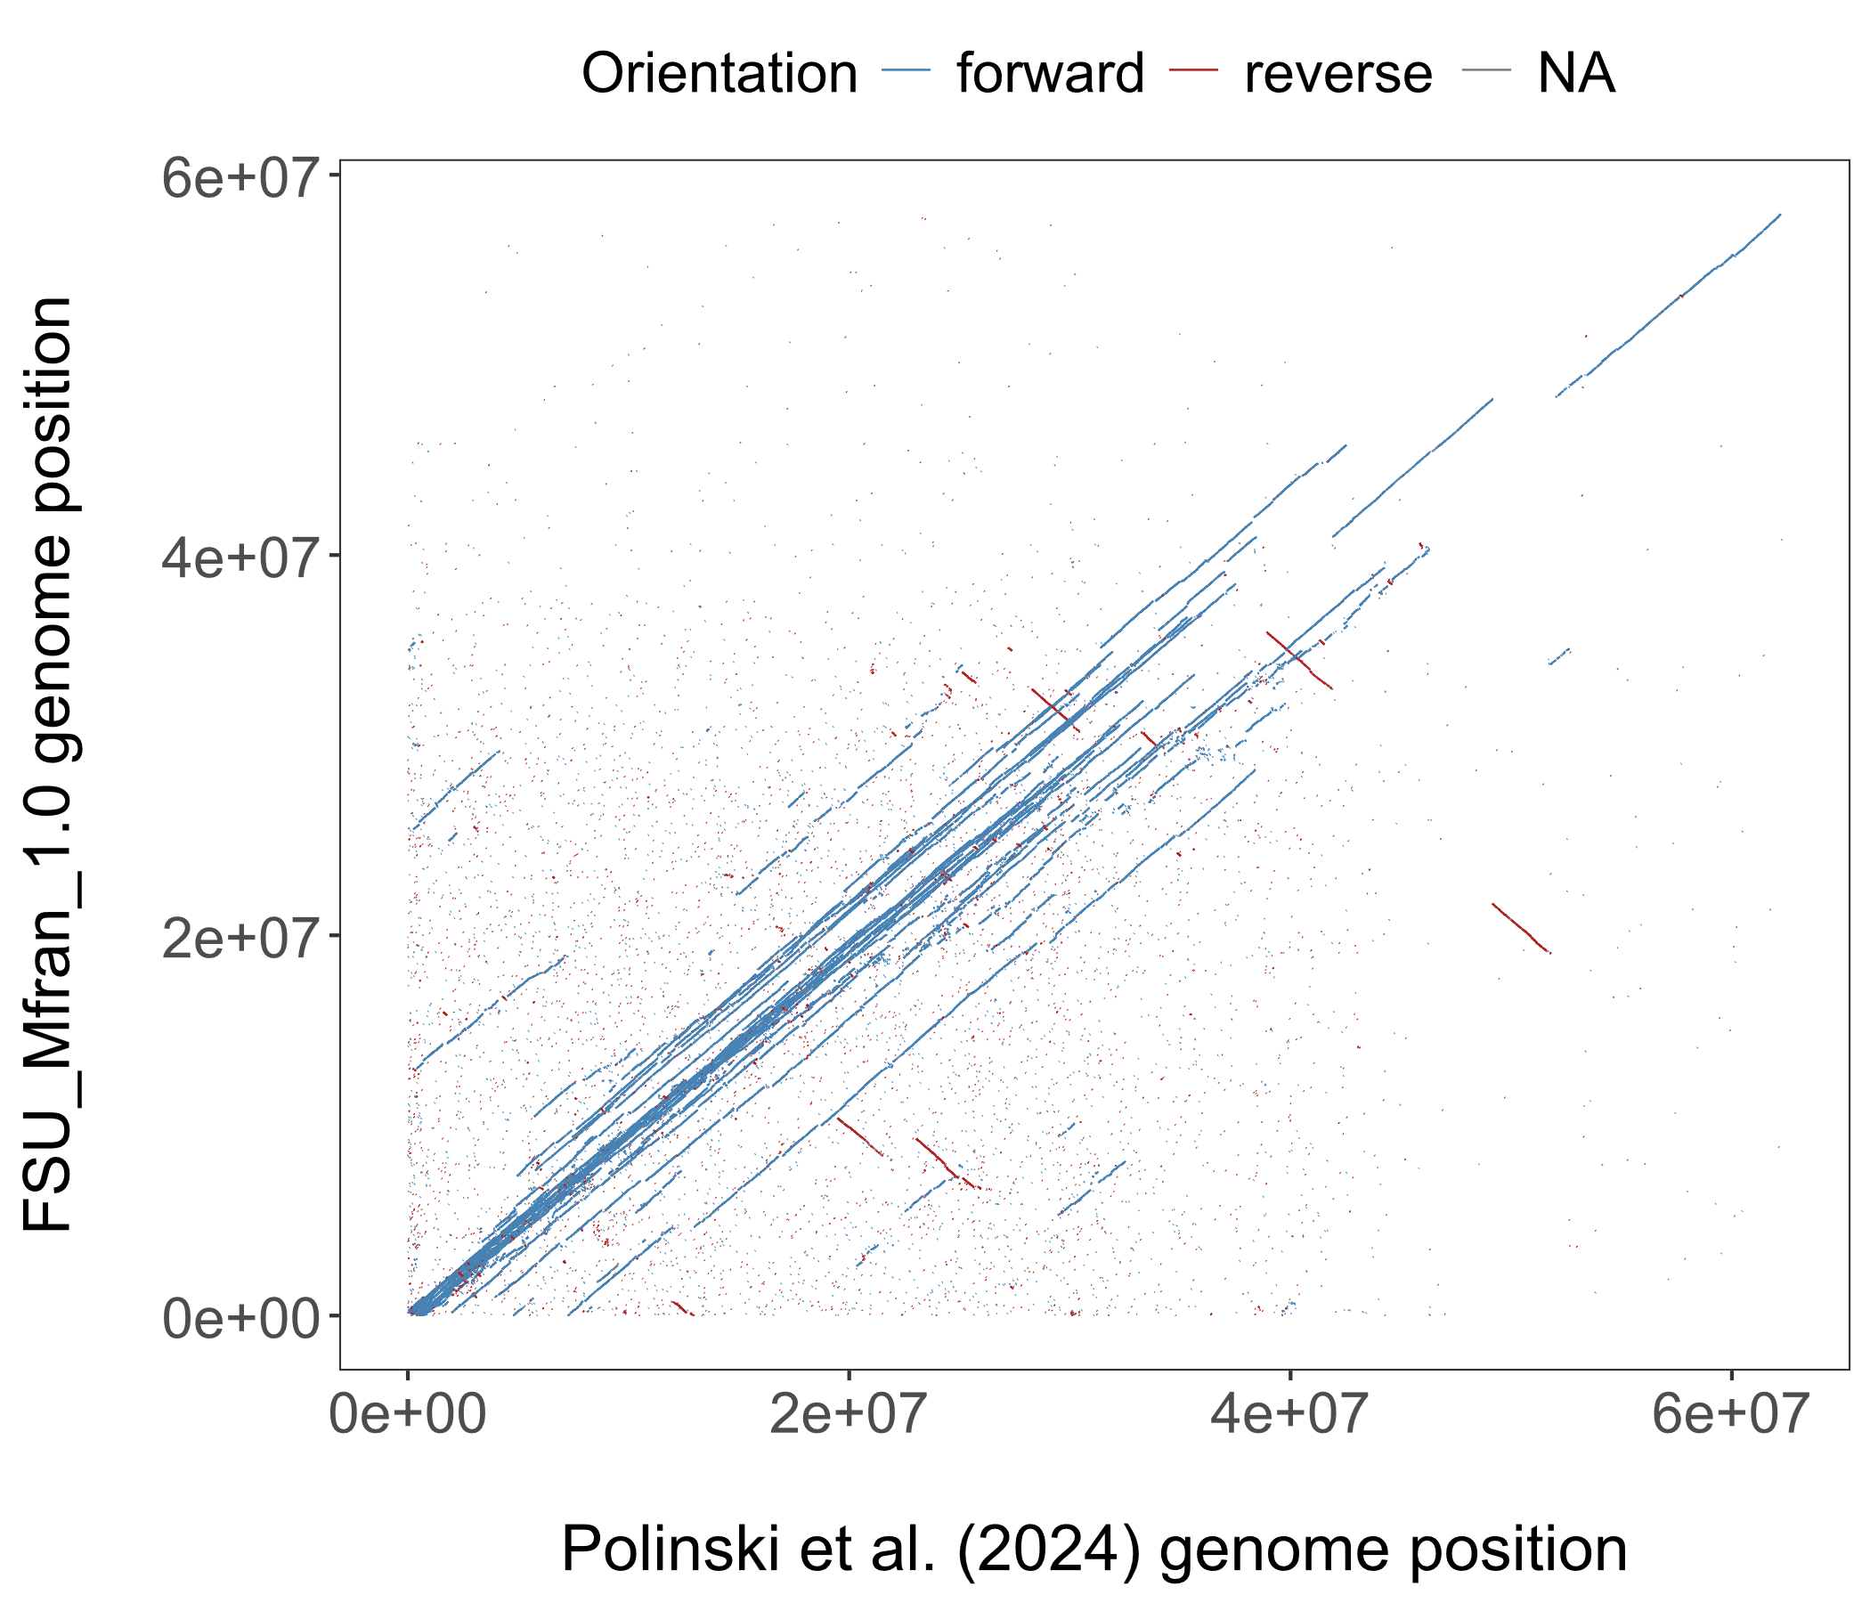
Figure S2: MUMmer dotplot showing alignment of our genome assembly against the Polinski et al. (2024) genome assembly.
Table S3: Comparison of BUSCO groups missing or fragmented in the genome assembly or annotation. BUSCO v5.7.1; lineage: metazoa_odb10

BUSCO ID | Description | Genome | Annotation
324249at33208 | Transcription factor IIIC subunit 5, HTH domain | Complete | Fragmented
367596at33208 | Zinc finger, CCHC-type | Complete | Fragmented
389591at33208 | ATP-dependent (S)-NAD(P)H-hydrate dehydratase | Complete | Fragmented
500808at33208 | SET domain | Complete | Fragmented
529852at33208 | Signal peptidase complex subunit 2 | Complete | Fragmented
535664at33208 | NADH dehydrogenase | Complete | Fragmented
541231at33208 | FAM192A/Fyv6, N-terminal | Complete | Fragmented
557962at33208 | NUDIX hydrolase domain | Complete | Fragmented
566447at33208 | THO complex subunit 7 homolog | Complete | Fragmented
577339at33208 | Selenoprotein F/M domain | Complete | Fragmented
604943at33208 | Trafficking protein particle complex subunit 2 | Complete | Fragmented
216257at33208 | Helicase, C-terminal | Complete | Missing
558385at33208 | Protein of unknown function with TPD sequence-motif | Complete | Missing
613522at33208 | Mitochondrial ribosomal protein L46 | Complete | Missing
648300at33208 | coiled-coil domain-containing protein 43 | Complete | Missing
325183at33208 | Fumarylacetoacetase, N-terminal | Fragmented | Complete
616120at33208 | Prefoldin beta-like | Fragmented | Complete
359532at33208 | Kelch repeat type 1 | Missing | Missing
514724at33208 | N-acetylglucosaminyl transferase component | Missing | Missing

Table S4: Descriptions of the 13 manually curated gamete recognition genes. The gene name, as well as the corresponding gene ID generated by the funannotate annotation pipeline are listed in the Gene column. Scaffold indicates the scaffold on which the gene is found in the genome assembly. Gene length includes the genomic span of the gene, including 5’ and 3’ UTRs, exons, and introns, while the protein length is the length of the predicted final protein. For two genes with two predicted transcript variants, the two protein lengths and number of exons are listed.

Gene | Scaffold | Gene length (exon+intron) | Protein length (aa) | Number of exons | Signal Peptide?
BND (FUN_027388) | Scaffold_12 | 4.6kb | 485 | 5 | Yes
EBR1  (FUN_018137) | Scaffold_8 | 114.8kb | 4066 | 71 | Yes
HSP110 (FUN_034791) | Scaffold_16 | 28.1kb | 886 | 18 | No
REJ (FUN_024313) | Scaffold_10 | 18.5 kb | 964 | 15 | No
REJ2 (FUN_016530) | Scaffold_7 | 36.2 kb | 1286 | 17 | No
REJ3 (FUN_002267) | Scaffold_1 | 36.2 kb | 2573 | 26 | Yes
REJ4 (FUN_019192) | Scaffold_8 | 55.6 kb | T1: 1997  T2: 2820 | T1: 18  T2: 24 | Yes
REJ5 (FUN_013421) | Scaffold_5 | 52.7 kb | 4252 | 52 | Yes
REJ6 (FUN_013234) | Scaffold_5 | 49.2 kb | 3454 | 32 | No
REJ7 (FUN_027198) | Scaffold_12 | 109.6 kb | 4555 | 66 | Yes
REJ8 (FUN_024805) | Scaffold_11 | 46.4 kb | 2951 | 31 | Yes
REJ9 (FUN_004309) | Scaffold_2 | 30.7 kb | 2603 | 28 | No
REJ10  (FUN_012500) | Scaffold_5 | 45.2 kb | 3648 | 43 | No
FUN_016250  (Contains REJ domain) | Scaffold_7 | 49.7 kb | 2537 | 21 | Yes
FUN_016252  (Contains REJ domain) | Scaffold_7 | 47.8 kb | 1782 | 21 | Yes
FUN_042622  (Contains REJ domain) | Scaffold_20 | 28.2 kb | 1321 | 24 | No
FUN_042625  (Contains REJ domain) | Scaffold_20 | 19.9kb | T1: 921  T2: 707 | T1: 17  T2: 13 | No

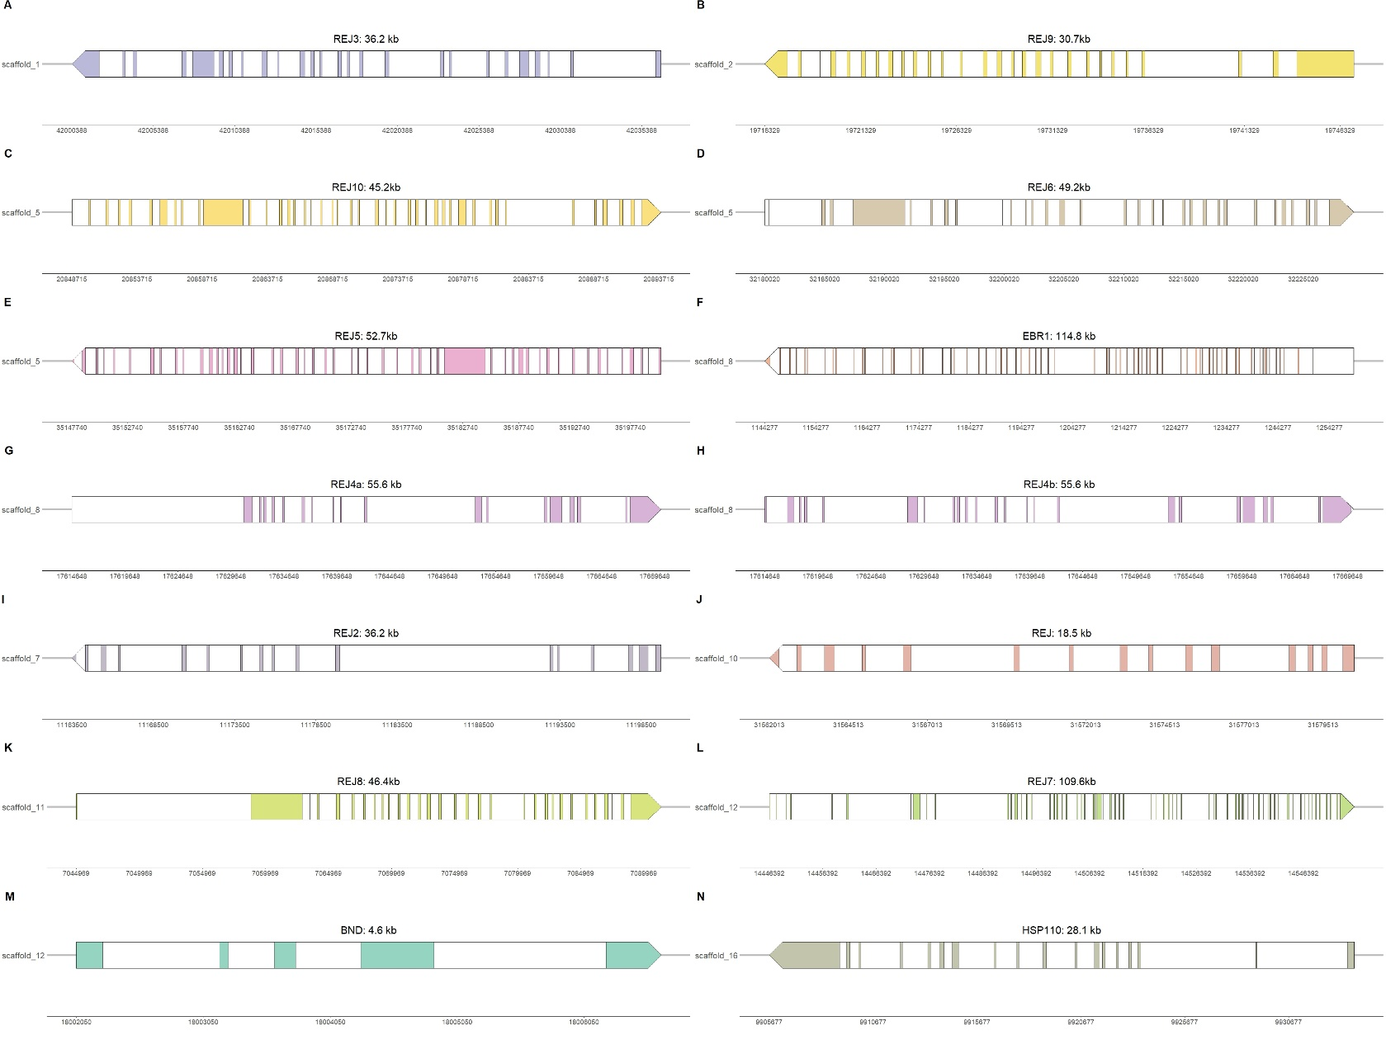
Figure S3: Plots of the annotated gamete recognition genes. The direction of the arrow indicates the direction of transcription (e.g., arrow pointing left indicates reverse transcription).
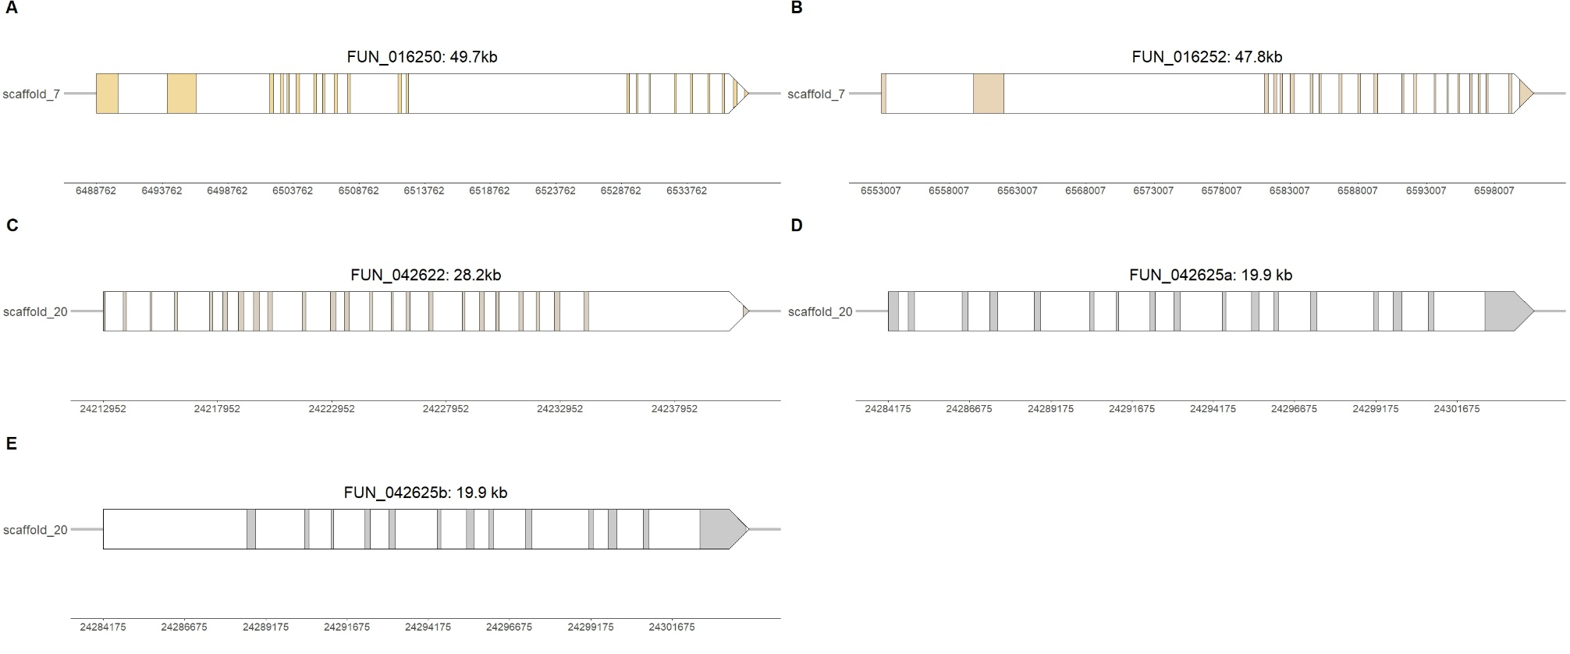
Figure S4: Plots of the annotated gene models that contained receptor for egg jelly (REJ) domains but did not match with the sequence for any of the 10 Strongylocentrotus purpuratus REJ genes. The direction of the arrow indicates the direction of transcription (e.g., arrow pointing left indicates reverse transcription).

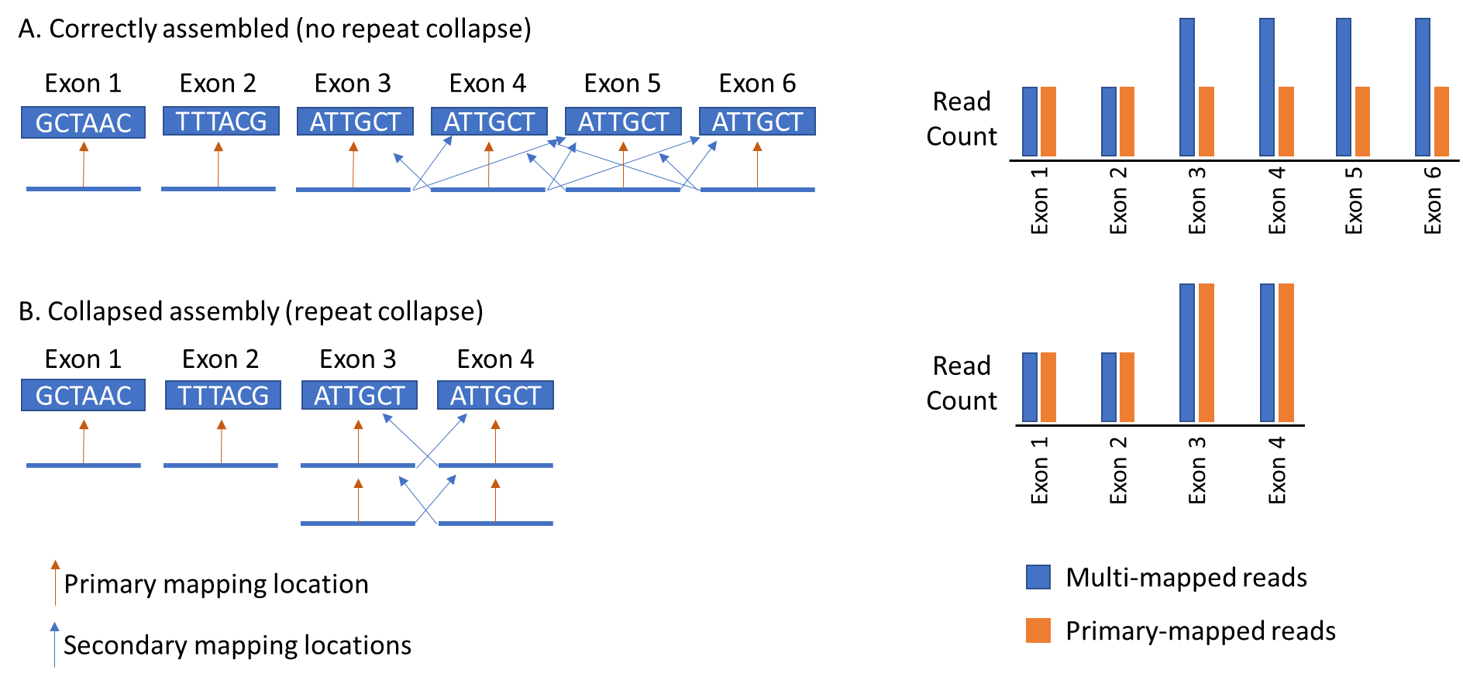

Figure S5: Cartoon illustrating the expected read alignment patterns in repetitive genomic regions and the consequences of repeat collapse during genome assembly. (A) In correctly assembled tandem repeat regions, elevated counts of multi-mapped reads are expected because reads can align to multiple highly similar repeat copies. (B) In contrast, if multiple repeat copies are collapsed into fewer assembled copies, reads originating from distinct genomic regions accumulate at the same assembled locus, resulting in elevated primary-mapped read counts relative to correctly assembled repetitive regions.
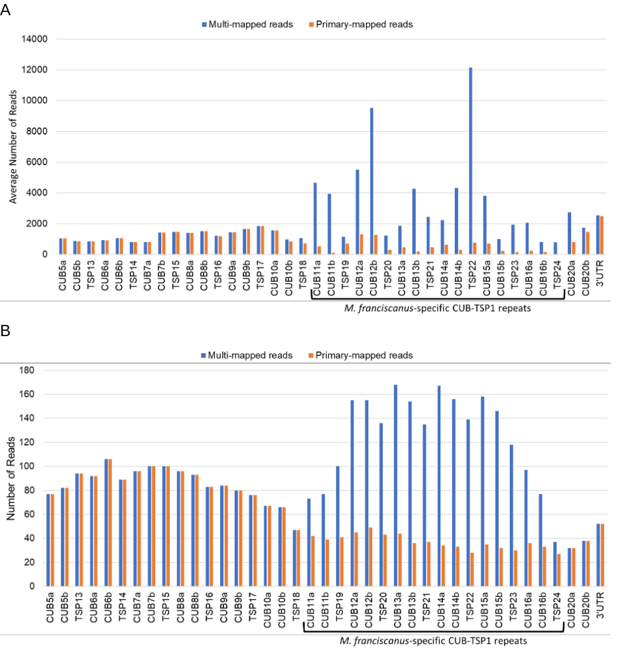
Figure S6: Plots of read counts by exon of the (A) 12 egg transcriptome samples or (B) PacBio HiFi reads aligned to the M. franciscanus-specific portion of EBR1 with high sequence similarity across repeats (CUB11a-TSP²⁴) compared to read counts across the more divergent preceding tandem repeat section (CUB5a-TSP1¹⁸). The M. franciscanus-specific portion of EBR1 is characterized by high rates of multi-mapped reads, however the number of primary mapped reads in this section does not suggest collapsed repeats, when compared to the preceding region of similar length. In both figures, blue indicates counts of all reads, including multi-mapped reads and orange indicates counts of only the primary mapped reads.

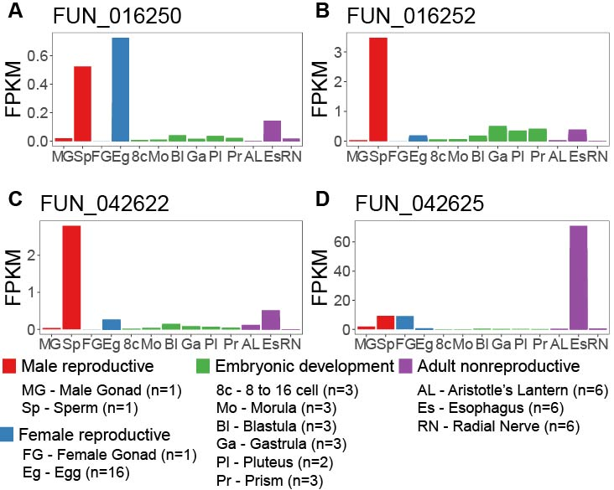

Figure S7: Expression of the 4 additional genes with receptor for egg jelly domains across different tissues. Expression levels are plotted as fragments per kilobase of transcript per million mapped reads, calculated using the fpkm() function in DESeq2. Tissues are grouped into four main types: male reproductive tissues (male gonad and sperm), female reproductive tissues (female gonad and eggs), stages of embryonic development (8-16 cell, morula, blastula, gastrula, pluteus, and prism), and adult non-reproductive tissues (Aristotle’s lantern, esophagus, and radial nerve). The number of samples per tissue type is included in parentheses next to the tissue type on the x-axes.

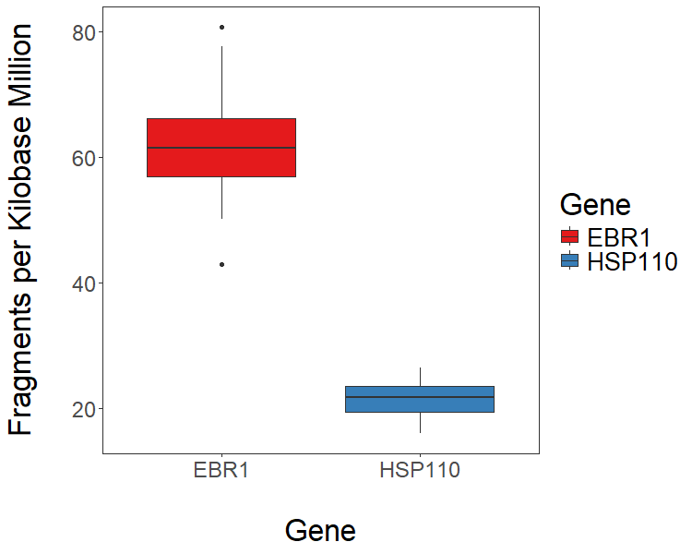

Figure S8: Comparison of EBR1 and HSP110 expression across 12 egg samples. Average expression across the egg samples is represented by fragments per kilobase of transcript per million mapped reads, estimated using the fpkm() function in DESeq2. On average, EBR1 is expressed significantly more than HSP110.

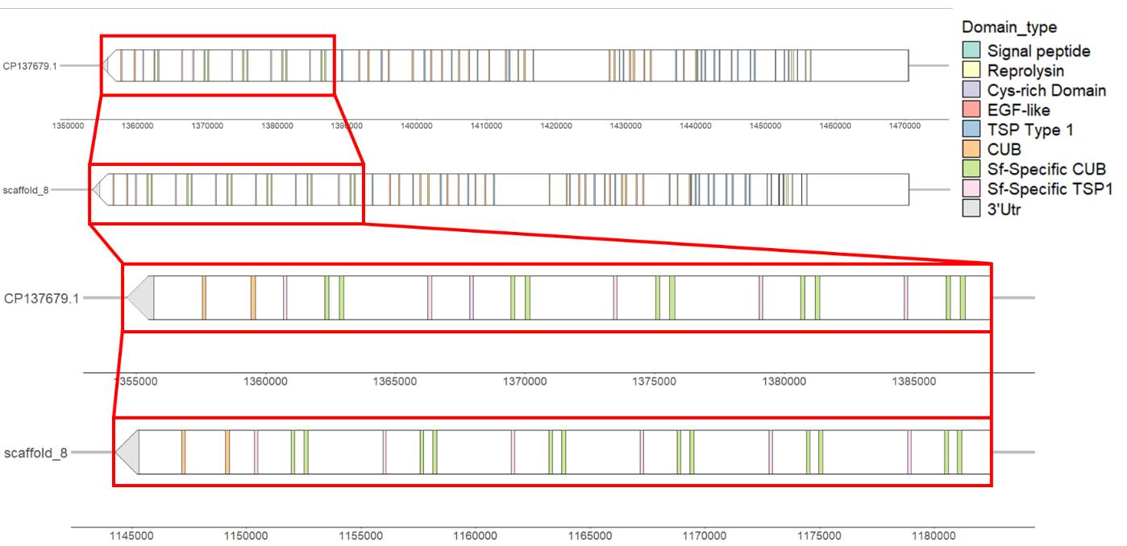

Figure S9: Comparison of EBR1 structure between the Polinski et al. (2024) GMGI-Mfr1.0 genome assembly, and our draft genome assembly. The red boxes highlight the M. franciscanus-specific region of EBR1. In the GMGI-Mfr1.0 genome assembly, 5 tandem repeats, with an additional TSP1 domain after the 4th repeat, were detected. In our draft genome assembly, 6 full tandem repeats are detected.

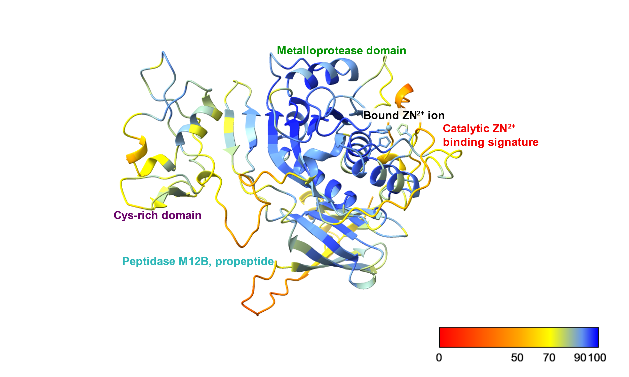
Figure S10: Ribbon protein structural model generated by AlphaFold3 for a portion of M. franciscanus EBR1, the characteristic N-terminal ADAMTS domains, with one bound ZN²⁺ ion. Ribbons are colored by predicted local distance difference test (pLDDT) scores, which provides a per-atom confidence score in the AlphaFold3-predicted protein structure. Shades of blue indicate higher confidence in the local position of atoms (pLDDT > 90), while yellow and orange indicate atoms of low confidence (pLDDT < 70).

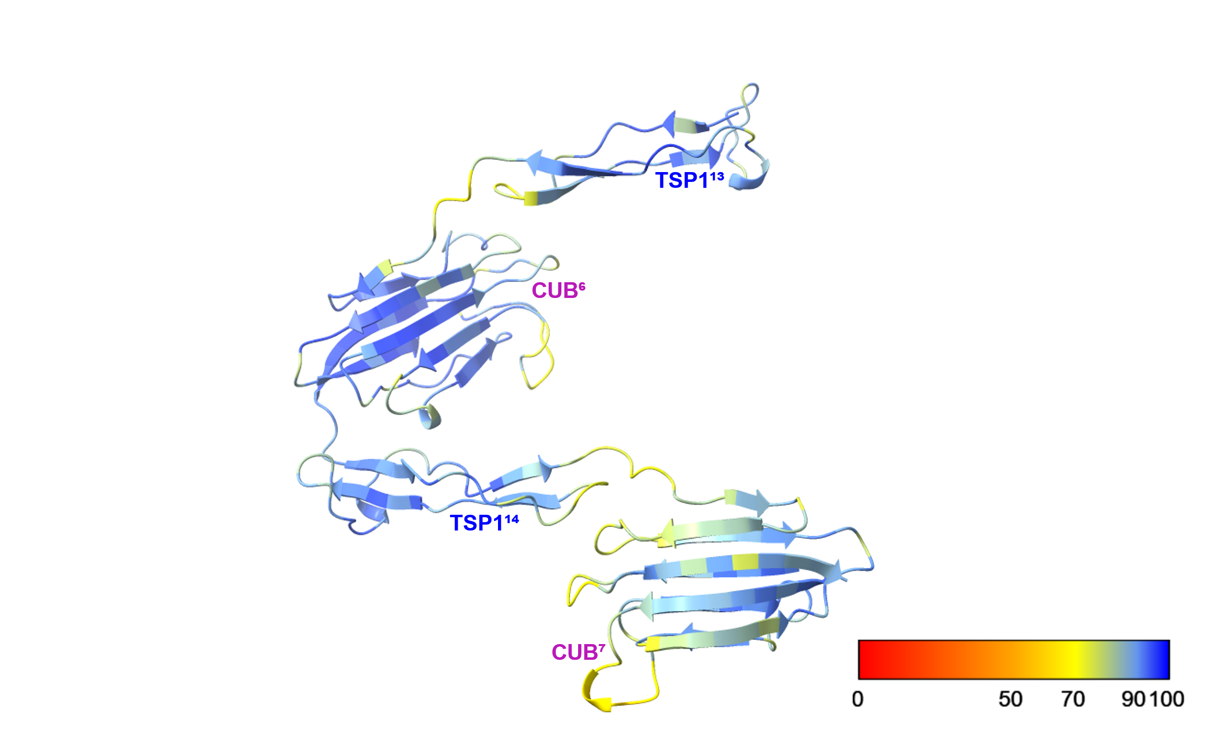
Figure S11: Ribbon protein structural model generated by AlphaFold3 for a portion of M. franciscanus EBR1, a set of TSP1-CUB repeats (TSP1¹³-CUB⁷). Ribbons are colored by predicted local distance difference test (pLDDT) scores, which provides a per-atom confidence score in the AlphaFold3-predicted protein structure. Shades of blue indicate higher confidence in the local position of atoms (pLDDT > 90), while yellow and orange indicate atoms of low confidence (pLDDT < 70).

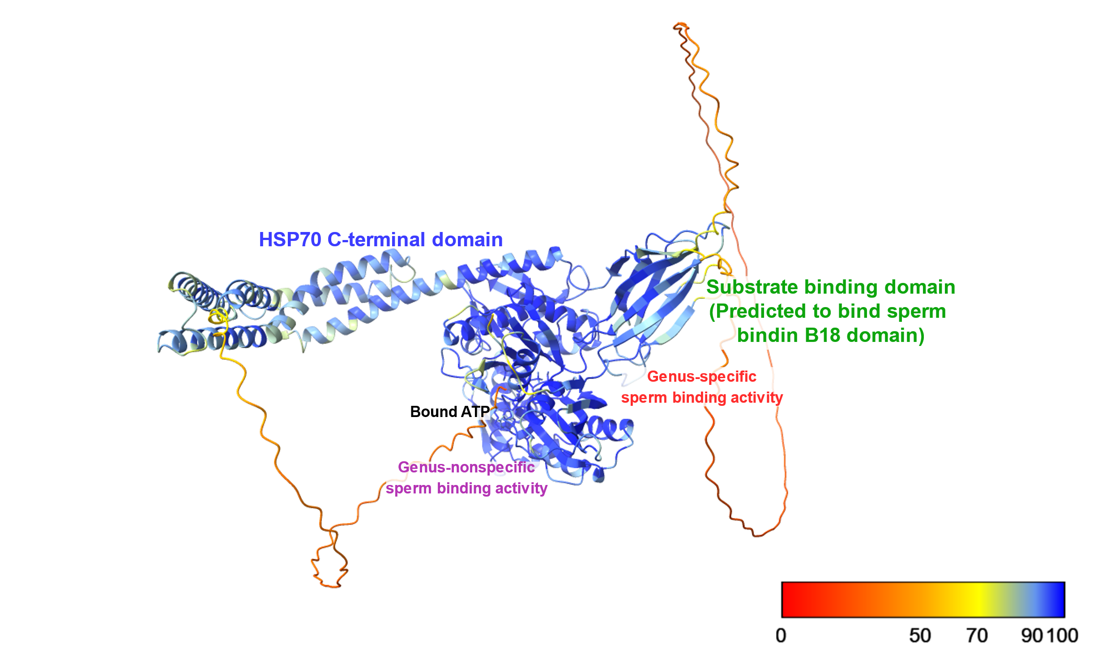
Figure S12: Ribbon protein structural model generated by AlphaFold3 for M. franciscanus HSP110 with one bound ATP molecule. Ribbons are colored by predicted local distance difference test (pLDDT) scores, which provides a per-atom confidence score in the AlphaFold3-predicted protein structure. Shades of blue indicate higher confidence in the local position of atoms (pLDDT > 90), while yellow and orange indicate atoms of low confidence (pLDDT < 70).

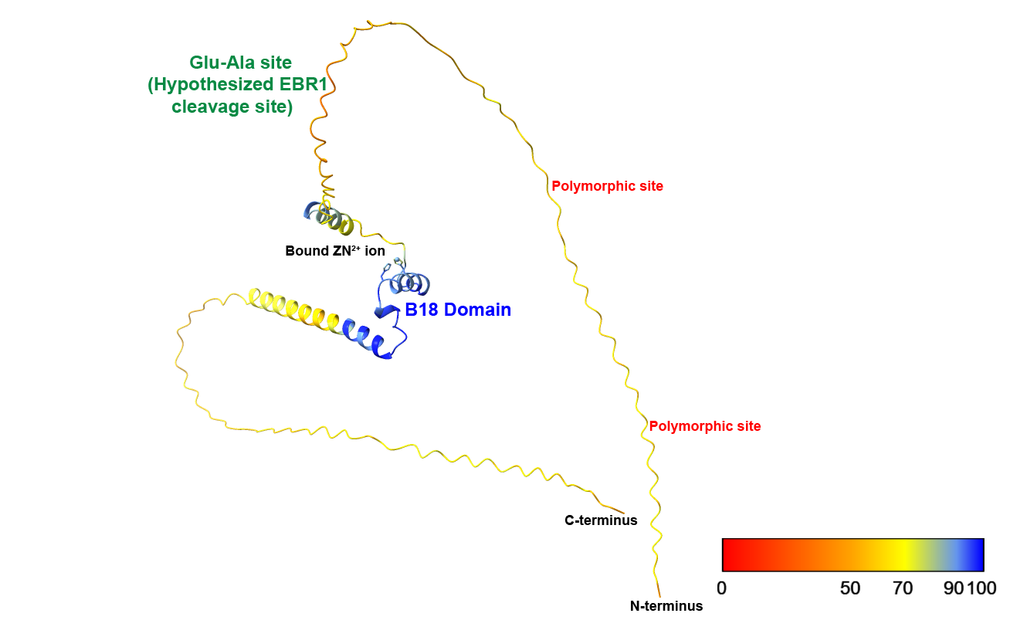
Figure S13: Ribbon protein structural model generated by AlphaFold3 for M. franciscanus mature Bindin, with one bound ZN²⁺ ion. Ribbons are colored by predicted local distance difference test (pLDDT) scores, which provides a per-atom confidence score in the AlphaFold3-predicted protein structure. Shades of blue indicate higher confidence in the local position of atoms (pLDDT > 90), while yellow and orange indicate atoms of low confidence (pLDDT < 70).

A
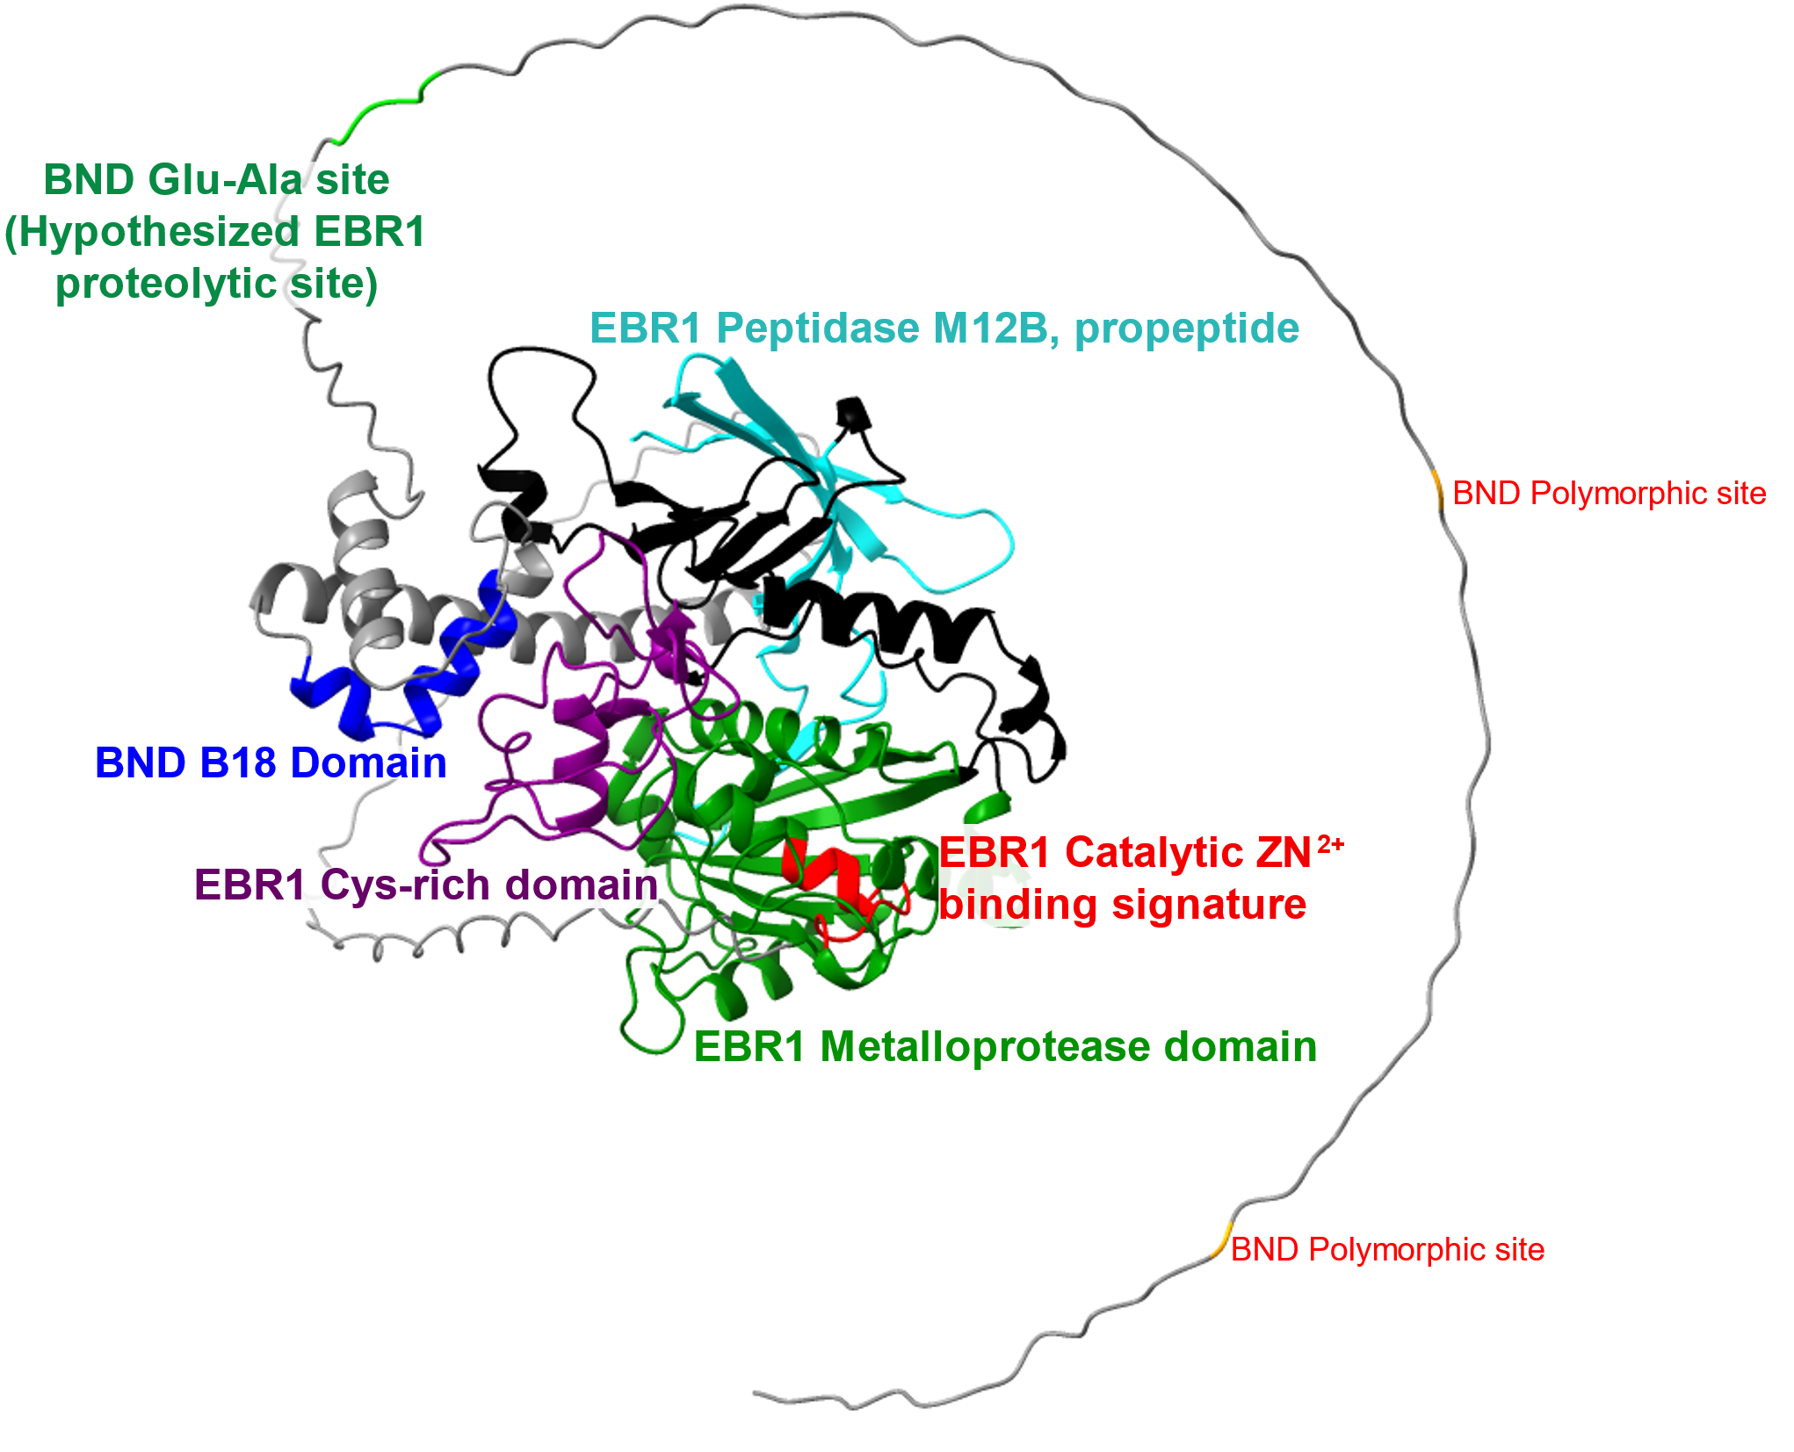
B
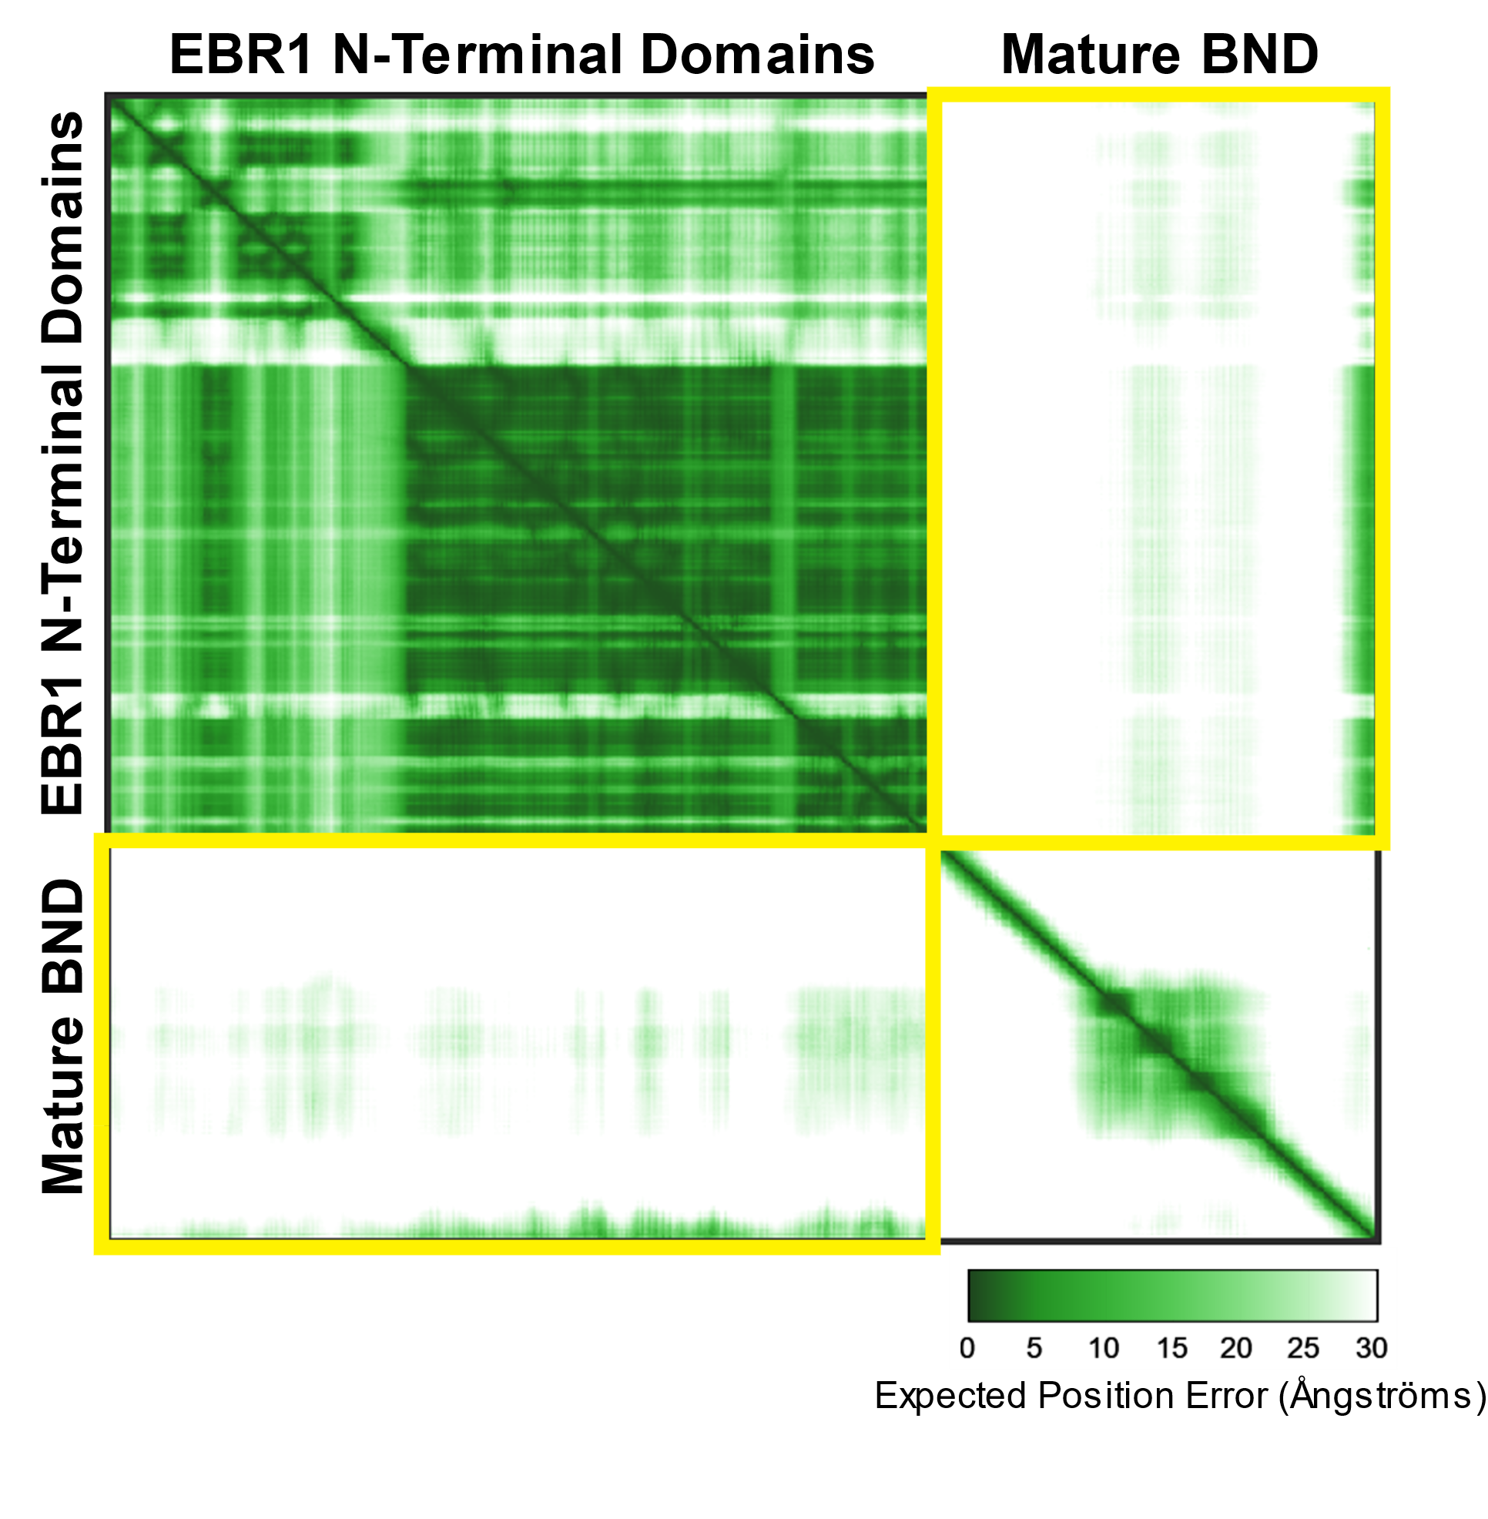
Figure S14: (A) Ribbon protein structural model generated by AlphaFold3 for a protein complex consisting of a portion of M. franciscanus EBR1, the characteristic N-terminal ADAMTS domains, and mature sperm bindin. Ribbons are colored to indicate domains of interest: EBR1 Peptidase M12B propeptide (cyan), EBR1 Metalloprotease domain (green) with the Catalytic ZN²⁺ binding signature (red), EBR1 Cys-rich domain (purple), BND B18 domain (blue), BND Glu-Ala site (lime green), and BND polymorphic sites (orange). (B) Predicted aligned error (PAE) plot for the EBR1-BND protein complex. Yellow boxes highlight the PAE scores for the predicted interface between EBR1 and BND. Darker green indicates lower predicted error.
A
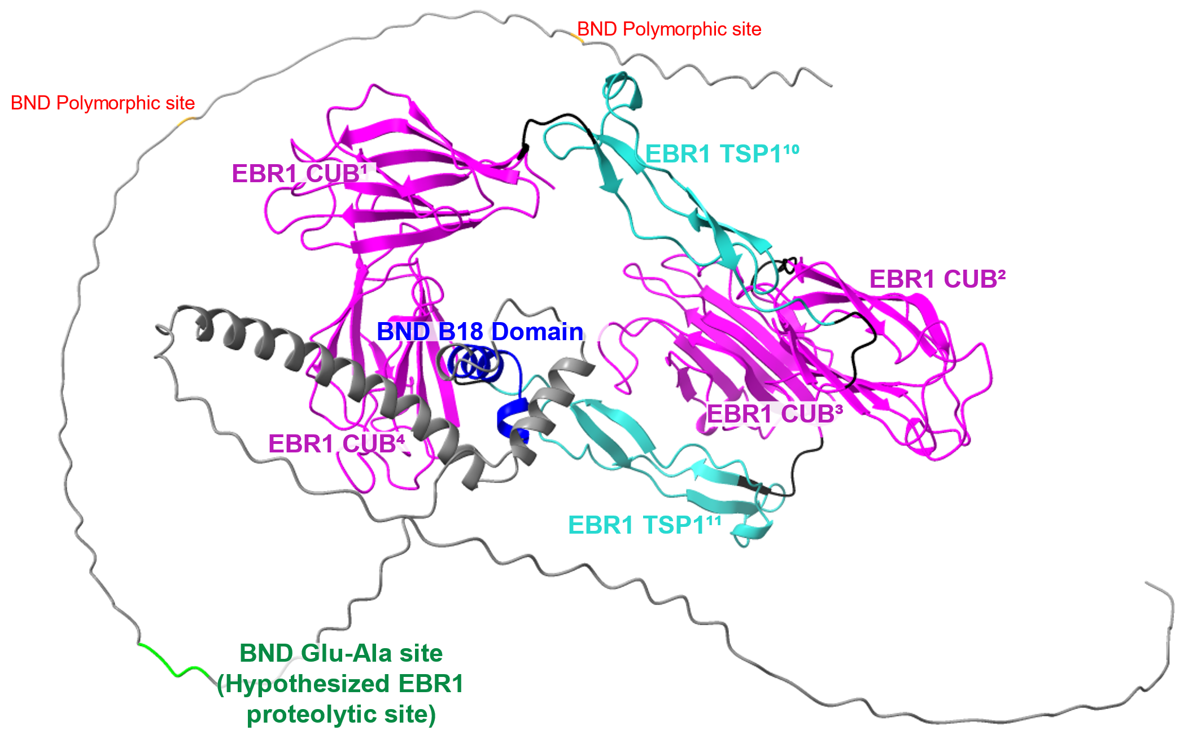
B
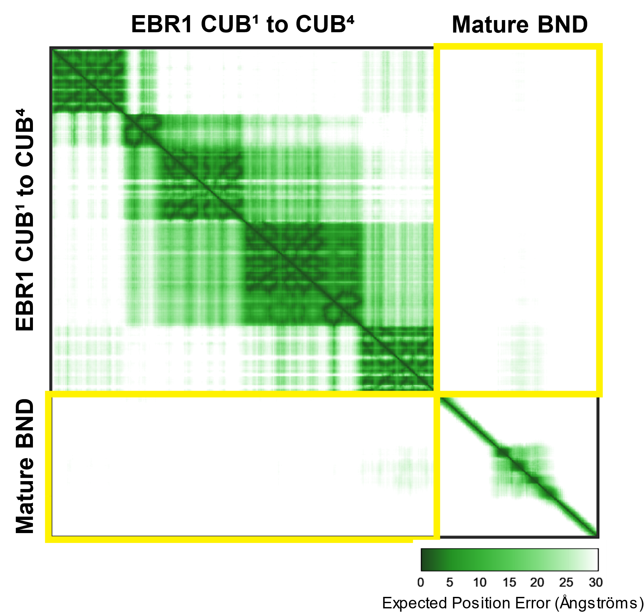
Figure S15: (A) Ribbon protein structural model generated by AlphaFold3 for a protein complex consisting of a portion of M. franciscanus EBR1, CUB¹-CUB⁴, and mature sperm bindin. Ribbons are colored to indicate domains of interest: EBR1 CUB domains (magenta), EBR1 TSP1 domains (light blue) BND B18 domain (blue), BND Glu-Ala site (lime green), and BND polymorphic sites (orange). (B) Predicted aligned error (PAE) plot for the EBR1-BND protein complex. Yellow boxes highlight the PAE scores for the predicted interface between EBR1 and BND. Darker green indicates lower predicted error.
A
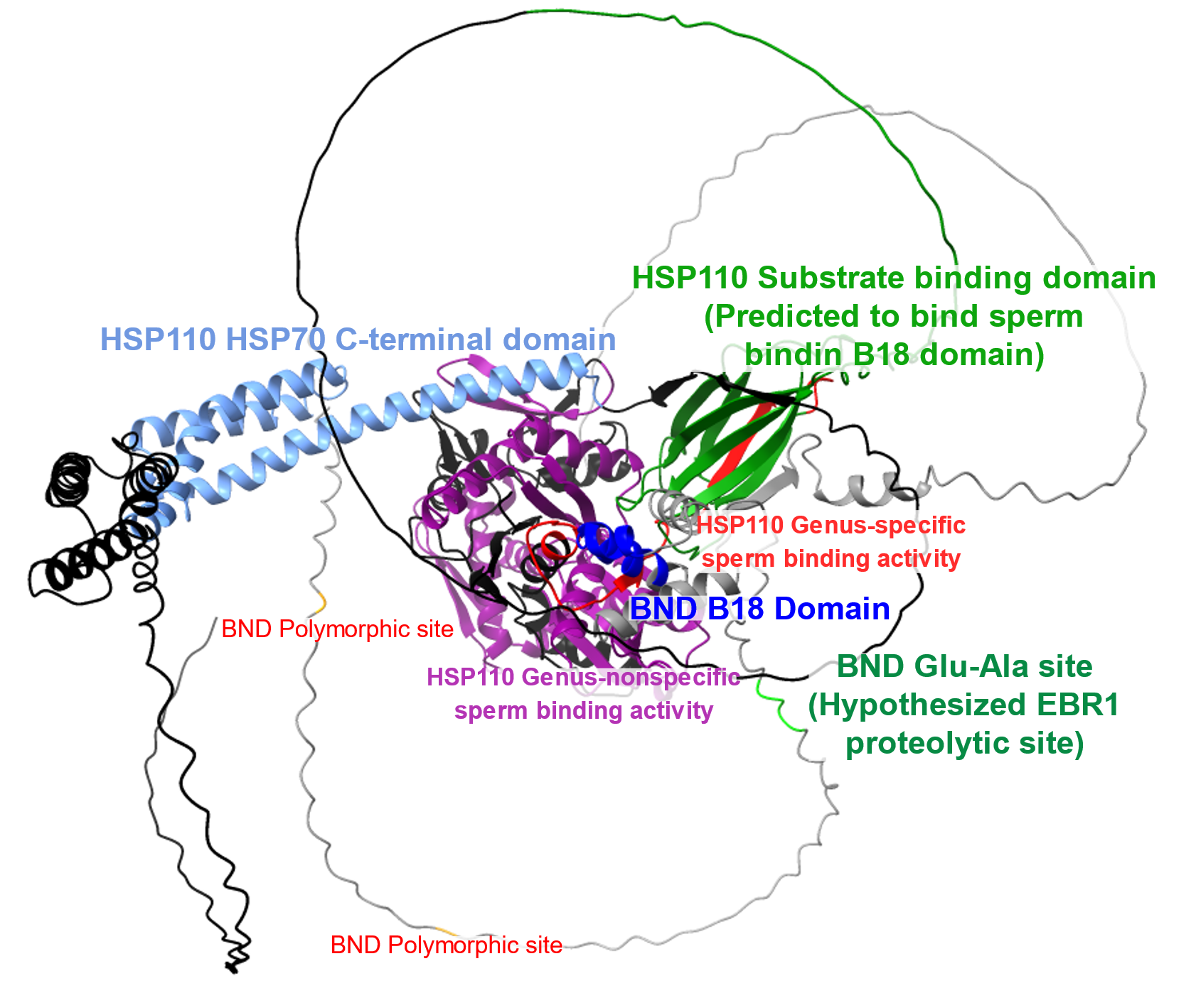
B
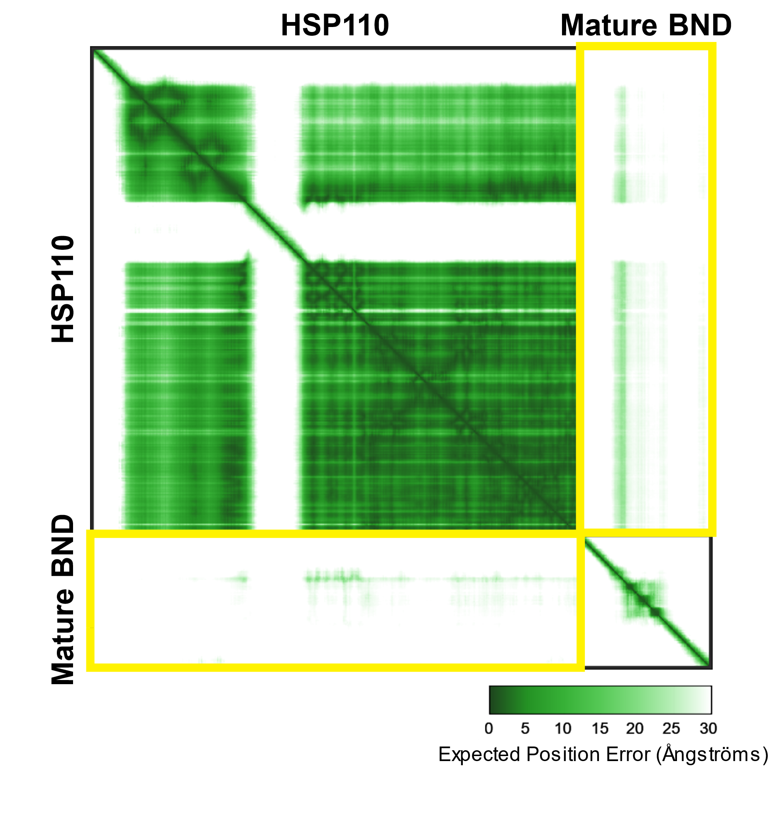
Figure S16: (A) Ribbon protein structural model generated by AlphaFold3 for a protein complex consisting of M. franciscanus HSP110 and mature sperm bindin. Ribbons are colored to indicate domains of interest: HSP110 genus-nonspecific sperm binding activity domain (purple), HSP110 genus-specific sperm binding activity domain (red), HSP110 substrate-binding domain (green), HSP110 HSP70 C-terminal domain (light blue), BND B18 domain (blue), BND Glu-Ala site (lime green), and BND polymorphic sites (orange). (B) Predicted aligned error (PAE) plot for the HSP110-BND protein complex. Yellow boxes highlight the PAE scores for the predicted interface between HSP110 and BND. Darker green indicates lower predicted error.
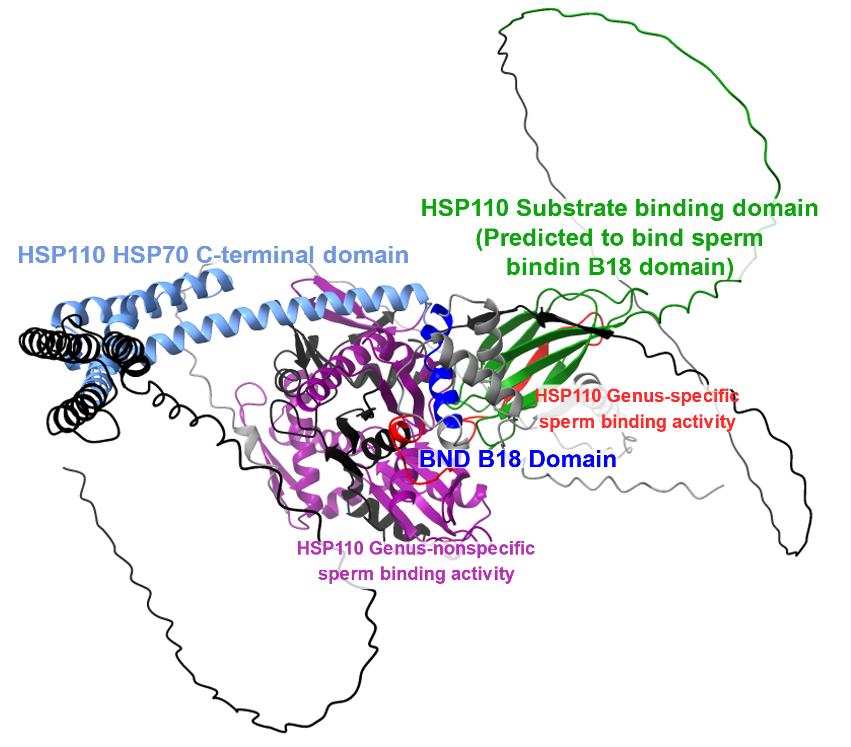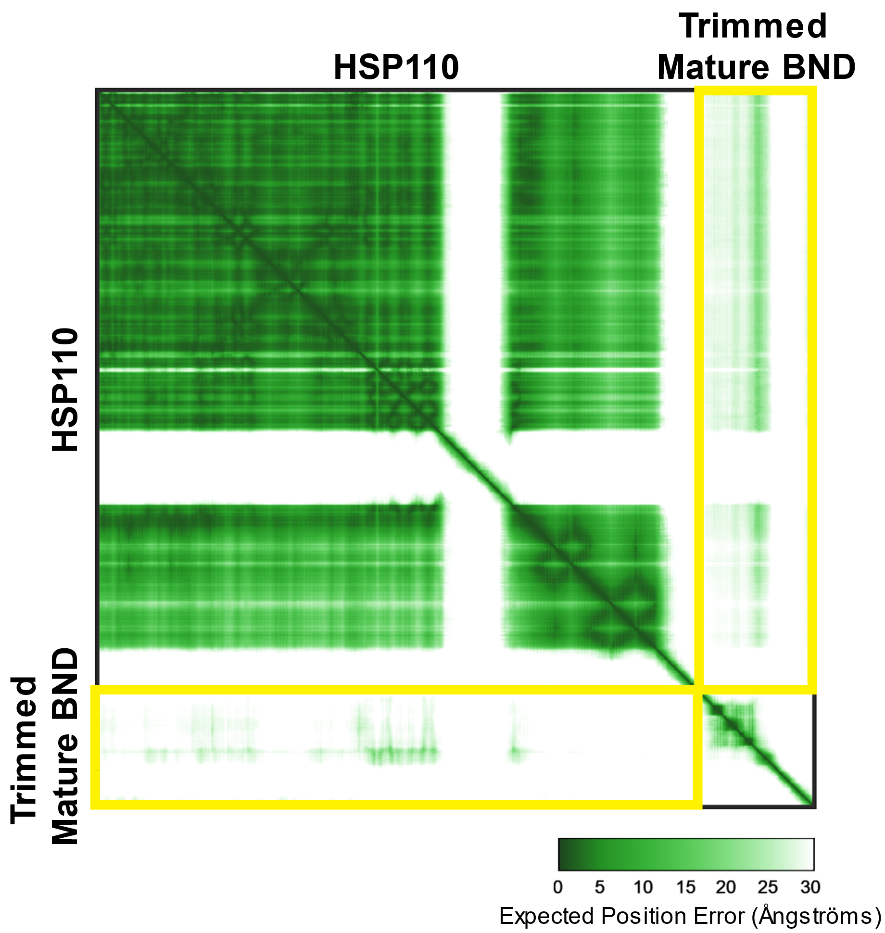
Figure S17: (A) Ribbon protein structural model generated by AlphaFold3 for a protein complex consisting of M. franciscanus HSP110 and mature sperm bindin, cut at our proposed Glu-Ala proteolytic site. Ribbons are colored to indicate domains of interest: HSP110 genus-nonspecific sperm binding activity domain (purple), HSP110 genus-specific sperm binding activity domain (red), HSP110 substrate-binding domain (green), HSP110 HSP70 C-terminal domain (light blue), and BND B18 domain (blue). (B) Predicted aligned error (PAE) plot for the HSP110-BND protein complex. Yellow boxes highlight the PAE scores for the predicted interface between HSP110 and BND. Darker green indicates lower predicted error.
A
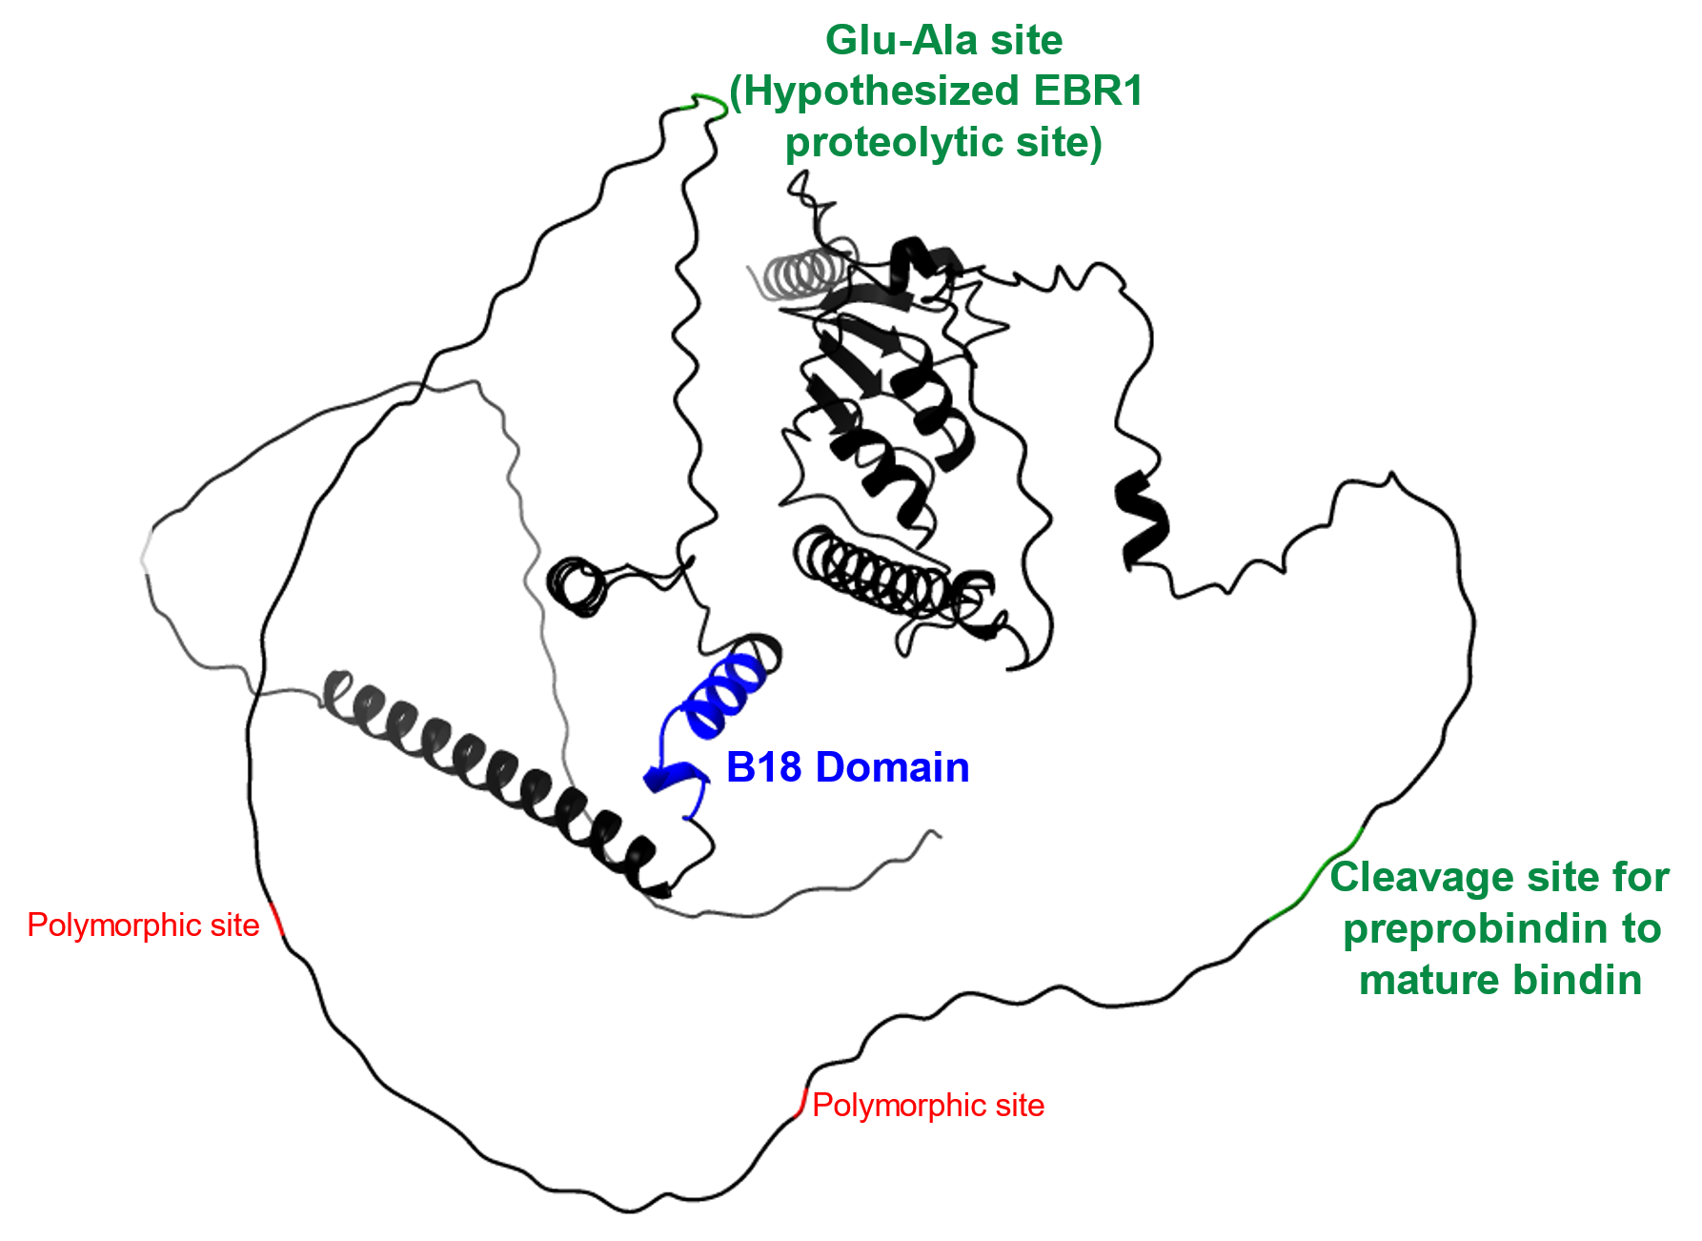
B
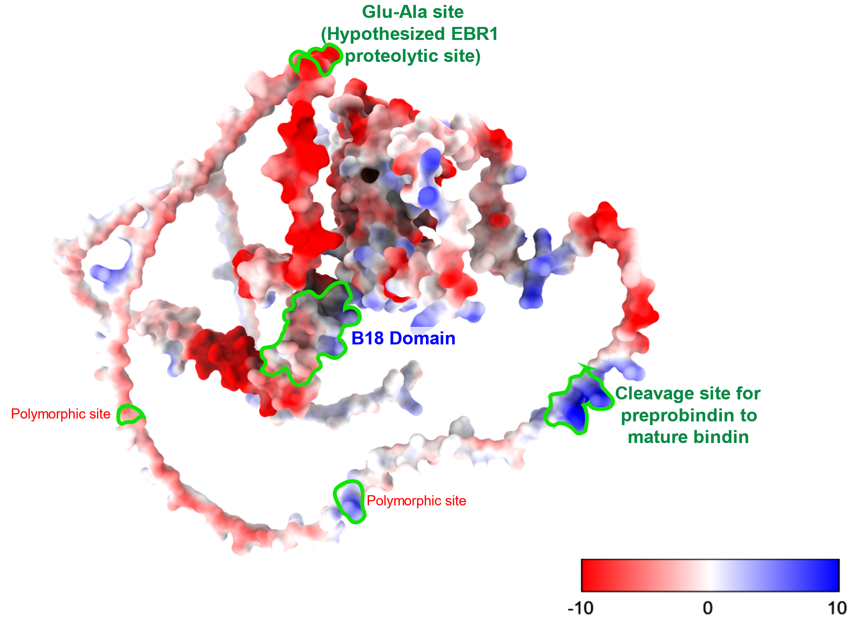

Figure S18: (A) Ribbon protein structural model generated by AlphaFold3 for preprobindin. This protein is cut by a trypsin-like protein processing enzyme at a conserved motif (RKKR) indicated in green and packaged into the acrosomal vesicle as mature bindin (Figure 10). The B18 domain, which includes the chaperone bindin motif predicted to bind with the substrate binding domain in HSP110, is highlighted in blue. In M. franciscanus, EBR1 may have proteolytic functions and cut the bindin protein at the Glu-Ala site highlighted in green. Two polymorphic sites are highlighted in red. Bindin genotype at these two sites interacts with EBR1 genotype at a variable site in a TSP1 domain to predict fertilization success in M. franciscanus (Levitan et al., 2019), suggesting potential interaction between the TSP1 domain in EBR1 and the sites in bindin, which may help EBR1 target the proteolytic Glu-Ala site. (B) Protein surface model generated in ChimeraX showing the electrostatic potential, with more red values indicating more negatively charged regions and blue indicating more positively charged regions. Green outlines indicate the labeled domains from (A). The two polymorphic sites are slightly positively charged, while the B18 domain is more negatively charged.
A P. miniata bindin
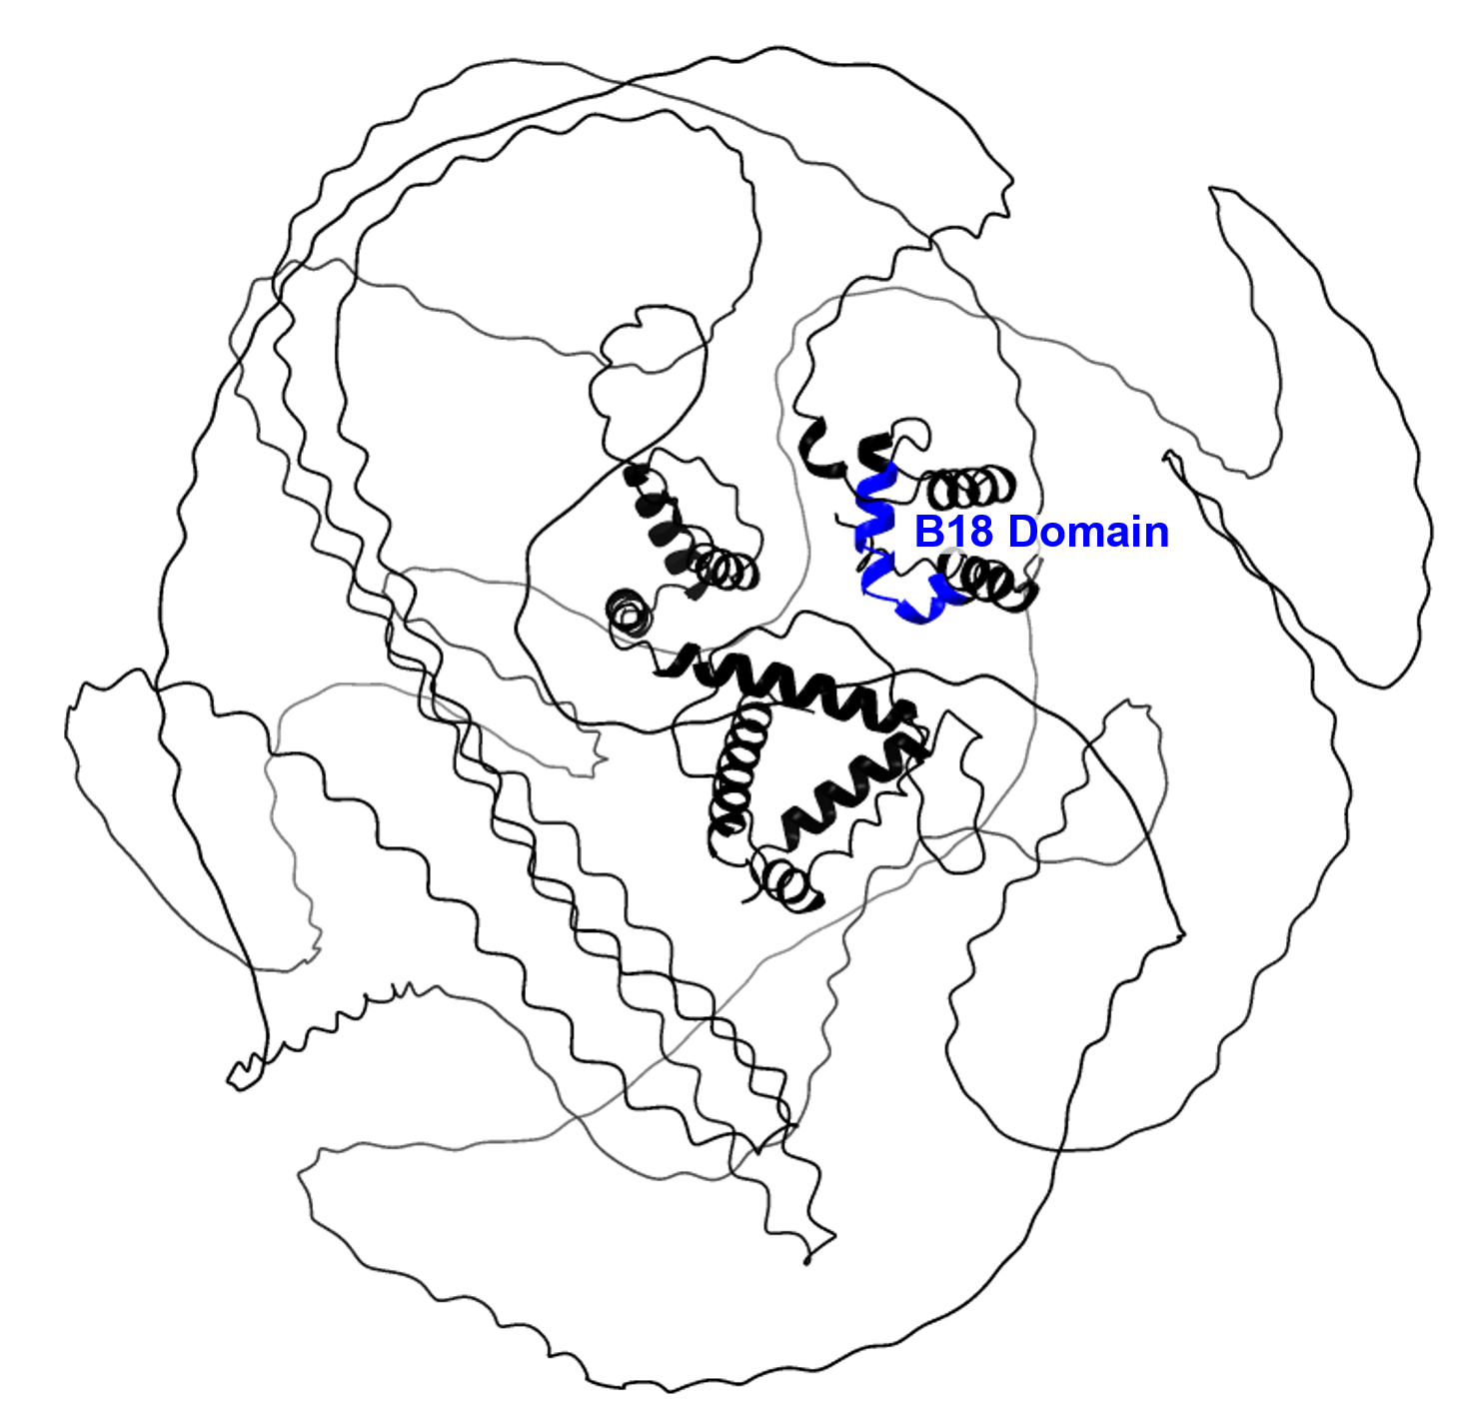

B P. miniata Obi1
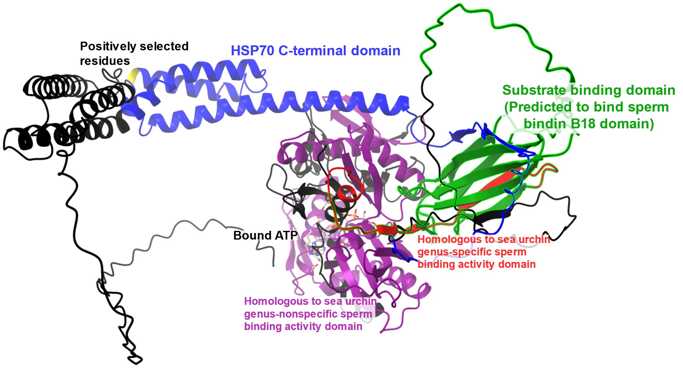

Figure S19: Ribbon protein structural models for P. miniata (A) bindin and (B) Obi1 generated by AlphaFold3. (A) In P. miniata the B18 domain is only 10aa from the C-terminal end of the protein, rather than being surrounded by disordered domains as in M. franciscanus. (B) Ribbon model for P. miniata Obi1 (the homolog of M. franciscanus HSP110) highlighting the regions that are homologous to previously characterized sea urchin protein domains that function in either genus-nonspecific sperm binding activity (purple) or genus-specific sperm binding activity (red). Additional domains were predicted by InterProScan, including the predicted substrate-binding domain (green) and the HSP70 C-terminal domain (blue), which functions in functions in stabilizing the protein complex in members of the HSP70 protein family. The B18 domain in sperm bindin is a predicted target binding site for the substrate-binding domain (Hart et al., 2014). Note that there is overlap between the 32aa domain with genus-specific sperm binding activity and the predicted substrate binding domain, indicated by red ribbon highlighted with green.

