Funnel and Forest plots

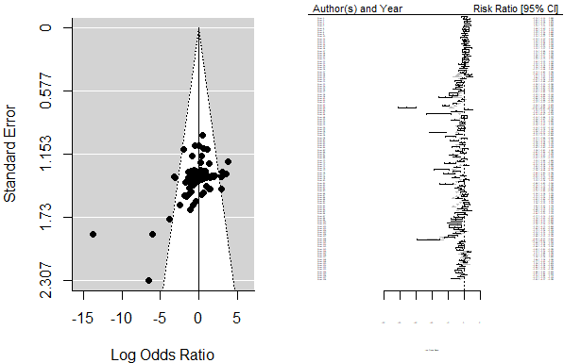

Aqueous Cu/Reprouction
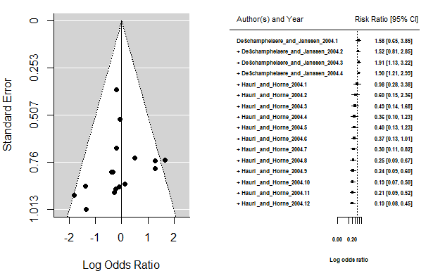

Dietary Cu (< = 120 µg/L) /Reprouction

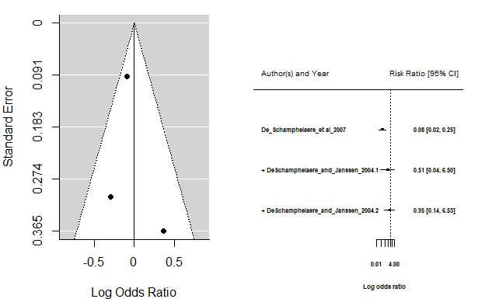
Dietary Cu (>120 µg/L)/ Reprouction

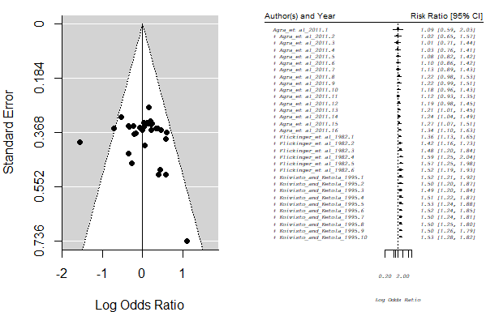

Aqueous Cu/Age
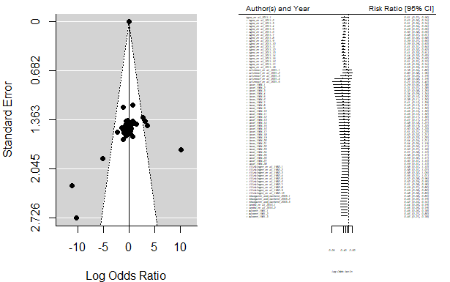

Aqueous Cu/Growth

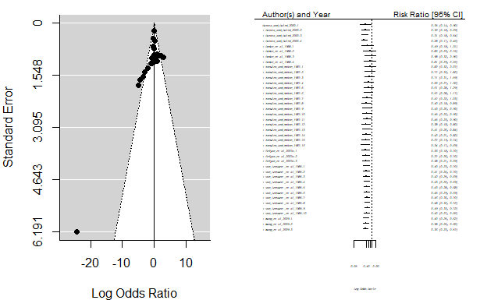
Aqueous Cd (< = 40 µg/L) /Reprouction

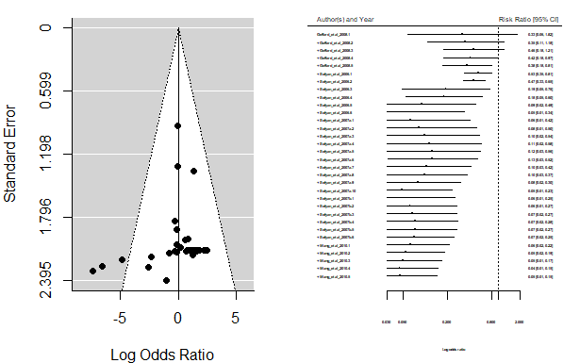

Dietary Cd (> 40 µg/L) /Reprouction

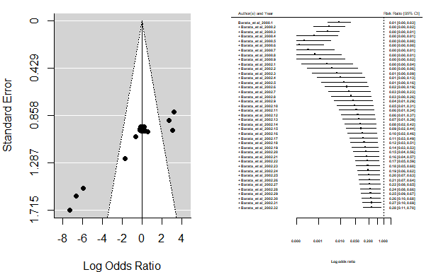
Aqueous Cd /Age

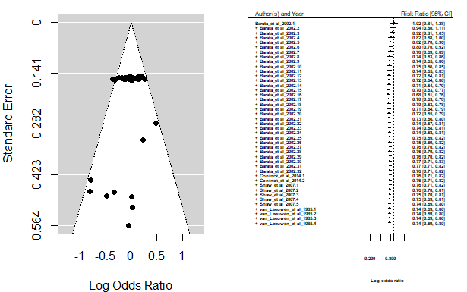

Aqueous Cd /Growth

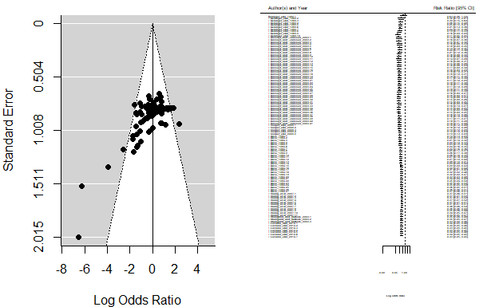
Water hardness/ Cu
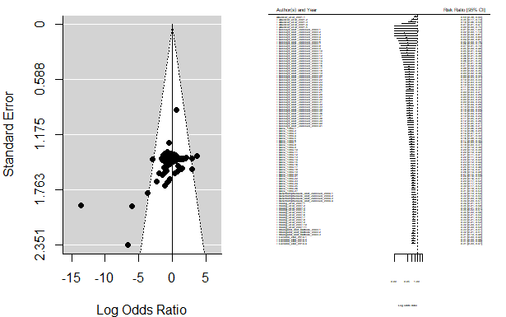
Exposure Duration/Cu

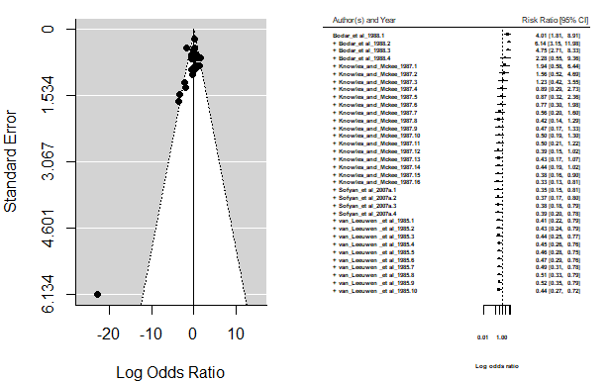
Water hardness/ Cd

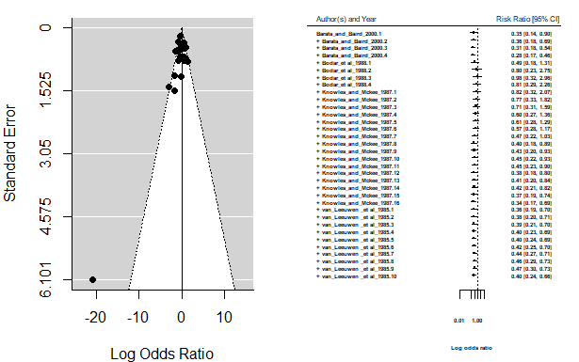

Exposure Duration/ Cd

