SUPPLEMENTAL MATERIAL

Table S1 Matched Female-Male Comparison of Holter Monitor Heart Rate Variability Measures
 | Mean RR interval |  | SDNN  (ms) |  | SDNNi  (ms) |  | SDANN  (ms) |  | rMSSD  (ms) |  | pNN50  (%)
 | female | male | female | male | female | male | female | male | female | male | female | male
All Children and Adolescents  1-18 years  Meta-analysis mean  95%CI | n=141  699  639-759 | n=155  741  680-803 | n=229  144  124-163 | n=231  166  143-190 | n=185  75  65-84 | n=181  85  78-91 | n=291  119  99-140 | n=263  134  116-151 | n=238  62  54-71 | n=222  66  62-70 | n=197  23  19-27 | n=202  25  23-28
Older Children  7-12 years  Meta-analysis mean  95%CI | NA | NA | n=54  127  100-154 | n=68  142  104-180 | NA | NA | n=116  98  64-132 | n=100  111  78-144 | n=63  74  67-82 | n=59  76  57-94 | n=22  22  18-26 | n=39  27  22-33
Adolescents  13-18 years  Meta-analysis mean  95%CI | n=121  737  719-755 | n=124  779  750-808 | n=165  161  146-177 | n=150  188  165-210 | n=165  78  73-83 | n=150  87  82-91 | n=165  138  121-155 | n=150  151  142-160 | n=165  60  51-68 | n=150  64  61-67 | n=165  25  22-28 | n=150  26  24-28

NA = meta-analysis not available due to only one comparison study. No matched female-male study in infants and only one each in younger children.
Fig. S1 PRISMA Search Strategy Flow Diagram

Identification of studies via databases and registers

Records removed before screening:
Duplicate records removed (n = 12)
Records removed for other reasons (n = 0)
Records identified from*:
Databases (n = 487)
Registers (n = 0)

Identification

Records excluded by researcher
(n = 321)
Records screened
(n = 475)

Reports not retrieved
(n = 6)
Reports sought for retrieval
(n = 154)

Screening

Reports excluded:
Controls not healthy (n = 11)
Less than 20 controls (n = 23)
Age range too wide (n = 47)
Insufficient data (n = 18)

Reports assessed for eligibility
(n = 148)

Studies included in review
(n = 49)
Included

Fig. S2 Forest Plot of Time-domain SDANN
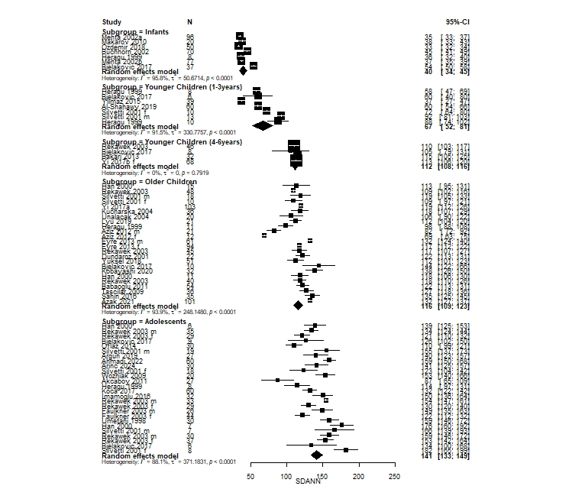

Fig. S3 Forest Plot of Time-domain rMSSD
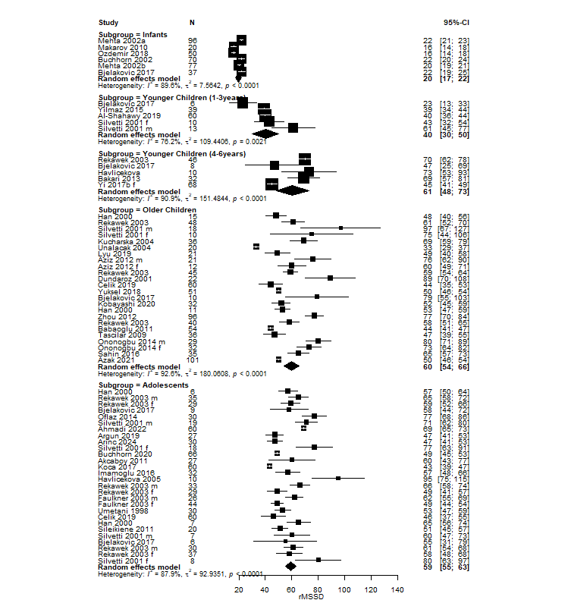

Fig. S4 Forest Plot of Time-domain pNN50
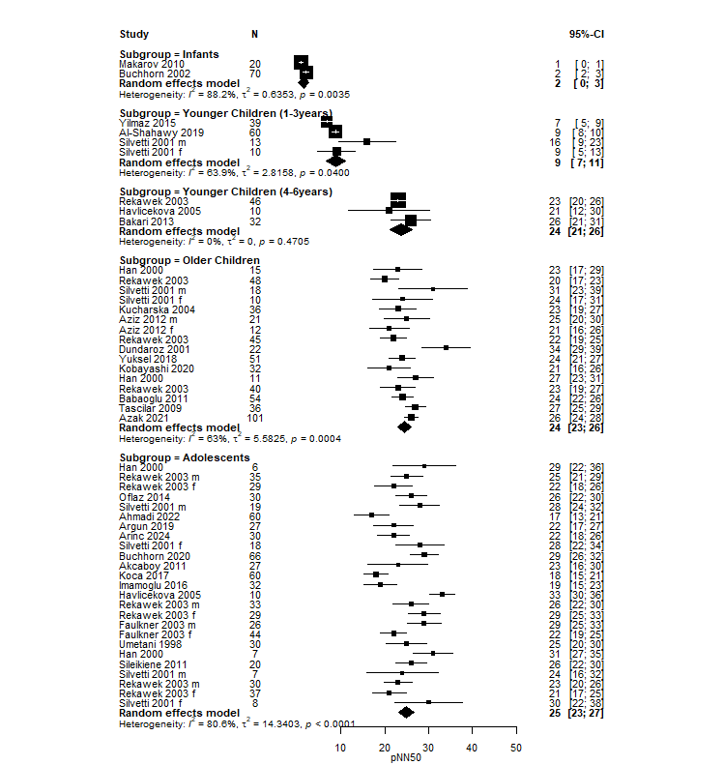

Fig. S5 Forest Plot of Mean RR Interval
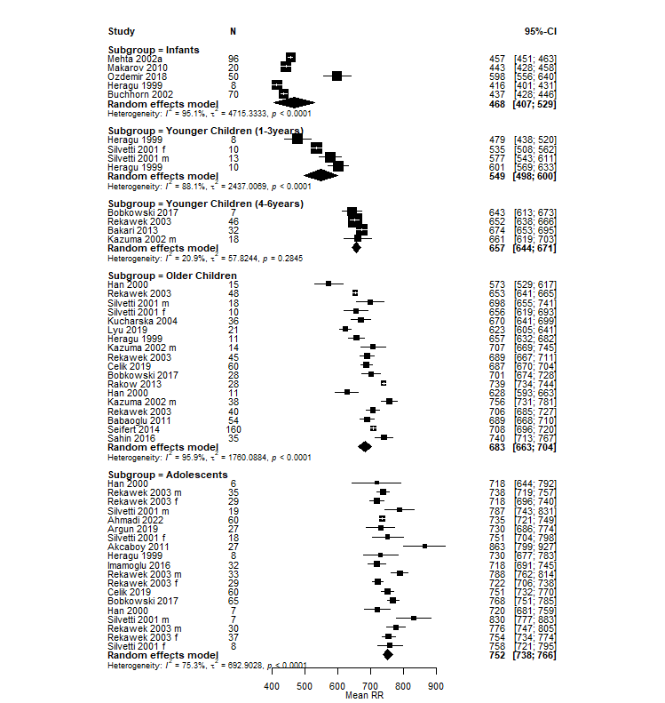

Fig. S6 Forest Plot of LF/HF Ratio
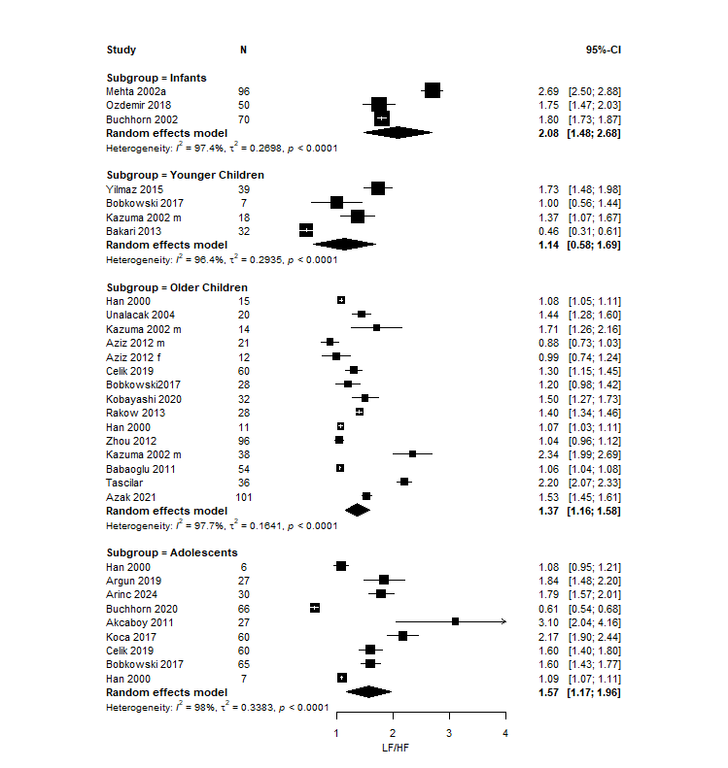

Fig. S7 Funnel Plots of SDNN and SDNNi
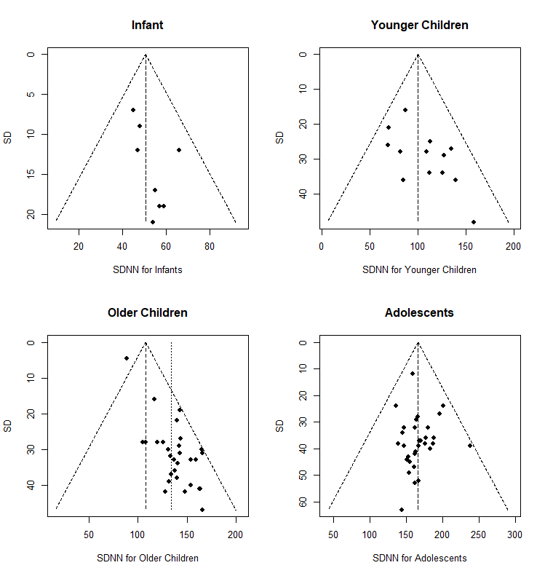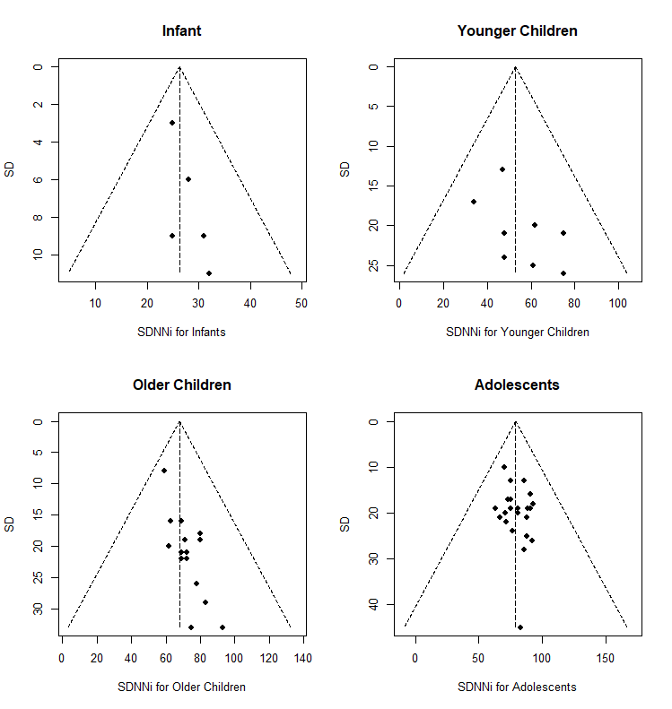

Fig. S8 Funnel Plots of SDANN and rMSSD
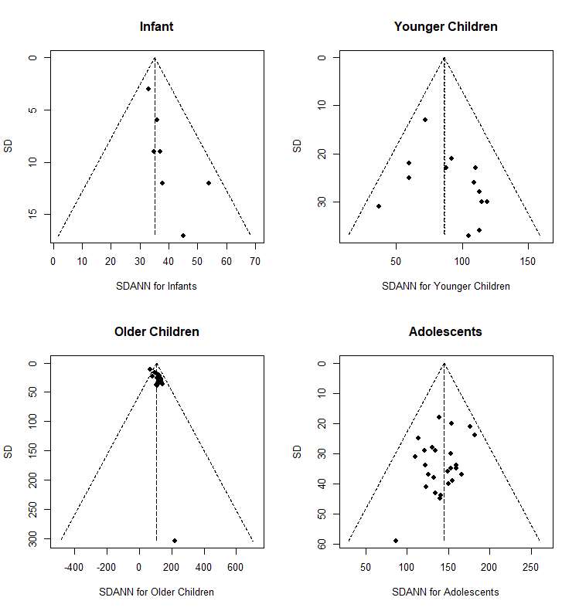
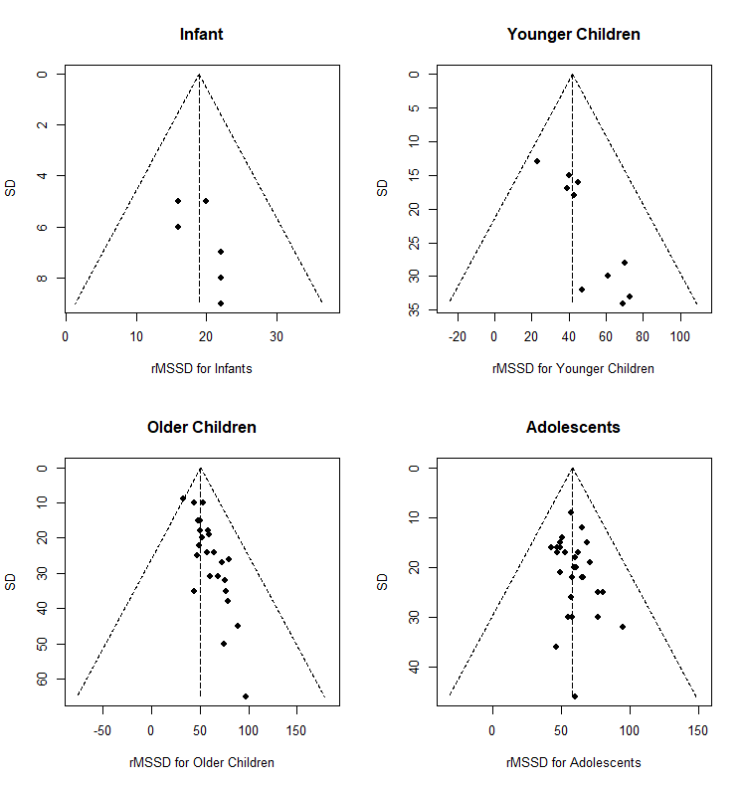

Fig. S9 Funnel Plots of pNN50 and Mean RR Interval
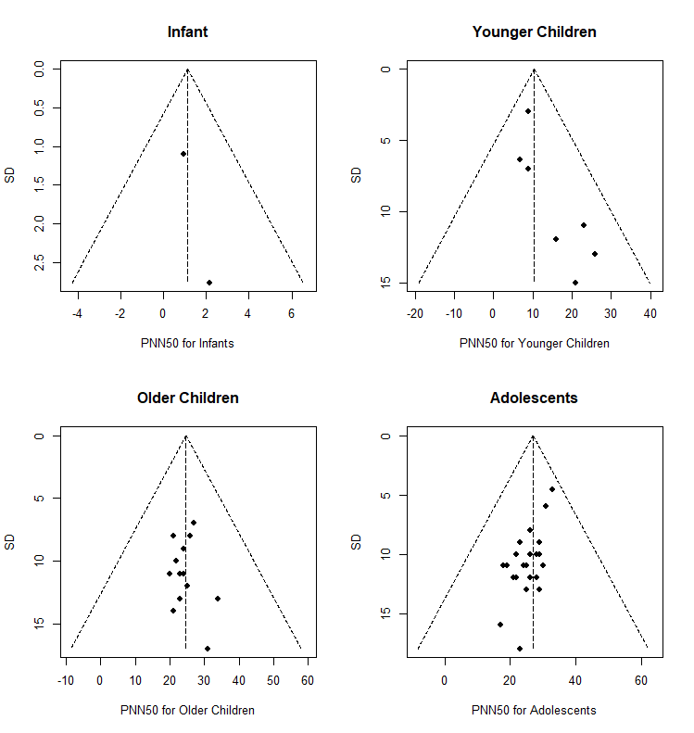
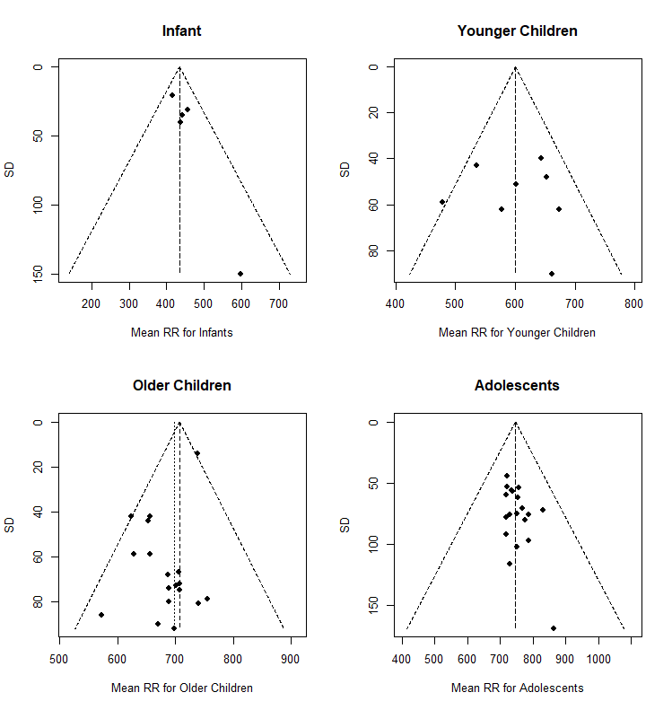

Fig. S10 Funnel Plots of ln LF and ln HF
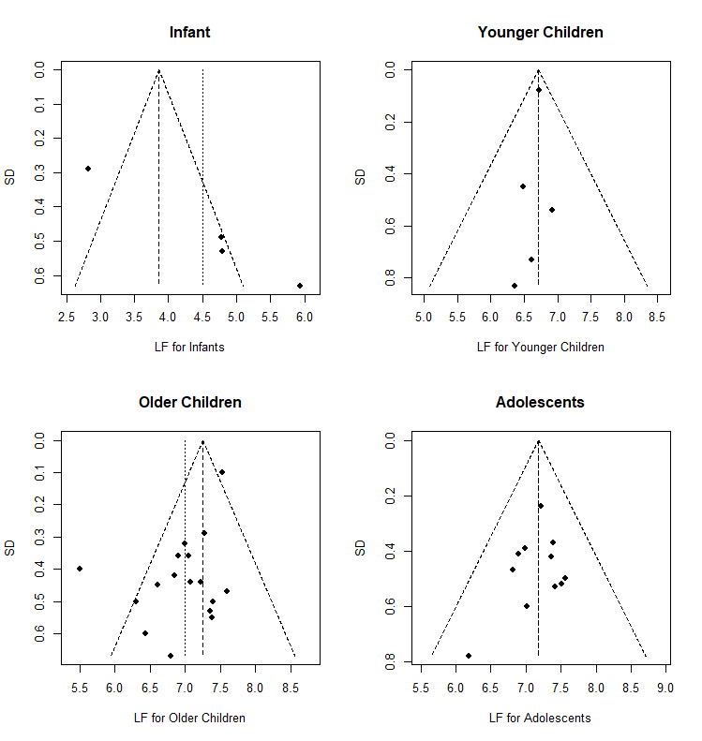
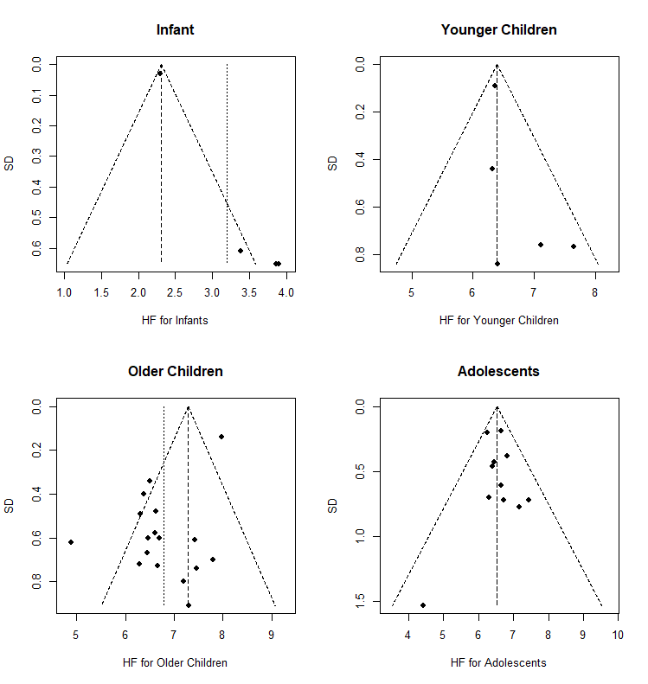

Fig. S11 Funnel Plot of LF/HF Ratio
