Supplementary material

Intra-rater reliability between low-resolution and super-resolution reconstruction biometry measurements
Materials and methods. Intra-rater reliability was evaluated using Lin’s Concordance Correlation Coefficient³³.
Results. In Table S1, intra-rater reliability is reported for the three raters considered. CCC is very high for most structures (above 0.9) indicating very strong reliability. The lowest scores (although still high) are obtained for median structures (length of corpus callosum and height of the vermis). There is no major concern that a given Super-resolution reconstruction method would lead to a decrease in agreement between the Super-resolution reconstruction and LR. Figure S1 provides a visual comparison with the Pearson correlation coefficient and shows clearly that LCC and HV have more scattered measures compared to bBIP, sBIP and TCD. Moreover, some bias in the measurements can be observed from I.V. and M.K. in the LCC, and N.G. in the HV. This is not surprising given that obtaining precise planes for measurements is challenging in LR stacks.

 | I.V. |  |  | M.K. |  |  | N.G.
 | NeSVoR | NiftyMIC | SVRTK | NeSVoR | NiftyMIC | SVRTK | NeSVoR | NiftyMIC | SVRTK
LCC | 0.73 | 0.65 | 0.69 | 0.87 | 0.86 | 0.86 | 0.93 | 0.92 | 0.92
HV | 0.91 | 0.91 | 0.90 | 0.92 | 0.92 | 0.93 | 0.87 | 0.89 | 0.90
bBIP | 0.99 | 0.99 | 0.99 | 0.99 | 0.99 | 0.98 | 0.98 | 0.98 | 0.98
sBIP | 0.98 | 0.99 | 0.98 | 0.99 | 0.99 | 0.99 | 0.99 | 0.99 | 0.99
TCD | 0.98 | 0.98 | 0.97 | 0.99 | 0.99 | 0.99 | 0.97 | 0.98 | 0.98
Table S1 Lin’s Concordance Correlation Coefficient (CCC) between the LR and SR measurements for each rater. This supplements the results presented in Figure 3. Measurements with CCC below 0.9 are highlighted in blue.
bBIP brain biparietal diameters, HV height of the vermis, LCC length of the corpus callosum, sBIP skull biparietal diameters, TCD transverse cerebellar diameter

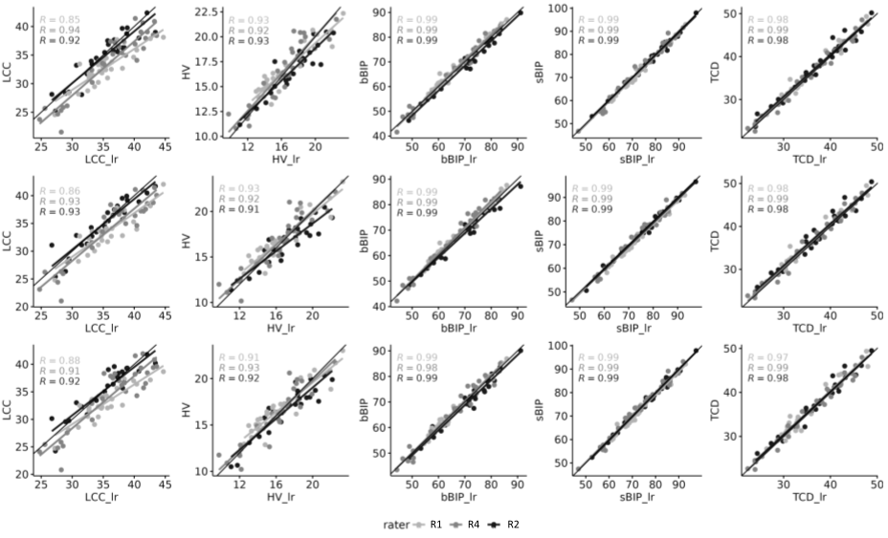Fig. S1 Linear regression between the LR and SR measurements for each rater.
bBIP brain biparietal diameters, HV height of the vermis, LCC length of the corpus callosum, sBIP skull biparietal diameters, TCD transverse cerebellar diameter

Complete statistical results for volumetry and biometry
Tables S2 and S3 contain the univariate and multivariate analyses for the biometry, and Tables S3 and S4 contain the univariate and multivariate analyses for the volumetry experiment.

Table S2 Statistical analyses for biometry measurements. Univariate analysis N= 252, df =2
 | Friedman χ² | p-value | Post-hoc testing
 | Friedman χ² | p-value | Comparison | p-value | Eff. size | Median diff.  [mm] | Median abs. diff [mm]
LCC | 6.93 | 0.03 | Non-significant after correction for multiple testing
HV | 0.17 | 0.92
bBIP | 9.24 | 9.8 × 10⁻³ | NeSVoR vs SVRTK | 0.03 | 0.28 | 0.3[-2.4, 3.1] | 0.7[0.2,3.4]
sBIP | 14.55 | 6.9 × 10⁻⁴ | NeSVoR vs SVRTK | 3 × 10⁻⁴ | 0.43 | -0.4[-1.9, 1.1] | 0.7[0.1,2.4]
sBIP | 14.55 | 6.9 × 10⁻⁴ | NeSVoR vs NiftyMIC | 0.01 | 0.32 | -0.4[-2.3,1.5] | 0.8[0.1,2.2]
TCD | 11.31 | 3.5 × 10⁻³ | NeSVoR vs SVRTK | 1 × 10⁻³ | 0.38 | 0.4[-0.9, 1.6] | 0.6[0.1,1.6]
TCD | 11.31 | 3.5 × 10⁻³ | NeSVoR vs NiftyMIC | 0.02 | 0.30 | 0.3[-0.9, 1.2] | 0.4[0.03,1.8]
bBIP brain biparietal diameters, HV height of the vermis, LCC length of the corpus callosum, sBIP skull biparietal diameters, TCD transverse cerebellar diameter

Table S3. Statistical analyses for biometry measurements. Multivariate analysis using a t-distributed GAMLSS model
 | Super-resolution reconstruction effect |  |  |  | Rater effect
 | Comparison | Est. effect [mm] | t-val. | p-value | Comp. | Est. effect [mm] | t-val. | p-value
LCC | NeSVoR vs NiftyMIC | -0.31±0.10 | -3.04 | 0.003 | I.V. vs M.K. | 1.85±0.11 | -3.04 | 0.003
LCC | NeSVoR vs SVRTK | -0.06±0.10 | 0.65 | 0.51 | I.V. vs N.G. | 0.54±0.11 | 5.06 | 1.1 × 10⁻⁶
HV | NeSVoR vs NiftyMIC | -0.05±0.07 | -0.75 | 0.45 | I.V. vs M.K. | -0.17±0.07 | -2.43 | 0.01
HV | NeSVoR vs SVRTK | -0.08±0.07 | -1.28 | 0.20 | I.V. vs N.G. | -0.99±0.07 | -14.06 | < 2 × 10⁻¹⁶
bBIP | NeSVoR vs NiftyMIC | -0.25±0.14 | -1.74 | 0.08 | I.V. vs M.K. | 0.56±0.15 | 3.84 | 1.7 × 10⁻⁴
bBIP | NeSVoR vs SVRTK | -0.35±0.14 | -2.48 | 0.01 | I.V. vs N.G. | -1.15±0.15 | -7.75 | 9 × 10⁻¹³
sBIP | NeSVoR vs NiftyMIC | 0.38±0.09 | 4.04 | 8.2 × 10⁻⁵ | I.V. vs M.K. | 1.82±0.09 | 19.1 | < 2 × 10⁻¹⁶
sBIP | NeSVoR vs SVRTK | 0.43±0.09 | 4.63 | 7.3 × 10⁻⁶ | I.V. vs N.G. | 0.32±0.09 | 4.04 | 0.001
TCD | NeSVoR vs NiftyMIC | -0.22±0.07 | -3.33 | 0.001 | I.V. vs M.K. | 0.63±0.07 | 9.23 | < 2 × 10⁻¹⁶
TCD | NeSVoR vs SVRTK | -0.35±0.07 | -5.29 | 3.9 × 10⁻⁷ | I.V. vs N.G. | -0.63±0.07 | -9.06 | 5 × 10⁻¹⁶
bBIP brain biparietal diameters, HV height of the vermis, LCC length of the corpus callosum;,sBIP skull biparietal diameters, TCD transverse cerebellar diameter

Table S4 Statistical analyses for volumetry measurements. Univariate analysis (N= 252, df =2)
 | Friedman χ² | p-value | Post-hoc testing
 | Friedman χ² | p-value | Comparison | p-value | Eff. size | Median diff. [cm³]
Extra-cerebral CSF | 47.21 | 5.5×10⁻¹¹ | NeSVoR vs SVRTK | 1×10⁻⁴ | 0.45 | -1.82[-12.83,2.28]
Extra-cerebral CSF | 47.21 | 5.5×10⁻¹¹ | NiftyMIC vs SVRTK | 7×10⁻¹³ | 0.80 | 2.11[-0.35,10.75]
Cortical GM | 61.31 | 4.9×10⁻¹⁴ | NeSVoR vs NiftyMIC | 3×10⁻⁹ | 0.67 | 0.66[-0.74,2.58]
Cortical GM | 61.31 | 4.9×10⁻¹⁴ | NeSVoR vs SVRTK | 7×10⁻⁸ | 0.61 | 0.46[-0.69,2.23]
Cortical GM | 61.31 | 4.9×10⁻¹⁴ | NiftyMIC vs SVRTK | 0.003 | 0.36 | 0.30[-1.54,1.40]
Cerebellum | 23.60 | 7.5 × 10⁻⁶ | NeSVoR vs SVRTK | 3×10⁻⁴ | 0.42 | 0.06[-0.16, 0.32]
Cerebellum | 23.60 | 7.5 × 10⁻⁶ | NiftyMIC vs SVRTK | 2×10⁻⁵ | 0.49 | 0.04[-0.10,0.33]
ST | 51.63 | 6.1 × 10⁻¹² | NeSVoR vs NiftyMIC | 3×10⁻¹⁰ | 0.71 | 1.16[-0.69, 4.68]
ST | 51.63 | 6.1 × 10⁻¹² | NeSVoR vs SVRTK | 0.03 | 0.29 | 0.34[-1.45,1.84]
ST | 51.63 | 6.1 × 10⁻¹² | NiftyMIC vs SVRTK | 1×10⁻⁶ | 0.55 | 0.48[-0.69,3.95]
Lateral ventricles | 30.93 | 1.9 × 10⁻⁷ | NeSVoR vs NiftyMIC | 7×10⁻⁶ | 0.52 | 0.07[-0.18, 0.27]
Lateral ventricles | 30.93 | 1.9 × 10⁻⁷ | NeSVoR vs SVRTK | 0.005 | 0.34 | 0.05[-0.14, 0.25]
Lateral ventricles | 30.93 | 1.9 × 10⁻⁷ | NiftyMIC vs SVRTK | 0.02 | 0.39 | 0.05[-0.22, 0.12]
CSF cerebrospinal fluid, GM gray matter, ST supratentorial brain tissue

Table S5 Statistical analyses for volumetry measurements. Multivariate analysis using a t-distributed GAMLSS model
 | Super-resolution reconstruction effect
 | Comparison | Est. Effect [cm³] | t-val. | p-value
Extra-cerebral CSF | NeSVoR vs NiftyMIC | -1.84±0.16 | -11.32 | < 2 × 10⁻¹⁶
Extra-cerebral CSF | NeSVoR vs SVRTK | -0.18±0.18 | -1.07 | 0.31
Cortical GM | NeSVoR vs NiftyMIC | -0.68±0.03 | -19.87 | < 2 × 10⁻¹⁶
Cortical GM | NeSVoR vs SVRTK | -0.39±0.03 | -11.42 | < 2 × 10⁻¹⁶
Cerebellum | NeSVoR vs NiftyMIC | -0.04±0.01 | -8.15 | 9 × 10⁻¹⁴
Cerebellum | NeSVoR vs SVRTK | -0.02±0.01 | -3.33 | 0.001
ST | NeSVoR vs NiftyMIC | -0.84±0.07 | -11.88 | < 2 × 10⁻¹⁶
ST | NeSVoR vs SVRTK | -0.43±0.06 | -7.40 | 8 × 10⁻¹²
Lateral Ventricles | NeSVoR vs NiftyMIC | -0.06±0.01 | -11.81 | < 2 × 10⁻¹⁶
Lateral Ventricles | NeSVoR vs SVRTK | -0.03±0.01 | -5.11 | 9 × 10⁻⁷
CSF cerebrospinal fluid, GM gray matter, ST supratentorial brain tissue
Single-site multi-rater analysis
As the data were rated twice at H3, this allowed us to carry out a more in-depth, single site analysis, removing potential confounders introduced by the nested design of the study. Tables S6, S7 and S8 respectively show the intra- and inter-rater reliability, the univariate biometric analysis and the multivariate analysis. The results are in line with the ones in the main paper, except that in this mono-centric evaluation, the effect of Super-resolution reconstruction is non-significant (the effect size remains the same).
The only additional result is the inter-rater reliability between A.Ma. and N.G., which remains very high overall, although it is slightly lower on median structures, especially in LR vermis height.

Table S6 Intra and inter-rater reliability. Intra-rater reliability was evaluated using Lin’s Concordance Correlation Coefficient (CC) and inter-rater reliability was evaluated using two-way Intraclass Correlation Coefficient (ICC)
 | Intra-rater reliability (LR-Super-resolution reconstruction) |  |  |  |  |  | Inter-rater reliability
 | A.Ma. |  |  | N.G.
 | NeSVoR | NiftyMIC | SVRTK | NeSVoR | NiftyMIC | SVRTK | LR | NeSVoR | NiftyMIC | SVRTK
LCC | 0.95 | 0.93 | 0.95 | 0.93 | 0.92 | 0.92 | 0.96 | 0.96 | 0.97 | 0.93
HV | 0.97 | 0.98 | 0.95 | 0.87 | 0.90 | 0.90 | 0.89 | 0.95 | 0.95 | 0.94
bBIP | 0.99 | 0.99 | 0.99 | 0.98 | 0.98 | 0.98 | 0.99 | 0.99 | 0.99 | 0.99
sBIP | 0.99 | 1.00 | 1.00 | 0.99 | 0.99 | 0.99 | 1.00 | 0.99 | 0.99 | 1.00
TCD | 0.99 | 0.99 | 0.99 | 0.97 | 0.98 | 0.98 | 0.98 | 0.99 | 0.99 | 0.99
bBIP brain biparietal diameters, HV height of the vermis, LCC length of the corpus callosum, sBIP skull biparietal diameters, TCD transverse cerebellar diameter
Table S7. Univariate analysis – Single site and two raters - N=156, df =2. A Kruskal-Wallis test was chosen as Friedman test does not allow for replicated measurements.
 | Kruskal-Wallis χ² | p-value
LCC | 0.26 | 0.88
HV | 0.21 | 0.90
bBIP | 0.02 | 0.99
sBIP | 0.10 | 0.95
TCD | 0.16 | 0.92
All median differences are below the voxel resolution (0.8mm isotropic)
bBIP brain biparietal diameters, HV height of the vermis, LCC length of the corpus callosum, sBIP skull biparietal diameters, TCD transverse cerebellar diameter
Table S8 Multivariate analysis – Single site and two raters – t-distributed GAMLSS model
 | Super-resolution reconstruction effect |  |  |  |  | Rater effect
 | Comparison | Est. effect | t-val. | p-value |  |  | Comp. | Est. effect | t-val. | p-value
LCC | NeSVoR vs NiftyMIC | -0.26±0.14 | -1.82 |  | 0.07 | A.M.. vs N.G. |  | 0.61±0.12 | 5.26 | 6.1 × 10⁻⁷
LCC | NeSVoR vs SVRTK | 0.04±0.14 | 0.29 |  | 0.77
HV | NeSVoR vs NiftyMIC | -0.03±0.10 | -0.35 |  | 0.73 | A.M. vs N.G. |  | -0.34±0.07 | -4.29 | 3.5× 10⁻⁵
HV | NeSVoR vs SVRTK | 0.07±0.10 | 0.79 |  | 0.42
bBIP | NeSVoR vs NiftyMIC | -0.13±0.22 | -0.57 |  | 0.57 | A.M. vs N.G. |  | -0.46±0.18 | -2.26 | 0.01
bBIP | NeSVoR vs SVRTK | -0.04±0.22 | 0.16 |  | 0.87
sBIP | NeSVoR vs NiftyMIC | 0.36±0.14 | 2.49 |  | 0.01 | A.M. vs N.G. |  | -0.41±0.12 | -3.53 | 5.9 × 10⁻⁴
sBIP | NeSVoR vs SVRTK | 0.32±0.14 | 2.25 |  | 0.03
TCD | NeSVoR vs NiftyMIC | -0.16±0.08 | -1.92 |  | 0.06 | A.M. vs N.G. |  | -0.57±0.07 | -6.05 | 1.6 × 10⁻⁸
TCD | NeSVoR vs SVRTK | -0.37±0.08 | -4.55 |  | 1.3 × 10⁻⁵
bBIP brain biparietal diameters, HV height of the vermis, LCC length of the corpus callosum, sBIP skull
biparietal diameters, TCD transverse cerebellar diameter

Rater-wise, super-resolution reconstruction-wise regression predictions
In Figure S2, we present a visual representation of the fits obtained using the data from different raters and the different Super-resolution reconstruction methods. It shows visually how more variability in the prediction originates from the rater rather than the Super-resolution reconstruction method.
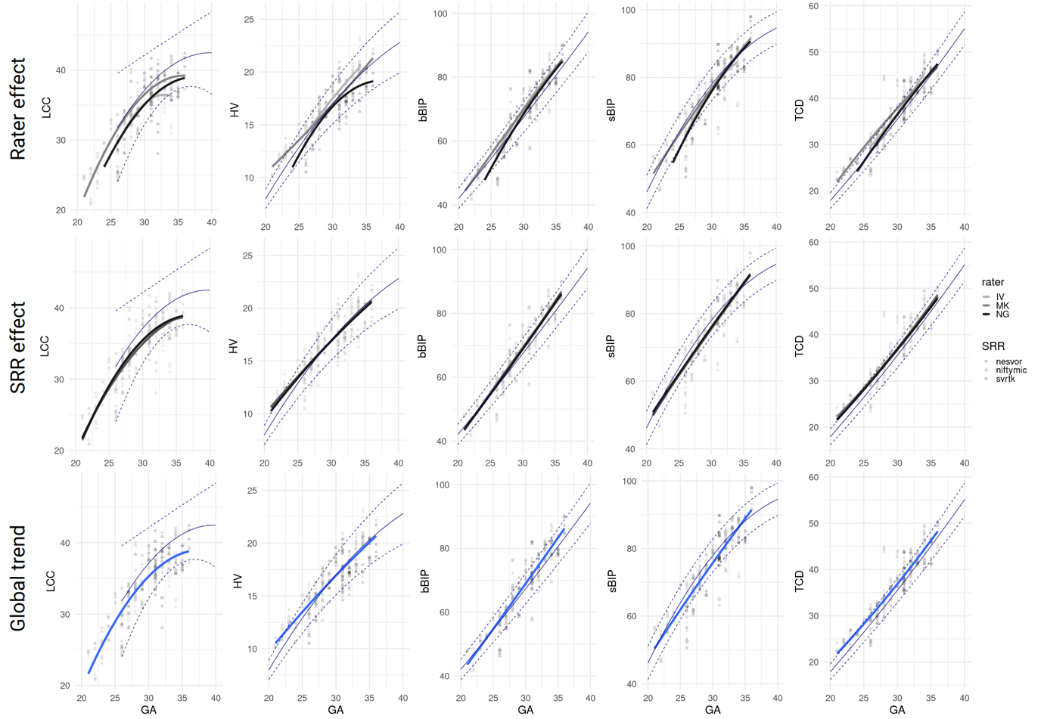Fig. S2 Quadratic fit split by rater (first row), by Super-resolution reconstruction method (second row) and global trend (third row). This visually illustrates the sources of variability in the fitting from different sources
bBIP brain biparietal diameters, HV height of the vermis, LCC length of the corpus callosum, sBIP skull biparietal diameters, TCD transverse cerebellar diameter

Additional results of the subjective rating experiment
Table S9 Details of the qualitative ratings asked to the raters in the first stage of the subjective evaluation
CORTEX
0 (much broken cortical plate), 1 (some broken), 2 (always visible) | Continuity
0 (overall blurry cortex), 1 (blurry at some areas), 2 (sharp and good cortical contrast) | Sharpness
Does the folding pattern correspond to the estimated GA? 0 (no) 1(yes) | Folding pattern
WHITE MATTER
Layering appearance visible and according to GA:  0 (not visible), 1 (partially visible), 2 (perfectly visible) | Layering
Overall appearance of WM intensity: 0 (poor quality, geometric artifacts like lines, dots, pixelization, checkerboard, etc.), 1 (partially unusual appearance), 2 (looks good as clinical series) | Intensity
CORPUS CALLOSUM (CC)
0 (overall blurry CC), 1 (blurry in some regions), 2 (sharp and good CC intensity contrast) | Sharpness
Thickness appears as expected: 0 (no), 1 (yes) | Thickness
Confidence of distinguishing the subsegments of the CC:  0 (not visible), 1 (somewhat confident), 2 (highly confident) | Rostrum
Confidence of distinguishing the subsegments of the CC:  0 (not visible), 1 (somewhat confident), 2 (highly confident) | Genu
Confidence of distinguishing the subsegments of the CC:  0 (not visible), 1 (somewhat confident), 2 (highly confident) | Body
Confidence of distinguishing the subsegments of the CC:  0 (not visible), 1 (somewhat confident), 2 (highly confident) | Splenium
Confidence of distinguishing the subsegments of the CC:  0 (not visible), 1 (somewhat confident), 2 (highly confident) | Total length of CC
VENTRICLES
Structure is 0 (incompatible with age), 1 (compatible with age) | Germinal Matrix & Ependyma
Structure is 0 (absent) 1(present) | Cavum septum pellucidum leaves
Ventricular wall regularity: 0 (all irregular), 1 (focally irregular), 2 (normal) | Ventricular wall regularity
INTERNAL CAPSULE
Can you distinguish BG &Thalami from surrounding WM?  0 (not at all), 1 (partially), 2 (clear distinction) | Internal capsule
POSTERIOR FOSSA
Is cerebellar foliation visible?  0 (not at all), 1 (partially), 2 (clear distinction) | Cerebellar foliation visibility
OVERALL SUBJECTIVE QUALITY ASSESSMENT
Overall perceived blurring of the image: 0 (multiple areas are blurred),  1 (few areas are blurred), 2 (no visible blurring) | Blurring
Overall quality of the image: 0 (I do not like this image), 1(I think that the quality is acceptable, but I would not use it for radiological assessment),  2 (Excellent image quality, I would like to use it for radiological assessment) | Subjective quality

Corpus callosum subjective rating
For the corpus callosum, all methods led to a good perception of sharpness and thickness. On the substructures (Table S10A), there was a consistent ordering in the rating quality for all methods (rostrum – genu – splenium/body), independently of the reconstruction method used. On the ventricles, internal capsule and posterior fossa (Table S10B), there was also a consistent hierarchy of NeSVoR < NiftyMIC < SVRTK.
Table S10 Subjective structural quality assessment, additional results. (A) Assessment of the corpus callosum and the clarity of its substructures on the images. (B) Assessment of the ventricles (Is the germinal matrix presence compatible with age; are the cavum septum pellucidum leaves present or absence; is the ventricular wall regular), the internal capsule (Are the basal ganglia (BG) and thalami clearly discernable from the white matter) and the posterior fossa (is the cerebellar foliation clear visible)
(A) | Corpus callosum
(A) | Sharpness | Thickness |  | Rostrum |  | Genu |  | Body | Splenium |  | Total length CC
NeSVoR | 1.04±0.69 | 0.92±0.28 |  | 0.88±0.90 |  | 1.25±0.85 |  | 1.46±0.72 | 1.33±0.70 |  | 1.29±0.69
NiftyMIC | 1.38±0.71 | 0.83±0.38 |  | 1.04±0.86 |  | 1.42±0.83 |  | 1.63±0.58 | 1.67±0.56 |  | 1.46±0.66
SVRTK | 1.42±0.58 | 0.83±0.38 |  | 1.08±0.83 |  | 1.79±0.51 |  | 1.71±0.46 | 1.67±0.64 |  | 1.67±0.48
(B) | Ventricles |  |  |  |  |  | Internal capsule |  |  | Posterior Fossa
(B) | Germinal Matrix & Ependyma |  | Cavum septum pellucidum leaves |  | Ventricular wall regularity |  | BG&Thalami visibility |  |  | Cerebellar foliation visibility
NeSVoR | 0.88±0.34 |  | 0.83±0.38 |  | 1.25±0.79 |  | 0.79±0.83 |  |  | 0.88±0.61
NiftyMIC | 0.83±0.38 |  | 0.83±0.38 |  | 1.33±0.64 |  | 1.08±0.78 |  |  | 1.00±0.78
SVRTK | 0.83±0.38 |  | 0.96±0.20 |  | 1.46±0.66 |  | 1.13±0.80 |  |  | 1.21±0.78
NeSVoR Neural Slice-to-Volume Reconstruction, SVRTK, Slice-to-Volume Reconstruction ToolKit

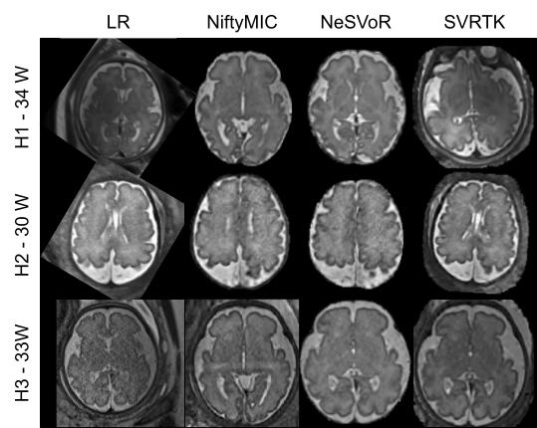
Fig. S3 Subjects from the three different hospitals reconstructed using the different methods presented in the work. The image from H1 was acquired at 3T, from H2 at 1.5T and from H3 at 1.5 T.
NeSVoR Neural Slice-to-Volume Reconstruction, SVRTK, Slice-to-Volume Reconstruction ToolKit

