Supplementary materials

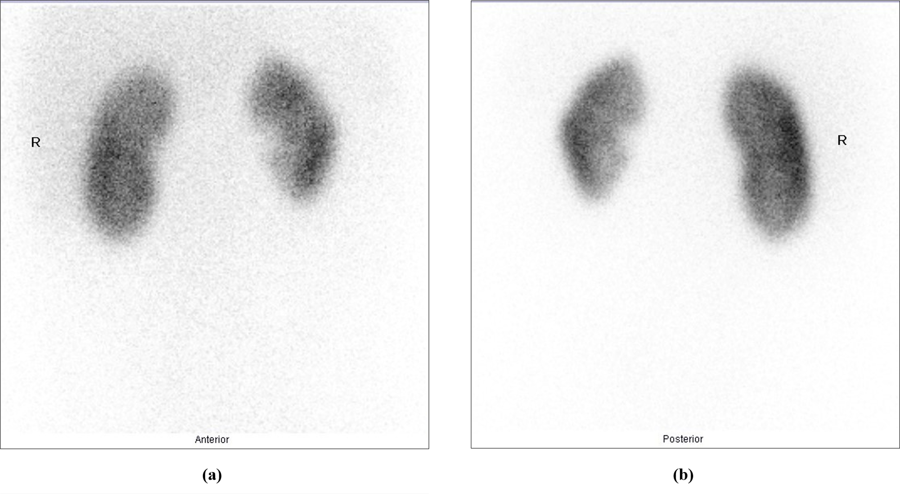
Supplementary material 1. Tc-99m dimercaptosuccinic acid scan, a. anterior static picture, b. posterior static picture

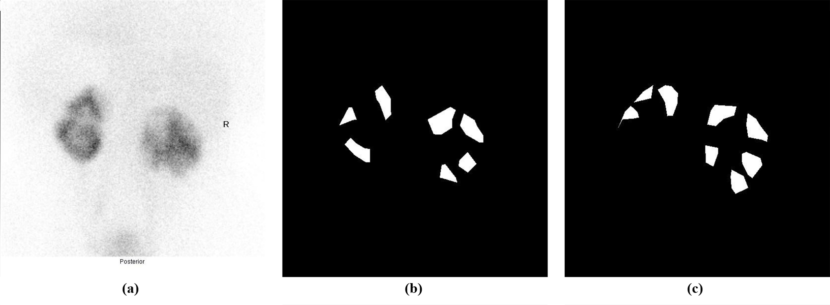
Supplementary material 2. Annotation mask of kidney scar. a. Tc-99m dimercaptosuccinic acid scan, b. first stage annotation, c. second stage annotation

Intra-observer agreement:

Supplementary material 3. Intra-observer agreement by observer-1
Overall impression of left and right kidney

  Left Kidney | Stage - 2
  Stage - 1 |  | No Scar | Scar | All
  Stage - 1 | No Scar | 143 | 5 | 148
  Stage - 1 | Scar | 22 | 50 | 72
  Stage - 1 | All | 165 | 55 | 220
  Cohen's Kappa Score: | 0.703
  Right Kidney | Stage - 2
  Stage - 1 |  | No Scar | Scar | All
  Stage - 1 | No Scar | 150 | 4 | 154
  Stage - 1 | Scar | 16 | 50 | 66
  Stage - 1 | All | 166 | 54 | 220
  Cohen's Kappa Score: | 0.77
Location of parenchymal defect of left and right Kidney
  Left Kidney | Stage - 2
  Stage - 1 |  | Not Affected | Upper pole | Mid-zone | Lower pole | Multiple Zone | All
  Stage - 1 | Not Affected | 144 | 2 | 1 | 1 | 0 | 148
  Stage - 1 | Upper pole | 7 | 11 | 1 | 0 | 0 | 19
  Stage - 1 | Mid-zone | 0 | 0 | 1 | 0 | 0 | 1
  Stage - 1 | Lower pole | 8 | 2 | 1 | 4 | 1 | 16
  Stage - 1 | Multiple Zone | 6 | 7 | 1 | 3 | 19 | 36
  Stage - 1 | All | 165 | 22 | 5 | 8 | 20 | 220
  Cohen's Kappa Score | 0.602
  Right Kidney | Stage - 2
  Stage - 1 |  | Not Affected | Upper pole | Mid-zone | Lower pole | Multiple Zone | All
  Stage - 1 | Not Affected | 151 | 0 | 0 | 4 | 0 | 155
  Stage - 1 | Upper pole | 3 | 11 | 1 | 0 | 3 | 18
  Stage - 1 | Mid-zone | 0 | 0 | 2 | 0 | 0 | 2
  Stage - 1 | Lower pole | 5 | 2 | 0 | 9 | 3 | 19
  Stage - 1 | Multiple Zone | 7 | 5 | 0 | 2 | 12 | 26
  Stage - 1 | All | 166 | 18 | 3 | 15 | 18 | 220
  Cohen's Kappa Score | 0.64
Percentage of kidney involvement of left and right kidney
  Left Kidney | Stage 2
  Stage 1 |  | 0% | <10% | 10-24% | 25-49% | 50-74% | >74% | All
  Stage 1 | 0% | 143 | 5 | 0 | 0 | 0 | 0 | 148
  Stage 1 | <10% | 14 | 14 | 4 | 0 | 0 | 0 | 32
  Stage 1 | 10-24% | 3 | 6 | 12 | 1 | 0 | 0 | 22
  Stage 1 | 25-49% | 2 | 4 | 1 | 1 | 0 | 0 | 8
  Stage 1 | 50-74% | 3 | 0 | 1 | 2 | 1 | 0 | 7
  Stage 1 | >74% | 0 | 1 | 0 | 1 | 1 | 0 | 3
  Stage 1 | All | 165 | 30 | 18 | 5 | 2 | 0 | 220
  Kendall's Tau-b | 0.62
  Right Kidney | Stage 2
  Stage 1 |  | 0% | <10% | 10-24% | 25-49% | 50-74% | >74% | All
  Stage 1 | 0% | 148 | 4 | 0 | 0 | 0 | 0 | 152
  Stage 1 | <10% | 8 | 19 | 4 | 0 | 0 | 0 | 31
  Stage 1 | 10-24% | 6 | 7 | 8 | 1 | 0 | 0 | 22
  Stage 1 | 25-49% | 2 | 1 | 3 | 3 | 0 | 0 | 9
  Stage 1 | 50-74% | 2 | 0 | 2 | 1 | 0 | 0 | 5
  Stage 1 | >74% | 0 | 0 | 0 | 1 | 0 | 0 | 1
  Stage 1 | All | 166 | 31 | 17 | 6 | 0 | 0 | 220
  Kendall's Tau-b | 0.69

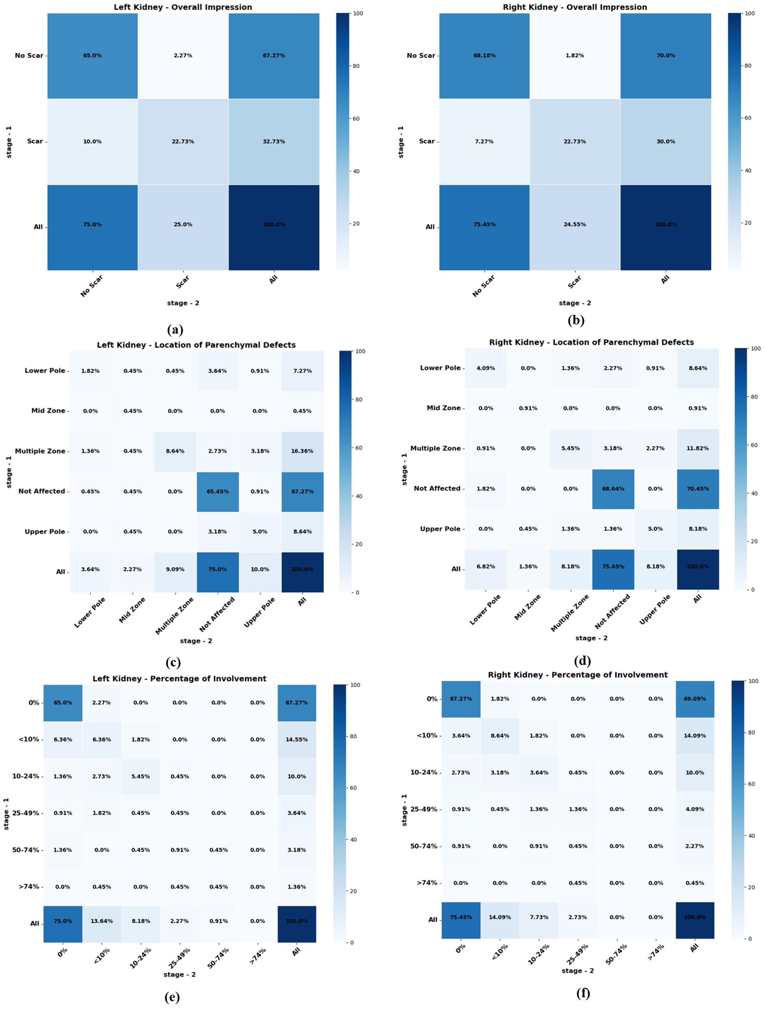
Supplementary material 4. Heatmap of intra-observer agreement by observer-1. Cohen's Kappa cross-tabulations for overall impression a. left kidney, b. right kidney. Cohen's Kappa cross-tabulations for location of parenchymal defect c. left kidney, d. right kidney. Kendall's Tau-b cross-tabulations for percent involvement of e. left kidney, f. right kidney

Supplementary material 5. Intra-observer agreement by observer-2.
Overall impression of left and right kidney

  Left Kidney | Stage - 2
  Stage - 1 |  | No Scar | Scar | All
  Stage - 1 | No Scar | 20 | 10 | 30
  Stage - 1 | Scar | 4 | 184 | 188
  Stage - 1 | All | 24 | 194 | 218
  Cohen's Kappa Score: | 0.704
  Right Kidney | Stage - 2
  Stage - 1 |  | No Scar | Scar | All
  Stage - 1 | No Scar | 38 | 15 | 53
  Stage - 1 | Scar | 4 | 161 | 165
  Stage - 1 | All | 42 | 176 | 218
  Cohen's Kappa Score: | 0.74
Location of parenchymal defect of left and right kidney
  Left Kidney | Stage - 2
  Stage - 1 |  | Not Affected | Upper pole | Mid-zone | Lower pole | Multiple Zone | All
  Stage - 1 | Not Affected | 18 | 5 | 2 | 1 | 4 | 30
  Stage - 1 | Upper pole | 2 | 36 | 4 | 0 | 31 | 73
  Stage - 1 | Mid-zone | 0 | 0 | 7 | 1 | 4 | 12
  Stage - 1 | Lower pole | 1 | 1 | 0 | 1 | 4 | 7
  Stage - 1 | Multiple Zone | 0 | 6 | 2 | 2 | 86 | 96
  Stage - 1 | All | 21 | 48 | 15 | 5 | 129 | 218
  Cohen's Kappa Score | 0.504
  Right Kidney | Stage - 2
  Stage - 1 |  | Not Affected | Upper pole | Mid-zone | Lower pole | Multiple Zone | All
  Stage - 1 | Not Affected | 38 | 5 | 1 | 0 | 9 | 53
  Stage - 1 | Upper pole | 3 | 40 | 2 | 0 | 34 | 79
  Stage - 1 | Mid-zone | 0 | 0 | 3 | 0 | 3 | 6
  Stage - 1 | Lower pole | 0 | 0 | 0 | 2 | 2 | 4
  Stage - 1 | Multiple Zone | 1 | 4 | 3 | 0 | 68 | 76
  Stage - 1 | All | 42 | 49 | 9 | 2 | 116 | 218
  Cohen's Kappa Score | 0.55
Percentage of kidney involvement of left and right kidney
  Left Kidney | Stage 2
  Stage 1 |  | 0% | <10% | 10-24% | 25-49% | 50-74% | >74% | All
  Stage 1 | 0% | 20 | 7 | 2 | 0 | 1 | 0 | 30
  Stage 1 | <10% | 1 | 14 | 17 | 4 | 1 | 0 | 37
  Stage 1 | 10-24% | 2 | 16 | 41 | 9 | 6 | 2 | 76
  Stage 1 | 25-49% | 1 | 5 | 14 | 4 | 5 | 2 | 31
  Stage 1 | 50-74% | 0 | 1 | 1 | 3 | 10 | 4 | 19
  Stage 1 | >74% | 0 | 0 | 0 | 0 | 2 | 23 | 25
  Stage 1 | All | 24 | 43 | 75 | 20 | 25 | 31 | 218
  Kendall's Tau-b | 0.43
  Right Kidney | Stage 2
  Stage 1 |  | 0% | <10% | 10-24% | 25-49% | 50-74% | >74% | All
  Stage 1 | 0% | 38 | 6 | 7 | 1 | 0 | 1 | 53
  Stage 1 | <10% | 2 | 17 | 12 | 1 | 2 | 0 | 34
  Stage 1 | 10-24% | 2 | 17 | 29 | 16 | 1 | 1 | 66
  Stage 1 | 25-49% | 1 | 0 | 7 | 7 | 12 | 2 | 29
  Stage 1 | 50-74% | 0 | 0 | 1 | 4 | 7 | 1 | 13
  Stage 1 | >74% | 0 | 0 | 1 | 0 | 3 | 19 | 23
  Stage 1 | All | 43 | 40 | 57 | 29 | 25 | 24 | 218
  Kendall's Tau-b | 0.52
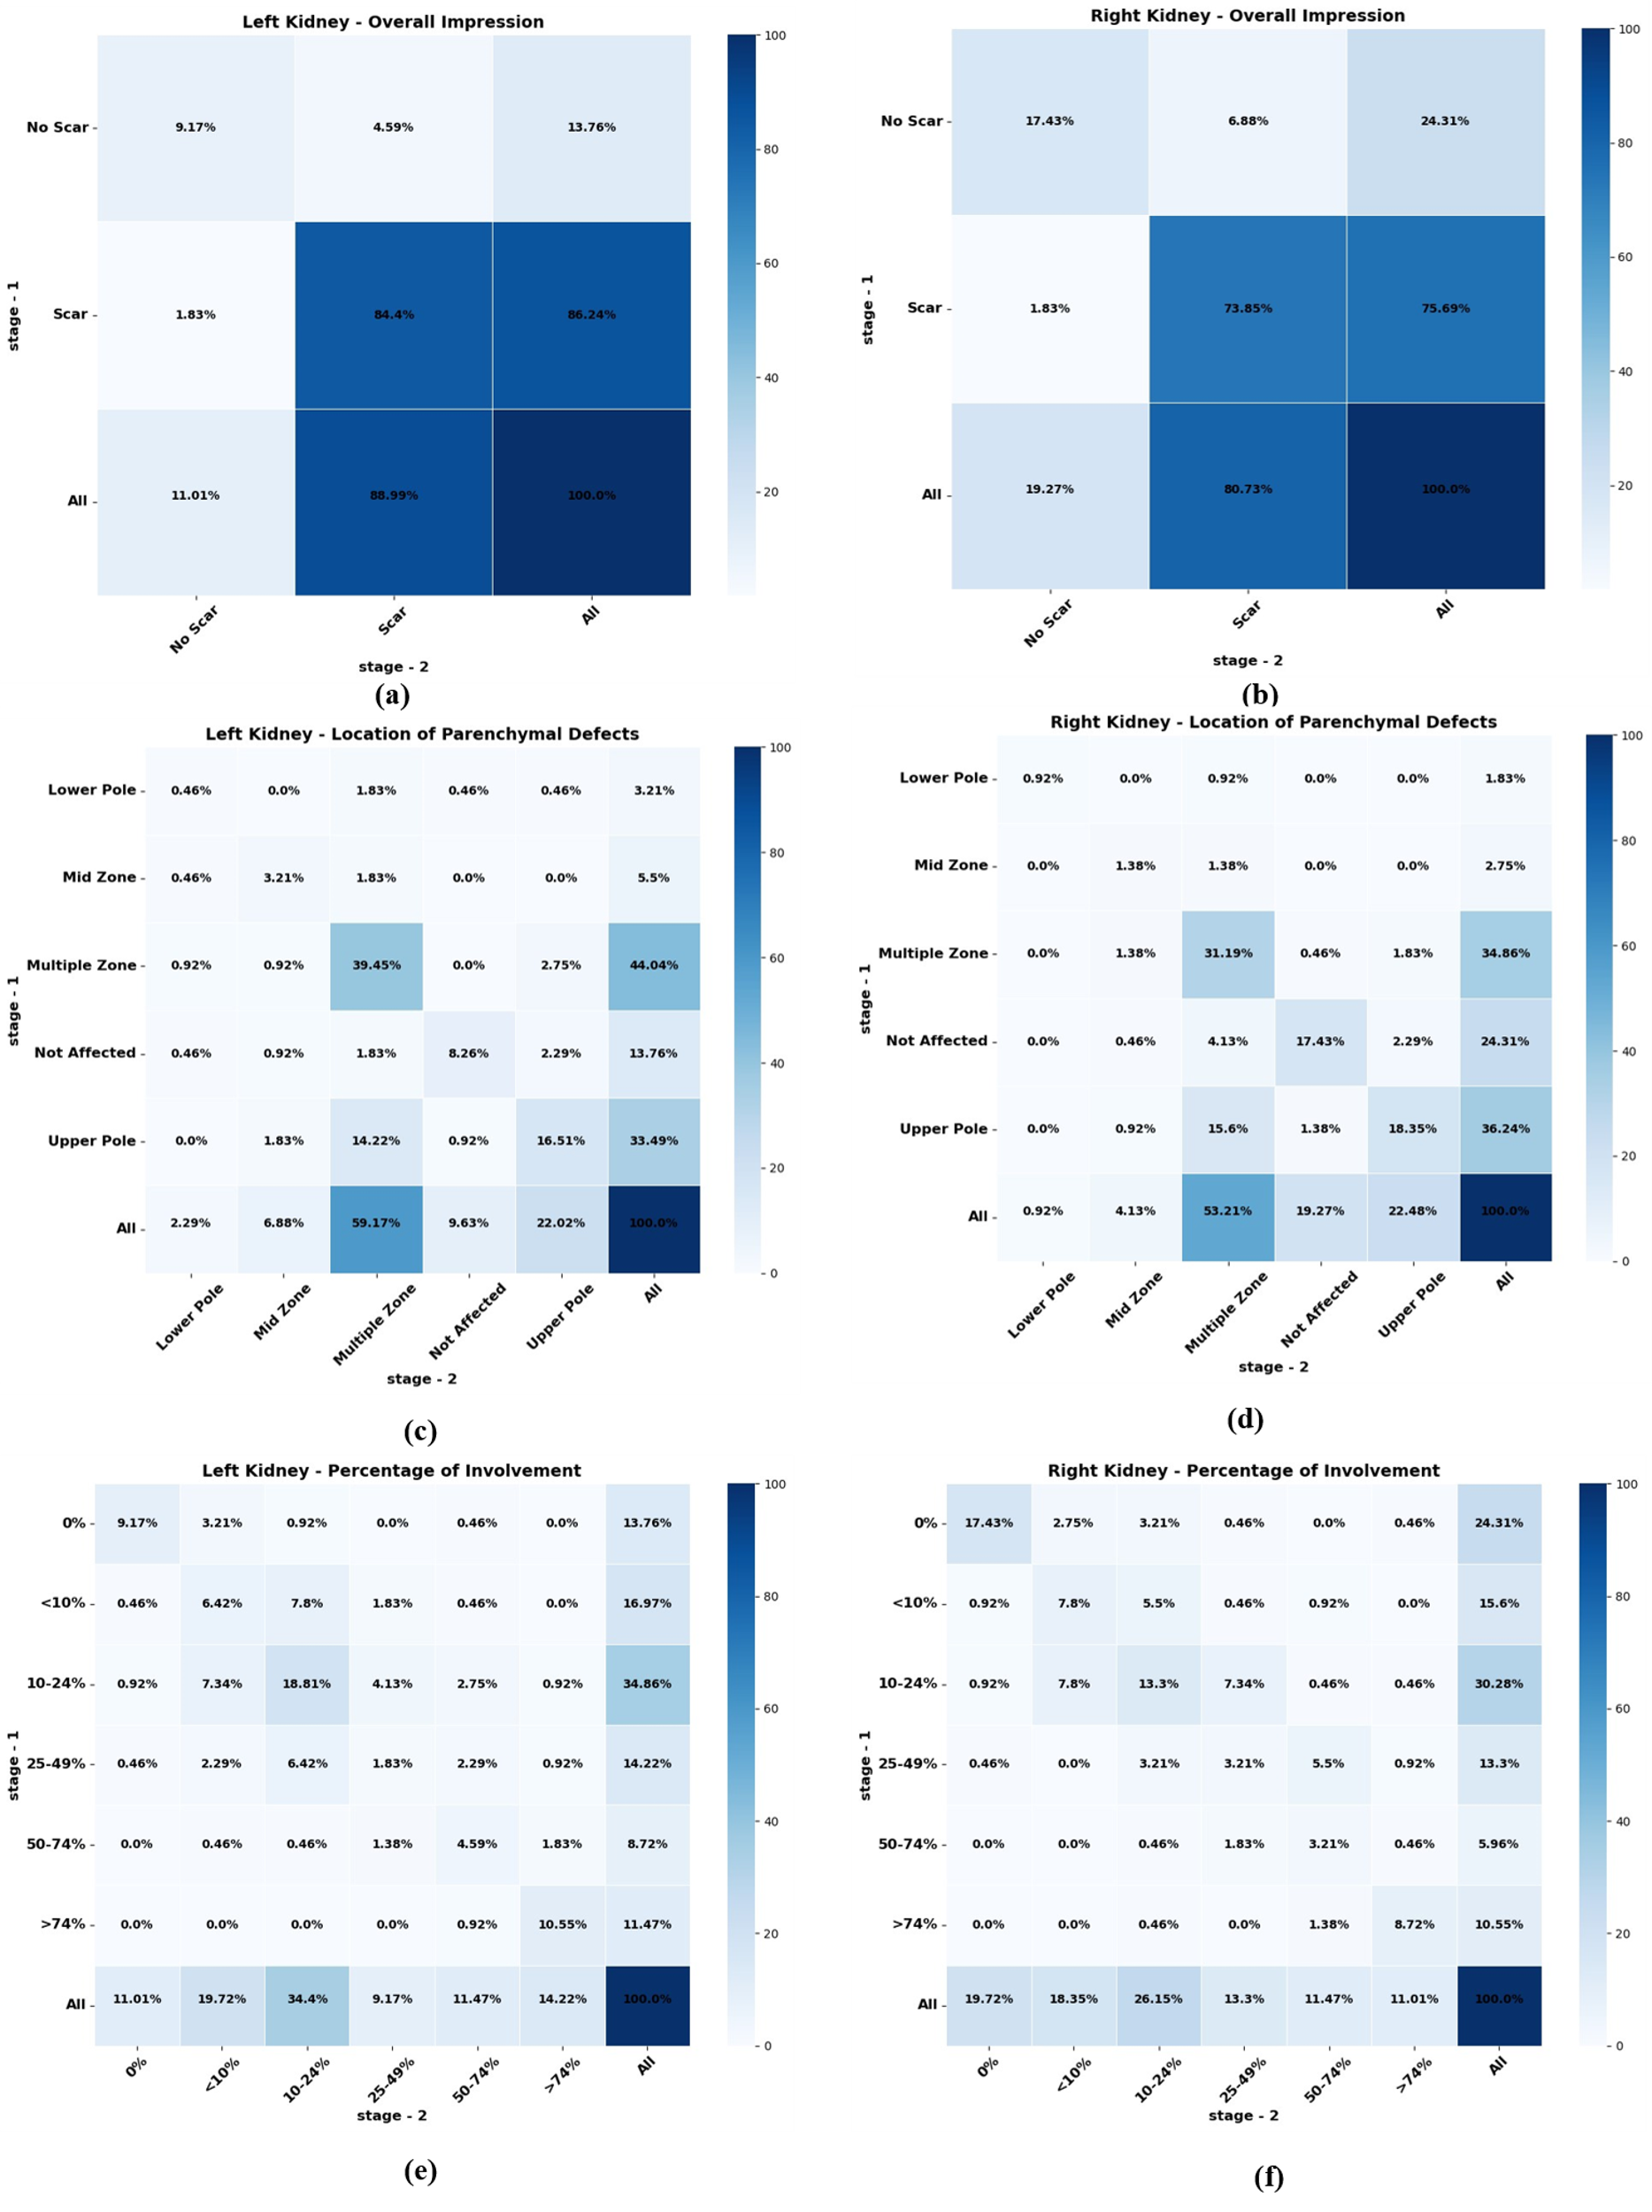
Supplementary material 6. Heatmap of intra-observer agreement by observer-2. Cohen's Kappa cross-tabulations for overall impression a. left kidney, b. right kidney. Cohen's Kappa cross-tabulations for location of parenchymal defect c. left kidney, d. right kidney. Kendall's Tau-b cross-tabulations for percent involvement of e. left kidney, f. right kidney

Supplementary material 7. Intra-observer agreement by observer-3
Overall impression of left and right kidney

  Left Kidney | Stage - 2
  Stage - 1 |  | No Scar | Scar | All
  Stage - 1 | No Scar | 141 | 5 | 146
  Stage - 1 | Scar | 11 | 63 | 74
  Stage - 1 | All | 152 | 68 | 220
  Cohen's Kappa Score: | 0.83
  Right Kidney | Stage - 2
  Stage - 1 |  | No Scar | Scar | All
  Stage - 1 | No Scar | 163 | 4 | 167
  Stage - 1 | Scar | 7 | 46 | 53
  Stage - 1 | All | 170 | 50 | 220
  Cohen's Kappa Score: | 0.86
Location of parenchymal defect of left and right kidney
  Left Kidney | Stage - 2
  Stage - 1 |  | Not Affected | Upper pole | Mid-zone | Lower pole | Multiple Zone | All
  Stage - 1 | Not Affected | 139 | 3 | 2 | 0 | 0 | 144
  Stage - 1 | Upper pole | 3 | 10 | 0 | 1 | 2 | 16
  Stage - 1 | Mid-zone | 2 | 1 | 5 | 0 | 3 | 11
  Stage - 1 | Lower pole | 4 | 0 | 0 | 7 | 2 | 13
  Stage - 1 | Multiple Zone | 2 | 0 | 2 | 3 | 29 | 36
  Stage - 1 | All | 150 | 14 | 9 | 11 | 36 | 220
  Cohen's Kappa Score | 0.73
  Right Kidney | Stage - 2
  Stage - 1 |  | Not Affected | Upper pole | Mid-zone | Lower pole | Multiple Zone | All
  Stage - 1 | Not Affected | 163 | 0 | 1 | 2 | 1 | 167
  Stage - 1 | Upper pole | 1 | 12 | 0 | 1 | 1 | 15
  Stage - 1 | Mid-zone | 1 | 0 | 3 | 0 | 0 | 4
  Stage - 1 | Lower pole | 4 | 1 | 0 | 5 | 1 | 11
  Stage - 1 | Multiple Zone | 1 | 0 | 0 | 0 | 22 | 23
  Stage - 1 | All | 170 | 13 | 4 | 8 | 25 | 220
  Cohen's Kappa Score | 0.82
Percentage of kidney involvement of left and right kidney
  Left Kidney | Stage 2
  Stage 1 |  | 0% | <10% | 10-24% | 25-49% | 50-74% | >74% | All
  Stage 1 | 0% | 145 | 5 | 0 | 0 | 0 | 0 | 150
  Stage 1 | <10% | 8 | 11 | 6 | 1 | 0 | 0 | 26
  Stage 1 | 10-24% | 1 | 4 | 13 | 8 | 1 | 0 | 27
  Stage 1 | 25-49% | 0 | 0 | 1 | 10 | 2 | 0 | 13
  Stage 1 | 50-74% | 0 | 0 | 0 | 0 | 3 | 0 | 3
  Stage 1 | >74% | 0 | 0 | 0 | 0 | 0 | 1 | 1
  Stage 1 | All | 154 | 20 | 20 | 19 | 6 | 1 | 220
  Kendall's Tau-b | 0.73
  Right Kidney | Stage 2
  Stage 1 |  | 0% | <10% | 10-24% | 25-49% | 50-74% | >74% | All
  Stage 1 | 0% | 162 | 3 | 2 | 1 | 0 | 0 | 168
  Stage 1 | <10% | 3 | 11 | 8 | 0 | 0 | 0 | 22
  Stage 1 | 10-24% | 4 | 0 | 10 | 4 | 0 | 0 | 18
  Stage 1 | 25-49% | 0 | 0 | 0 | 8 | 3 | 0 | 11
  Stage 1 | 50-74% | 0 | 0 | 0 | 0 | 1 | 0 | 1
  Stage 1 | >74% | 0 | 0 | 0 | 0 | 0 | 0 | 0
  Stage 1 | All | 169 | 14 | 20 | 13 | 4 | 0 | 220
  Kendall's Tau-b | 0.78
Supplementary material 8. Intra-observer agreement by observer-4
Overall impression of left and right kidney

  Left Kidney | Stage - 2
  Stage - 1 |  | No Scar | Scar | All
  Stage - 1 | No Scar | 136 | 1 | 137
  Stage - 1 | Scar | 8 | 75 | 83
  Stage - 1 | All | 144 | 76 | 220
  Cohen's Kappa Score: | 0.91
  Right Kidney | Stage - 2
  Stage - 1 |  | No Scar | Scar | All
  Stage - 1 | No Scar | 154 | 0 | 154
  Stage - 1 | Scar | 4 | 62 | 66
  Stage - 1 | All | 158 | 62 | 220
  Cohen's Kappa Score: | 0.95
Location of parenchymal defect of left and right kidney
  Left Kidney | Stage - 2
  Stage - 1 |  | Not Affected | Upper pole | Mid-zone | Lower pole | Multiple Zone | All
  Stage - 1 | Not Affected | 136 | 0 | 0 | 1 | 0 | 137
  Stage - 1 | Upper pole | 3 | 13 | 0 | 0 | 0 | 16
  Stage - 1 | Mid-zone | 1 | 0 | 6 | 0 | 0 | 7
  Stage - 1 | Lower pole | 1 | 0 | 0 | 11 | 1 | 13
  Stage - 1 | Multiple Zone | 4 | 1 | 0 | 0 | 42 | 47
  Stage - 1 | All | 145 | 14 | 6 | 12 | 43 | 220
  Cohen's Kappa Score | 0.89
  Right Kidney | Stage - 2
  Stage - 1 |  | Not Affected | Upper pole | Mid-zone | Lower pole | Multiple Zone | All
  Stage - 1 | Not Affected | 155 | 1 | 0 | 0 | 0 | 156
  Stage - 1 | Upper pole | 1 | 9 | 0 | 0 | 0 | 10
  Stage - 1 | Mid-zone | 1 | 0 | 2 | 0 | 0 | 3
  Stage - 1 | Lower pole | 1 | 0 | 0 | 11 | 0 | 12
  Stage - 1 | Multiple Zone | 1 | 1 | 1 | 2 | 34 | 39
  Stage - 1 | All | 159 | 11 | 3 | 13 | 34 | 220
  Cohen's Kappa Score | 0.909
Percentage of kidney involvement of left and right kidney
  Left Kidney | Stage 2
  Stage 1 |  | 0% | <10% | 10-24% | 25-49% | 50-74% | >74% | All
  Stage 1 | 0% | 139 | 0 | 0 | 1 | 0 | 1 | 141
  Stage 1 | <10% | 3 | 21 | 4 | 0 | 0 | 0 | 28
  Stage 1 | 10-24% | 3 | 5 | 11 | 2 | 0 | 0 | 21
  Stage 1 | 25-49% | 0 | 0 | 7 | 1 | 0 | 0 | 8
  Stage 1 | 50-74% | 1 | 0 | 1 | 1 | 4 | 0 | 7
  Stage 1 | >74% | 0 | 0 | 0 | 0 | 1 | 14 | 15
  Stage 1 | All | 146 | 26 | 23 | 5 | 5 | 15 | 220
  Kendall's Tau-b: | 0.86
  Right Kidney | Stage 2
  Stage 1 |  | 0% | <10% | 10-24% | 25-49% | 50-74% | >74% | All
  Stage 1 | 0% | 155 | 0 | 0 | 0 | 0 | 0 | 155
  Stage 1 | <10% | 1 | 20 | 7 | 0 | 0 | 0 | 28
  Stage 1 | 10-24% | 0 | 2 | 10 | 2 | 0 | 0 | 14
  Stage 1 | 25-49% | 1 | 0 | 2 | 1 | 3 | 0 | 7
  Stage 1 | 50-74% | 1 | 0 | 0 | 2 | 6 | 1 | 10
  Stage 1 | >74% | 0 | 0 | 0 | 0 | 1 | 5 | 6
  Stage 1 | All | 158 | 22 | 19 | 5 | 10 | 6 | 220
  Kendall's Tau-b: | 0.91

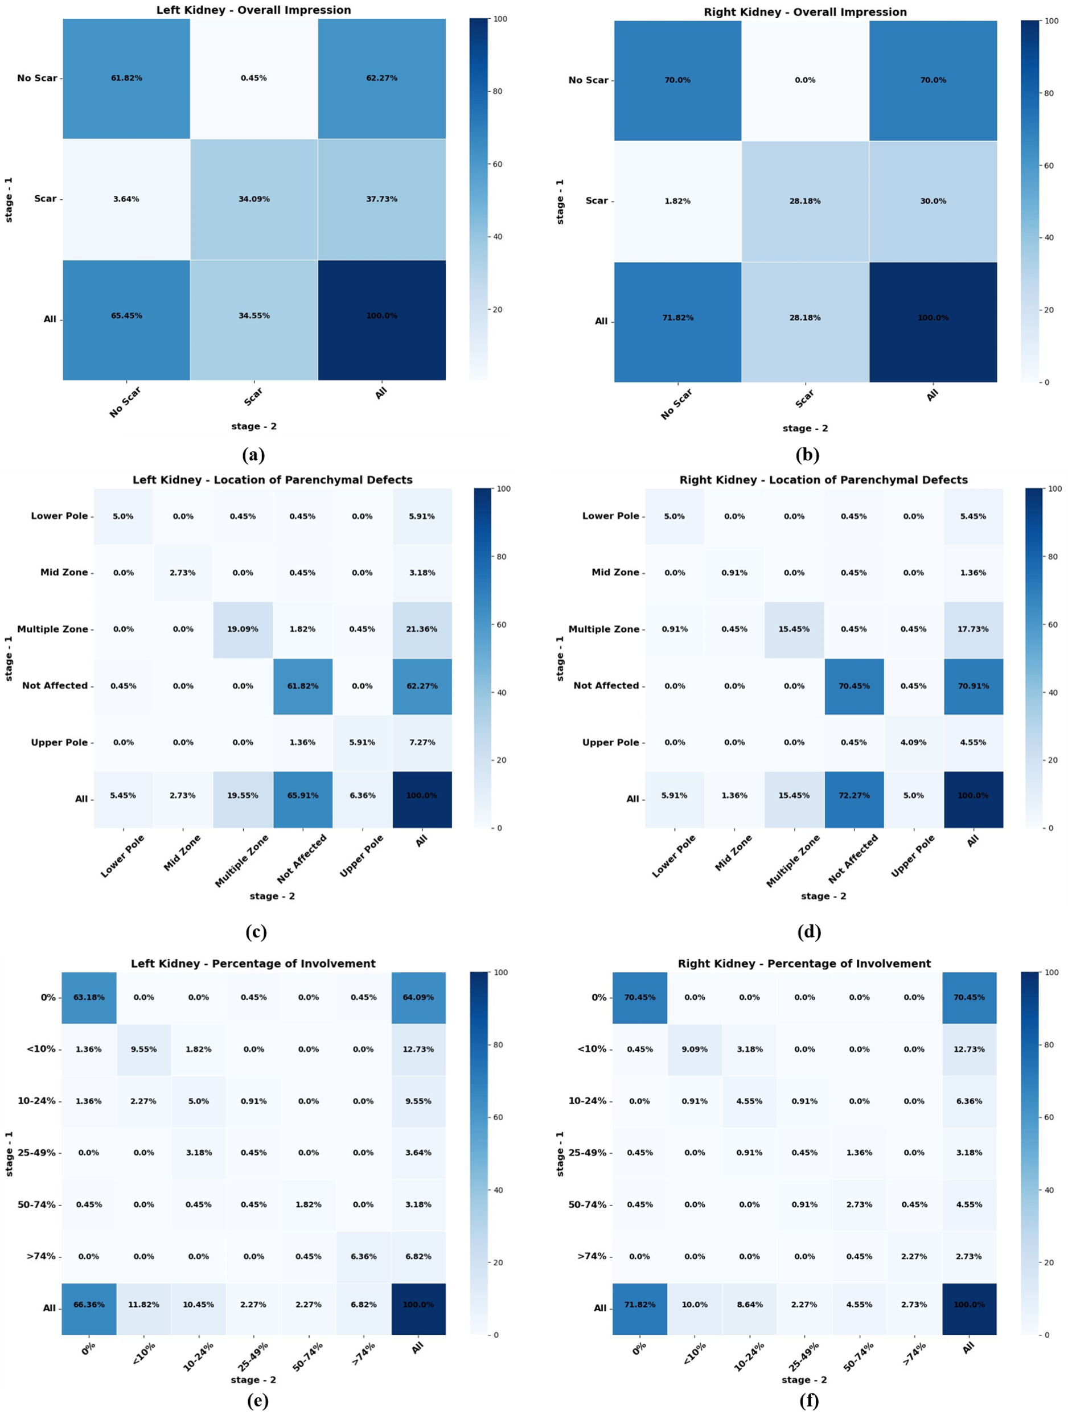
Supplementary material 9. Heatmap of intra-observer agreement by observer-4. Cohen's Kappa cross-tabulations for overall impression a. left kidney, b. right kidney. Cohen's Kappa cross-tabulations for location of parenchymal defect c. left kidney, d. right kidney. Kendall's Tau-b cross-tabulations for percent involvement of e. left kidney, f. right kidney

