Fungal community assembly in the Amazonian Dark Earth

Adriano Reis Lucheta^{1†}, Fabiana de Souza Cannavan^{2†}, Luiz Fernando Wurdig Roesch³, Siu Mui Tsai², Eiko Eurya Kuramae^{1*}

¹Department of Microbial Ecology, Netherlands Institute of Ecology (NIOO/KNAW), Wageningen, The Netherlands
²Centro de Energia Nuclear na Agricultura (CENA), Universidade de São Paulo (USP), Piracicaba, Brasil
³Centro Interdisciplinar de Pesquisas em Biotecnologia (CIP-Biotec), Universidade Federal do Pampa, São Gabriel, Brasil
† These authors share first authorship.

*Corresponding Author: Eiko E. Kuramae, Department of Microbial Ecology, Netherlands Institute of Ecology (NIOO-KNAW), Droevendaalsesteeg 10, Wageningen 6708 PB, The Netherlands. Tel.: +31(0)317 47 35 02; e-mail: e.kuramae@nioo.knaw.nl

Online Resource 1 – Schematic design used for soil sampling. Samples selected for DNA extraction were represented in yellow.

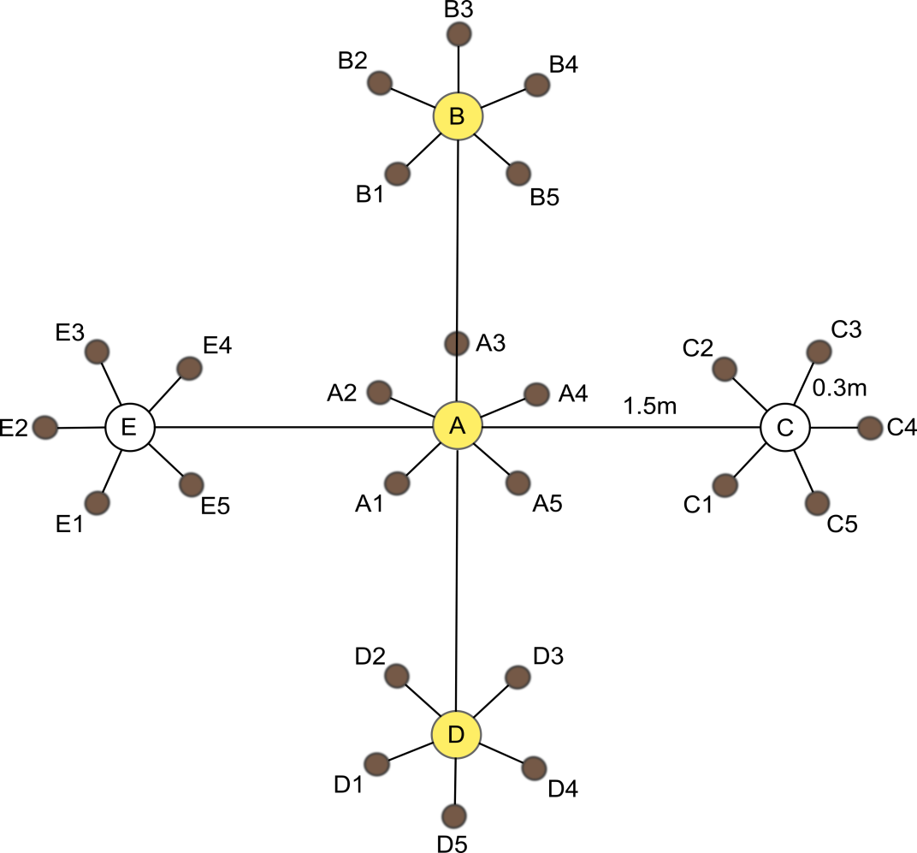

Online Resource 2 - List of barcoded primers used for 18S rRNA gene amplification and 454 pyrosequencing of Açutuba (ACU), Balbina (BAL), Barro Branco (BBO) and Hatahara (HAT) Amazonian Dark Earth (ADE) and adjacent (ADJ) soil samples.
Site | Soil Type | Replicate | Primer Name | Primer Sequence | Key | MID
ACU | ADE | 1 | FR1(MID-67) | AICCATTCAATCGGTAIT | CGTATCGCCTCCCTCGCGCCATCAG | TCGATAGTGA
 |  |  | FF390w(MID-67) | CGWTAACGAACGAGACCT | CTATGCGCCTTGCCAGCCCGCTCAG | TCGATAGTGA
ACU | ADE | 2 | FR1(MID-68) | AICCATTCAATCGGTAIT | CGTATCGCCTCCCTCGCGCCATCAG | TCGCTGCGTA
 |  |  | FF390w(MID-68) | CGWTAACGAACGAGACCT | CTATGCGCCTTGCCAGCCCGCTCAG | TCGCTGCGTA
ACU | ADE | 3 | FR1(MID-69) | AICCATTCAATCGGTAIT | CGTATCGCCTCCCTCGCGCCATCAG | TCTGACGTCA
 |  |  | FF390w(MID-69) | CGWTAACGAACGAGACCT | CTATGCGCCTTGCCAGCCCGCTCAG | TCTGACGTCA
ACU | ADJ | 1 | FR1(MID-67) | AICCATTCAATCGGTAIT | CGTATCGCCTCCCTCGCGCCATCAG | TCGATAGTGA
 |  |  | FF390w(MID-67) | CGWTAACGAACGAGACCT | CTATGCGCCTTGCCAGCCCGCTCAG | TCGATAGTGA
ACU | ADJ | 2 | FR1(MID-68) | AICCATTCAATCGGTAIT | CGTATCGCCTCCCTCGCGCCATCAG | TCGCTGCGTA
 |  |  | FF390w(MID-68) | CGWTAACGAACGAGACCT | CTATGCGCCTTGCCAGCCCGCTCAG | TCGCTGCGTA
ACU | ADJ | 3 | FR1(MID-69) | AICCATTCAATCGGTAIT | CGTATCGCCTCCCTCGCGCCATCAG | TCTGACGTCA
 |  |  | FF390w(MID-69) | CGWTAACGAACGAGACCT | CTATGCGCCTTGCCAGCCCGCTCAG | TCTGACGTCA
BAL | ADE | 1 | FR1(MID-24) | AICCATTCAATCGGTAIT | CGTATCGCCTCCCTCGCGCCATCAG | TAGAGACGAG
 |  |  | FF390w(MID-24) | CGWTAACGAACGAGACCT | CTATGCGCCTTGCCAGCCCGCTCAG | TAGAGACGAG
BAL | ADE | 2 | FR1(MID-25) | AICCATTCAATCGGTAIT | CGTATCGCCTCCCTCGCGCCATCAG | TCGTCGCTCG
 |  |  | FF390w(MID-25) | CGWTAACGAACGAGACCT | CTATGCGCCTTGCCAGCCCGCTCAG | TCGTCGCTCG
BAL | ADE | 3 | FR1(MID-26) | AICCATTCAATCGGTAIT | CGTATCGCCTCCCTCGCGCCATCAG | ACATACGCGT
 |  |  | FF390w(MID-26) | CGWTAACGAACGAGACCT | CTATGCGCCTTGCCAGCCCGCTCAG | ACATACGCGT
BAL | ADJ | 1 | FR1(MID-24) | AICCATTCAATCGGTAIT | CGTATCGCCTCCCTCGCGCCATCAG | TAGAGACGAG
 |  |  | FF390w(MID-24) | CGWTAACGAACGAGACCT | CTATGCGCCTTGCCAGCCCGCTCAG | TAGAGACGAG
BAL | ADJ | 2 | FR1(MID-25) | AICCATTCAATCGGTAIT | CGTATCGCCTCCCTCGCGCCATCAG | TCGTCGCTCG
 |  |  | FF390w(MID-25) | CGWTAACGAACGAGACCT | CTATGCGCCTTGCCAGCCCGCTCAG | TCGTCGCTCG
BAL | ADJ | 3 | FR1(MID-26) | AICCATTCAATCGGTAIT | CGTATCGCCTCCCTCGCGCCATCAG | ACATACGCGT
 |  |  | FF390w(MID-26) | CGWTAACGAACGAGACCT | CTATGCGCCTTGCCAGCCCGCTCAG | ACATACGCGT
BBO | ADE | 1 | FR1(MID-61) | AICCATTCAATCGGTAIT | CGTATCGCCTCCCTCGCGCCATCAG | CTATAGCGTA
 |  |  | FF390w(MID-61) | CGWTAACGAACGAGACCT | CTATGCGCCTTGCCAGCCCGCTCAG | CTATAGCGTA
BBO | ADE | 2 | FR1(MID-62) | AICCATTCAATCGGTAIT | CGTATCGCCTCCCTCGCGCCATCAG | TACGTCATCA
 |  |  | FF390w(MID-62) | CGWTAACGAACGAGACCT | CTATGCGCCTTGCCAGCCCGCTCAG | TACGTCATCA
BBO | ADE | 3 | FR1(MID-63) | AICCATTCAATCGGTAIT | CGTATCGCCTCCCTCGCGCCATCAG | TAGTCGCATA
 |  |  | FF390w(MID-63) | CGWTAACGAACGAGACCT | CTATGCGCCTTGCCAGCCCGCTCAG | TAGTCGCATA
BBO | ADJ | 1 | FR1(MID-61) | AICCATTCAATCGGTAIT | CGTATCGCCTCCCTCGCGCCATCAG | CTATAGCGTA
 |  |  | FF390w(MID-61) | CGWTAACGAACGAGACCT | CTATGCGCCTTGCCAGCCCGCTCAG | CTATAGCGTA
BBO | ADJ | 2 | FR1(MID-62) | AICCATTCAATCGGTAIT | CGTATCGCCTCCCTCGCGCCATCAG | TACGTCATCA
 |  |  | FF390w(MID-62) | CGWTAACGAACGAGACCT | CTATGCGCCTTGCCAGCCCGCTCAG | TACGTCATCA
BBO | ADJ | 3 | FR1(MID-63) | AICCATTCAATCGGTAIT | CGTATCGCCTCCCTCGCGCCATCAG | TAGTCGCATA
 |  |  | FF390w(MID-63) | CGWTAACGAACGAGACCT | CTATGCGCCTTGCCAGCCCGCTCAG | TAGTCGCATA
HAT | ADE | 1 | FR1(MID-64) | AICCATTCAATCGGTAIT | CGTATCGCCTCCCTCGCGCCATCAG | TATATATACA
 |  |  | FF390w(MID-64) | CGWTAACGAACGAGACCT | CTATGCGCCTTGCCAGCCCGCTCAG | TATATATACA
HAT | ADE | 2 | FR1(MID-65) | AICCATTCAATCGGTAIT | CGTATCGCCTCCCTCGCGCCATCAG | TATGCTAGTA
 |  |  | FF390w(MID-65) | CGWTAACGAACGAGACCT | CTATGCGCCTTGCCAGCCCGCTCAG | TATGCTAGTA
HAT | ADE | 3 | FR1(MID-66) | AICCATTCAATCGGTAIT | CGTATCGCCTCCCTCGCGCCATCAG | TCACGCGAGA
 |  |  | FF390w(MID-66) | CGWTAACGAACGAGACCT | CTATGCGCCTTGCCAGCCCGCTCAG | TCACGCGAGA
HAT | ADJ | 1 | FR1(MID-64) | AICCATTCAATCGGTAIT | CGTATCGCCTCCCTCGCGCCATCAG | TATATATACA
 |  |  | FF390w(MID-64) | CGWTAACGAACGAGACCT | CTATGCGCCTTGCCAGCCCGCTCAG | TATATATACA
HAT | ADJ | 2 | FR1(MID-65) | AICCATTCAATCGGTAIT | CGTATCGCCTCCCTCGCGCCATCAG | TATGCTAGTA
 |  |  | FF390w(MID-65) | CGWTAACGAACGAGACCT | CTATGCGCCTTGCCAGCCCGCTCAG | TATGCTAGTA
HAT | ADJ | 3 | FR1(MID-66) | AICCATTCAATCGGTAIT | CGTATCGCCTCCCTCGCGCCATCAG | TCACGCGAGA
 |  |  | FF390w(MID-66) | CGWTAACGAACGAGACCT | CTATGCGCCTTGCCAGCCCGCTCAG | TCACGCGAGA

Online Resource 3 – Summary of the number of sequences and OTUs after each bioinformatics steep.
 | UCLUST Clustering | Filter by Taxonomy (Fungi Domain only) | Singletons Removal | Rarefaction
Number of Samples | 24 | 24 | 24 | 24
Number of Total Sequences | 132 764 | 105 579 | 105 019 | 41 472
Min. | 2232 | 1742 | 1728 | 1728
Max. | 8477 | 6734 | 6712 | 1728
Median | 5826 | 4373 | 4355 | 1728
Mean | 5531.8 | 4395 | 4375.8 | 1728
Std. dev. | 1397.1 | 1156.7 | 1155.3 | 0.0
Number of OTUs | 2568 | 1420 | 960 | 859
Number of sequences per sample
BAL ADE R1 | 4986 | 3865 | 3844 | 1728
BAL ADE R2 | 5210 | 3818 | 3793 | 1728
BAL ADE R3 | 6040 | 4158 | 4139 | 1728
BAL ADJ R1 | 4143 | 3170 | 3150 | 1728
BAL ADJ R2 | 2232 | 1742 | 1728 | 1728
BAL ADJ R3 | 3595 | 2699 | 2688 | 1728
BBO ADE R1 | 5741 | 4697 | 4673 | 1728
BBO ADE R2 | 8111 | 6734 | 6712 | 1728
BBO ADE R3 | 6282 | 5303 | 5277 | 1728
BBO ADJ R1 | 6068 | 4369 | 4352 | 1728
BBO ADJ R2 | 5138 | 3667 | 3648 | 1728
BBO ADJ R3 | 5391 | 3754 | 3739 | 1728
ACU ADE R1 | 5941 | 4902 | 4890 | 1728
ACU ADE R2 | 8477 | 6324 | 6303 | 1728
ACU ADE R3 | 6139 | 4847 | 4829 | 1728
ACU ADJ R1 | 5911 | 4816 | 4793 | 1728
ACU ADJ R2 | 6016 | 4888 | 4873 | 1728
ACU ADJ R3 | 6877 | 5813 | 5789 | 1728
HAT ADE R1 | 5087 | 4053 | 4030 | 1728
HAT ADE R2 | 7142 | 5625 | 5604 | 1728
HAT ADE R3 | 3796 | 3166 | 3138 | 1728
HAT ADJ R1 | 6031 | 5558 | 5545 | 1728
HAT ADJ R2 | 3524 | 3134 | 3124 | 1728
HAT ADJ R3 | 4886 | 4377 | 4358 | 1728

Online Resource 4 – Rarefaction curves representing the number of observed species according to the soil samples sequencing effort (A), or after sampling merge according to sampling location (B) or soil type (C).

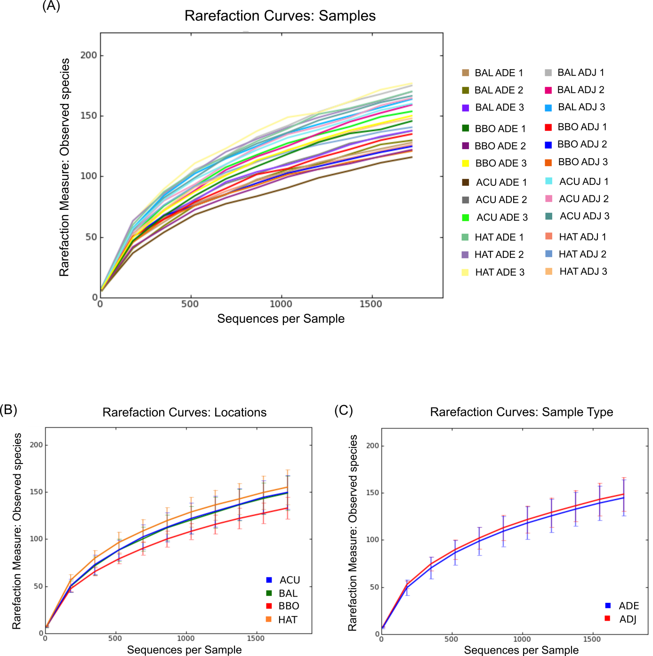

Online Resource 5 - Contribution of soil physico-chemical and fertility attributes in the dissimilarities of Amazonian Dark Earth (ADE) and adjacent (ADJ) soils fungal communities calculated by similarity percentage analysis (SIMPER) using Bray-Curtis distance.

Soil Properties | Average Dissimilarities | Contribution (%) | Cumulative (%)
P | 3.8 | 13.7 | 13.7
m% | 3.7 | 13.3 | 27.0
Ca | 2.9 | 10.3 | 37.4
SB | 2.6 | 9.4 | 46.8
Al | 2.5 | 8.9 | 55.7
Zn | 2.3 | 8.5 | 64.1
V% | 2.2 | 7.9 | 72.1
Mn | 1.7 | 6.3 | 78.3
Mg | 1.4 | 5.0 | 83.4
Fe | 1.3 | 4.7 | 88.1
Cu | 1.0 | 3.4 | 91.5
H+Al | 0.7 | 2.6 | 94.1
OM | 0.7 | 2.5 | 96.6
CEC | 0.5 | 1.8 | 98.4
pH | 0.3 | 0.9 | 99.3
B | 0.2 | 0.7 | 100.0

Organic matter (OM); cation exchange capacity in pH 7 (CEC); sum of bases (SB); V- soil base saturation index (%). m- Al saturation index.

