Supplementary material 1
Elevated atmospheric CO₂ modifies mostly the active rhizosphere soil microbiome in the Giessen FACE experiment
David Rosado-Porto, Stefan Ratering, Massimiliano Cardinale, Corinna Maisinger, Gerald Moser, Marianna Deppe, Christoph Müller, Sylvia Schnell
Beta diversity dispersion of soil cores per ring
For evaluation of the differences between the four replicate soil core samples within the six rings beta diversity dispersion was analysed, after centered log ratio transformation, creation of a distance matrix on an euclidian space and an ordination using Principal Components method.
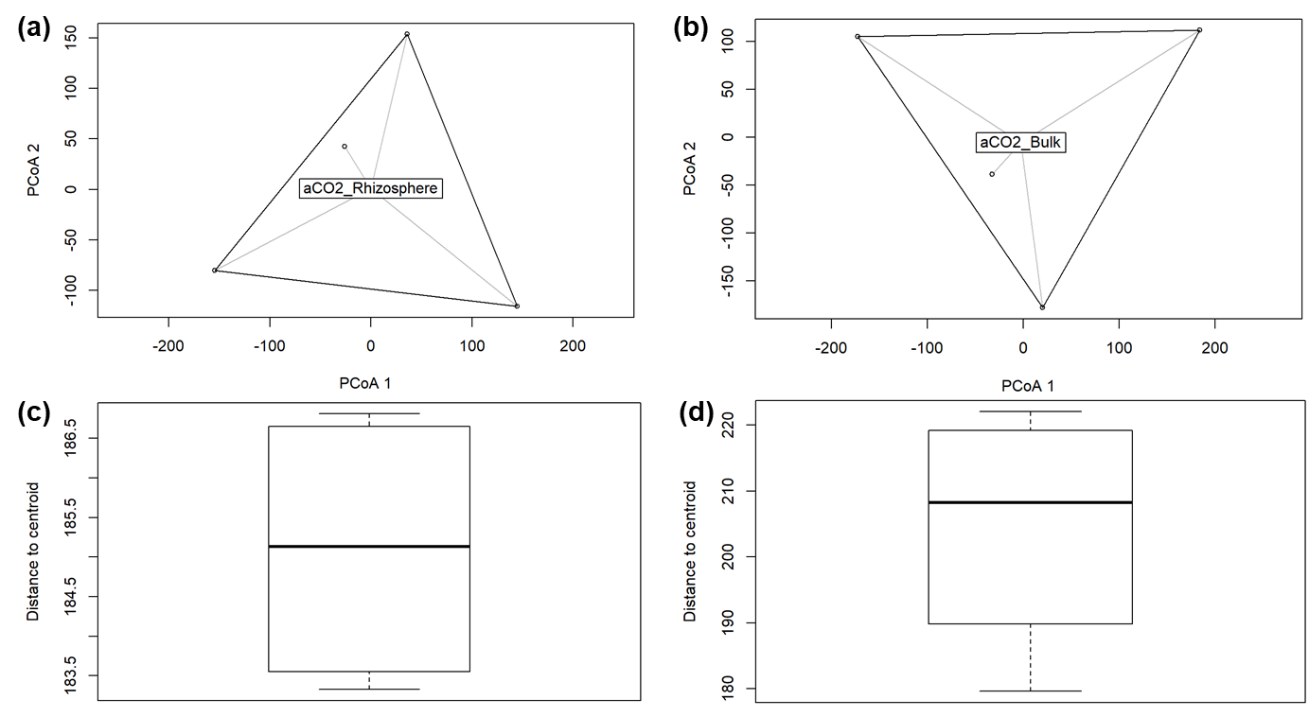
Dispersion of soil cores from ring ambient CO₂ A1
Figure 1. a) Rhizosphere soil cores distance to the centroid on the Aitchison distance space. b) Bulk soil cores distance to the centroid on the Aitchison distance space. c) Boxplot of the dispersion of the four rhizosphere soil cores to the centroid. d) Boxplot of the dispersion of the four bulk soil cores to the centroid.
Soil core | Rhizosphere soil |  |  | Bulk soil
Soil core | PCoA1 | PCoA2 |  | PCoA1 | PCoA2
1 | -25.80094 | 42.39630 |  | 183.98338 | 111.6005
2 | 144.69421 | -115.87543 |  | -172.43575 | 105.1300
3 | -154.55176 | -80.12298 |  | 20.50771 | -177.9165
4 | 35.65849 | 153.60212 |  | -32.05535 | -38.8139
Centroid | 0.08293701 | 0.7826727 |  | -2.238718 | -5.915377

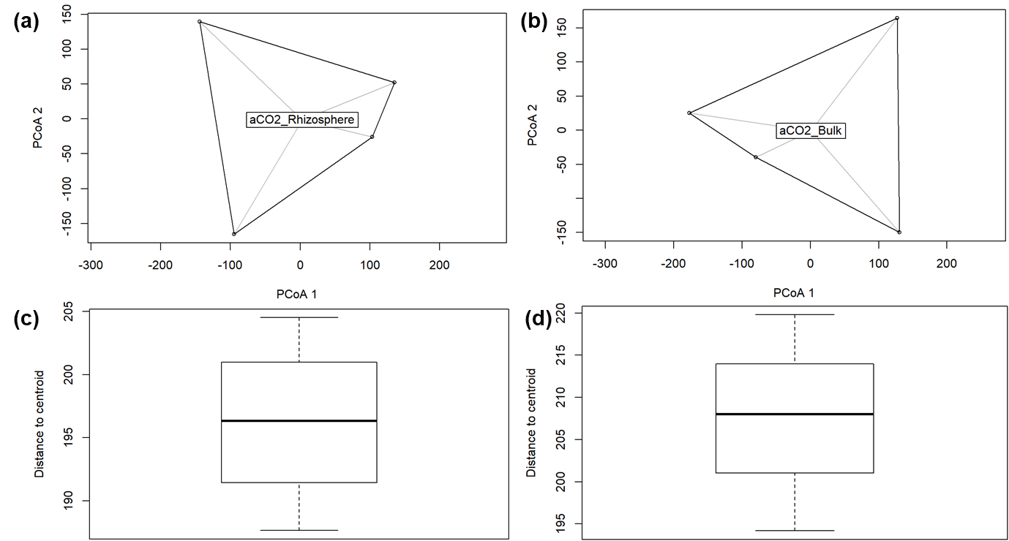
Dispersion of soil cores from ring ambient CO₂ A2
Figure 2. a) Rhizosphere soil cores distance to the centroid on the Aitchison distance space. b) Bulk soil cores distance to the centroid on the Aitchison distance space. c) Boxplot of the dispersion of the four rhizosphere soil cores to the centroid. d) Boxplot of the dispersion of the four bulk soil cores to the centroid
Soil core | Rhizosphere soil |  |  | Bulk soil
Soil core | PCoA1 | PCoA2 |  | PCoA1 | PCoA2
1 | 135.59410 | 52.11665 |  | 130.48605 | -149.88747
2 | 103.29415 | -26.04585 |  | 126.89718 | 164.30589
3 | -94.88099 | -165.50639 |  | -177.36804 | 25.11917
4 | -144.00725 | 139.43559 |  | -80.01519 | -39.53759
Centroid | 2.953534 | -1.379265 |  | 0.900758 | -0.9933014

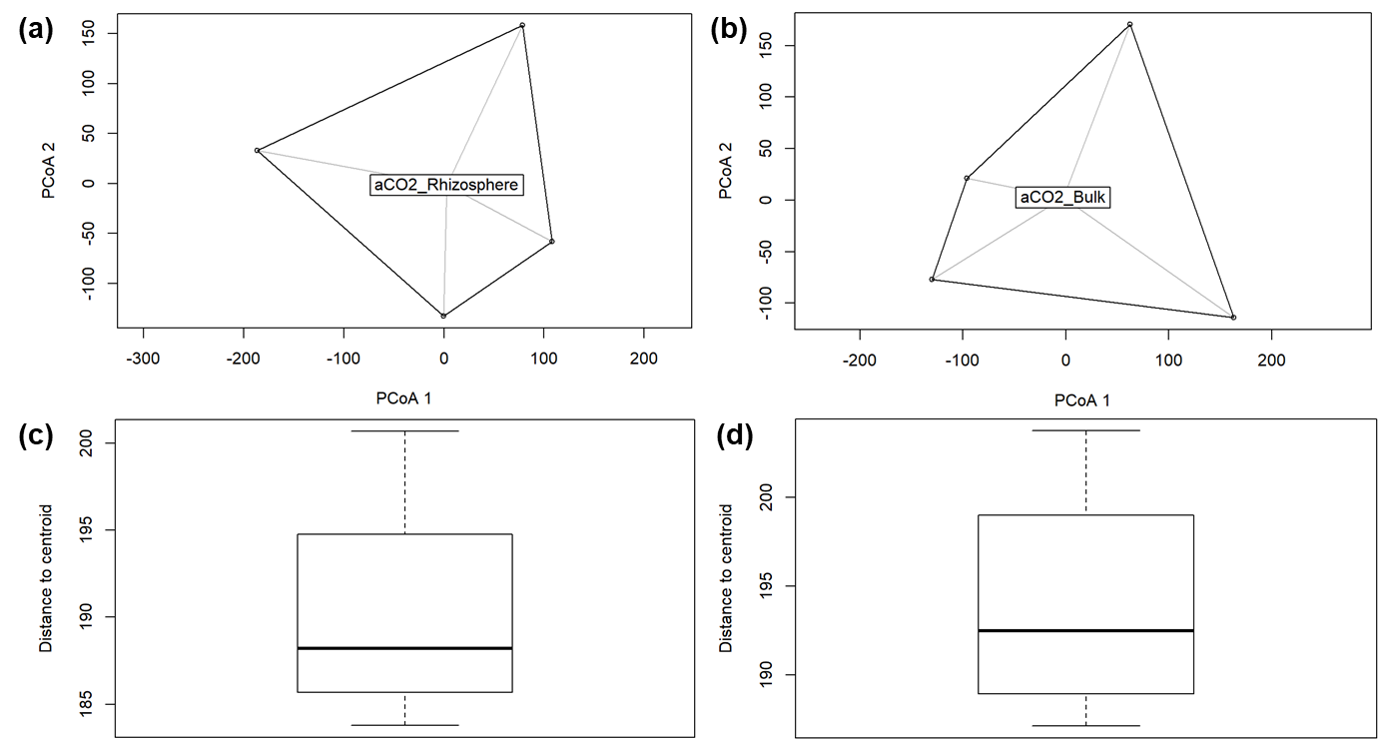
Dispersion of soil cores from ring ambient CO₂ A3
Figure 3. a) Rhizosphere soil cores distance to the centroid on the Aitchison distance space. b) Bulk soil cores distance to the centroid on the Aitchison distance space. c) Boxplot of the dispersion of the four rhizosphere soil cores to the centroid. d) Boxplot of the dispersion of the four bulk soil cores to the centroid.

Soil core | Rhizosphere soil |  |  | Bulk soil
Soil core | PCoA1 | PCoA2 |  | PCoA1 | PCoA2
1 | 78.745905 | 158.24572 |  | 163.44855 | -114.17100
2 | 108.168563 | -58.39199 |  | -96.01281 | 20.96616
3 | -186.607149 | 33.14931 |  | -129.89925 | -77.20935
4 | -0.307318 | -133.00304 |  | 62.46351 | 170.41419
Centroid | 2.950533 | -1.509491 |  | -2.558924 | 2.204324

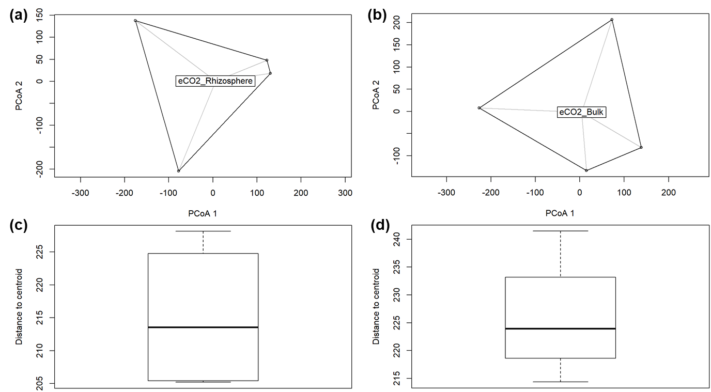
Dispersion of soil cores from ring elevated CO₂ E1
Figure 4. a) Rhizosphere soil cores distance to the centroid on the Aitchison distance space. b) Bulk soil cores distance to the centroid on the Aitchison distance space. c) Boxplot of the dispersion of the four rhizosphere soil cores to the centroid. d) Boxplot of the dispersion of the four bulk soil cores to the centroid.

Soil core | Rhizosphere soil |  |  | Bulk soil
Soil core | PCoA1 | PCoA2 |  | PCoA1 | PCoA2
1 | 122.64175 | 48.16592 |  | 72.67961 | 206.641682
2 | 130.62563 | 18.26833 |  | 138.75110 | -81.113733
3 | -77.77673 | -204.18850 |  | 14.83166 | -133.417941
4 | -175.49064 | 137.75424 |  | -226.26238 | 7.889992
Centroid | 6.037281 | 0.2841273 |  | 4.394225 | -1.951842

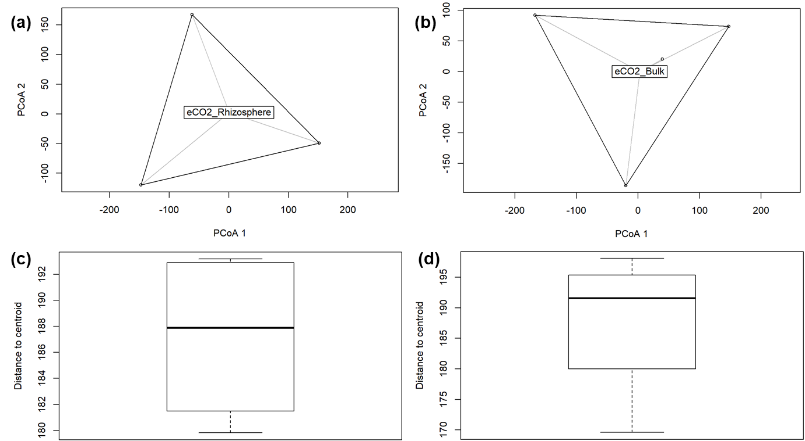
Dispersion of soil cores from ring elevated CO₂ E2
Figure 5. a) Rhizosphere soil cores distance to the centroid on the Aitchison distance space. b) Bulk soil cores distance to the centroid on the Aitchison distance space. c) Boxplot of the dispersion of the four rhizosphere soil cores to the centroid. d) Boxplot of the dispersion of the four bulk soil cores to the centroid.

Soil core | Rhizosphere soil |  |  | Bulk soil
Soil core | PCoA1 | PCoA2 |  | PCoA1 | PCoA2
1 | 57.78793 | 1.541002 |  | 147.46292 | 73.87424
2 | 151.76817 | -48.972109 |  | -19.70307 | -186.11782
3 | -147.68316 | -119.776634 |  | -167.19865 | 91.88826
4 | -61.87294 | 167.207742 |  | 39.43880 | 20.35531
Centroid | 0.3317109 | 2.198898 |  | 2.836266 | 0.2872584

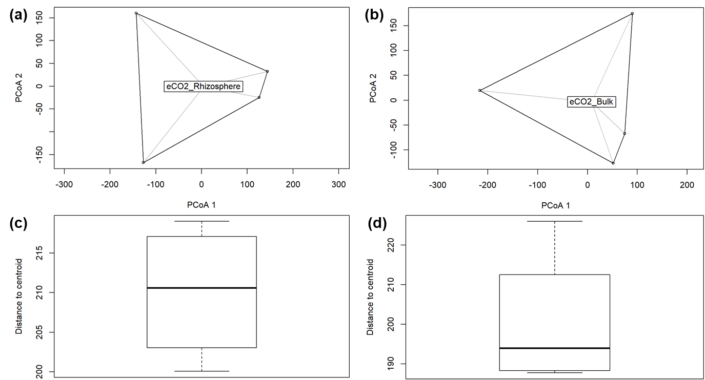
Dispersion of soil cores from ring elevated CO₂ E3
Figure 6. a) Rhizosphere soil cores distance to the centroid on the Aitchison distance space. b) Bulk soil cores distance to the centroid on the Aitchison distance space. c) Boxplot of the dispersion of the four rhizosphere soil cores to the centroid. d) Boxplot of the dispersion of the four bulk soil cores to the centroid.
Soil core | Rhizosphere soil |  |  | Bulk soil
Soil core | PCoA1 | PCoA2 |  | PCoA1 | PCoA2
1 | 144.0663 | 32.32366 |  | 74.47449 | -66.96166
2 | 125.9443 | -24.58944 |  | 51.56435 | -126.67887
3 | -127.0612 | -167.76252 |  | -216.33316 | 19.45550
4 | -142.9494 | 160.02830 |  | 90.29432 | 174.18503
Centroid | 4.478243 | -0.7855918 |  | 8.294987 | -3.311289

Conclusions
The beta diversity results and its dispersion for each ring show that the cores taken per ring are different enough to be at different positions on the Aitchison space. Furthermore, when analyzing the dispersion and their distance to the centroids, all of them showed a fairly great level of dispersion, which leads us to think that the soil cores although they are very similar among them, also they are sufficiently different to not be considered as technical replicates, but single samples.

