Supplementary material 4
Elevated atmospheric CO₂ modifies mostly the active rhizosphere soil microbiome in the Giessen FACE experiment
David Rosado-Porto, Stefan Ratering, Massimiliano Cardinale, Corinna Maisinger, Gerald Moser, Marianna Deppe, Christoph Müller, Sylvia Schnell
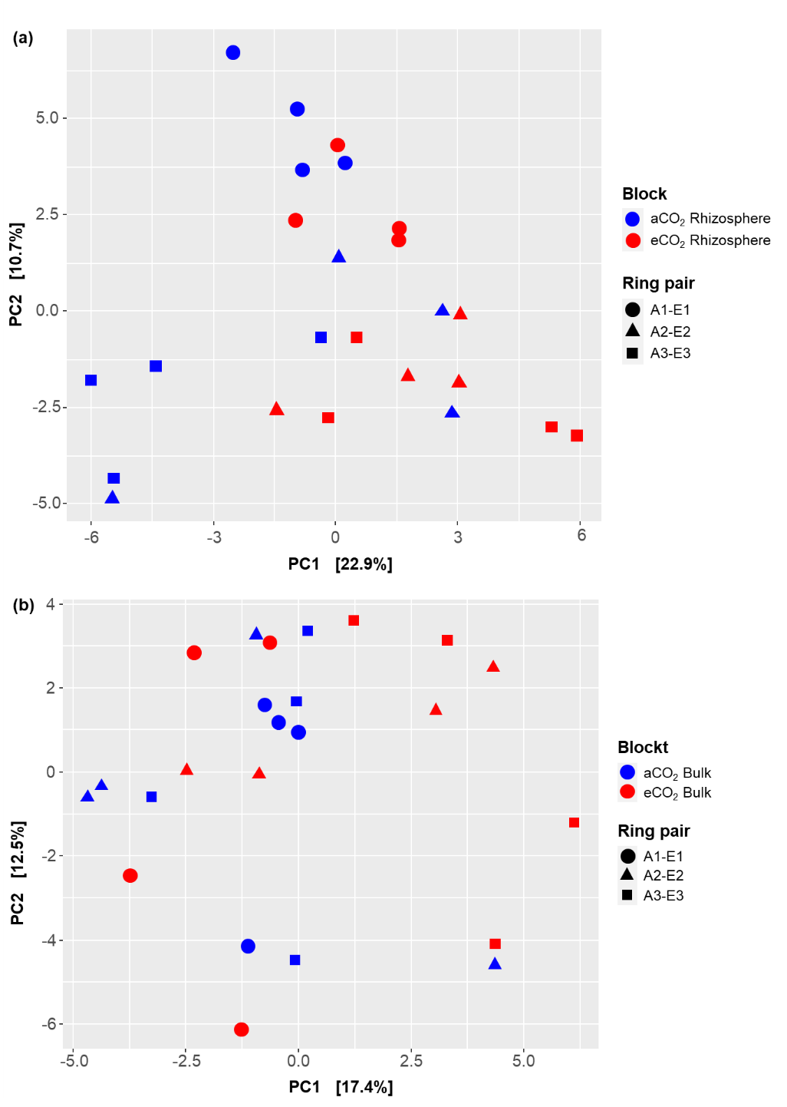
Figure S4.1. Principal Components Analysis (PCA) of Enzyme Commission number‘s (EC number) predicted metagenome, calculated based on Aitchison community dissimilarity distance matrix of (a) rhizosphere soils from ambient and elevated CO₂ rings and (b) bulk soils from ambient and elevated CO₂ rings. A, ambient CO₂ rings; E, elevated CO₂ rings; aCO₂, ambient CO₂ conditions; eCO₂, elevated CO₂ conditions.

Tab S4. Beta diversity p-values of Permutational Multivariate Analysis of Variance Using Distance Matrices of predicted functional metagenome from Gi-FACE’s rhizosphere and bulk soils, calculated based on Aitchison community dissimilarity distance matrix.
Factor | Rhizosphere soil |  |  | Bulk soil
Factor | EC number | KEGG Orthology | MetaCyc  Pathway | EC number | KEGG Orthology | MetaCyc  Pathway
Block | 0.005 ** | 0.019 * | 0.022 * | 0.197 | 0.179 | 0.317
Ring | 0.001 *** | 0.002 ** | 0.005 ** | 0.011 * | 0.05 * | 0.342
Significance codes: 0.0001 ‘***’ , 0.001 ‘**’ , 0.01 ‘*’ , 0.05 ‘.’.
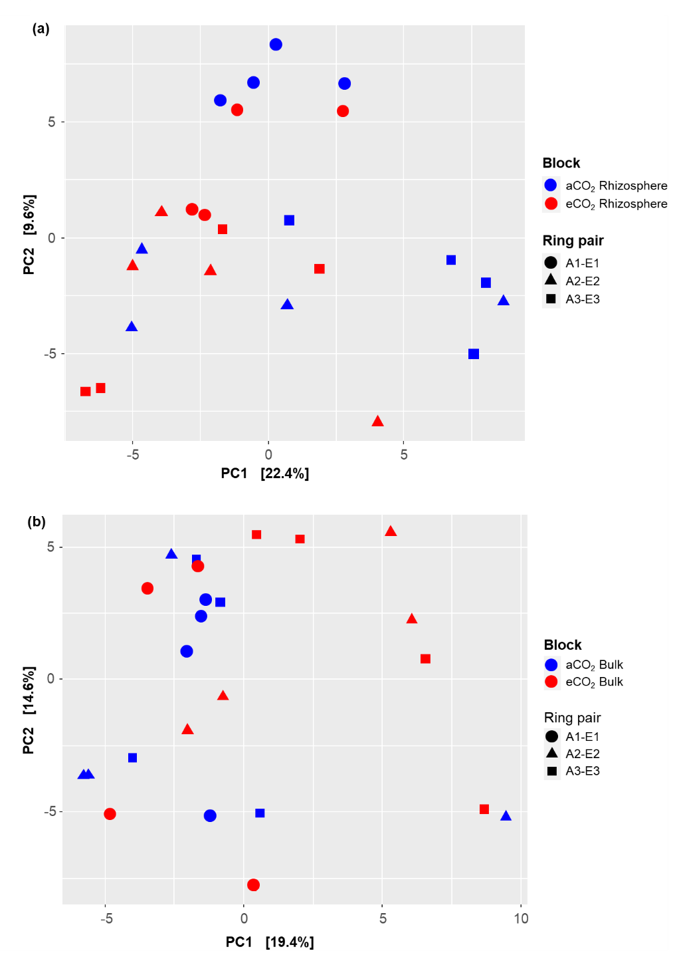

Figure S4.2. Principal Components Analysis (PCA) of KEGG Orthology (KO) for molecular functions predicted metagenome, calculated based on Aitchison community dissimilarity distance matrix of (a) rhizosphere soils from ambient and elevated CO₂ rings and (b) bulk soils from ambient and elevated CO₂ rings. A, ambient CO₂ rings; E, elevated CO₂ rings; aCO₂, ambient CO₂ conditions; eCO₂, elevated CO₂ conditions.

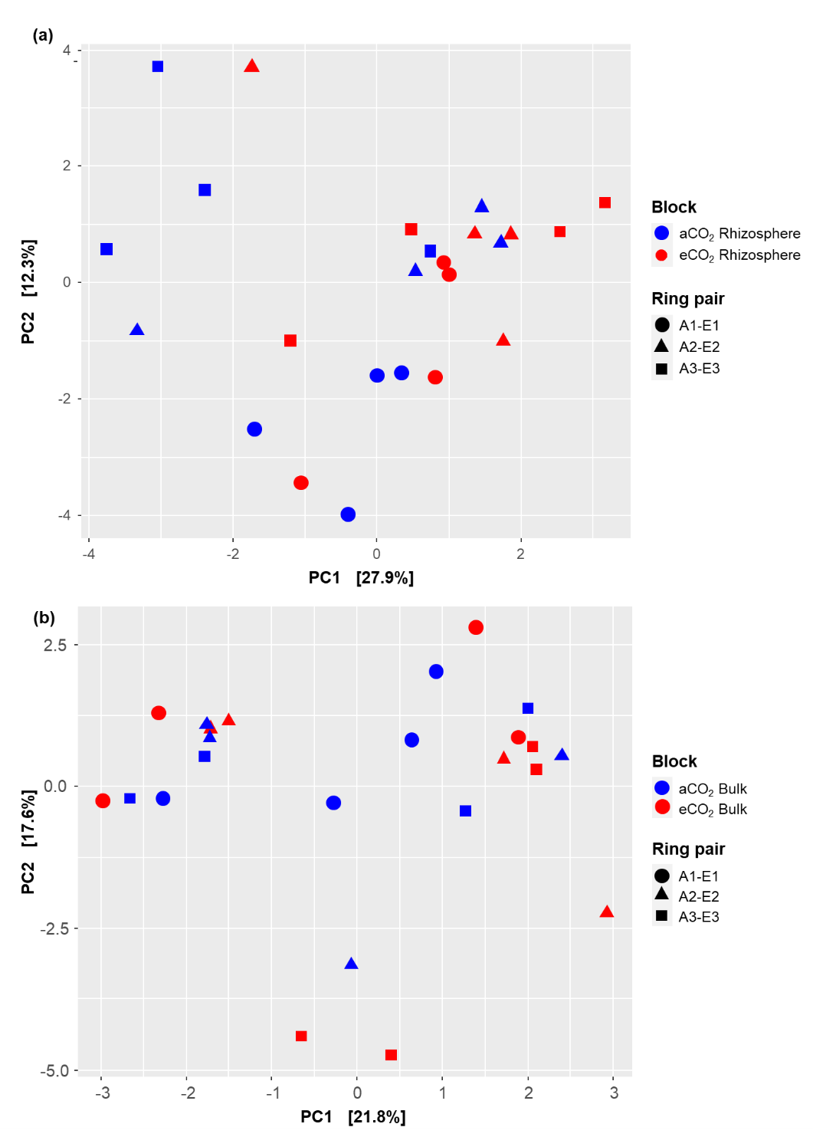
Figure S4.3. Principal Components Analysis (PCA) of MetaCyc Metabolic Pathways of the predicted metagenome, calculated based on Aitchison community dissimilarity distance matrix of (a) rhizosphere soils from ambient and elevated CO₂ rings and (b) bulk soils from ambient and elevated CO₂ rings. A, ambient CO₂ rings; E, elevated CO₂ rings; aCO₂, ambient CO₂ conditions; eCO₂, elevated CO₂ conditions.

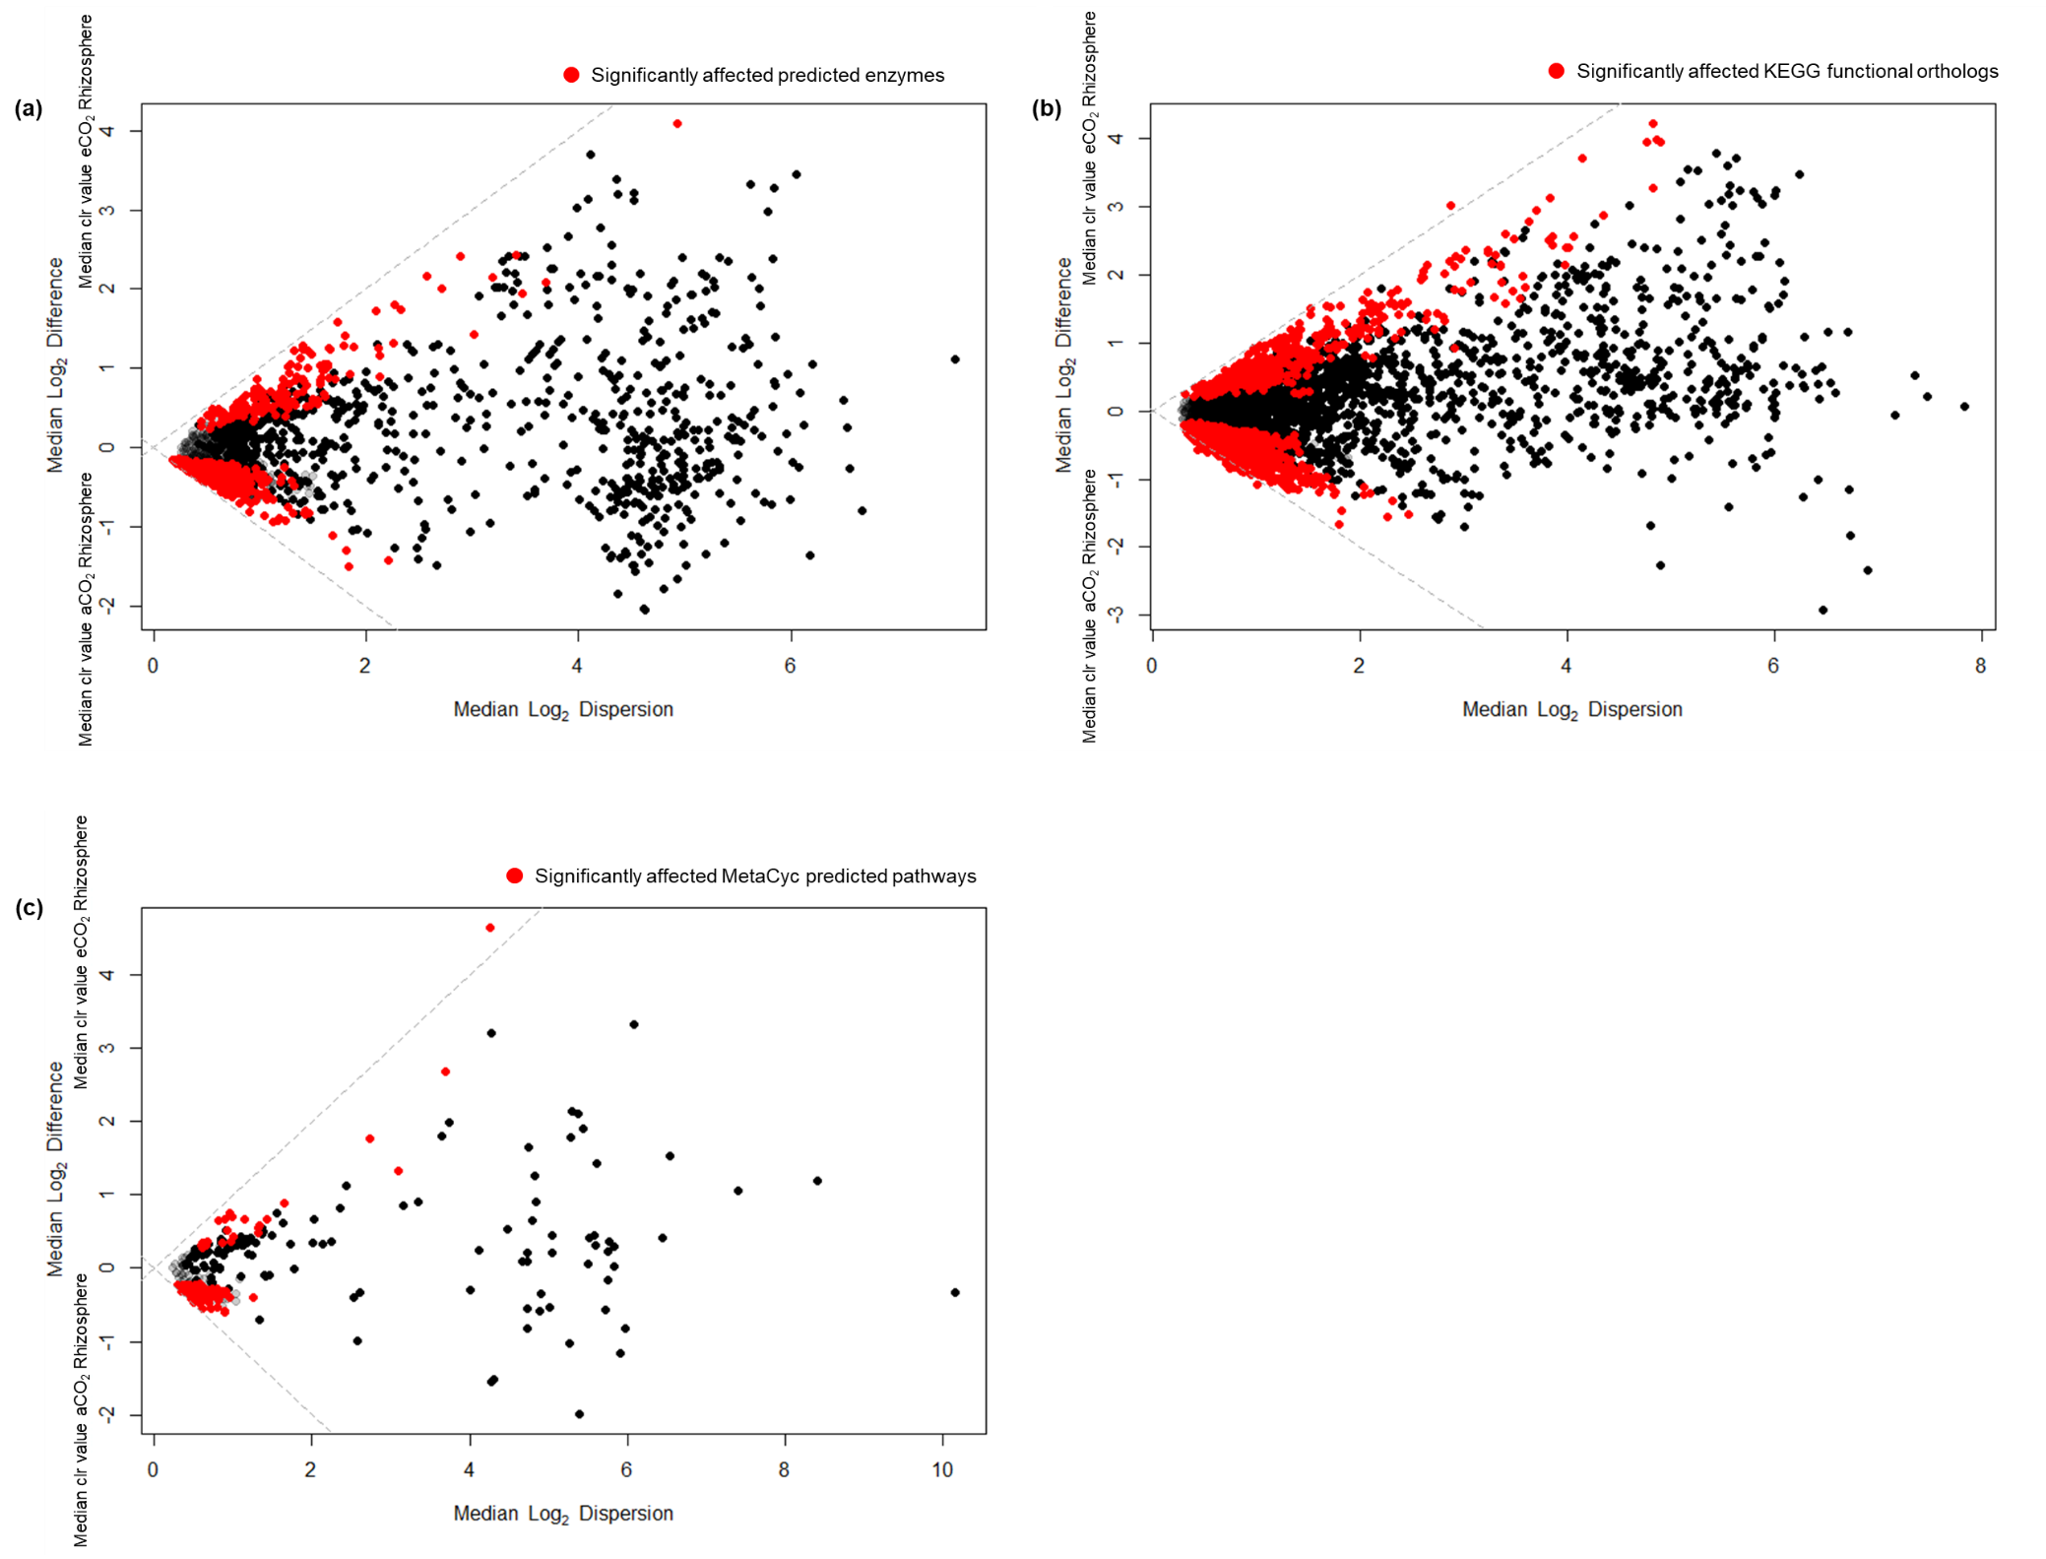
Figure S4.4. Differential abundances of predicted metagenome of rhizosphere soil under elevated and ambient CO₂ of (a) Enzyme Commission number‘s (EC number); (b) KEGG Orthology (KO) for molecular functions; (c) MetaCyc pathways with Aldex2 using centered log ratio (clr) transformation and the geometric mean abundance of all features; red points indicate significantly different features after Welch's t-test and Benjamini-Hochberg correction with an alpha threshold <0.1.

