Supplementary Tables
Table S2 Summary of Illumina Miseq reads for each sample (16S). Where, C: Cameroon; G: Gabon; N: Nigeria; HR: High rainfall; SV: Savannas; S: Rhizosphere soil; R: Plantain roots

Sample Name | Reads Length (bp) | Raw Data (Mbp) | Adapter (%) | Nbase (%) | PloyBase (%) | Low Quality (%) | Clean Data (Mbp) | Data Utilization Ratio (%) | Raw Reads | Clean Reads | Read Utilization Ratio (%)
C.HR.R | 299:293 | 21.96 | 0 | 0.04 | 0 | 2.106 | 20.93 | 95.33 | 37087*2 | 35693*2 | 96.24
C.SV.R | 297:298 | 21.98 | 0 | 0.032 | 0.003 | 1.796 | 20.98 | 98.25 | 37891*2 | 36125*2 | 97.39
G.HR.R | 296:294 | 21.54 | 0 | 0.037 | 0.002 | 1.891 | 20.62 | 95.74 | 36504*2 | 35256*2 | 96.58
G.HR.S | 298:298 | 21.66 | 0 | 0.081 | 0.003 | 2.33 | 20.54 | 94.81 | 36349*2 | 34838*2 | 95.84
G.SV.R | 294:294 | 21.72 | 0 | 0.031 | 0.004 | 1.754 | 20.86 | 96.03 | 36943*2 | 35790*2 | 96.88
G.SV.S | 297:294 | 21.98 | 0 | 0.026 | 0.005 | 2.242 | 20.93 | 95.21 | 37198*2 | 35748*2 | 96.1
N.HR.R | 299:294 | 21.85 | 0 | 0.029 | 0.003 | 1.888 | 20.96 | 95.93 | 36847*2 | 35615*2 | 96.66
N.HR.S | 294:295 | 21.84 | 0 | 0.04 | 0.013 | 2.285 | 20.7 | 94.77 | 37085*2 | 35539*2 | 95.83
N.SV.R | 293:294 | 21.56 | 0 | 0.033 | 0.001 | 2.063 | 20.6 | 95.56 | 36726*2 | 35389*2 | 96.36
N.SV.S | 299:298 | 21.66 | 0 | 0.058 | 0.009 | 2.276 | 20.56 | 94.92 | 36282*2 | 34815*2 | 95.96

Table S3 Summary of Illumina Miseq reads for each sample (ITS). Where, C: Cameroon; G: Gabon; N: Nigeria; HR: High rainfall; SV: Savannas; S: Rhizosphere soil; R: Plantain roots

Sample Name | Reads Length (bp) | Raw Data (Mbp) | Adapter (%) | Nbase (%) | PloyBase (%) | Low Quality (%) | Clean Data (Mbp) | Data Utilization Ratio (%) | Raw Reads | Clean Reads | Read Utilization Ratio (%)
C.HR.R | 250:250 | 40.35 | 0 | 0.077 | 0.099 | 0.335 | 40 | 99.12 | 80708*2 | 80026*2 | 99.15
C.SV.R | 250:250 | 35.21 | 0 | 0.037 | 0.567 | 0.627 | 20.89 | 98.25 | 48235*2 | 47893*2 | 98.99
G.HR.R | 250:250 | 40.66 | 0 | 0.035 | 0.565 | 0.608 | 40 | 98.37 | 81323*2 | 80029*2 | 98.41
G.HR.S | 250:250 | 21.1 | 0 | 0.043 | 0.492 | 0.666 | 20.72 | 98.2 | 42199*2 | 41469*2 | 98.27
G.SV.R | 250:250 | 21.68 | 0 | 0.034 | 2.266 | 0.87 | 20.87 | 96.28 | 43352*2 | 41764*2 | 96.34
G.SV.S | 250:250 | 21.32 | 0 | 0.039 | 2.298 | 0.716 | 20.51 | 96.18 | 42650*2 | 41047*2 | 96.24
N.HR.R | 250:250 | 35.58 | 0 | 0.073 | 0.596 | 0.529 | 35 | 98.38 | 71155*2 | 70038*2 | 98.43
N.HR.S | 250:250 | 21.17 | 0 | 0.028 | 0.352 | 0.616 | 20.86 | 98.52 | 42346*2 | 41753*2 | 98.6
N.SV.R | 250:250 | 30.54 | 0 | 0.041 | 0.732 | 0.593 | 30 | 98.22 | 61087*2 | 60029*2 | 98.27
N.SV.S | 250:250 | 21.2 | 0 | 0.101 | 1.205 | 0.632 | 20.66 | 97.47 | 42392*2 | 41343*2 | 97.53

Table S4 Analysis of similarities (ANOSIM) Where, C: Cameroon; G: Gabon; N: Nigeria; HR: High rainfall; SV: Savannas; S: Rhizosphere soil; R: Plantain roots

16S ITS
Group Name (Factor Name) | p value | R value | Level
HR.R_vs_SV.R | 0.8 | -0.222 | anosim/genus
HR.S_vs_SV.S | 0.333333 | 0.75 | anosim/genus
HR.R_vs_HR.S | 0.4 | 0 | anosim/genus
SV.R_vs_SV.S | 0.5 | 0 | anosim/genus
Group Name (Factor Name) | p value | R value | Level
HR.R_vs_SV.R | 1 | -0.111 | anosim/genus
HR.S_vs_SV.S | 0.333333 | 1 | anosim/genus
HR.R_vs_HR.S | 0.8 | -0.25 | anosim/genus
SV.R_vs_SV.S | 0.25 | 1 | anosim/genus

Table S5 Major bacterial taxa in samples. Where, C: Cameroon; G: Gabon; N: Nigeria; HR: High rainfall; SV: Savannas; S: Rhizosphere soil; R: Plantain roots

Taxon | C.HR.R | G.HR.R | N.HR.R | G.HR.S | N.HR.S | C.SV.R | G.SV.R | N.SV.R | G.SV.S | N.SV.S
Archaea;Euryarchaeota | 0 | 0 | 0 | 6 | 0 | 0 | 0 | 0 | 0 | 0
Bacteria;AD3 | 0 | 0 | 0 | 296 | 7 | 0 | 0 | 0 | 8 | 4
Bacteria;Acidobacteria | 2 | 1 | 1 | 1911 | 4394 | 1 | 3 | 3 | 1516 | 2697
Bacteria;Actinobacteria | 17 | 21 | 172 | 7910 | 7001 | 43 | 11 | 82 | 3168 | 5522
Bacteria;Armatimonadetes | 0 | 0 | 0 | 0 | 0 | 0 | 0 | 0 | 4 | 11
Bacteria;BRC1 | 0 | 0 | 0 | 0 | 5 | 0 | 0 | 0 | 3 | 7
Bacteria;Bacteroidetes | 6341 | 3087 | 7146 | 462 | 128 | 3736 | 3276 | 5617 | 2073 | 1215
Bacteria;Chlamydiae | 0 | 0 | 0 | 63 | 2 | 0 | 0 | 0 | 58 | 39
Bacteria;Chlorobi | 0 | 0 | 0 | 10 | 14 | 0 | 1 | 0 | 12 | 11
Bacteria;Chloroflexi | 2 | 3 | 0 | 1196 | 2360 | 1 | 3 | 1 | 915 | 1669
Bacteria;Cyanobacteria | 276 | 19 | 2008 | 26 | 57 | 13 | 8 | 1120 | 15 | 93
Bacteria;Elusimicrobia | 0 | 0 | 0 | 10 | 2 | 0 | 0 | 0 | 1 | 7
Bacteria;FBP | 0 | 0 | 0 | 0 | 0 | 0 | 0 | 0 | 0 | 11
Bacteria;FCPU426 | 0 | 0 | 0 | 11 | 0 | 0 | 0 | 0 | 0 | 1
Bacteria;Fibrobacteres | 0 | 0 | 0 | 0 | 4 | 0 | 0 | 0 | 1 | 5
Bacteria;Firmicutes | 8476 | 10962 | 4784 | 4665 | 520 | 11160 | 6175 | 3126 | 1938 | 2250
Bacteria;GAL15 | 0 | 0 | 0 | 79 | 68 | 0 | 0 | 0 | 14 | 3
Bacteria;GN04 | 0 | 0 | 0 | 2 | 0 | 0 | 0 | 0 | 0 | 0
Bacteria;Gemmatimonadetes | 0 | 1 | 0 | 182 | 704 | 0 | 0 | 0 | 178 | 311
Bacteria;MVP-21 | 0 | 0 | 0 | 0 | 0 | 0 | 0 | 0 | 0 | 8
Bacteria;Nitrospirae | 0 | 0 | 1 | 390 | 633 | 0 | 1 | 0 | 243 | 345
Bacteria;OD1 | 0 | 0 | 0 | 4 | 2 | 0 | 0 | 0 | 13 | 26
Bacteria;OP3 | 0 | 0 | 0 | 0 | 0 | 0 | 0 | 0 | 0 | 3
Bacteria;Other | 0 | 0 | 0 | 10 | 27 | 0 | 0 | 0 | 6 | 24
Bacteria;Planctomycetes | 1 | 0 | 0 | 398 | 485 | 0 | 0 | 0 | 184 | 449
Bacteria;Proteobacteria | 8217 | 10861 | 10048 | 4671 | 3695 | 10415 | 16196 | 12599 | 5875 | 5797
Bacteria;SBR1093 | 0 | 0 | 0 | 0 | 0 | 0 | 0 | 0 | 0 | 4
Bacteria;TM6 | 0 | 0 | 0 | 36 | 3 | 0 | 0 | 0 | 26 | 20
Bacteria;TM7 | 0 | 1 | 7 | 75 | 44 | 0 | 0 | 0 | 114 | 242
Bacteria;Thermi | 0 | 0 | 0 | 0 | 5 | 0 | 0 | 0 | 6 | 1
Bacteria;Verrucomicrobia | 0 | 0 | 0 | 625 | 19 | 0 | 1 | 0 | 635 | 505
Bacteria;WPS-2 | 0 | 0 | 0 | 36 | 76 | 0 | 0 | 0 | 0 | 9
Bacteria;WS2 | 0 | 0 | 0 | 0 | 6 | 0 | 0 | 0 | 0 | 5
Bacteria;WS3 | 0 | 0 | 0 | 33 | 48 | 0 | 0 | 0 | 3 | 46

Table S6 Major fungal taxa in samples. Where, C: Cameroon; G: Gabon; N: Nigeria; HR: High rainfall; SV: Savannas; S: Rhizosphere soil; R: Plantain roots

Taxon | C.HR.R | G.HR.R | N.HR.R | G.HR.S | N.HR.S | C.SV.R | G.SV.R | N.SV.R | N.SV.S | G.SV.S
Fungi;Ascomycota | 23285 | 26207 | 20283 | 13979 | 18037 | 21678 | 17504 | 23589 | 36392 | 28496
Fungi;Basidiomycota | 51839 | 48959 | 38731 | 13650 | 6824 | 2578 | 12697 | 25114 | 755 | 2570
Fungi;Chytridiomycota | 0 | 29 | 4 | 10 | 16 | 0 | 5 | 19 | 5 | 35
Fungi;Glomeromycota | 0 | 0 | 0 | 0 | 0 | 3 | 24 | 0 | 0 | 0
Fungi;Unclassified | 0 | 0 | 0 | 28 | 44 | 59 | 0 | 0 | 114 | 209
Fungi;Zygomycota | 198 | 127 | 206 | 1988 | 4180 | 690 | 90 | 1858 | 395 | 374

Supplementary Figures
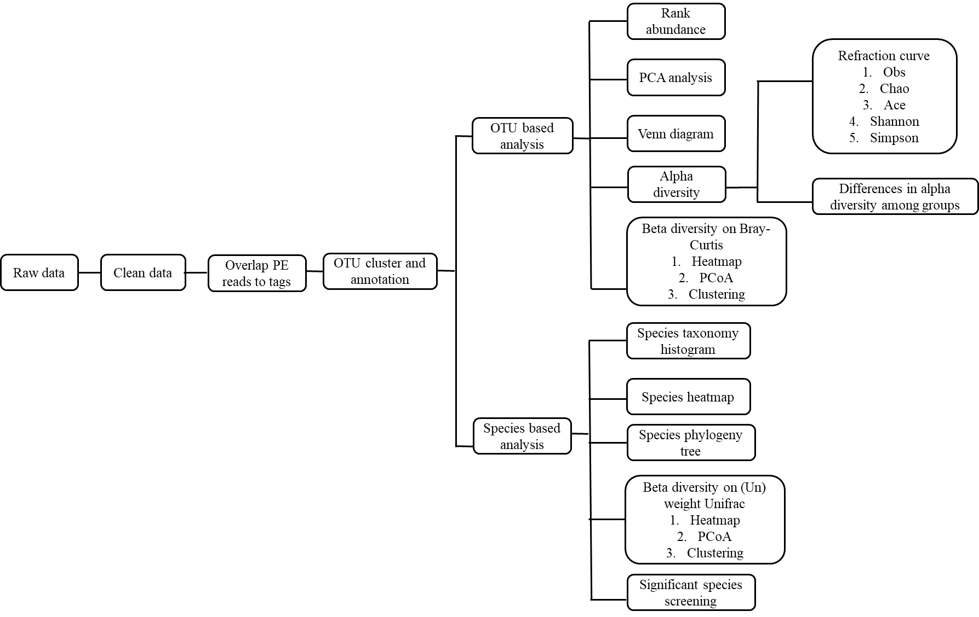

Fig. S1 Bioinformatics analysis pipeline for meta-genomic analysis.

Fig. S2 Physiological parameters of the countries representing different sampling locations.
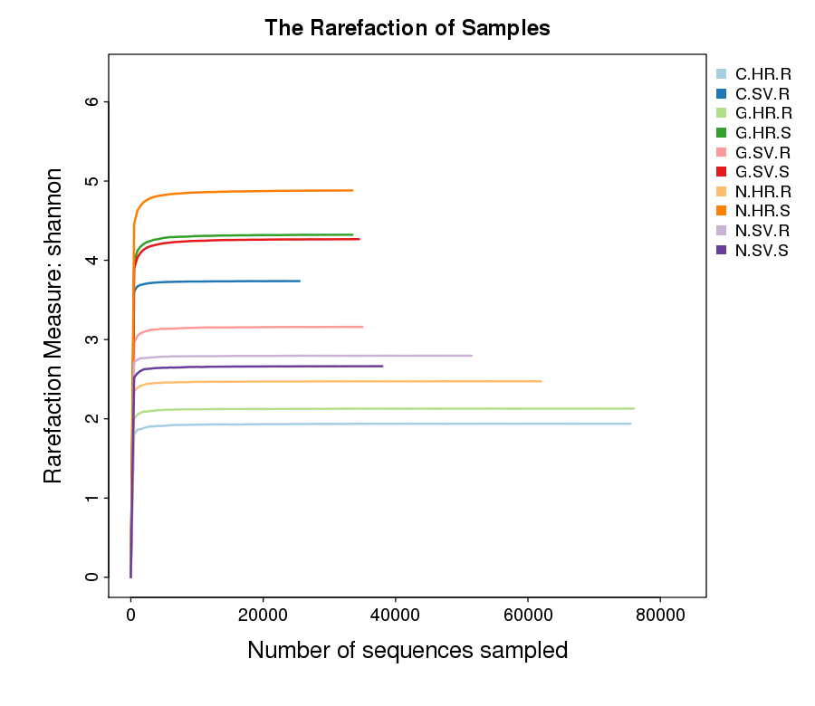
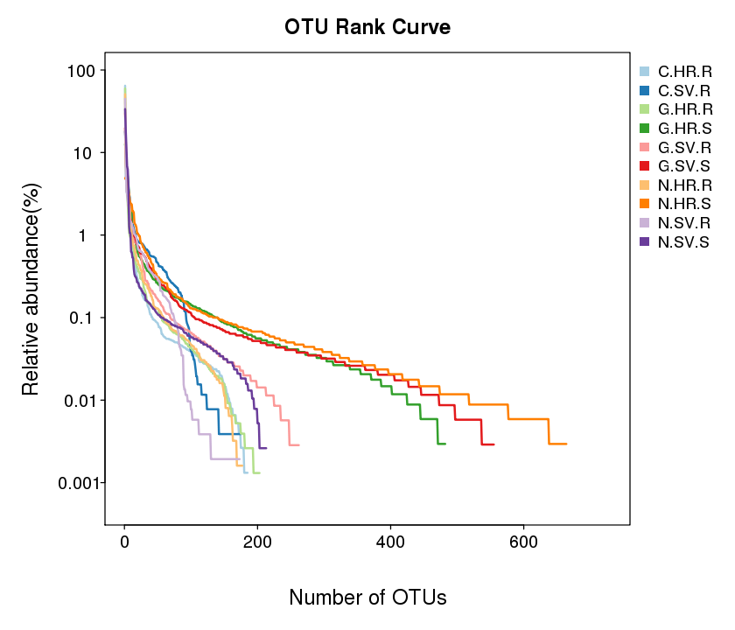

Fig. S3 Alpha diversity of samples (16S). Where, C: Cameroon; G: Gabon; N: Nigeria; HR: High rainfall; SV: Savannas

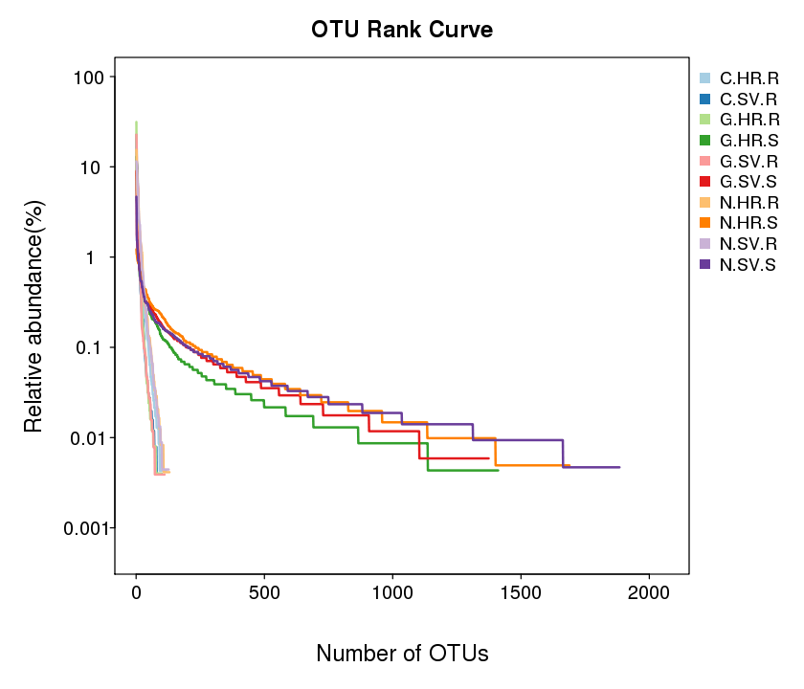
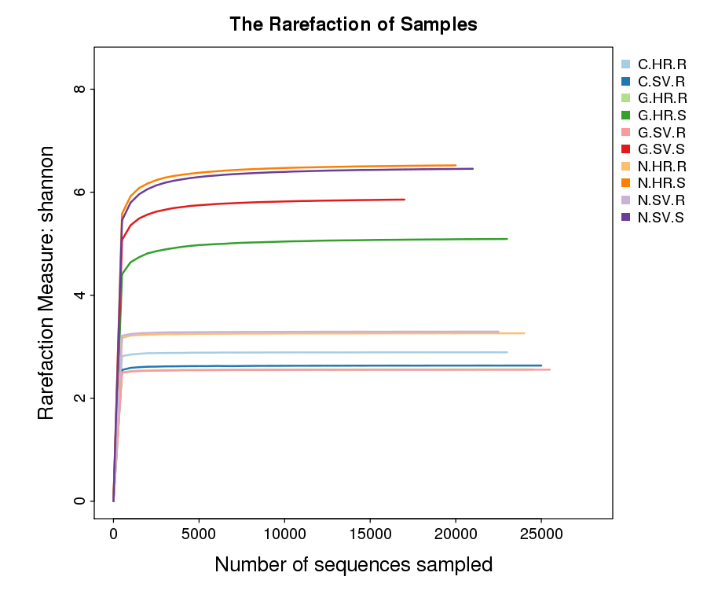

Fig. S4 Alpha diversity of samples (ITS). Where, C: Cameroon; G: Gabon; N: Nigeria; HR: High rainfall; SV: Savannas

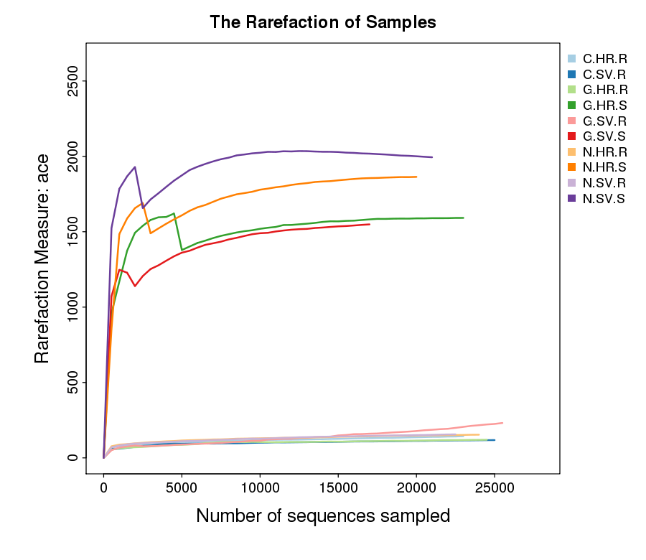
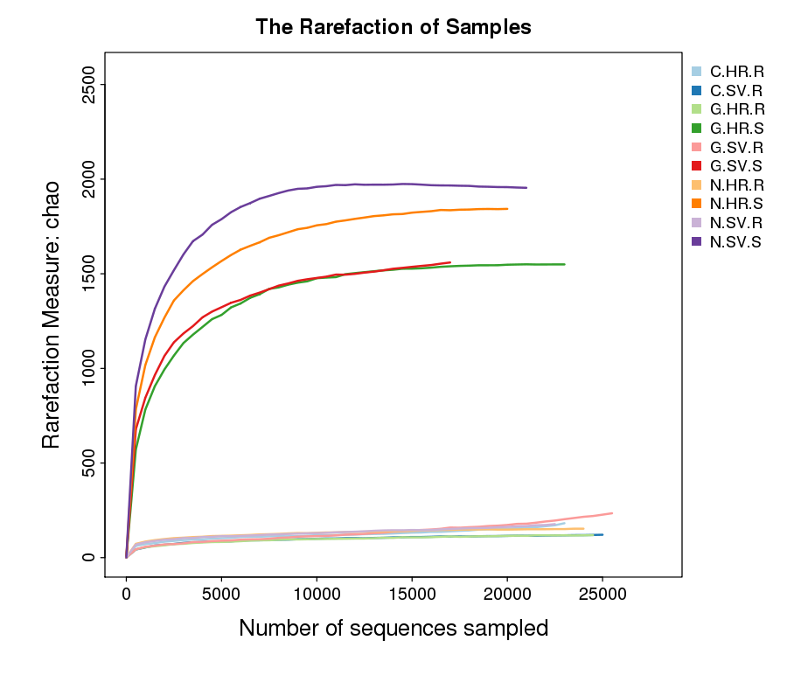

A B

Fig. S5 Alpha diversity of bacterial communities indicating the biodiversity of the samples. A. Observed species, ACE; P < 0.05 B. Observed species, Chao; P < 0.05. Where, C: Cameroon; G: Gabon; N: Nigeria; HR: High rainfall; SV: Savannas

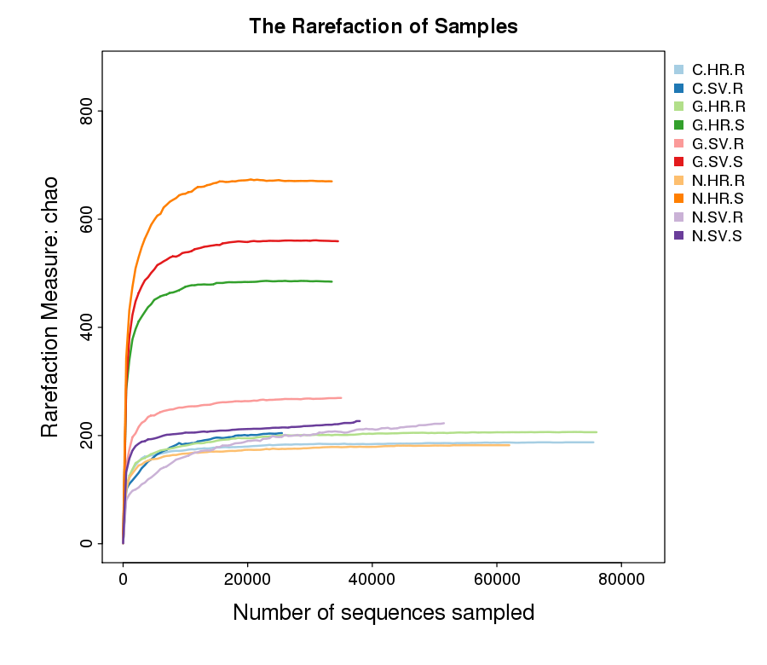
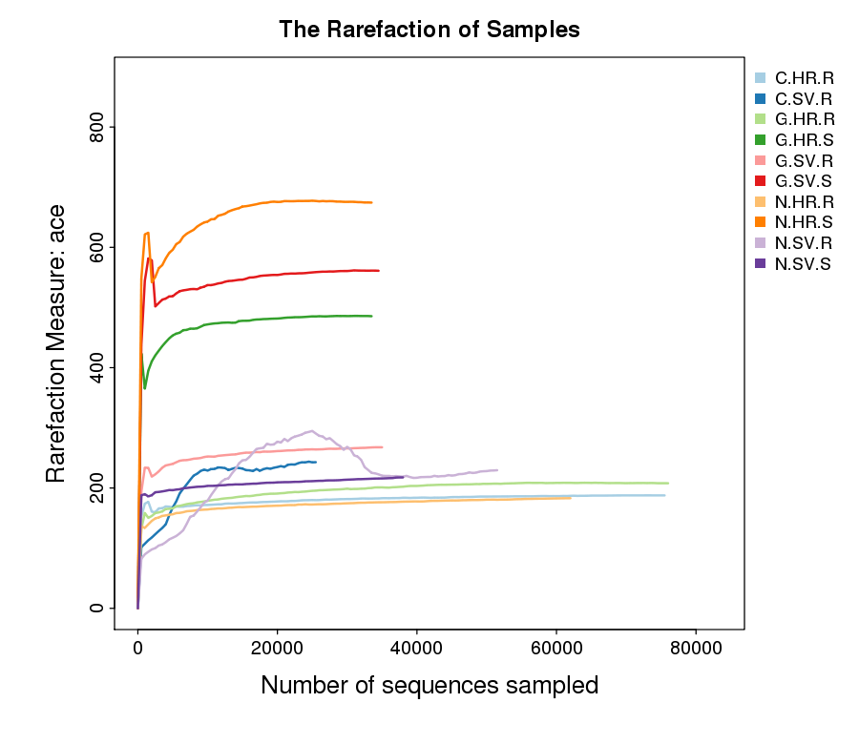

Fig. S6 Alpha diversity of fungal communities indicating the biodiversity of the samples. A. Observed species, ACE; P < 0.05 B. Observed species, Chao; P < 0.05. Where, C: Cameroon; G: Gabon; N: Nigeria; HR: High rainfall; SV: Savannas

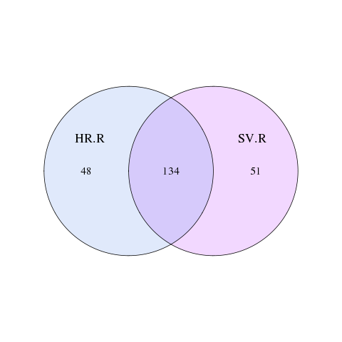
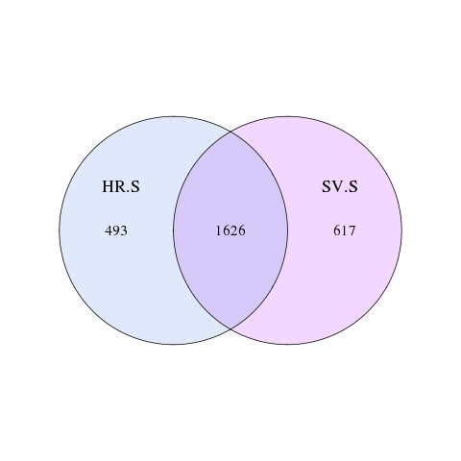
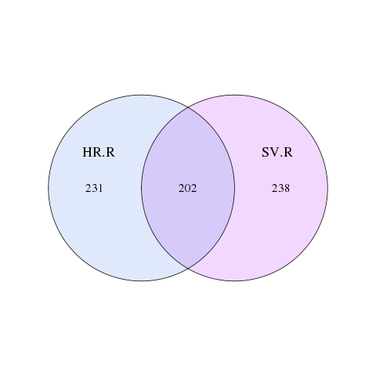
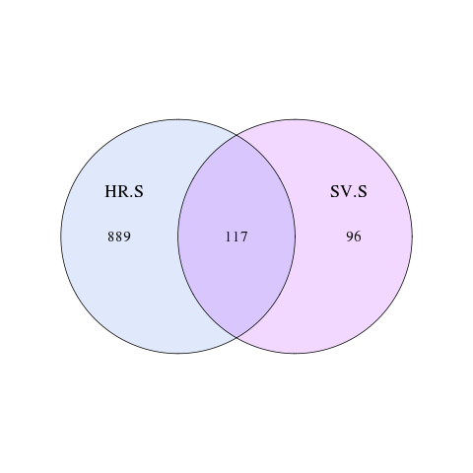

Fig. S7 Venn diagram of the plantain rhizosphere. Up- bacterial and below- fungal community. The observed OTUs for each treatment were produced in the UCLUST algorithm to show the shared and unique OTUs. Only the most abundant OTUs among all the samples were represented. Where, HR: High rainfall; SV: Savannas; S: Rhizosphere soil; R: Plantain roots

