Supplementary Material
Impact of cultivation and origin on the fruit microbiome of apples and blueberries and implications for the exposome

Wisnu Adi Wicaksono^{1#}, Aisa Buko¹, Peter Kusstatscher¹, Tomislav Cernava¹, Aki Sinkkonen², Olli H Laitinen³, Suvi M. Virtanen^{4,5,6,7}, Heikki Hyöty^{3,8}, Gabriele Berg^{1,9,10#}
¹Institute of Environmental Biotechnology, Graz University of Technology, Graz, Austria
² Natural Resources Institute Finland Luke, Turku, Finland
³ Faculty of Medicine and Health Technology, Tampere University, Tampere, Finland
⁴ Health and Well-Being Promotion Unit, Finnish Institute for Health and Welfare, Helsinki, Finland
⁵ Faculty of Social Sciences, Unit of Health Sciences, Tampere University, Tampere, Finland ⁶ Research, Development and Innovation Centre, Tampere University Hospital, Tampere, Finland
⁷ Center for Child Health Research, Tampere University and Tampere University Hospital, Tampere, Finland
⁸ Fimlab Laboratories, Pirkanmaa Hospital District, Tampere, Finland
⁹ Leibniz Institute for Agricultural Engineering and Bioeconomy (ATB), Potsdam, Germany
¹⁰ Institute for Biochemistry and Biology, University of Potsdam, Potsdam, Germany

#Corresponding author:
Wisnu Adi Wicaksono
Email: wisnu.wicaksono@tugraz.at
Gabriele Berg
Email: gabriele.berg@tugraz.at

Supplementary Materials
Supplementary Table S1. Detailed sample description for apples and blueberries obtained in Austria and Finland.

Sample ID | Fruit | Growing system | Country | Location | Species/Cultivar
AP1 | Apple | Natural | Austria | Graz_1 | N. A
AP2 | Apple | Natural | Austria | Graz_1 | N. A
AP3 | Apple | Natural | Austria | Graz_1 | N. A
AP4 | Apple | Natural | Austria | Graz_2 | N. A
AP5 | Apple | Natural | Austria | Graz_2 | N. A
AP6 | Apple | Natural | Austria | Graz_2 | N. A
AP7 | Apple | Natural | Austria | Graz_3 | N. A
AP8 | Apple | Natural | Austria | Graz_3 | N. A
AP9 | Apple | Natural | Austria | Graz_3 | N. A
AP10 | Apple | Natural | Austria | Graz_4 | N. A
AP11 | Apple | Natural | Austria | Graz_4 | N. A
AP12 | Apple | Natural | Austria | Graz_4 | N. A
AP13 | Apple | Natural | Austria | Graz_5 | N. A
AP14 | Apple | Natural | Austria | Graz_5 | N. A
AP15 | Apple | Natural | Austria | Graz_5 | N. A
AP16 | Apple | Natural | Austria | Graz_6 | N. A
AP17 | Apple | Natural | Austria | Graz_6 | N. A
AP18 | Apple | Natural | Austria | Graz_6 | N. A
AP19 | Apple | Natural | Austria | Weiz_1 | Summered
AP20 | Apple | Natural | Austria | Weiz_1 | Summered
AP21 | Apple | Natural | Austria | Weiz_1 | Summered
AP22 | Apple | Natural | Austria | Weiz_2 | Mantet
AP23 | Apple | Natural | Austria | Weiz_2 | Mantet
AP24 | Apple | Natural | Austria | Weiz_2 | Mantet
AP25 | Apple | Natural | Austria | Weiz_2 | Gloster
AP26 | Apple | Natural | Austria | Weiz_3 | Gloster
AP27 | Apple | Natural | Austria | Weiz_3 | Gloster
AP28 | Apple | Natural | Austria | Murtal_1 | N. A
AP29 | Apple | Natural | Austria | Murtal_1 | N. A
AP30 | Apple | Natural | Austria | Murtal_1 | N. A
AP31 | Apple | Natural | Austria | Murtal_2 | N. A
AP32 | Apple | Natural | Austria | Murtal_2 | N. A
AP33 | Apple | Natural | Austria | Murtal_2 | N. A
AP34 | Apple | Natural | Austria | Murtal_3 | N. A
AP35 | Apple | Natural | Austria | Murtal_3 | N. A
AP36 | Apple | Natural | Austria | Murtal_3 | N. A
AP37 | Apple | Natural | Austria | Murtal_4 | N. A
AP38 | Apple | Natural | Austria | Murtal_4 | N. A
AP39 | Apple | Natural | Austria | Murtal_4 | N. A
AP40 | Apple | Natural | Austria | Südoststeiermark_1 | Grafensteiner
AP41 | Apple | Natural | Austria | Südoststeiermark_1 | Grafensteiner
AP42 | Apple | Natural | Austria | Südoststeiermark_1 | Grafensteiner
AP43 | Apple | Natural | Austria | Güssing_1 | Grafensteiner
AP44 | Apple | Natural | Austria | Güssing_1 | Grafensteiner
AP45 | Apple | Natural | Austria | Güssing_1 | Grafensteiner
AP46 | Apple | Natural | Finland | Hirvensalmi_1 | Valkea kuulas
AP47 | Apple | Natural | Finland | Hirvensalmi_1 | Valkea kuulas
AP48 | Apple | Natural | Finland | Hirvensalmi_1 | Valkea kuulas
AP49 | Apple | Natural | Finland | Hirvensalmi_2 | Petteri
AP50 | Apple | Natural | Finland | Hirvensalmi_2 | Petteri
AP51 | Apple | Natural | Finland | Hirvensalmi_2 | Petteri
AP52 | Apple | Natural | Finland | Hirvensalmi_3 | Sarso
AP53 | Apple | Natural | Finland | Hirvensalmi_3 | Sarso
AP54 | Apple | Natural | Finland | Hirvensalmi_3 | Sarso
AP55 | Apple | Natural | Finland | Vantaa_1 | Huvitus
AP56 | Apple | Natural | Finland | Vantaa_1 | Huvitus
AP57 | Apple | Natural | Finland | Vantaa_1 | Huvitus
AP58 | Apple | Natural | Finland | Vantaa_2 | N. A
AP59 | Apple | Natural | Finland | Vantaa_2 | N. A
AP60 | Apple | Natural | Finland | Vantaa_2 | N. A
AP61 | Apple | Horticultural | Finland | Store F1 | Pirja
AP62 | Apple | Horticultural | Finland | Store F1 | Pirja
AP63 | Apple | Horticultural | Finland | Store F1 | Pirja
AP64 | Apple | Horticultural | Finland | Store F2 | Royal Gala
AP65 | Apple | Horticultural | Finland | Store F2 | Royal Gala
AP66 | Apple | Horticultural | Finland | Store F2 | Royal Gala
AP67 | Apple | Horticultural | Finland | Store F2 | Royal Gala
AP68 | Apple | Horticultural | Finland | Store F2 | Royal Gala
AP69 | Apple | Horticultural | Finland | Store F2 | Royal Gala
AP70 | Apple | Horticultural | Finland | Store F2 | Golden delicious
AP71 | Apple | Horticultural | Finland | Store F2 | Golden delicious
AP72 | Apple | Horticultural | Finland | Store F2 | Golden delicious
AP73 | Apple | Horticultural | Finland | Store F2 | Granny smith
AP74 | Apple | Horticultural | Finland | Store F2 | Granny smith
AP75 | Apple | Horticultural | Finland | Store F2 | Granny smith
AP76 | Apple | Horticultural | Finland | Store F3 | Red melba
AP77 | Apple | Horticultural | Finland | Store F3 | Red melba
AP78 | Apple | Horticultural | Finland | Store F3 | Red melba
AP79 | Apple | Horticultural | Finland | Store F3 | Ida red
AP80 | Apple | Horticultural | Finland | Store F3 | Ida red
AP81 | Apple | Horticultural | Finland | Store F3 | Ida red
AP82 | Apple | Horticultural | Austria | Store_A1 | Gala
AP83 | Apple | Horticultural | Austria | Store_A1 | Gala
AP84 | Apple | Horticultural | Austria | Store_A1 | Gala
AP85 | Apple | Horticultural | Austria | Store_A1 | Golden delicious
AP86 | Apple | Horticultural | Austria | Store_A1 | Golden delicious
AP87 | Apple | Horticultural | Austria | Store_A1 | Golden delicious
AP88 | Apple | Horticultural | Austria | Store_A1 | Summer
AP89 | Apple | Horticultural | Austria | Store_A1 | Summer
AP90 | Apple | Horticultural | Austria | Store_A1 | Summer
AP91 | Apple | Horticultural | Austria | Store_A1 | Red Jonaprinz
AP92 | Apple | Horticultural | Austria | Store_A1 | Red Jonaprinz
AP93 | Apple | Horticultural | Austria | Store_A1 | Red Jonaprinz
AP94 | Apple | Horticultural | Austria | Store_A2 | Gala
AP95 | Apple | Horticultural | Austria | Store_A2 | Gala
AP96 | Apple | Horticultural | Austria | Store_A2 | Gala
AP97 | Apple | Horticultural | Austria | Store_A2 | Golden delicious
AP98 | Apple | Horticultural | Austria | Store_A2 | Golden delicious
AP99 | Apple | Horticultural | Austria | Store_A2 | Golden delicious
AP100 | Apple | Horticultural | Austria | Store_A3 | Gala
AP101 | Apple | Horticultural | Austria | Store_A3 | Gala
AP102 | Apple | Horticultural | Austria | Store_A3 | Gala
AP103 | Apple | Horticultural | Austria | Store_A3 | Ida red
AP104 | Apple | Horticultural | Austria | Store_A3 | Ida red
AP105 | Apple | Horticultural | Austria | Store_A3 | Ida red
AP106 | Apple | Horticultural | Austria | Store_A3 | Golden delicious
AP107 | Apple | Horticultural | Austria | Store_A3 | Golden delicious
AP108 | Apple | Horticultural | Austria | Store_A3 | Golden delicious
BL1 | Blueberry | Horticultural | Austria | Store_A1 | V. corymbosum
BL2 | Blueberry | Horticultural | Austria | Store_A1 | V. corymbosum
BL3 | Blueberry | Horticultural | Austria | Store_A1 | V. corymbosum
BL4 | Blueberry | Horticultural | Austria | Store_A1 | V. corymbosum
BL5 | Blueberry | Horticultural | Austria | Store_A1 | V. corymbosum
BL6 | Blueberry | Horticultural | Austria | Store_A1 | V. corymbosum
BL7 | Blueberry | Horticultural | Austria | Store_A2 | V. corymbosum
BL8 | Blueberry | Horticultural | Austria | Store_A2 | V. corymbosum
BL9 | Blueberry | Horticultural | Austria | Store_A2 | V. corymbosum
BL10 | Blueberry | Horticultural | Austria | Store_A2 | V. corymbosum
BL11 | Blueberry | Horticultural | Austria | Store_A2 | V. corymbosum
BL12 | Blueberry | Horticultural | Austria | Store_A2 | V. corymbosum
BL13 | Blueberry | Horticultural | Austria | Store_A3 | V. corymbosum
BL14 | Blueberry | Horticultural | Austria | Store_A3 | V. corymbosum
BL15 | Blueberry | Horticultural | Austria | Store_A3 | V. corymbosum
BL16 | Blueberry | Horticultural | Austria | Store_A3 | V. corymbosum
BL17 | Blueberry | Horticultural | Austria | Store_A3 | V. corymbosum
BL18 | Blueberry | Horticultural | Austria | Store_A3 | V. corymbosum
BL19 | Blueberry | Horticultural | Austria | Store_A1 | V. corymbosum
BL20 | Blueberry | Horticultural | Austria | Store_A1 | V. corymbosum
BL21 | Blueberry | Horticultural | Austria | Store_A1 | V. corymbosum
BL22 | Blueberry | Horticultural | Austria | Store_A1 | V. corymbosum
BL23 | Blueberry | Horticultural | Austria | Store_A1 | V. corymbosum
BL24 | Blueberry | Horticultural | Austria | Store_A1 | V. corymbosum
BL25 | Blueberry | Horticultural | Austria | Store_A2 | V. corymbosum
BL26 | Blueberry | Horticultural | Austria | Store_A2 | V. corymbosum
BL27 | Blueberry | Horticultural | Austria | Store_A2 | V. corymbosum
BL28 | Blueberry | Horticultural | Austria | Store_A2 | V. corymbosum
BL29 | Blueberry | Horticultural | Austria | Store_A2 | V. corymbosum
BL30 | Blueberry | Horticultural | Austria | Store_A2 | V. corymbosum
BL31 | Blueberry | Horticultural | Austria | Store_A3 | V. corymbosum
BL32 | Blueberry | Horticultural | Austria | Store_A3 | V. corymbosum
BL33 | Blueberry | Horticultural | Austria | Store_A3 | V. corymbosum
BL34 | Blueberry | Horticultural | Austria | Store_A3 | V. corymbosum
BL35 | Blueberry | Horticultural | Austria | Store_A3 | V. corymbosum
BL36 | Blueberry | Horticultural | Austria | Store_A3 | V. corymbosum
BL37 | Blueberry | Natural | Austria | Murtal_5 | V. myrtillus
BL38 | Blueberry | Natural | Austria | Murtal_5 | V. myrtillus
BL39 | Blueberry | Natural | Austria | Murtal_5 | V. myrtillus
BL40 | Blueberry | Natural | Austria | Murtal_5 | V. myrtillus
BL41 | Blueberry | Natural | Austria | Murtal_1 | V. corymbosum
BL42 | Blueberry | Natural | Austria | Murtal_1 | V. corymbosum
BL43 | Blueberry | Natural | Austria | Murtal_1 | V. corymbosum
BL44 | Blueberry | Natural | Austria | Murtal_1 | V. corymbosum
BL45 | Blueberry | Natural | Austria | Südoststeiermark_2 | V. myrtillus
BL46 | Blueberry | Natural | Austria | Südoststeiermark_2 | V. myrtillus
BL47 | Blueberry | Natural | Austria | Südoststeiermark_2 | V. myrtillus
BL48 | Blueberry | Natural | Austria | Südoststeiermark_2 | V. myrtillus
BL49 | Blueberry | Natural | Austria | Graz_7 | V. myrtillus
BL50 | Blueberry | Natural | Austria | Graz_7 | V. myrtillus
BL51 | Blueberry | Natural | Austria | Graz_7 | V. myrtillus
BL52 | Blueberry | Natural | Austria | Graz_7 | V. myrtillus
BL53 | Blueberry | Horticultural | Finland | Store F2 | V. corymbosum
BL54 | Blueberry | Horticultural | Finland | Store F2 | V. corymbosum
BL55 | Blueberry | Horticultural | Finland | Store F2 | V. corymbosum
BL56 | Blueberry | Horticultural | Finland | Store F2 | V. corymbosum
BL57 | Blueberry | Horticultural | Finland | Store F2 | V. corymbosum
BL58 | Blueberry | Horticultural | Finland | Store F2 | V. corymbosum
BL59 | Blueberry | Horticultural | Finland | Store F3 | V. corymbosum
BL60 | Blueberry | Horticultural | Finland | Store F3 | V. corymbosum
BL61 | Blueberry | Horticultural | Finland | Store F3 | V. corymbosum
BL62 | Blueberry | Horticultural | Finland | Store F3 | V. corymbosum
BL63 | Blueberry | Horticultural | Finland | Store F3 | V. corymbosum
BL64 | Blueberry | Horticultural | Finland | Store F3 | V. corymbosum
BL65 | Blueberry | Horticultural | Finland | Store F3 | V. corymbosum
BL66 | Blueberry | Horticultural | Finland | Store F3 | V. corymbosum
BL67 | Blueberry | Horticultural | Finland | Store F3 | V. corymbosum
BL68 | Blueberry | Horticultural | Finland | Store F3 | V. corymbosum
BL69 | Blueberry | Horticultural | Finland | Store F3 | V. corymbosum
BL70 | Blueberry | Horticultural | Finland | Store F3 | V. corymbosum
BL71 | Blueberry | Horticultural | Finland | Store F2 | V. corymbosum
BL72 | Blueberry | Horticultural | Finland | Store F2 | V. corymbosum
BL73 | Blueberry | Horticultural | Finland | Store F2 | V. corymbosum
BL74 | Blueberry | Horticultural | Finland | Store F2 | V. corymbosum
BL75 | Blueberry | Horticultural | Finland | Store F2 | V. corymbosum
BL76 | Blueberry | Horticultural | Finland | Store F2 | V. corymbosum
BL77 | Blueberry | Natural | Austria | Deutschlandsberg_1 | V. corymbosum
BL78 | Blueberry | Natural | Austria | Deutschlandsberg_1 | V. corymbosum
BL79 | Blueberry | Natural | Austria | Deutschlandsberg_1 | V. corymbosum
BL80 | Blueberry | Natural | Austria | Deutschlandsberg_1 | V. corymbosum
BL81 | Blueberry | Natural | Austria | Deutschlandsberg_2 | V. corymbosum
BL82 | Blueberry | Natural | Austria | Deutschlandsberg_2 | V. corymbosum
BL83 | Blueberry | Natural | Austria | Deutschlandsberg_2 | V. corymbosum
BL84 | Blueberry | Natural | Austria | Deutschlandsberg_2 | V. corymbosum
BL89 | Blueberry | Natural | Finland | Hietasaari_1 | V. myrtillus
BL90 | Blueberry | Natural | Finland | Hietasaari_1 | V. myrtillus
BL91 | Blueberry | Natural | Finland | Hietasaari_1 | V. myrtillus
BL92 | Blueberry | Natural | Finland | Hietasaari_1 | V. myrtillus
BL93 | Blueberry | Natural | Finland | Korpisaari_1 | V. myrtillus
BL94 | Blueberry | Natural | Finland | Korpisaari_1 | V. myrtillus
BL95 | Blueberry | Natural | Finland | Korpisaari_1 | V. myrtillus
BL96 | Blueberry | Natural | Finland | Korpisaari_1 | V. myrtillus
BL97 | Blueberry | Natural | Finland | Mainrenniemi | V. myrtillus
BL98 | Blueberry | Natural | Finland | Mainrenniemi | V. myrtillus
BL99 | Blueberry | Natural | Finland | Mainrenniemi | V. myrtillus
BL100 | Blueberry | Natural | Finland | Mainrenniemi | V. myrtillus
BL101 | Blueberry | Natural | Finland | Ryökäsvesi_1 | V. myrtillus
BL102 | Blueberry | Natural | Finland | Ryökäsvesi_1 | V. myrtillus
BL103 | Blueberry | Natural | Finland | Ryökäsvesi_1 | V. myrtillus
BL104 | Blueberry | Natural | Finland | Ryökäsvesi_1 | V. myrtillus

Supplementary Table S2. Pairwise comparisons of community compositions of apples and blueberries from different growing systems and countries of origin.
 | Fruit | Pairwise comparison | P_{adj}
Bacteria | Apple | Naturally grown Austria vs Horticultural  Austria | 0.002*
Bacteria | Apple | Naturally grown Finland vs Horticultural Finland | 0.079
Bacteria | Apple | Naturally grown Finland vs Naturally grown Austria | 0.092
Bacteria | Apple | Horticultural Austria vs Horticultural Finland | 0.002*
Bacteria | Apple | Horticultural Austria vs Naturally grown Finland | 0.002*
Bacteria | Apple | Naturally grown Austria vs Horticultural Finland | 0.010*
Bacteria | Blueberry | Naturally grown Austria vs Horticultural Austria | 0.002*
Bacteria | Blueberry | Naturally grown Finland vs Horticultural Finland | 0.002*
Bacteria | Blueberry | Naturally grown Finland vs Naturally grown Austria | 0.011*
Bacteria | Blueberry | Horticultural Austria vs Horticultural Finland | 0.002*
Bacteria | Blueberry | Horticultural Austria vs Naturally grown Finland | 0.002*
Bacteria | Blueberry | Naturally grown Austria vs Horticultural Finland | 0.011*
Fungi | Apple | Naturally grown Austria vs Horticultural Austria | 0.002*
Fungi | Apple | Naturally grown Finland vs Horticultural Finland | 0.010*
Fungi | Apple | Naturally grown Finland vs Naturally grown Austria | 0.003*
Fungi | Apple | Horticultural Austria vs Horticultural Finland | 0.004*
Fungi | Apple | Horticultural Austria vs Naturally grown Finland | 0.002*
Fungi | Apple | Naturally grown Austria vs Horticultural Finland | 0.002*
Fungi | Blueberry | Naturally grown Austria vs Horticultural Austria | 0.002*
Fungi | Blueberry | Naturally grown Finland vs Horticultural Finland | 0.002*
Fungi | Blueberry | Naturally grown Finland vs Naturally grown Austria | 0.006*
Fungi | Blueberry | Horticultural Austria vs Horticultural Finland | 0.002*
Fungi | Blueberry | Horticultural Austria vs Naturally grown Finland | 0.002*
Fungi | Blueberry | Naturally grown Austria vs Horticultural Finland | 0.002*

Supplementary Table S3. Identification of specific bacterial ASVs based on BLAST analysis.
Dataset | ASV ID | P value | LDA  score | NCBI BLAST match | Accession no. | Relative abundance (%)
 |  |  |  |  |  | Horticultural | Naturally grown
Apple | Pseudomonas ASV1 | <0.001 | 2.1 | Pseudomonas mandeli | OK135852.1 | 51.9 | 27.8
Apple | Ralstonia ASV2 | <0.001 | 1.5 | Ralstonia insidiosa | MT394016.1 | 8.7 | 2.7
Apple | Stenotrophomonas ASV3 | <0.001 | 1.0 | Stenotrophomonas maltophilia | MT533812.1 | 4.2 | 2.3
Apple | Pseudomonas ASV4 | 0.007 | -1.1 | Pseudomonas viridiflava | MT605451.1 | 3.4 | 5.8
Apple | Pseudomonas ASV5 | 0.012 | -1.2 | Pseudomonas gingeri | KX817286.1 | 2.5 | 5.0
Apple | Pantoea ASV7 | <0.001 | -1.2 | Pantoea agglomerans | MT635441.1 | 1.5 | 4.4
Apple | Unc. Enterobacteriaceae ASV8 | <0.001 | -1.6 | Tatumella ptyseos | MK720714.1 | 0.4 | 8.1
Blueberry | Unc. Enterobacteriaceae ASV8 | <0.001 | 1.9 | Tatumella ptyseos | MK720714.1 | 7.8 | 0.8
Blueberry | Unc. Enterobacteriaceae ASV9 | 0.041 | 1.6 | Serratia sp | MT626726.1 | 7.8 | 3.7
Blueberry | Ralstonia ASV2 | <0.001 | 1.2 | Ralstonia insidiosa | MT394016.1 | 3.3 | 1.9
Blueberry | Sphingomonas ASV10 | <0.001 | 1.1 | Sphingomonas aerolata | LR722768.1 | 3.0 | 1.8
Blueberry | Unc. Enterobacteriaceae ASV11 | 0.004 | -1.1 | Enterobacter hormaechei | CP044335.1 | 0.5 | 1.6
Blueberry | Komagataeibacter ASV12 | <0.001 | -1.1 | Komagataeibacter intermedius | MK099873.1 | 0.2 | 1.4
Blueberry | Unc. Burkholderiaceae ASV13 | 0.024 | -1.3 | Robbsia sp. | MT012253.1 | 0.9 | 2.6
Blueberry | Dyella ASV14 | 0.029 | -1.4 | Dyella japonica | KC241898.1 | 0.8 | 3.3
Blueberry | Gluconobacter ASV15 | <0.001 | -1.8 | Gluconobacter cerinus | MN367105.1 | 1.1 | 7.6

Supplementary Table S4. Identification of specific fungal ASVs based on BLAST analysis.
Dataset | ASV ID | Pvalues | LDA score | NCBI BLAST match | Accession no. | Relative abundance (%)
 |  |  |  |  |  | Horticultural | Naturally grown
Apple | Cladosporium ASV1 | 0.016 | 1.1 | Cladosporium cladosporioides | MT609901.1 | 16.6 | 11.8
Blueberry | Unc. Sclerotiniaceae ASV2 | <0.001 | 1.3 | Botrytis cinerea | MT573470.1 | 10.3 | 1.4
Blueberry | Cladosporium ASV3 | <0.001 | 1.3 | Cladosporium allicinum | MT573471.1 | 12.5 | 3.7
Blueberry | Unc. Didymellaceae ASV4 | <0.001 | 1.1 | Epicoccum layuense | MT573479.1 | 5.4 | 0.6
Blueberry | Cladosporium ASV1 | 0.003 | 1.1 | Cladosporium cladosporioides | MT609901.1 | 14.3 | 9.3

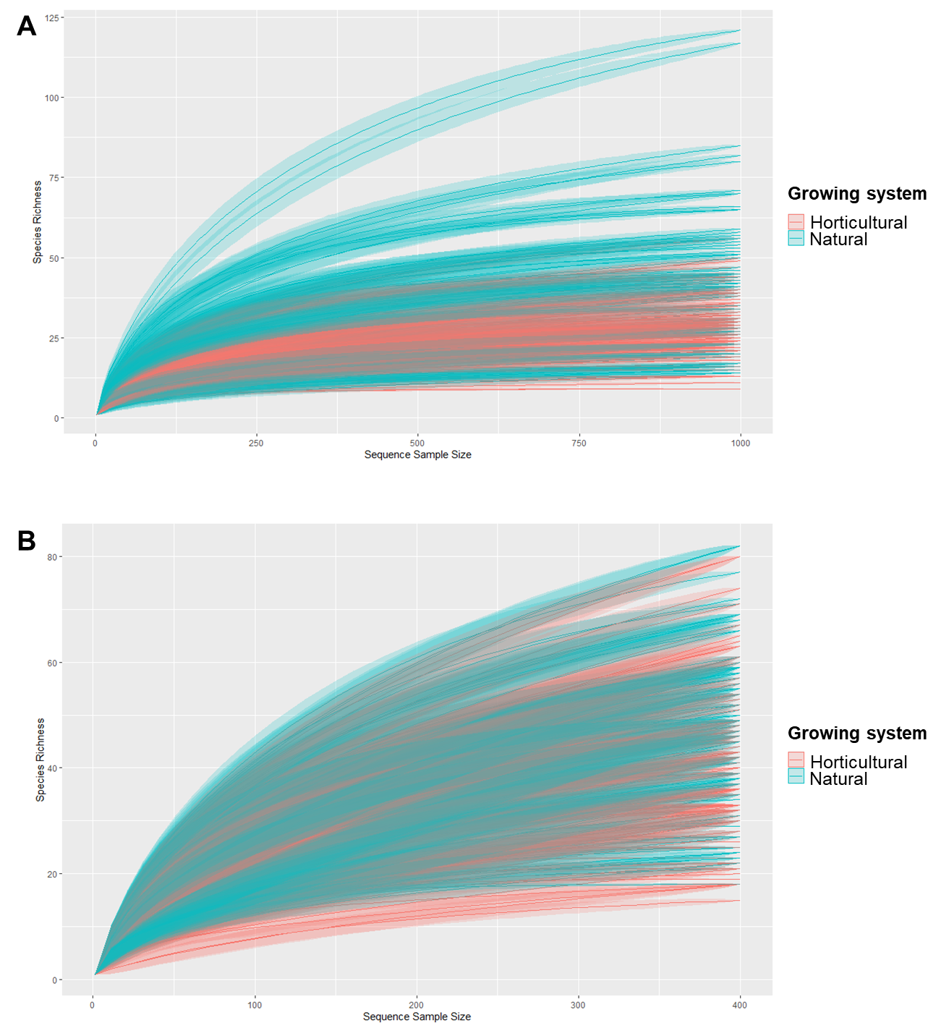
Supplementary Figure S1. Rarefaction curves for 16S rRNA and ITS gene amplicon libraries of naturally grown and horticultural fruits.

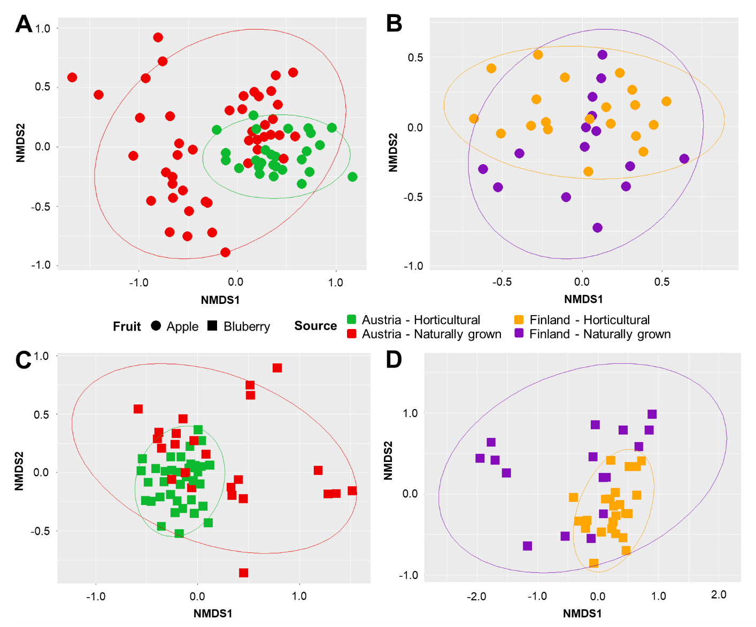

Supplementary Figure S2. Community clustering of bacterial composition between of naturally grown and horticultural fruits. The nonmetric multidimensional scaling (MDS) plots show bacterial communities from apples and blueberries that were obtained in Austria (A and C, respectively) and Finland (B and D, respectively).
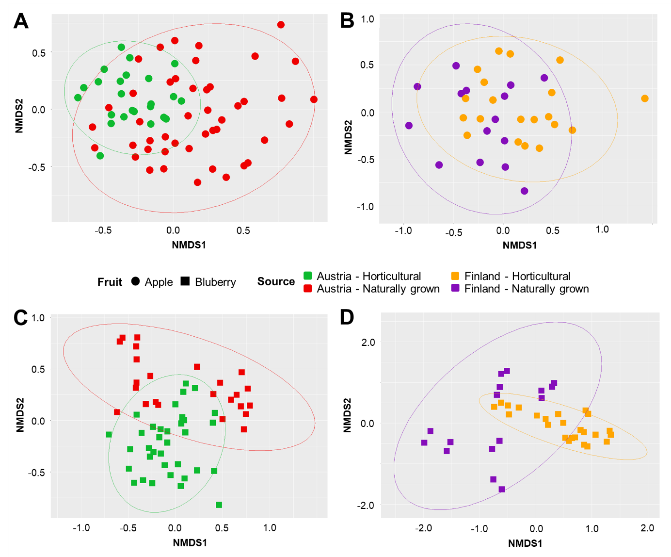
Supplementary Figure S3. Community clustering of fungal community compositions of naturally grown and horticultural fruits. The nonmetric multidimensional scaling (MDS) plots show fungal communities from apples and blueberries that were obtained in Austria (A and C, respectively) and Finland (B and D, respectively).

